**Agricultural Analysis Problem**

Nidhi Kumari

20th Feb 2019

**Table of Contents**

|  |  |  |  |  |  |
| --- | --- | --- | --- | --- | --- |
| **1** | **Introduction** | | | |  |
|  | 1.1 | | Data | . . . . . . . . . . . . . . . . . . . . . . . . . . . . . . . . . . . . . . . . . . . . . . . . . . . . . |  |
| **2** | **Methodology** | | | |  |
|  | 2.1 | | Exploratory Data Analysis . . . . . . . . . . . . . . . . . . . . . . . . . . . . . . . . . . . .. . . | |  |
|  |  | | 2.1.1 | Outlier Analysis . . . . . . . . . . . . . . . . . . . . . . . . . . . . . . . . . . . . . . . |  |
|  |  | | 2.1.2 | Analysis. . . . . . . . . . . . . . . . . . . . . . . . . . . . . . . . . . . . . . . . . . . . . . |  |
|  |  | | 2.1.3 | Trends and Seasonality . . . . . . . . . . . . . . . . . . . . . . . . . ... . . . . . . |  |
|  |  |

**1. Introduction**

**1.1 Data**

Cleaning of data is done in excel. There is an issue with the cases of commodities.

**Data (Monthly_data_CMO Dataset)**

**There is total** 62429 observations and 11 variables.

There is total 349 APMCs and 204 commodities.

**2. Methodology**

**2.1 Exploratory Data Analysis**

**2.1. Outlier Analysis**

Since, we have 205 commodities. So, we need to calculate outliers for each commodities.

commodity <- split(data, data$Commodity) #to split the data for each commodity

**##### Filtering Outliers ####**

for(j in 2:205){

for(i in 5:8){

bp <- boxplot(commodity[[j]][,i], plot = FALSE)

commodity[[j]][which(commodity[[j]][,i] %in% bp$out),i] <- NA # to remove the outliers

}

}

**#number of outliers in each commodity AND removing them**

for(i in 2:205){

print(names(commodity[i]))

print(sum(is.na(commodity[[i]])))

n <- sum(is.na(commodity[[i]]))

if(n!=0)

commodity[[i]] <- na.omit(commodity[[i]])

}

**1. amba koy**

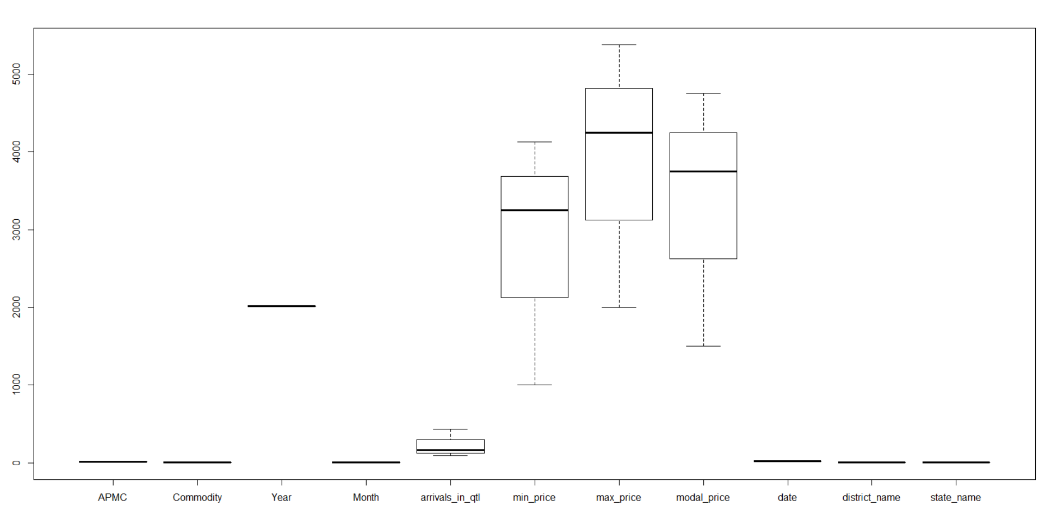

**2. ambat chuka**

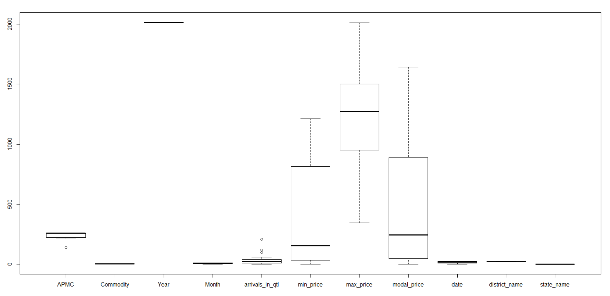

**3. amla**

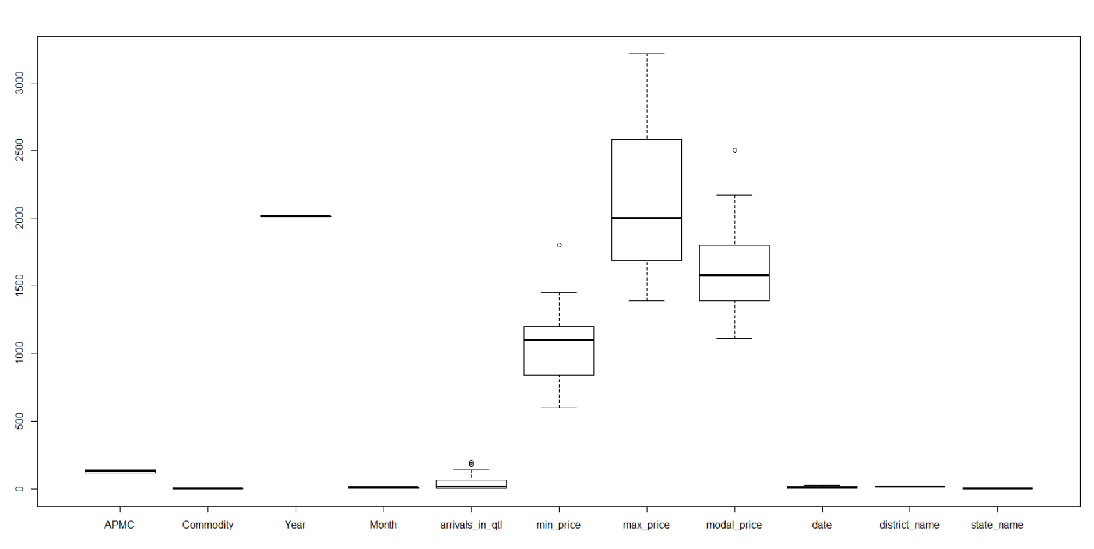

**4. apple**

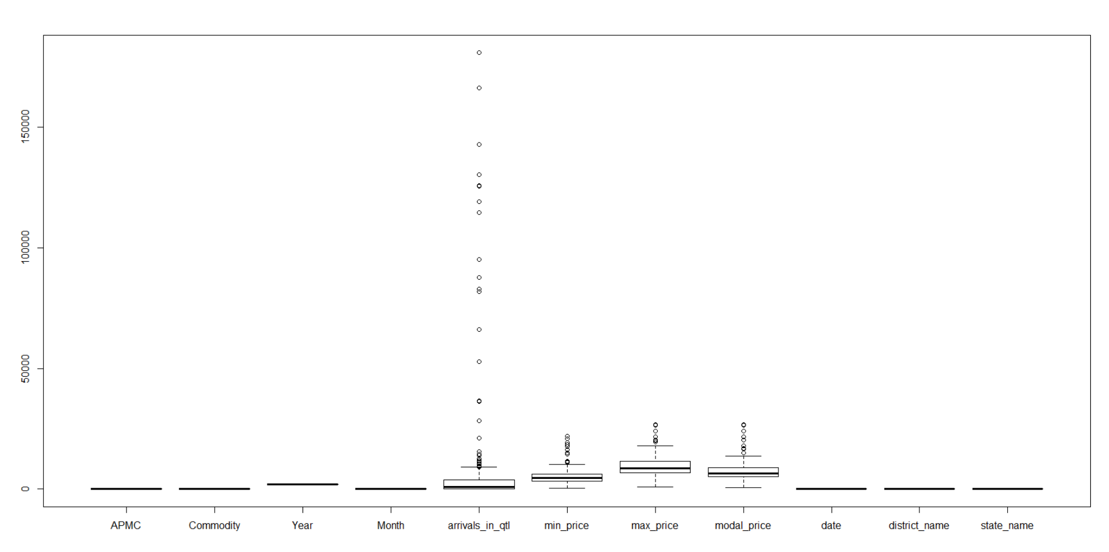

**5. arvi**

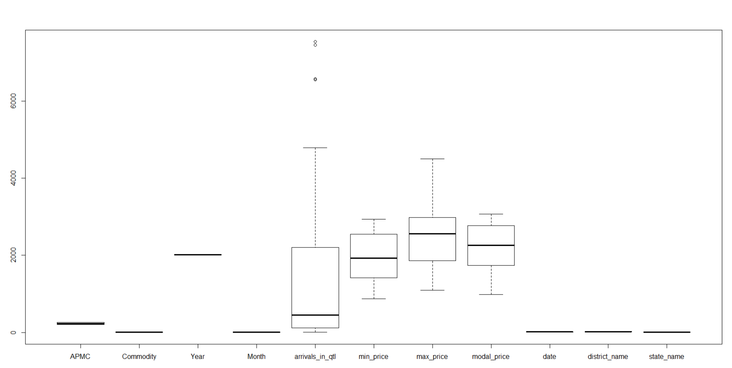

**6. aster**

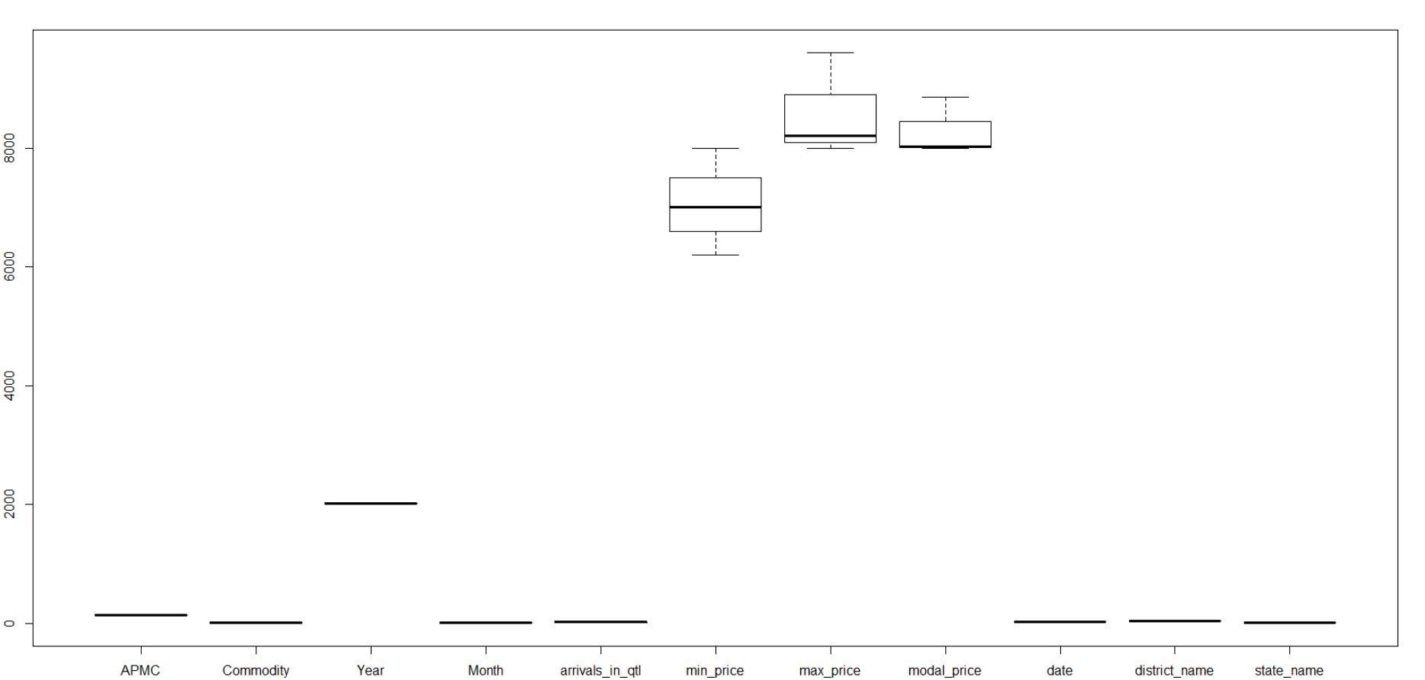

**7. awala**

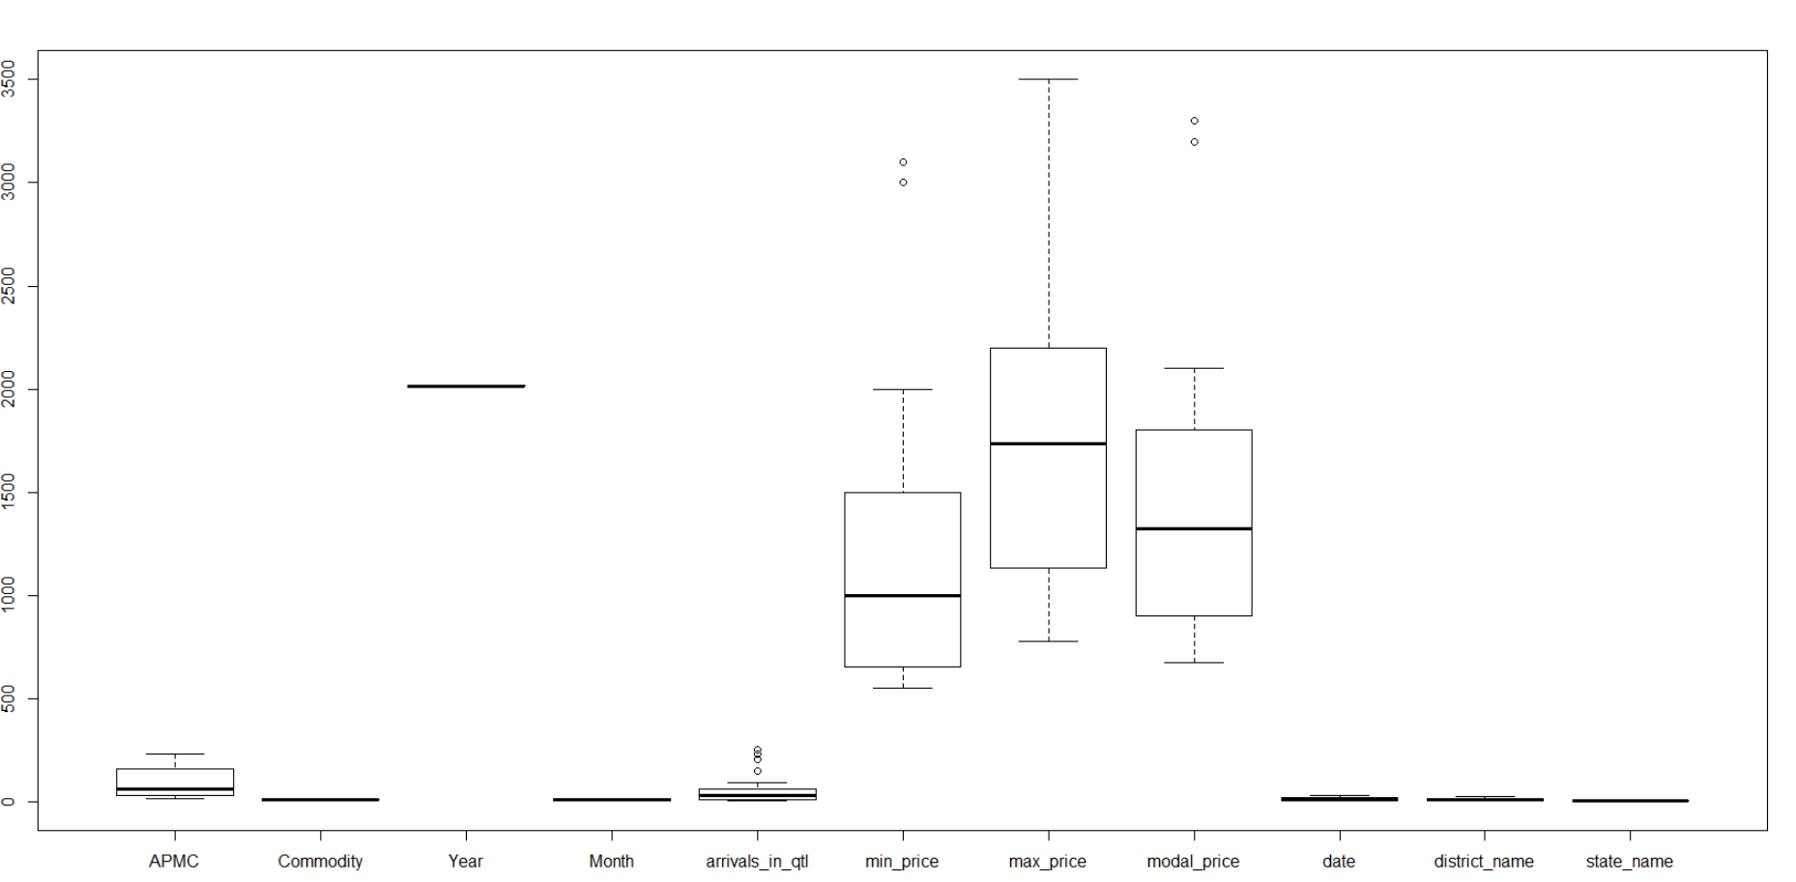

**8. bajri**

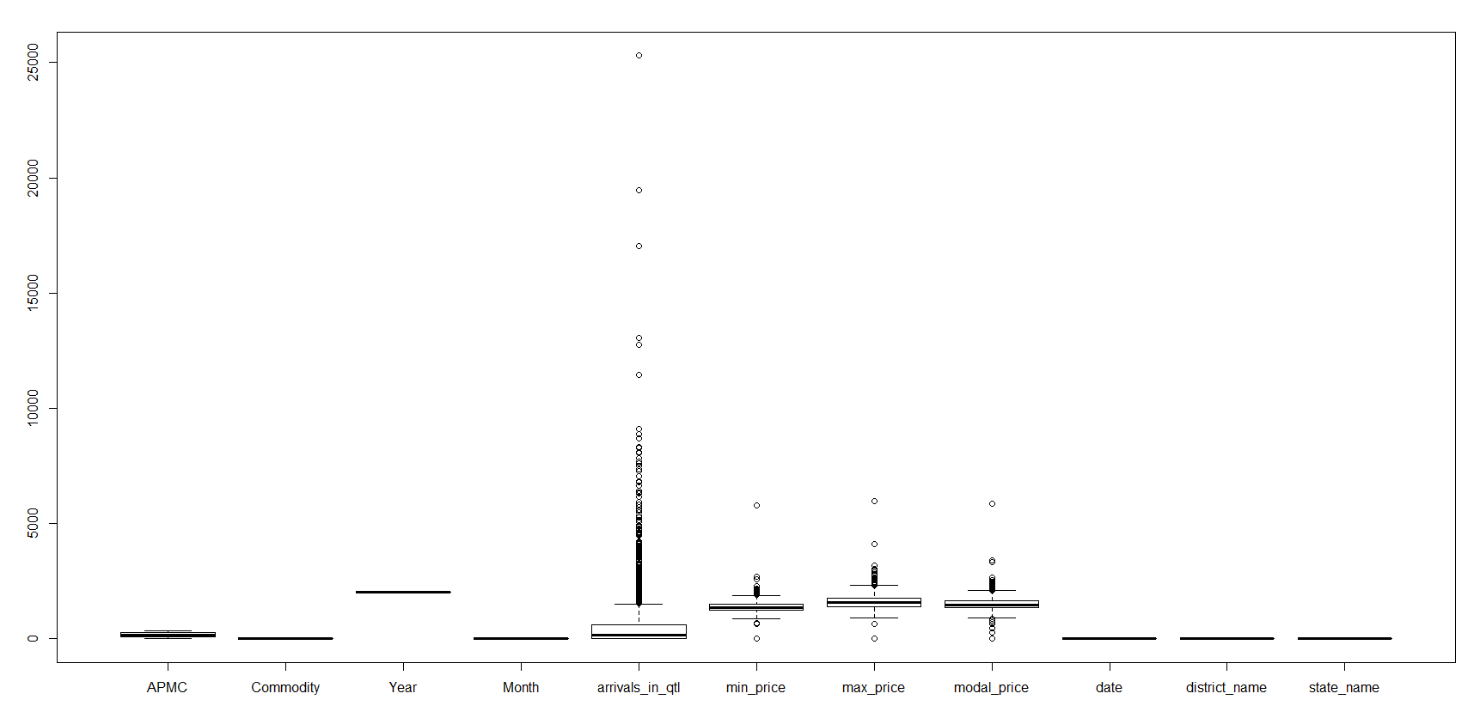

**9. banana**

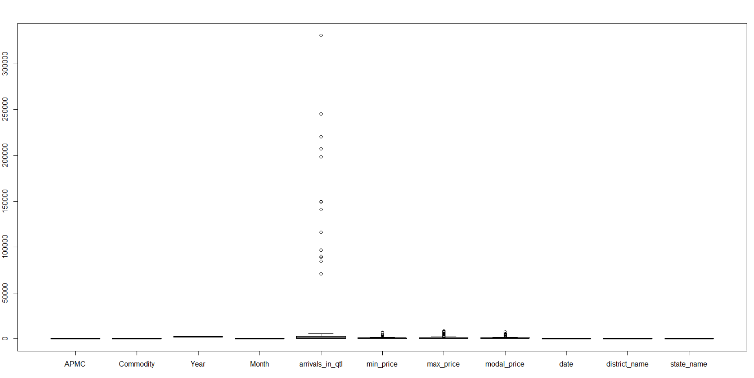

**10. banana(raw)**

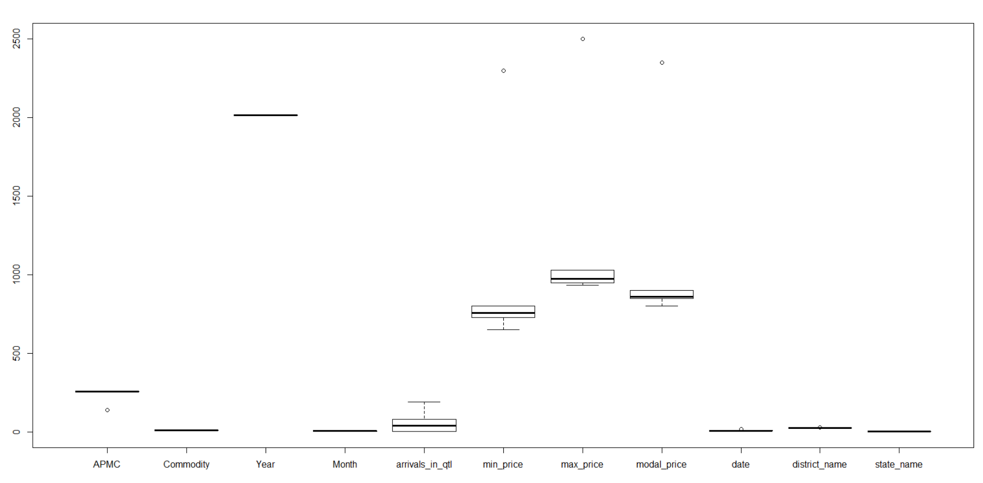

**2.1.2 Analysis in Tableau.**

**Dashboard 1**

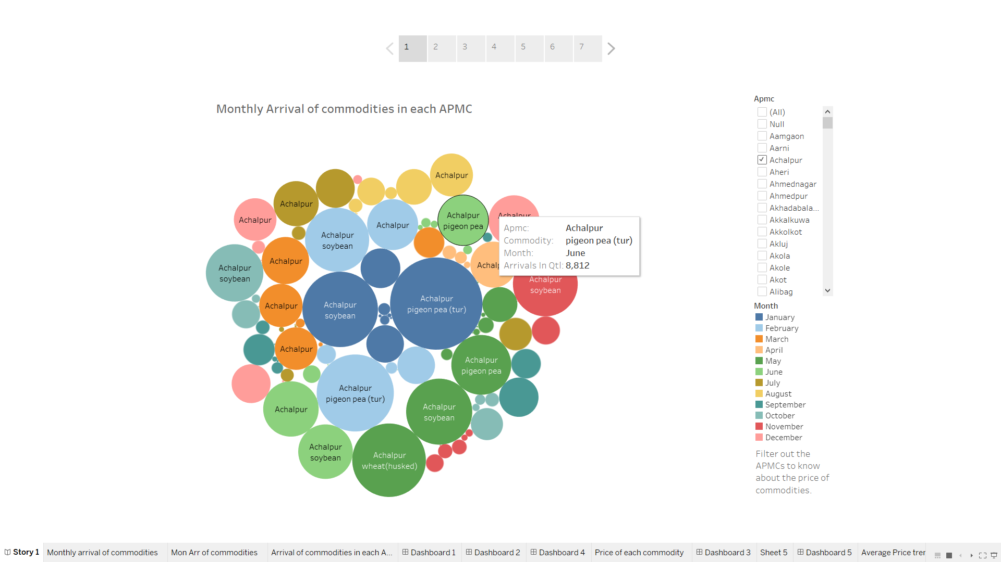

**From this dashboard we can conclude about the monthly arrival of commodities in particular APMC by filtering out the APMC.Dashboard 2**

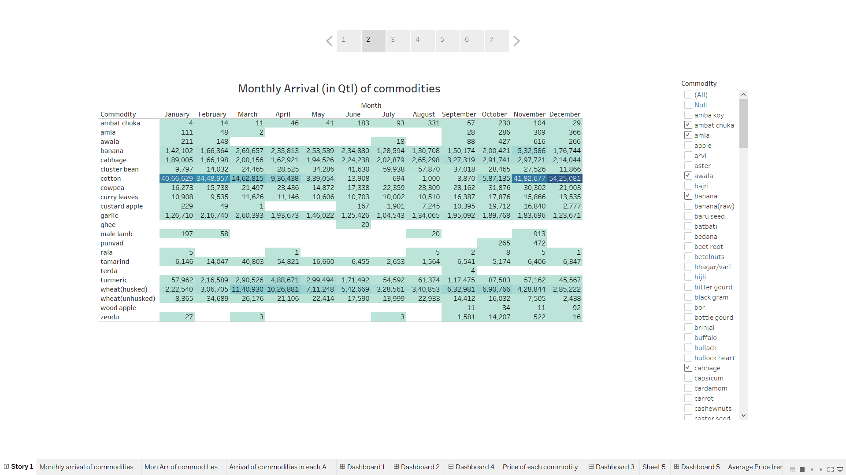

**From this table we can know about the exact arrival of commodities in quintal by filtering out the commodities.**

**Dashboard 3**

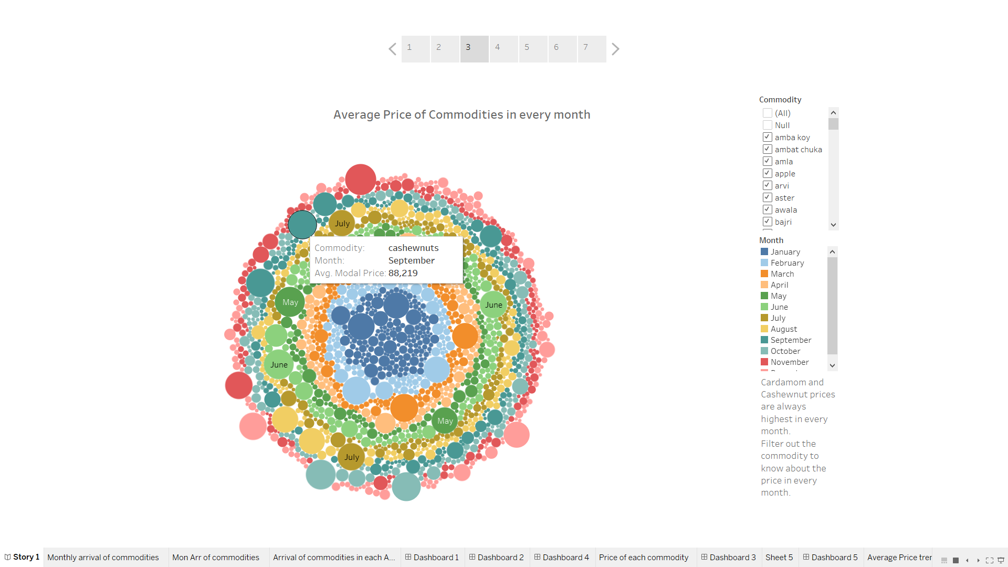

**From here we can filter out the commodities and get to know the price in every month.**

**Dashboard 4**

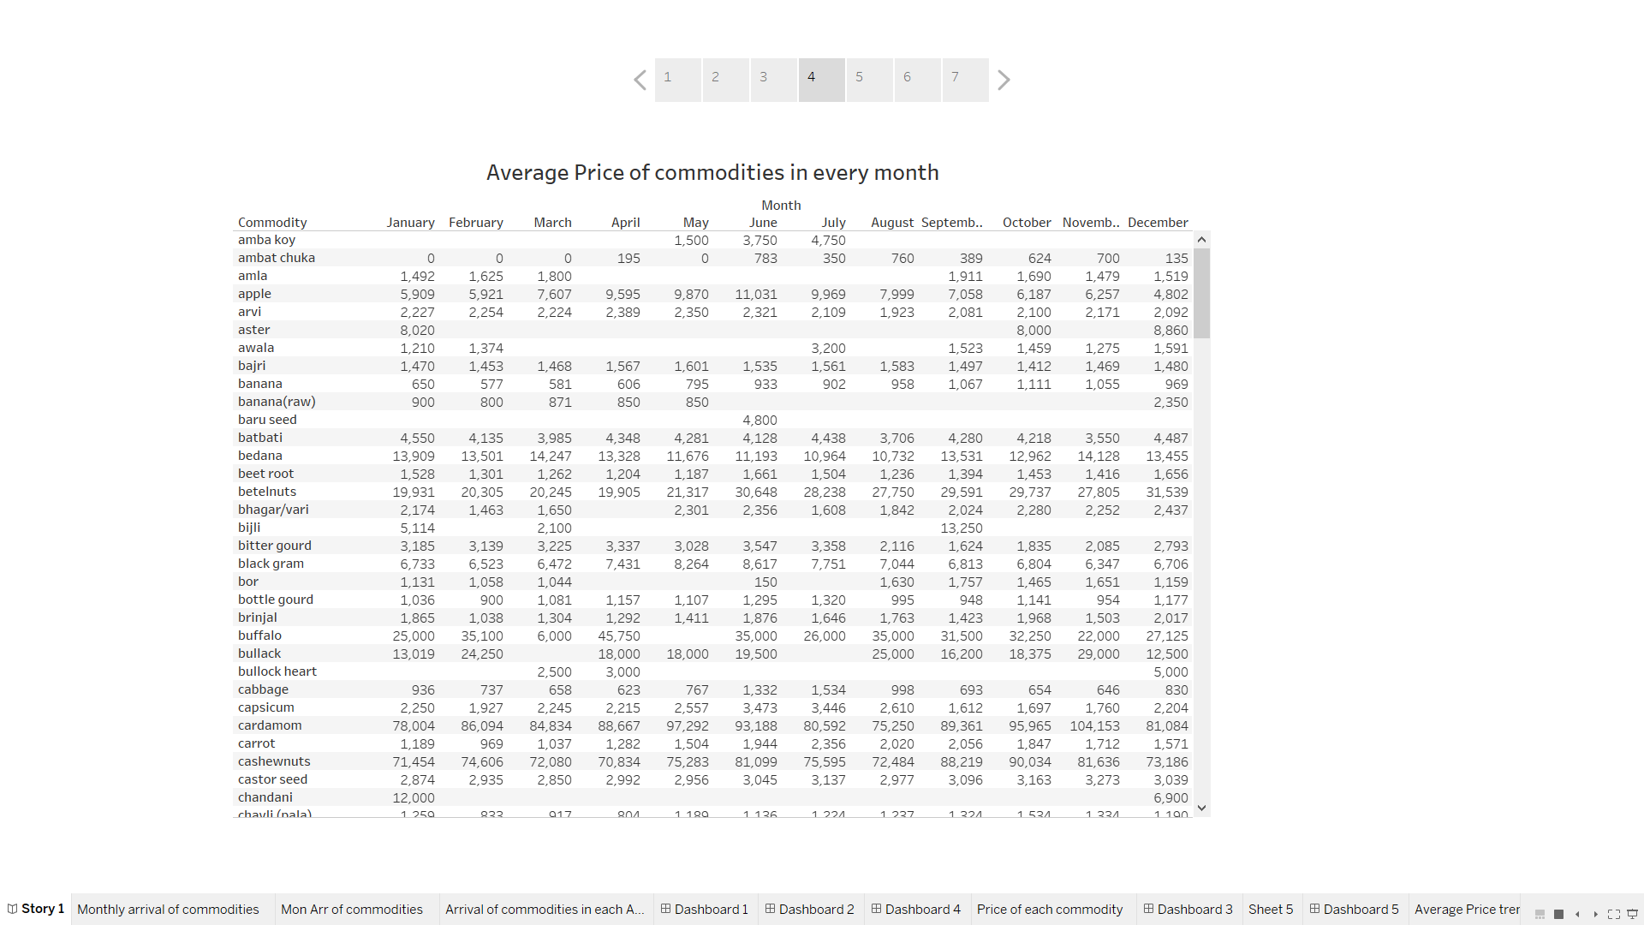

**This table tells about the price of commodities in every month.**

**Dashboard 5**

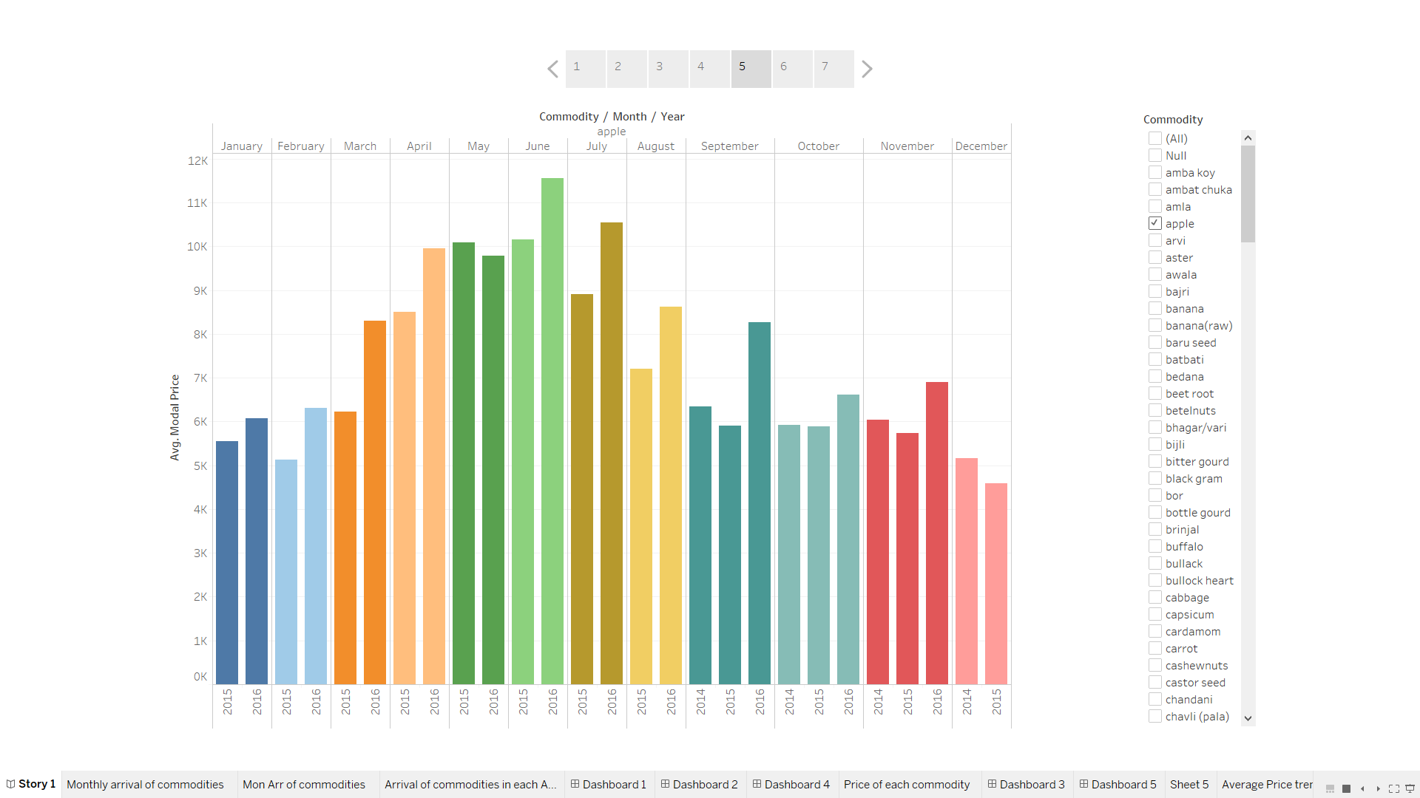

**From this, we can know the trend in price for every commodity by filtering it out both monthly and yearly**

**From this dashboard we can see for apple commodity.**

**Dashboard 6**

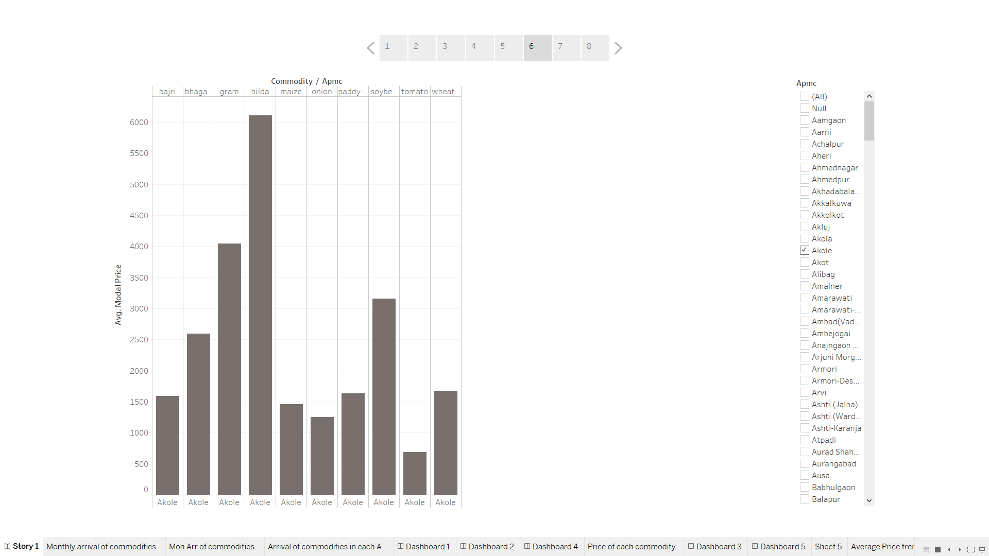

**From this dashboard, we can get to know about the price trend of commodities in each APMC by filtering it out.**

**Here, we can see that In Akole APMC, hinda commodity has highest modal price.**

**Dashboard 7**

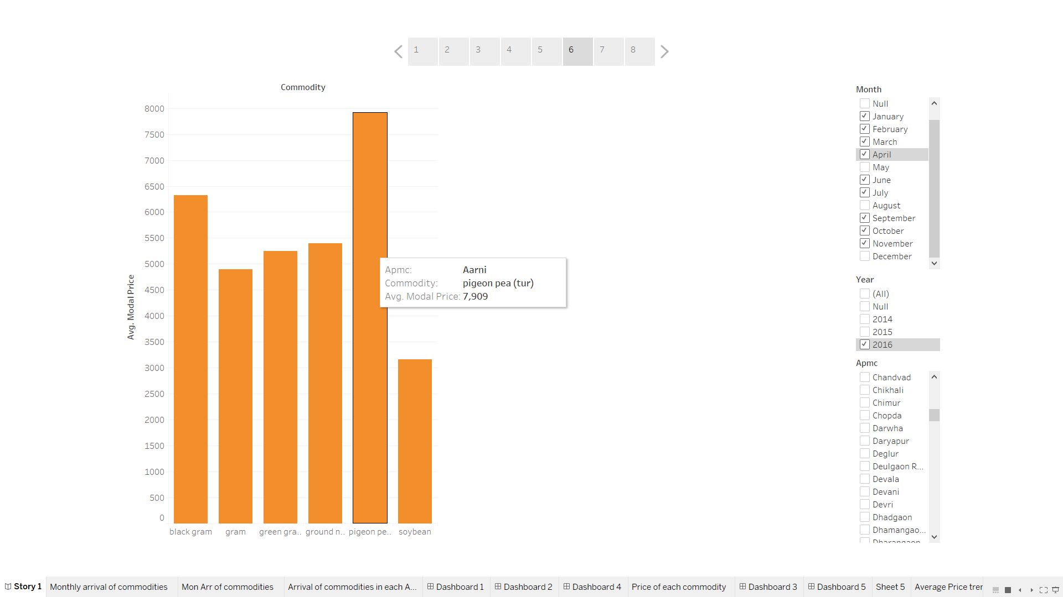

**From here, we can find the trend in price of each commodity in a particular APMC, in particular month and in a particular year.**

**Dashboard 8**

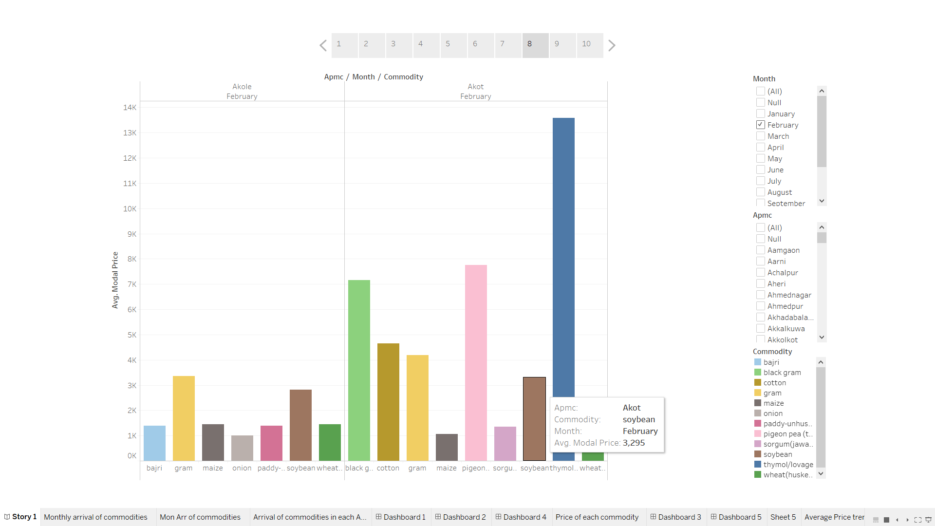

**From this dashboard, we can compare prices of commodities in desired APMC and month.**

**From here, we can see, Price of Soybean in February in higher in Akot APMC than Akole APMC. In this way we can also compare with other APMCs.**

**Dashboard 9**

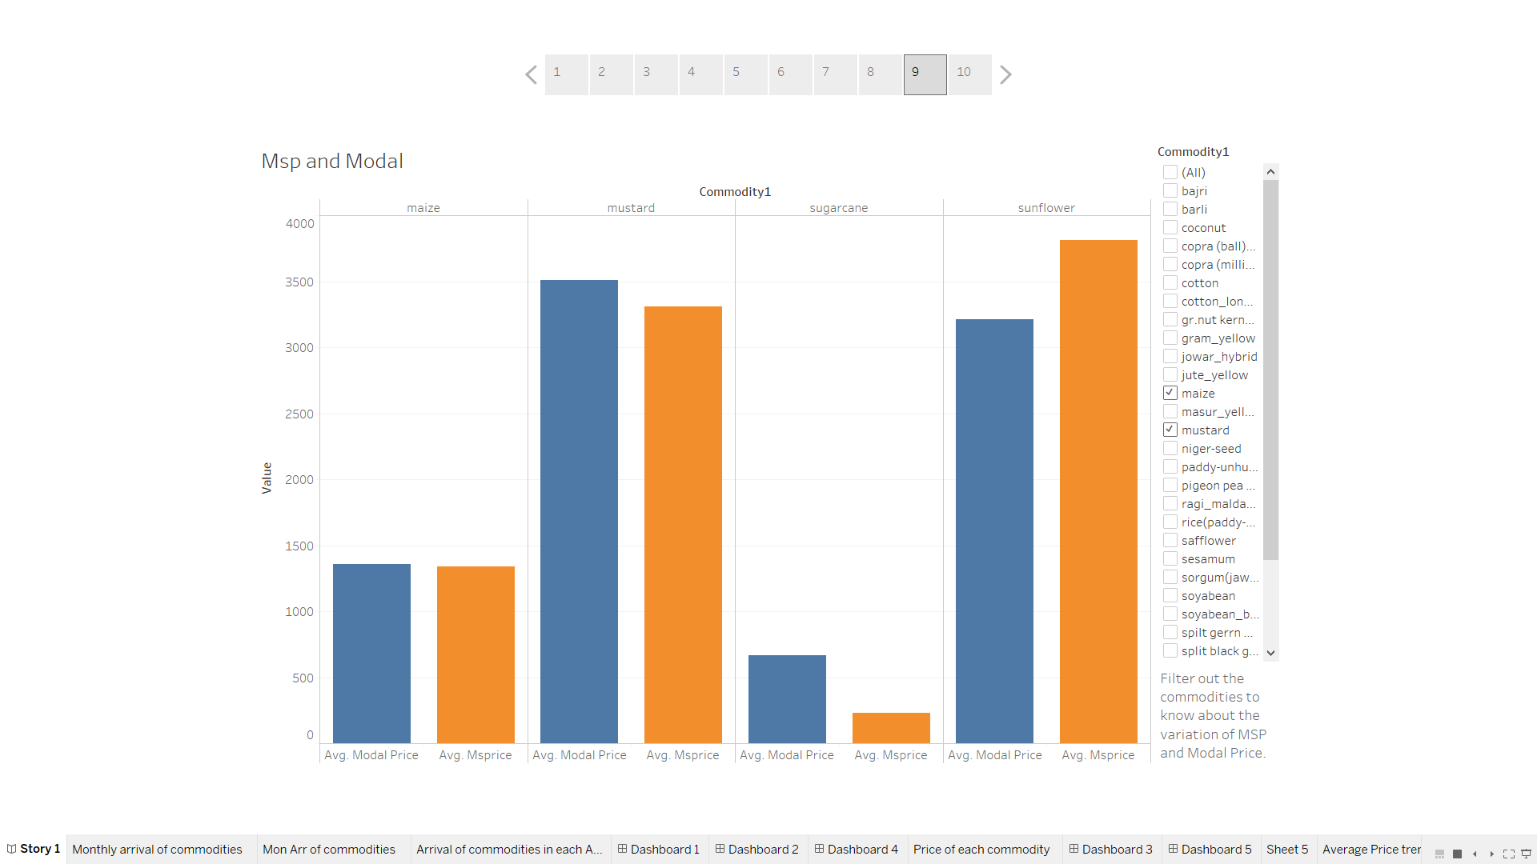

**From here, we can compare MSP and Modal Price of every commodities by filtering it out.**

**Msp of Sunflower is higher than its Modal Price**

**Msp of Mustard is lesser than its Modal Price.**

**Dashboard 10**

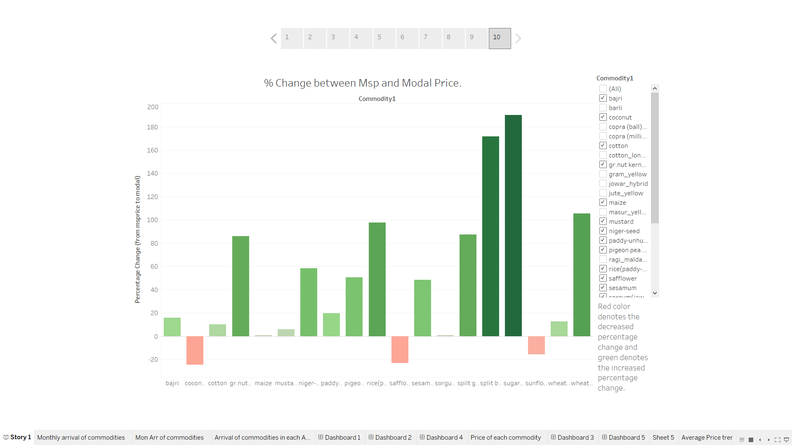

**From here, we can get to know about the percentage change between MSP and Modal Price for each commodity.**

**From here, we can interpret that there is decreased percentage change btw Msp and Modal prices of Coconut, Safflower and sunflower.**

**Please go through the Story 1 of my tableau dashboard which I have published.**

**Link is mentioned below**

[**https://public.tableau.com/profile/nidhi.kumari2634#!/vizhome/Dashboard_1635/Story1?publish=yes**](https://public.tableau.com/profile/nidhi.kumari2634%23!/vizhome/Dashboard_1635/Story1?publish=yes)

**2.1.3 Seasonal effect for each commodity**

There is additive seasonality in most of the commodities

**1. Amba Koy**

**Additive Seasonality**

Amba Koy production clearly follows quarterly seasonality. As it is recorded monthly, there are 12 data points recorded per year, and we use a moving average window of 12.

There is constant trend over years in this case. Price is almost constant trend from year 2014 to 2016. There is quarterly seasonality in this case.

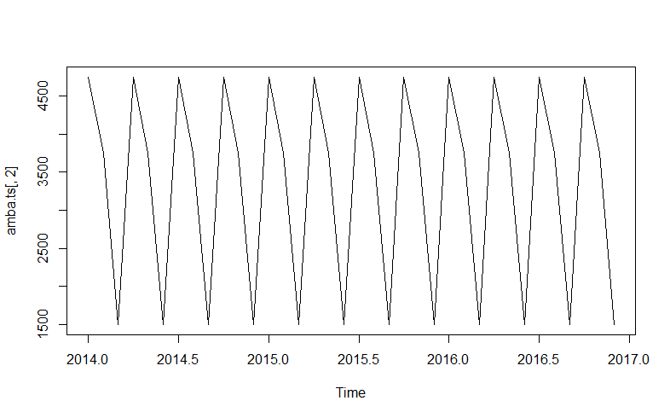

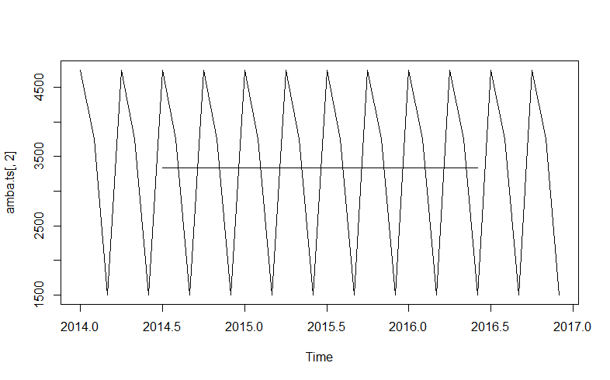

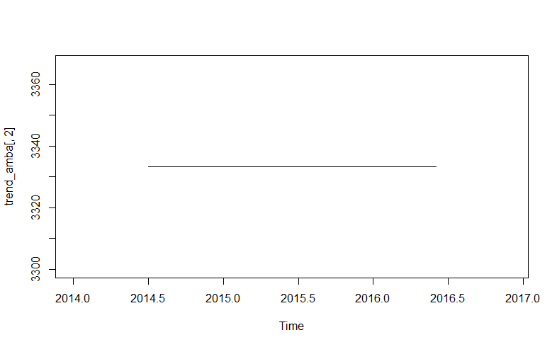

**2. Ambat Chuka**

**Additive Seasonality**

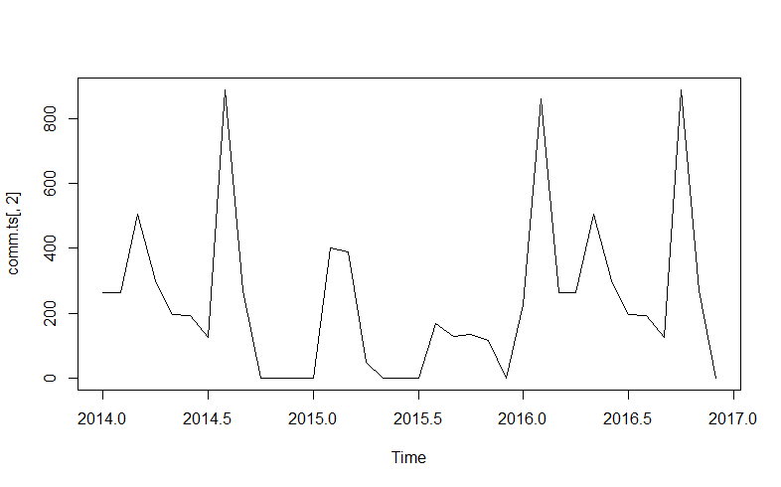

Seasonality with trend line

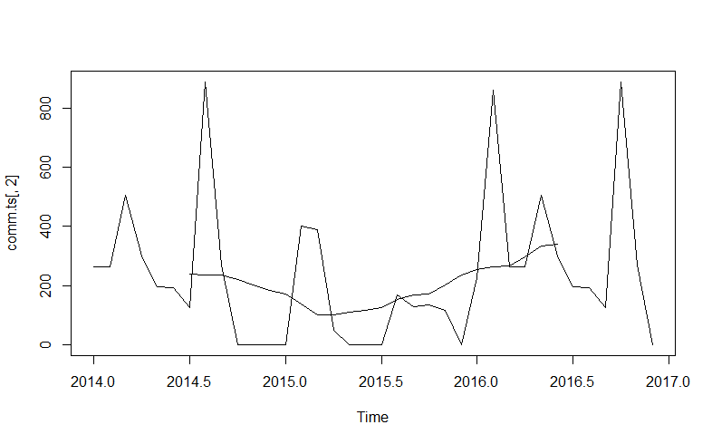

Trend line

(There is decrease in price in the beginning of the year 2015 and then price has increased after that.)

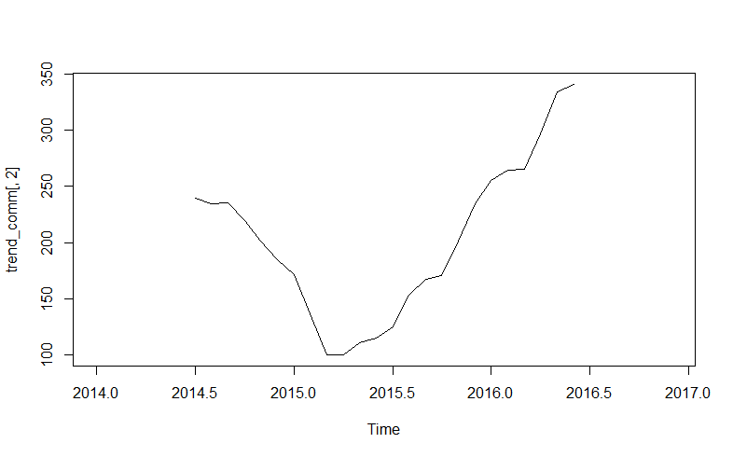

**Before De-Seasonlise**

Jan Feb Mar Apr May Jun Jul Aug Sep Oct Nov Dec

2014 264 263 506 300 196 193 125 888 270 0 0 0

2015 0 400 388 50 0 0 0 167 129 136 115 0

2016 225 859 264 263 506 300 196 193 125 888 270 0

**After De-seasonalise**

Jan Feb Mar Apr May Jun Jul

1 1.222842e+136 1.057361e-18 8.422319e+129 2.769957e+125 2.127652e+117 8.368437e+93 2.802184e+86

2 2.714109e+21 3.330945e+41 4.771806e+78 7.393541e+16 1.607615e+32 1.270016e+10 1.447726e+32

3 1.412166e+119 7.306925e+240 6.701423e+24 2.363617e+109 9.103112e+251 2.466913e+140 1.916041e+117

Aug Sep Oct Nov Dec

1 Inf 4.494084e+118 5.865635e+36 4.727818e+20 9.554116e+74

2 4.734225e+69 2.612879e+57 6.797741e+95 4.154571e+70 9.554116e+74

3 9.266280e+80 4.785654e+55 Inf 8.593516e+137 9.554116e+74

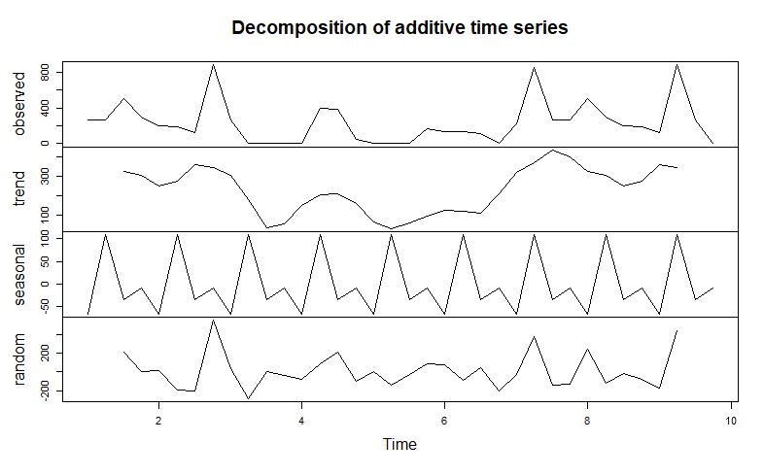**3. Amla**

**Seasonality**

**Annual Seasonality is followed in this case.**

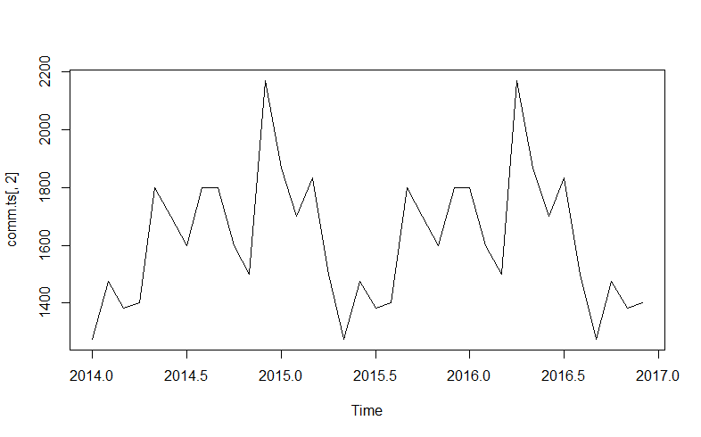

**Seasonality with Trend Line**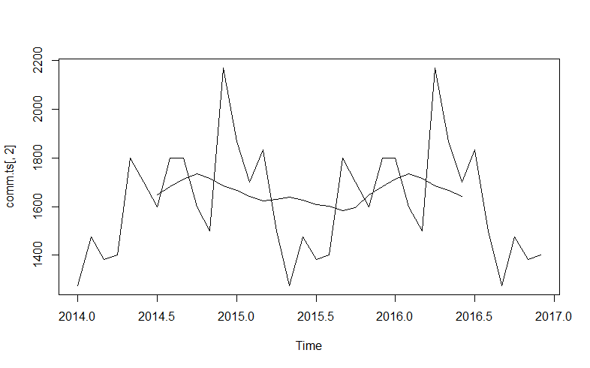

**Trend Line**

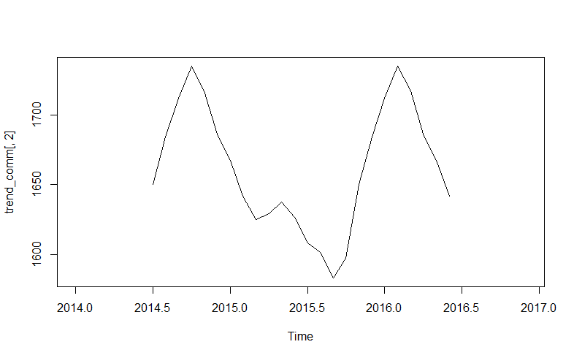

**After and Before de-seasonalise (Red denotes before and green denotes after)**

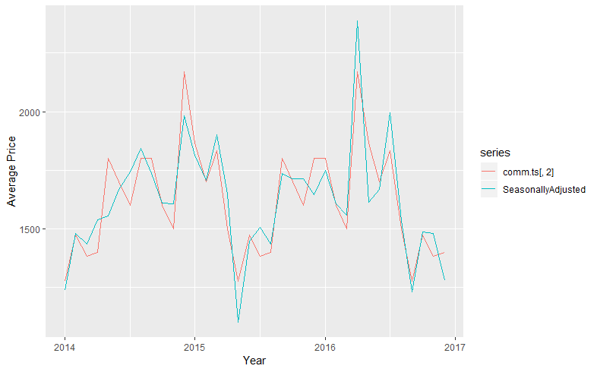

**4. Apple**

**Seasonality**

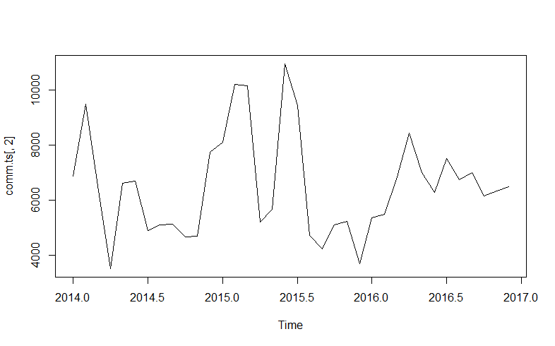

**Seasonality with Trend Line**

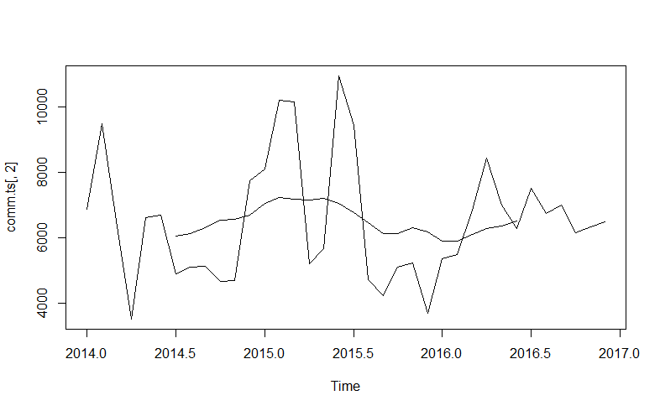

**Trend Line**

**There was an increase in price in the beginning of year 2015 then after few months price decreased.**

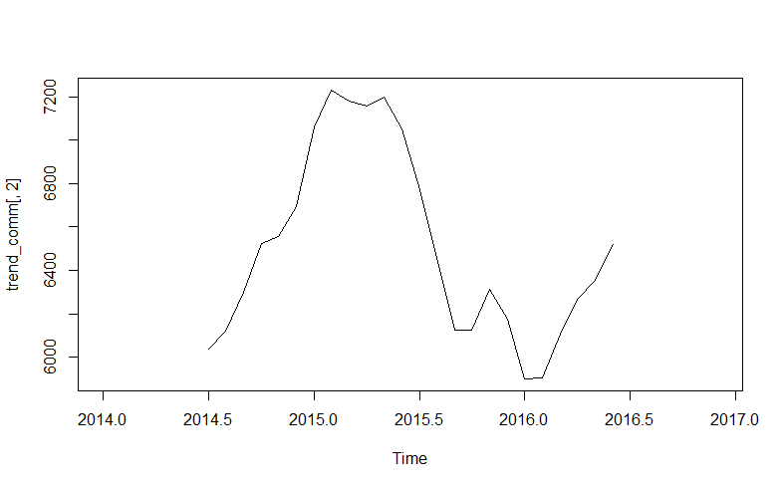

**5. Arvi**

**Seasonality**

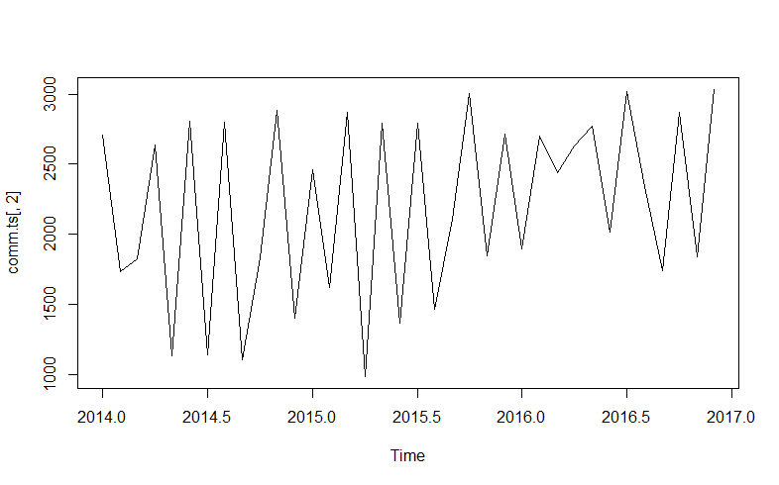

**Seasonality with trend line**

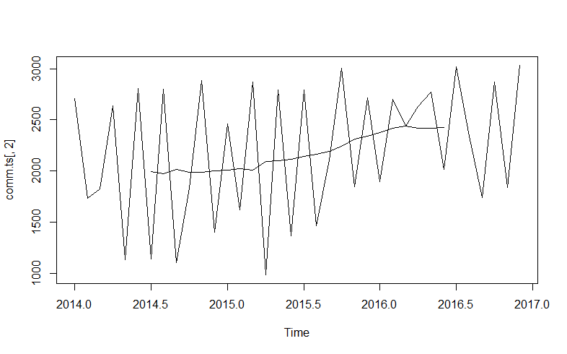

**Trend Line**

**There is an increase over years in price of arvi**

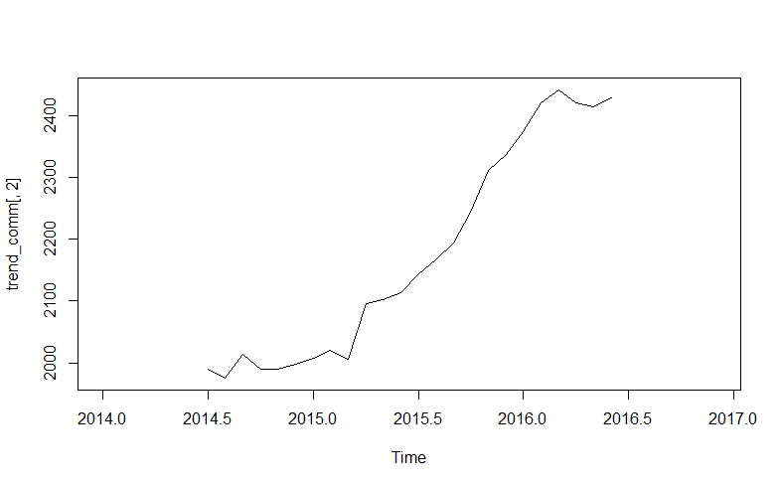

**After and Before de-seasonalise (Red denotes before and green denotes after)**

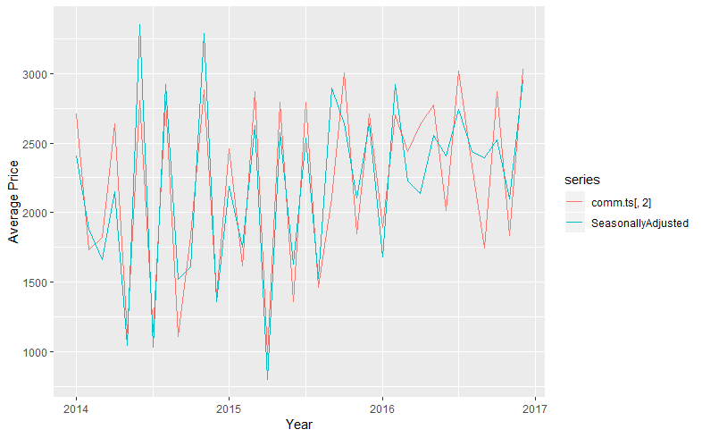

**6. Aster**

**Seasonality**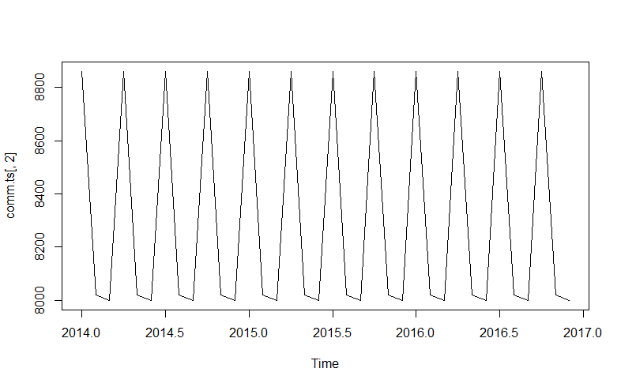

**Seasonality with Trend Line**

**No change in Price over years**

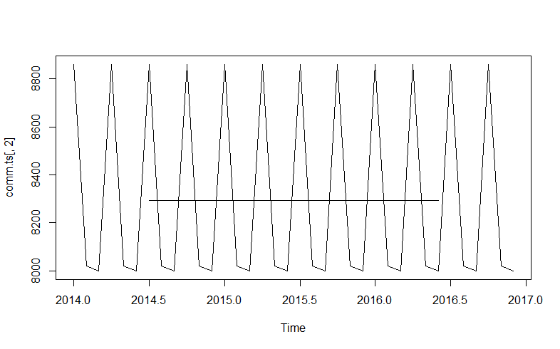

**After and Before de-seasonalise (Red denotes before and green denotes after)**

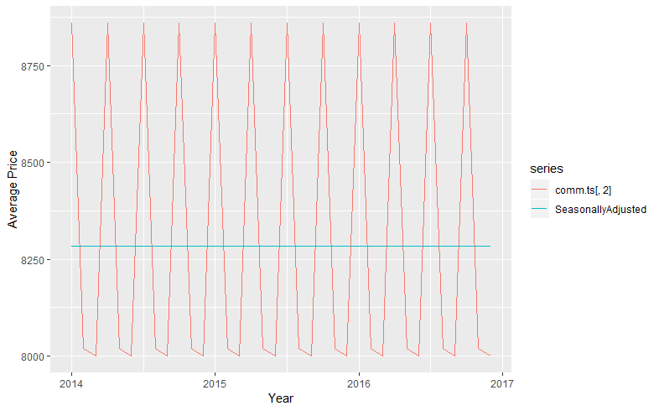 **7. Awala**

**Seasonality**

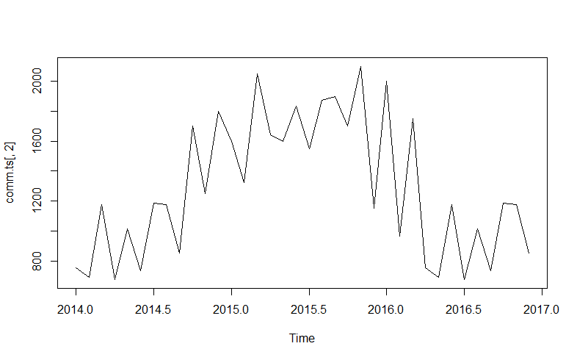

**Seasonality with Trend Line**

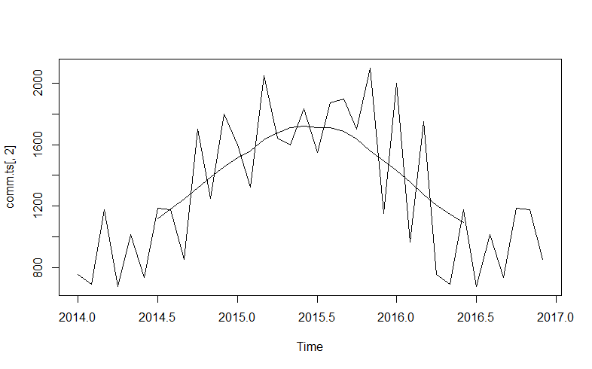

**After and Before de-seasonalise (Red denotes before and green denotes after)**

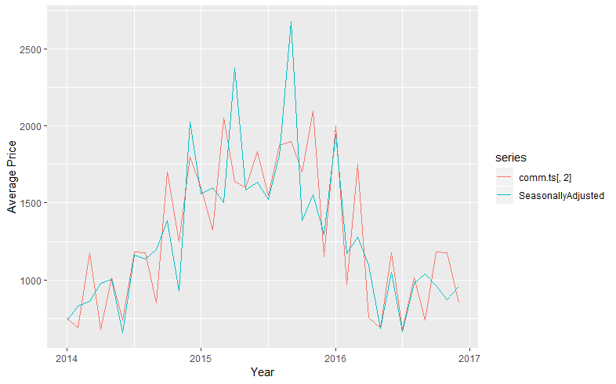

**8. Bajri**

**Seasonality**

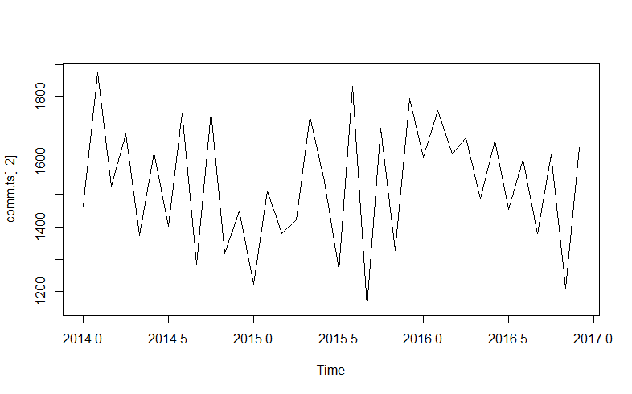

**Seasonality with trend line**

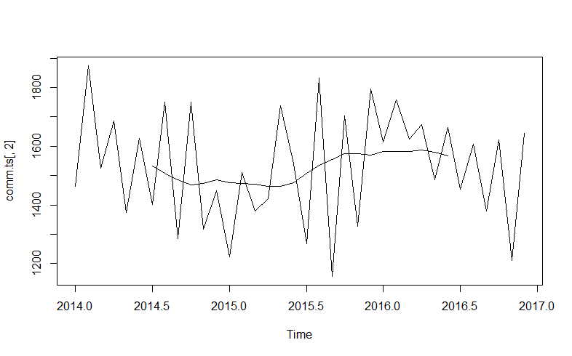

**After and Before de-seasonalise (Red denotes before and green denotes after)**

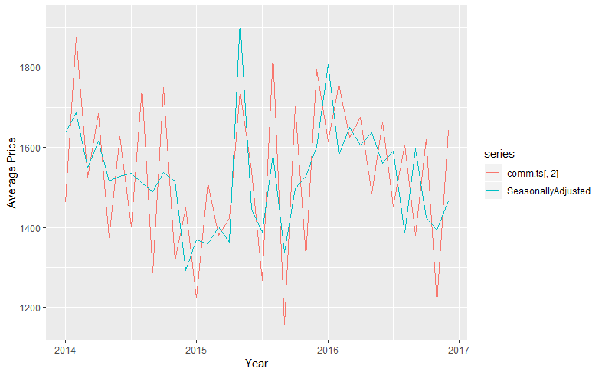

**9. Banana**

**Seasonality**

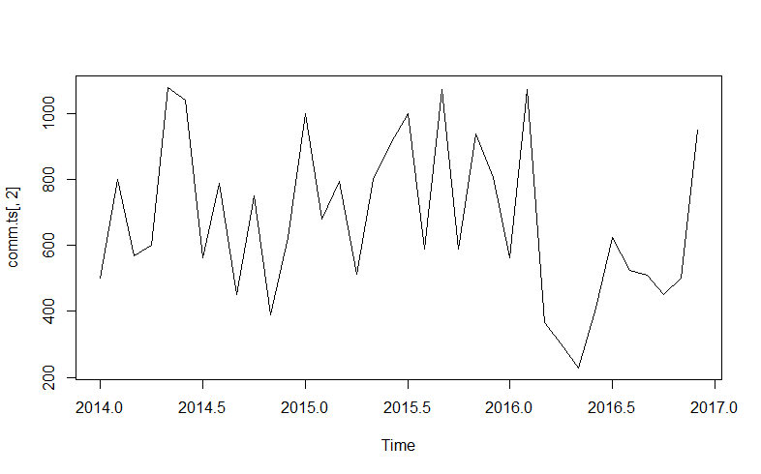

**Seasonality with Trend Line**

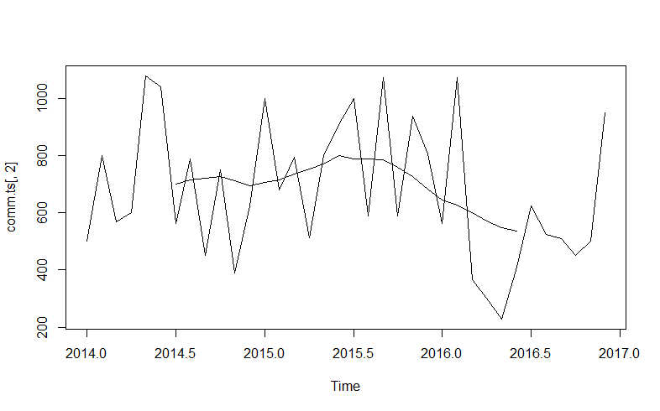

**After and Before de-seasonalise (Red denotes before and green denotes after)**

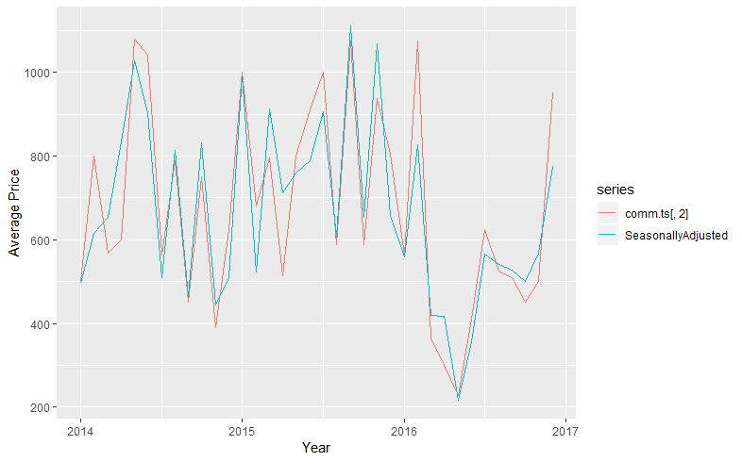

**10. Banana (Raw)**

**Seasonality**

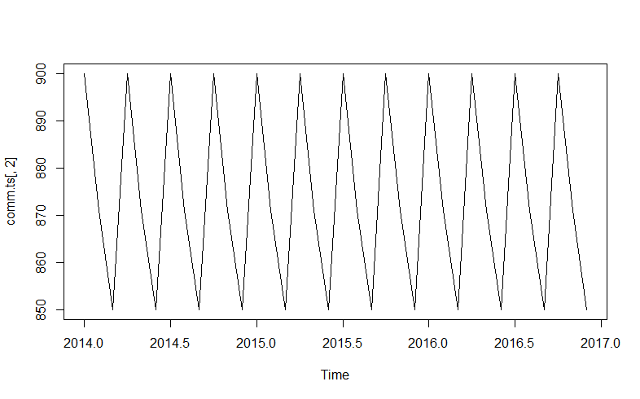

**Seasonality with trend line (constant Trend)**

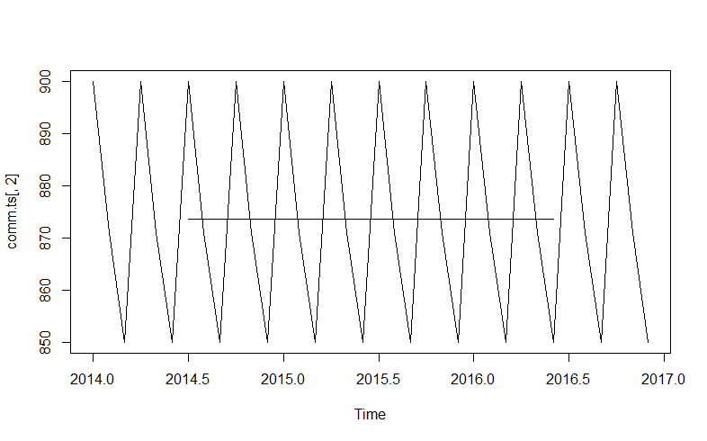

**In the same, we will find seasonality of all the other remaining commodities and de-seasonalize them.**