A
MAJOR PROJECT ON
Identification Of Diabetic Retinopathy Using the Retinal Images Using Image Processing
(A report submitted in partial fulfilment of the requirements for the degree of Bachelor of Technology in Electrical and Electronics Engineering)
Submitted by
B.RUCHITHA (197Z1A0201)
Under the Guidance of
P.SAI JYOTHI(M.Tech)
Assistant Professor
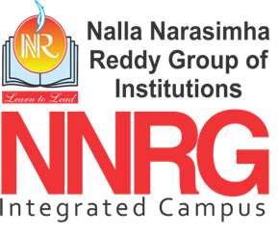
Department of Electrical & Electronics Engineering
NALLA NARASIMHA REDDY EDUCATION SOCIETIE’S GROUP OF INSTITUTIONS
Approved by AICTE, NewDelhi, Affiliated to JNTU-Hyderabad(Accredited by NAAC,NBA)
Near Narapally, Chowdariguda(V), Korremula‘X’Road, Ghatkesar(M), Medchal(D), Hyderabad-500088, Telangana state.
2022-2023

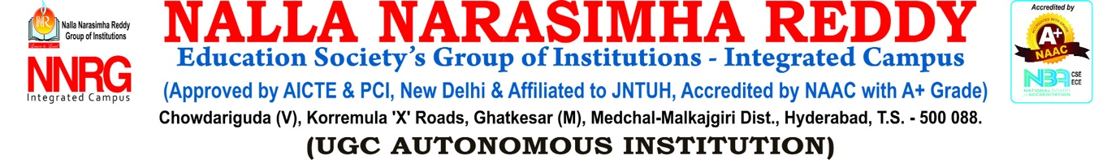

CERTIFICATE

This is to certify that the technical seminar entitled “DAIBETIC RETINOPATY DETECTION USING IMAGE PROCESSING” is being submitted by B.RUCHITHA (197Z1A0201), in partial fulfilment for the award of Degree of Bachelor of Technology in Electrical & Electronics Engineering to the Jawaharlal Nehru Technological University, Hyderabad during the academic year 2022-2023 is a record of bonafide work carried out by her under our guidance and supervision. The results embodied in this report have been submitted by the student(s) to any other University or Institutions for the award of any degree or diploma.

Supervisor signature Head of the Department

External Examiner
ACKNOWLEDGMENT
I express my deep sense of gratitude to our beloved chairman Sri. Nalla Narasimha Reddy, Nalla Narasimha Reddy Education Society’s Group of Institutions for the valuable guidance and for permitting me to carry out this Seminar.
With immense pleasure, I record my deep sense of gratitude to our beloved Director Dr.CV krishna Reddy and Dean Dr. G.Janardhan Raju Nalla Narasimha Reddy School of Engineering for permitting me to carry out this seminar.
I express my deep sense of gratitude to our beloved Head Dr.P.Ramesh, Department of Electrical and Electronics Engineering, Nalla Narasimha Reddy School of Engineering, for the valuable guidance and suggestions, keen interest and through encouragement extended throughout period of seminar work.
I take immense pleasure to express our deep sense of gratitude to my beloved Guide P.Sai Jyothi(M.Tech)Associate professor in Electrical and Electronics Engineering, for his valuable suggestions and rare insights, for constant source of encouragement and inspiration throughout my seminar work.
I express my thanks to all those who contributed for the successful completion of my Seminar work.

With gratitude,
B.RUCHITHA (197Z1A0201)

ABSTRACT
Diabetic Retinopathy (DR) has been considered to be the most harmful eye related disease which causes blindness or vision loss in a long run. Thus, detecting this disease at first place is mandatory. Diagnosing to be done from medical images has been gaining importance in medical science. However, identifying abnormalities in retinal images are difficult and challenging in medical field. Thus, efficient computing methods has to be employed to facilitate the detection of DR from Retinal images. Here, a MATLAB based system has been utilized for analysing the fundus image that are captured via Peek retina attached on smartphone camera lens. Various performance measures have been utilized in validating the proposed technique. From those performance analysis, we could observe 98% accuracy in detecting PDR and NPDR within 39 seconds (half minute). Proposed method used Support vector machine (SVM) classifier for identification of DR.
Keywords: Retinal images , Diabetic Retinopathy (DR), Support vector machine (SVM) classifier.

