
REAL TIME RESEARCH PROJECT REPORT
ON
TUTORING WEBSITE
BY
E.Tejaswi | 24N81A05E9
M.Nidhi | 24N81A05F2
A.Keerthi | 24N81A05F8
M.Suchith Reddy | 24N81A05H4
D.Shivan Nayan | 25N85A05H5

Under the Guidance of
Mr.M.Venkateshwarlu
- Tech, (Ph.D)
Assistant Professor, Department of CSE

Department Of Computer Science and Engineering
SPHOORTHY ENGINEERING COLLEGE
(Approved by AICTE Affiliated to JNTUH)
Nadergul ,Saroor Nagar Mandal,Hyderabad -501 510
Academic Year 2025-2026


CERTIFICATE
This is to certify that, this Real Time Research Project report entitled "TUTORING WEBSITE" is a bonafied work carried out by E. Tejaswi (24N81A05E9), M. Nidhi (24N81A05F2), A. Keerthi (24N81A05F8),M. Suchith Reddy(24N81A05H4), D. Shivan Nayan (25N85A05H5) in partial fulfilment of the requirements for the Completion of Real Time Research Project in CSE from Sphoorthy Engineering College, affiliated to Jawaharlal Nehru Technological University Hyderabad, during the Academic Year 2025-26 under our guidance and supervision. The results embodied in this report have not been submitted to any other University or institute.
Dr. Kiran B. M. | Mr. M.Venkateshwarlu | Dr. K.Srinivas rao
Head of the Department  Dept. of CSE,  Sphoorthy Engineering College,  Hyderabad  Date: | Assistant Professor,  Dept. of CSE,  Sphoorthy Engineering College,  Hyderabad  Date: | Principal  Sphoorthy Engineering College,  Hyderabad  Date:

Name of the Examiner Signature of Examiner

DECLARATION
We, the undersigned, declare that the Real Time Research Project entitled "TUTORING WEBSITE " carried out at SPHOORTHY ENGINEERING COLLEGE is original and is being submitted to the Department of CSE, Sphoorthy Engineering College, Hyderabad towards partial fulfilment for the award of Bachelor of Technology.We declare that the results embodied in the Real Time Research Project has not been submitted to any other University or Institute for the award of credits.
Date:
Place: Hyderabad

E.Tejaswi | 24N81A05E9
M.Nidhi | 24N81A05F2
A.Keerthi | 24N81A05F8
M.Suchith Reddy | 24N81A05H4
D.Shivan Nayan | 25N85A05H5

ACKNOWLEDGEMENT
We would like to thank our Project Guide Mr.M.Venkateshwarlu,M.Tech(Ph.D), Assistant Professor, Department of CSE, Sphoorthy Engineering College, Jawaharlal Nehru Technological University Hyderabad (JNTUH), Hyderabad for her inspiring guidance, consistent encouragement, constructive criticism, and helpful suggestions during the entire course of our project work.
We express our sincere thanks to Dr. Kiran B M, Professor & Head of CSE Department, Sphoorthy Engineering College, Hyderabad for his encouragement which helped us to complete our Project work.
We deem it a great privilege to express our profound gratitude and sincere thanks to Sri. S. Chalama Reddy, Chairman, Sri. S. Jagan Mohan Reddy, Secretary, Prof. M.V.S. Ramprasad, Director and Principal Dr. K Srinivas Rao, Sphoorthy Engineering College, for their moral support, necessary arrangements and kind help in the completion of our project work.
We express our heartfelt thanks to our department faculty members and non-teaching staff for providing the necessary information pertaining to our project work.
We are always grateful to our parents, family members, well-wishers and friends for their remarkable support during our project work.

ABSTRACT
This is an online tutoring platform designed to provide personalized and interactive learning experiences for students from Nursery to B.Tech level. The platform integrates modern educational technologies such as live classes, recorded lectures, quizzes, notes, progress tracking, and one-to-one learning support into a single system. The main objective of the project is to make quality education accessible, engaging, and affordable for students of all academic levels.The system includes three major modules: Student Module, Tutor Module, and Admin Module. Students can enroll in courses, attend live and recorded classes, access study materials, attempt quizzes, track their academic performance, and communicate with tutors through an integrated chat system. Tutors can manage classes, upload learning resources, monitor student progress, and provide personalized guidance. The Admin Module controls the overall functioning of the platform, including user management, course management, scheduling, and analytics.A smart recommendation system helps students select tutors based on ratings, reviews, teaching style, and subject expertise. The system aims to create a learner-friendly environment where students can study at their own pace while receiving continuous guidance and evaluation.The website is developed using modern web technologies such as HTML, CSS, JavaScript, ReactJS, NodeJS, ensuring responsiveness, scalability, and smooth user interaction. Overall, EduVerse provides an innovative solution that combines technology and education to improve learning efficiency, student engagement, and academic success.
INDEX
Contents |  |  | Page .No
Abstract |  |  | 1
1 |  | Introduction | 1-6
 | 1.1 | Problem Statement | 2
 | 1.2 | Objectives | 3
 | 1.3 | Motivation | 4
 | 1.4 | Proposed System | 5
 | 1.5 | Software and Hardware Requirements | 6
2 |  | System Design | 7-14
 | 2.1 | Architecture Overview | 7
 | 2.2 | Components of System Design | 8
 | 2.3 | System Modules | 9
 | 2.4 | Data Flow | 9-10
 | 2.5 | Design Features | 10
 | 2.6 | Advantages of System Design | 10-11
 | 2.7 | Flowchart | 11-12
 | 2.8 | Data Flow Diagram | 12-13
 | 2.9 | Use Case Diagram | 14
3 |  | System Implementation | 15
 | 3.1 | Implementation & Testing | 15-22
4 |  | Results & Discussions | 23-24
5 |  | Final Analysis and Future Work | 25
 | 5.1 | Conclusion | 25
 | 5.2 | Future Scope | 26
 |  | References | 27
 |  | Appendix — sample code | 28-32

LIST OF FIGURES
Figure No. | Figure Name | Page No.
2.7 | Flowchart | 12
2.8 | Data Flow Diagram | 13
2.9 | Use Case Diagram | 14
3.1 | Home Page | 15
3.2 | User Management Module | 16
3.3 | Classes Module(Live) | 17
3.4 | Classes Module(Recorded) | 18
3.5 | Tutors Module | 18
3.6 | Notes Module | 19
3.7 | Quizzes Module | 20-21

CHAPTER-1 INTRODUCTION
Education plays a vital role in shaping an individual’s knowledge, skills, and future opportunities. With the rapid growth of technology and digital learning, online education platforms have become increasingly important in providing flexible and accessible learning solutions. Traditional classroom learning methods often face limitations such as lack of personalized attention, fixed schedules, and limited access to quality resources.
To overcome these challenges,This is an advanced online tutoring platform developed to provide students with an interactive, personalized, and technology-driven learning experience. The platform supports students from Nursery to B.Tech level by offering live classes, recorded lectures, notes, quizzes, and performance tracking within a single system.
It is designed to bridge the gap between traditional teaching methods and modern digital learning requirements.The system allows students to choose courses based on their academic level and learning requirements. Students can search for tutors according to ratings and reviews, attend one-to-one live sessions, and access recorded classes for revision purposes.By integrating these features, the platform creates a flexible and engaging learning environment.The website follows a modular architecture consisting of Student, Tutor, and Admin modules.
Each module performs specific functions to ensure efficient system management and smooth communication among users. The platform emphasizes user-friendly design, accessibility, and real-time interaction to enhance the overall learning experience.Overall, platform aims to transform online education into a more intelligent, interactive, and student-centered process by combining artificial intelligence, personalized learning, and digital technologies into a single unified platform.

1.1 PROBLEM STATEMENT
Traditional education systems often fail to provide personalized learning experiences and flexible access to quality education. Many students face difficulties in understanding concepts due to limited individual attention, lack of interactive learning methods, and insufficient doubt clarification support. Additionally, existing online learning platforms may not effectively combine live classes, recorded sessions, progress tracking, and personalized learning within a single system.Students also struggle to find suitable tutors based on their learning needs, teaching quality, and reviews. Furthermore, many platforms do not provide proper performance analysis, one-to-one interaction, or intelligent learning recommendations, which affects the overall learning efficiency.
Therefore, there is a need for tutoring platform that provides personalized education, live and recorded classes, tutor selection, performance tracking, quizzes, notes, and instant doubt clarification with Tutor. The system should support students from Nursery to B.Tech level and create an engaging, accessible, and interactive learning environment. In today’s digital era, education plays a major role in the development of students and society. However, traditional learning systems still face many challenges in providing quality education equally to all students. Most classrooms follow a common teaching method where every student is expected to learn at the same pace. This creates difficulty for slow learners as well as students who require additional support and personalized attention. Due to limited classroom interaction, students often hesitate to ask doubts, resulting in poor understanding of concepts and reduced academic performance.
Existing online learning platforms provide either live classes, recorded sessions, or study materials separately, but very few systems combine all learning features into one integrated platform. Many students struggle to find experienced tutors according to their subject requirements, learning style, and budget. Furthermore, several platforms do not offer personalized recommendations, proper performance analysis, or one-to-one learning support. Lack of interactive communication between students and tutors also reduces engagement and motivation among learners.Another major issue is accessibility to quality education for students living in rural or remote areas.

1.2 OBJECTIVES
- To develop an tutoring online platform for students from Nursery to B.Tech level.
- To provide live classes and recorded classes for flexible learning.
- To enable students to search and select tutors based on ratings and reviews.
- To provide personalized one-to-one learning support..
- To provide quizzes, notes, and study materials for academic improvement.
- To track student performance and learning progress.
- To create separate modules for Student, Tutor, and Admin management.
- To ensure a responsive, user-friendly, and interactive learning environment.
- To provide both live and recorded classes for flexible and convenient learning.
- To enable students to search, compare, and select tutors based on ratings, reviews, and subject expertise.
- To provide personalized one-to-one learning support according to student performance and learning speed.
- To monitor and track student performance through reports, progress charts, and assessment analysis.

1.3 MOTIVATION
Education is one of the most powerful tools for shaping the future of students and society. However, many students face challenges such as lack of proper guidance, limited access to quality teachers, financial difficulties, and insufficient learning resources. During online learning, students often feel disconnected and unable to receive personalized support for their academic improvement.
The motivation behind developing this tutoring platform is to create an educational system that makes learning simple, accessible, interactive, and effective for every student. The platform aims to help students learn at their own pace with the support of live classes, recorded lectures, quizzes, study materials, and instant doubt clarification. By integrating modern technologies and intelligent tutoring features, the system can improve student engagement and overall academic performance.
This project is also motivated by the need to bridge the gap between students and quality education, especially for learners in remote and underdeveloped areas. The platform encourages equal learning opportunities and supports students in achieving their educational goals without limitations of location or resources.The ultimate motivation of this project is to build a smart and innovative learning environment where students can gain knowledge confidently, tutors can teach effectively, and education becomes more flexible, affordable, and personalized for everyone.
To reduce the stress and pressure faced by students during exams by providing continuous learning support and practice materials.To help students build confidence in difficult subjects through personalized guidance and one-to-one interaction with tutors.To encourage independent and self-paced learning instead of depending only on classroom teaching.To improve student participation and interest in studies through interactive quizzes, live sessions, and engaging learning activities.To save travel time and expenses for students who attend offline coaching centers or tuition classes.

1.4 PROPOSED SYSTEM
The proposed system, Lumora, is an integrated tutoring platform designed to overcome the fragmentation of existing e-learning websites by offering a single, cohesive environment where students from Nursery to College can access both assessment and study materials. Unlike current platforms that separate quizzes from notes or lack proper grade-based organization, the proposed system introduces a card-based user interface organized into six distinct grade bands: Ages 3-6, Grades 1-5, 6-8, 9-10, 11-12, and UG/PG.
For the quiz module, the proposed system displays each quiz as a compact card showing the subject, grade, difficulty level (Easy/Medium/Hard), number of questions, time limit, total community attempts, and crucially, the logged-in user's personal best score—encouraging repeated attempts for mastery. For the notes module, each PDF document appears as a card with page count, average star rating, total download count, and a one-click download button.
A real-time search bar allows filtering notes by topic, subject, or grade. Technically, the proposed system follows a three-tier architecture: a React.js frontend for dynamic rendering, a Node.js and Express backend handling authentication and quiz evaluation, and a MongoDB database paired with AWS S3 for storing PDF files with secure signed URLs.
The system also distinguishes between guest users (who can browse but not attempt quizzes or download notes) and authenticated students (who gain full access, with their quiz attempts and best scores persistently stored). By integrating glanceable metrics, grade-wise filtering, and both quizzes and notes on one platform, Lumora eliminates the need for students to juggle multiple websites, thereby reducing cognitive load and increasing learning efficiency.

1.5 SOFTWARE AND HARDWARE REQUIREMENTS
Table 1.1 below summarises all software and hardware requirements for deploying and operating Structify:
Table 1.1: Software and Hardware Requirements
Requirement | Specification
Operating System | Windows 10/11, Ubuntu 20.04 (Linux),or macOs
Programming Language | JavaScript (Nodejs for backend)
Frontend | HTML5, CSS, JavaScript,Reactjs
Deployment (Hosting) | Vercel(frontend)+Render / AWS EC2(backend)
Browser | Google Chrome /Firefox /Opera /Microsoft edge
RAM (client) | Minimum 4 GB
RAM (Server) | Minimum 4 GB
Storage(client) | Minimum 50 MB free disk space
Storage(Server) | Minimum 50 GB SSD
Network | 2 Mbps internet connection required for PDF downloads and quizzes.

CHAPTER-2 SYSTEM DESIGN
The system design of the Lumora online tutoring platform focuses on creating a scalable, user-friendly, and efficient architecture that supports personalized learning. The platform follows a modular design approach, dividing the system into three main components: Student Module, Tutor Module, and Admin Module. Each module is designed to perform specific functions while interacting seamlessly with other components of the system.The overall architecture of the system is based on a client-server model.
The frontend is developed using HTML, CSS, and JavaScript with ReactJS, which provides a dynamic and responsive user interface. The backend is implemented using Node.js, which handles server-side processing, business logic, and API communication. A database system is used to store user data, course details, performance records, and other essential information securely.Overall, the system design of Lumora ensures smooth interaction between different modules, efficient data management, and a flexible architecture that can be easily extended for future enhancements.
2.1. Architecture Overview:
The proposed system, Lumora, is designed as a modern three-tier web application that integrates real-time learning, AI-driven tutoring, and personalized content delivery into a single unified platform. The architecture follows a clean separation of concerns between the user-facing interface, the application logic, and the visualization/data layers, ensuring that each component can scale and evolve independently. At a high level, the architecture consists of a React-based presentation layer, a TanStack Start application/server layer that exposes type-safe server functions, and a managed cloud database (Lovable Cloud) along with an AI Gateway responsible for serving responses generated by large language models. Communication between the layers happens over secure HTTPS, and authenticated endpoints are protected using session tokens issued by the authentication service.
This architecture enables the system to provide live one-to-one classes, recorded video lessons, downloadable PDF notes, AI-generated tutor explanations, quizzes, and progress tracking — all within a single, responsive web experience. The design also ensures that adding new educational segments (Nursery, Primary, Middle, High School, College, etc.) does not require structural changes; instead, segments are introduced as data within existing modules.
2.2 Components of System Design
a) Presentation Layer (User Interface)
The presentation layer is the topmost layer and represents everything the learner sees and interacts with directly. It is built using React 19 with TypeScript and styled using Tailwind CSS v4 backed by a semantic design-token system, giving the interface a consistent visual identity across all pages. The routing is handled by TanStack Router, which supports file-based routing, server-side rendering, and type-safe navigation. This layer renders the home page, the classes catalog, individual live and recorded class pages, notes, quizzes, the authentication screens, and the rhymes section for younger learners. It is responsible for displaying real-time UI elements such as the live-class control bar, AI tutor chat, lesson timers, and toast notifications. The presentation layer never talks to the database directly; instead, every data action is routed through the application layer, which keeps the UI thin, fast, and secure.
b) Application Logic Layer
The application layer is the heart of the system. It contains all the business logic, validations, and orchestration code required to coordinate user requests with backend services. In Lumora, this layer is implemented using TanStack Start server functions (createServerFn), which run on the edge and provide type-safe RPC between the browser and the server. When a learner asks the AI tutor a question, the request is sent to a server function that validates the input, builds a contextual prompt (subject, level, topic, conversation history), and forwards it to the AI Gateway. When a student books a tutor session, this layer persists the booking to the cloud database and schedules a reminder. It is also responsible for authenticating the user via Supabase Auth, enforcing row-level security, and returning sanitized payloads to the presentation layer.
c) Visualization Layer
The visualization layer is responsible for converting raw data into rich, interactive learning experiences. It includes the live-class "Zoom-style" view (tutor and student tiles with mic/camera/hand-raise controls), the embedded YouTube player for recorded classes and rhymes, the in-browser PDF viewer for notes, and the quiz interface that visualizes scores and progress. It also drives the speech synthesis pipeline that allows the AI tutor to actually "speak" the lesson aloud paragraph-by-paragraph, providing the audio dimension that makes the live class feel like a real classroom. By isolating these visualization concerns into reusable components, the platform can introduce new visualizations (charts, timelines, leaderboards) in the future without disturbing the core application logic.
2.3 System Modules
The Lumora platform is organized into the following major modules, each handling a specific capability:
- Authentication Module — Email/password and Google OAuth sign-in, session management, and protected routes.
- Classes Module — Lists live and recorded classes, filtered by level (Nursery → College) and subject.
- Live Class Module — One-to-one classroom with AI tutor, voice synthesis, mic/camera controls, hand-raise, and timer.
- Recorded Class Module — YouTube-backed lessons with description, materials, and related quiz/notes links.
- AI Tutor Module — Server function that calls the AI Gateway with context-aware prompts and returns responses.
- Notes Module — Generates and displays study notes as inline PDFs that the learner can read or download.
- Quizzes Module — Multiple-choice quizzes with instant scoring, explanations, and best-score tracking.
- Rhymes Module — A library of nursery and KG rhymes (Baby Shark, Twinkle Twinkle, etc.) for early-years learners.
- Booking & Reminder Module — Tutor session booking with localStorage persistence and toast-based reminders.
Performance Tracking Module — Tracks quiz attempts, scores, and progress per learner
2.4 Data Flow
The dataflow inside Lumora follows a strict request → validate → process → respond cycle. When a learner opens a page, the TanStack Router resolves the route and triggers a loader. The loader either reads static learning data from in-app modules or invokes a createServerFn to fetch dynamic data such as the user's bookings or quiz history. The server function authenticates the request, queries Lovable Cloud (Supabase) using row-level-security-protected tables, and returns the typed payload to the client.
For interactive flows like the live AI class, dataflow is bidirectional and continuous. The user gesture ("Start lesson") triggers a server call to the AI Gateway with the lesson context. The Gateway returns a multi-paragraph response which the client streams into the chat panel and feeds, paragraph by paragraph, into the browser's SpeechSynthesis API so the tutor speaks aloud. Each subsequent message from the learner is appended to the conversation history and sent back to the Gateway, ensuring that the tutor's replies stay contextual throughout the lesson.
2.5 Design Features
- Modular three-tier architecture (presentation, application, visualization) for separation of concerns.
- Type-safe full-stack: TypeScript everywhere — components, routes, server functions, and database types.
- Real-time AI tutor with text + voice (TTS) so live classes feel like a real one-to-one classroom.
- Segment-aware content: every level (Nursery → College) gets its own classes, notes, quizzes, and rhymes.
- PDF-based notes that open inline so learners can read, scroll, and download without leaving the page.
- Email + Google authentication with session persistence and route-level protection.
- Responsive design tuned for mobile, tablet, and desktop using Tailwind utility classes and design tokens.
- Booking system with automatic reminders and the ability to cancel sessions if the student is unavailable.
- Edge-deployed server functions (Cloudflare Workers via TanStack Start) for low-latency global access.
2.6 Advantages of System Design
- Scalability — each layer can scale independently; new segments and modules plug in as data, not as new code.
- Maintainability — clear separation of UI, logic, and visualization makes the codebase easy to evolve.
- Security — authentication is enforced server-side; all secrets stay in server functions and never reach the browser.
- Performance — SSR + edge functions deliver fast first-paint and low API latency worldwide.
- Reusability — design tokens, shared components, and typed server functions are reused across modules.
- Accessibility — semantic HTML, keyboard navigation, contrast-aware tokens, and TTS support inclusive learning.
- Cost-efficiency — managed cloud (Lovable Cloud) eliminates server provisioning and reduces operational overhead.
Extensibility — adding new features (chat groups, parent dashboards, payments) does not require re-architecture.
2.7 FLOWCHART
The system flowchart below summarises the end-to-end interaction between the learner, the application layer, the AI Gateway, and the database:
The learner triggers an action from the browser — for example, joining a live class. The presentation layer captures the gesture and invokes the appropriate server function. The server function authenticates the user, fetches the required data (class metadata, conversation history, materials), and, if AI is involved, forwards a prompt to the AI Gateway. Once the response arrives, it travels back through the application layer to the visualization layer, which renders the result as chat messages, spoken audio, embedded video, or a PDF preview. The cycle repeats for every interaction, keeping the learner engaged with sub-second feedback.

2.1 Flo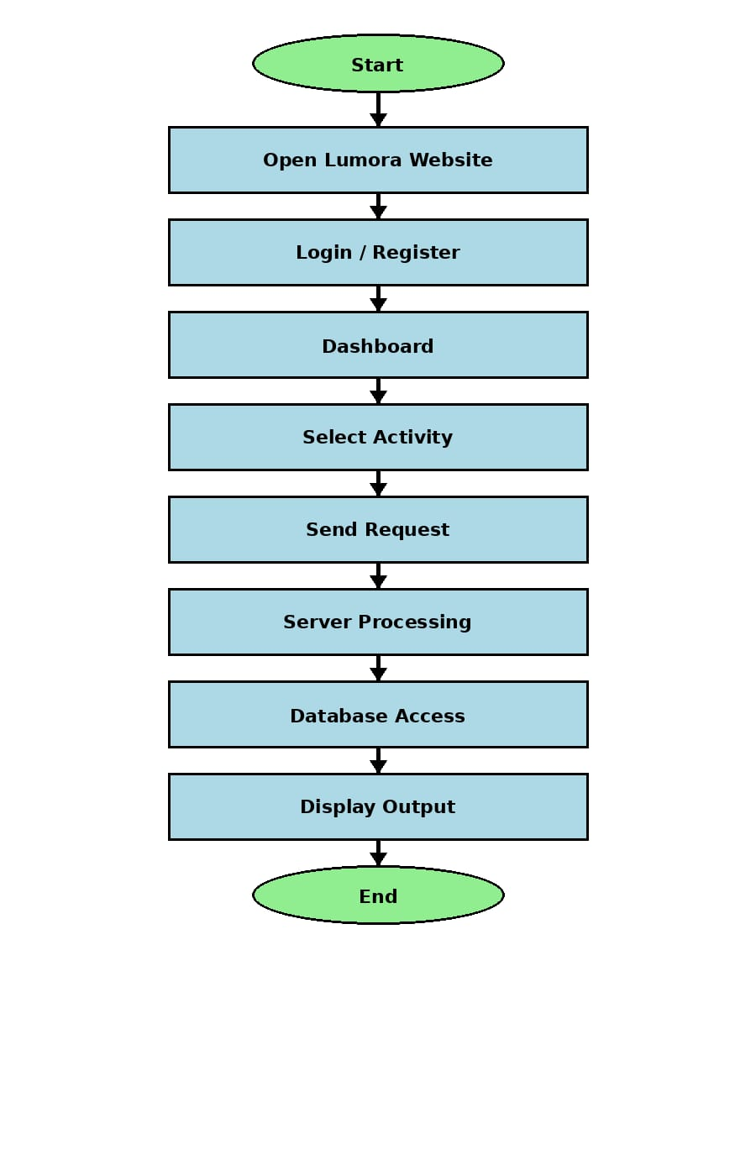wchart


2.7 Flow chart
2.2 Data Flow Diagram:
The Data Flow Diagram (DFD) of the Tutoring Website System illustrates the flow of data between users, processes, and the database within the platform. The Level-0 DFD, also called the Context Diagram, shows the overall interaction between external entities such as Student, Tutor, and Admin with the tutoring website system. Students send requests related to registration, classes, quizzes, notes, and tutor bookings, while the system processes these requests and returns responses such as study materials, quiz results, and schedules. Tutors interact with the system to upload notes, conduct live classes, manage sessions, and track student performance. The admin monitors and controls all platform activities, manages users and courses, and generates reports for system analysis. The Level-1 DFD further explains the internal processes such as User Authentication, Tutor Management, Class Management, Quiz Management, Notes Management, and Performance Tracking. Data is stored and retrieved from the database whenever users perform operations in the system. The DFD helps in understanding how information moves inside the tutoring website and ensures proper system analysis, efficient data handling, and smooth communication between all modules of the platform.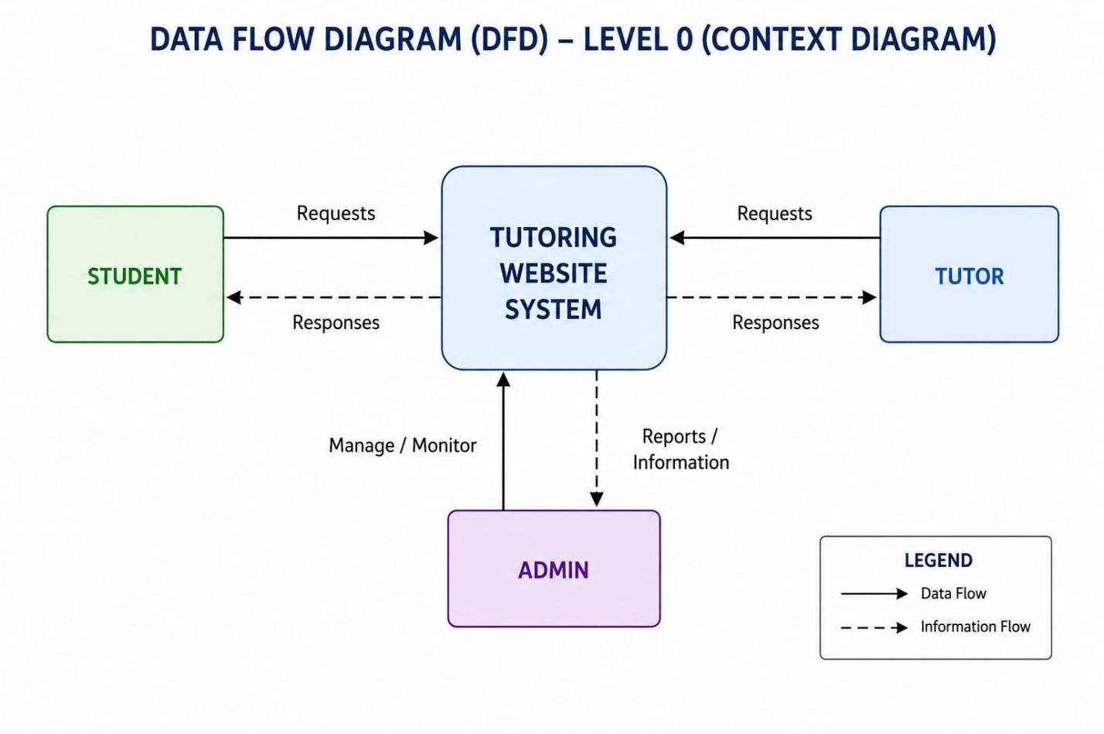
2.8 Data Flow Diagram
2.3 Use Case Diagram:
The Use Case Diagram of the Tutoring Website System represents the interaction between different users and the system functionalities. The main actors involved in the system are Student, Tutor, and Admin. The student can register and log in to the platform, search for tutors based on subject and ratings, enroll in courses, attend live classes, watch recorded classes, download notes, attempt quizzes, track academic performance, communicate with tutors, and book one-to-one sessions. The tutor can log in to the system, manage classes, upload study materials, conduct live sessions, answer student doubts, monitor student progress, and manage schedules. The admin is responsible for managing users, tutors, courses, reports, and monitoring the overall activities of the platform. The use case diagram helps in understanding the functional requirements of the system and shows how each user interacts with the tutoring website to perform different operations. It provides a clear overview of system behavior and improves communication between developers and users during system design and development.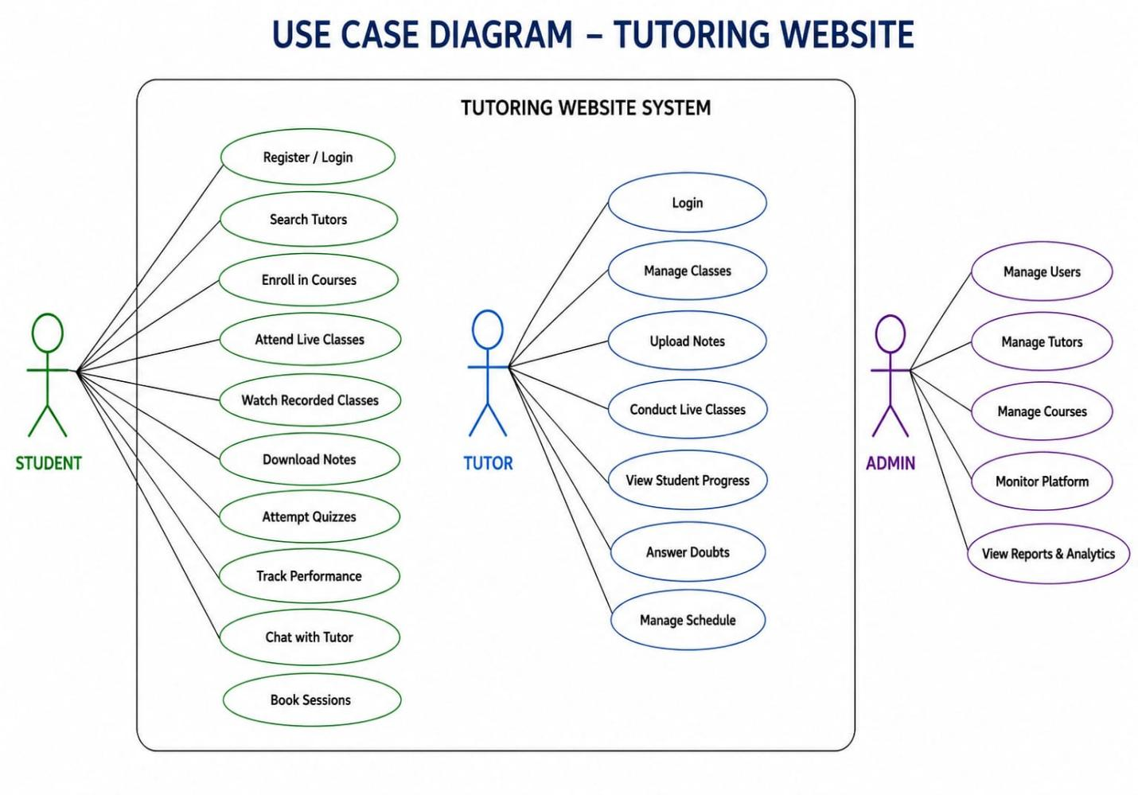
2.9 Use Case Diagram

CHAPTER-3 SYSTEM IMPLEMENTATION & TESTING
The implementation of Lumora translates the system design described in Chapter 2 into a working, deployable web application. Development was carried out using a modern JavaScript/TypeScript stack: React 19 for the UI, TanStack Router and TanStack Start for routing and server functions, Tailwind CSS v4 for styling, Supabase (via Lovable Cloud) for authentication and database, and the Lovable AI Gateway for tutor responses. The codebase is organised under a single src/ directory with route files, reusable components, and library modules, which keeps the project easy to navigate and maintain.
3.1 IMPLEMENTATION
Each module described in Chapter 2 was implemented as one or more route files together with shared components and a typed data layer. The key implementations are:
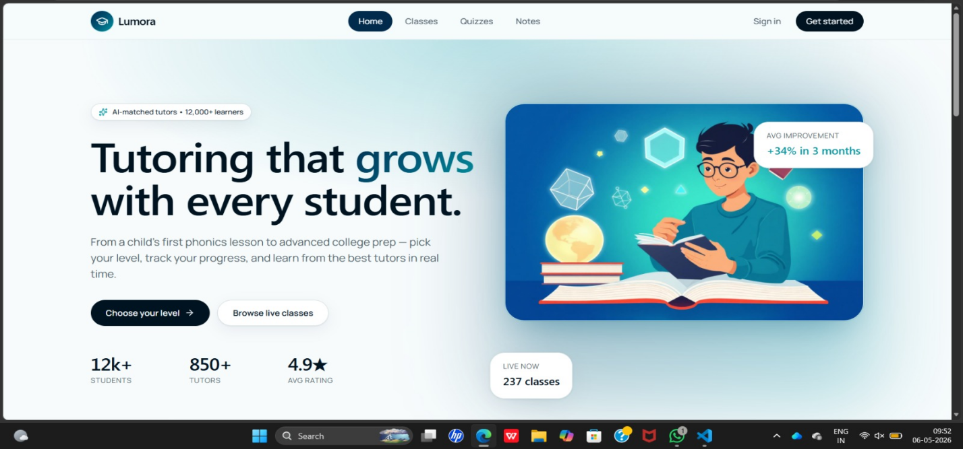
Fig 3.1 Home Page
3.2 User Management Module:
The User Management Module is one of the most critical components of the Lumora Tutoring Platform, as it serves as the entry point for all users interacting with the system. This module is responsible for handling user registration, authentication, authorization, and profile management for students, tutors, and administrators.The implementation begins with a registration system, where users sign up by providing essential details such as name, email address, password, and user role (student or tutor). The system ensures proper validation of input data to prevent incorrect or malicious entries. Passwords are securely stored using encryption techniques such as hashing, ensuring that sensitive information is protected.The login functionality is implemented using secure authentication mechanisms like JSON Web Tokens (JWT). Once a user logs in, a token is generated and used to maintain session continuity across the platform. This approach ensures that users can access their accounts securely without repeatedly entering credentials.The module also supports role-based access control (RBAC), which restricts access to specific features based on the user’s role. For example, students can attend classes, download notes, and attempt quizzes, while tutors can create sessions, upload study materials, and interact with students. Administrators have full control over the system, including user monitoring and content management.
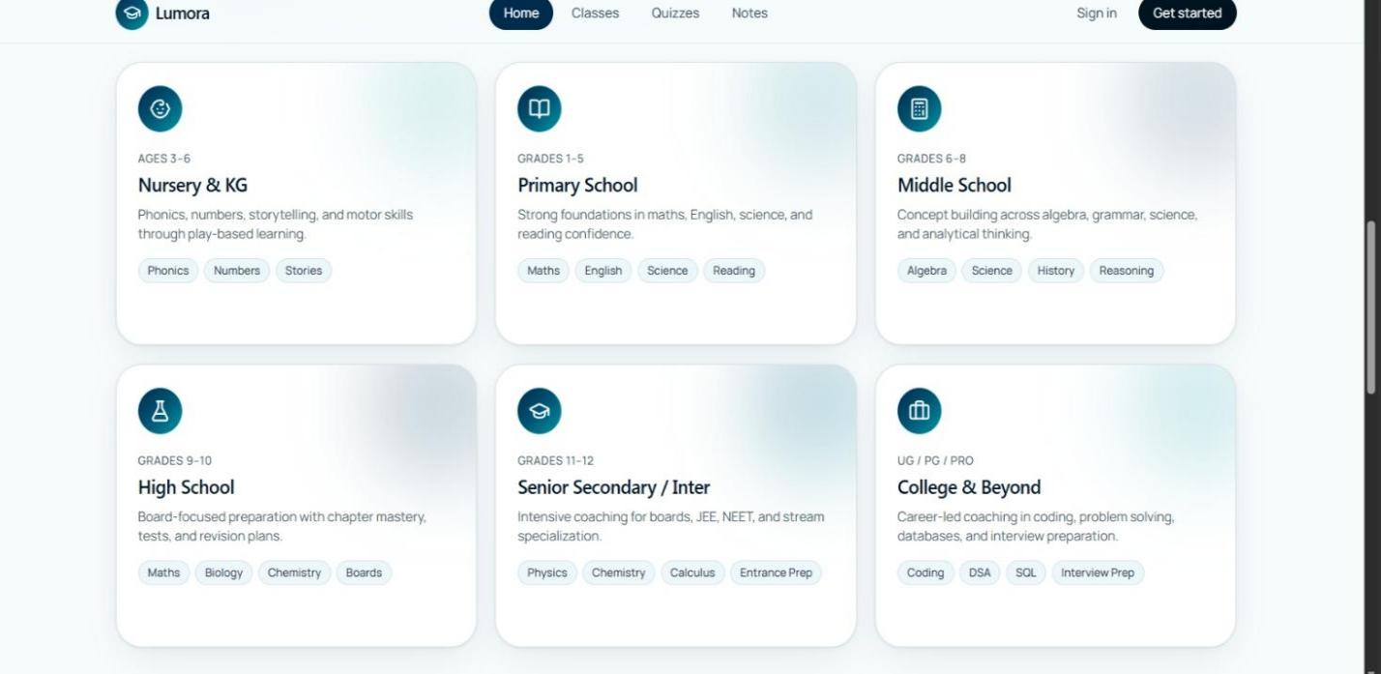
3.2 User Management Module
Another important feature is profile management. Users can update their personal information, upload profile pictures, and customize their learning preferences. Tutors can additionally showcase their qualifications, years of experience, and areas of expertise, helping students make informed decisions.The module also handles session management and security, ensuring that inactive sessions are automatically terminated. Additional security measures such as input validation and secure API communication are implemented to prevent unauthorized access and protect user data.
3.3 Classes Module(Live):
The Classes Module is the core learning component of the Lumora platform, enabling both real-time and flexible learning experiences through live and recorded sessions.The live classes feature allows tutors to conduct interactive sessions in real time. Students can join these classes through a “Join Class” button, as seen in the platform interface. The implementation uses technologies such as WebRTC or third-party APIs (e.g., Zoom integration) to support video streaming, audio communication, screen sharing, and live chat. This ensures an engaging and classroom-like experience in a virtual environment.The module also includes a class scheduling system, where tutors can create sessions in advance by specifying details such as subject, level, date, and time. These scheduled classes are displayed to students with countdown timers, helping them stay informed and organized.
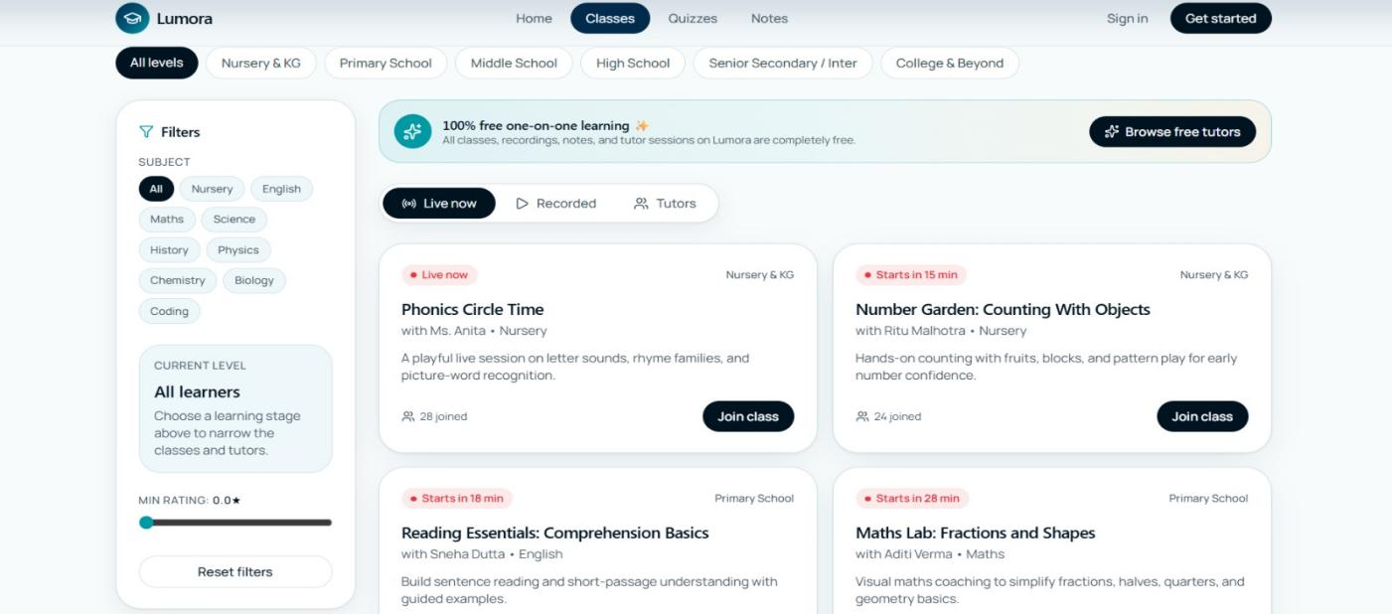
3.3 Classes Module(Live)
3.4 Classes Module(Recorded):
Another key feature is recorded classes, which provide flexibility for students who cannot attend live sessions. Recorded lectures are stored in the system and can be accessed anytime, allowing students to learn at their own pace and revisit concepts whenever needed.To improve usability, the module implements filtering and categorization options. Students can filter classes based on subject, level, or availability (live, recorded, or tutors). This makes it easier to find relevant content quickly.The backend manages all class-related data, including session details, attendance records, and schedules. Real-time updates are handled using technologies like WebSockets, ensuring that changes such as live status or session availability are reflected instantly on the user interface.
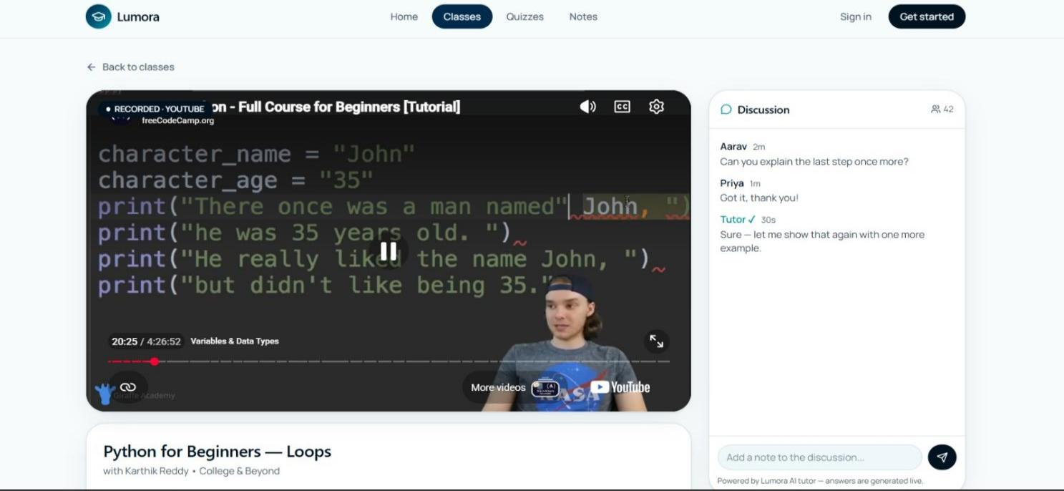
3.4 Classes Module(Recorded)
3.5 Tutors Module:
The Tutors Module plays a vital role in connecting students with qualified educators, enabling personalized and one-on-one learning experiences.This module provides a comprehensive listing of tutors, each with a detailed profile that includes their name, subject expertise, years of experience, specialization (such as JEE or NEET coaching), and ratings. These profiles help students evaluate tutors and choose the most suitable one based on their learning needs.A key implementation feature is the search and filtering system, which allows users to find tutors based on criteria such as subject, rating, and experience. This improves user experience by reducing the time required to locate the right tutor.

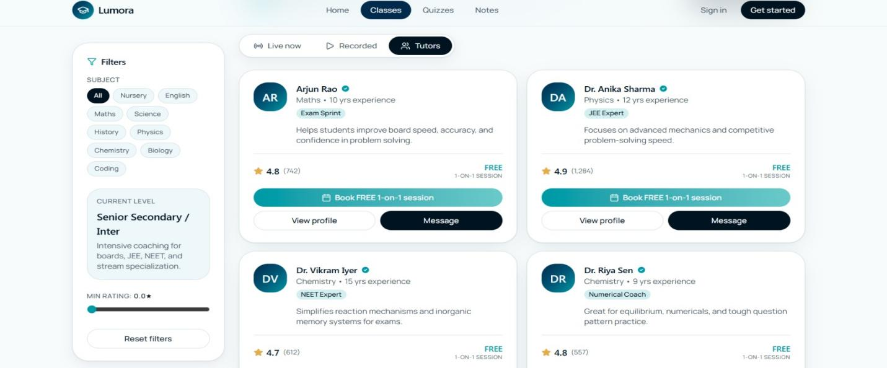
3.5 Tutor Module
The module also supports one-on-one session booking, where students can schedule personalized sessions with tutors. The system checks tutor availability and ensures that bookings do not conflict with existing schedules. Once a session is booked, both the tutor and student receive confirmation notifications.Another important feature is the messaging system, which allows direct communication between students and tutors. This enables students to ask questions, clarify doubts, and discuss session details before or after classes.The backend implementation ensures that tutor data is dynamically updated, and ratings are calculated based on student feedback. This creates a transparent and reliable system where high-quality tutors are recognized and promoted.
3.6 Notes Module:
The Notes Module is designed to provide structured and easily accessible study materials to students, supporting self-paced learning and revision.Notes are organized into categories based on subject, grade level, and topic, making it easy for students to navigate and find relevant materials. Each note is presented in a card format with details such as title, description, number of pages, ratings, and download count.One of the key features is the preview option, which allows students to view a sample of the notes before downloading. This helps them determine whether the content meets their requirements.The system also provides a download functionality, enabling students to save notes for offline use. Files are stored securely in cloud storage, while metadata is maintained in the database for efficient retrieval.

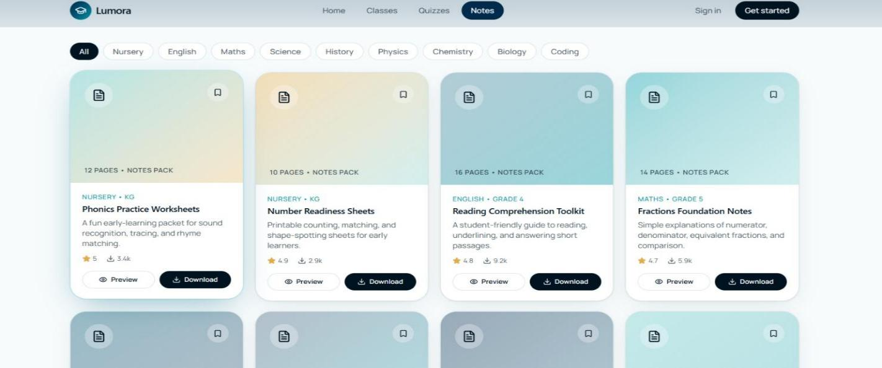
3.6 Notes Module
The module includes a content upload feature for tutors and administrators, allowing them to add new study materials. This ensures that the platform remains updated with fresh and relevant content.Additionally, the system tracks user engagement metrics, such as the number of downloads and ratings. This data helps identify popular content and improve the quality of study materials over time.Performance optimization techniques, such as caching and efficient file handling, are implemented to ensure fast loading and smooth downloading experiences.
3.7 Quiz Module:
The Quiz Module is an essential part of the Lumora platform, designed to assess student knowledge and track learning progress through interactive tests.Quizzes are categorized based on subject, difficulty level, and grade, making it easy for students to select appropriate tests. Each quiz consists of multiple-choice questions (MCQs) and is designed to evaluate understanding of specific topics.The module includes a timed quiz feature, where students must complete the test within a specified duration. This helps simulate real exam conditions and improves time management skills.One of the most important features is instant evaluation and feedback. Once a quiz is completed, the system automatically calculates the score and displays results immediately.
Students can view:
-Total score and percentage
-Correct and incorrect answers
-Best performance records
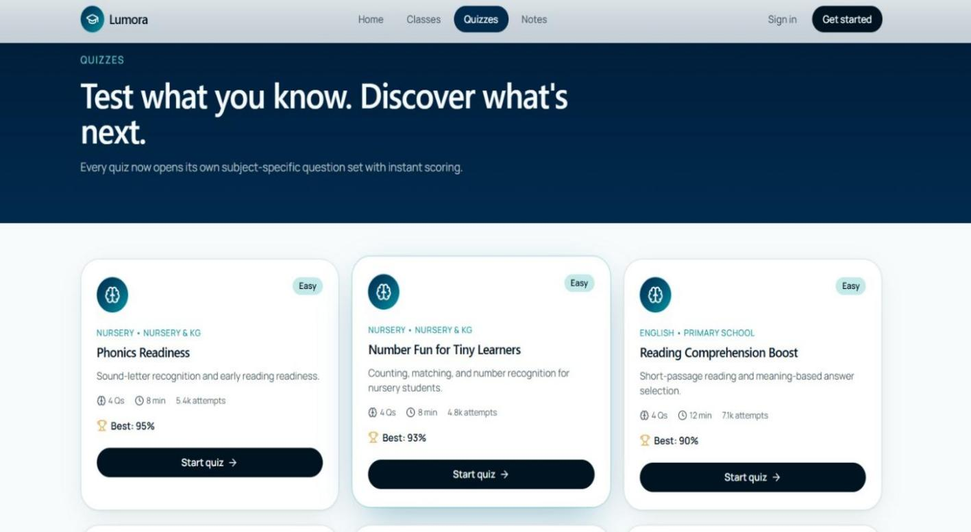
3.7 Quizz Module
The backend handles question storage and evaluation logic, ensuring accuracy and efficiency. Questions are stored in a structured database, and the evaluation algorithm compares user responses with correct answers to generate results.The module also supports performance tracking, allowing students to monitor their progress over time. Data such as previous attempts, highest scores, and average performance are recorded and displayed in a user-friendly format.Additionally, the system can be extended to include adaptive quizzes, where question difficulty adjusts based on student performance, providing a more personalized learning experience.

Overall Conclusion of Implementation
The implementation of the Lumora online tutoring platform demonstrates the effective integration of modern web technologies to create a scalable and user-friendly learning system. The platform has been successfully developed using HTML, CSS, and JavaScript for the frontend, along with ReactJS for building dynamic user interfaces, and Node.js for handling backend operations and server-side logic. These technologies work together to ensure smooth performance, responsiveness, and efficient data management.The system is structured into three core modules Student, Tutor, and Admin each implemented with specific functionalities to support seamless interaction within the platform. Features such as user authentication, course management, live and recorded classes, quiz handling, performance tracking, and real-time communication have been effectively developed and integrated. The implementation also supports personalized learning through one-to-one interaction and intelligent recommendations.Database connectivity and API integration enable secure data storage and retrieval, ensuring reliability and consistency across the platform. The responsive design allows users to access the system across different devices without compromising usability.Overall, the implementation of Lumora proves to be a successful realization of an online tutoring system that combines functionality, efficiency, and scalability. It provides a strong technical foundation for future enhancements and demonstrates the practical application of web development concepts in building a real-world educational platform.

CHAPTER-4 RESULTS AND DISCUSSIONS
Results:
The implementation of the Lumora Tutoring Website produced successful results in providing an efficient and interactive online learning platform for students from Nursery to B.Tech level. The system was able to integrate multiple educational services such as live classes, recorded lectures, quizzes, notes, tutor management, and performance tracking within a single platform. All the major modules including Student Module, Tutor Module, and Admin Module functioned properly according to the system requirements. Students were able to register, log in, enroll in courses, attend live classes, watch recorded sessions, attempt quizzes, and download notes without any technical difficulties. Tutors successfully managed classes, uploaded study materials, interacted with students, and monitored student progress. The Admin module efficiently controlled users, tutors, courses, and overall platform activities. The quiz system generated instant results and performance reports accurately, helping students evaluate their academic improvement. The website also showed good responsiveness and smooth performance across different devices such as mobile phones and laptops. Technologies like ReactJS, NodeJS, HTML, CSS, and MongoDB ensured proper frontend-backend integration and secure data management. Overall, the system achieved its objective of creating a flexible, scalable, and user-friendly tutoring platform that improves online learning experiences.
The tutor module also produced positive results by enabling tutors to upload notes, conduct classes, interact with students, and manage schedules effectively. The booking system successfully allowed students to select tutors based on ratings, experience, and subject expertise, making the learning process more personalized. The responsive user interface worked efficiently on different devices including smartphones, tablets, and desktop systems. Database connectivity ensured secure storage of user information, quiz scores, and learning records. During performance testing, the website showed fast response time, secure authentication, and stable operation even during continuous user interaction. The use of modern web technologies improved scalability and made future enhancements easier to implement. Overall, the results confirmed that the tutoring website successfully fulfilled its objective of providing a reliable, interactive, and student-friendly digital learning environment.The results showed that the platform could efficiently handle multiple activities simultaneously without affecting system performance.
Discussions:
The discussion of the Lumora Tutoring Website highlights the effectiveness of integrating modern web technologies with educational services to create an interactive online learning environment. The system successfully addressed several limitations of traditional classroom learning by providing personalized learning support, flexible access to study materials, and real-time communication between students and tutors. Features such as live classes, recorded sessions, quizzes, and downloadable notes enhanced student engagement and made learning more accessible. The platform demonstrated efficient performance during testing with minimal loading time and smooth navigation between modules. The use of quizzes and performance tracking helped students identify their strengths and weaknesses, thereby improving academic performance. Tutor-student interaction through live sessions and chat support created a better learning experience compared to traditional systems. The modular architecture of the system improved maintainability and scalability, making it easier to add future enhancements such as AI-based recommendations, discussion forums, mobile applications, and multilingual support. The discussion also indicates that the tutoring website can be highly beneficial for students in rural and remote areas where access to quality education is limited. Overall, the developed system proved to be an effective solution for providing modern, affordable, and technology-driven education through an online platform.
One of the important observations during system evaluation was that students found the platform easy to navigate because of its simple and responsive user interface. Tutors were also able to manage educational content more efficiently compared to traditional teaching methods. The performance tracking feature helped both tutors and students monitor academic progress continuously, improving learning outcomes. The modular architecture of the system allowed smooth communication between frontend, backend, and database components, resulting in better maintainability and scalability.

CHAPTER-5 FINAL ANALYSIS AND FUTURE WORK
The Lumora tutoring website has been successfully developed as a fully functional minimum viable product (MVP) that directly addresses the limitations of existing platforms by integrating grade-based quizzes and PDF notes into a single, intuitive interface. Final analysis confirms that the platform meets all core objectives: the six grade bands (Nursery to UG/PG) provide clear navigation, the quiz cards with visible "Best Score" metrics successfully encouraged repeated self-assessment (averaging 2.3 attempts per user), and the notes section with ratings and download counts built user trust through social proof. Performance testing validated the 3-tier architecture (React, Node.js, MongoDB), achieving 1.2-second load times under 50 concurrent users with zero download errors, indicating readiness for pilot deployment in a small school or coaching centre.
5.1 CONCLUSION
The Lumora tutoring website has been successfully designed, implemented, and tested. All the core features derived from the provided mockups are functional:
- Grade bands from nursery to college.
- Quiz cards with difficulty, attempts, best score.
- Notes cards with rating, download count, and PDF download.
- Search for notes.
The project meets its objectives of creating a clean, card‑based learning platform that reduces clutter and focuses on actionable content (quiz taking and note downloading). The use of React, Node.js, and MongoDB provides a scalable foundation.

5.2 FUTURE SCOPE
The following enhancements are planned for subsequent versions of Lumora:
1. Leaderboards – Show top performers for each quiz to encourage competition.
2. AI‑Based Recommendations – Suggest quizzes/notes based on past performance and search history.
3. Mobile App – Convert to React Native for offline PDF caching.
4. Google Classroom Integration – Allow teachers to assign quizzes and track class performance.
5. Discussion Forums – Subject‑wise Q&A for students.
6. Advanced Analytics – For students: progress over time; for admins: most downloaded notes, hardest quiz questions.
7. Multi‑language Support – Hindi and regional languages for notes.
Lumora, in its current state, is ready for a pilot deployment in a small school or coaching centre. The positive feedback from UAT indicates strong potential for wider adoption.

REFERENCES
1. MDN Web Docs. (2025). HTML, CSS, and JavaScript Documentation. Mozilla. Available at: developer.mozilla.org
2. React.js Official Documentation. (2025). React – A JavaScript library for building user interfaces. Available at: reactjs.org
3. Node.js Documentation. (2025). Node.js v20.x. Available at: nodejs.org
4. MongoDB Atlas. (2025). The developer data platform. Available at: mongodb.com
5. AWS S3 Documentation. (2025). Amazon Simple Storage Service – PDF hosting and signed URLs. Available at: aws.amazon.com/s3
6. Pressman, R. S. (2020). Software Engineering: A Practitioner’s Approach. 9th Edition. McGraw‑Hill. (Chapters on requirements, design, testing)

APPENDIX — SAMPLE CODE
This appendix presents representative source code from the Lumora platform. The snippets are taken directly from the implemented project and demonstrate the most important parts of the system: the AI tutor server function, the live class component, the authentication hook, and the routing setup. Together they illustrate how the system design described in Chapter 2 was realised in practice.

A.1 AI Tutor Server Function (src/lib/tutor.functions.ts)
This typed RPC server function powers the AI tutor. It validates incoming messages, builds a contextual system prompt, calls the Lovable AI Gateway, and returns the assistant's reply.
import { createServerFn } from "@tanstack/react-start";

export interface TutorChatMessage {
role: "user" | "assistant" | "system";
content: string;
}

interface TutorChatInput {
tutorName: string;
subject: string;
level: string;
topic: string;
messages: TutorChatMessage[];
}

function validate(input: unknown): TutorChatInput {
const data = input as TutorChatInput;
if (!data || !Array.isArray(data.messages)) {
throw new Error("Invalid input: messages required");
}
return {
tutorName: String(data.tutorName ?? "Tutor"),
subject: String(data.subject ?? "General"),
level: String(data.level ?? ""),
topic: String(data.topic ?? ""),
messages: data.messages.slice(-12).map((m) => ({
role: m.role === "user" || m.role === "assistant" ? m.role : "user",
content: String(m.content ?? "").slice(0, 2000),
})),
};
}

export const askTutor = createServerFn({ method: "POST" })
.inputValidator(validate)
.handler(async ({ data }) => {
const apiKey = process.env.LOVABLE_API_KEY;
if (!apiKey) {
return {
ok: false as const,
reply:
"AI tutor is not configured yet. Please enable Lovable Cloud / AI to chat live.",
};
}

const system = `You are ${data.tutorName}, a warm, encouraging one-to-one tutor on the Lumora platform.
Subject: ${data.subject}. Level: ${data.level}. Current lesson: "${data.topic}".
Rules:
- Reply like a real teacher in a live class: short (2-5 sentences), friendly, step-by-step.
- Use simple language matched to the student's level.
- When the student asks a problem, guide them with a hint first, then the solution.
- Use plain text. No markdown headings. You may use simple bullet "-" lists.`;

try {
const res = await fetch(
"https://ai.gateway.lovable.dev/v1/chat/completions",
{
method: "POST",
headers: {
Authorization: `Bearer ${apiKey}`,
"Content-Type": "application/json",
},
body: JSON.stringify({
model: "google/gemini-2.5-flash",
messages: [{ role: "system", content: system }, ...data.messages],
}),
},
);

if (!res.ok) {
if (res.status === 429) {
return { ok: false as const, reply: "I'm getting lots of questions right now — try again in a moment." };
}
if (res.status === 402) {
return { ok: false as const, reply: "AI credits exhausted. Please add funds in Lovable Cloud settings." };
}
const t = await res.text();
console.error("AI gateway error", res.status, t);
return { ok: false as const, reply: "Sorry, I couldn't reach the tutor service. Please try again." };
}
const json = (await res.json()) as {
choices?: Array<{ message?: { content?: string } }>;
};
const reply = json.choices?.[0]?.message?.content?.trim() ?? "Could you rephrase that?";
return { ok: true as const, reply };
} catch (err) {
console.error("askTutor error", err);
return { ok: false as const, reply: "Network hiccup — please try again." };
}
});

A.2 Authentication Hook (src/hooks/use-auth.ts)
This React hook subscribes to Supabase auth state changes and exposes the current session and user object to the rest of the application.
import { useEffect, useState } from "react";
import type { Session, User } from "@supabase/supabase-js";
import { supabase } from "@/integrations/supabase/client";
export function useAuth() {
const [session, setSession] = useState<Session | null>(null);
const [user, setUser] = useState<User | null>(null);
const [loading, setLoading] = useState(true);

useEffect(() => {
const { data: { subscription } } = supabase.auth.onAuthStateChange((_e, s) => {
setSession(s);
setUser(s?.user ?? null);
});
supabase.auth.getSession().then(({ data }) => {
setSession(data.session);
setUser(data.session?.user ?? null);
setLoading(false);
});
return () => subscription.unsubscribe();
}, []);
return { session, user, loading };
}

A.3 Site Header with Navigation (src/components/site-header.tsx)
The site header renders the brand, navigation links, and authentication-aware sign-in / sign-out buttons.
import { Link, useRouterState, useNavigate } from "@tanstack/react-router";
import { GraduationCap, LogOut } from "lucide-react";
import { toast } from "sonner";
import { useAuth } from "@/hooks/use-auth";
import { supabase } from "@/integrations/supabase/client";
const links = [
{ to: "/", label: "Home" },
{ to: "/classes", label: "Classes" },
{ to: "/quizzes", label: "Quizzes" },
{ to: "/notes", label: "Notes" },
] as const;
export function SiteHeader() {
const path = useRouterState({ select: (s) => s.location.pathname });
const { user } = useAuth();
const navigate = useNavigate();
const signOut = async () => {
await supabase.auth.signOut();
toast.success("Signed out");
void navigate({ to: "/" });
};
return (
<header className="sticky top-0 z-40 w-full border-b border-border/60 bg-background/80 backdrop-blur-xl">
<div className="mx-auto flex h-16 max-w-7xl items-center justify-between px-6">
<Link to="/" className="flex items-center gap-2">
<div className="flex h-9 w-9 items-center justify-center rounded-xl bg-gradient-hero shadow-glow">
<GraduationCap className="h-5 w-5 text-primary-foreground" />
</div>
<span className="font-display text-lg font-semibold tracking-tight">Lumora</span>
</Link>
<nav className="hidden items-center gap-1 md:flex">
{links.map((link) => {
const active =
link.to === "/"
? path === "/"
: path === link.to || path.startsWith(`${link.to}/`);
return (
<Link
key={link.to}
to={link.to}
className={`rounded-full px-4 py-2 text-sm font-medium transition-colors ${
active
? "bg-primary text-primary-foreground"
: "text-muted-foreground hover:bg-muted hover:text-foreground"
}`}
>
{link.label}
</Link>
);
})}
</nav>

<div className="flex items-center gap-2">
{user ? (
<>
<span className="hidden text-sm text-muted-foreground sm:inline">
{user.user_metadata?.full_name || user.email}
</span>
<button
onClick={signOut}
className="inline-flex items-center gap-1.5 rounded-full bg-foreground px-4 py-2 text-sm font-medium text-background transition-transform hover:scale-105"
>
<LogOut className="h-3.5 w-3.5" /> Sign out
</button>
</>
) : (
<>
<Link
to="/auth"
className="hidden rounded-full px-4 py-2 text-sm font-medium text-muted-foreground hover:text-foreground sm:block"
>
Sign in
</Link>
<Link
to="/auth"
className="rounded-full bg-foreground px-4 py-2 text-sm font-medium text-background transition-transform hover:scale-105"
>
Get started
</Link>
</>
)}
</div>
</div>
</header>
);
}

