Index
Index
Index

Serial number | Title | Page number
1. | Acknowledgement | 3
2. | Abstract | 4
3. | List of figures | 5
4. | List of tables | 6
5. | Chapter 1: Introduction  - Introduction  - Purpose of the project  - Scope  - Definitions, acronyms and abbreviations  - Existing system  - Proposed system  - Statement of problem | 7-9
6. | Chapter 2: Software requirement software  2.1 General constraints  2.2 Assumptions  2.3 Specific requirements  2.3.1 External interface requirements  2.3.1.1 User interface  2.3.1.2 Hardware interface  2.3.2 Software interface requirements  2.4 Functional requirements  2.5 Non Functional requirements  2.6 User characteristics | 10-13
7. | Chapter 3: Design  3.1 ER Diagram  3.2 Schema Diagram  3.3 Normalization  3.4 DFD diagram | 14-17
8. | Chapter 4: Implementation  4.1 Implementation  4.2 Programming language selection  4.3 Query for creation of tables  4.4 Description of tables  4.5 Triggers used  4.6 Procedures used  4.7 code snippets | 18-21
9. | Chapter 5: Result snapshots | 22-28
10. | Chapter 6: Conclusion  6.1 Conclusion  6.2 Limitations  6.3 Future enhancements | 29-29
11. | References | 30

Acknowledgement

We would like to express our deepest appreciation to all those who provided us the possibility to complete this report. A special gratitude to our project guide, Mrs. Shubha Raj K.B., whose contribution in stimulating suggestions and encouragement, helped us to coordinate our project especially in writing this report.
We are grateful to Dr. Sandesh B J, Associate Professor and HOD of Computer Science and Engineering Department who has seen to it that all of us are doing well with the project work.
Furthermore we would also like to acknowledge with much appreciation the crucial role of our guide Mrs. Shubha Raj K.B., who gave the permission to use all required equipment and the necessary materials to complete this project. Last but not the least, we have to appreciate the guidance given by other supervisor as well as the panels especially in our project presentation that has improved our presentation skills thanks to their comment and advises.

Nidhi R Patil
USN: 1PE16CS091
Paridhi Gupta
USN :1PE16CS107

Acknowledgement

Abstract

Student Registration System for Universities (SRSU) as a kind of management information system can not only record the information for student registration each term quickly and efficiently, but also do statistics on the students' basic information, registration information, and payment information and give results of the analysis. The background of the subject is analyzed in the report firstly, and the technologies used in the development are introduced. Then the implementation of the system is given in detail. The upgrade and expansion of the system are prospected in the end of the report.

Abstract

List of figures

Serial  number | Name of  figure | Title | Page  number
1. | Fig 3.1 | ER Diagram | 16
2. | Fig 3.2 | Schema Diagram | 17
4. | Fig 3.4 | DFD Diagram | 19
5. | Fig 5.1 | Login Page | 24
6. | Fig 5.2 | Home page | 24
7. | Fig 5.3 | Add/edit/delete student | 25
8. | Fig 5.4 | Add/delete admin | 25
10. | Fig 5.5 | Add/delete admin | 27
11. | Fig 5.6 | Fee details | 27
12. | Fig 5.7 | Adding course | 28
13. | Fig 5.8 | Documents details | 29
14. | Fig 5.9 | Add/edit documents | 29
15. | Fig 5.10 | Bus facility | 30

List of tables

List of tables

admin(id, name,password,mail)
bus(route_id, location)
bus_std(student_id,route_id)
courses(course_id, course_name)
document(student_id,document_name)
fee(mode_name,fees)
route(route_id,location)
studentdetails(roll_no,name,father_name,phone_number,blood,course_id,mode_name,date_of_enrollment)

Chapter 1: Introduction
Introduction

  - Introduction
In most of the educational institutions registrations are a tedious process. It involves filling of some forms by students and submission of required documents which involves heavy paperwork. Our aim is to eliminate the paperwork and make the admission process simpler. Making the admission process for educational institutions simper by reducing the paperwork involved and to provide a user friendly interface. Through this system we mainly aim to overcome the problems of time and money required for manual labour. Over the past few decades technology has influenced every sector of the economy but still it has been observed in India that the admission process in most of the educational institutions are done manually which involves a lot of paperwork and labour. If any information is to be retrieved for any student it requires lot of time and effort.

    - Purpose
Our major objectives include, reducing manual labour, cost and time spent on labour and Easy retrieval of information thus avoiding long queues and wait time for both students and the institution. We believe that technology can make life simpler and we want to achieve this goal in the registration system through this project.

    - Scope
This document aims to demonstrate how the project will accomplish the functional and non- functional requirements captured in the following pages. The document will provide a framework through describing the high level components and architecture, sub systems, interfaces and database design. This is achieved through the use of entity relation diagrams and data flow diagrams.
Introduction

1.1.3 Definitions, acronyms and abbreviations
Acronym/Abbreviation | Definition/Explanation
DFD | Data Flow Diagram: Data flow diagram (DFD) represents the flows of data between different processes in a business.
UML | Unified Modelling Language: UML is a standard language for specifying, visualizing, constructing, and documenting the artefacts of software systems.
ER diagram | Entity relationship diagram: It shows the relationships of entity sets stored in a database.  Introduction
Schema diagram | A database schema is the skeleton structure that represents the logical view of the entire database.
SRS | Software Requirements Specification: It is a document that fully describes the expected behaviour of a software system.
Java | Java is a general-purpose computer programming language that is concurrent, class based, object oriented and specifically designed to have as few implementation dependencies as possible
NetBeans | NetBeans is an integrated development environment (IDE) for Java. NetBeans allows applications to be developed from a set of modular software components called modules.
JDBC | Java Database Connectivity (JDBC) is an application programming interface (API) for the programming language Java, which defines how a client may access a database.
TITLE | Title of the requirement for identification.
DESC | Brief description about the requirement.
ID | Identifier for requirements.
FR | Functional Requirement.

Introduction
  - Existing system
There are several solutions availabe for student registration system provided by various universities. These systems are propritiery sofware and are not available for people outside the respective universities. A project on Student Information Management system which was carried out by Kapil Kaushik Ankur Agarwal Tushar Somani, an IT student of Institute of Engineering and Technology, Maharishi provides a simple interface for maintenance of student information. It can be used by any educational institute or colleges to maintain records of students easily. Achieving this objectives is difficult using a manual system as the information is scattered, can be redundant and collecting relevant information can be very time consuming. All these problems are solved using this project. Throughout the project the focus has been on presenting information in an easy and intelligible manner. The project is very useful for those who want to know about
Student Information Management Systems and want to develop software/websites based on the same concept. The profile creation of student thus reducing paper work and automating the records generation process in an educational institution.
Introduction

  - Proposed system
The proposed system provides various facilities like, efficient storing and management of student data, security by limiting access of information to specific set of people. It provides functionalities to add student data, edit and display the current data. It also includes maintaining records of bus facilities, documents provided by students and fees details.

  - Statement of the problem
The website should be able to provide an overall shopping experience to the customer who is able to browse products and purchase them. The vendor must be able to provide his services to the patrons and accordingly follow up with shipping of goods.

Chapter 2: Software Requirement Specification

2.1 General Constraints
2.1.1 The main constraint here would be verifying the authenticity of documents submitted by students, which is not always possible. There can be security risks involved.
2. 1.2 The developed system should run on any platform (Unix, Linux, Mac, Windows etc.)
2.1.3 The user will require training to understand the working of the software which has to be done before deployment of the system.
2.1.4 The information collected during process must be protected in the student’s interest.

2.2 Assumptions
2.2.1 The details related to the students are provided manually.
2.2.2 The power to change any details lies only with the administraor.
2.2.3 If student wants any changes in their records he/she must contact the administrator.

2.3 Specific Requirements
2.3.1 External Interface Requirements
2.3.1.1 User Interfaces
Software Requirements Specification
Each part of the user interface intends to be as user friendly as possible, requiring zero or minimum training during deployment. The fonts and buttons used will be intended to be very fast and easy to load on systems.

2.3.1.2 Hardware Interfaces
- Processor: Pentium or higher.
- RAM: 312MB or higher.

2.3.2 Software Interfaces
- Operating System: Linux or Windows
- Development tool and Scripting Languages: Php, Java.
- Database: MySQL.

2.4 Functional Requirements
This section includes the requirements that specify all the fundamental actions of the software system.
2.4.1 User Class
2.4.1.1 Functional Requirement 1.1
ID: FR1
TITLE: Login Page.
DESC: The page must ask for email and password, if the values are correct then it should switch to home page else display message stating invalid information..
2.4.1.2 Functional Requirement 1.2
ID: FR2
TITLE: Home Page.
DESC: The page must display all the operations available through the system like, adding students, modifying student details etc.
2.4.1.3 Functional Requirement 1.3
Software Requirements Specification
ID: FR3 TITLE: Add Student
DESC: The page must ask for all the required student details and update it to the database.

2.4.1.4 Functional Requirement 1.4
ID: FR4
TITLE: Edit Student Information
DESC: The administrator must be able to edit or delete student information.
2.4.1.5 Functional Requirement 1.5
ID: FR5
TITLE: Show Students
DESC: The page must display all the student data to the administrator.
2.4.1.6 Functional Requirement 1.6
ID: FR6
TITLE: Fee Structure
DESC: Based on the mode of enrollement the page must display particular student’s details.
2.4.1.7 Functional Requirement 1.7
ID: FR7
TITLE: Bus facility
DESC: The page must display all the routes and the buses for the selected route and their timings.
2.4.1.8 Functional Requirement 1.8
ID: FR8
TITLE: Documents
DESC: While submitting various forms to the system, mandatory fields must be checked for validation whether the admin has filled appropriate data in these mandatory fields. If not, proper error message should be displayed.

2.5 Non-functional requirements
The requirements in this section provide a detailed specification of the user interaction with the software and measurements placed on the system performance.

2.5.1 Performance requirement 1.1
ID: QR1
TITLE: Lucid home page.
DESC: The home page must be comprehensible and easily used by the customer without and training required.
2.5.2 Performance requirement 1.2
ID: QR2
TITLE: Speed of loading.
DESC: The home page must be loaded in a matter of moments without the initial lag due to dependencies.

2.6 User Characteristics
There is only one kind of user for the proposed system, hence only way the system can be manifested is,
2.6.1 Administrators
Administrators are the ones who add or administer the student data and update or delete them.

Chapter 3: Design
3.1 ER Diagram
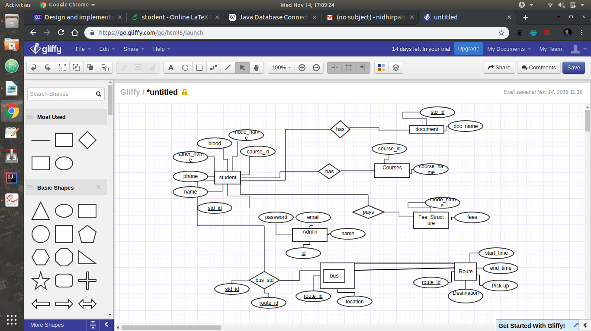

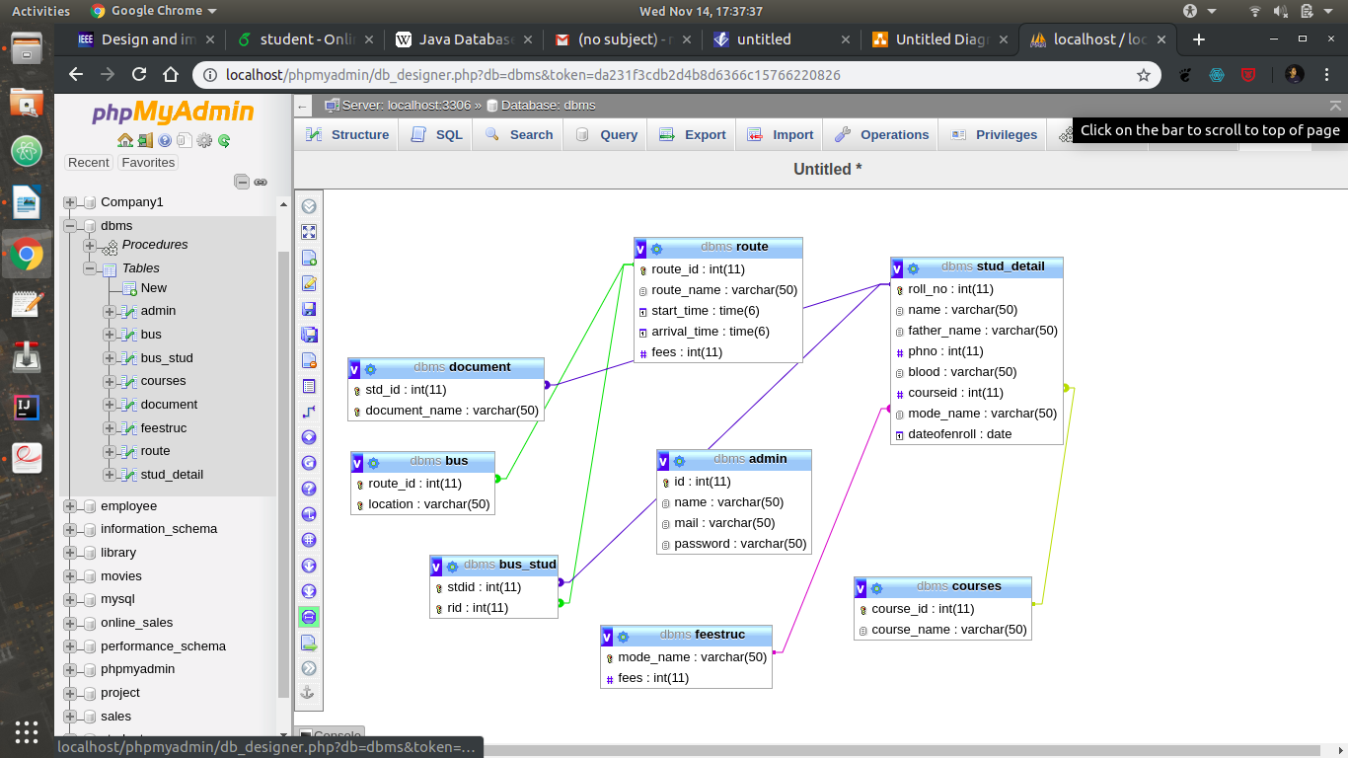
3.2 Schema Diagram

3.3 Normalization

Database normalization is the process of organizing the fields and tables of a relational database tominimize data redundancy and dependency. Normalization usually involves dividing a database into two or more tables and defining relationships between the tables. The objective is to isolate data so that additions, deletions, and modifications of a field can be made in just one table and then propagated through the rest of the database via the defined relationships.
There are three main normal forms, each with increasing levels of normalization:
• First Normal Form (1NF): Each field in a table contains different information. For example, in aStudent list, each table would contain only one email field.
• Second Normal Form (2NF): Each field in a table that is not a determiner of the contents ofanother field must itself be a function of the other fields in the table.
• Third Normal Form (3NF): No duplicate information is permitted. So, for example, if two tables both require an email field, the email information would be separated into a separate table, and the two other tables would then access the email information via a password field in the student table. Any change to a email would automatically be reflect in all tables that link to the student table.
Our database is in 3rd normal form.

3.4 DFD

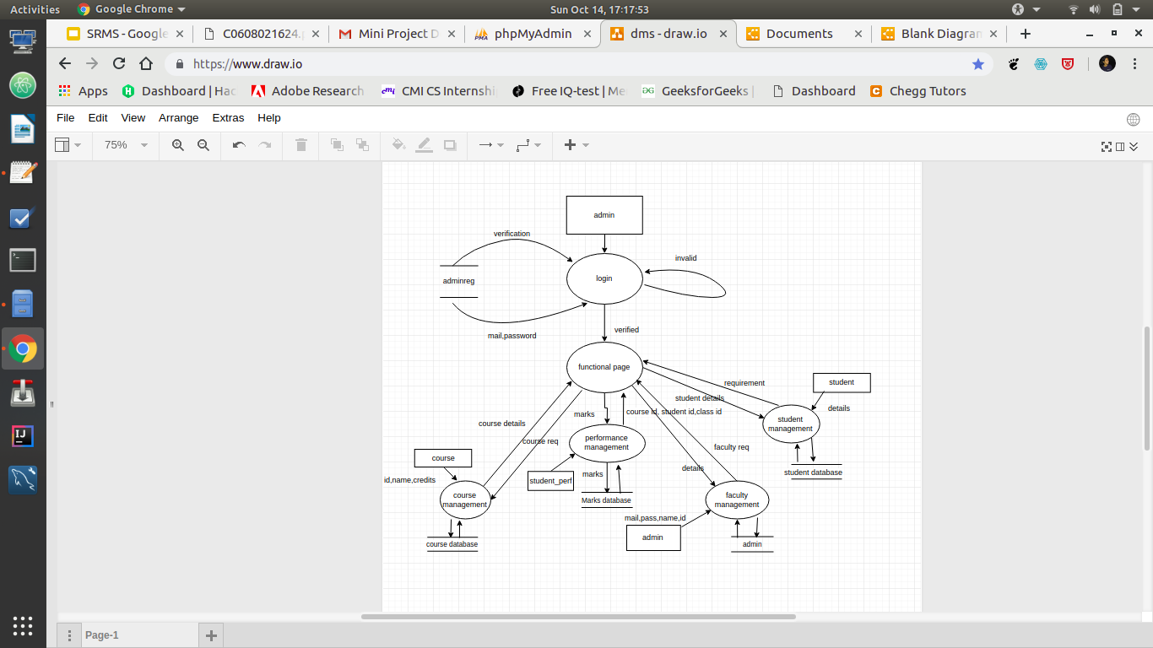

Chapter 4: Implementation
Implementation

4.1 Implementation
For implementing the system, we need to first set up the apache server. XAMPP is an application server for hosting PHP websites. XAMPP is a cross platform web server stack that comes with built in apache, MySQL, PHP and Perl. Since most actual web server deployments use the same components as XAMPP, it makes transitioning from a local test server to a live server extremely easy as well. Once this is done, we choose an IDE to our convenience. For this project we have used NetBeans IDE.

4.2 Programming language selection
JDBC API is a Java API that can access any kind of tabular data, especially data stored in a Relational Database. JDBC works with Java on a variety of platforms, such as Windows, Mac OS, and the various versions of UNIX. For the database, we use MySQL which is a relational database management system based on SQL (structured query language)

4.3 Query for creation
4.3.1 Table 1
CREATE TABLE `admin` (
`id` int(11) NOT NULL,
`name` varchar(50) NOT NULL,
`mail` varchar(50) NOT NULL,
`password` varchar(50) NOT NULL
) ENGINE=InnoDB DEFAULT CHARSET=latin1;
4.3.2 Table 2
CREATE TABLE `bus` (
`route_id` int(11) NOT NULL,
`location` varchar(50) NOT NULL
) ENGINE=InnoDB DEFAULT CHARSET=latin1;
4.3.3 Table 3
CREATE TABLE `bus_stud` (
`stdid` int(11) NOT NULL,
`rid` int(11) NOT NULL
) ENGINE=InnoDB DEFAULT CHARSET=latin1;

4.3.4 Table 4
CREATE TABLE `courses` (
`course_id` int(11) NOT NULL,
`course_name` varchar(50) NOT NULL
) ENGINE=InnoDB DEFAULT CHARSET=latin1;
4.3.5 Table 5
CREATE TABLE `document` (
`std_id` int(11) NOT NULL,
`document_name` varchar(50) NOT NULL
) ENGINE=InnoDB DEFAULT CHARSET=latin1;
4.3.6 Table 6
CREATE TABLE `feestruc` (
`mode_name` varchar(50) NOT NULL,
`fees` int(11) NOT NULL
) ENGINE=InnoDB DEFAULT CHARSET=latin1;
4.3.7 Table 7
CREATE TABLE `route` (
`route_id` int(11) NOT NULL,
`route_name` varchar(50) NOT NULL,
`start_time` time(6) NOT NULL,
`arrival_time` time(6) NOT NULL,
`fees` int(11) NOT NULL
) ENGINE=InnoDB DEFAULT CHARSET=latin1;
4.3.8 Table 8
CREATE TABLE `stud_detail` (
`roll_no` int(11) NOT NULL,
`name` varchar(50) NOT NULL,
`father_name` varchar(50) NOT NULL,
`phno` int(11) NOT NULL,
`blood` varchar(50) NOT NULL,
`courseid` int(11) NOT NULL,
`mode_name` varchar(50) NOT NULL DEFAULT 'CET',
`dateofenroll` date NOT NULL
) ENGINE=InnoDB DEFAULT CHARSET=latin1;

4.4 Description of tables
There are 7 tables in total that are used. Each of them are used for a different purpose and they are related to each other in an intuitive or direct manner. The first table is used to store admin details which include email Id, name, admin ID and password. Second table records route Id and location of the corresponding Id. Table 3 includes information about which student has been assigned which bus route. Table 4 records Courses offered by the college. Table 5 stores information about all the documents submitted by the students. Table 6 stores information about different fees based of mode of admission. Table 8 being the most important information about the students viz, Id, Name, Father’s name, phone nuber,course ID etc about the students. Table 7 stores information about routes from different places along with timings.

4.5 Triggers used
A trigger is a set of actions that are run automatically when a specified change operation (SQL INSERT, UPDATE, or DELETE statement) is performed on a specified table. Triggers are useful for tasks such as enforcing business rules and validating input data.
The trigger used is to check if the email ID has already been registered in the database.

4.6 Procedures used
A procedure (often called a stored procedure) is a subroutine like a subprogram in a regular computing language, stored in database. Stored procedures are fast and portable.
The procedure used in this system is to warn the user about missing document of the student when the student is added or when the student’s details are being updated.

Chapter 5: Result snapshots
Result Snapshots
5.1 Login Page
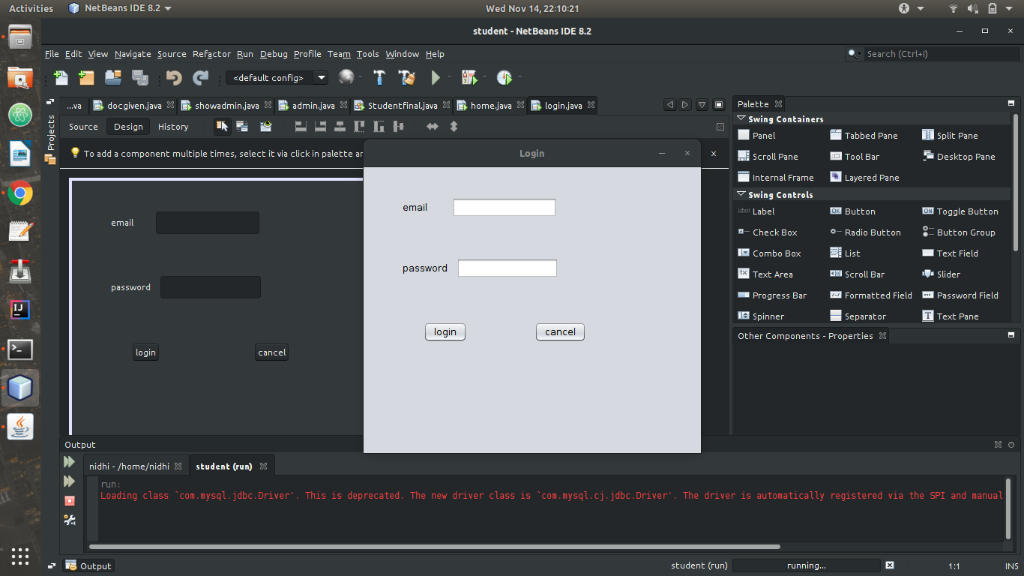
5.2 Home Page
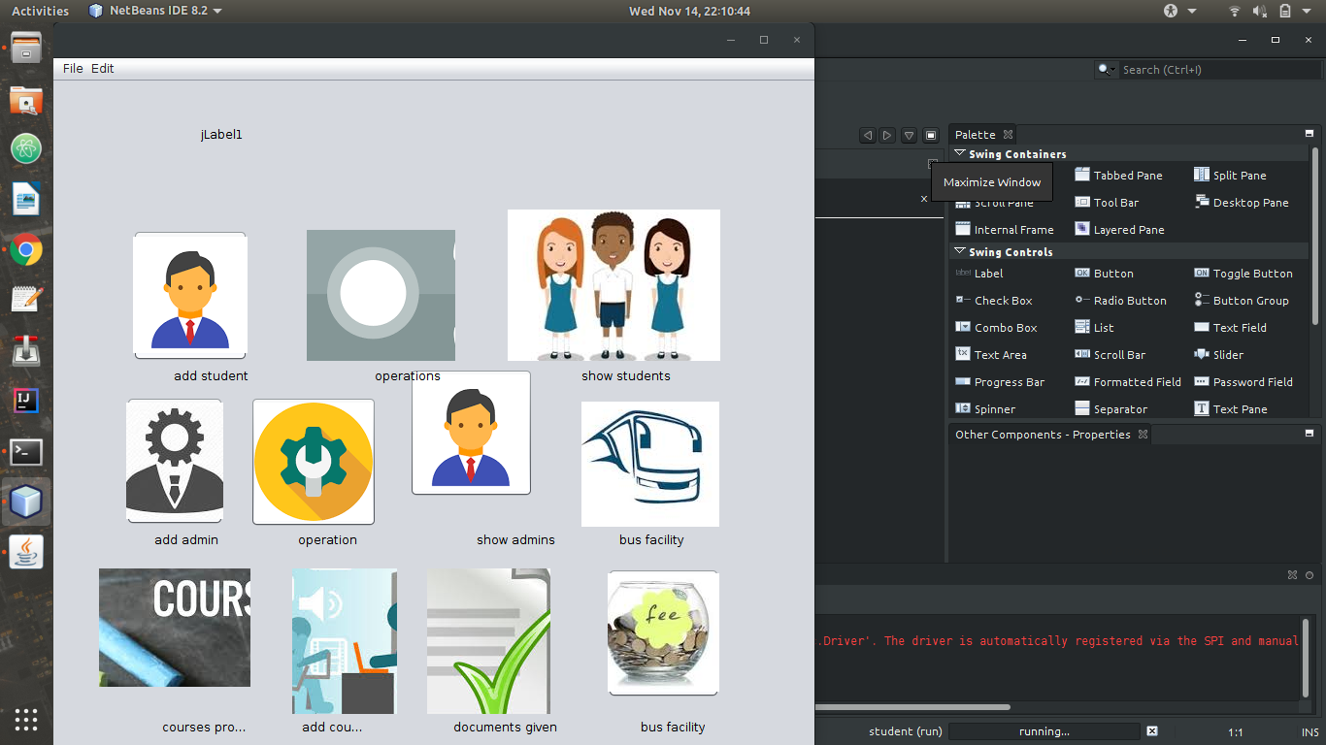

5.3 Add/edit/delete student

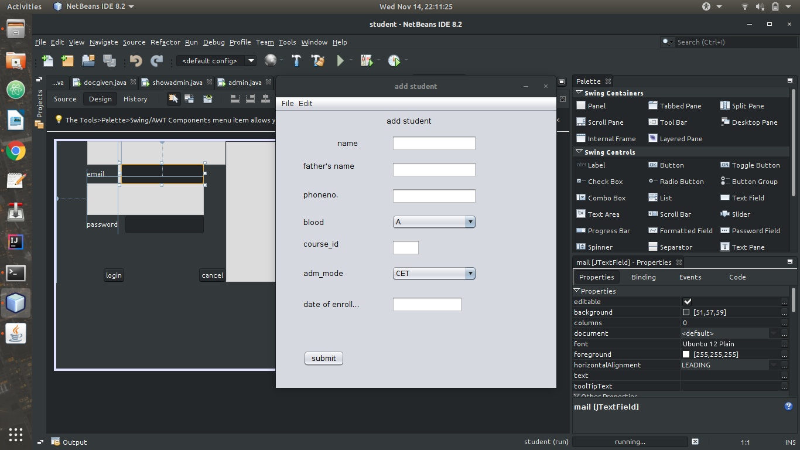
5.4 Add/Delete Admin
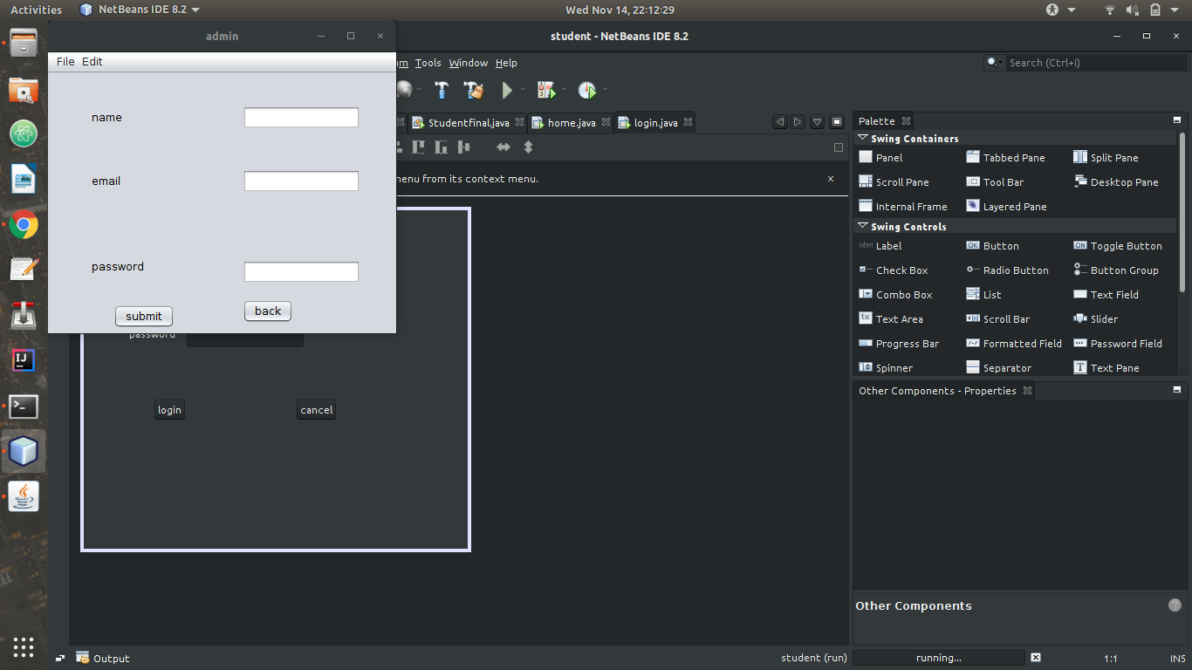
5.5 Student Details

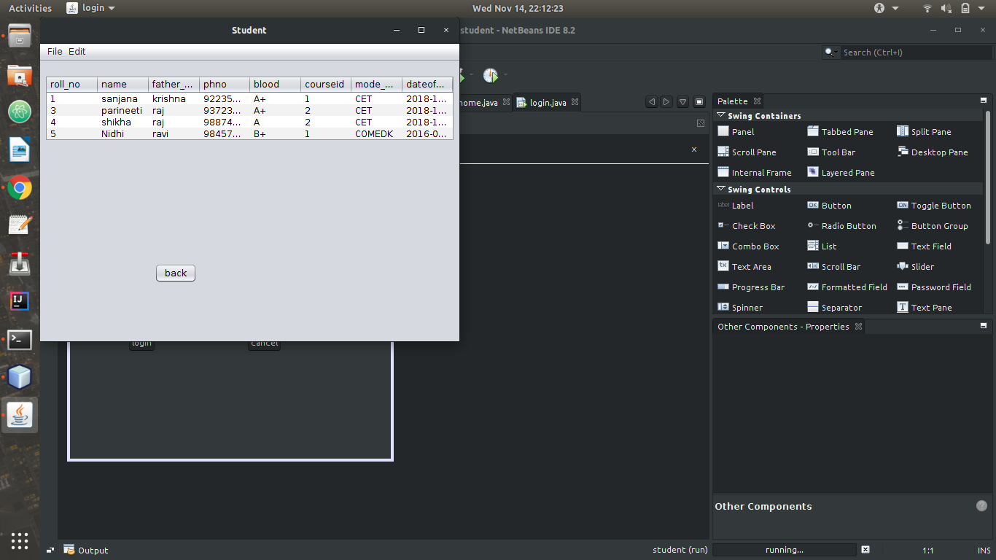
5.6 Add/ Delete Admin
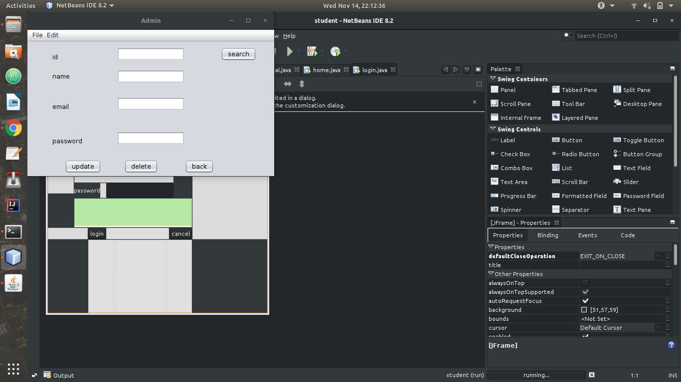

5.7 Fee details

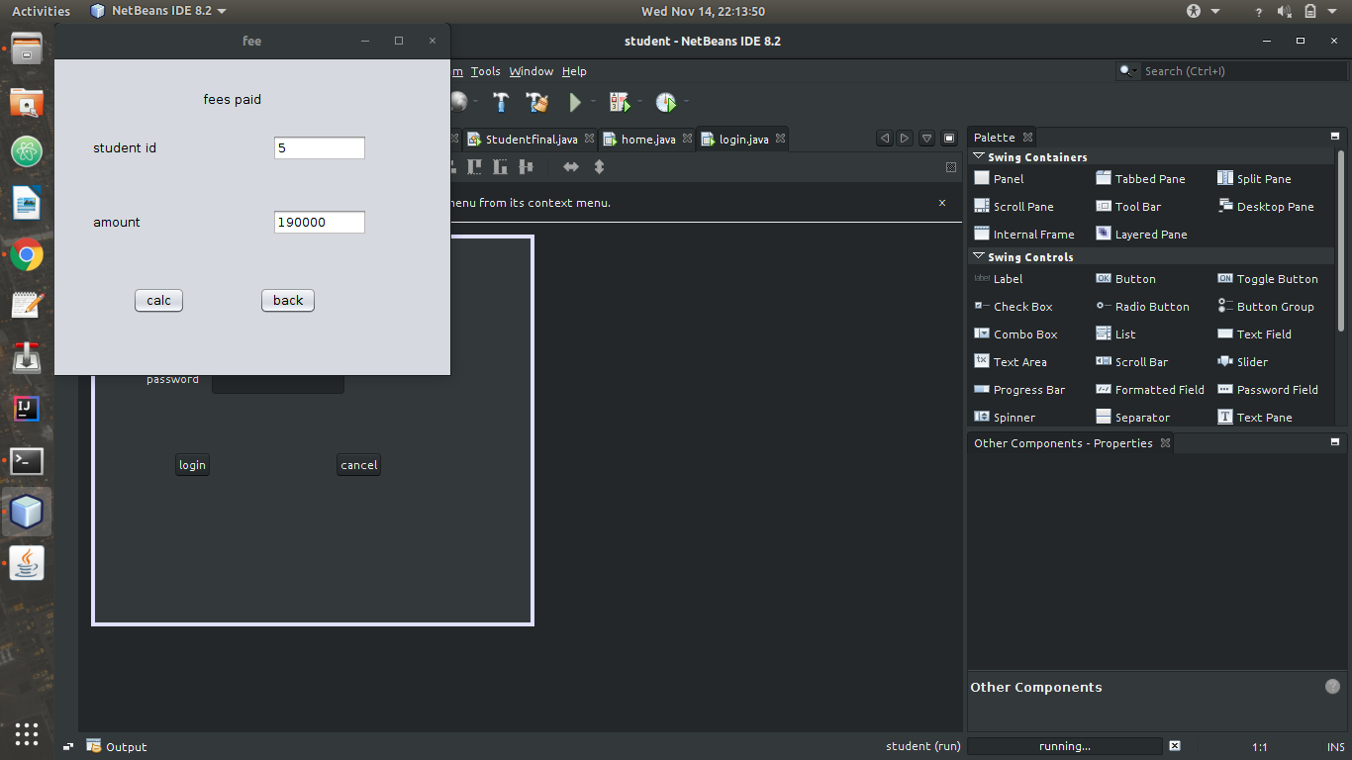
5.8 Adding Course
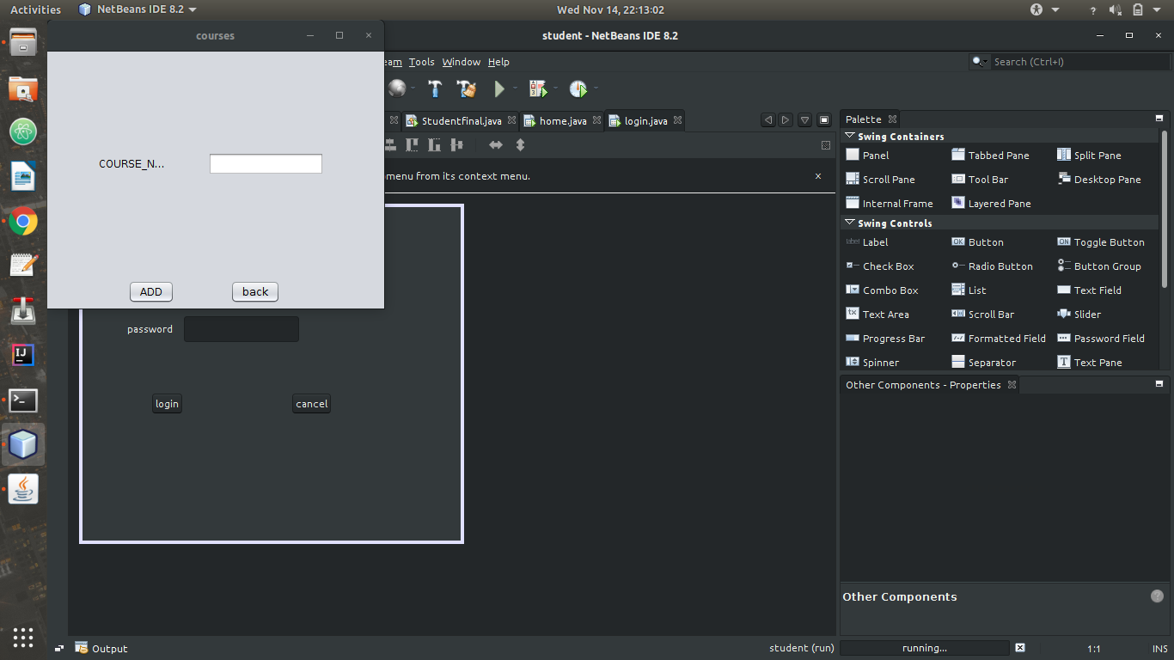

5.9 Documents details

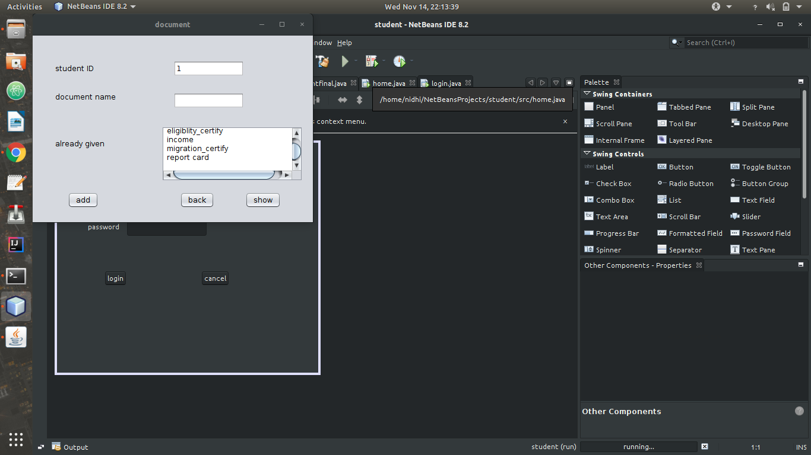

5.10 Bus Facility
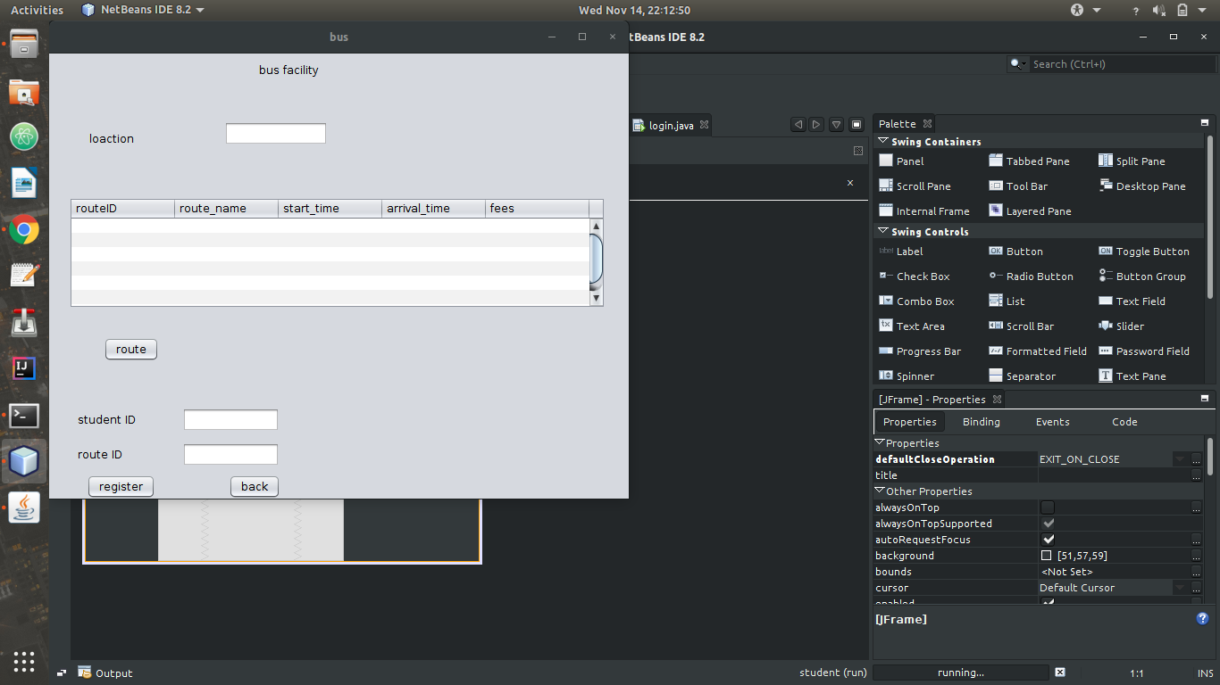

5.2 Code Snippets
Result Snapshots

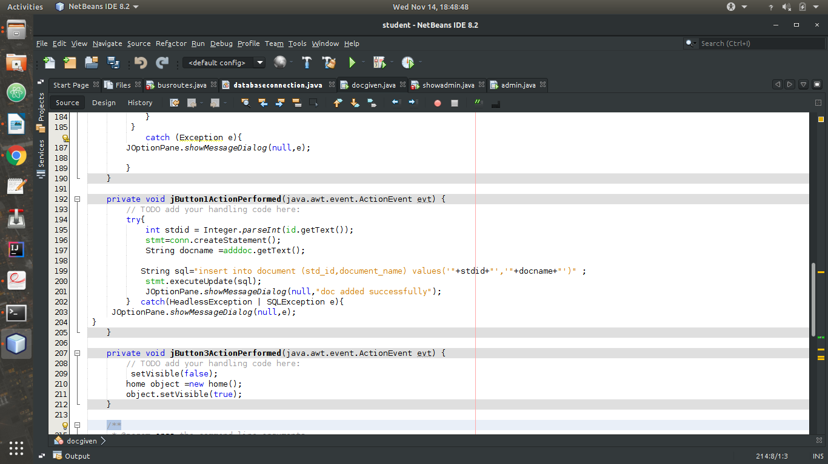

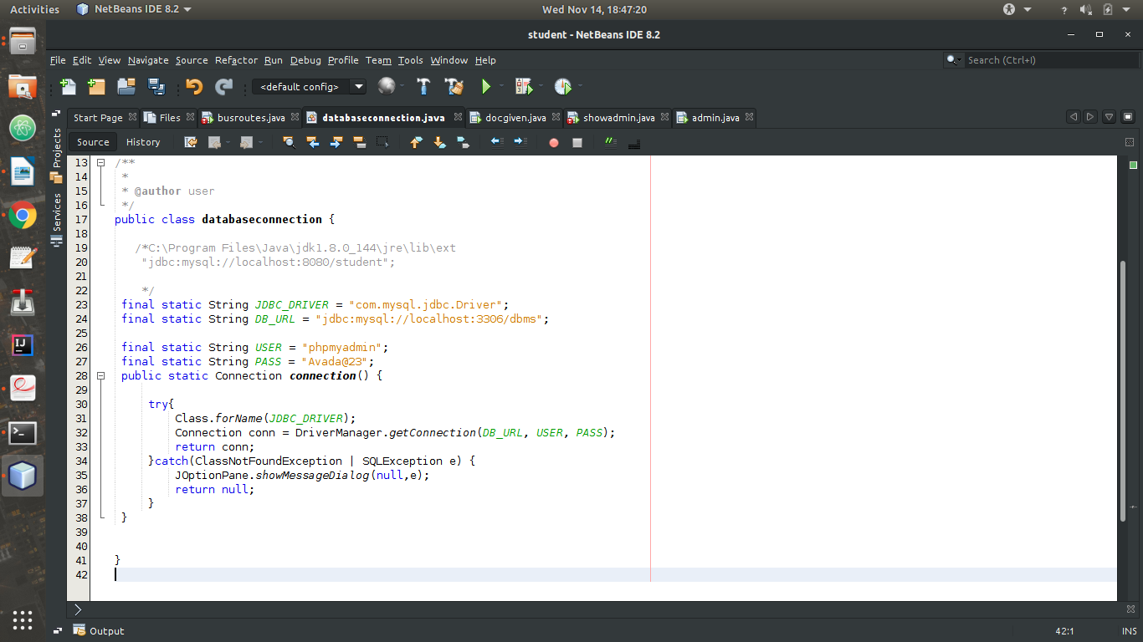

Chapter 6: Conclusion
Conclusion
6.1 Conclusion
The designed and developed system efficiently solves the problems involved in the registration process especially during the start of an academic year, of a university or college. The data captured in the system will be authentic and can be used for other purposes like data retrieve and management, since the students themselves will feed all the required data. This solves the problems of avoidable delays involved in inter departmental transfer of data.
6.2 Limitations
6.2.1 Security risks
The major risk associated with this system is entering of wrong data by the administrator. The database has to keep all the data safe and back up must be done so that no valuable information is lost.

6.2.3 Customer satisfaction
Customer satisfaction is often the most daunting task and is difficult to achieve when it comes to deployment if software because of the ease of use of the software.

6.3 Future enhancements
6.3.1 Addition of marks
A module can be added to track the performance of students by keeping track of grades of different exams conducted by the college.
6.3.2 Adding Student Attendance
Students attendance data can be stored and analyzed for different reasons.
6.3.2 Providing student login
Students can view their marks and attendance real time and improve their performance accordingly.
6.3.3 Enable students to chose courses
If the college provides different subjects online then this facility can be provided where in student choses his/her subjects.

Chapter 7: References
The documents that have been references are enlisted below
7.1 For SRS references
7.1.1 http://www.cse.chalmers.se/~feldt/courses/reqeng/examples/srs_example_2010_group2.pdf
7.1.2 http://www.cse.iitd.ac.in/~cs5080212/Group08_(STUB)_SRS_Draft_Version.pdf
7.2 For literature references
7.2.1 https://en.wikipedia.org/jdbc
7.2.2 https://en.wikipedia.org/netbeans
7.2.3 php.net/manual/en/index.php

Refe

