HELPNET
Final Project Report
HELPNET - A Unified Community Services Platform for Bangladesh
Prepared from repository implementation and executed test evidence
2026-11-03

Chapter 1: Introduction
HELPNET is a web platform for community-service workflows in Bangladesh. It combines account/profile management with blood donation, volunteer opportunities, health questions, goods exchange, farming, waste pickup, trust features, and administrator review. This report describes implemented code, not production deployment.

Chapter 2: Literature Review and Existing System
The repository uses documented Django, DRF, JWT, and Selenium technologies. A formal literature survey or comparative field study was not included in the repository; no external study results are invented. Existing feature behavior and gaps are derived from source and tests.

Chapter 3: Requirement Analysis
Implemented requirements include registration/login, multiple profiles, role-scoped services, private verification evidence, admin decisions, community listings, notifications, ratings, and moderation. Non-functional concerns include authentication, ownership, private files, environment configuration, and testability. Formal stakeholder-approved SRS traceability was not supplied.
Requirement | Implementation evidence
Accounts/profiles | Profile API, dashboard switching and lifecycle
NGO verification | Private documents, statuses/reasons/timestamps and admin review
Community services | Blood, volunteer, health, goods, farmer, waste, ratings, notifications
Security | JWT, ownership and role checks, private document endpoints

Chapter 4: System Analysis and Design
Browser templates and JavaScript call REST endpoints; Django ORM models persist domain data. A custom UUID User owns multiple typed UserProfile rows. Domain apps own their records. NGO organization verification is separate from individual NID verification.
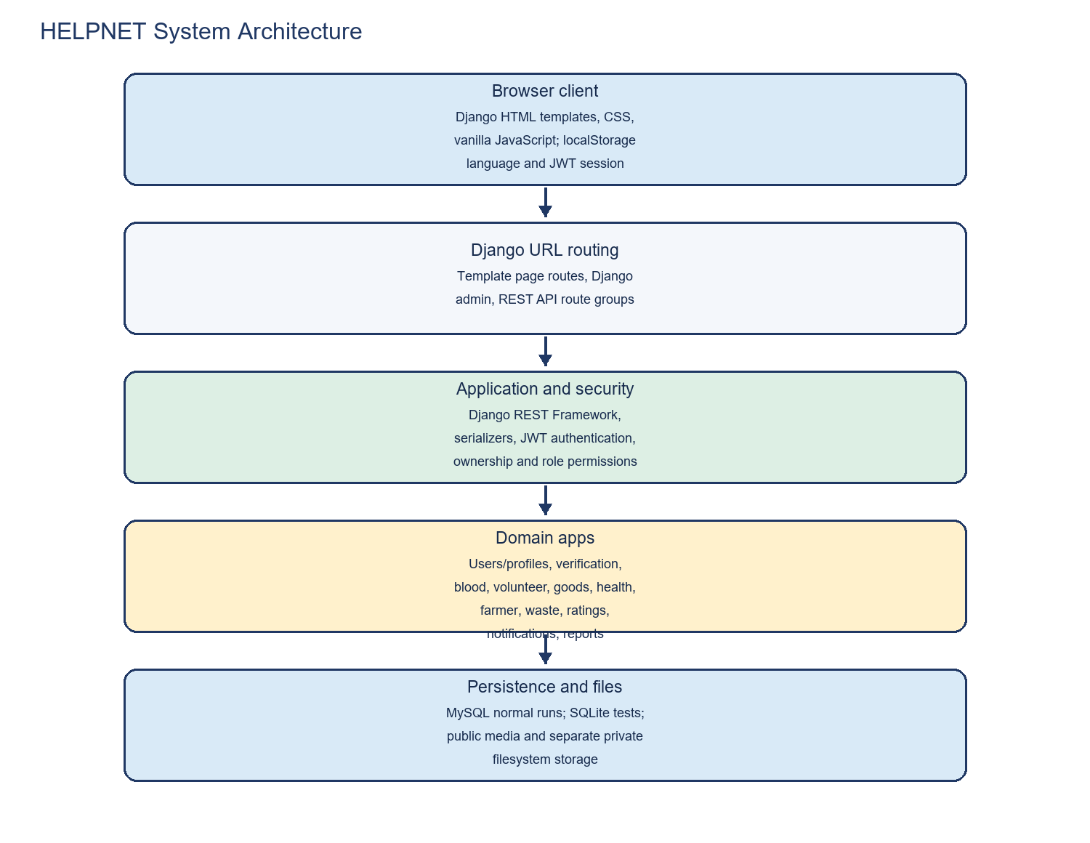
Architecture.
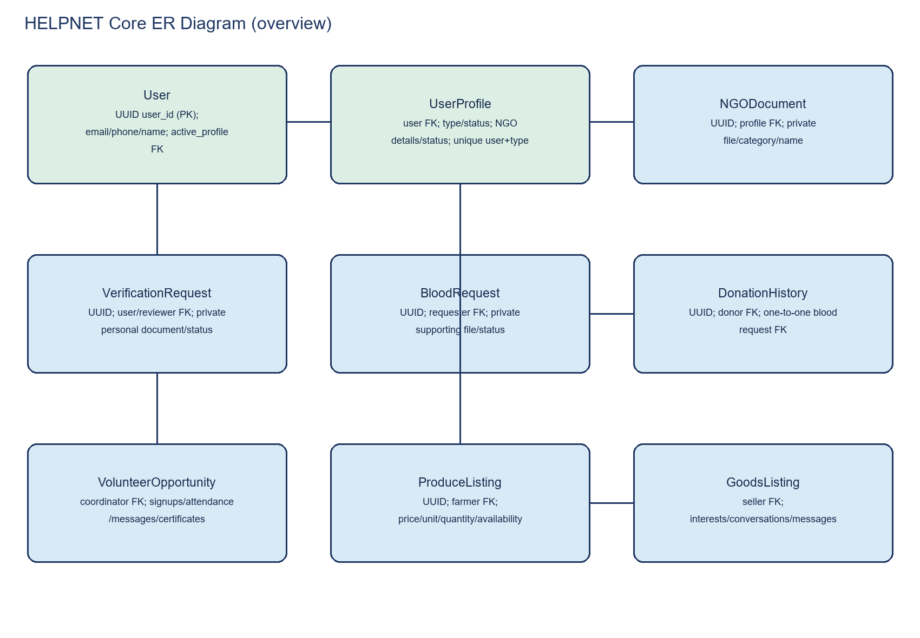
ER overview.
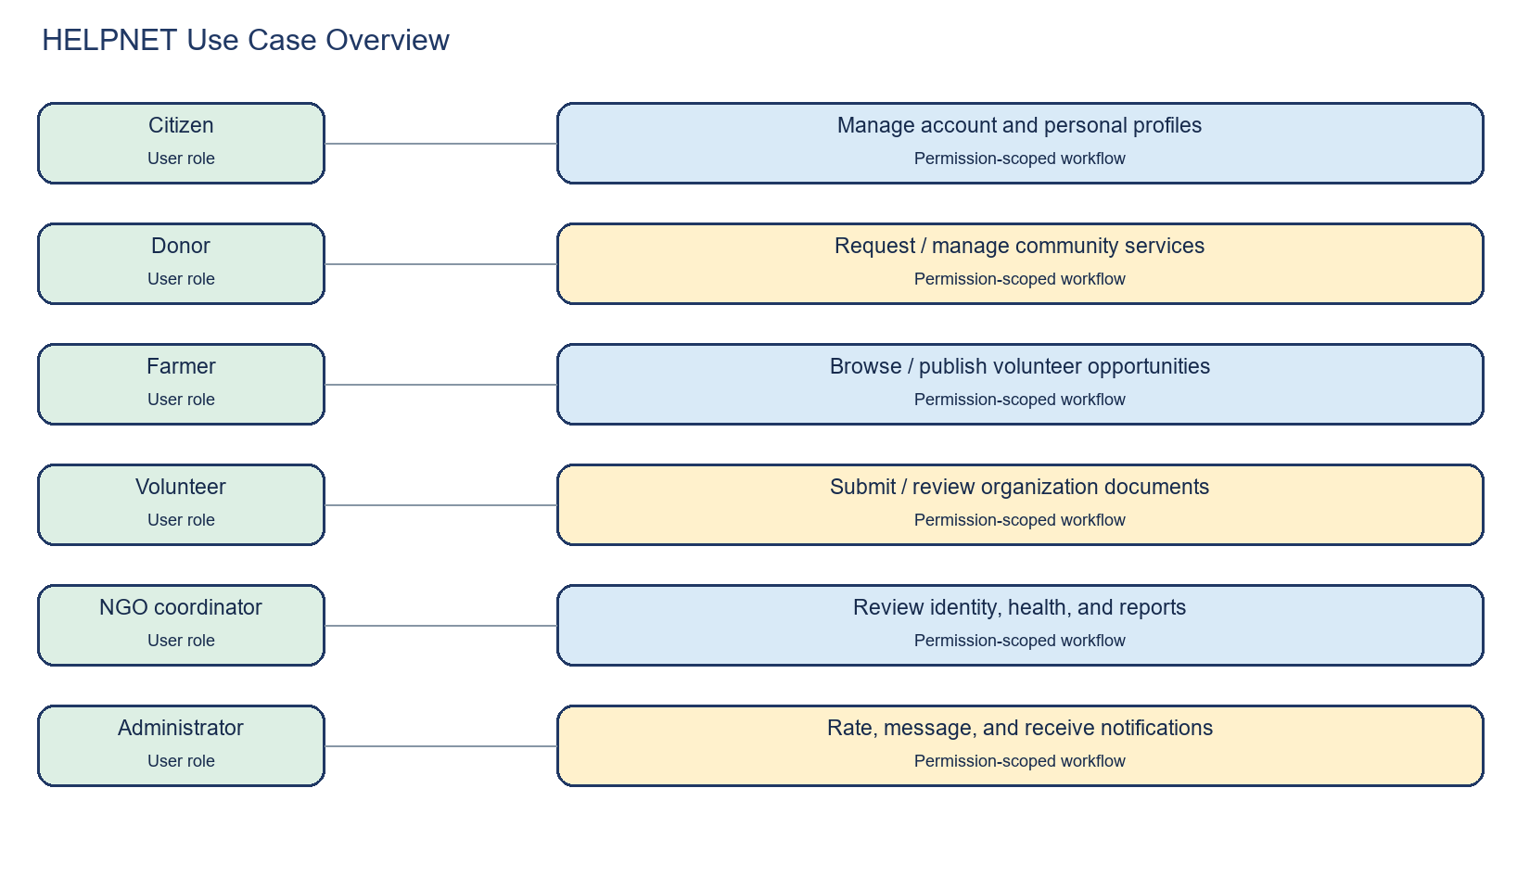
Use cases.
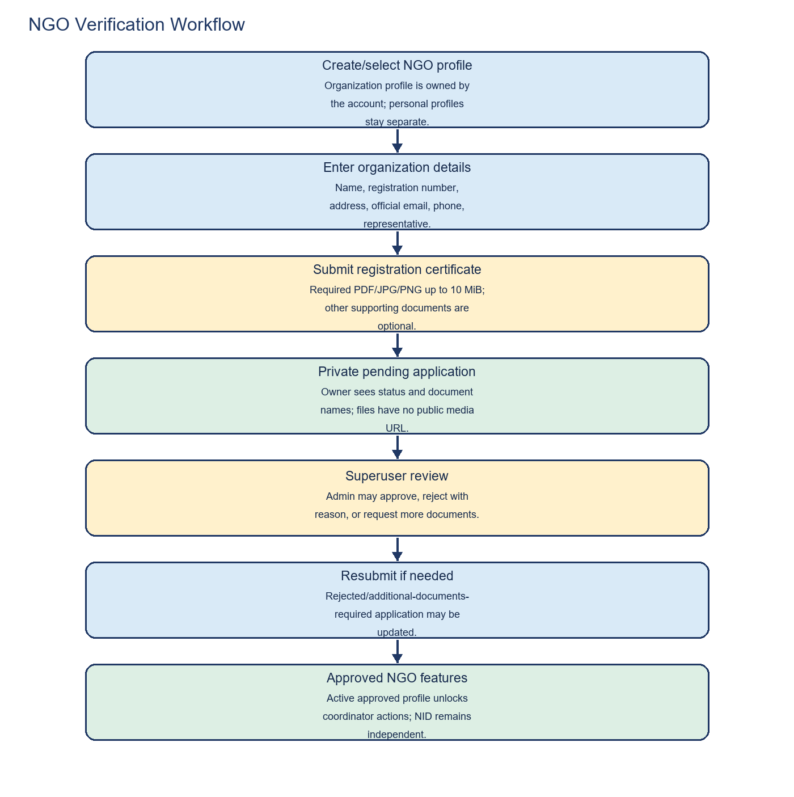
NGO workflow.

Chapter 5: Implementation
Django apps implement users, identity verification, blood, goods, health, farmer, waste, volunteer, ratings, notifications, reports, and common pages. NGO evidence is privately stored and reviewed by superusers. Profile switching changes the server-selected active profile. Farmer editing is labeled Edit product on the product detail page. Frontend uses HTML/CSS/vanilla JavaScript.

Chapter 6: Testing and Validation
The backend suite passed 128 tests. A full Selenium-directory run collected 98 cases: 51 browser cases and 47 HTTP-only route checks. Initial outcome was 94 passed/4 fixture failures; after fixture correction, all four passed on targeted rerun. A final browser pass yielded 51/51 and screenshots. System and migration drift checks passed.
Test group | Result | Scope
Backend | 128 passed | pytest with SQLite test configuration
Selenium browser | 51 passed | Django test server; 51 screenshots
Page routes | 47 passed | HTTP-only; not browser automation
System/migrations | Passed | No system issues or migration drift
Production MySQL/SMTP | Not tested | Requires deployment environment

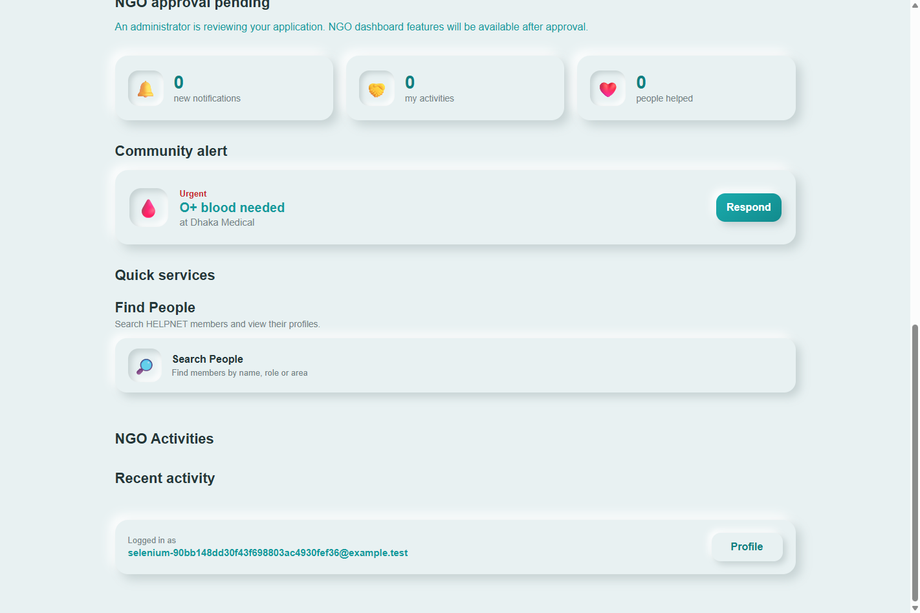
Browser evidence: NGO submission.
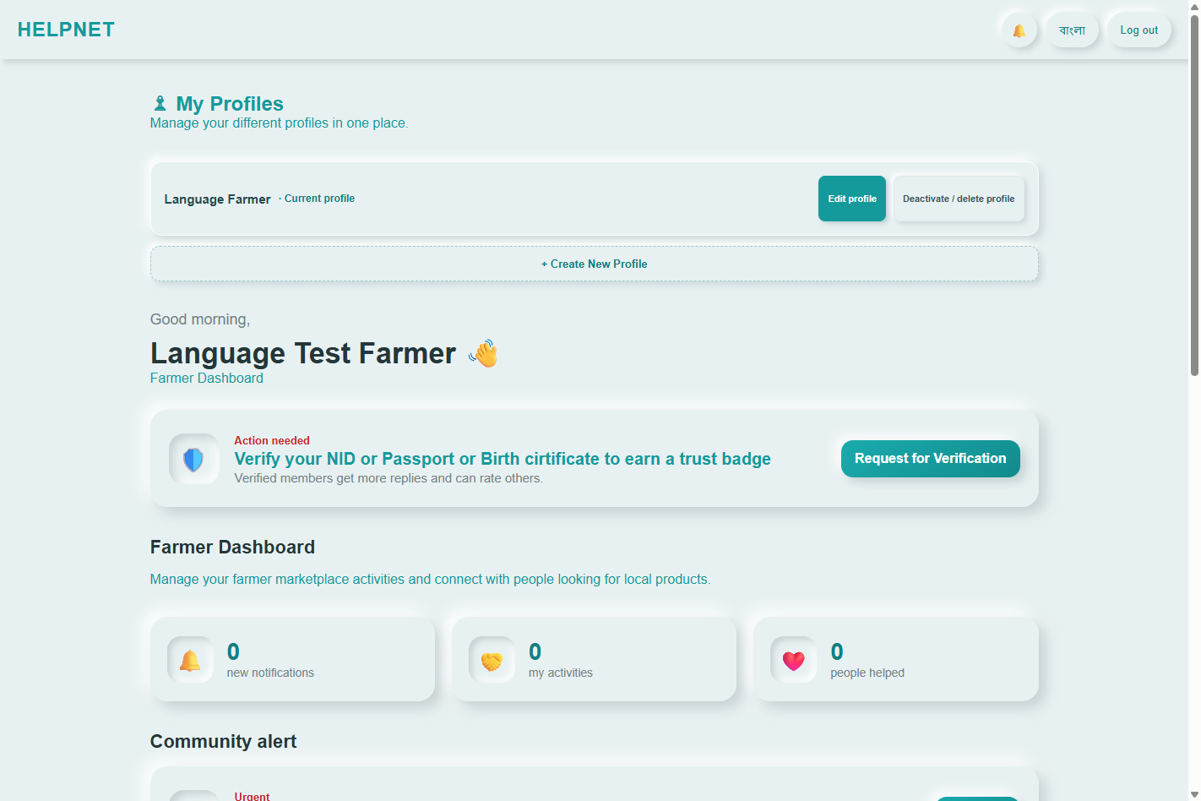
Browser evidence: profile localization.

Chapter 7: Results and Discussion
Tests exercised the actual local Django application and isolated test database using synthetic records. Selenium identified hidden NGO validation feedback and a profile form without a Save control; both were fixed and retested. Some authenticated feature tests seed a test JWT rather than using the login form. Results show local functional behavior, not production readiness.

Chapter 8: Conclusion and Future Work
HELPNET contains interconnected role-scoped community features and verified local backend/browser workflows. Next steps: production MySQL migration rehearsal; deployed storage/HTTPS/HSTS decisions; SMTP validation; broader localization; browser coverage for remaining admin/document replacement flows; accessibility/performance tests; formal stakeholder acceptance.

References
- Django Software Foundation, Django 5.2 documentation, https://docs.djangoproject.com/en/5.2/ (accessed 2026-11-03).
- Django REST Framework, API Guide, https://www.django-rest-framework.org/ (accessed 2026-11-03).
- Django REST Framework Simple JWT documentation, https://django-rest-framework-simplejwt.readthedocs.io/ (accessed 2026-11-03).
- Selenium Project, Selenium documentation, https://www.selenium.dev/documentation/ (accessed 2026-11-03).
- Jones, M., Bradley, J., and Sakimura, N. JSON Web Token (JWT), RFC 7519. IETF, 2015. https://www.rfc-editor.org/rfc/rfc7519.

Appendices
Appendix A: test cases, execution report, results CSV, and screenshots are in `project_documentation/selenium_evidence/`. Appendix B: API and schema details are in the adjacent Markdown guides. Team contributions, costs, formal approvals, and stakeholder records were not supplied and require team verification.

