HELPNET
Technical Documentation
System, architecture, modules, APIs, data, privacy, and setup
Prepared from repository implementation and executed test evidence
2026-11-03

1. Introduction
This document describes HELPNET as implemented in the repository. It distinguishes implemented behavior from partial, untested, or deployment-dependent areas.

2. Project overview
A Bangladesh-focused community services platform combining account/profile management with blood donation, volunteering, health questions, goods exchange, farming, waste pickup, ratings, notifications, and moderation.

3. Problem statement
Community-service workflows are separated by role and domain. HELPNET provides one account and interface for discovering and coordinating services while retaining ownership, verification, and moderation boundaries.

4. Objectives
Support account authentication, multiple profiles, role-scoped services, private verification evidence, organization review, content moderation, and repeatable automated validation.

5. Scope
Scope includes repository Django APIs, page templates, JavaScript, models, and tests. No production availability, external partner integration, or deployment certification is asserted.

6. Main features and modules
Users/profiles; NGO and personal verification; blood donation; volunteer management; goods exchange; health questions/professionals; farmer produce; waste collection; ratings; notifications; reports/moderation; administration.
Module | Scope
Accounts/profiles | JWT account, multiple profiles, switching and lifecycle
NGO verification | Private evidence, organization status and admin decisions
Community services | Blood, volunteer, health, goods, farmer, waste
Trust/admin | Ratings, notifications, identity verification, reports

7. User roles and permissions
Personal profiles: Citizen, Blood Donor, Farmer, and Volunteer. NGO profile represents an organization under the same account. Superuser authority is independent. NGO coordinator actions require an active approved NGO profile.
Actor | Boundary
Citizen / Donor / Farmer / Volunteer | Own personal profile and permitted feature operations
NGO coordinator | Active approved NGO profile required; no admin authority
Superuser | Review, moderation, and administrative endpoints

8. System architecture
Browser templates/static JavaScript call Django REST Framework APIs. JWT authentication and permissions protect API operations. Domain apps use Django ORM, with MySQL for normal runs and SQLite tests. Private documents use separate storage and authorized download views.
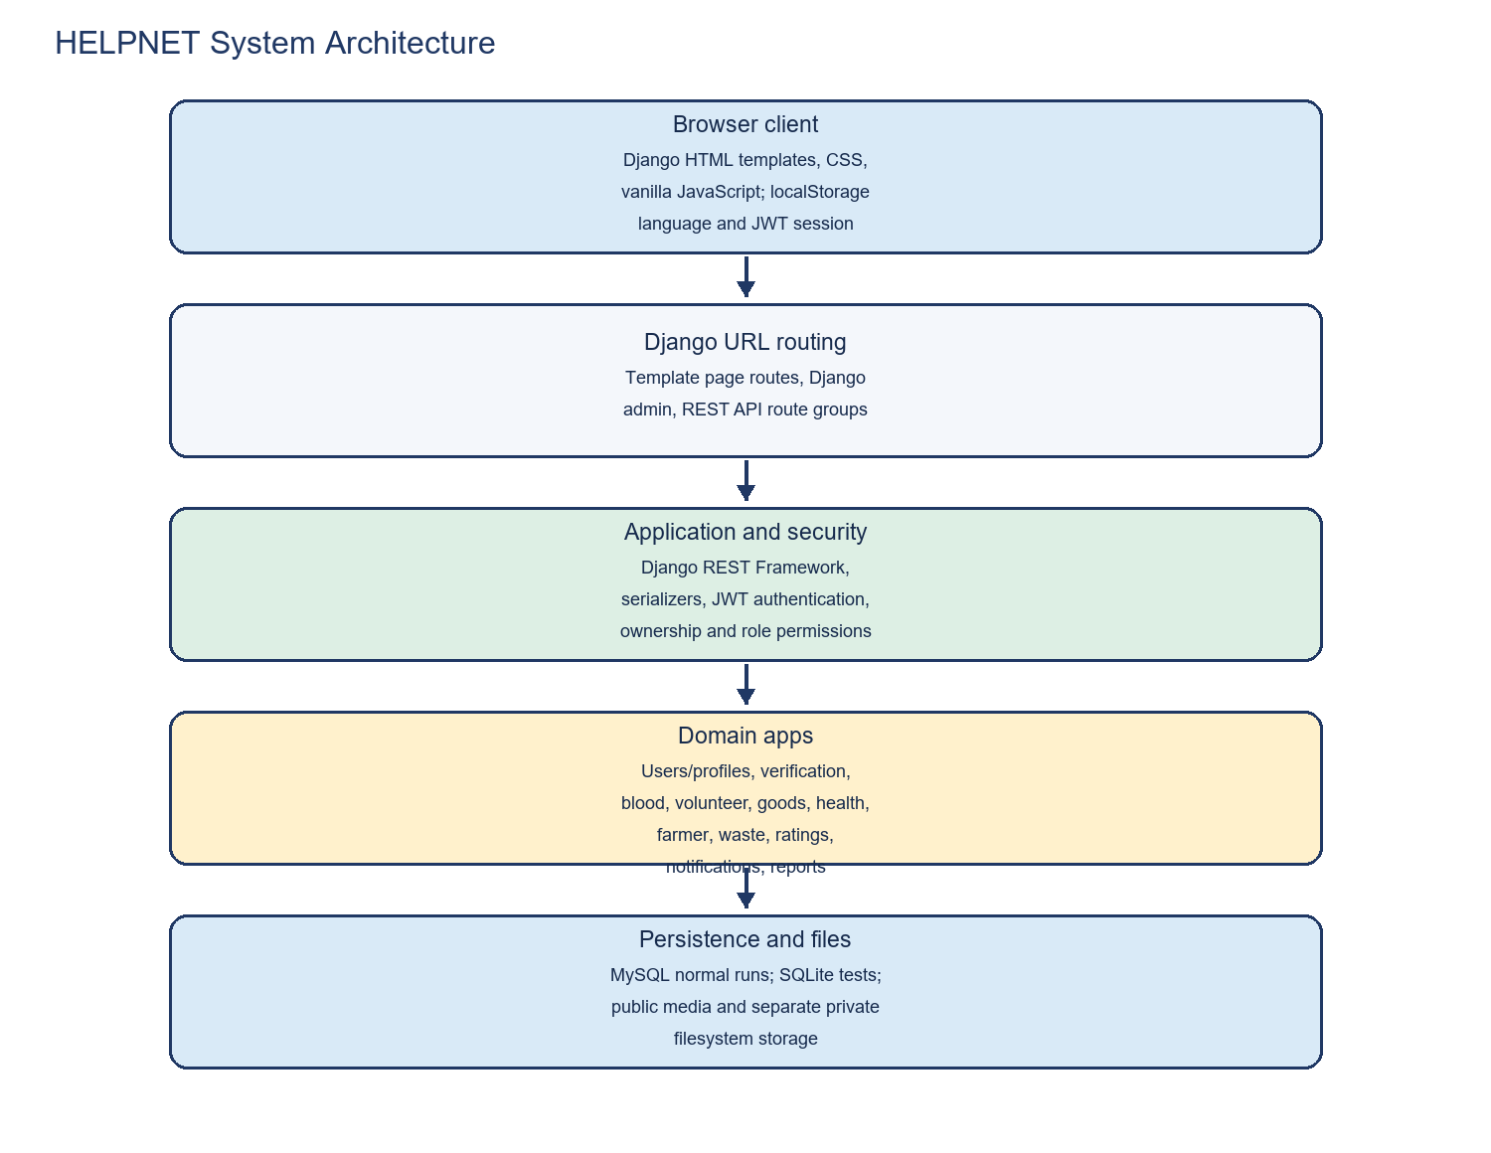
Figure 1. HELPNET system architecture.

9. Technology stack
Python 3.14 environment; declared dependencies include Django 5.2, DRF, SimpleJWT, django-environ, MySQL client, ReportLab, Pillow, pytest, pytest-django, and Selenium. Frontend is HTML/CSS/vanilla JavaScript; no npm build is configured.

10. Frontend and backend structure
`backend/helpnet/` holds settings/root routes; `backend/apps/` holds feature modules; `frontend/pages/`, `frontend/js/`, and `frontend/css/` hold UI; `tests/selenium/` holds browser tests.

11. Database design
The custom UUID-keyed User owns typed profiles; domain records reference accounts and interactions. See the accompanying database guide for constraints and migration details.

12. ER diagram
The ER image is a core relationship overview, not a complete field-level schema.
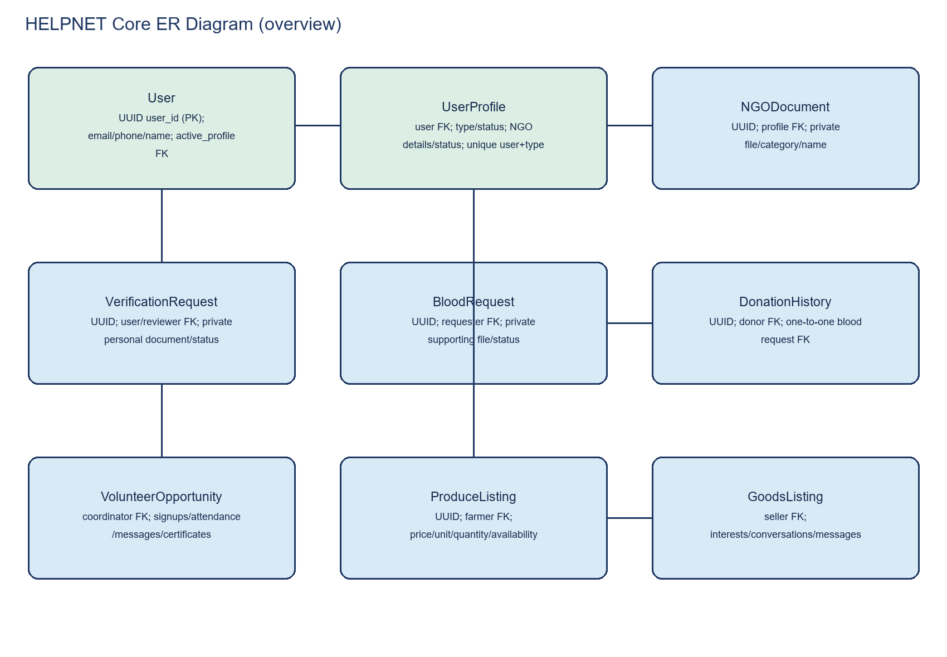
Figure 2. Core entity relationships.

13. Use case diagram
The use-case image summarizes user and administrator workflows within their implemented permissions.
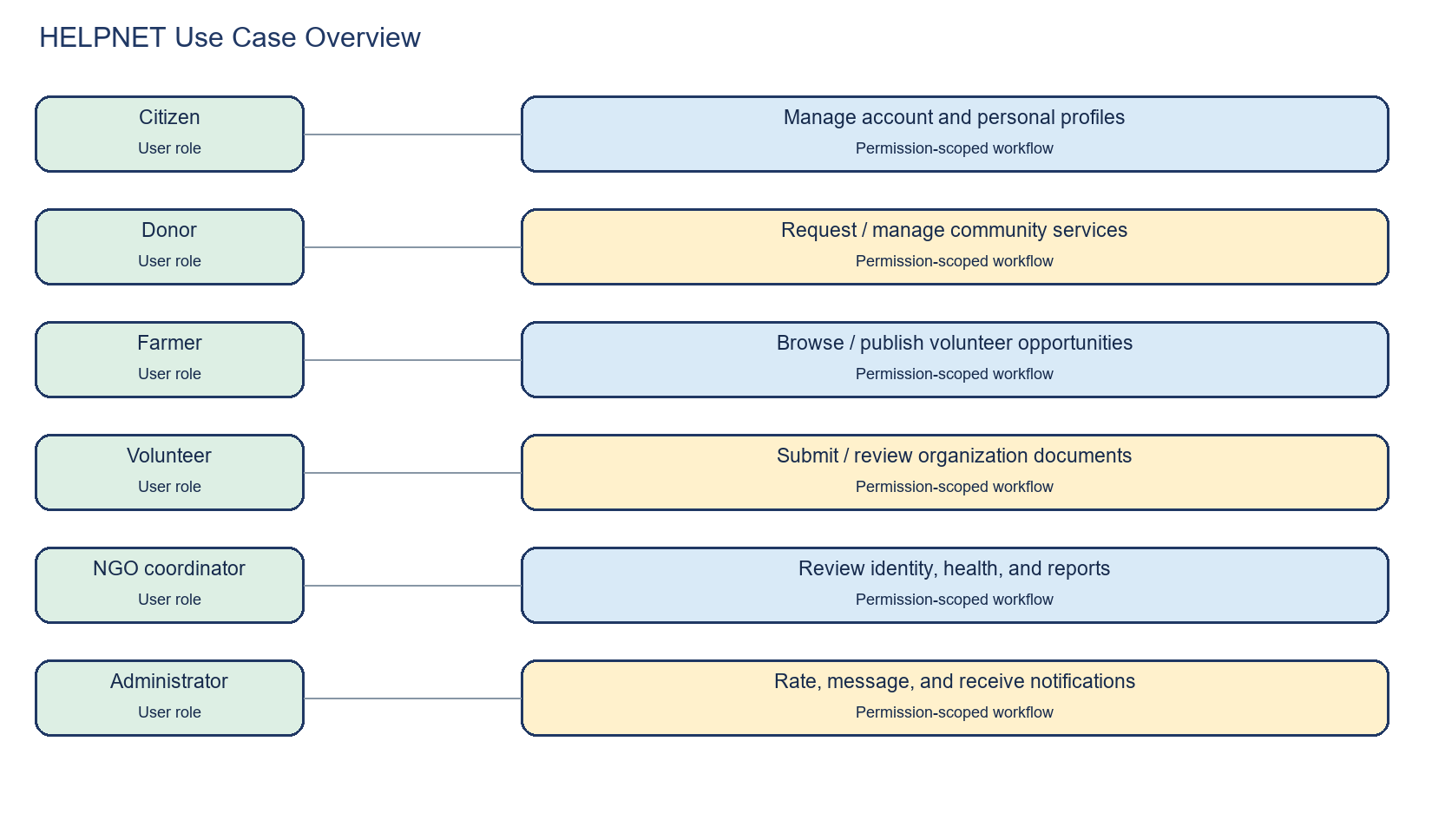
Figure 3. Implemented use cases.

14. Workflow diagrams
NGO review status transitions and blood-request coordination are diagrammed; personal NID remains a separate verification flow.
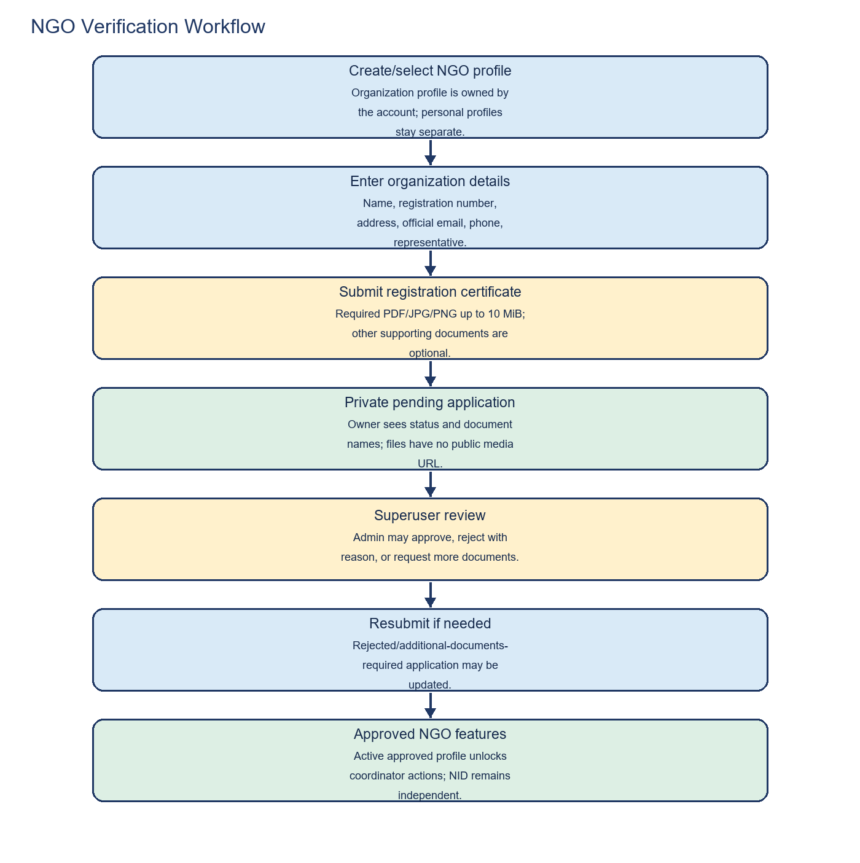
Figure 4. NGO verification.
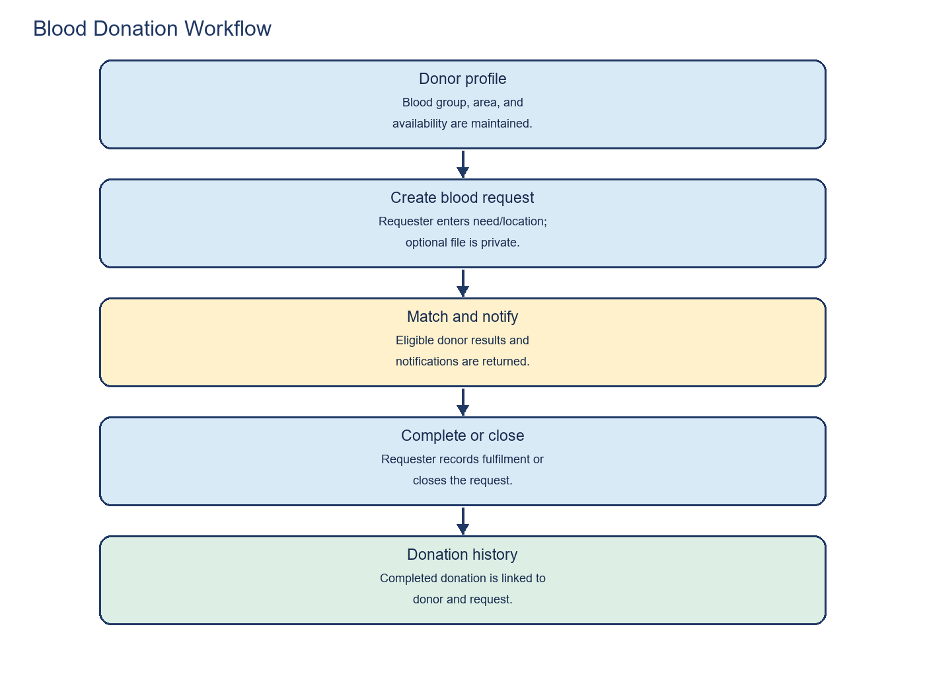
Figure 5. Blood-request workflow.

15. Authentication and authorization
DRF defaults to JWT and authenticated access. Registration/login/password reset are public. Owner-scoped querysets and permission classes constrain access; superuser checks protect review/moderation. Access tokens last one day and refresh tokens 60 days; automatic browser refresh is not implemented.

16. API documentation
REST paths are under `/api/`; endpoint methods, payload summaries, authentication, and response conventions are in `HELPNET_API_Documentation.md`. Template pages are separate GET routes.

17. Multiple-profile management
One account can own Citizen, Donor, Farmer, Volunteer, and NGO profiles. Dashboard controls create/switch/edit/deactivate/reactivate. Active profile is server-side; API ownership checks prevent cross-account access. API delete deactivates instead of deleting account/history.
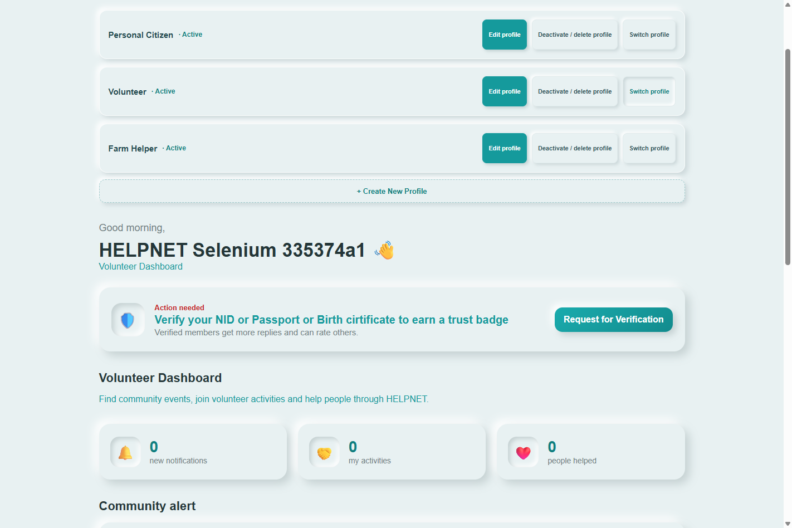
Figure 6. Profile management Selenium evidence.

18. NGO document verification
Required organization details and registration certificate; optional other official/authorization/supporting files. PDF/JPG/JPEG/PNG are checked by extension, MIME, signature, and 10 MiB limit. Files are private; owner/superuser download access; review supports under-review, approval, rejection, and additional-documents-required with reasons/timestamps.
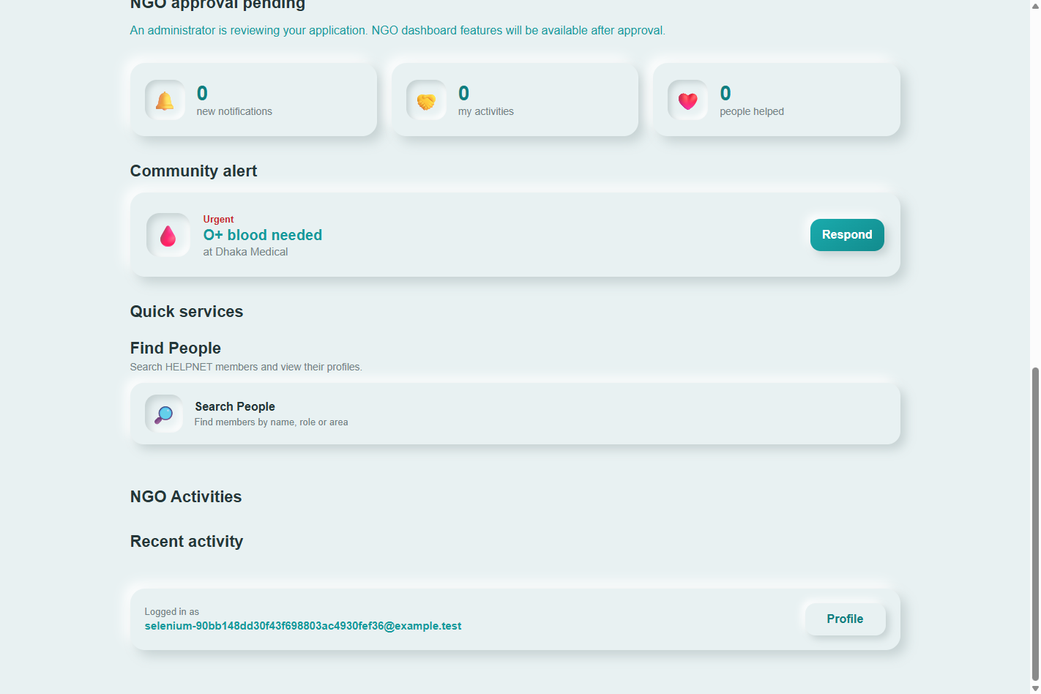
Figure 7. NGO submission Selenium evidence.
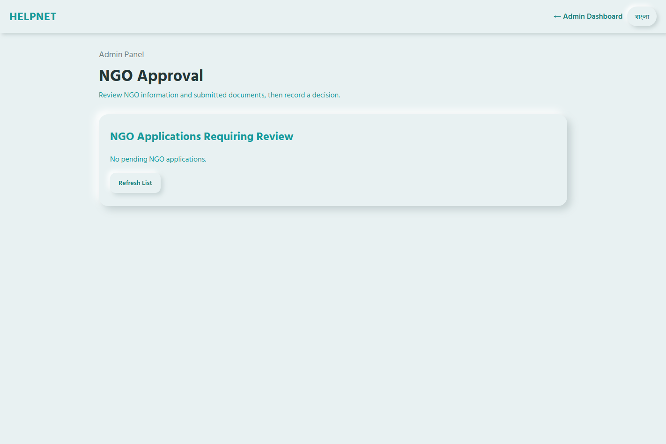
Figure 8. NGO admin review Selenium evidence.

19. Personal NID verification
Personal NID, passport, or birth-certificate applications are stored and reviewed separately. NGO approval does not set personal verification.

20. Blood donation and requests
Donor details and availability, blood requests, matches, notifications, completion/closure, and donation history. Attachments are private and requester/superuser-only.

21. Volunteer management
Approved active NGO coordinators publish opportunities; volunteers sign up; participants message; coordinators manage attendance and issue certificates after completed attendance. Supporting documents are private.

22. Ratings and notifications
User ratings use 1-5 and remain null when absent; notifications are user-owned and can be marked read by that owner. Waste-collector ratings are separate.

23. Farmer marketplace and goods exchange
Produce fields include name, category, price, unit, quantity, availability, location, description; product images are not supported by the current model. Detail page has Edit product. Goods includes listing interest, conversations/messages, status, and reports.
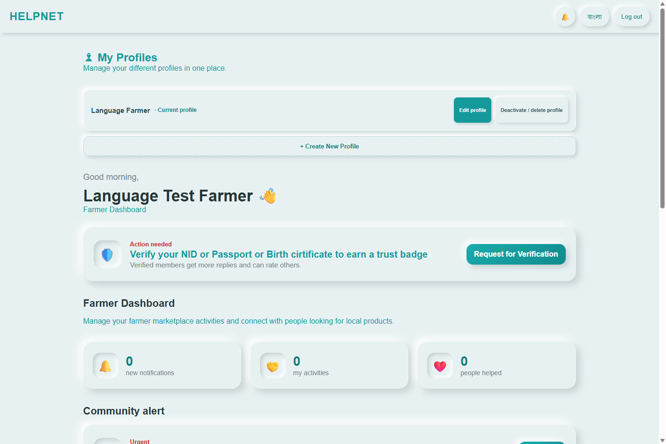
Figure 9. Profile localization Selenium evidence.

24. Other implemented modules
Health Q&A and professional directory; waste pickup and collector reviews; generic reports/moderation; admin logs; volunteer CSV export.

25. Installation and setup
Create a virtual environment; install requirements; copy `backend/.env.example` to a private local `.env`; configure local database and secret values without publishing them; run migrations.

26. Database setup
Normal settings select MySQL through environment values; tests select SQLite. Production MySQL migration was not performed for this report.

27. Running the application
From repository root, configure local environment then run `python backend/manage.py runserver`. Django serves pages/static assets; no separate frontend build step.

28. Testing instructions
Backend: `.venv\Scripts\python.exe -m pytest -q`. Browser suite: `.venv\Scripts\python.exe -m pytest tests\selenium -q`. See the testing report for measured outcomes and scope.

29. Security and privacy
Environment-based settings, secure-cookie/HTTPS defaults with DEBUG off, private document handlers, file validation, safe text rendering, ownership checks, and separation of NGO/NID authority. HSTS is opt-in. Git history was not rewritten.

30. Known limitations
Production MySQL/media/SMTP unverified; no configured Cloudinary, queue, or cache; localization is incomplete; no standalone JS lint/build; no performance/accessibility testing; some legacy role checks remain; browser suite does not cover every admin/document-replacement path.

Implementation change record
This record summarizes the current worktree changes. It does not imply a commit or deployment.
Change area | Key files / behavior
NGO profiles and verification | `backend/apps/users/models.py`, `views.py`, `permissions.py`, `serializers.py`, `urls.py`, `storage.py`; `frontend/js/dashboard.js`, `ngo-approval.js`; `frontend/pages/dashboard.html`, `ngo-approval.html`; owner/admin private-document flow and review states.
Blood-document privacy | `backend/apps/blood/models.py`, `views.py`, `urls.py`, `storage.py`; authenticated requester/admin downloads and file migration.
Security and previously fixed workflows | `backend/helpnet/settings.py`, `backend/.env.example`, `.gitignore`; admin verification rendering/script placement, volunteer certificate POST, rating behavior, farmer edit paths.
Profile/farmer UI | `frontend/js/profile.js`, `dashboard.js`, `farmer.js`, `i18n.js`; `frontend/pages/profile.html`, `produce-details.html`; localized profile Save and product editing.
Tests and reports | `backend/apps/*/tests*`, `tests/selenium/conftest.py`, `test_recent_changes.py`, corrected NGO Selenium fixtures; audit, summary, Selenium evidence, and generated reports.
Private uploads | 19 private upload assets were removed from current Git tracking and remain ignored; filenames are omitted from this report. Git history was not rewritten.

API / schema item | Current behavior
Profile selection/lifecycle | `GET/PUT /api/auth/active-profile/`; `POST /api/auth/profiles/<id>/reactivate/`; profile detail updates are owner-scoped and DELETE deactivates.
NGO application | `GET/POST /api/auth/profiles/<id>/ngo-verification/`; required organization fields/certificate, optional supporting documents, validated private storage.
NGO review/documents | `GET /api/auth/ngo-profiles/pending/`; `PATCH /api/auth/ngo-profiles/<id>/approval/`; `GET /api/auth/ngo-verification-documents/<uuid>/`; superuser review and owner/admin downloads.
Blood documents | `GET /api/blood/requests/<uuid>/document/`; requester or superuser only.
Volunteer certificates | Generic `POST /api/volunteer/certificates/` reads `event_id` from the body; event-specific route carries it in the URL.
Migrations | `users.0007_userprofile_ngo_address_and_more`; `blood.0004_private_blood_request_documents`. Migration drift check passed; no production migration was run.

