HELPNET
User Manual
Account, profile, community-service, and administration workflows
Prepared from repository implementation and executed test evidence
2026-11-03

1. Account registration and sign-in
Open `/register/` to create a Citizen or NGO account using the displayed form. Sign in at `/login/`; account recovery starts at `/forgot-password/`. Password-reset delivery depends on the configured email service.

2. Dashboard and profile management
Open `/dashboard/`. In My Profiles, create available personal profiles or an NGO profile. Use Switch profile for the active role. Edit profile changes profile details. Deactivate preserves related records; use Reactivate profile to restore it. This does not delete the login account.
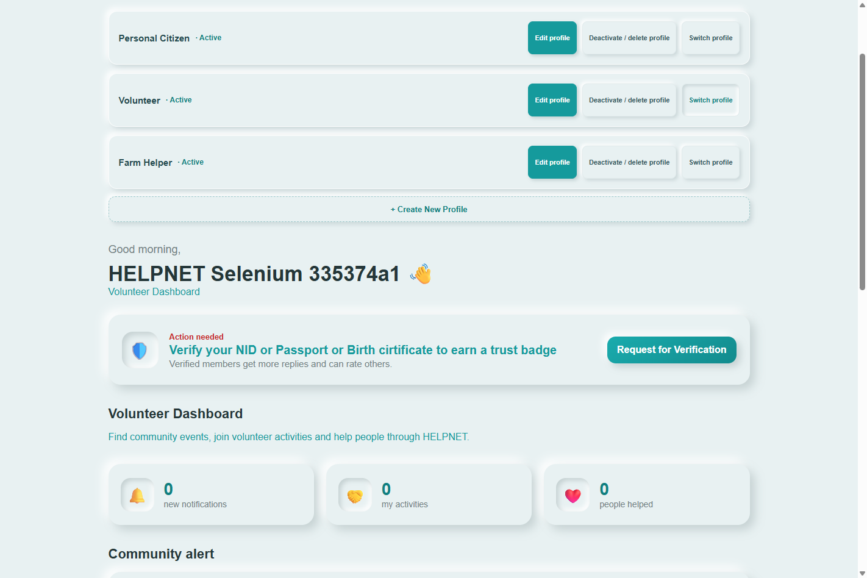
Dashboard profile lifecycle evidence.

3. Edit account details and language
Open `/profile/`, change fields, and choose Save. The language toggle supports English/Bangla on covered pages; the choice is stored in browser local storage and survives refresh. Localization is not yet uniform site-wide.
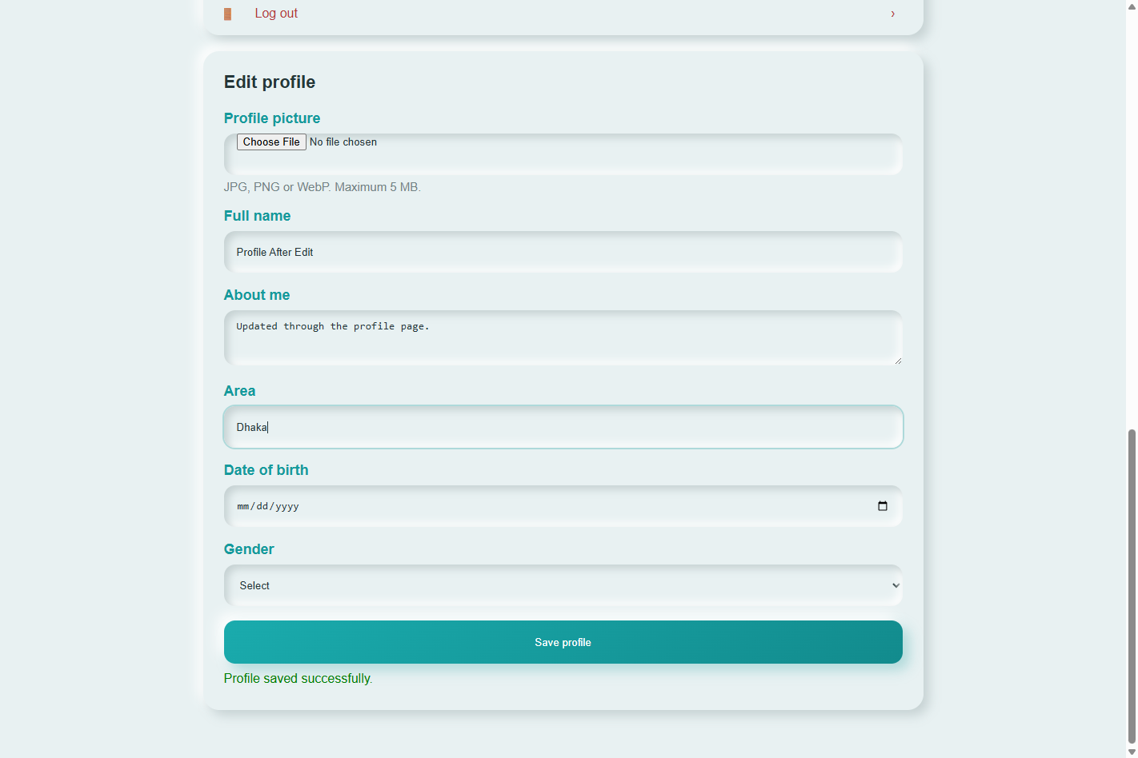
Profile edit/save evidence.
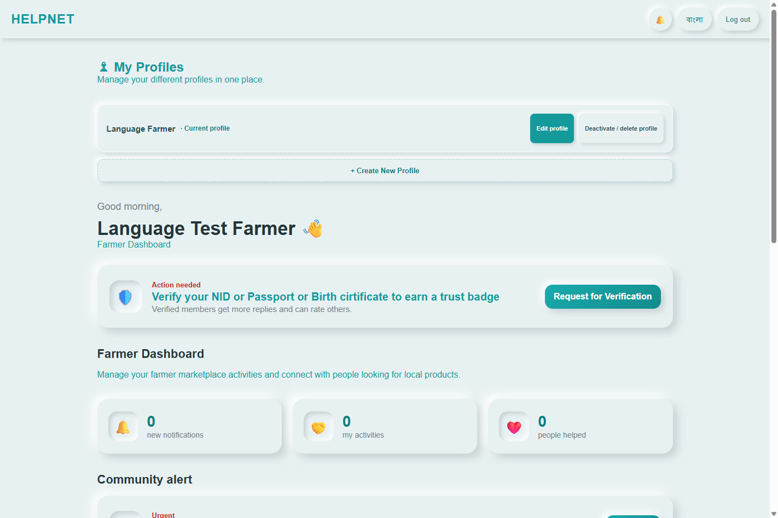
Profile language evidence.

4. NGO verification
Dashboard → My Profiles → select/create the NGO profile → Request Verification. Enter organization name, registration number, address, official email, phone, and authorized representative. Upload the required registration certificate (PDF/JPG/JPEG/PNG, max 10 MiB). Other official documents, authorization letters, and supporting files are optional unless requested by an admin. Submit and confirm Pending status and document names.
Documents are private. If rejected or asked for more documents, review the admin reason and submit replacement/additional files. NGO approval and personal NID status are separate.
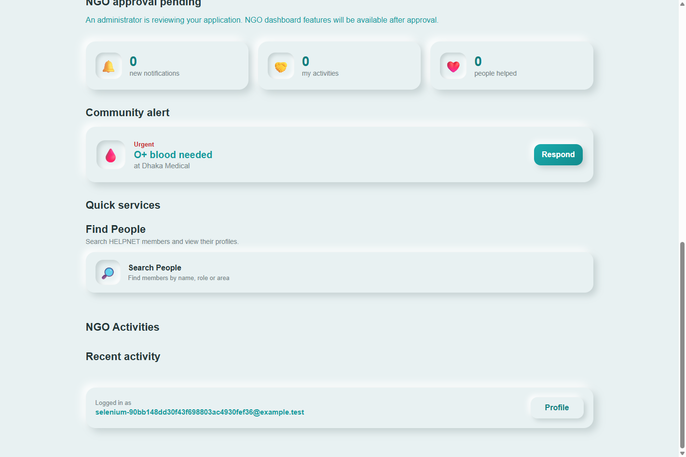
NGO submission browser evidence.

5. Personal identity verification
Use `/nid-verification/` for the individual's NID, passport, or birth certificate. Review is independent of NGO approval.

6. Farmer products
Open `/farmer-market/` using a Farmer profile. To update a product, open product details and choose Edit product; save supported listing fields. Product images are not in the current produce model.

7. Community-service pages
Task | Page
Blood donor, request, matching, history | /blood/
Volunteer opportunities | /volunteer-opportunities/
NGO opportunity creation | /create-opportunity/; active approved NGO coordinator required
Goods listings | /goods-list/; create at /create-goods/
Health questions | /health-questions/; ask at /create-health-question/
Waste pickup | /waste-pickup/
Ratings / notifications | /ratings/ and /notifications/

8. Administrator review
Superusers use `/admin-ngo-approval/` to inspect applications/documents and approve, reject with a reason, or request additional documents with a reason. Other admin areas include identity verification, moderation, logs, health-professional review, and volunteer management. NGO approval does not grant admin permissions.
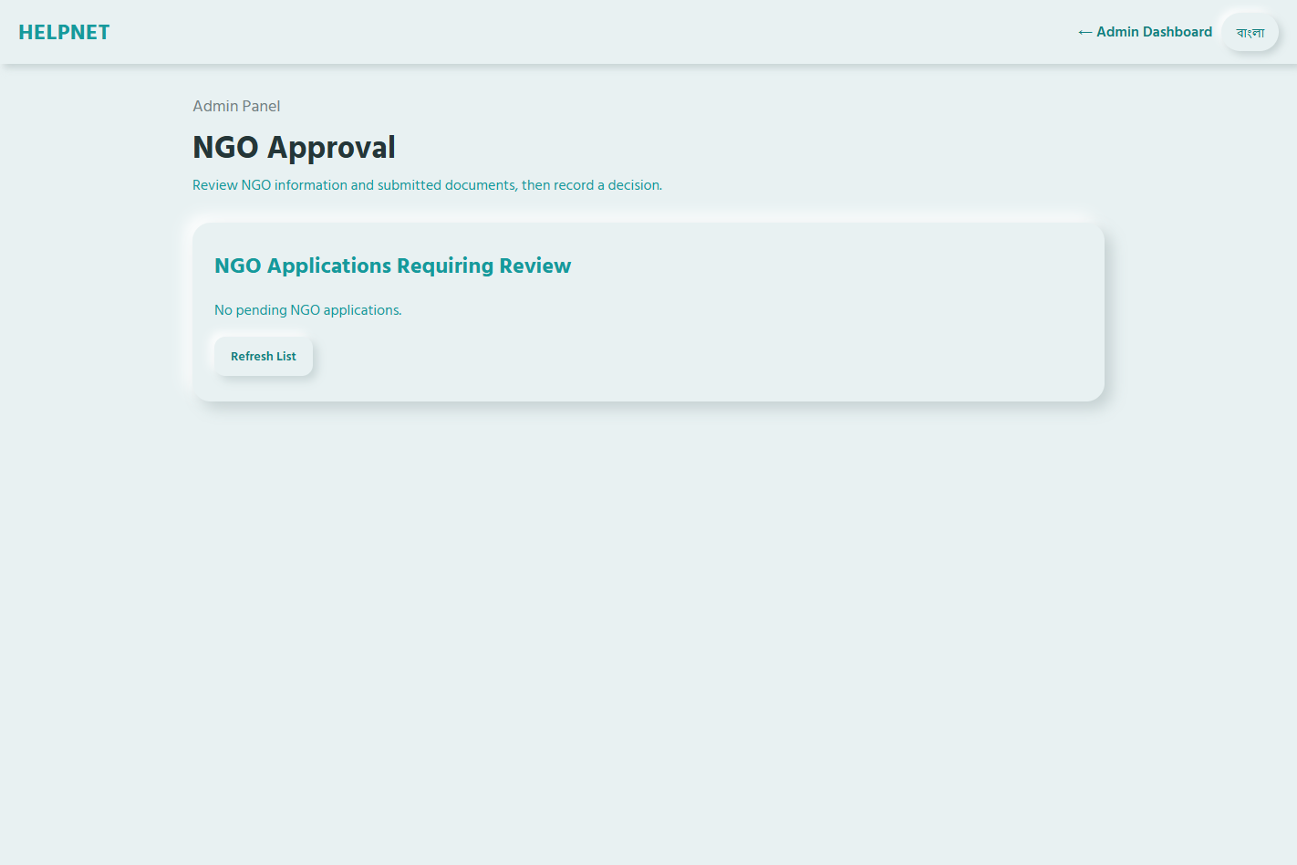
Admin review page evidence.

9. Privacy and troubleshooting
- Do not share private registration certificates or identity documents through public URLs.
- For upload errors, check accepted format and 10 MiB limit.
- If a role-specific action is unavailable, check active profile and its verification status.
- Reactivate an inactive profile in Dashboard → My Profiles; deactivation does not delete the account.
- Only access records allowed to your account or participant role.

10. Limitations
Localization is partial; email reset, production APIs, and media storage depend on deployment configuration. Local test results do not certify production migrations or security configuration.

