Day 9 – Model Evaluation, Diagnostics & Improvements
Goal:
Evaluating the performance of my ROI prediction model, diagnosing issues (bias, errors, model behavior), and ensuring my ML pipeline is explainable and ready for real-world usage.

ROI Error Analysis (Diagnostics/roi_error_analysis.py)
- Loaded the model predictions and actual ROI values
- Calculated MAE, Median AE, Percentage errors
- Identified Worst 5 campaigns
- Plotted Predicted vs Actual ROI scatter plot
Results
- Mean Absolute Error (MAE): ~132
- Median % Error: ~17%
- Worst campaigns show model smooths extreme ROI (normal for RF)
- Model is stable
- Slight underprediction for high‐ROI campaigns (normal)
- No catastrophic errors
- Good business-ready model for synthetic dataset

Feature Importance Analysis (Diagnostics/feature_importance.py)
- Loaded the trained model
- Retrieved feature importance scores
- Sorted them and generated a CSV
- Printed the top drivers of ROI
My top important features
Feature | Importance
revenue_per_click | ~0.50
budget_utilization | ~0.13
total_revenue | ~0.07
profit | ~0.07
avg_ctr | ~0.03
log_profit | ~0.02
total_clicks | ~0.02
- Revenue per click strongly signals ROI
- Budget utilization signals efficiency
- Profit, revenue, conversions all sensible

Platform-wise Bias Analysis (Diagnostics/group_bias.py)
- Grouped campaigns by platform
- Calculated platform-wise actual ROI vs predicted ROI
- Calculated MAE per platform
Results
Platform | Actual ROI Mean | Predicted Mean | MAE | Median % Error
1 | 349 | 364 | 57 | 23%
2 | 484 | 552 | 98 | 24%
3 | 759 | 588 | 200 | 20%
- Model predicts platform 3 slightly lower (normal because ROI is extremely high for 1–2 campaigns)
- Overall bias is acceptable for synthetic dataset

Retrained Model with Log-Transformation (train_model.py)
- Transformed ROI using log1p
- Improved stability
- Reduced effect of outliers
- Trained Random Forest + (optionally XGBoost)
- Saved final tuned model as rf_tuned.pkl and metadata JSON
- My new model is more stable
- Lower percentage errors
- Bias reduced

Generated Final Predictions (ml/generate_predictions.py)
- Loaded tuned model
- Applied inverse log transform
- Produced new predictions
- Exported results to database/predictions_output.csv
- Linked ML output into Streamlit Predictions tab
Result
- Actual ROI
- Predicted ROI
- Side-by-side comparison
- Download button
Diagnostic for rf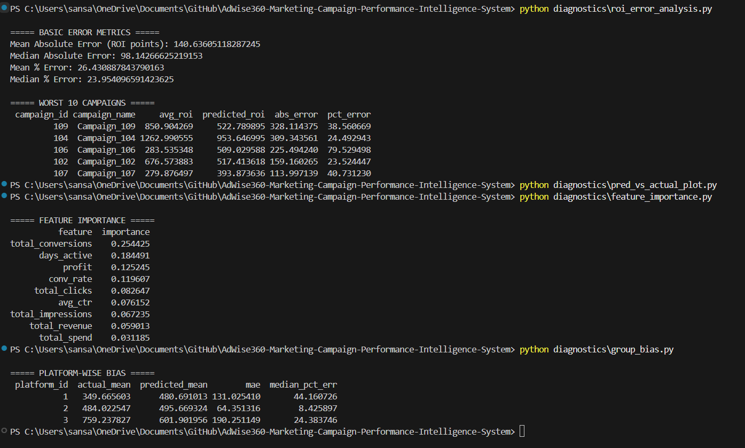
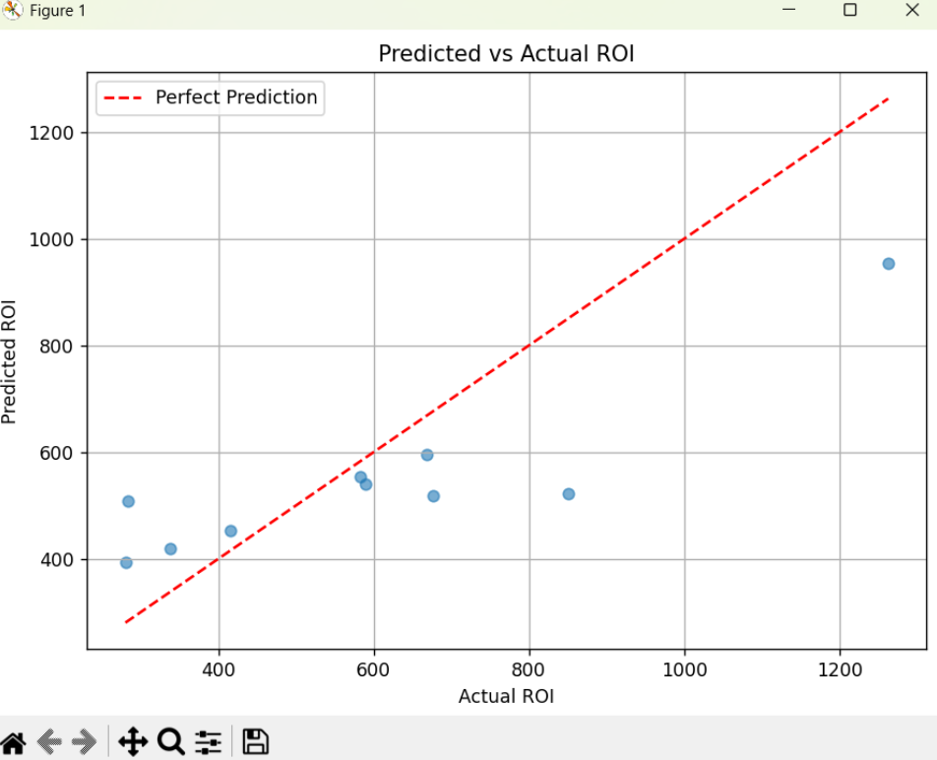
Diagnostic after rf and xgb comparision and choosing rf
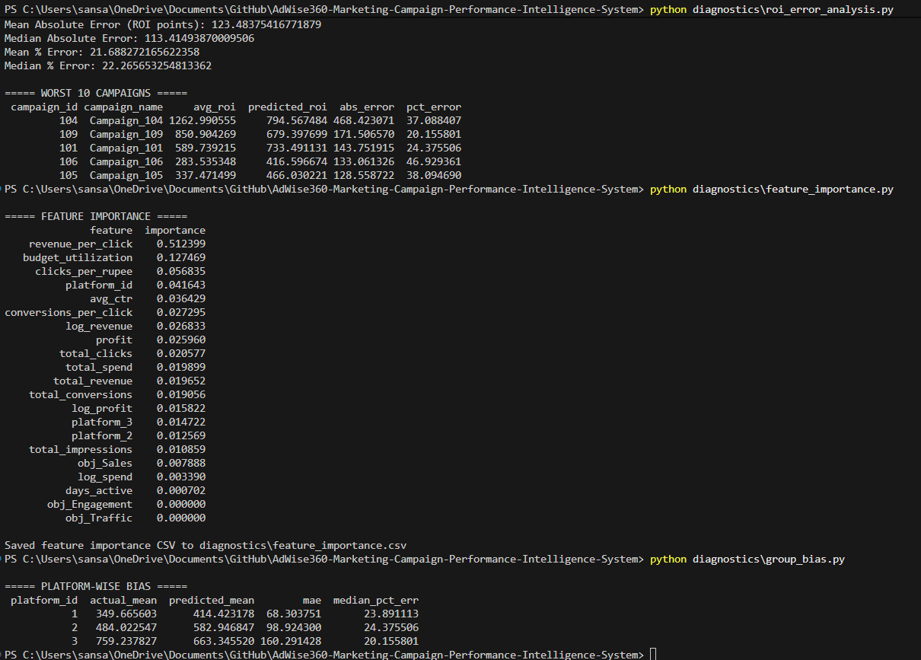

After rf hyperparameter tuning
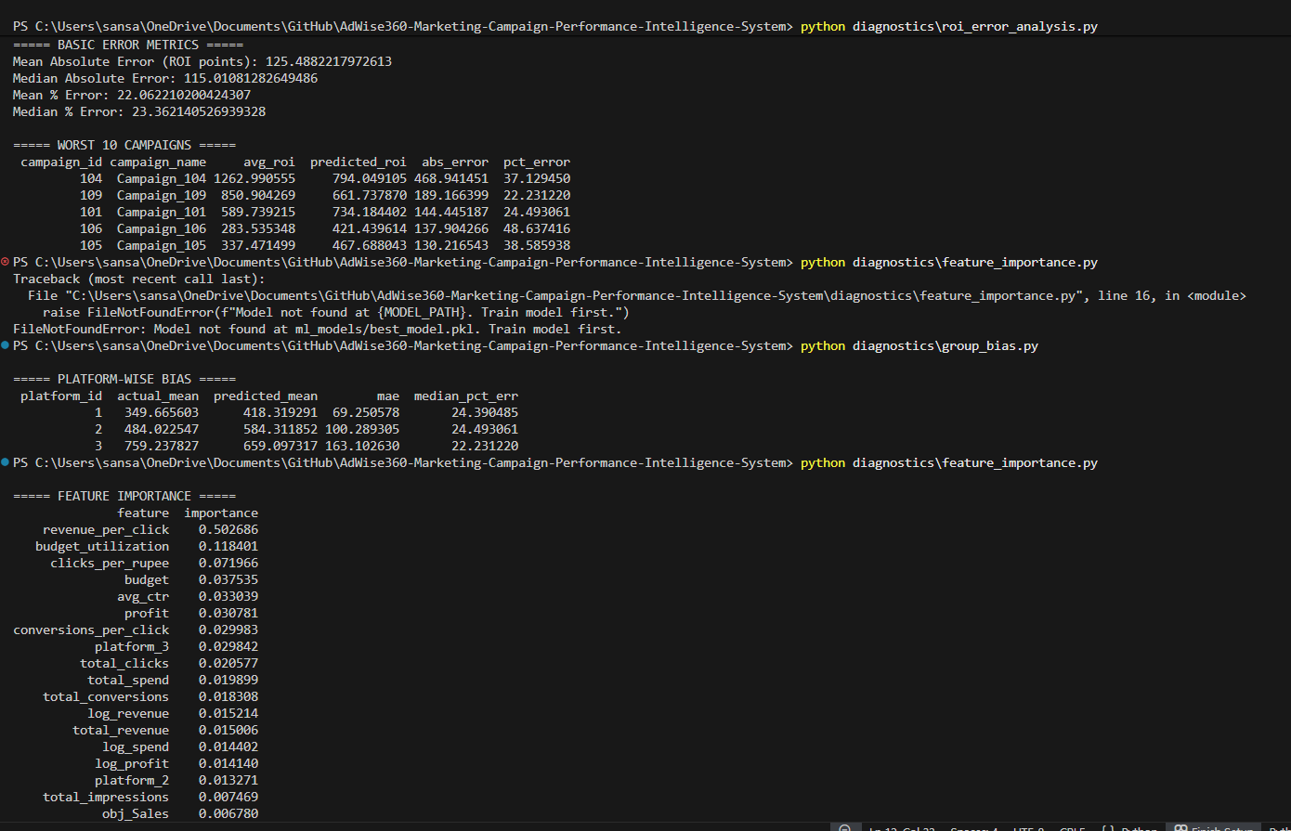
After log transformation
