Practical 9:
Secure User Registration with Database Insert, Duplicate Email Check, and Password Hashing
Problem Definition Implement secure user registration by inserting user details into MySQL using MYSQLi. Validate input on frontend and backend, check duplicate
email/username, hash passwords using password_hash(), and display
appropriate messages.

Theory :

Key Questions / Analysis / Interpretation
1. Is password_hash() used before storing passwords?
Yes. The password_hash() function converts the password into a secure hash before storing it in the MySQL database.
2. Is duplicate email/username checked?
Yes. The SELECT query checks whether the username or email already exists. The UNIQUE constraint in the database also prevents duplicates.
3. Are frontend and backend validations consistent?
Yes. Frontend validation uses HTML attributes like required, minlength, and maxlength. Backend validation uses PHP to check empty fields, username length, email format, and password length. Both validations follow the same rules.
Implementation/out put/result:
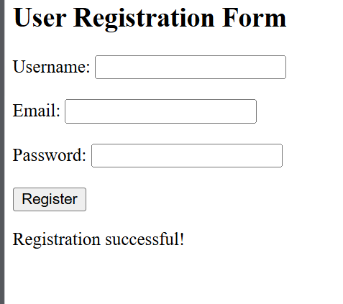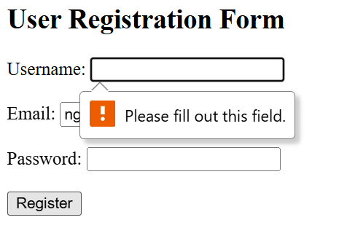

Git hub link:
https://github.com/nidhisavalia/25dce103-web

Learning outcomes:

Learned to create a user registration form using HTML and PHP.
Learned to connect PHP with a MySQL database using MySQ
Learned to validate user input on both the frontend and backend.
Learned to check duplicate usernames and email addresses.
Learned to secure passwords using the password_hash() function.
Learned to insert user details into a database and display appropriate messages.
Faculty remarks:

