**Examples**

**Example 1**

<html>

<body align=center>

    <table border=2 width=400px cellspacing=4 cellpadding=30 rules="all">

        <caption> Sample table</caption>

        <tr cellpadding="30">

            <th rowspan=2 colspan=2 bgcolor="pink" >0</th>

            <th rowspan=2 >1</th>

            <th rowspan=2 >2</th>

            <th rowspan=2 colspan=2 bgcolor="yellow"> 3</th>

        </tr>

        <tr >

        </tr>

        <tr >

            <td colspan=2></td>

            <th rowspan=2 colspan=2 bgcolor="grey">4</th>

            <td colspan=2></td>

        </tr>

        <tr>

            <th rowspan=2 colspan=2 bgcolor="lightblue"> 5</th>

            <th rowspan=2 colspan=2 bgcolor="lightgreen">8</th>

        </tr>

        <tr>

            <th>6</th>

            <th>7</th>

        </tr>

    </table>

</body>

</html>

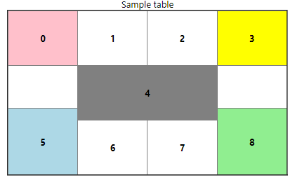

**Example 2**

<svg height="100" width="240" style="border: 1px solid black;">

    <polygon points="0,100,40,50,80,100,80,100,120,50,160,100,160,100,200,50,240,100" fill="brown" stroke="black" stroke-width="3"/>

    <circle cx="160" cy="30" r="20" fill="yellow" stroke="black" stroke-width="3"/>

</svg>

<svg height="140" width="300" style="border: 5px solid black;">

    <rect x="20" y="20" width="250" height="100" fill="white" stroke="black" stroke-width=""/>

    <circle cx="140" cy="70" r="49" fill="#fff" stroke="#000"/>

    <line x1="140" y1="20" x2="140" y2="119" stroke="black"/>

</svg>

<svg height="140" width="300" style="border: 5px solid black;">

    <rect x="20" y="20" width="250" height="100" fill="white" stroke="black" stroke-width=""/>

    <line x1="20" y1="119" x2="270" y2="20" stroke="black"/>

    <line x1="20" y1="20" x2="270" y2="119" stroke="black"/>

</svg>

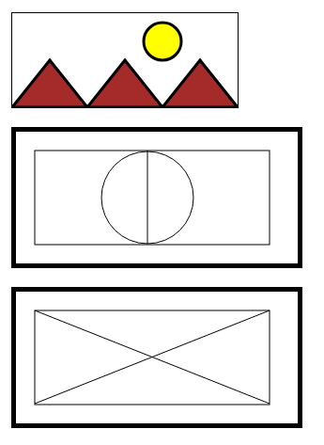

**Example 3**

Design a simple form to register for new user information and use fieldset and legend to differentiate personal details and educational details. Personal Details should contain Full Name, Email, Mobile number, Gender, Birth Date and Hobbies. and Educational Details should contain SSC Percentage, HSC Percentage, Branch(dropdown-CE,IT,CSE,CST,AIML). Add Submit and reset buttons.