**Grid and Table Tasks**

1. **Write a script to create four sections having table coulmn enter random data in table that data should have font size in rem unit. Shrink the width of table to observe the responsive image all four table should be display vertically on sm device(try various class of table).**

<div class="container">

  <div class="row">

    <div class="col-sm-3">

      <div class="table-responsive">

        <table class="table table-striped table-sm table-bordered table-hover table-danger">

          <thead class="thead-dark">

            <tr><th>Roll Number</th><th>Name</th></tr>

          </thead>

          <tr><td>1</td><td>A</td></tr>

          <tr><td>2</td><td>B</td></tr>

          <tr><td>3</td><td>C</td></tr>

        </table>

      </div>

    </div>

    <div class="col-sm-3">

      <div class="table-responsive">

        <table class="table table-striped table-sm table-bordered table-hover table-danger">

          <thead class="thead-dark">

            <tr><th>Roll Number</th><th>Name</th></tr>

          </thead>

          <tr><td>1</td><td>A</td></tr>

          <tr><td>2</td><td>B</td></tr>

          <tr><td>3</td><td>C</td></tr>

        </table>

      </div>

    </div>

    <div class="col-sm-3">

      <div class="table-responsive">

        <table class="table table-striped table-sm table-bordered table-hover table-danger">

          <thead class="thead-dark">

            <tr><th>Roll Number</th><th>Name</th></tr>

          </thead>

          <tr><td>1</td><td>A</td></tr>

          <tr><td>2</td><td>B</td></tr>

          <tr><td>3</td><td>C</td></tr>

        </table>

      </div>

    </div>

    <div class="col-sm-3">

      <div class="table-responsive">

        <table class="table table-striped table-sm table-bordered table-hover table-danger">

          <thead class="thead-dark">

            <tr><th>Roll Number</th><th>Name</th></tr>

          </thead>

          <tr><td>1</td><td>A</td></tr>

          <tr><td>2</td><td>B</td></tr>

          <tr><td>3</td><td>C</td></tr>

        </table>

      </div>

    </div>

  </div>

</div>

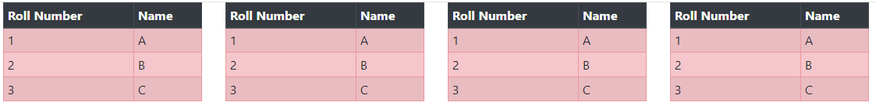

1. **Write a script to create two sections having table column enter random data in table that data should have font size in rem unit. Shrink the width of table to observe the responsive image of all tables should be display vertically on sm device, compulsory using classes of tables.**

<div class="container">

  <div class="row">

    <div class="col-sm-6">

      <div class="table-responsive">

        <table class="table table-striped table-sm table-bordered table-hover table-danger">

          <thead class="thead-dark">

            <tr><th>Roll Number</th><th>Name</th></tr>

          </thead>

          <tr><td>1</td><td>A</td></tr>

          <tr><td>2</td><td>B</td></tr>

          <tr><td>3</td><td>C</td></tr>

        </table>

      </div>

    </div>

    <div class="col-sm-6">

      <div class="table-responsive">

        <table class="table table-striped table-sm table-bordered table-hover table-danger">

          <thead class="thead-dark">

            <tr><th>Roll Number</th><th>Name</th></tr>

          </thead>

          <tr><td>1</td><td>A</td></tr>

          <tr><td>2</td><td>B</td></tr>

          <tr><td>3</td><td>C</td></tr>

        </table>

      </div>

    </div>

  </div>

  </div>

</div>

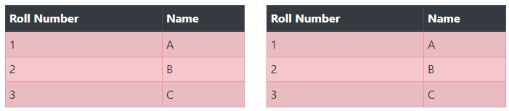

1. **Write html/css script using bootstrap to take four sections using div. first section has text related componets like paragarph abbr and pre tag.second section has a table having three rows first is lowercase , second upeercase and third capitalize. third div has simple direct case in justify manner and last div has blockquote all div width are 25%.**

  <div class="container">

    <div class="row">

      <div class="col-md-3">

        <p>Lorem ipsum dolor, sit amet consectetur adipisicing elit.</p>

        <pre>

            hi

            hello

                what is your name?

        </pre>

        <abbr title="How are you?">Hello</abbr>

      </div>

      <div class="col-md-3">

        <div class="table-responsive">

          <table class="table table-striped table-sm table-bordered table-hover table-danger">

            <thead class="thead-dark">

              <tr><th>Table Data</th></tr>

            </thead>

            <tr><td class="text-lowercase">HelLOOOoo!</td></tr>

            <tr><td class="text-uppercase">how are you?</td></tr>

            <tr><td class="text-capitalize">this is ab example</td></tr>

          </table>

        </div>

      </div>

      <div class="col-md-3 text-justify">

        Lorem ipsum dolor sit amet consectetur adipisicing elit. Sunt ea officiis sapiente quam a omnis, totam sed voluptatem dolore necessitatibus quidem eligendi explicabo facere et recusandae quibusdam numquam laborum. Quod.</p>

      </div>

      <div class="col-md-3">

        <blockquote class="blockquote">

            ‘उठो, जागो और तब तक मत रुको जब तक मंजिल मिल न जाए’

        </blockquote>

        <p class="blockquote-footer">Swami Vivekanand</p>

      </div>

    </div>

  </div>

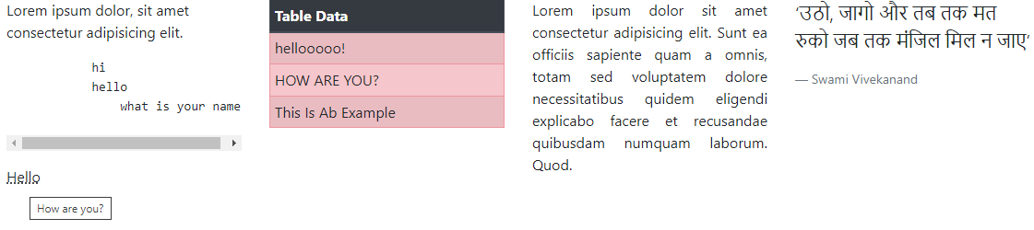

1. **Write a script to create four sections having table coulmn. Enter random data in table. Table should have different color classes for different rows. Shrink the width of table to observe the responsive image all four table should be display vertically on sm device(try various class of table).**

<div class="container">

    <div class="row">

      <div class="col-sm-3">

        <div class="table-responsive">

          <table class="table table-bordered table-hover">

            <thead class="thead-dark">

              <tr><th>Roll Number</th><th>Name</th></tr>

            </thead>

            <tr class="table-warning"><td>1</td><td>A</td></tr>

            <tr class="table-info"><td>2</td><td>B</td></tr>

            <tr class="table-danger"><td>3</td><td>C</td></tr>

          </table>

        </div>

      </div>

      <div class="col-sm-3">

        <div class="table-responsive">

          <table class="table table-bordered table-hover">

            <thead class="thead-dark">

              <tr><th>Roll Number</th><th>Name</th></tr>

            </thead>

            <tr class="table-warning"><td>1</td><td>A</td></tr>

            <tr class="table-info"><td>2</td><td>B</td></tr>

            <tr class="table-danger"><td>3</td><td>C</td></tr>

          </table>

        </div>

      </div>

      <div class="col-sm-3">

        <div class="table-responsive">

          <table class="table table-striped table-bordered ">

            <thead class="thead-dark">

              <tr><th>Roll Number</th><th>Name</th></tr>

            </thead>

            <tr class="table-warning"><td>1</td><td>A</td></tr>

            <tr class="table-info"><td>2</td><td>B</td></tr>

            <tr class="table-danger"><td>3</td><td>C</td></tr>

          </table>

        </div>

      </div>

      <div class="col-sm-3">

        <div class="table-responsive">

          <table class="table table-bordered table-hover">

            <thead class="thead-dark">

              <tr><th>Roll Number</th><th>Name</th></tr>

            </thead>

            <tr class="table-warning"><td>1</td><td>A</td></tr>

            <tr class="table-info"><td>2</td><td>B</td></tr>

            <tr class="table-danger"><td>3</td><td>C</td></tr>

          </table>

        </div>

      </div>

    </div>

  </div>

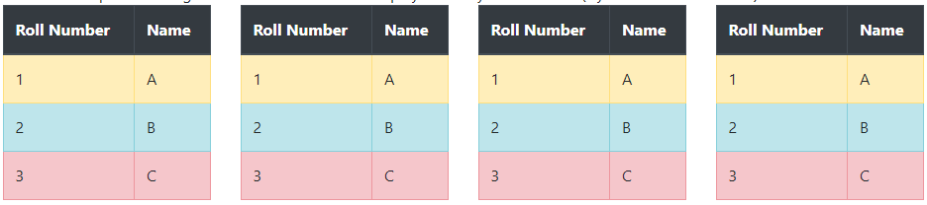

1. **Write HTML/CSS script using bootstrap to set four images of some product horizontally and show their price, features and available quantity in grid system, responsive effect must be observed.**
2. **Write a script to design 2 sections horizontally in a row. One section is having a title and paragraph, 2nd section has a definition list of 3 things. Sections should be arranged vertically on reducing width <1400px.**
3. **Write html/css script using bootstrap to take two sections using div. Use any three typography classes in 1st section. Second section has a table. Observe responsive concepts and use table oriented classes in 2nd section.**
4. **Write html/css script using bootstrap to set four images of some product horizonatlly and show their price , features and available quntity in grid system, responsive effect must be observed. Sections should be responsive by shrinking width of 1400px.**
5. **Write html/css script using bootstrap to create three sections using div tag first section as heading and second section as its description and third section has respective links to search that image. Show responsive web page concepts.**
6. **Write bootstrap script to have two sections of image and image description, left div description and right div should have photo. give appropriate partition classes and observe responsive concepts.**
7. **Write html/css script using bootstrap to create two sections using div tag first section as heading and second section as its description. Heading should be center align and description should be left align in that section includes responsive web page concepts.**
8. **Design one web-page for “online-shopping of beauty products”. Use Bootstrap concept for display images of different beauty products in proper alignment.**

**Modal Tasks**

1. **Write a script to pop up a dialog box on clicking a button. Dialog box must have a title, a message of “Submitted successfully”, X button in header to close dialog and one separate “Close” button in footer to close it.**
2. **Design a following form using bootstrap. Once user click on a submit button one dialog box should open with confirmation message like “Do you want to login?” with close button. Dialog box contain header, body & footer part.**

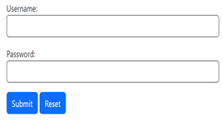

<div class="container">

**<form action="#">**

        UserName:

        <input type="text" class="form-control mb-3"/>

        Password:

        <input type="password" class="form-control"/>

**<button class="btn btn-primary mt-3" data-bs-toggle="modal" data-bs-target="#m1">Submit</button>**

        <input type="reset" class="btn btn-primary mt-3">

**<div class="modal" id="m1">**

            <div class="modal-dialog">

              <div class="modal-content">

                <!-- Modal Header -->

                <div class="modal-header">

                  <h4 class="modal-title">Modal Heading</h4>

                  <button type="button" class="btn-close" data-bs-dismiss="modal"></button>

                </div>

                <!-- Modal body -->

                <div class="modal-body">

                    Do you want to login?

                </div>

                <!-- Modal footer -->

                <div class="modal-footer">

                  <button type="button" class="btn btn-danger" data-bs-dismiss="modal">Close</button>

                </div>

              </div>

            </div>

**</div>**

**</form>**

</div>

**Accordion Tasks**

1. **Write an HTML script using bootstrap to design a page of newspaper having three articles by showing only titles initially. Script should enable a render to open a particular article viewing and clicking its title and close it by clicking it again. If render opens any other article, then previous article should disappear.**
2. **Write an HTML script using bootstrap to design a page of essay having three titles by showing only titles initially. Script should enable a render to open a particular essay by viewing and clicking its title and close it by clicking it again.if render opens any other title then previous title should disappear.**

**Progress bar Tasks**

1. **Write a script using HTML/CSS using Bootstrap to create two sections of 30% and 70% width. First section has parameters with different color indications and show progress-bar in specific color only with random progress.**
2. **Write a script using HTML/CSS an bootstrap to create two section 30% and 70% width. First section has parameters with different color indications and show progress-bar in specific color only with random progress. All progress bars should have animated effects.**

  <div class="container">

        <div class="row m-4">

**<div class="col-sm-3 border border-dark p-2">**

                <div class="progress bg-success rounded" style="width:15%;"> </div>WhatsAPP

                <div class="progress bg-danger rounded" style="width:15%;"> </div>Instagram

                <div class="progress bg-warning rounded" style="width:15%;"> </div>Facebook

**</div>**

**<div class="col-sm-9 border border-dark p-2">**

                <div class="progress mb-4">

                    <div class="progress-bar bg-success progress-bar-striped progress-bar-animated" style="width:30%">30%</div>

                </div>

                <div class="progress mb-4">

                    <div class="progress-bar bg-danger progress-bar-striped progress-bar-animated" style="width:20%">20% </div>

                </div>

                <div class="progress">

                    <div class="progress-bar bg-warning progress-bar-striped progress-bar-animated" style="width:40%">40%</div>

                </div>

**</div>**

        </div>

    </div>

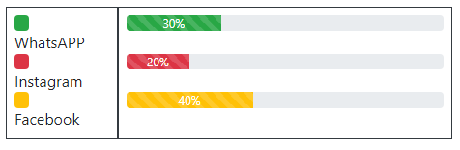

**Carousel Tasks**

1. **Design a web page with Bootstrap to make a set of advertisements moving like a slide show. It must have buttons to jump on next/previous slides and to jump on random slides.**
2. **Write an HTML using bootstrap-5 to make a set of a slide show of any three random images with buttons having a caption. It must have buttons to jump on next/previous slides also.**

**Form Tasks**

**Design a form with following fields:  
Username, password, Address, Gender, Address, toggle switch also validates the form before submitting the form and each and every field is mandatory.**

**Nav and Navbar Tasks**

1. **Write a Script using bootstrap to create a navbar in which ,When we click on the link it automatically scrolls down to the currently active element.**
2. **Write a HTML script using bootstrap to render a responsive navigation of links,which shows an additional icon,if width of device goes<992px and navigation items should disappear.**
3. **Write an HTML using bootstrap-5 to create navigation bar of two nav items in which navigation items should be displayed in tab form and when user clicks on a navigation item then content associated with that navigation link will be displayed.**
4. **Write an HTML using bootstrap-5 to create navigation bar in which all navigation item should be displayed in pill form and when user clicks on a navigation item then content associated with that navigation link will be displayed**
5. **Write an HTML using bootstrap-5 to create navigation link in which all navigation item should be displayed in dynamic and toggleable tabs form and when user clicks on a navigation item then content associated with that navigation link will be displayed.**
6. **Write an HTML code using bootstrap-5 to create a navbar in which one of the navigation item has dropdown menu**

**Collapse**

**Write bootstrap to create a simple collapse button and open/close one section of paragraph by clicking that button.**