**Chapter 2**

* + **Define keywords for search engines:**

<meta name="keywords" content="HTML, CSS, JavaScript">

* + **Define a description of your web page:**

<meta name="description" content="Web tutorials for HTML">

* + **Define the author of a page:**

<meta name="author" content="LJU">

* + **Set the viewport to make your website responsive and look good on all devices:**

<meta **name="viewport"** content="width=device-width, initial-scale=1.0">

* + **Refresh: Defines a time interval for the document to refresh itself.**

<meta **http-equiv**="**refresh**" content="300">

* **HTML Comments**

**<!-- Write your comments here -->**

# HTML Headings

# HTML headings are titles or subtitles that you want to display on a webpage.

# <h1>Heading 1</h1> <h2>Heading 2</h2> <h3>Heading 3</h3> <h4>Heading 4</h4> <h5>Heading 5</h5> <h6>Heading 6</h6>

## **The HTML <pre> tag and <p> tag**

**Example**

**<!-- Example with <pre> -->**

<pre>

This is preformatted

text, with line breaks

and extra spaces retained.

</pre>

**<!-- Example with <p> -->**

<p>

This is paragraph text,

with line breaks and extra spaces

ignored.

</p>

**Output:**

This is preformatted

text, with line breaks

and extra spaces retained.

This is paragraph text, with line breaks and extra spaces ignored.

# Data Formatting tags

1. **<b>:** Defines bold text
2. **<strong>:** The HTML <strong> element defines text with strong importance. The content inside is typically displayed in bold.

In summary, use <b> for purely stylistic bolding and <strong> when the text has more importance or needs to be semantically emphasized.

1. **<i>:** The content inside is displayed in *italic*.
2. **<em>:** It is also one of the element of HTML used in formatting texts. It is used to define emphasized text or statements. The content inside is displayed in *italic*.

**Note:**

Despite the fact that both <em> and <i> tags give the same visual effect, i.e. italic text, search engine robots pay more attention to the first one. That’s why it is recommended to use the <**em>** tag for **website optimization**.  <em> tag informs Google crawlers that the selected content is particularly important and deserves attention.

Same for the <**strong**> and <**b**> tags. Both tags give the same visual effect, but <**strong**> tag informs Google crawlers that the selected content is particularly important and deserves attention.

1. **<font>:** The <font> tag in HTML plays an important role in the web page to create an attractive and readable web page. The font tag is used to change the color, size, and style of a text. The base font tag is used to set all the text to the same size, color and face.

**Default size = 3, Range of size = 1 to 7**

# <body>

# <font size="5" face="Comic sans MS" color="green"> Welcome to LJU </font>

# </body>

# Output: Welcome to LJU

1. **<u>:** If you write anything within <u>.........</u> element, is shown in underlined text.
2. **<ins>:** The <ins> tag defines a text that has been inserted into a document. Browsers will usually underline inserted text.
3. **<del>:** The <del> tag defines text that has been deleted from a document. Browsers will usually strike a line through deleted text.

**Example:**

<h1>My favorite color is <del>blue</del> <ins>red</ins>!</h1>

**Output:**

D:\NAS\sem3\notes\HTML\ins.png

**Note: <u>** is purely for **visual underlining** without meaning. **<ins>** is for **indicating added or inserted content**, with underlining being the default style. In modern web development, it’s generally better to use semantic tags like <ins> when conveying meaning and <u> only when you want underlining purely for design.

1. **<hr>: Horizontal Rule.** The <hr> element is most often displayed as a horizontal rule that is used to separate content in an HTML page.

|  |  |  |
| --- | --- | --- |
| **Attribute** | **Value** | **Description** |
| [align](https://www.geeksforgeeks.org/html-hr-align-attribute/) | left center right | Used to specify the alignment of the horizontal rule.  Default is center. |
| [noshade](https://www.geeksforgeeks.org/html-hr-noshade-attribute/) | noshade | Used to specify the bar without shading effect. |
| [size](https://www.geeksforgeeks.org/html-hr-size-attribute/) | pixels | Used to specify the height of the horizontal rule. |
| [width](https://www.geeksforgeeks.org/html-hr-width-attribute/) | Pixels/percentage | Used to specify the width of the horizontal rule. |

  <h3>Textt1</h3>

    <hr size="10" width="40%">

    <h3>Textt2</h3>

    <hr size="20" width="50%" noshade align="right">

    <h3>Textt3</h3>

    <hr size="2">

**Output:**

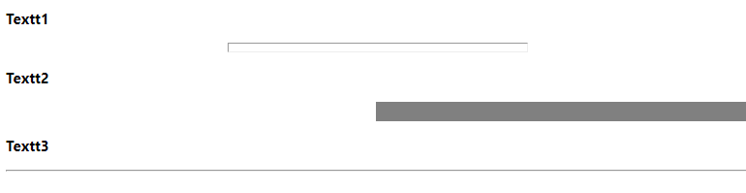

1. **<br>:**

* The <br> tag inserts a single line break.
* This tag is an empty tag which means that it has no end tag.

<body>

<p>This is sample example</p>

<p>This is <br> sample example</p>

</body>

**Output:**

This is sample example

This is  
sample example

1. **<center>: Not Supported in HTML5.** The <center> tag was used in HTML4 to align text in center.
2. **<sup>:**  The <sup> tag is used to add a superscript text to the HTML document.

 <h3>2<sup>2</sup> + 5<sup>2</sup> = 29</h3>

**Output:**

### **22 + 52 = 29**

1. **<sub>:** The <sub> tag is used to add a subscript text to the HTML document.

<h4>CH<sub>3</sub></h4>

<h4>H<sub>2</sub>SO<sub>4</sub></h4>

**Output:**

#### **CH3**

#### **H2SO4**

1. **<mark>:** The <mark> tag defines text that should be marked or highlighted.

<h1>This is <mark>Highlighted text!!</mark></h1>

**Output:**

D:\NAS\sem3\notes\HTML\ins.png

1. **<small>:**The <small> tag defines smaller text (like copyright and other side-comments).

**Tip:** This tag is not deprecated, but it is possible to achieve richer (or the same) effect with CSS.

1. **<big>: Not Supported in HTML5.** The <big> tag was used to define bigger text.

**Example:**

   <p>This is a normal paragraph.</p>

   <p><small>This is a normal paragraph.</small></p>

   <p><big>This is a normal paragraph.</big></p>

**Output:**

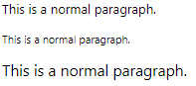

* **HTML Link: Anchor tag (<a>)**

Defines a hyperlink, which is used to link from one page to another. The most important attribute of the <a> element is the href attribute, which indicates the link's destination.

# Attributes:

* **href:** Specifies the URL of the page the link goes to
* **target:** Specifies where to open the linked document

<a href=”url” target="_blank | _self | _parent | _top " name=”a_link”>Test</a>

_blank = Opens the linked document in a new window or tab

_self = Opens the linked document in the same frame as it was clicked (this is default)

_parent = Opens the linked document in the parent frame

_top = Opens the linked document in the full body of the window

<a **href**=”https://www.example.com” **target**=”_blank”>Click here</a>

* **Images: <img> tag**

The <img> tag is used to embed an image in an HTML page. Images are not technically inserted into a web page; images are linked to web pages. The <img> tag creates a holding space for the referenced image.

<img **src**="1.png" **width**="50" **height**="30" **alt**="test" **align**="right" **border**=”5”>

# HTML Lists:

**There are two types of lists:**

* 1. **Unordered list:** An unordered list starts with the <ul> tag. Each list item starts with the <li> tag. The list items will be marked with disc (small black circles) by default.

# Attribute:

**type:** type = ” disc/square/circle/none”

   <ul>

            <li>Test 1</li>

            <li>Test 2</li>

            <ul type="square">

                <li>Test 3</li>

                <li>Test 4</li>

            </ul>

        </ul>

**Output:**

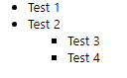

**type="disc"**:

Items are marked with **filled circles** as bullet points. This is default.

● Item 1

● Item 2

● Item 3

**type="square"**:

Items are marked with **squares**.

■ Item 1

■ Item 2

■ Item 3

**type="circle"**:

Items are marked with **hollow circles**.

⚪ Item 1

⚪ Item 2

⚪ Item 3

**type="none":**

No bullet points are shown for the list items.

Item 1

Item 2

Item 3

* 1. **Ordered list:** An ordered list starts with the <ol> tag. Each list item starts with the <li> tag. The list items will be marked with numbers by default:

# Attribute:

**type:** type=” 1/ i/ I/ a/ A”

**start:** Specifies the start value of an ordered list

**reversed:** Specifies that the list order should be reversed (9,8,7...)

     <ol start="5">

            <li>Test 1</li>

            <li>Test 2</li>

            <li>Test 3</li>

            <ol type="A">

                <li>Test 4</li>

                <li>Test 5</li>

                <ol reversed type="i">

                    <li>Test 6</li>

                    <li>Test 6</li>

                </ol>

            </ol>

        </ol>

**Output:**

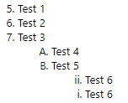

**For type ‘a’ 27,28,29.. letters are aa,ab,ac… respectively.**

* **HTML Definition List:**

The <dl> tag defines a description list. The <dl> tag is used in conjunction with

<dt> (defines terms/names/title) and <dd> (describes each term/name/data).

<dl> : definition list

<dt> : definition term

<dd> : definition detail

* **HTML Table:**
* The <table> tag defines an HTML table.
* An HTML table consists of one <table> element and one or more [<tr>](https://www.w3schools.com/tags/tag_tr.asp), [<th>](https://www.w3schools.com/tags/tag_th.asp), and [<td>](https://www.w3schools.com/tags/tag_td.asp) elements.
* The <tr> element defines a table row, the <th> element defines a table header, and the <td> element defines a table cell.
* An HTML table may also include [<caption>](https://www.w3schools.com/tags/tag_caption.asp), [<thead>](https://www.w3schools.com/tags/tag_thead.asp), [<tfoot>](https://www.w3schools.com/tags/tag_tfoot.asp), and [<tbody>](https://www.w3schools.com/tags/tag_tbody.asp) elements.

# Tags for table:

|  |  |
| --- | --- |
| <caption> | The <caption> tag defines a table caption. |
| <table> | Defines a table. |
| <th> | Defines a header cell in a table |
| <tr> | Defines a row in a table |
| <td> | Defines a cell in a table |
| <thead> | Groups the header content in a table |
| <tbody> | Groups the body content in a table |
| <tfoot> | Groups the footer content in a table |

**HTML <table> tag attributes:**

|  |  |  |
| --- | --- | --- |
| **Attribute** | **Value** | **Description** |
| align | right  left center justify char | Deprecated − Visual alignment. |
| bgcolor | rgb(x,x,x) #hexcode colorname | Deprecated − Specifies the background color of the table. |
| border | pixels | Deprecated − Specifies the border width. A value of "0" means no border. |
| cellpadding | pixels or % | Deprecated − Specifies the space between the cell borders and their contents. |
| cellspacing | pixels or % | Deprecated − Specifies the space between cells. |
| rules | none groups rows cols all | Deprecated − The **HTML <table> rules Attribute** is used to *specify which parts of the inside borders that should be visible*. |
| width | pixels or % | Deprecated − Specifies the width of the table. |

# <td><th><tr> tags attributes:

|  |  |  |
| --- | --- | --- |
| **Attribute** | **Value** | **Description** |
| **align** | right  left center justify char | Deprecated − Visual alignment. |
| **bgcolor** | rgb(x,x,x) #hexcode colorname | Deprecated − Specifies the background color of the cell. |
| **colspan** | Number of columns to merge | Number of columns a header cell should span |
| **rowspan** | Number of rows to merge | Set the number of rows a header cell should span. |

**Example 1:**

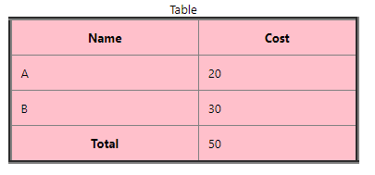

<table border="4" cellpadding="10" rules="all" bgcolor="pink" width="50%" align="center">

          <caption>Table</caption>

          <thead>

            <tr>

              <th>Name</th>

              <th>Cost</th>

            </tr>

          </thead>

          <tbody>

            <tr>

              <td>A</td>

              <td>20</td>

            </tr>

            <tr>

              <td>B</td>

              <td>30</td>

            </tr>

          </tbody>

          <tfoot>

            <tr>

              <th>Total</th>

              <td>50</td>

            </tr>

          </tfoot>

        </table>

**Example 2**

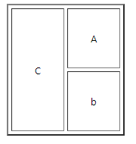

  <table border="2" cellspacing="4" cellpadding="30">

          <tr>

            <td rowspan="2">C</td>

            <td>A</td>

          </tr>

          <tr>

            <td>b</td>

          </tr>

        </table>

**Example3:**

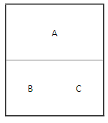

<table border="2" **rules="rows"** cellpadding="30">

          <tr>

            <td colspan="2" align="center">A</td>

          </tr>

          <tr>

            <td>B</td>

            <td>C</td>

          </tr>

</table>

* **HTML Frame:**
* HTML frames are used to divide your browser window into multiple sections where each section can load a separate HTML document.
* A collection of frames in the browser window is known as a frameset.
* The window is divided into frames in a similar way the tables are organized: into rows and columns.

The <frame> tag has been **deprecated in HTML5** and should no longer be used in modern web development. In older versions of HTML (like HTML4), if you use <frameset> to define a layout with frames, the **main HTML page should not include a <body> tag**. If you include the <body> tag, it will ignore the <frameset> and only display the content inside the <body> tag.

**Here's a simple frame document:**

<!DOCTYPE HTML>

<HTML>

<HEAD>

<TITLE>A simple frameset document</TITLE>

</HEAD>

<FRAMESET **cols**="20%, 80%">

<FRAMESET **rows**="10%, *">

<FRAME src="frame1.html">

<FRAME src="frame2.gif">

</FRAMESET>

<FRAME src="frame3.html">

</FRAMESET>

</HTML>

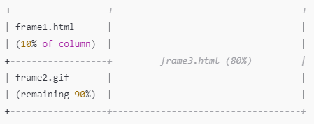

The page is split into two main **columns**:

* The left column occupies **20%** of the page width and is further split into **two rows**:
  + The top row (10% height) displays the content of frame1.html.
  + The bottom row (remaining height) displays the image frame2.gif.
* The right column occupies **80%** of the page width and displays the content of frame3.html.
* **HTML Forms <form>:**

**Optgroup and selected,hidden,disabled example**

<select name="degree_branch">

    <option value="select" **selected disabled**> Select Branch</option>

    <optgroup label="Computer">

        <option value="cse"> CSE </option>

        <option value="cst"> CST </option>

        <option value="ce"> CE </option>

        <option value="it"> IT </option>

    </optgroup>

    <optgroup label="Other">

        <option value="ec"> EC </option>

        <option value="civil"> Civil </option>

        <option value="Mech"> Mechanical </option>

    </optgroup>

</select>

**Selected attribute keeps the option selected at first time we load the web page.**

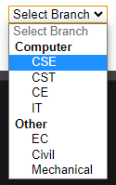

**Disabled attribute disables the option. We cannot select the disabled option.**

<select name="degree_branch">

    <option value="select" **selected hidden**> Select Branch</option>

    <optgroup label="Computer">

        <option value="cse"> CSE </option>

        <option value="cst"> CST </option>

        <option value="ce"> CE </option>

        <option value="it"> IT </option>

    </optgroup>

    <optgroup label="Other">

        <option value="ec"> EC </option>

      <option value="civil"> Civil </option>

        <option value="Mech"> Mechanical </option>

    </optgroup>

</select>

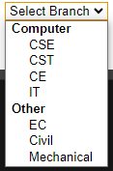

**Hidden attribute hides the option.**

**Example**

    <form method="get" action="n1.html" align="left">

        <fieldset>

            <legend align="left"> Sign-Up</legend>

            <label **for="uname"**> User Name <input **id="uname"** type="**text**" **placeholder="Username" name="uname"** autofocus autocomplete **required**/> </label>

            <label for="pass"> Password <input type="**password**" id = "pass" **maxlength="8" minlength="3"** value="123" disabled/> </label> <br/><br/>

            <label> Your Email ID <input type="**email**" value="email" readonly placeholder="this is readonly field" /> </label>  <br/><br/>

            <label >Age:<input type="**range**" id="age" name="age" min="20" max="70" step="2"></label><br/><br/>

            <label for="age">age <input type="**number**" id="age" name="number" min="10" max="20" ></label><br><br>

            <label> Gender <input type="**radio**" **checked** **name="gender"** **value="male"**/> Male </label>

            <label><input type="**radio**" **name="gender"** **value="female"**/> Female </label> <br/><br/>

           <label> Subjects</label>

<input type="**checkbox**" **name=”subject” value="DS"**/> DS

           <input type="**checkbox**" **name=”subject”** **value="DBMS"** /> DBMS

           <input type="**checkbox**" **name=”subject” value="CN"**/> CN

           <input type="**checkbox**" **name=”subject” value="FSD"**/> FSD <br/><br/>

            <label>DOB <input type="**date**" name="dob" **min="2023-10-01"** > <!--  yyyy-mm-dd  --></label><br><br>

            <label for="s1">search <input type="**search**" name="s" id="s1"></label><br><br>

            <label> Department </label>

            <**select** **name**="department">

                <**option** value=" "   **selected hidden**> Select Department</option>

                <**optgroup** **label="CE"**>

                    <**option**> CSE </option>

                    <**option**> CST </option>

                    <**option**> CSD </option>

                    <**option** **disabled**> RAI </option>

                </**optgroup**>

                <**optgroup** **label="Mech"**>

                    <**option**> CAD </option>

                    <**option**> CAM </option>

                    <**option**> Thermal </option>

                </**optgroup**>

            </**select**> <br/><br/>

        <label> Address  <**textarea** name="addr" **rows="6" cols="20"**>Enter Your Address</**textarea**> </label><br/><br/>

        <label> Upload CV <input type="**file**" name="f1" **multiple**/></label> <br/><br/>

        <input type="**image**" src="submit.jpg" alt="Photo" width="150" height="100"><br/><br/>

        <input type="submit" value="Click Me"/>

        <input type="button" value="button submit"><br/><br/>

        <input type="reset" value="Reset"/>

        </fieldset>

    </form>

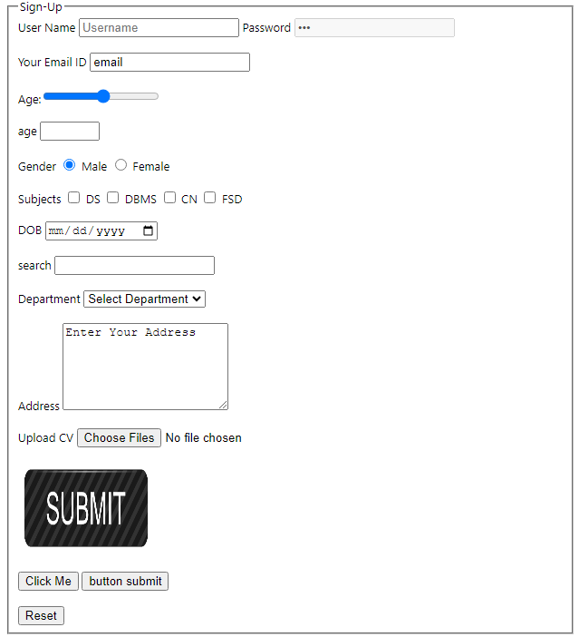

* **HTML Block and Inline Elements**

Every HTML element has a default display value, depending on what type of element it is.

There are two display values: block and inline.

**Block-level Elements**

* A block-level element always starts on a new line, and the browsers automatically add some space (a margin) before and after the element.
* A block-level element always takes up the full width available (stretches out to the left and right as far as it can).
* Two commonly used block elements are: **<p> and <div>**.
* The <p> element defines a paragraph in an HTML document.
* The <div> element defines a division or a section in an HTML document.
* Other examples are <ul>,<pre>,<li>,<ol>,<section>,<dl>,<dd>,<dt> etc

**Inline Elements**

* An inline element does not start on a new line.
* An inline element only takes up as much width as necessary.
* For an example **<span>** element inside a paragraph.
* Other examples are <a>,<b>,<i>,<sup>,<sub> etc

**Chapter 3**

***New Semantic elements added***

Semantic Elements: Semantic elements have meaningful names which tells about type of content. For example, header, footer, table, … etc. HTML5 introduces many semantic elements as mentioned below which make the code easier to write and understand for the developer as well as instructs the browser on how to treat them.

• article

• aside

• footer

• header

• nav

• section

**<iframe>**

<iframe **src**=”[**https://www.youtube.com/embed/LXb3EKWsInQ?playlist=2_kAzyaX7SU,oHdecbMrcbI,LXb3EKWsInQ,kVxTrhojpFI&loop=1&autoplay=1&mute=1&controls=0**](https://www.youtube.com/embed/LXb3EKWsInQ?playlist=2_kAzyaX7SU,oHdecbMrcbI,LXb3EKWsInQ,kVxTrhojpFI&loop=1&autoplay=1&mute=1&controls=0)**” title="YouTubevideo playlist" allowfullscreen>**

</iframe>

**<audio>**

<audio **controls loop autoplay muted**>

<source **src**="a1.mp3" type="audio/mp3">

Your browser does not support the video tag.

</audio>

**<video>**

<video **width="320" height="240" loop autoplay muted controls**>

<source **src**="v1.mp4" **type**="video/mp4">

<source **src**="v1.ogg" **type**="video/ogg">

Your browser does not support the video tag.

</video>

## SVG Line - <line>

    <svg height="250" width="500" >

        <line **x1="100" y1="10" x2="200" y2="200"** stroke=rgb(0,230,255) stroke-width="3"></line>

        <line **x1="300" y1="50" x2="40" y2="220"** stroke=red stroke-width="3"/>

    </svg>

## SVG Circle

## <svg height="100" width="100" style="border:1px solid black">   <circle cx="50" cy="50" r="40" stroke="black" stroke-width="3" fill="red" /> </svg>

## SVG Rectangle - <rect>

<svg width="250" height="180" style="border:3px solid purple">  
  <rect x="50" y="20" **rx="20" ry="20"** width="150" height="150" stroke="black" stroke-width="3" fill="red"/>  
</svg>

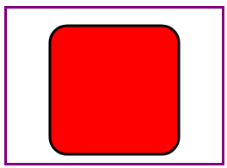

* The rx and the ry attributes rounds the corners of the rectangle

## SVG Ellipse - <ellipse>

The <ellipse> element is used to create an ellipse.

An ellipse is closely related to a circle. The difference is that an ellipse has an x and a y radius that differs from each other, while a circle has equal x and y radius:

<svg height="140" width="500">  
  <ellipse **cx="200" cy="80" rx="100" ry="50"** stroke="black" stroke-width="3" fill="red"/>  
</svg>

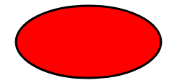

**Logo using ellipse**

<svg height="140" width="500">

    <ellipse **cx="200" cy="80" rx="100" ry="50"** stroke="black" stroke-width="3" fill="pink"/>

    <text **fill="#000"** **font-size="50" x="155" y="100"** font-family="verdana">LJU</text>

</svg>

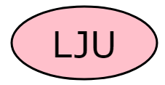

## SVG Polygon - <polygon>

The <polygon> element is used to create a graphic that contains at least three sides.

Polygons are made of straight lines, and the shape is "closed" (all the lines connect up).

**<polygon points="x1,y1,x2,y2,x3,y3,x4,y4….xn,yn" stroke="color" stroke-width="5" fill="black" />**

<svg height="250" width="300" style="border: 3px solid red;">

    <polygon **points="20,100,80,200,200,40,20,10"** stroke="orange" stroke-width="5" fill="black" />

</svg>

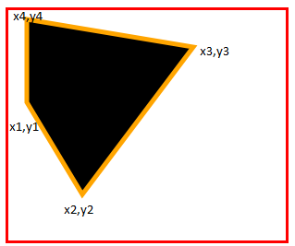

**Use the <polygon> element to create a Star:**

<svg height="210" width="500">

    <polygon points="100,10,40,198,190,78 10,78,160,198"

    stroke="purple" stroke-width="3" fill="pink" **fill-rule="nonzero"** />

  </svg>

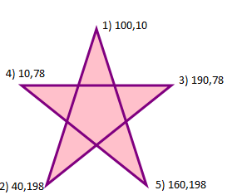

* The **fill-rule** attribute is a presentation attribute defining the algorithm to use to determine the inside part of a shape.
* After counting the crossings paths, if the result is zero then the point is outside the path. Otherwise, it is inside**. Default value is “nonzero”**

**Change the fill-rule property to "evenodd":**

<svg height="210" width="500">

    <polygon points="100,10,40,198,190,78 10,78,160,198"

    stroke="purple" stroke-width="3" fill="pink" fill-rule="evenodd" />

  </svg>



# HTML Image Maps

**<area> and <map>**

* The <area> tag defines an area inside an image map (an image map is an image with clickable areas).
* <area> elements are always nested inside a <map> tag.

**Example:**

<html>

    <head> <title>Area & Map</title> </head>

    <body>

        <h1> Map & Area </h1>

<!-- Image Map Generated by http://www.image-map.net/ -->

**<img src="test.jpg" usemap="#image-map">**

**<map name="image-map">**

**<area target="_blank" alt="laptop" title="laptop" href="" coords="0,3,339,523" shape="rect">**

**<area target="_blank" alt="tea" title="tea" href="" coords="437,382,85" shape="circle">**

**<area target="_blank" alt="book" title="book" href="" coords="** **465,261, 578,191,668,234,775,393,617,496" shape="poly">**

**<area target="_blank" alt="flower" title="flower" href="" coords="** **322,0,324,0 414,149,609,202,783,112,800,3" shape="poly">**

**</map>**

        </body>

</html>