**Example 1**

**Create a React component that displays a list of products. Each product has a name, price, and image. Use filter() to show only products with a price less than ₹10,000, and use map() to display their details (image, name, and price) on the screen.**

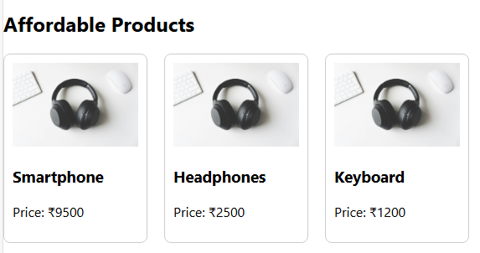

const ProductList = () => {

  // Array of product objects

  const products = [

    {

      name: 'Smartphone',

      price: 9500,

      image: '1.jpg'

    },

    {

      name: 'Laptop',

      price: 55000,

      image: '1.jpg'

    },

    {

      name: 'Headphones',

      price: 2500,

      image: '1.jpg'

    },

    {

      name: 'Keyboard',

      price: 1200,

      image: '1.jpg'

    }

  ];