Design an HTML form to collect user details with proper validations.
Form Requirements:
- Email Field: Must be filled before submitting and follow proper email format. This field should be autofocused.
- Password Field: Minimum length 8 characters, maximum length 15 characters. This field is also mandatory.
- Exam Date Field: Accept dates only between 05-Oct-2025 and 25-Oct-2025.
- Gender Field: Two options (Female, Male), user can select only one option at a time. Male field should be selected initially.
- Age Field: Allow values between 18 and 35, default value 20.
- City Dropdown: Group cities by state (Gujarat → Ahmedabad, Surat; Rajasthan → Jaipur, Udaipur).
- Message Field: Text area with default message “Test Message”.
- Buttons: Submit button to send the form, Reset button to clear the form.

Design svg as shown below using different shapes.




Write an HTML program to display the given image. When the user clicks on an individual shape, it should open a different picture: circle.jpg for the circle, triangle.jpg for the triangle, square.jpg for the square, and polygon.jpg for the polygon
.

Example
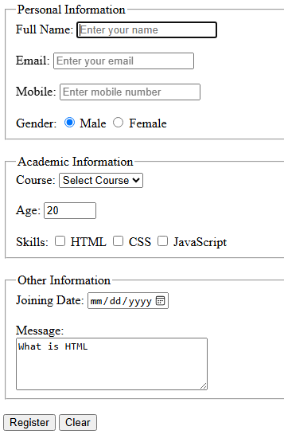
The form should be divided into the following three fieldsets:
- Personal Information
  - Full Name – text input, required, minimum 3 and maximum 30 characters, autofocus.
  - Email – email input, required.
  - Mobile Number – telephone input, required, maximum 10 characters.
  - Gender – radio buttons with Male and Female options. Default option is male.
- Academic Information
  - Course – dropdown containing M.Tech, B.Tech, and PhD.
  - Age – number input accepting values between 18 and 40, with default value 20.
  - Skills – checkboxes for HTML, CSS, and JavaScript.
- Other Information
  - Joining Date – date input allowing dates only from January 1, 2026 to December 31, 2026.
  - Message – textarea with 4 rows and 30 columns. Default value is as image.
Finally, add Register and Clear buttons

