**1.Git-HOL**

**Step 1: Setup your machine with Git Configuration**

1. To check if Git client is installed properly: Open Git bash shell and execute



1. To configure user level configuration of user ID and email ID execute



1. To check if the configuration is properly set, execute the following command.



**OUTPUT**

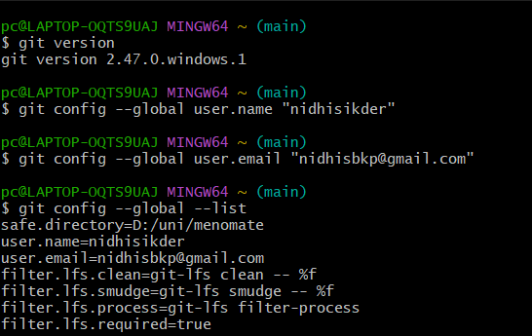

**Step 2: Integrate notepad++.exe to Git and make it a default editor**

1. To check, if notepad++.exe execute from Git bash



1. Exit Git bash shell, open bash shell and execute



Now, notepad++ will open from Git bash shell

1. To create an alias command for notepad++.exe, execute





1. To configure the editor, execute the command



1. To verify if notepad++ is the default editor, execute the command



**OUTPUT**

**Step 3: Add a file to source code repository**

1. Open Git bash shell and create a new project “**GitDemo**” by executing the command



1. Git bash initializes the “**GitDemo**” repository. To verify, execute the command

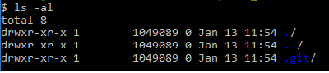

1. To create a file **“welcome.txt”** and add content to the file, execute the command



1. To verify if the file “welcome.txt” is created, execute

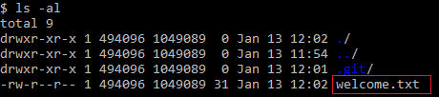

1. To verify the content, execute the command



1. Check the status by executing

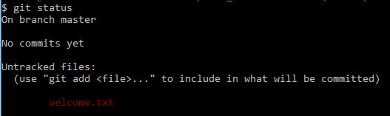

1. To make the file to be tracked by Git repository, execute the command



1. To add multi line comments, we are opening default editor to comment. Execute the command



1. To check if local and “Working Directory” git repository are same, execute git status



**OUTPUT**

