
SVKM’s NMIMS
Mukesh Patel School of Technology Management & Engineering /
School of Technology Management & Engineering

Year:- 2025 - 26 | Program:- B. Tech | Semester:- III

Subject:- Data Structures and Algorithms

Case Study title: Hostel Maintenance Request Manager
Team Details
Name | Nidhi Sirisilla | Kasim Zaidan | Satyam Patil
Roll No | B203 | B227 | B389
SAP ID | 70022500043 | 70022500104 | 70022600946

Bachelor of Technology (Computer Engineering)
Second Year, Semester III
Faculty: Dr. Rashmi Sharma
AY 2025-26

INDEX

Sr. No. | Topic | Page No.
1 | Storyline | 3
2 | Need of Data Structures | 5
3 | Data Structures use in your case study | 6
4 | Detailed flowchart of case study | 8
5 | Analysis of Algorithm used in case study | 10
6 | Conclusion | 12
7 | References | 13

Storyline
The Hostel Maintenance Request Manager is a console application written in C that organises how maintenance problems are reported and handled in a student hostel. Plumbing leaks, electrical faults, broken furniture, cleaning needs and internet failures are usually reported verbally or on paper. Such complaints are easily forgotten, urgent faults get no priority over minor ones, and students cannot see whether anyone has picked up their request.
This program replaces that informal process with one register of requests. A student logs in, raises a request with an urgency level, and can track it until it is resolved. A maintenance admin sees pending work in priority order, assigns the next job, and marks it resolved. The project is also built to show how data structures and algorithms from the course solve a real problem.
Purpose and Scope
The purpose is to track every request through its life cycle (Pending, Assigned, Resolved) while serving the most urgent work first. The scope covers one hostel with blocks A to E and a maintenance office, up to 100 requests in the register, and two roles (student and admin) inside a single program. The admin password is admin123, and six sample requests are loaded when the program starts.
Key Features
- Two roles in one program: a student menu with 6 options and an admin menu with 13 options.
- Request register: each request stores ID, student name, block, room, category, description, priority and status.
- Priority queue behaviour: pending requests are queued by urgency (High, Medium, Low) and by age inside each level.
- Undo: the last submit, cancel or delete can be reversed using a stack.
- Fast lookup: a binary search tree indexes request IDs; linear and binary search are also available for comparison.
- Sorting with analysis: requests can be sorted by priority, block and room, or student name, and the program reports comparisons and time for three sorting algorithms.
- Technician route: BFS and DFS over the hostel map show nearby blocks and a patrol route with open requests.
- Input validation: every number, block letter and menu choice is validated before use.
User Case Example
Karan Mehta in block B, room 312, finds that the WiFi router on his floor is down. He logs in as a student, chooses category Internet, describes the problem and marks the urgency as High. The program gives the request ID 1003 and says how many requests are ahead of it. The admin later opens the pending queue, sees request 1003 near the top, uses Assign next, and marks the request resolved once the router is repaired. Karan can track the status at any time using the request ID.
Benefits
- Urgent faults such as short circuits or water failure are handled before minor ones.
- Students can see the status and queue position of their own requests.
- Requests are not lost, and every cancel or delete can be undone.
- The program reports the number of steps each search or sort takes, which supports learning and algorithm analysis.
Target Users
- Hostel students who need to report maintenance problems
- Hostel wardens and maintenance staff who assign and close requests
- Students and teachers of the Data Structures and Algorithms course who want a worked example
Need of Data Structures
A program that only prints and reads values cannot manage hundreds of changing records. A maintenance system must add requests, find one by ID, reorder work by urgency, undo mistakes and report totals, and each of these operations is cheap or expensive depending on how the data is organised. Choosing the right data structure for each need keeps the program fast, correct and easy to extend.
The table below lists the main needs of this project and why a suitable data structure is required for each.
Need in the project | Problem without a suitable structure | Structure that meets it
Keep all requests together, in ID order | Separate variables cannot hold an unknown number of records | Array of structures
Find a request by ID quickly | Scanning all records takes n steps every time | Binary search tree (and binary search)
Serve urgent requests first, fairly | Unordered storage gives no notion of turn or priority | Circular queue rebuilt by priority
Undo the last action | Earlier actions are forgotten once performed | Stack of actions
Show resolved work in order of completion | Fixed-size storage wastes space or overflows | Singly linked list
Plan a route between blocks | Block connections cannot be stored as a list | Graph (adjacency matrix) with BFS and DFS
Compare ways of ordering data | No basis to judge which method is faster | Insertion, selection and merge sort
Count and total over all records | Repeated loops become long and hard to read | Recursion over the array and tree

Together, these structures also show a core idea of the subject: the same data can be stored in several ways, and every way trades time against memory and simplicity.
Data Structures Used in the Case Study
Every structure below appears in hostel_maintenance.c and is used by a real feature rather than as a separate demonstration. The course outcome (CO) for each is given in the first column.
CO | Structure | Where it is used in the code | Purpose
CO1 | Array of Request structures: reqs[100] | registerRequest(), removeRequest(), viewMine(), showAll() | Main register, kept sorted by ID; new records are inserted in place by shifting later records
CO2 | Linear search | linearSearchRoom() | Finds all requests for a block and room
CO2 | Binary search | searchById() | Searches the sorted array by ID and reports steps taken
CO2 | Insertion, selection, merge sort | insertionSort(), selectionSort(), mergeSort(), sortMenu() | Orders a copy of the register by priority, block and room, or name; counts comparisons and time
CO3 | Recursion | countStatusRec(), prioritySumRec(), countMineRec(), traverse(), dfs() | Counts by status, urgency score, tree traversals and patrol route
CO4 | Stack: undoStack[50] | push(), pop(), undoLast() | Undo of the last submit, cancel or delete
CO4 | Circular queue: cq[100] | cqEnqueue(), cqDequeue(), rebuildQueue(), assignNext() | Pending work, most urgent first and oldest first
CO4 | Singly linked list | showLog() | Resolved log, built with head and tail pointers and then freed
CO5 | Binary search tree | bstInsert(), bstSearch(), bstDelete(), shiftIdx() | Index from request ID to array position
CO5 | Graph: adjacency matrix adj[6][6] | bfs(), dfs(), routePlanner() | Hostel map, nearest blocks and patrol route

How the structures work together
When a student submits a request, registerRequest() places the record in the array in ID order and shiftIdx() adjusts the positions stored in the tree. The ID and array position are then added to the BST. rebuildQueue() refills the circular queue with pending IDs in priority order, and the action is pushed on the undo stack. When the admin assigns the next request, the queue gives the ID, the BST finds its position in the array, and the status changes to Assigned. Resolved requests later appear in the linked-list log. The graph is separate and is used only for route planning.
Core definitions in the program
typedef struct {
int id; char student[40]; char block; int room;
char category[20]; char desc[80];
int priority; /* 1 High, 2 Medium, 3 Low */
int status; /* 0 Pending, 1 Assigned, 2 Resolved */
} Request;
typedef struct BNode { int id, idx; struct BNode *left, *right; } BNode;
Detailed Flowchart of Case Study
Flowchart 1: overall program flow
The program starts by loading sample data and showing the main menu. A student logs in with name, block and room, while an admin must enter the correct password. In both menus the request queue is rebuilt before each action so that it always reflects the latest data.
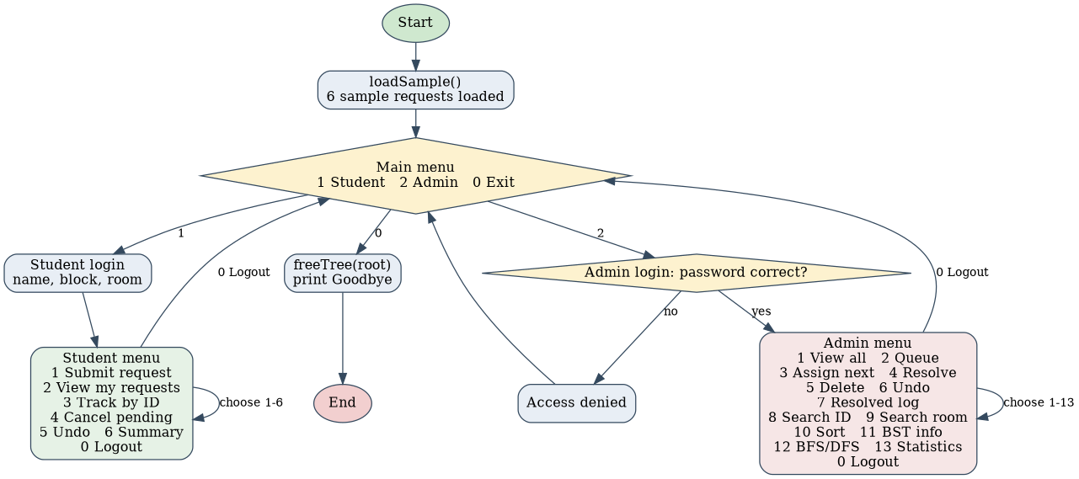
Figure 1: Overall program flow (main menu, student session, admin session)
Flowchart 2: life cycle of a request
A request moves from submission to queue, then to assignment and resolution. Cancel, delete and undo use the stack and the register as shown by the dashed path.
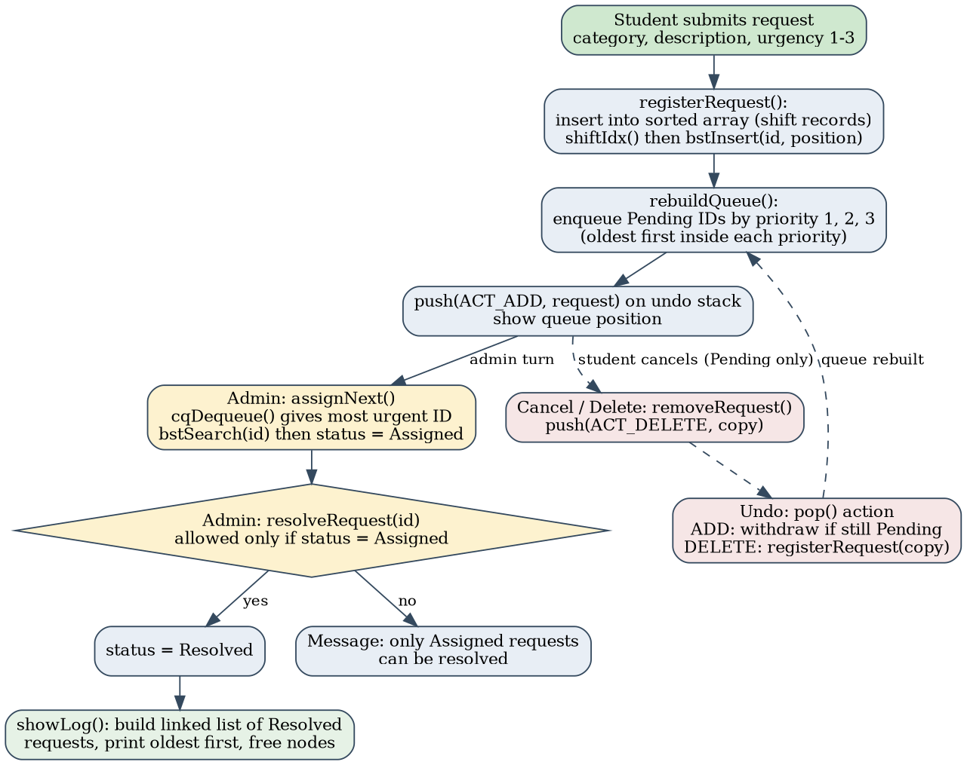
Figure 2: Request life cycle with queue, stack and linked-list log
Analysis of Algorithm Used in Case Study
Let n be the number of requests in the register (at most 100), h the height of the BST, and V the number of places in the hostel map (6). The table gives the time and extra space of the main operations as implemented in the code.
Operation | Function | Time | Extra space | Note
Insert request in sorted array | registerRequest() | O(n) | O(1) | Scan for position, then shift records right
Remove request from array | removeRequest() | O(n) | O(1) | Shift records left and fix BST positions
BST insert / search | bstInsert(), bstSearch() | O(h) | O(h) recursive insert, O(1) search | O(log n) if balanced, O(n) if skewed
Binary search by ID | searchById() | O(log n) | O(1) | Array is always sorted by ID
Linear search by room | linearSearchRoom() | O(n) | O(1) | Checks every record
Insertion sort | insertionSort() | O(n²) worst, O(n) best | O(1) | Stable
Selection sort | selectionSort() | O(n²) in every case | O(1) | Few swaps, many comparisons
Merge sort | mergeSort() | O(n log n) | O(n) | Needs temporary array
Queue enqueue / dequeue | cqEnqueue(), cqDequeue() | O(1) | O(1) | Index wraps with modulo
Rebuild queue | rebuildQueue() | O(3n) = O(n) | O(1) | One pass per priority level
Stack push / pop | push(), pop() | O(1) | O(1) | Oldest action dropped when 50 are stored
Recursive count / sum | countStatusRec(), prioritySumRec() | O(n) | O(n) call stack | Iterative version needs O(1) space
BFS / DFS on adjacency matrix | bfs(), dfs() | O(V²) | O(V) | V is only 6 here

Measured results from the program
Running the program with its six sample requests gave the following output from the Sort + performance analysis option (comparison counts are exact, and times are the average of 2000 runs on the test machine, so they vary between computers).
Sort key | Insertion | Selection | Merge
Priority: comparisons | 9 | 15 | 9
Block and room: comparisons | 10 | 15 | 9
Time per sort, n = 6 | about 0.2 microseconds | about 0.2 microseconds | about 0.4 microseconds

Search by ID for request 1006 visited 6 nodes in the BST but took only 3 steps with binary search over 6 records. Searching for request 1001 took 1 node in the BST and 2 steps in binary search. Linear search by room made 6 comparisons, equal to n.
Observations
- Small n: with only six records all three sorts finish in well under a microsecond, so merge sort looks slower because of its extra copying. The O(n²) and O(n log n) difference appears only as n grows toward the limit of 100 and beyond.
- Skewed BST: request IDs are issued in increasing order (1001, 1002, ...), so each new node becomes the right child of the previous one and the tree becomes a chain. Searches then take O(n) steps, which is why request 1006 needed 6 node visits. A self-balancing tree such as an AVL tree would restore O(log n).
- Space: the register uses a fixed array of 100 records, the queue and stack are fixed arrays, and only the BST and the resolved log use dynamic memory, which is released with freeTree() and inside showLog().
CONCLUSION
The Hostel Maintenance Request Manager shows how a simple real-life process can be organised using the data structures and algorithms of the course. The array register keeps requests in ID order, the circular queue serves urgent work first, the stack allows safe undo, the linked list produces the resolved log, the BST indexes IDs, and the graph supports route planning. Each structure solves a specific need instead of being added for its own sake.
The analysis section showed both the benefits and the limits of the design. Binary search and queue operations behave as expected, and the sorting comparison clearly separates the three algorithms by the number of comparisons. At the same time, the test run exposed a weakness: because IDs are always increasing, the BST degenerates into a chain and loses its speed advantage.
Because the program uses only the standard C library and fixed-size arrays, it is portable and easy to follow, and input validation makes it robust for everyday use. Its limits are the 100-request capacity, data that disappears when the program exits, and a simple password check.
Future improvements include replacing the BST with an AVL tree, saving requests to a file or database, using a true priority queue such as a heap, adding timestamps and technician names, and building a graphical or web interface. With these changes the project could grow from a learning exercise into a practical hostel maintenance tool.

Reference
1. Weiss, M. A. (1997). Data Structures and Algorithm Analysis in C (2nd ed.). Addison-Wesley
2. GeeksforGeeks. (n.d.). Data Structures and Algorithms (DSA) Tutorial
GeeksforGeeks
3. cppreference.com. (n.d.). C Language Reference.
4. GeeksforGeeks. (n.d.). Complete A2Z Reference for DSA Concepts.
5. National Institute of Standards and Technology (NIST). (n.d.). Dictionary of Algorithms and Data Structures.

