**MUSIC RECOMMENDATION SYSTEM**

For the award of the degree of

**B. TECH**

In

Computer Science and Engineering

(Artificial Intelligence and Machine Learning)

Submitted By

NIDHI SINGHAL (2000681530033)

SHREYA SINGH (2000681530047)

UMIKA KHUGSHAL (2000681530052)

Under the guidance of

**MR. AJAY SAH**



**­­­**Meerut Institute of Engineering & Technology, Meerut

**INTRODUCTION**

What is recommendation system? Why do we need recommendation system?

The recommendation system is subclass of information filtering system that provides suggestions for items that re most pertinent to a particular user. Major types of recommendation system are

* Collaborative Recommender System
* Content Based Recommender System
* Knowledge Based Recommender System
* Popularity Based Recommender System
* Hybrid Recommender System

It helps the user to get personalized recommendations, helps users to take correct decisions for example its usage can be seen in E-Commerce websites like Amazon and Entertainment based like Spotify, Netflix etc.

A recommender system can be designed in two ways

* By scanning and analysing user interactions with data like rating and likes. Creating tags (Content Based).
* By Finding users of similar preferences dividing them into clusters and then recommending them stuff liked by either of them (Collaborative based).

**OBJECTIVE AND SCOPE**

Objective of this project is to provide user with the recommendations based on his/her previous likes and activities.

The recommender system deals with a large volume of information present by filtering the most important information based on the data provided by a user and other factors that take care of the user’s preference and interest. It finds out the match between user and item and imputes the similarities between users and items for recommendation.

This Project is based on Content Based Recommendation. Where tags allotted to a particular dataset is compared with all others and then results are drawn.

Process is usually done in 4 phases

Collection 🡪 Storing 🡪 Analyzing 🡪 Filtering

Most of the top MNC’s have switched to their own version of recommendation system as foremost advantage of Recommendation System is Customer Satisfaction.

What would be the life if Recommendation Systems are grown further?

Even now a days each and every application is using recommendation systems and its effect is clearly visible.

It is found that in earlier days YouTube used Collaborative filtering but now it switched to Hybrid one.

Hence growth of recommendation systems would be a boon for business providers and give a good experience to users.

**METHODOLOGY**

The methodology for building this system is fairly simple, an individual can follow the below steps to develop such a recommendation system.

1. Choose a dataset of songs of your choice and requirement usually available on Kaggle.

* In this project we used Million songs dataset

1. Apply some pre-processing over data

* If more than one csv files of a dataset then merge them together.
* Check for Null Values and remove them.
* Check for Duplicate Values and Remove if any.
* Lemmatize the data.
* Merge the columns to form tags for comparison

1. Now tags are converted to vectors and then cosine distance is found and stored in similarity matrics (spars matrix).
2. Creating a Recommend Function which take title of songs as input and then finds its index in dataset afterwards closest value to it is found using similarity matrix.
3. And result is displayed on webpage created using Python GUI.

**WORK FLOW OF PROJECT**

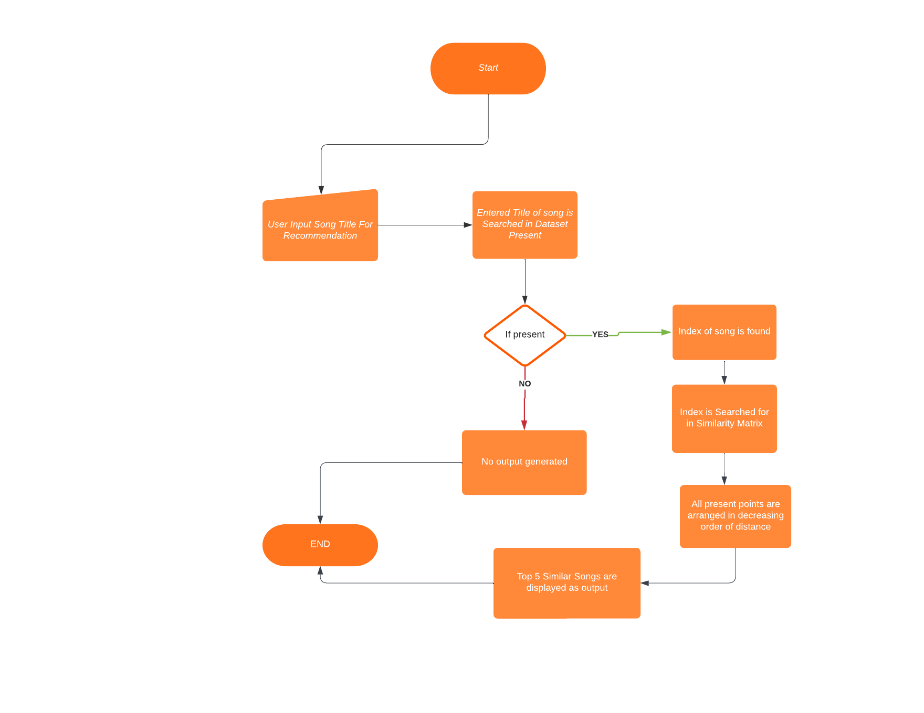

**Technologies Used**

This project will be using the following technology stack:

1. Python
2. Machine Learning
3. Computation over data like Cosine Similarity, Vectorization
4. Python Libraries like
   * Pandas
   * Numpy
   * Streamlit
   * Pickle

**REFRENCES**

* <https://jupyter.org/>
* <http://millionsongdataset.com/>
* <https://streamlit.io/>
* <https://github.com/>
* <https://stackoverflow.com/>
* <https://www.nltk.org/>
* <https://www.lucidchart.com/pages/>