MeetingAI
MEETING INTELLIGENCE

MEETINGAI · HYBRID NLP + LLM
Project
Report
AI-powered meeting intelligence: transcripts, decisions, action items, calendar, chat and minutes - with names on every voice.
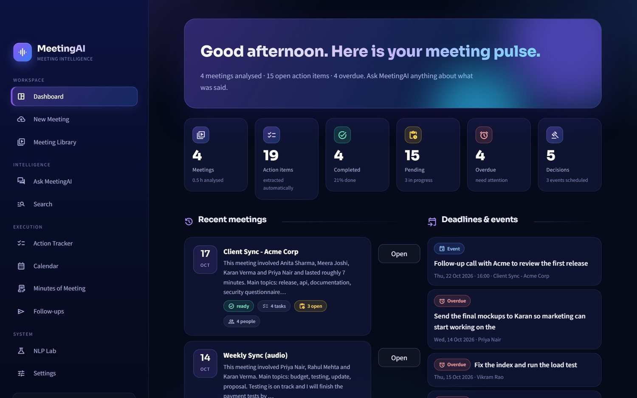
LIVE APPLICATION https://gd4n8x8sjkkxmdhfptkc9m.streamlit.app/
SOURCE CODE https://github.com/nidhitiwari23/Meeting-AI-
EDITION October 2026

Contents
1 Executive summary
2 The problem, the objectives and the scope
3 A tour of the application
4 System architecture
5 Start-up, set-up and "training"
6 End-to-end processing flow
7 Speech and "who said what"
8 Classical NLP: how sentences are understood
9 The confidence gateway
10 The LLM layer and the validation layer
11 Search and the chatbot
12 Minutes, calendar, follow-ups and e-mail
13 Data model and storage
14 User-interface design
15 Technology stack and why each piece was chosen
16 Assumptions and design decisions - consolidated
17 Security, privacy and honesty by design
18 Deployment
19 Source-code map
20 Glossary
Tip: open the Navigation Pane (View → Navigation) to jump between sections.

1 Executive summary
A meeting assistant that listens, remembers, organises and answers - and says so honestly when it does not know.

Meetings produce decisions, promises and deadlines, and most of them are forgotten within days. MeetingAI turns a meeting recording or a written transcript into organised, searchable knowledge. It runs as a web application built entirely in Python and can be deployed for free.
12  application pages | 14  processing steps per meeting | 610  seed sentences used to train the classifier | 16  free services & libraries combined | 0  paid components required

Figure 1 · The MeetingAI dashboard
What a user gets from one upload
• A transcript with timestamps and speaker names ("Priya: ...", not "Speaker 2") using pyannote speaker recognition.
• A structured summary: overview, key discussion points, decisions and conclusions.
• Action items with owner, deadline, priority and status. When the meeting did not say who or when, the application shows Unassigned or Not specified instead of guessing.
• Decisions with the exact quote that proves them, and dated events that are placed on a calendar automatically.
• A chatbot and a cross-meeting search whose answers come only from the meetings and always show their sources.
• Editable Minutes of Meeting (Word, PDF, Markdown) that can be e-mailed after you confirm.
• Follow-up suggestions (recaps, reminders) that stay drafts until you approve them.
KEY IDEA · WHAT MAKES THE PROJECT DIFFERENT
• Hybrid NLP. Fast, explainable classical NLP runs first. A confidence gateway sends only doubtful sentences to a free LLM.
• Validation. Everything an LLM returns is checked against the real transcript (verbatim quotes, real owners, dates computed by code).
• Honesty. Unknown owner = Unassigned, unknown date = Not specified, unanswerable question = not found.
• Runs free. Free-tier LLMs, a local embedding model, SQLite and ChromaDB - deployable on Streamlit Community Cloud.

2 The problem, the objectives and the scope
Why the project exists, what it had to achieve, and where its boundaries are.

The problem. Important information is buried in long conversations. Manual minutes take time, ordinary transcription gives a wall of text without understanding, and general-purpose chatbots may invent facts that were never said.

2.1 Objectives and where each one is met
# | Objective | Where it lives
1 | Upload audio, video or text transcripts | New Meeting page, parsing.py, stt.py
2 | Speech-to-text with speakers and timestamps | stt.py, diarize.py, speakers.py
3 | Structured AI summary | llm_tasks.py, with an offline fallback in nlp.py
4 | Action items with owner / deadline / status, editable | nlp.py, gateway.py, Action Tracker page
5 | Grounded meeting chatbot | rag.py, Ask MeetingAI page
6 | Cross-meeting search with sources | rag.py, db.py (FTS5), Search page
7 | Meeting library and history (including chat history) | db.py, Library page
8 | Minutes of Meeting: edit, accept, export, e-mail | mom.py, mailer.py
9 | Events and deadlines scheduled on a calendar | dates.py, Calendar page, ics.py
10 | Central action tracker with statuses | Action Tracker page
11 | Follow-up suggestions that ask before sending | followups.py
12 | Dashboard statistics | Dashboard page
13 | Honest handling of missing or uncertain information | gateway.py, validation in pipeline.py
14 | Professional dark SaaS-style interface | ui/theme.py, ui/components.py

2.2 Scope
In scope | Deliberately out of scope
Recorded or transcribed meetings, English-language focus | Live (real-time) meeting capture
One shared workspace (optionally password-protected) | Per-user accounts and permissions
Free-tier AI services with automatic fallback | Paid or self-hosted large models
E-mail via SMTP; calendar via links and .ics files | Direct calendar creation through OAuth sign-in

ASSUMPTION · SINGLE SHARED WORKSPACE
Assumption: one deployment serves one team, so all meetings live in one shared database. Why: per-user accounts would need authentication, authorisation and a hosted database - none of which fit a free, single-process deployment. Effect: anyone with the link sees the same data, which is why an optional APP_PASSWORD gate exists.

3 A tour of the application
Every page shares one design language - navy background, violet-blue gradients, glass cards, status chips and icons.

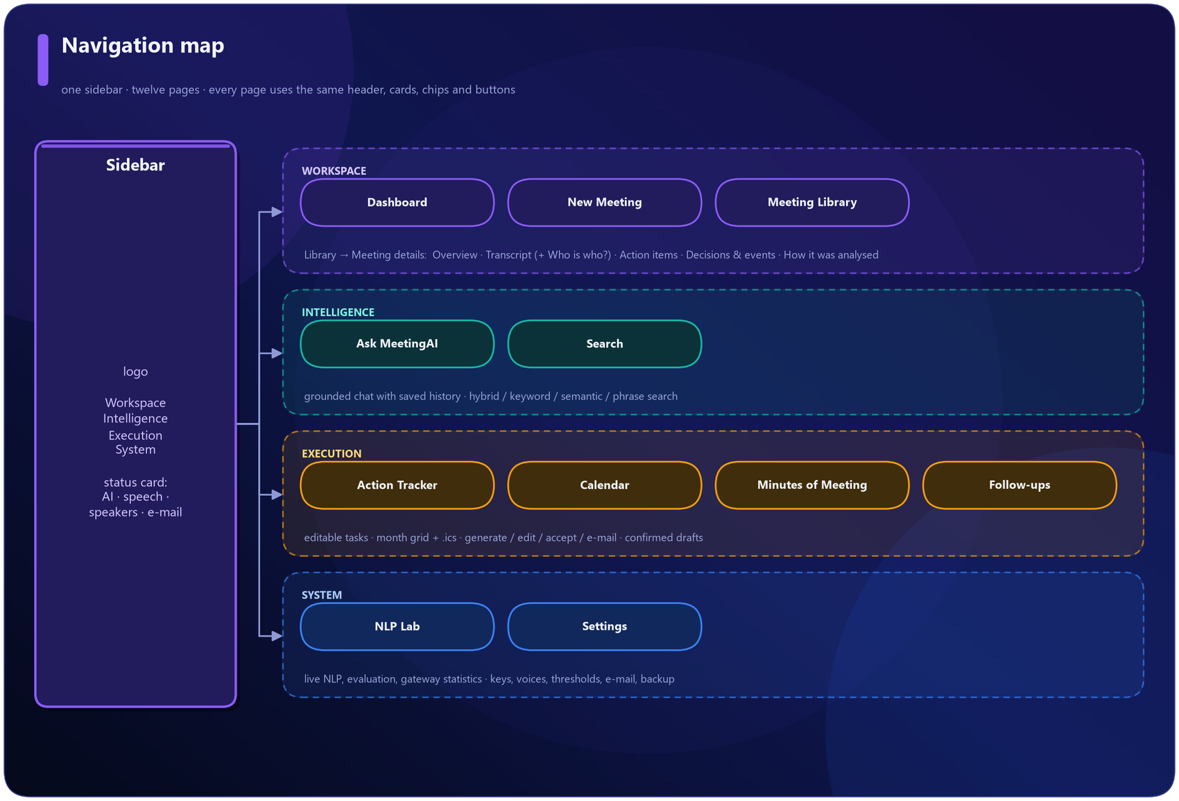
Figure 2 · Navigation map: sidebar groups and pages

3.1 Dashboard
KPIs (meetings, action items, completed, pending, overdue, decisions), recent meetings, upcoming deadlines and events, a task-status donut, open work by owner, and NLP-engine health - how many items classical NLP handled alone versus how many went to the LLM.
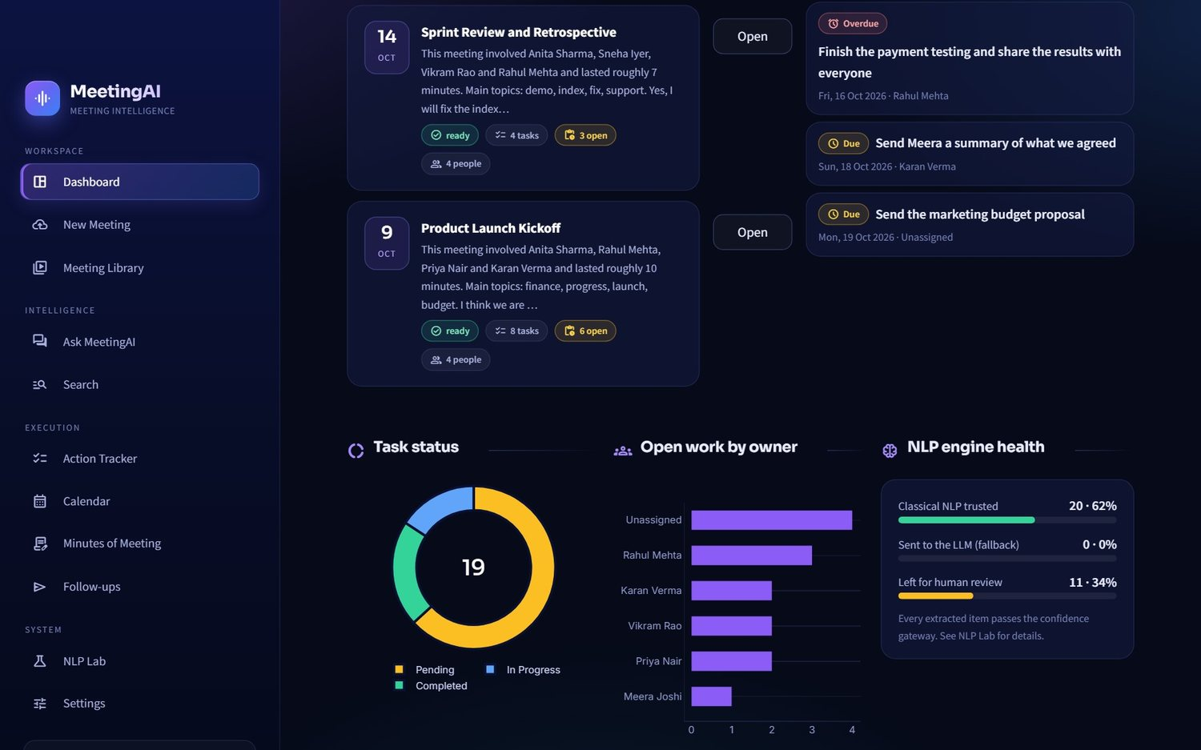
Figure 3 · Dashboard - charts and NLP engine health

3.2 New Meeting
Drag in audio, video or a transcript (txt, vtt, srt, docx, pdf), or paste one. A status panel shows which engines are connected. Progress is shown as a live stepper.
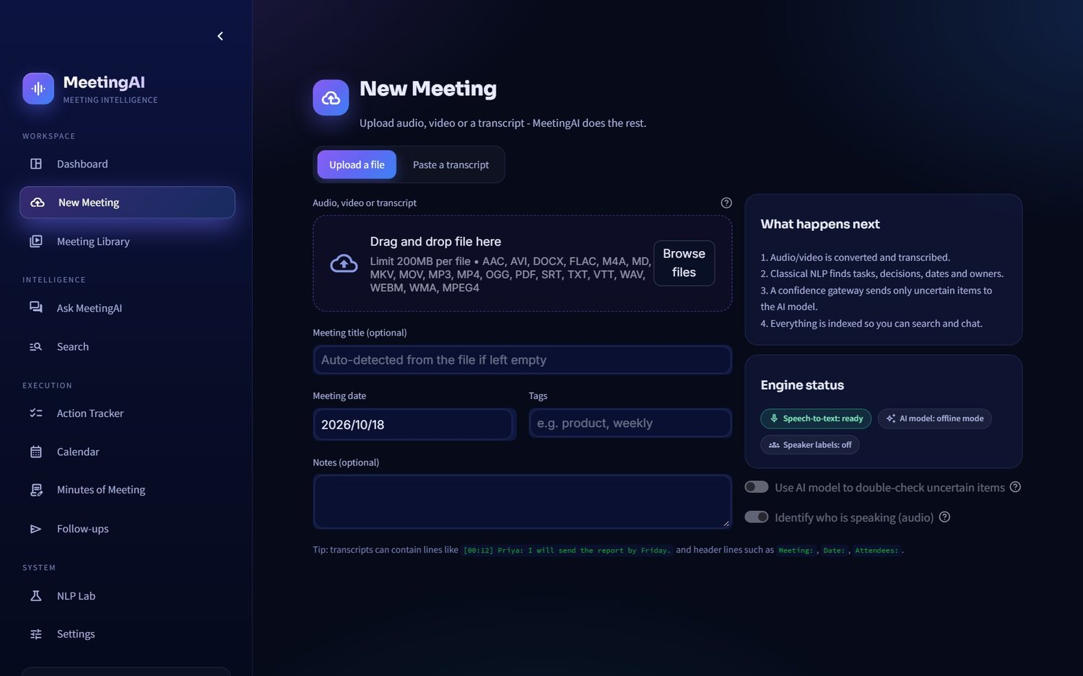
Figure 4 · Upload page

3.3 Meeting Library
Every analysed meeting as a card: date, summary snippet, status, task counts, tags. Search, sort, open, ask AI, or delete.
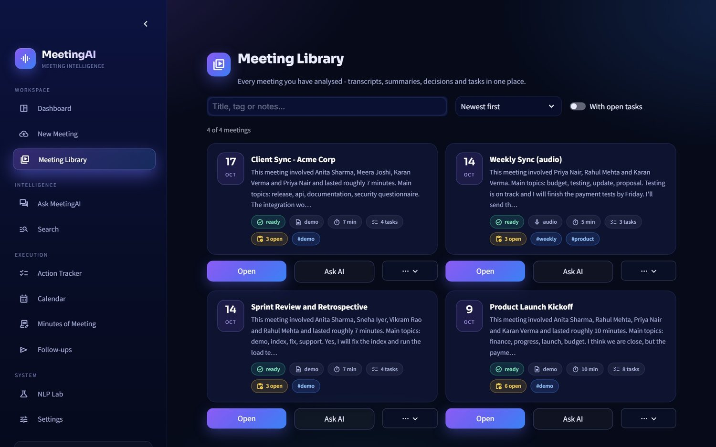
Figure 5 · Meeting library

3.4 Meeting details
Overview - summary, key discussion points, conclusions, topics, participants and an "at a glance" panel.
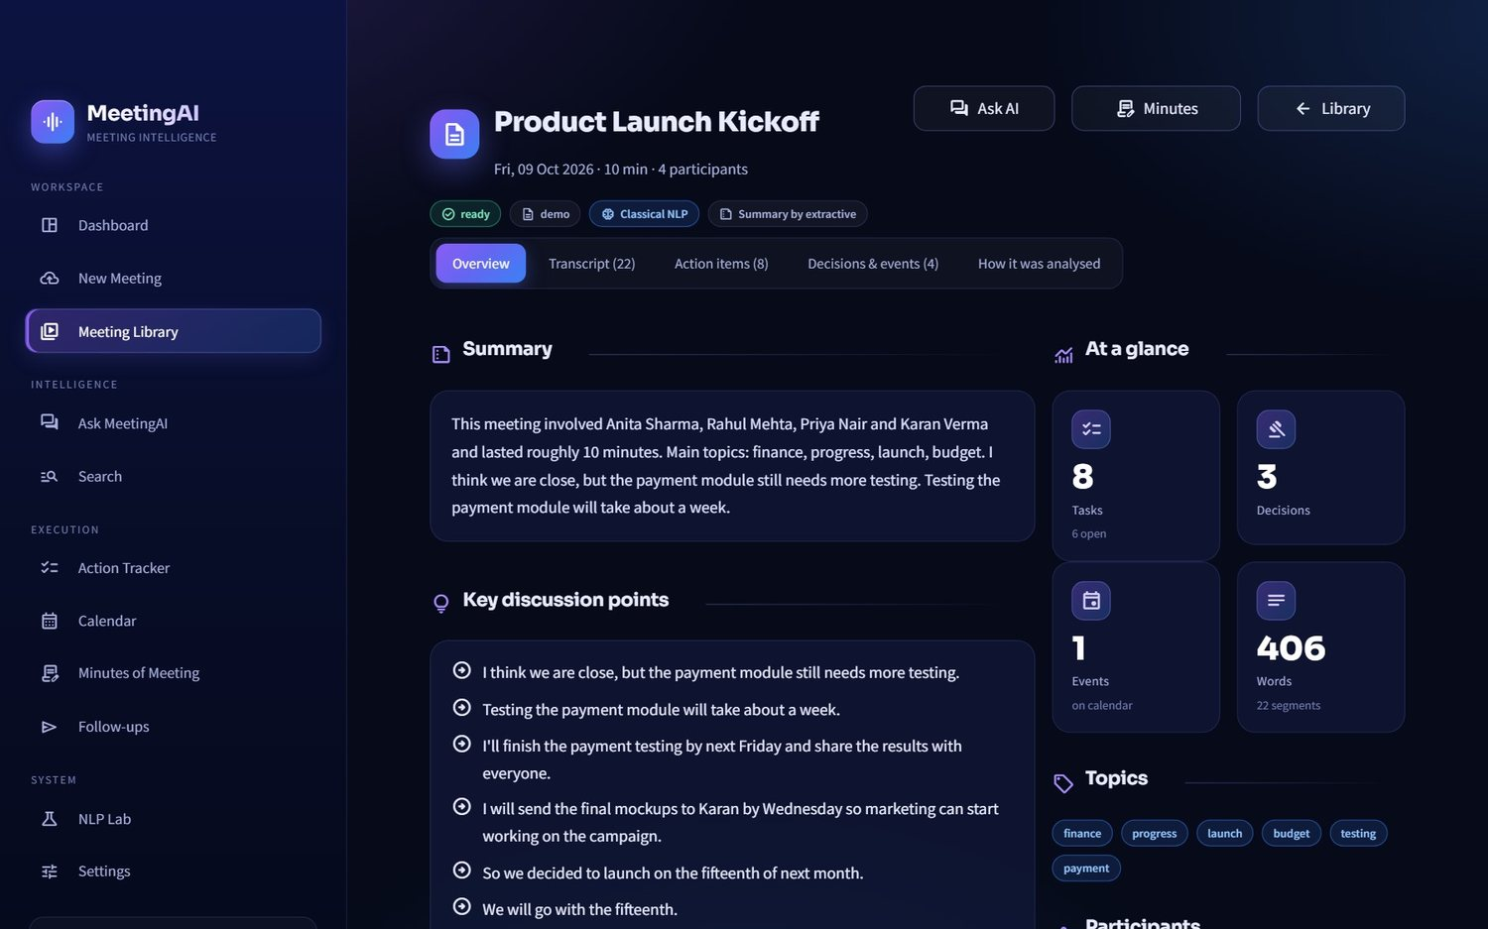
Figure 6 · Meeting overview
Transcript - one coloured avatar per speaker, timestamps, search, a speaker filter, and chips marking where tasks, decisions and events were said. If the original recording exists you can jump the audio player to any line.
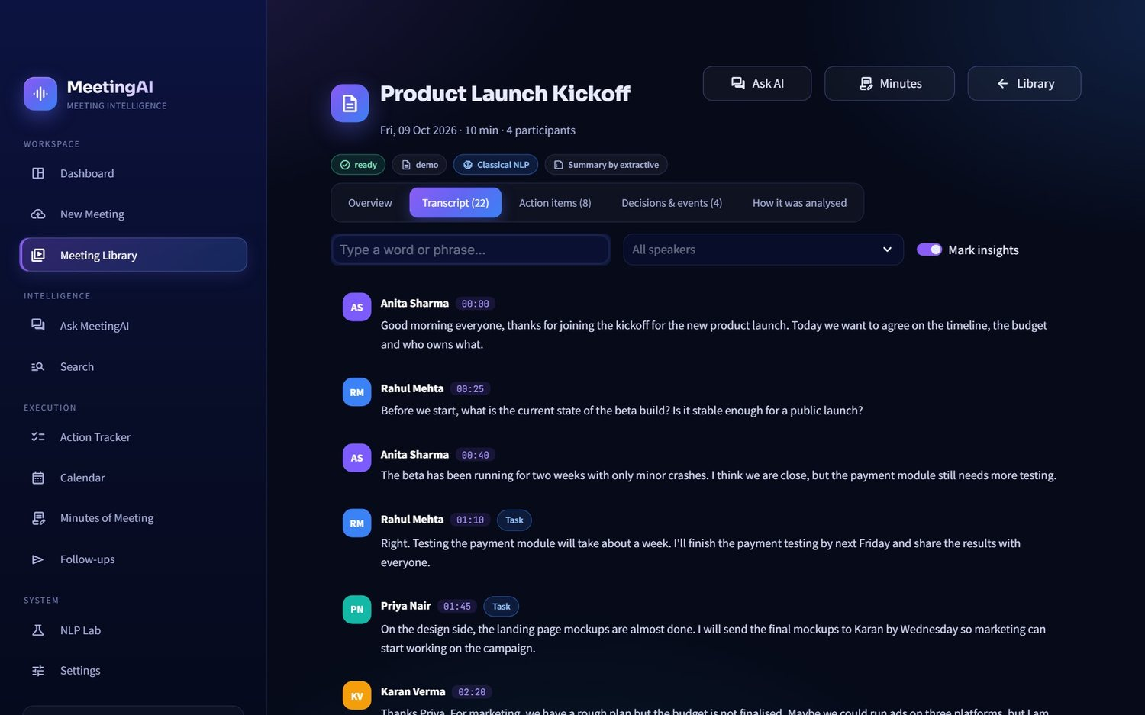
Figure 7 · Transcript with speaker names and insight chips
Action items - an editable table (task, owner, deadline, status, priority) with the exact deadline wording, source meeting, confidence and "needs review" flags.
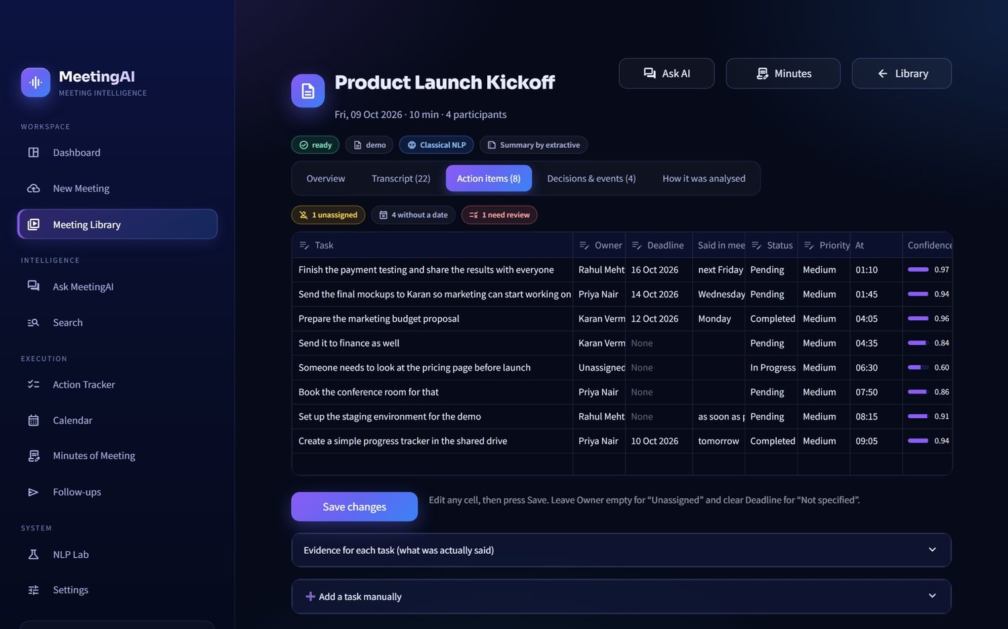
Figure 8 · Editable action items
Decisions and events - each decision shows the quote that proves it; each event can be added to Google Calendar or downloaded as .ics.
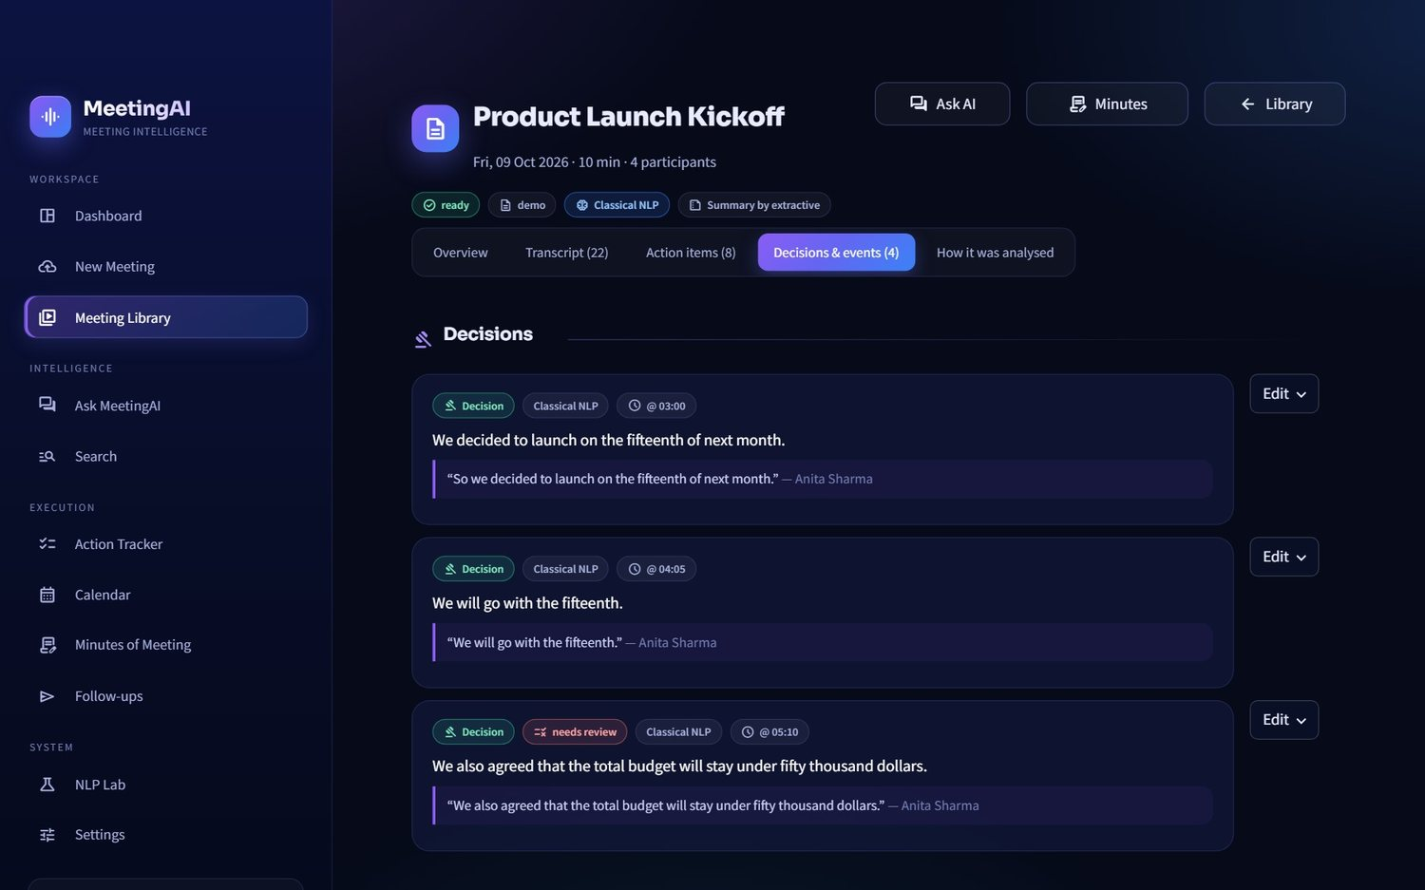
Figure 9 · Decisions and events
How it was analysed - the transparency tab. For every candidate sentence it shows the confidence, margin, outcome (accepted / sent to the LLM / review), reason code and a plain-English explanation.
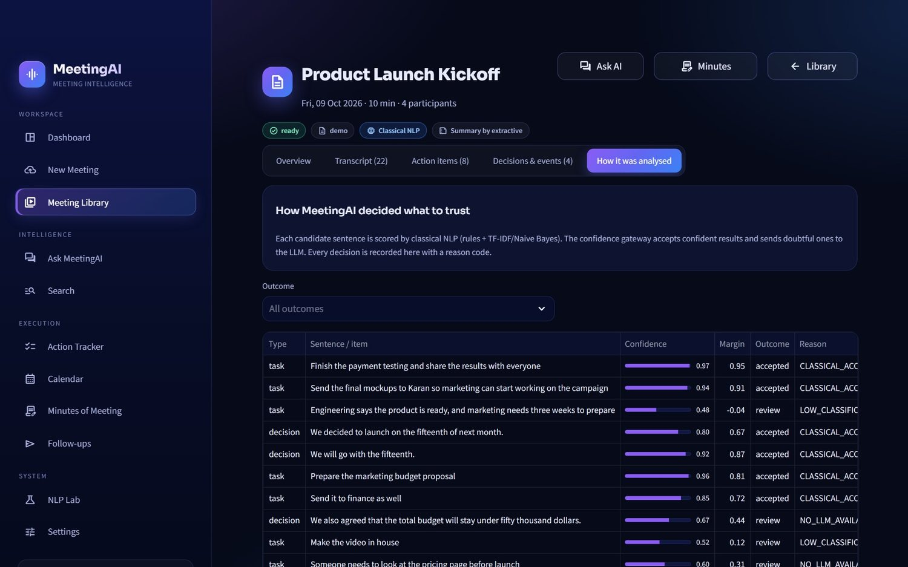
Figure 10 · Gateway decisions per meeting

3.5 Who is who? (speaker names)
pyannote separates voices; this panel puts names on them. Suggestions come from what people said ("I'm Priya", "Rahul, can you..."), each with its evidence and confidence. Play a sample, correct the name, press Apply names, and optionally Remember this voice so that future meetings label it automatically.
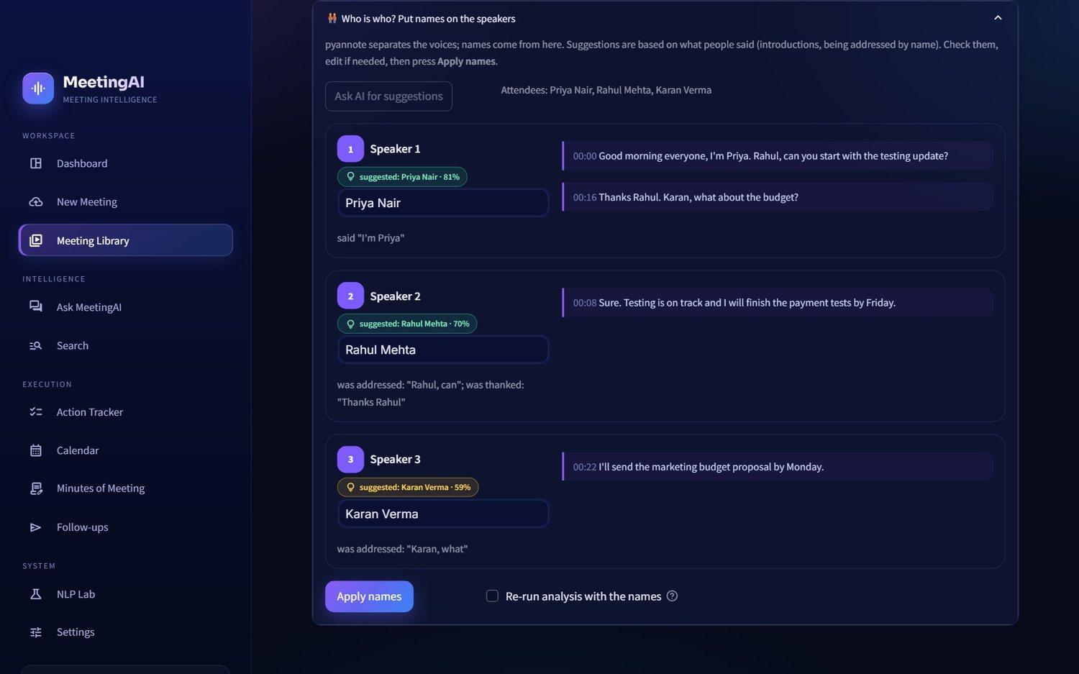
Figure 11 · Who is who panel

3.6 Ask MeetingAI
A chatbot restricted to your meetings. Answers cite sources, show how I searched, and say "not found" when the meetings do not contain the answer. Chats are saved and can be continued later.
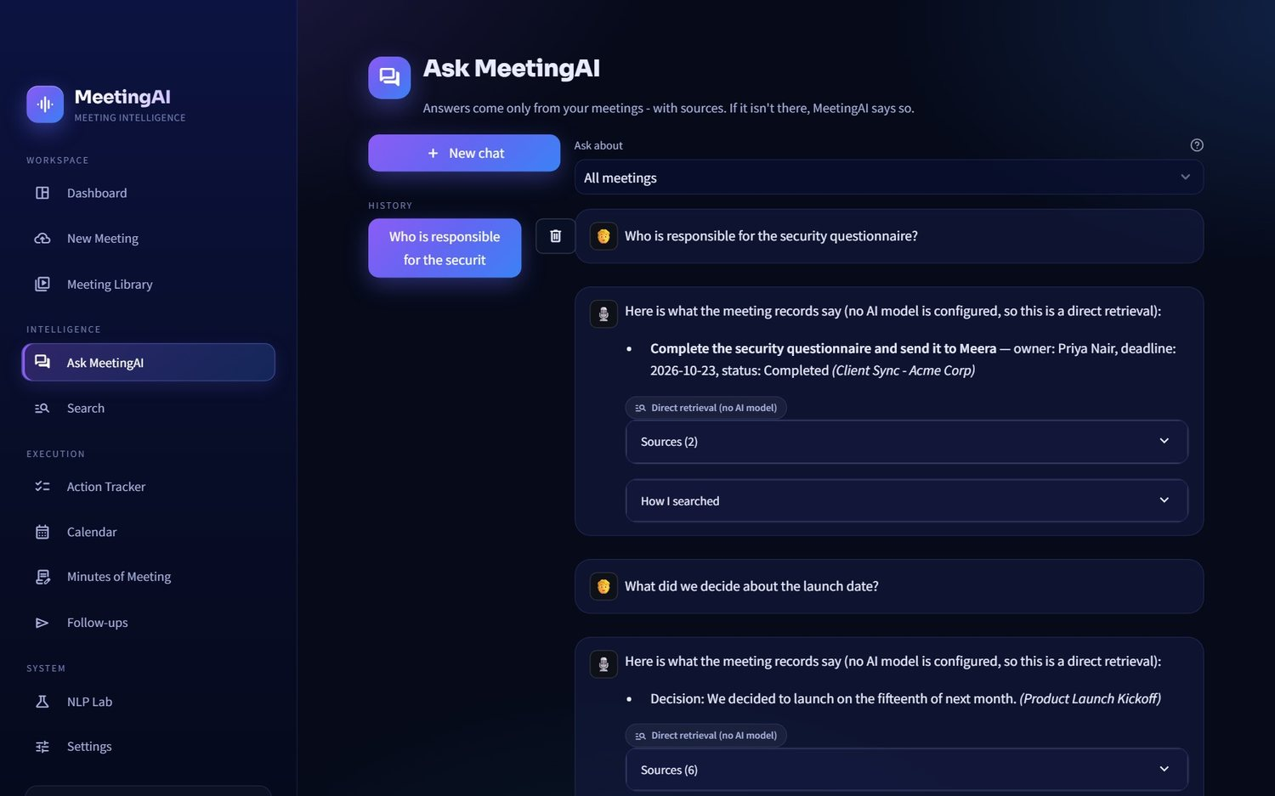
Figure 12 · Chat

3.7 Search
Smart (hybrid), keyword, semantic or exact-phrase search across all meetings. Results show the meeting, timestamp, speakers, the supporting text with highlights, and whether a hit came from keywords, meaning or both.
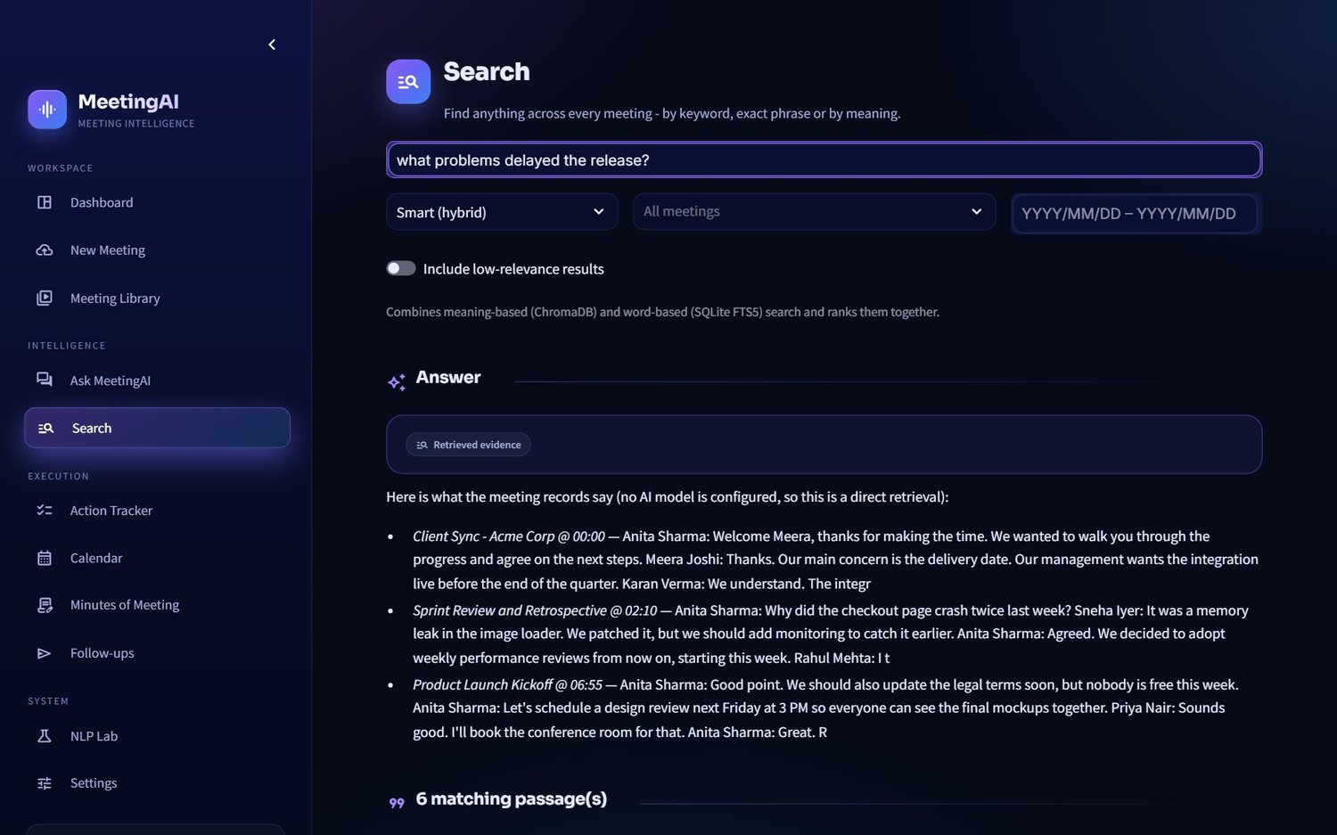
Figure 13 · Cross-meeting search

3.8 Action Tracker
All tasks from all meetings in one table with filters (status, owner, meeting, deadline, text, needs-review). Edit inline and press Save changes.
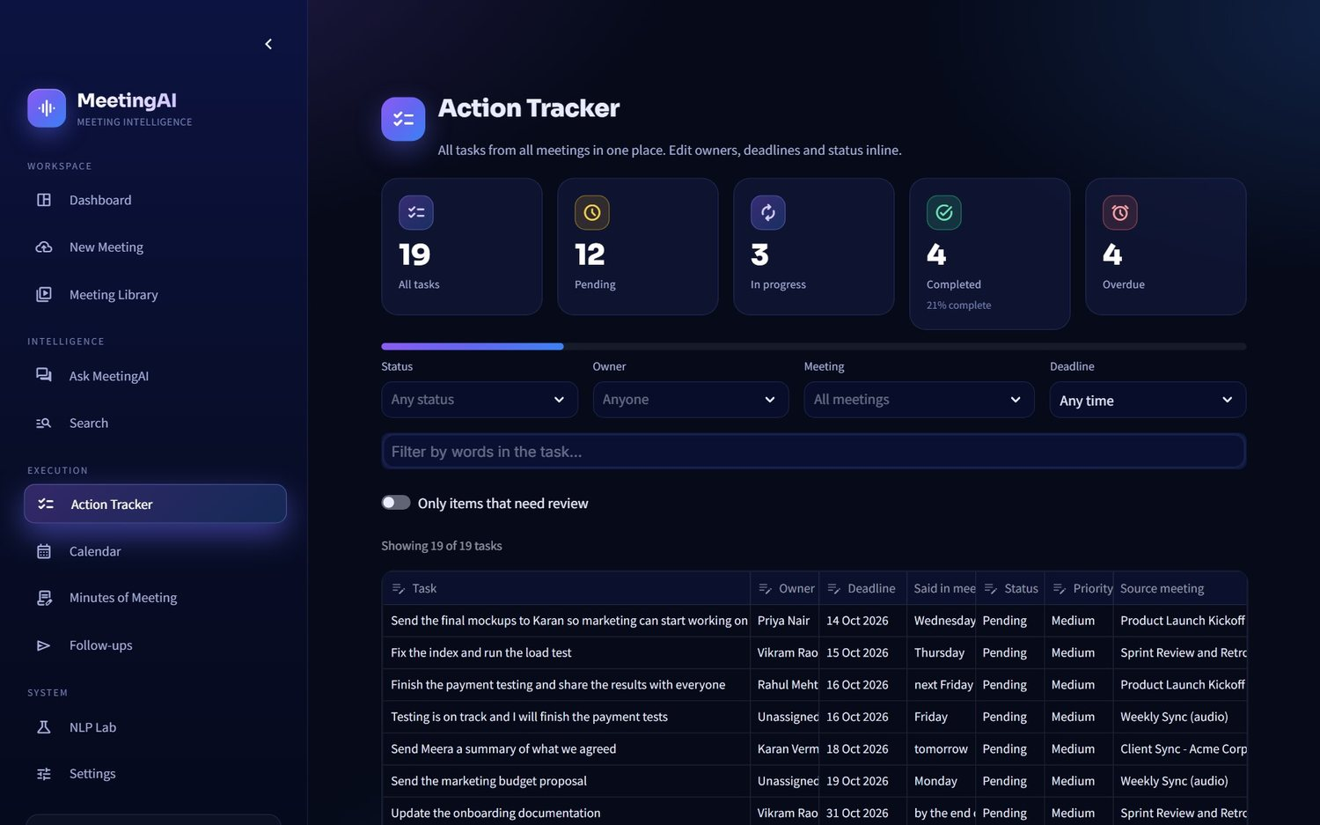
Figure 14 · Action tracker

3.9 Calendar
A month grid. Events and task deadlines found in meetings appear on their dates (violet = event, blue = deadline, red = overdue, green = done), followed by an agenda list with Add to Google buttons and a downloadable .ics file.
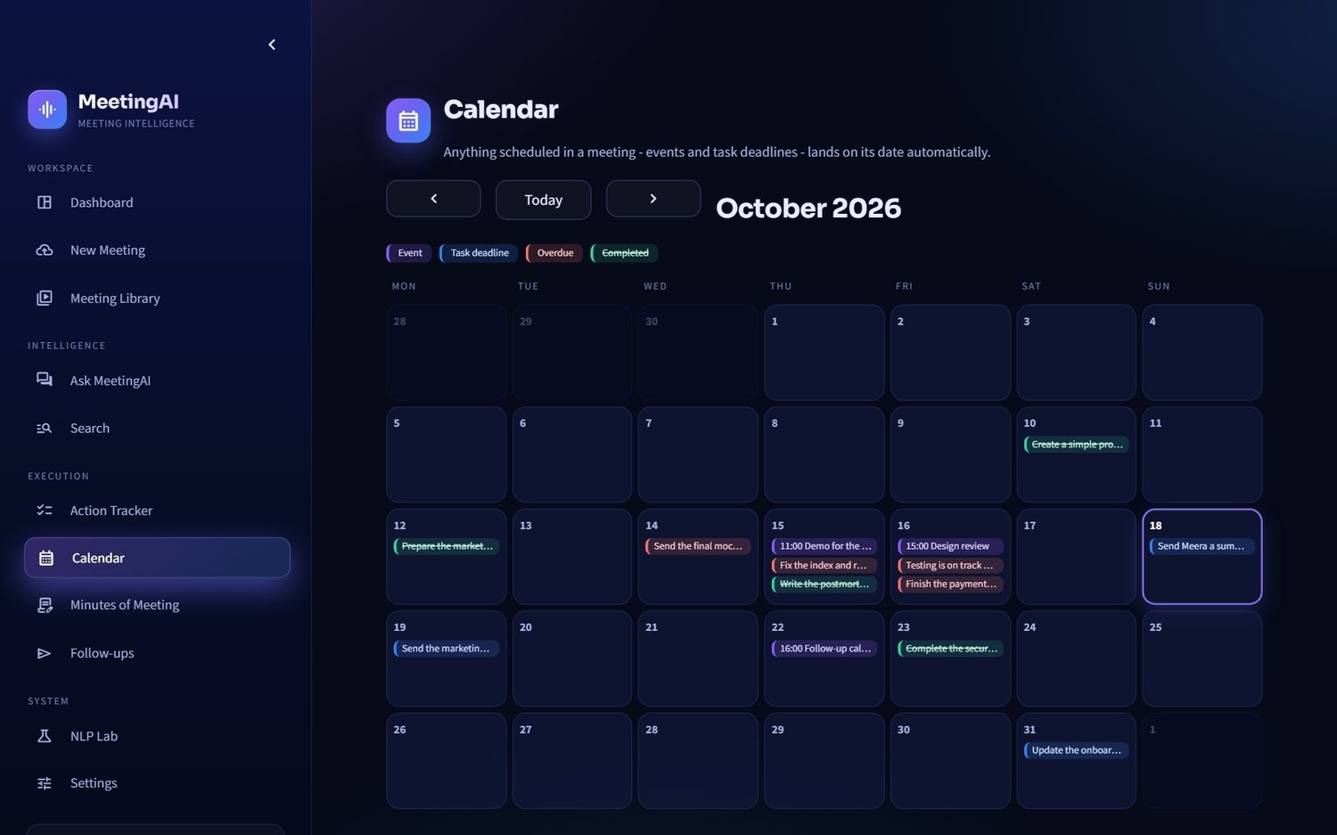
Figure 15 · Calendar month view
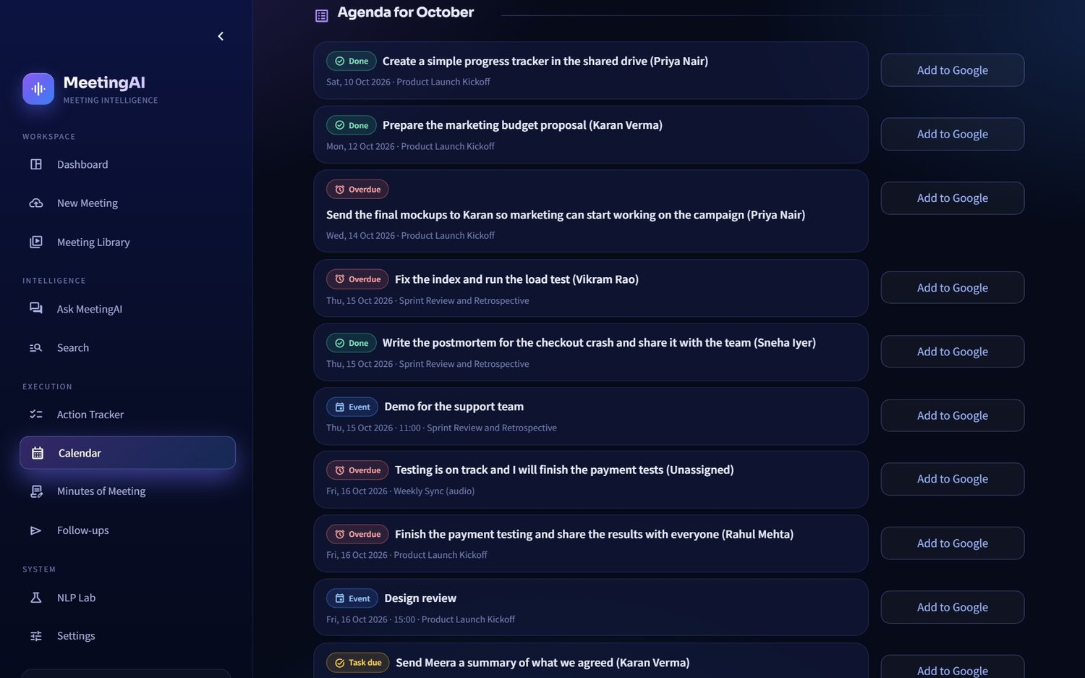
Figure 16 · Calendar agenda

3.10 Minutes of Meeting
Generate a professional draft, edit it, preview it, accept it, then download Word / PDF / Markdown or e-mail it to the addresses you enter - after a confirmation tick.
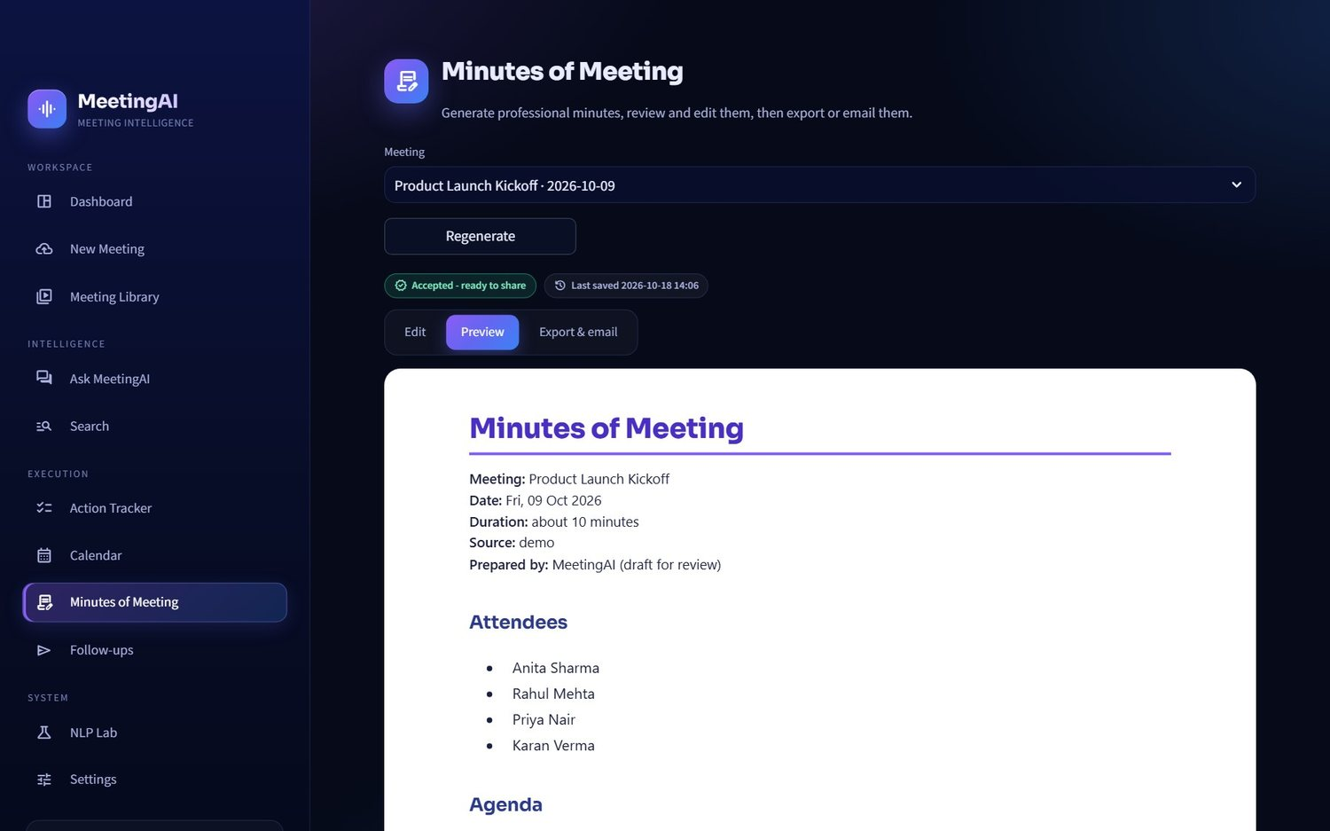
Figure 17 · Minutes preview
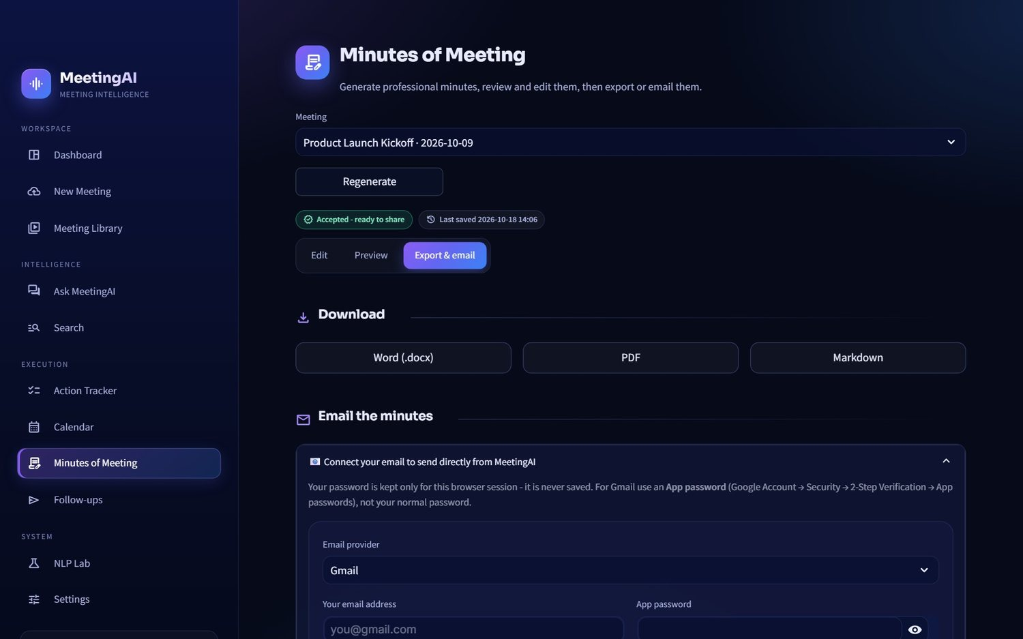
Figure 18 · Minutes export and e-mail

3.11 Follow-ups
Suggested recaps, reminders per person, requests for owners of unassigned tasks and event reminders. Edit, polish with AI (facts unchanged), then send or open in your mail app.
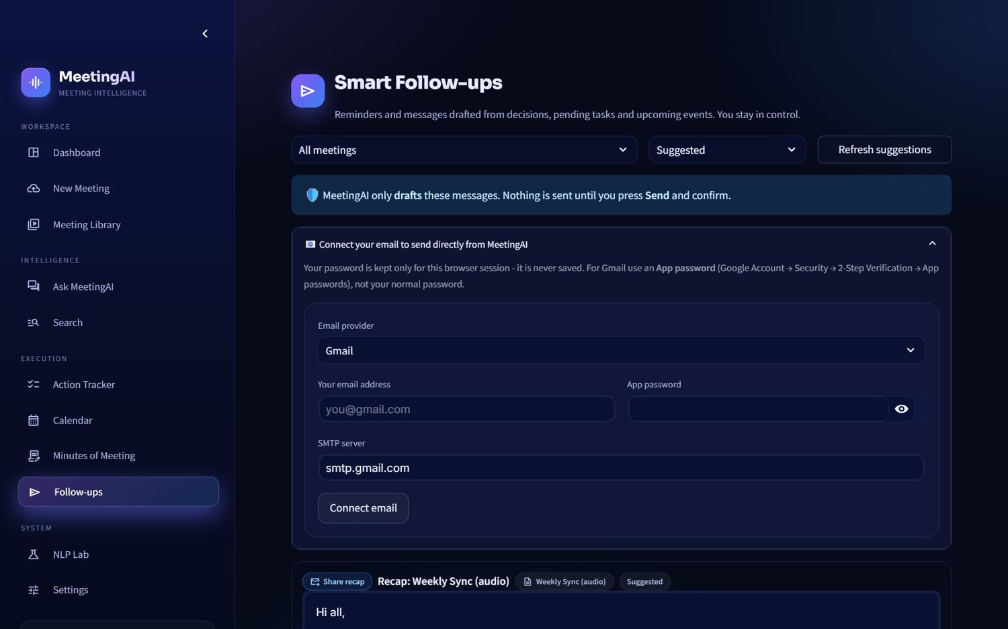
Figure 19 · Follow-ups

3.12 NLP Lab
A "look under the hood" page: try the NLP live on any text, see held-out accuracy and the confusion matrix, tune the thresholds with a simulator, and see gateway statistics.
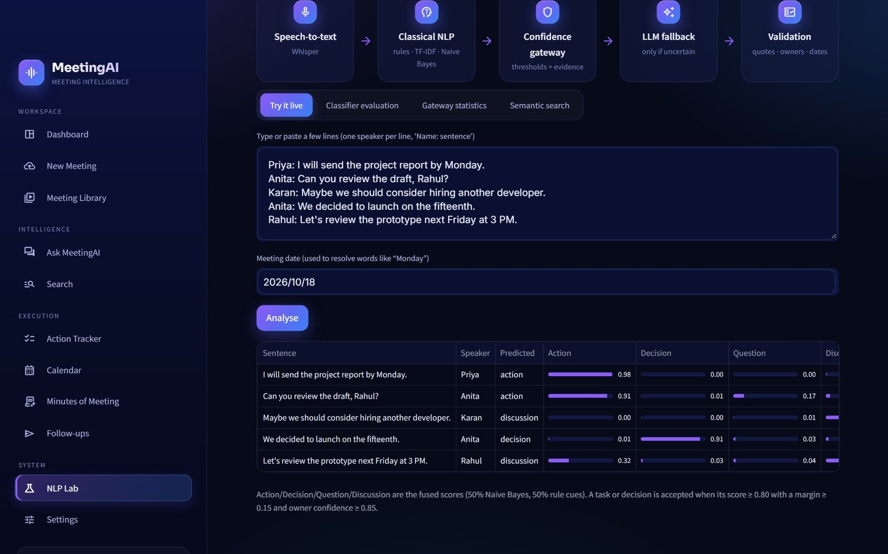
Figure 20 · NLP Lab - live analysis
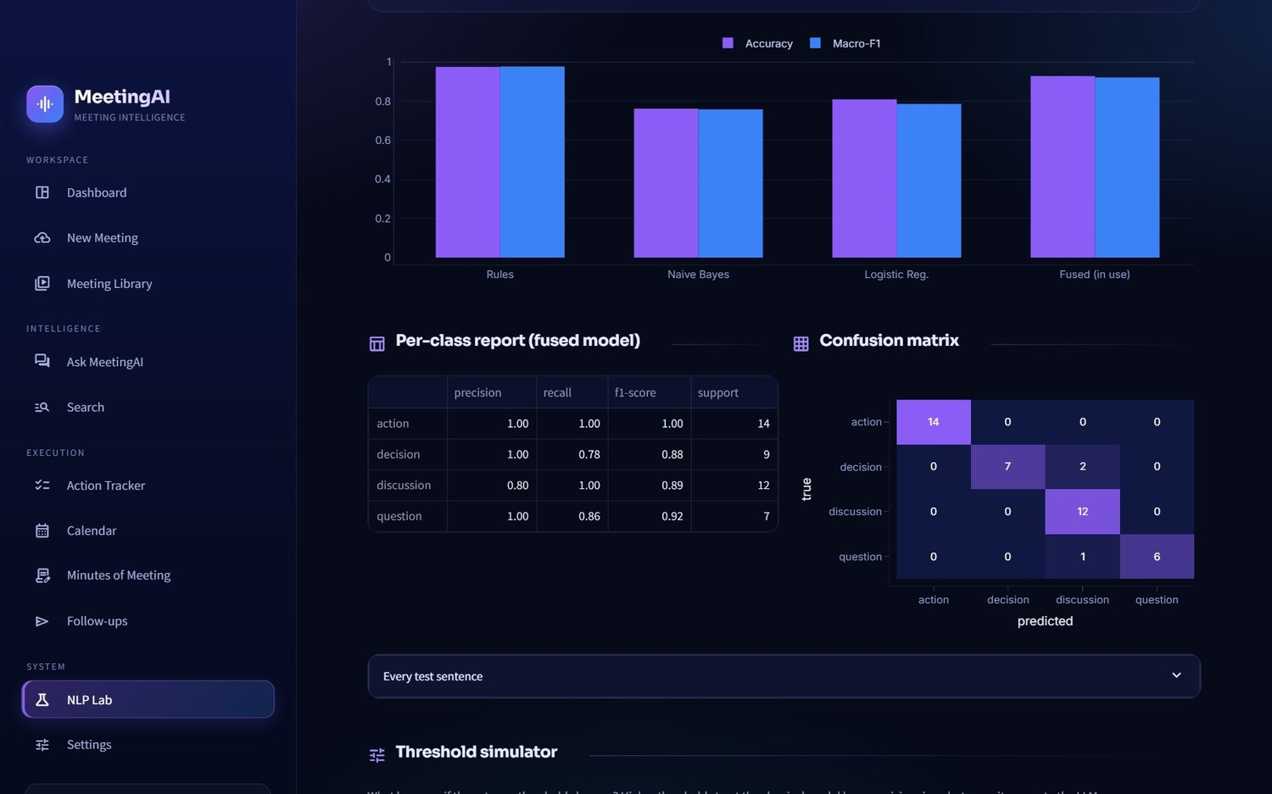
Figure 21 · NLP Lab - classifier evaluation
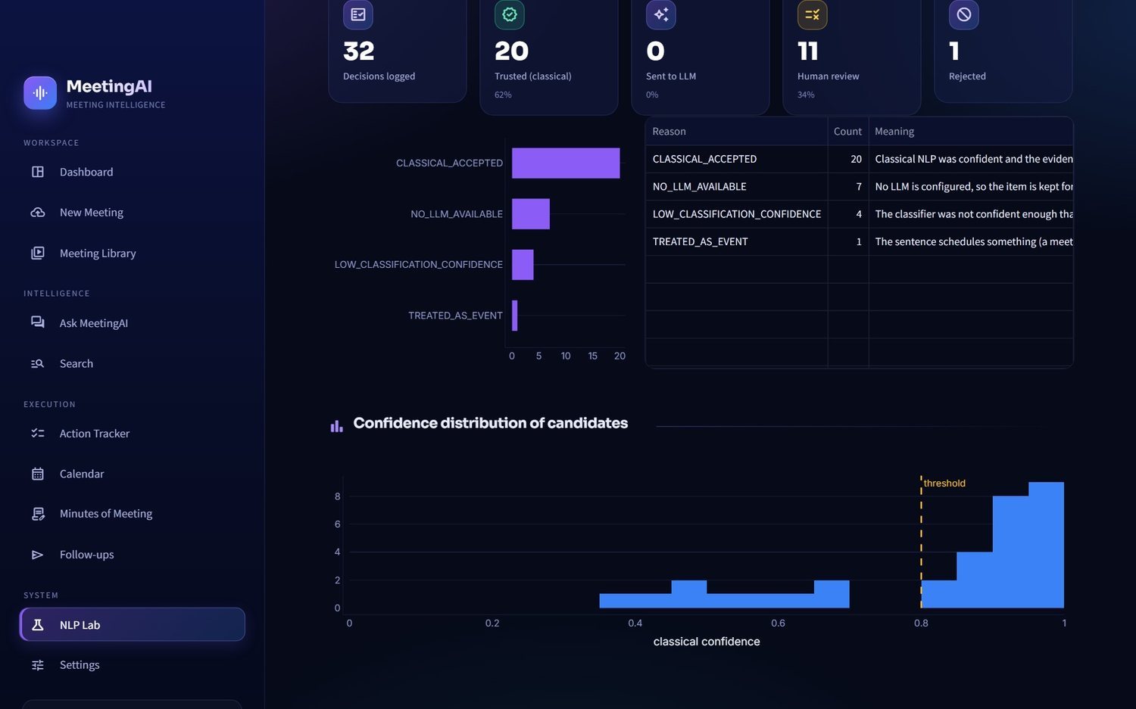
Figure 22 · NLP Lab - gateway statistics

3.13 Settings
Connect free AI services, choose speech and speaker engines, save team voices, tune the confidence gateway, configure e-mail, back up or restore data.
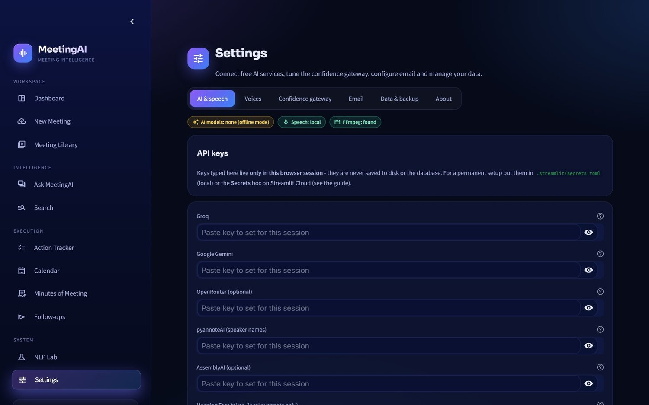
Figure 23 · Settings - AI and speech
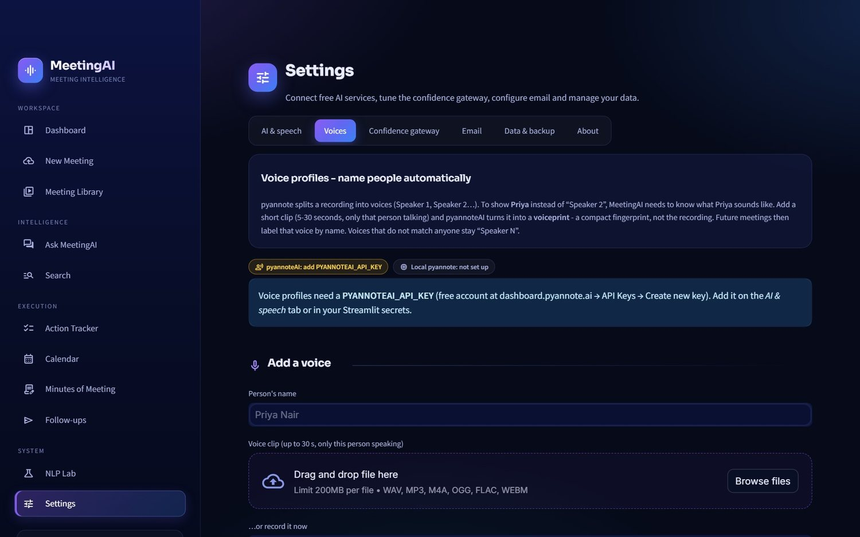
Figure 24 · Settings - voice profiles
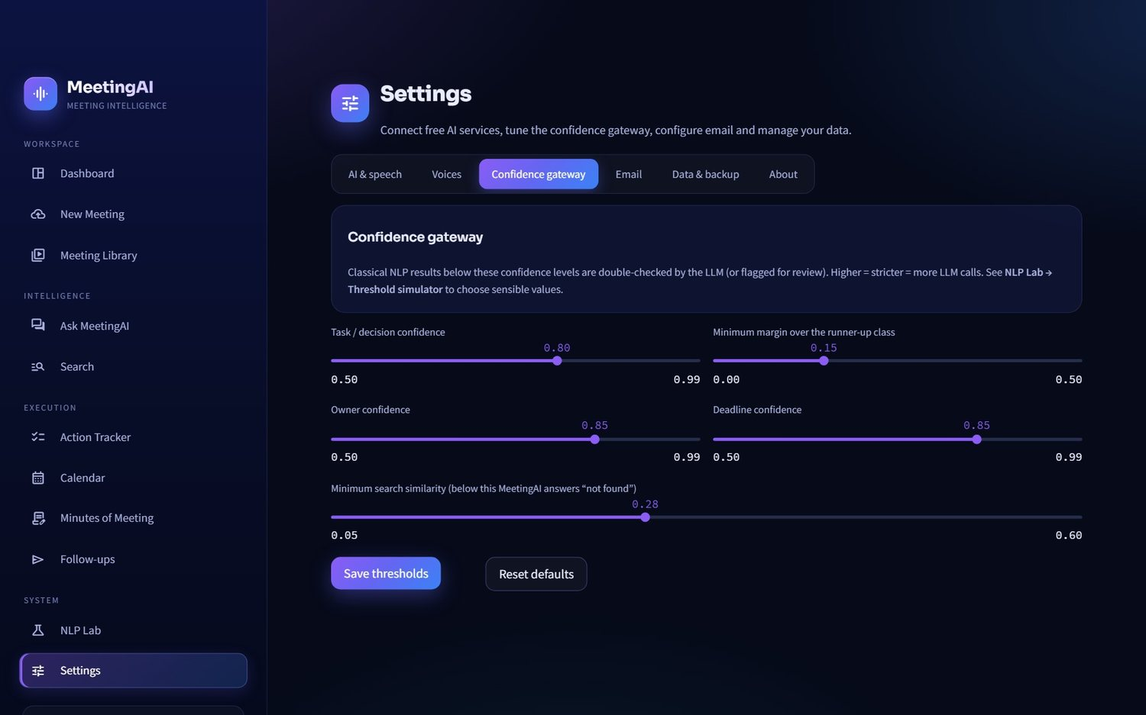
Figure 25 · Settings - confidence gateway

3.14 Phone layout
Columns stack, the sidebar collapses after navigation, and tables scroll.
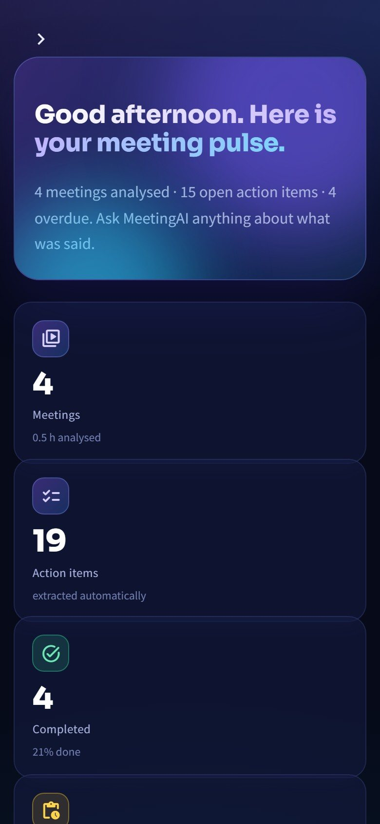
Figure 26 · Phone layout

4 System architecture
Four layers with one strict rule - pages never contain business logic.

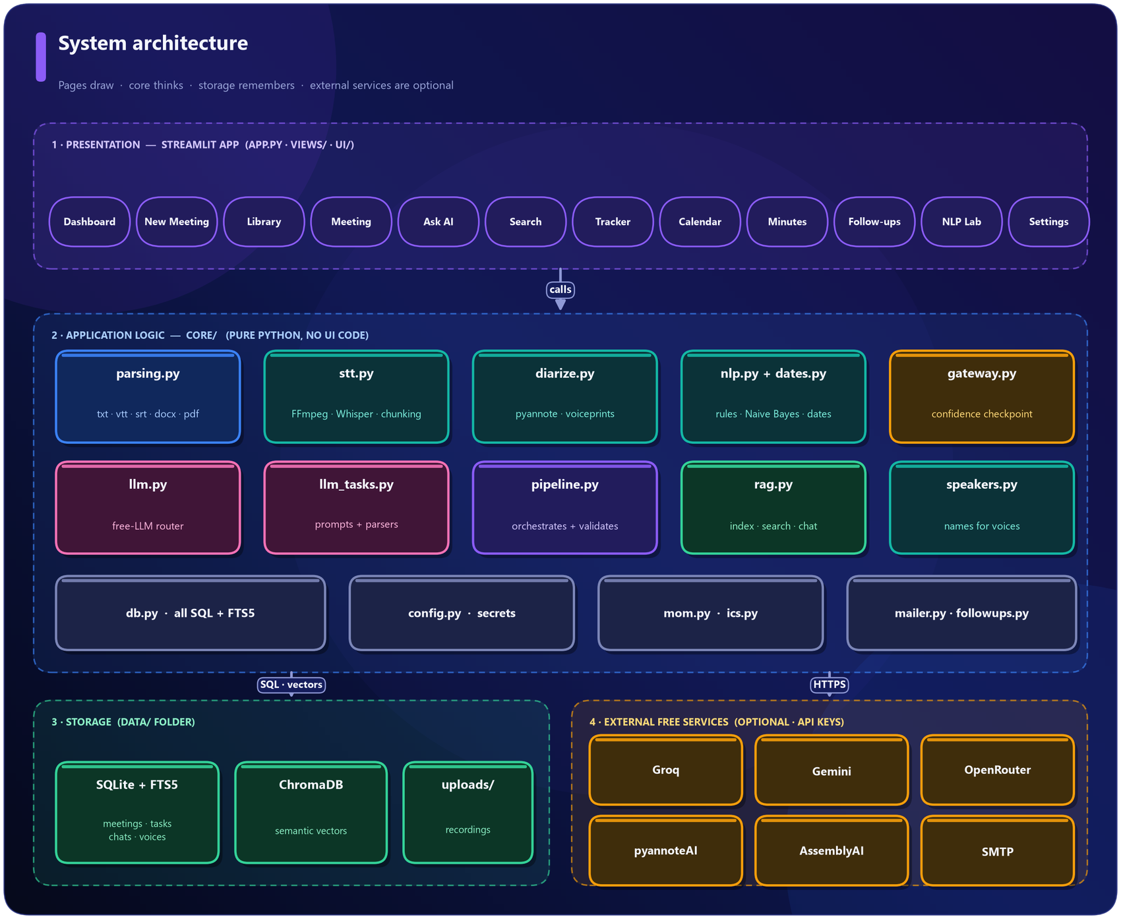
Figure 27 · System architecture
Layer | Folder | Responsibility
Presentation | app.py, views/, ui/ | Pages, theme, reusable HTML components, charts, navigation
Application logic | core/ | Parsing, speech, speakers, NLP, gateway, LLM, search, minutes, e-mail
Storage | data/ (created at run time) | SQLite database, FTS5 index, ChromaDB vectors, uploaded recordings
External services | HTTPS | Groq, Gemini, OpenRouter, pyannoteAI, AssemblyAI, SMTP

NOTE · EVERY EXTERNAL SERVICE IS OPTIONAL
With no keys at all, text transcripts still produce tasks, decisions, events, summaries, search and minutes using classical NLP only. Each service is checked at run time and has a fallback, so a missing key never breaks a page.

How a Streamlit application runs. Streamlit re-runs the whole script after every click. app.py therefore does the same four things each time: apply the theme, check the optional password, draw the sidebar, and import and render the selected page. Per-user state (current page, selected meeting, chat session) lives in st.session_state; durable data lives in SQLite; expensive objects (the trained classifier) are cached.
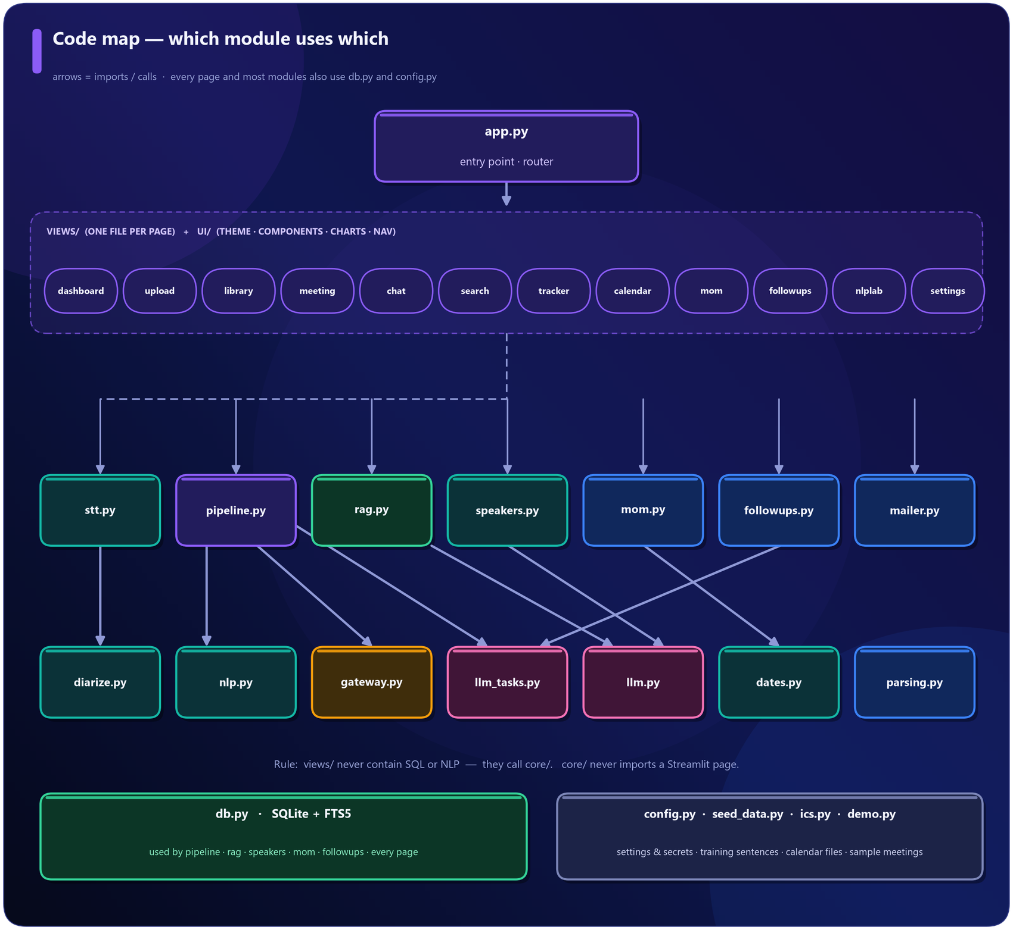
Figure 28 · Which module uses which

5 Start-up, set-up and "training"
What is prepared before the first upload - and why nothing large is pre-trained or stored.

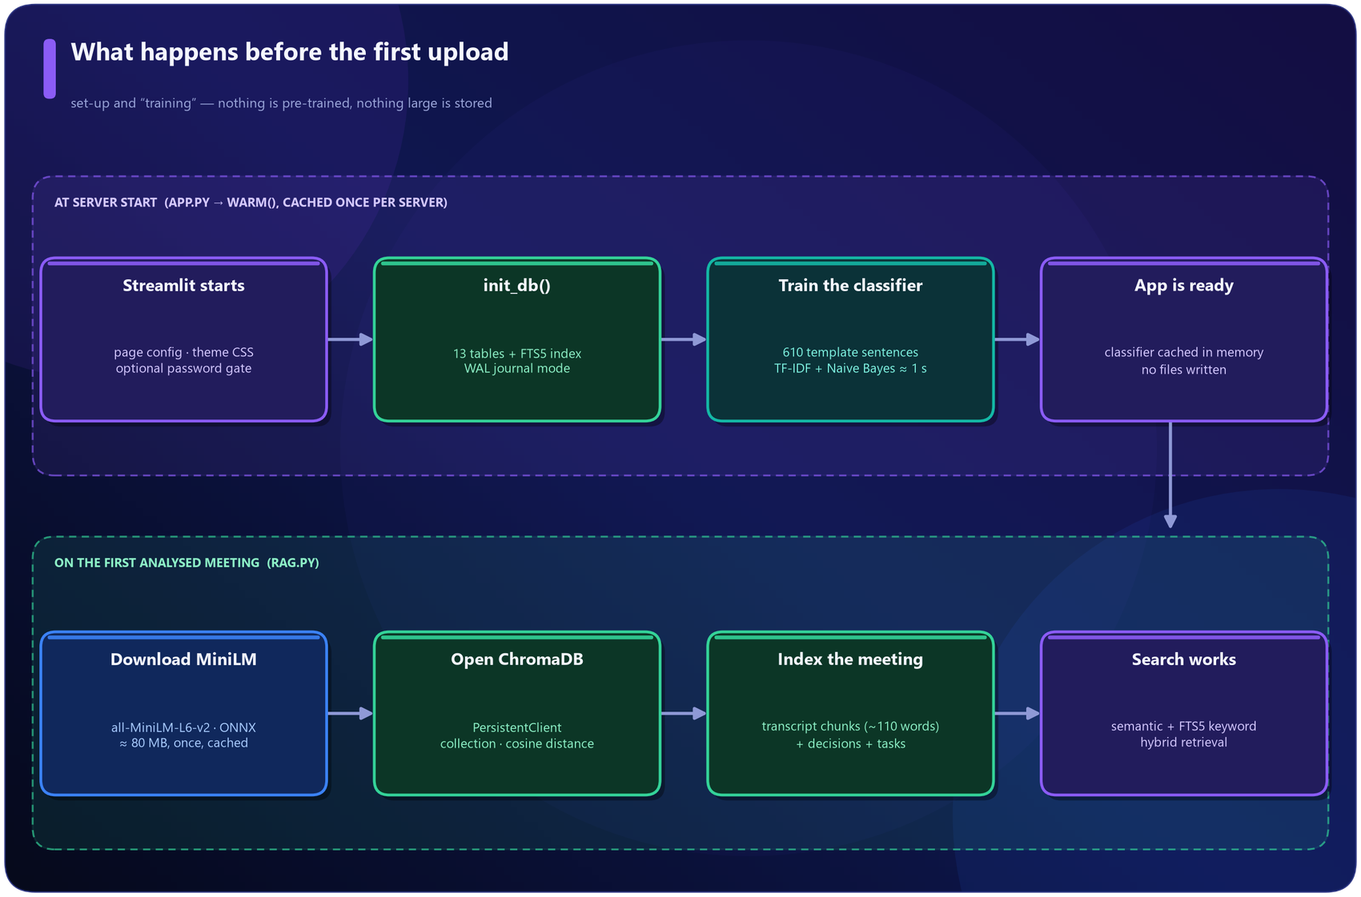
Figure 29 · Start-up sequence

5.1 At server start
• init_db() creates 13 tables and the FTS5 keyword index in data/meetingai.db.
• The classical NLP model is trained from scratch in about one second and cached in memory for the lifetime of the server process. Nothing is saved to disk.
• The theme CSS is injected and the optional password gate is checked.

5.2 What "training" means in this project
There is no large pre-trained model of our own and no GPU work. The only model trained is a small text classifier:
Item | Detail
Training data | core/seed_data.py builds 610 sentences from hand-written templates (190 action, 110 decision, 100 question, 210 discussion), using fixed random seed 42 so results are repeatable
Example template | "{P} will {V} {O} {D}." becomes "Priya will send the budget sheet by Monday." Names, verbs, objects and dates are swapped in
Test data | 42 hand-written sentences in a different style, never used for training; used only by the NLP Lab
Features | TF-IDF over unigrams and bigrams (sublinear_tf=True)
Models | MultinomialNB(alpha=0.3) is used in the app; a logistic regression is trained alongside only for comparison in the NLP Lab

ASSUMPTION · TEMPLATE-GENERATED SEED DATA
Assumption: a small synthetic seed corpus is enough to give the classifier a useful baseline. Why: no public meeting corpus has the labels this project needs (action items, owners, deadlines), and annotating real meetings was outside the project's scope. Effect: the classifier is a baseline, not a production model. The confidence gateway exists precisely to compensate: when the model is unsure, the sentence goes to the LLM.

DESIGN DECISION · TRAIN AT START-UP INSTEAD OF SHIPPING A MODEL FILE
Training takes about a second, so there is no model file to version, no pickle to load from an untrusted source, and the training data stays visible and editable. Changing the seed sentences immediately changes the model.

5.3 On the first analysed meeting
• The all-MiniLM-L6-v2 embedding model (ONNX build, about 80 MB, 384 numbers per text) is downloaded once and cached.
• A ChromaDB PersistentClient collection with cosine distance is opened.
• The meeting's transcript chunks, decisions and tasks are embedded and indexed.
ASSUMPTION · A SMALL ONNX EMBEDDING MODEL INSTEAD OF PYTORCH
Assumption: a compact general-purpose English model gives good-enough semantic search for meeting text. Why: PyTorch needs about 2 GB; the free cloud tier offers about 1 GB. The ONNX MiniLM model is small, fast and CPU-friendly. Effect: semantic quality is good for English but not state-of-the-art; the backend can be switched to BGE-small (EMBEDDING_BACKEND=sbert) where memory allows.

6 End-to-end processing flow
The fourteen steps executed by pipeline.py for every meeting.

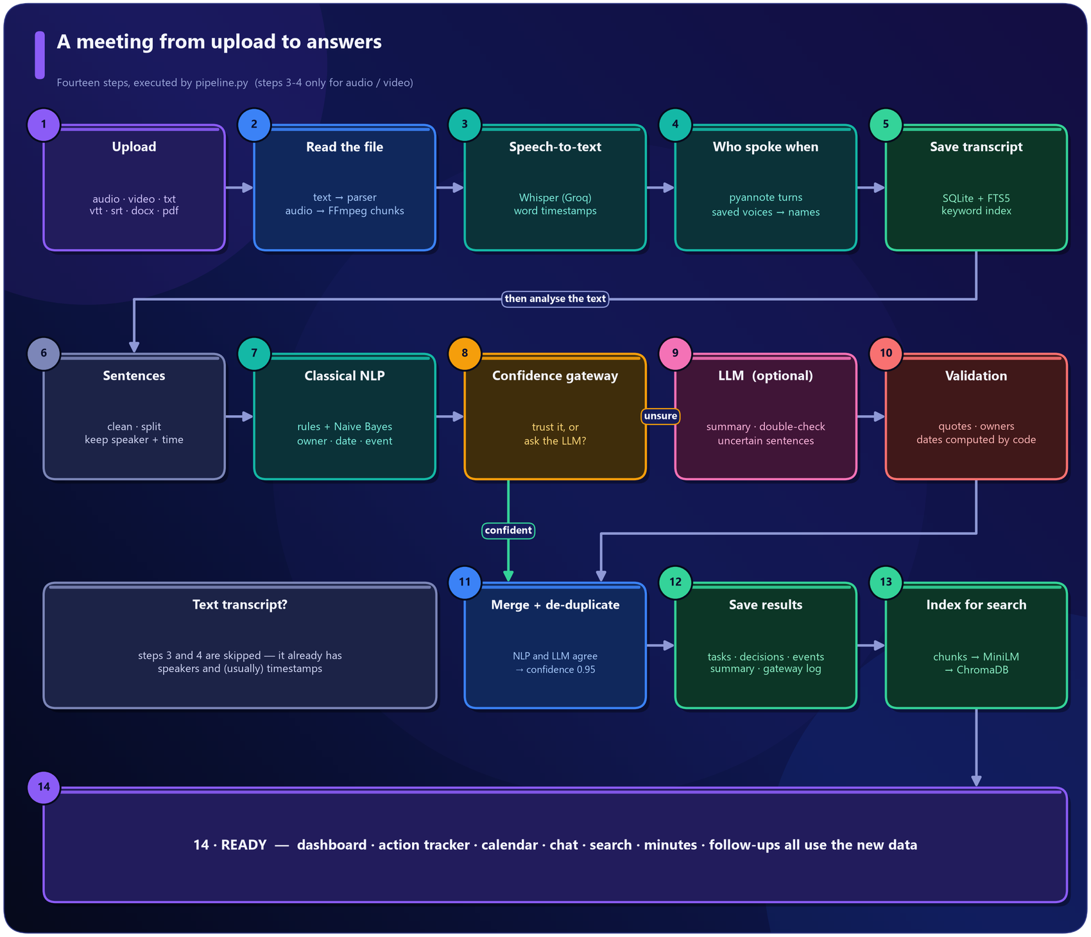
Figure 30 · A meeting from upload to answers
1. Upload. views/upload.py creates a meeting row and chooses a path by file type.
2. Read the file. Text goes through parsing.py (speaker lines, subtitle files, header lines such as Meeting: and Attendees:). Audio and video are converted by FFmpeg into mono 16 kHz MP3 chunks of ten minutes.
3. Speech-to-text. Whisper (via Groq) transcribes each chunk with word timestamps.
4. Who spoke when. pyannote separates the voices; saved voices add names.
5. Save transcript to SQLite and the FTS5 keyword index.
6. Sentences. The text is cleaned of fillers ("um", "you know"), split into sentences, and each sentence remembers its speaker, timestamp and neighbours.
7. Classical NLP scores every sentence and extracts owner, deadline and events.
8. Confidence gateway decides which results are trusted.
9. LLM (optional) writes the summary, double-checks uncertain sentences and looks for items the rules missed.
10. Validation checks every LLM item against the transcript (quotes, owners, dates).
11. Merge and de-duplicate - agreement between classical NLP and the LLM raises confidence to 0.95.
12. Save results (tasks, decisions, events, summary, gateway log).
13. Index for search in ChromaDB.
14. Ready - dashboard, tracker, calendar, chat, search, minutes and follow-ups all use the new data.
ASSUMPTION · SYNCHRONOUS PROCESSING
Assumption: meetings are processed in the foreground, with a progress stepper. Why: the free host runs a single Streamlit process; a background worker would add infrastructure (queues, extra processes) that free hosting does not provide. Effect: very long recordings keep the upload page busy until they finish; ten-minute chunking keeps each external call small and resumable.

7 Speech and "who said what"
pyannote finds the voices; names come from saved voiceprints, clues in the conversation, or you.

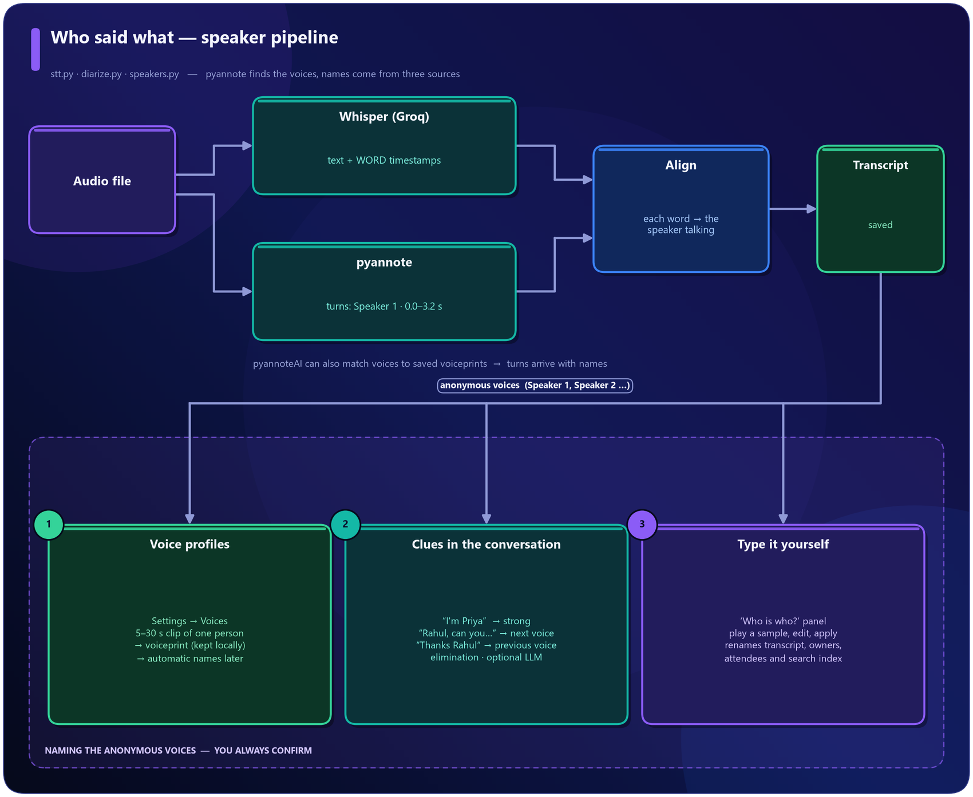
Figure 31 · Speaker pipeline

7.1 Speech-to-text
stt.py converts media with FFmpeg and sends each chunk to Groq Whisper (large-v3-turbo), asking for word-level timestamps. Chunks are time-shifted so the transcript has one continuous timeline. Whisper's two-to-five-second fragments are merged into readable paragraphs (same speaker, small gap, at most 60 words), and segments Whisper probably invented over silence are discarded. A local Whisper model (faster-whisper or openai-whisper) is used if installed and no cloud engine is configured.
ASSUMPTION · TEN-MINUTE CHUNKS, 32 KBPS MONO AUDIO
Why: the free Groq tier limits uploads to roughly 25 MB. Ten minutes of 32 kbps mono MP3 is about 2.4 MB, leaving a very large safety margin, and speech recognition does not need more than 16 kHz mono.

7.2 Diarization with pyannote
diarize.py supports two ways to run pyannote:
 | pyannoteAI hosted API | pyannote.audio locally
Needs | PYANNOTEAI_API_KEY | PyTorch (~2 GB), HF_TOKEN, accepted model terms
Works on free cloud hosting | Yes | No (memory)
Recognises saved voices by name | Yes | No (anonymous labels)

The hosted flow uploads the audio to temporary storage (media://...), submits a diarize job (or an identify job when voice profiles exist), polls the job until it succeeds, and reads the speaker turns (Speaker 1: 0.0 - 3.2 s, ...). Errors are translated into plain language (invalid key, no credits, rate limit).
DESIGN DECISION · HOSTED PYANNOTE FOR THE DEPLOYED APP
The brief asked for pyannote. Running it locally is possible, but it cannot fit on the free cloud tier. The hosted pyannoteAI API (from the pyannote authors) gives the same family of models without PyTorch, and additionally supports voiceprints for automatic naming. Local pyannote remains available for use on a personal computer.

7.3 Aligning words with speakers
assign_speakers gives every Whisper word to the speaker whose turn contains the word's midpoint, so a sentence is split exactly where the voice changes. One-word interjections ("yeah") do not fragment a turn. If a recording has no word timestamps, the speaker with the largest time overlap wins the segment. Raw labels (SPEAKER_00) become Speaker 1, Speaker 2 in order of first appearance.

7.4 Putting names on voices
1. Voice profiles (automatic). Settings → Voices: give a name and a 5-30 second clip of one person. pyannoteAI returns a voiceprint, a compact fingerprint stored in the local database. On later recordings the identify job matches voices to voiceprints; a voice that matches well enough gets the name, the rest stay "Speaker N".
2. Clues in the conversation (speakers.py): self-introductions ("I'm Priya", weight 3), being addressed ("Rahul, can you..." means the next voice, 1.2), being thanked ("Thanks Rahul" means the previous voice, 0.9), elimination (one unnamed voice and one unused attendee), and an optional LLM that must quote its evidence. Names must be attendees or appear in the transcript.
3. Manual. The Who is who? panel with audio samples. Suggestions are never applied silently.
ASSUMPTION · MATCH STRICTNESS 60 / 100
Assumption: a pyannoteAI match score of 60 or more is trustworthy. Why: pyannoteAI documents 50-70 as the sensible range - lower produces wrong names, higher leaves real colleagues as "Speaker N". 60 sits in the middle. Effect: adjustable in Settings → Voices. Unknown people are never forced onto a name.

ASSUMPTION · EVIDENCE WEIGHTS FOR NAME SUGGESTIONS
Assumption: a self-introduction is stronger evidence (3.0) than being addressed (1.2) or thanked (0.9). Why: people name themselves reliably, whereas "Thanks Rahul" could refer to someone who spoke earlier. Confidence is 0.45 + 0.12 x votes, capped at 0.95, and the user always confirms.

Applying names renames the transcript, task owners and decisions, updates the attendee list and refreshes the search index. If the speaker service fails or has no credits, the transcript is still saved (as one speaker) with a visible warning.

8 Classical NLP: how sentences are understood
Two independent experts vote on every sentence; three extractors then find the owner, the deadline and any event.

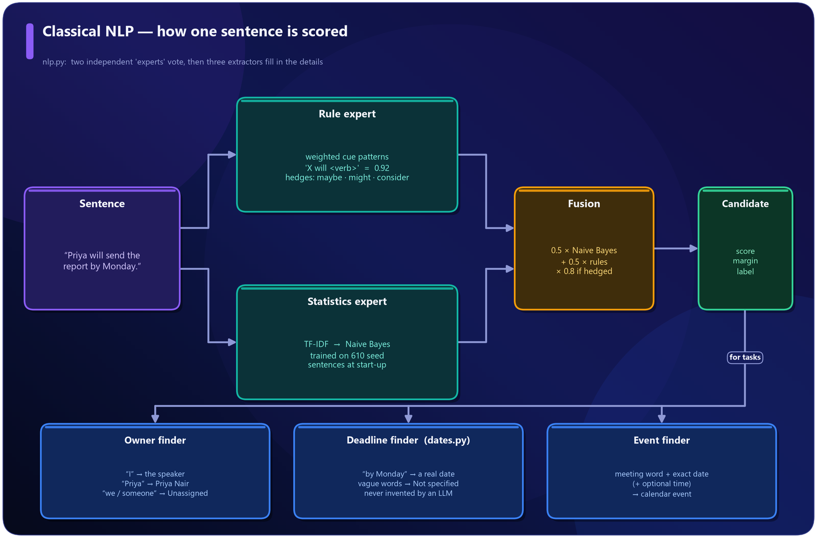
Figure 32 · Classical NLP scoring

8.1 The rule expert
Weighted cue patterns, combined as 1 - (1-w1)(1-w2)...:
Cue | Weight
"action item", "next steps are" | 0.95
"X will / 'll <action verb>" | 0.92
"can you / could you <verb>" | 0.88
"going to <verb>", "responsible for", "assigned to" | 0.85 - 0.88
"needs to <verb>" | 0.80
"we decided / agreed / resolved" | 0.96
"the decision is", "Decision:" | 0.96 - 1.0
"let's go with", "it's settled" | 0.85 - 0.92

Hedging words (maybe, might, perhaps, we could, consider...) mark a suggestion instead of a commitment. A question mark does not turn a request into a question: "Priya, can you send the report?" stays a task.

8.2 The statistics expert
TF-IDF features and Multinomial Naive Bayes (section 5.2) give a probability for each label: action, decision, question, discussion.

8.3 Fusion
score = 0.5 x NaiveBayes + 0.5 x rules, multiplied by 0.8 when the sentence is hedged. The margin is the gap to the best competing label. Sentences scoring below 0.33 are treated as ordinary conversation and never reach the gateway.
ASSUMPTION · EQUAL WEIGHT FOR RULES AND STATISTICS; HEDGE FACTOR 0.8; FLOOR 0.33
Assumption: the two experts deserve equal say. Why: the statistics expert was trained on template data and the rules were written by hand; neither is clearly better, and averaging lets each correct the other. Effect: values were chosen by inspecting behaviour on the sample meetings and the held-out sentences, not by large-scale tuning. They are constants in nlp.py and can be changed.

8.4 The extractors
• Owner (extract_owner): "I" becomes the speaker; "Priya will..." matches a known speaker's full name ("Priya Nair"); "Priya, can you..." addresses Priya; "we / someone" means Unassigned; "he / she / they" cannot be resolved. Each result carries a confidence (0.95 for a known person down to 0.4 for a pronoun).
• Deadline (dates.py): finds expressions such as "by Monday", "next Friday at 3 PM", "end of the month", "in two weeks", "25th October" and converts them relative to the meeting date.
• Event (extract_event): a meeting-type word (call, demo, review, sync, workshop...) plus an exact date becomes a calendar event with an optional time.
KEY IDEA · DATES ARE COMPUTED BY CODE, NEVER BY AN LLM
The date resolver is deterministic and unit-tested. Vague phrases ("next week", "soon") keep their text but receive no calendar date; the deadline shows Not specified. Ambiguous numeric dates such as 03/04 are never guessed.

ASSUMPTION · DATE CONVENTIONS
Assumption: relative dates are measured from the meeting date, "Monday" means the next Monday strictly after it, and "next Monday" means the Monday of the following calendar week; "end of the week" means Friday. Why: a meeting held on Wednesday that says "by Monday" means the coming Monday. Calendar weeks start on Monday in most workplaces. Effect: if a team uses different conventions, the rules live in one file (core/dates.py).

9 The confidence gateway
The checkpoint between classical NLP and the LLM. Four questions, asked in order.

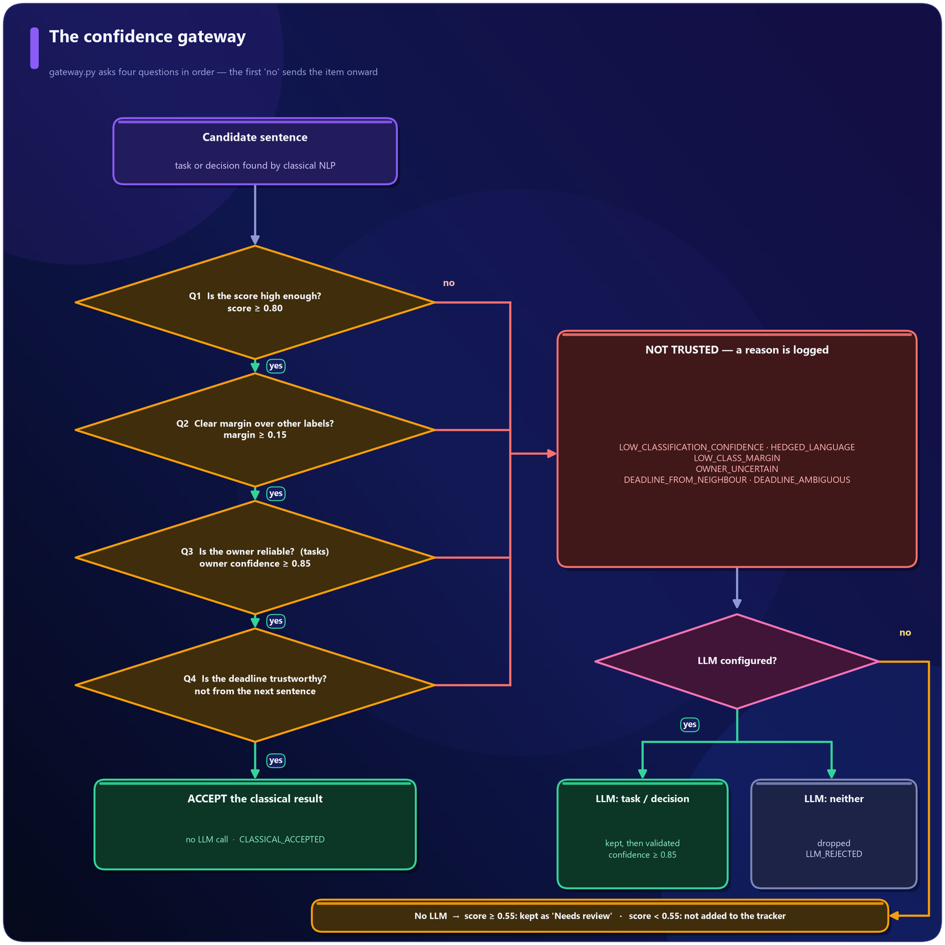
Figure 33 · Confidence gateway
Question | Compared | Default
Q1 Is the score high enough? | fused score (after hedge penalty) | at least 0.80
Q2 Is it clearly ahead of the other labels? | margin | at least 0.15
Q3 Is the owner reliable? (tasks) | owner confidence | at least 0.85
Q4 Is the deadline trustworthy? (tasks) | not from the neighbouring sentence; exact-date confidence | at least 0.85

Failing is not rejecting. It means "not sure". Then:
• LLM configured: the sentence and its context go to one batched call. If the LLM says task or decision it is kept (method LLM fallback, confidence at least 0.85) and validated; if it says "neither" the sentence is dropped.
• No LLM: an item with score of at least 0.55 is kept and marked Needs review; below that it is not added to the tracker. Either way the decision is logged.
Every decision is stored with a reason code (CLASSICAL_ACCEPTED, LOW_CLASSIFICATION_CONFIDENCE, LOW_CLASS_MARGIN, OWNER_UNCERTAIN, DEADLINE_FROM_NEIGHBOUR, HEDGED_LANGUAGE, LLM_CONFIRMED, LLM_REJECTED, MISSING_EVIDENCE, ...) and a readable message. Thresholds are editable in Settings and explored with the NLP Lab's Threshold simulator.
Worked examples
Sentence | Score | Owner | Date | Result
"Priya will send the project report by Monday." | 0.98 | 0.95 | 0.95 | accepted, no LLM
"Please book the conference room." | 0.87 | 0.50 | - | OWNER_UNCERTAIN -> LLM; else Unassigned
"Maybe we should consider hiring another developer." | low (hedged) | - | - | not a task
"We need to fix the login bug soon." | 0.85 | 0.90 ("we" = nobody) | 0.60 (vague) | accepted; owner Unassigned, deadline Not specified

ASSUMPTION · THRESHOLD VALUES 0.80 / 0.15 / 0.85 / 0.85
Assumption: these are sensible starting values, not measured optima. Why: a wrong owner or date does more harm than a wrong label, so owner and deadline are held to a higher bar (0.85) than classification (0.80). The 0.15 margin is a common convention for "clearly ahead". Raw Naive Bayes probabilities are often over-confident, so the rules half of the fusion keeps scores honest. Effect: all four are sliders in Settings. A vague deadline deliberately does not fail the gateway, because an LLM cannot invent a date that was never said.

10 The LLM layer and the validation layer
Free models do the language work; code checks everything they say.

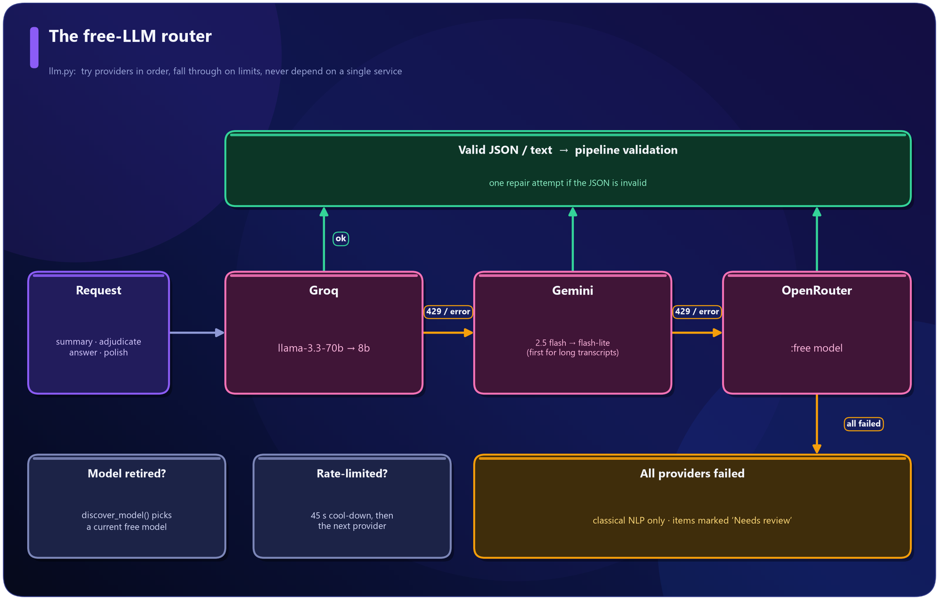
Figure 34 · The free-LLM router

10.1 A router over free LLMs
llm.py speaks the OpenAI-compatible API of Groq, Gemini and OpenRouter using plain HTTPS. Providers are tried in order; a rate limit puts a provider on a 45-second cool-down and the next one is tried; for very long transcripts Gemini (large context window) goes first; if a free model has been retired, the router asks the provider for its current model list and picks a replacement. Malformed JSON gets one automatic repair attempt.
ASSUMPTION · FREE-TIER MODEL NAMES WILL CHANGE
Why: free model catalogues are renamed or retired frequently. Instead of hard-coding one name the router carries defaults, allows overrides through secrets (GROQ_MODEL, GEMINI_MODEL, ...) and can discover a working model on its own.

10.2 What the LLM is asked to do
Call | Purpose
Analysis (per chunk of transcript) | Summary, key points, topics, conclusions, plus independent task / decision / event suggestions
Merge (long meetings) | Combine chunk summaries into one
Adjudication (one batch) | "Is each uncertain sentence a task, a decision or neither?"
Answer | Grounded chat and search answers
Naming, polishing (optional) | Speaker-name evidence, friendlier follow-up wording

The prompts demand verbatim quotes and copied date phrases instead of computed dates, and ask for JSON so that results can be validated mechanically.

10.3 Validation: never trust an LLM blindly
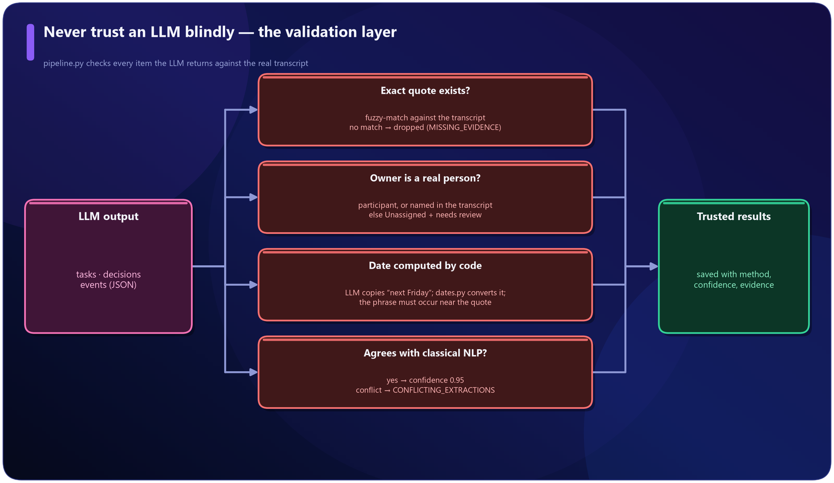
Figure 35 · Validation layer
• Quote check. Each task, decision and event must include an exact quote; fuzzy matching finds it in the transcript or the item is dropped (MISSING_EVIDENCE).
• Owner check. The owner must be a participant or appear in the transcript; otherwise Unassigned and a review flag.
• Date check. Our own resolver converts the copied phrase, and the phrase must occur near the quote.
• Agreement. An item found by both classical NLP and the LLM is marked NLP + LLM agree (confidence 0.95). Different owners produce CONFLICTING_EXTRACTIONS and a review flag.
ASSUMPTION · FUZZY-MATCH TOLERANCE FOR QUOTES
Assumption: a quote matching at 82 % (or 92 % for an immediate accept) of its characters counts as "found". Why: models sometimes drop punctuation or a filler word from an otherwise exact quote; demanding 100 % would reject genuine items, while accepting much less would allow paraphrases.

11 Search and the chatbot
Find the evidence first, answer only from it, then verify the answer.

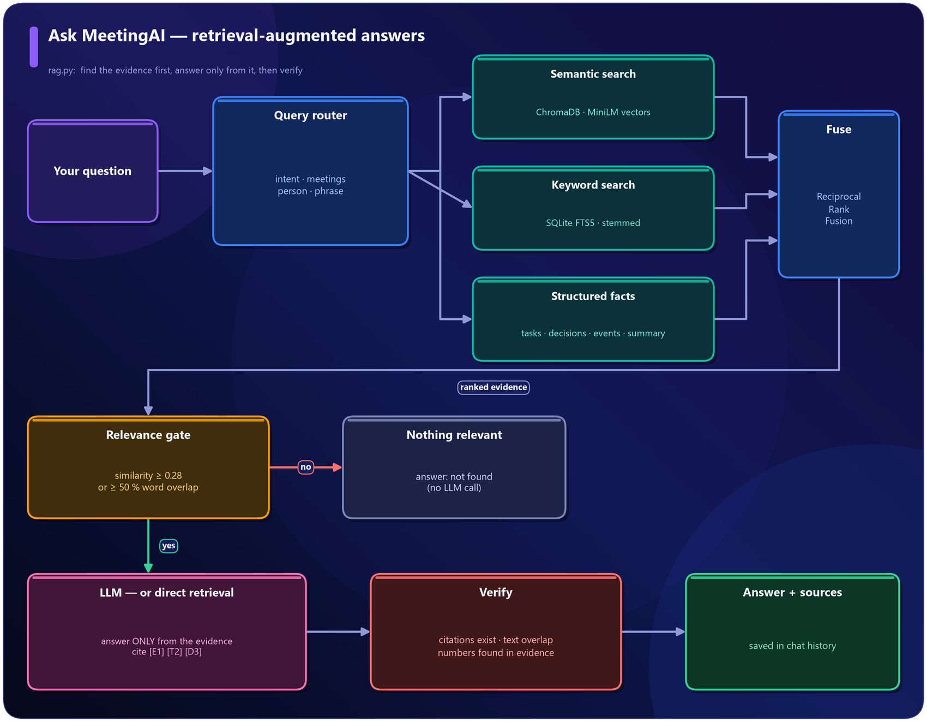
Figure 36 · Retrieval-augmented answers
Indexing. The transcript is cut into chunks of about 110 words, each embedded by MiniLM and stored in a ChromaDB collection (cosine distance). Decisions and tasks are indexed too. SQLite is the source of truth - ChromaDB can always be rebuilt from it.
The query router (route_query) reads the question and chooses which sources matter:
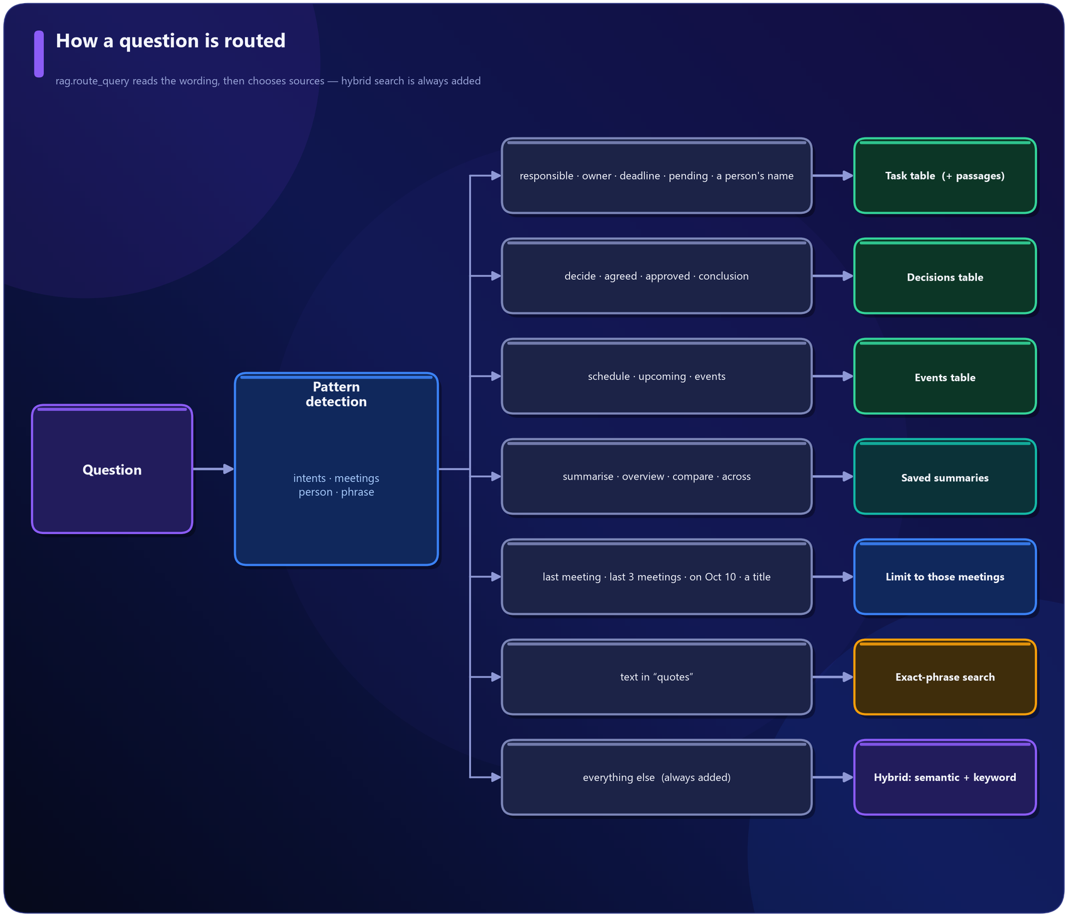
Figure 37 · How a question is routed
Hybrid search. Semantic search (meaning) and SQLite FTS5 keyword search (words, with stemming) each return a ranked list; Reciprocal Rank Fusion (1 / (60 + rank)) merges them so that passages ranking well in both rise to the top.
Relevance gate. If nothing is relevant (similarity of at least 0.28, or at least half of the question's content words appear in the text) the answer is "not found" and no LLM is called.
Answering. The best evidence is labelled [E1], [T2], [D1] ... and given to the LLM with strict rules: answer only from this, cite it, say what is missing. Afterwards the code verifies that cited ids exist, measures how much of the answer is supported by the cited text, and warns about numbers that are not in the evidence. Without an LLM the same evidence is shown directly (a "direct retrieval" answer). Questions, answers, sources and routing details are saved in the chat history.
ASSUMPTION · CHUNK SIZE ~110 WORDS, SIMILARITY FLOOR 0.28, RRF CONSTANT 60
Why: meeting speech is short-turn; about 110 words keeps a chunk on one topic. 0.28 was calibrated by comparing cosine scores of relevant and unrelated queries on the sample meetings (relevant: roughly 0.28 - 0.65; unrelated: below about 0.2). 60 is the standard constant in the original RRF paper. Effect: the floor is a slider in Settings. Near-miss wording ("stock market crash" vs "checkout crash") can still pass the floor; the LLM then answers "not found" because the evidence does not support the question.

12 Minutes, calendar, follow-ups and e-mail
Everything that leaves the application waits for your confirmation.

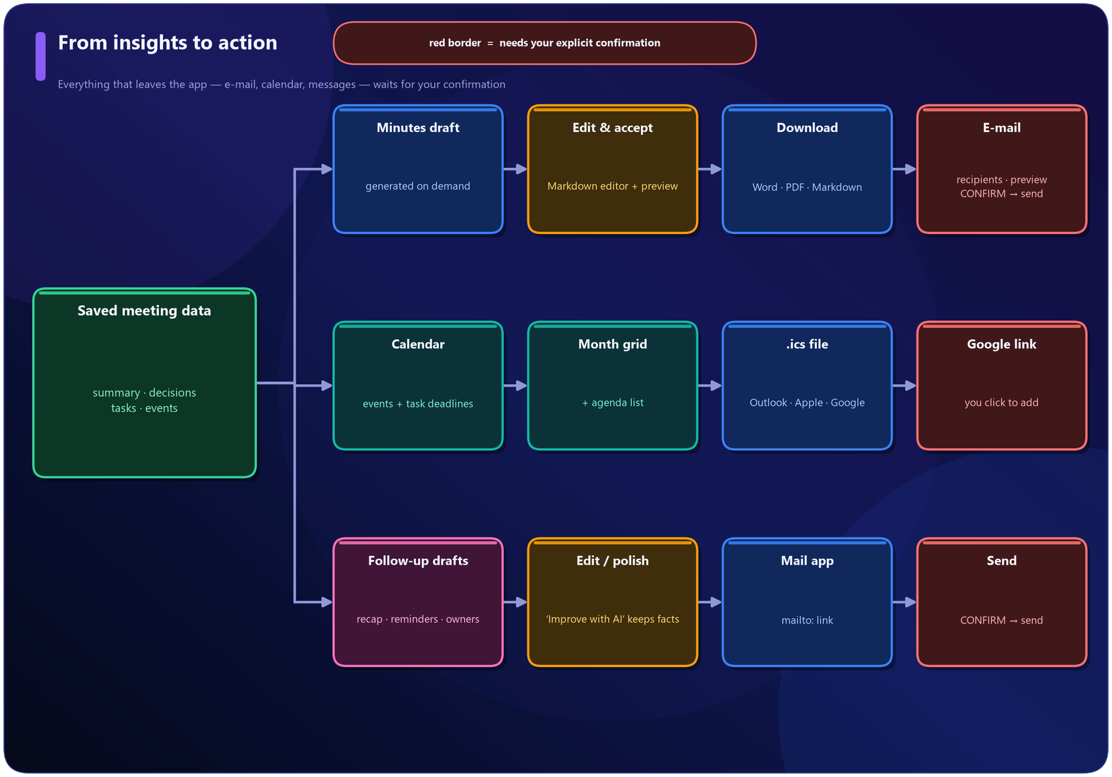
Figure 38 · From insights to action
• Minutes (mom.py) are generated on demand from saved data: details, attendees, agenda, summary, highlights, decisions, action items, events and conclusions. Uncertain rows carry a warning mark. The editor accepts Markdown; Accept unlocks e-mailing; exports are Word, PDF and Markdown, produced by our own renderer (python-docx and ReportLab).
• E-mail (mailer.py) uses SMTP (Gmail app password, Outlook, Yahoo, Brevo ...). Addresses are validated, a preview is shown, a confirmation tick is required, and attachments (Word and/or PDF) are chosen by the user. A "Connect your e-mail" panel appears wherever sending is needed and SMTP is not configured; if sending is impossible a mailto: link is offered.
• Calendar (views/calendar.py, ics.py) merges events and task deadlines. Items can be exported as .ics or added through a Google Calendar link - the user confirms by clicking.
• Follow-ups (followups.py) are drafted from decisions, pending tasks per person, unowned tasks and upcoming events. They are never sent automatically.
DESIGN DECISION · CALENDAR THROUGH LINKS AND .ICS FILES, NOT OAUTH
Creating events directly in Google Calendar needs an OAuth sign-in flow, a verified app and stored tokens - heavy for a free single-process deployment, and a security burden. A pre-filled "Add to Google Calendar" link and a standards-compliant .ics file achieve the same result with no permissions, work with Outlook and Apple Calendar too, and keep the user in control.

ASSUMPTION · MINUTES ARE GENERATED ONLY ON REQUEST
Why: the brief asked for minutes the user can review before sharing. Generating them automatically for every meeting would create drafts nobody asked for. The draft is built from stored, already-validated data, so it needs no extra LLM call.

13 Data model and storage
SQLite is the source of truth; ChromaDB holds only vectors and can be rebuilt at any time.

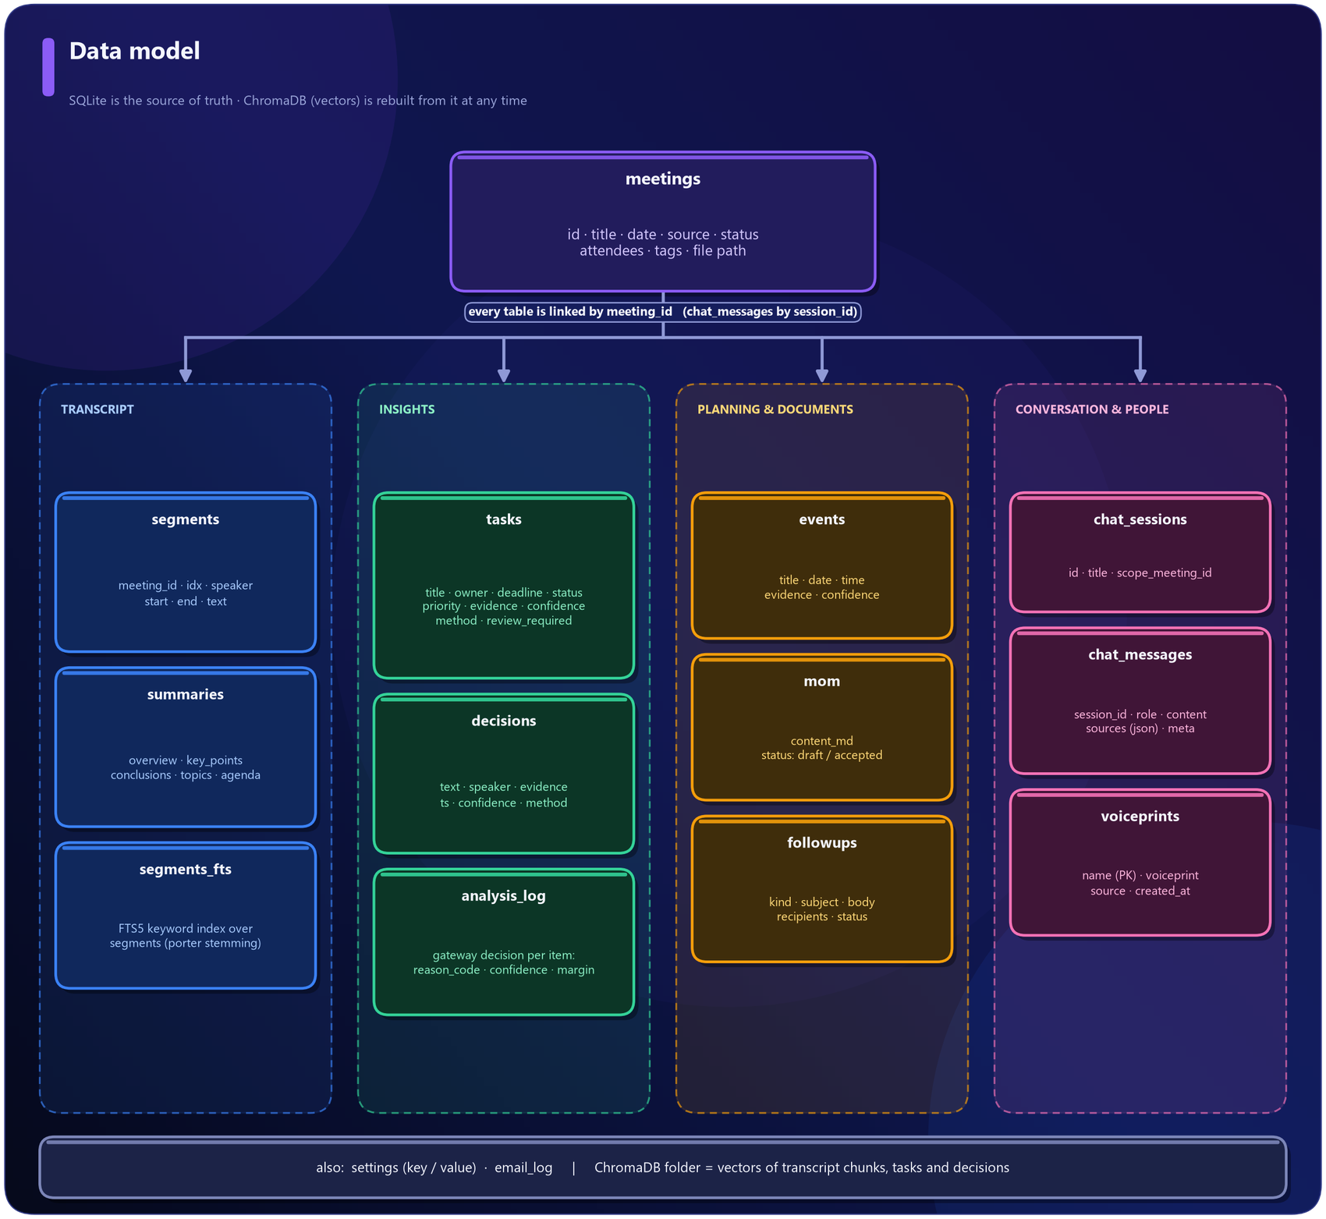
Figure 39 · Data model
SQLite (data/meetingai.db) holds every durable fact: meetings, transcript segments (plus the segments_fts keyword index), summaries, decisions, tasks, events, minutes, chat sessions and messages, follow-ups, the gateway log (analysis_log), the e-mail log, settings and voiceprints. ChromaDB (data/chroma/) holds only vectors, and uploaded recordings live in data/uploads/.
DESIGN DECISION · SQLITE PLUS CHROMADB INSTEAD OF A HOSTED DATABASE
The project deliberately avoids a database server (no PostgreSQL, no Supabase): SQLite is a file, ships with Python and supports full-text search through FTS5; ChromaDB runs inside the app for semantic search. The two are complementary - exact lookups and keywords in SQLite, meaning in ChromaDB.

ASSUMPTION · TEMPORARY STORAGE ON FREE HOSTING
Assumption: users accept that free hosting may reset the disk. Why: a persistent database would require a paid or externally managed service. Effect: Settings → Data & backup creates a zip (database, vectors, recordings) that can be restored later. Locally, data simply persists.

14 User-interface design
A dedicated AI-product look instead of a default dashboard.

• Palette: deep navy (#060A19) background with violet (#8B5CF6) to blue (#3B82F6) gradients, glass-style cards, and green / amber / red reserved for status.
• Typography: Sora for headings, Inter for text, JetBrains Mono for timestamps; Material Symbols icons.
• Components (ui/components.py): metric cards, status chips, speaker avatars, the transcript viewer, a month grid, steppers, empty states.
• Behaviour: smooth fade-ins, an animated hero, loading steppers and spinners, toast messages, helpful empty states, responsive columns, and a sidebar that collapses after navigation on phones.
• Consistency: every page uses the same header, section titles, cards and buttons, so the product feels like one application.
DESIGN DECISION · CUSTOM CSS INSIDE STREAMLIT
Streamlit's default look is plain, so about 240 lines of CSS restyle the sidebar, buttons, inputs, tabs, chat bubbles and tables. Cards and chips are small HTML builders (H() strips indentation so that Markdown never turns HTML into a code block, and every piece of user text is escaped with esc()).

15 Technology stack and why each piece was chosen
Everything is free to use; each choice solves a specific constraint.

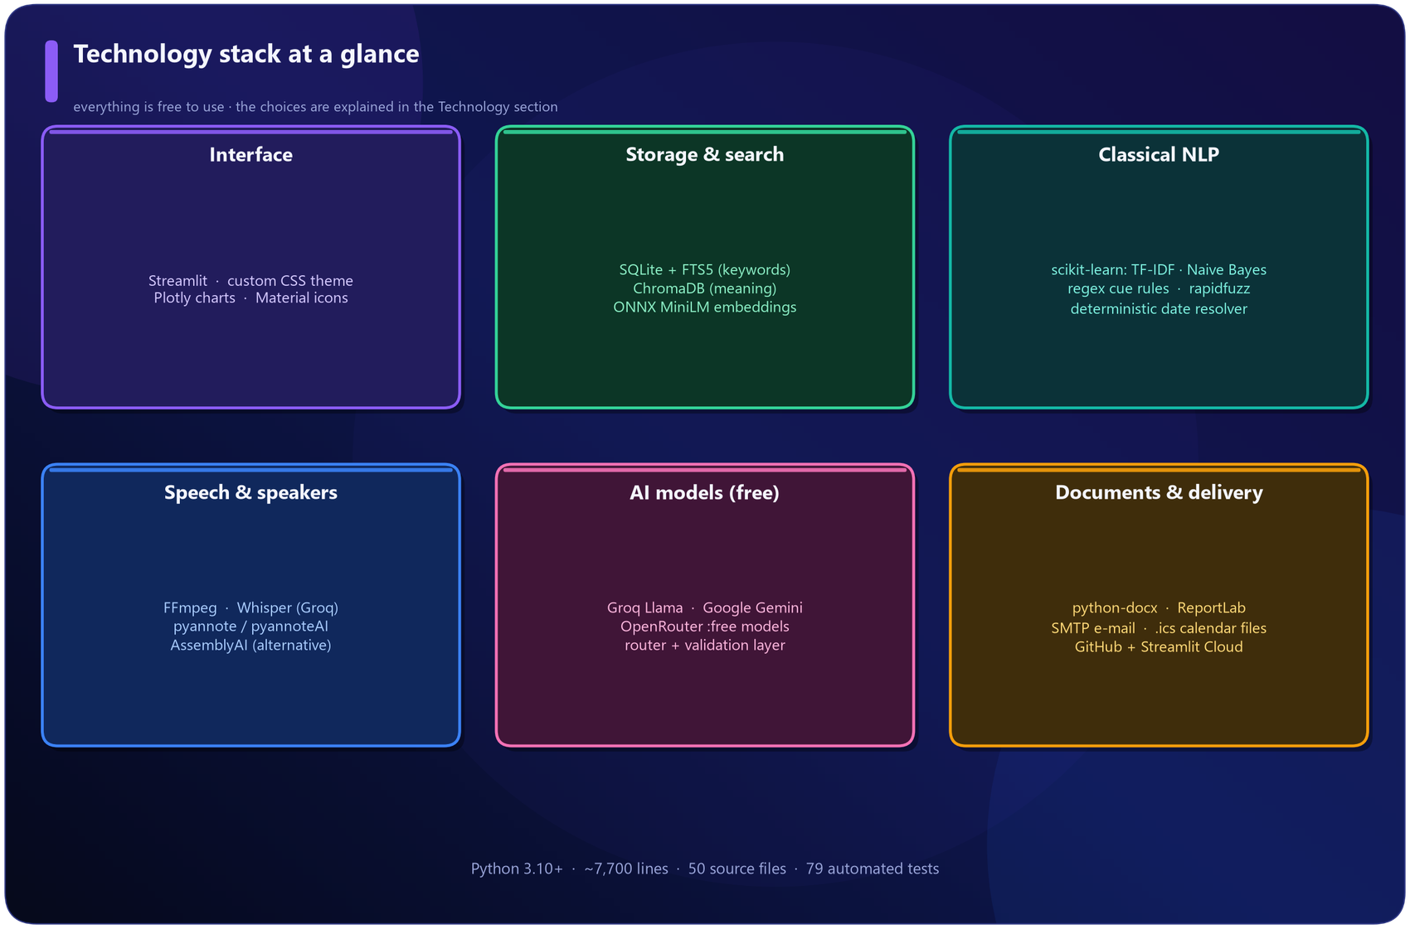
Figure 40 · Technology stack
Job | Technology | Why
Interface | Streamlit + custom CSS | One language (Python), fast to build, free hosting
Charts | Plotly | Interactive and themeable
Structured data | SQLite | A full database in one file; nothing to install or pay for
Keyword search | SQLite FTS5 (porter stemming) | Built in and fast
Semantic search | ChromaDB + ONNX MiniLM | Local vector database; a small model without PyTorch fits free hosting
Classical NLP | scikit-learn, regular expressions, rapidfuzz | Fast, offline, explainable, produces confidence
Dates | Custom resolver (dates.py) | Deterministic and testable; never hallucinates
Speech-to-text | Whisper via Groq (or local) | Best open ASR; Groq's free tier is fast
Speakers | pyannote (pyannoteAI hosted or local); AssemblyAI as alternative | Leading diarization toolkit; the hosted API fits free hosting and recognises voices
LLMs | Groq (Llama), Gemini, OpenRouter free models | All free tiers; automatic fallback when one is limited
Audio | FFmpeg | The standard tool
Documents | python-docx, ReportLab | Pure Python, no Office installation needed
E-mail | SMTP | Works with any provider
Deployment | Streamlit Community Cloud + GitHub | Free, redeploys on every push

16 Assumptions and design decisions - consolidated
Every place where the project chose a value or a rule instead of measuring it, with the reason.

The callout boxes in earlier sections explain assumptions in context. This table gathers them in one place so that a reader can see at a glance what was assumed, why, and how to change it.
# | Assumption / decision | Why it was made | How to change it
1 | One shared workspace, no user accounts | Accounts need auth and a hosted database; not possible on free single-process hosting | Optional APP_PASSWORD; accounts are future work
2 | Classifier trained on 610 template-generated sentences | No public dataset has action / owner / deadline labels | Edit core/seed_data.py or add real annotated sentences
3 | Train at start-up, store no model file | Takes about 1 s; avoids stale or untrusted pickle files | n/a
4 | Rules and Naive Bayes fused 50 / 50; hedge factor 0.8; floor 0.33 | Neither expert is clearly better; values chosen by inspection | Constants in core/nlp.py
5 | Gateway thresholds 0.80 / 0.15 / 0.85 / 0.85 | Starting values; owner and date errors are costlier than label errors | Settings sliders + NLP Lab simulator
6 | Vague deadlines do not trigger the LLM | An LLM cannot invent a date that was never spoken | n/a (by design)
7 | Dates relative to the meeting date; weekday and week rules as in section 8 | Matches how people speak in a meeting | core/dates.py
8 | Dates are never produced by an LLM | Prevents hallucinated calendar entries | n/a (by design)
9 | Unknown owner = Unassigned, unknown date = Not specified | Honesty requirement of the brief | n/a (by design)
10 | Audio converted to 32 kbps mono, 10-minute chunks | Free API upload limits (about 25 MB) | CHUNK_SECONDS in core/stt.py
11 | Hosted pyannote for deployment | PyTorch does not fit the free tier; the hosted API also offers voiceprints | HF_TOKEN + requirements-local.txt for local pyannote
12 | Voice-match strictness 60 / 100 | pyannoteAI recommends 50-70 | Settings → Voices
13 | Name-suggestion evidence weights (3.0 / 1.2 / 0.9) | Self-introduction is stronger than being addressed or thanked | core/speakers.py
14 | Word midpoint decides the speaker of a word | Simple and robust against small timing offsets | assign_speakers in core/diarize.py
15 | MiniLM ONNX embeddings, ~110-word chunks, similarity floor 0.28, RRF constant 60 | Small, CPU-friendly, calibrated on sample queries | EMBEDDING_BACKEND, Settings slider
16 | LLM quotes must match the transcript at 82 % or better | Tolerates punctuation / filler differences, rejects paraphrase | verify_quote in core/pipeline.py
17 | Free-model names will change | Free catalogues are renamed often | Secrets overrides + automatic model discovery
18 | Processing is synchronous | Free hosting has one process, no worker queue | n/a
19 | Calendar through links and .ics, not OAuth | No stored tokens, works with any calendar | n/a
20 | Minutes generated only on request | The user reviews before anything is shared | n/a
21 | Temporary disk on free hosting | A persistent database would be a paid service | Backup / restore in Settings
22 | English-language focus | Models, cue patterns and seed sentences are English | New cue patterns and seed data per language
23 | Sample meetings use dates relative to today | The calendar and tracker always show upcoming and overdue items | core/demo.py

NOTE · READING THE TABLE HONESTLY
None of these values claims to be an optimum. They are documented so that they can be challenged, measured and replaced - and the NLP Lab, the gateway log and the Settings sliders exist to make that easy.

17 Security, privacy and honesty by design
Keys stay out of the code, users stay in control, and the system never pretends to know.

• Keys are never written to the database or the repository: Streamlit secrets, environment variables, or typed into Settings (kept for the browser session only).
• Password gate: set APP_PASSWORD to protect a public deployment; the comparison is constant-time.
• Confirmation before side effects: e-mails and follow-ups are sent only after an explicit tick or click; calendar additions are links the user clicks.
• Untrusted content: transcripts and LLM output are treated as data - they cannot trigger actions, and LLM output must pass validation.
• What leaves the machine (only when configured): audio to Groq and pyannoteAI (or AssemblyAI); transcript text to Groq / Gemini / OpenRouter. A switch on the upload page turns LLM use off per meeting.
• Voiceprints stay in your own database; create them only for people who agreed, and delete them at any time.
• Honesty: unknown owners show Unassigned, unknown dates Not specified, unanswerable questions not found, uncertain items Needs review.
• Safe file handling: restore archives are checked against path traversal; uploaded files get generated names.

18 Deployment
Free hosting on Streamlit Community Cloud, straight from GitHub.

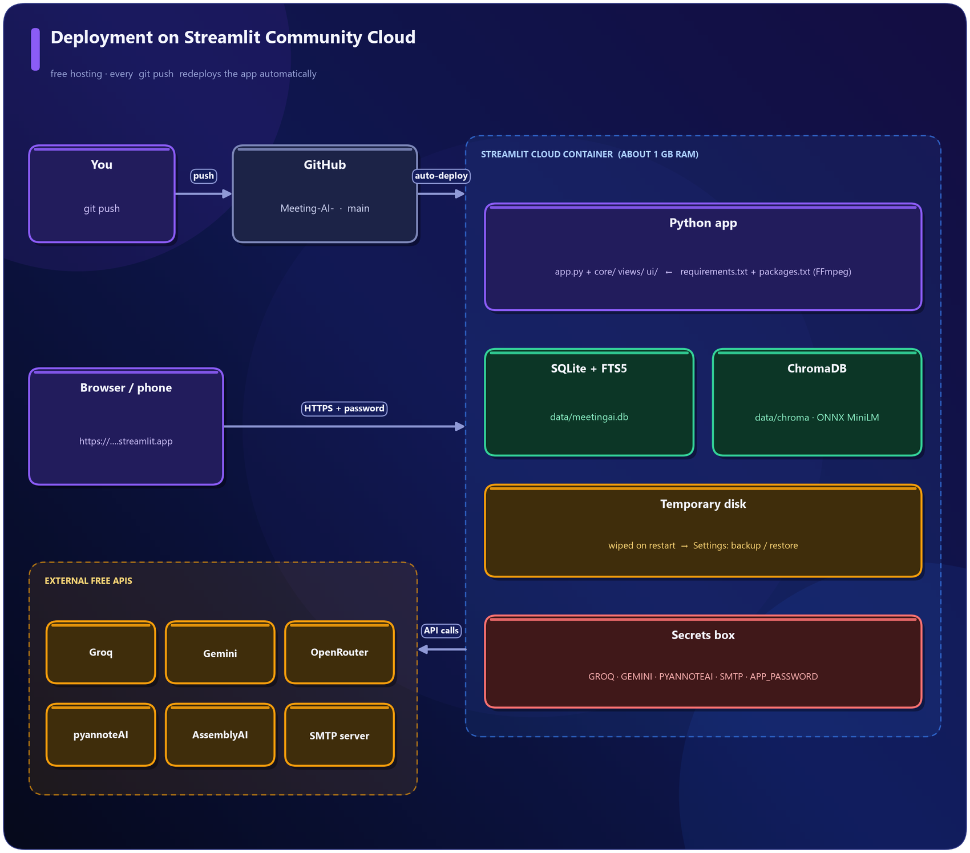
Figure 41 · Deployment architecture
Live application | https://gd4n8x8sjkkxmdhfptkc9m.streamlit.app/
Source repository | https://github.com/nidhitiwari23/Meeting-AI-
Hosting | Streamlit Community Cloud (free)

Deployment steps
1. Push the code to GitHub (git push origin main).
2. In Streamlit Cloud choose the repository, branch main and file app.py; pick Python 3.11 or 3.12.
3. Streamlit installs requirements.txt (Python packages) and packages.txt (FFmpeg).
4. Paste the API keys into the app's Secrets box (GROQ_API_KEY, GEMINI_API_KEY, PYANNOTEAI_API_KEY, SMTP_*, APP_PASSWORD).
5. Every later git push redeploys automatically.
Facts about the free tier that shaped the design: about 1 GB of memory (hence ONNX instead of PyTorch), the app sleeps when idle, and the disk is temporary (hence backup and restore). Alternatives: Hugging Face Spaces (more memory), Render, Google Cloud Run, or running locally.

19 Source-code map
One line per file. The Code Walkthrough document explains every file in depth.

Entry point and configuration
File | What it does
app.py | Page setup, optional password gate, sidebar, loads the selected page
requirements.txt / packages.txt | Python packages / system packages (FFmpeg) for deployment
requirements-local.txt | Optional: local pyannote.audio (PyTorch)
.streamlit/config.toml, secrets.toml.example | Dark theme and upload limit / template for API keys

`core/` - application logic
File | What it does
config.py | Paths, defaults, secret lookup (session, secrets, environment)
db.py | All SQLite tables and every read / write function, FTS5 search
parsing.py | Reads txt / vtt / srt / docx / pdf into speaker segments
stt.py | FFmpeg conversion, Whisper (Groq / local), AssemblyAI, merging, orchestration
diarize.py | pyannote (hosted / local), voiceprints, word-to-speaker alignment
speakers.py | Name suggestions for anonymous voices, applying names
dates.py | Finds and converts date and time expressions
seed_data.py | Training and test sentences for the classifier
nlp.py | Sentences, rules, Naive Bayes, owner / deadline / event extraction, offline summary
gateway.py | The confidence gateway and reason codes
llm.py | Free-LLM router with fallback and model discovery
llm_tasks.py | Prompts and parsers for everything the LLM does
pipeline.py | Orchestrates analysis, validation, merging and saving
rag.py | ChromaDB index, hybrid search, query router, grounded answers
mom.py | Minutes generation and Markdown / HTML / Word / PDF rendering
mailer.py | SMTP sending, address validation, mailto: links
ics.py | Calendar files and Google Calendar links
followups.py | Drafts follow-up messages and reminders
demo.py | Three sample meetings

`ui/` and `views/` - the interface
File | What it does
ui/theme.py | All CSS (colours, cards, animations, responsive rules)
ui/components.py | Reusable HTML: cards, chips, transcript viewer, calendar grid
ui/charts.py, ui/nav.py | Themed Plotly charts; navigation helpers
views/dashboard.py ... views/settings.py | One file per page: dashboard, upload, library, meeting, chat, search, tracker, calendar, mom, followups, nlplab, settings
views/_tasks.py, _speakers.py, _email.py | Shared panels: editable task table, Who is who?, Connect e-mail

20 Glossary
Plain-language definitions of the terms used in this report.

Term | Meaning
Action item | A task someone agreed to do
ASR | Automatic speech recognition - turning audio into text
Chunk | A short piece of transcript stored for searching
Confidence | A number from 0 to 1 showing how sure a model is
Diarization | Working out who spoke when
Embedding | A list of numbers representing the meaning of a text
FTS5 | SQLite's built-in full-text search
Gateway | The checkpoint deciding whether classical NLP is trusted or the LLM must double-check
Hallucination | Confident but false AI output
LLM | Large language model (Llama, Gemini)
Margin | The gap between the best and second-best guess
MoM | Minutes of Meeting
Naive Bayes | A simple probability-based classifier
NLP | Natural language processing
RAG | Retrieval-augmented generation: find relevant text first, then answer only from it
RRF | Reciprocal rank fusion, a way of merging two ranked lists
TF-IDF | A score of how important a word is in a text compared with all others
Voiceprint | A compact numeric fingerprint of a voice
Whisper | OpenAI's open speech-recognition model

