MeetingAI - Code Walkthrough
Every source file explained: what it does, how it works, and how the pieces fit together.
Live application | https://YOUR-APP-NAME.streamlit.app
Source code | https://github.com/nidhitiwari23/Meeting-AI-
Size | about 7,700 lines of Python in 50 source files, plus 79 automated tests
Companion document | MeetingAI - Project Report (architecture, screenshots, design decisions)

Contents
1. How to read this document
2. The big picture
3. How a Streamlit app runs (and why it matters for the code)
4. Repository layout
5. app.py - the entry point
6. core/ - the application logic (file by file)
7. ui/ - theme and reusable components
8. views/ - one file per page
9. Tests
10. Configuration and deployment files
11. Recipes: how to extend the project
12. Design rules and gotchas
____________________________________________________________

1. How to read this document
Each file has four short parts:
- Purpose - what the file is for, in one or two sentences.
- Key pieces - the important functions/classes, each with a one-line description.
- How it works - the logic in plain language.
- Talks to - which other files it uses, so you can follow the flow.
Function names are real; you can search for them in the code.

2. The big picture
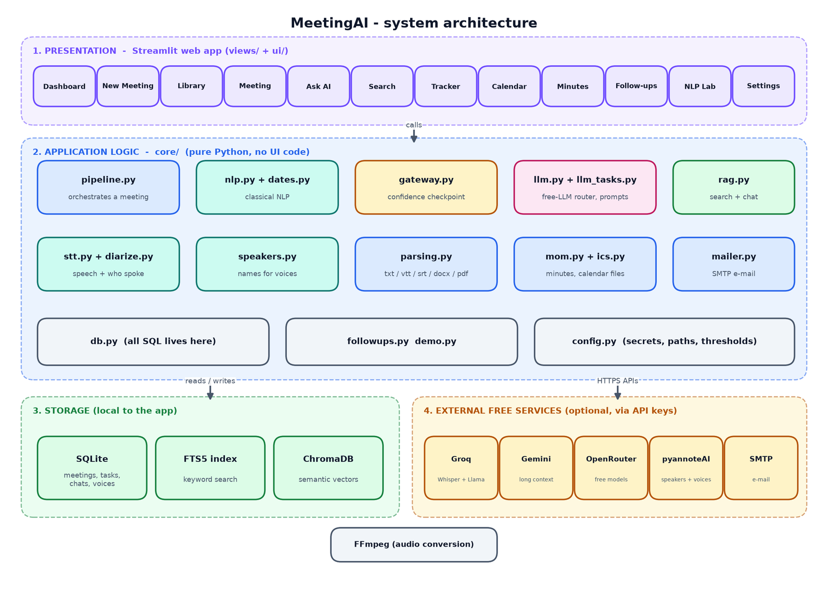
System architecture
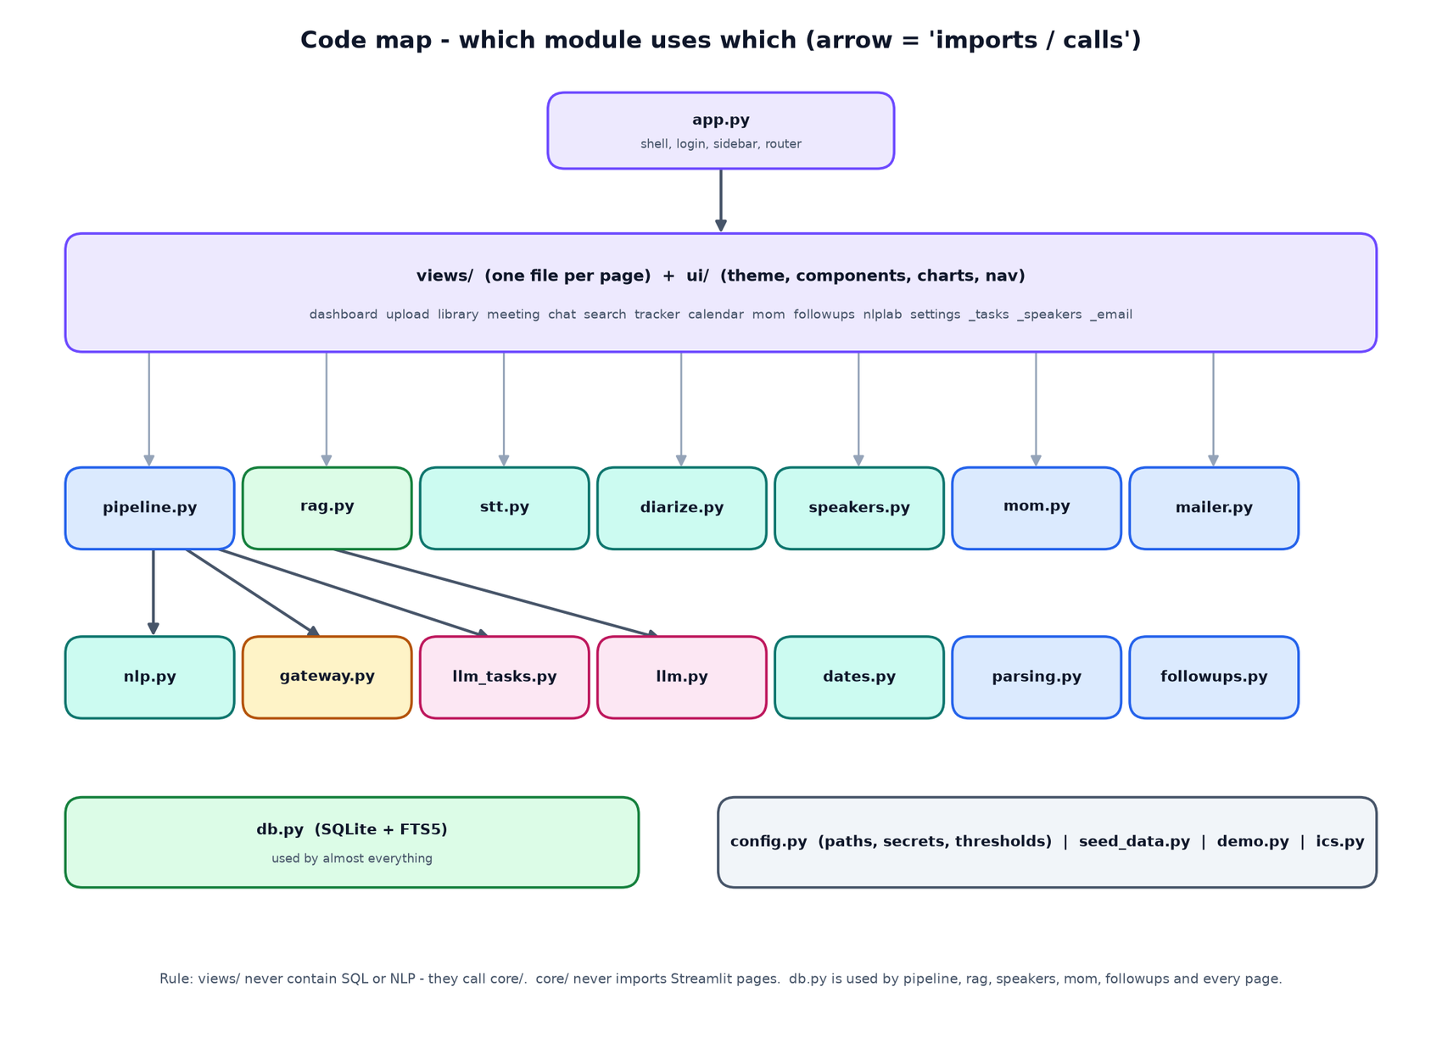
Which module uses which
Three rules keep the code understandable:
1. `views/` draws, `core/` thinks. Pages contain no SQL and no NLP; they call functions in core/.
2. `db.py` is the only file that writes SQL (except small read queries in a few pages).
3. Everything external is optional. Each service (LLM, speech, speakers, e-mail) is checked at run time and has a fallback.

3. How a Streamlit app runs (and why it matters)
Streamlit re-executes the whole script from top to bottom after every click or keystroke. That has consequences visible all over the code:
- `st.session_state` keeps per-user values between re-runs (current page, selected meeting, chat session, cached suggestions). ui/nav.py is just helpers around it.
- Navigation is a normal function call. nav.goto("meeting", meeting_id) stores the page name and calls st.rerun(); app.py then imports and renders views/<page>.py.
- Slow, reusable objects are cached (@st.cache_resource for the trained classifier; module-level variables for the embedding model and the ChromaDB client).
- Durable data goes to SQLite, never only to session state.
- Widgets need stable keys (key="m_trq") so Streamlit does not forget their value when the page re-runs.
- Long jobs run synchronously with a progress bar (views/upload.py), because the app is a single process on free hosting.

4. Repository layout
nlp+agentic ai/
├─ app.py entry point
├─ requirements.txt packages.txt requirements-local.txt
├─ .streamlit/ config.toml secrets.toml.example
├─ core/ (19 files) logic: parsing, speech, speakers, NLP, gateway, LLM, search, minutes, e-mail
├─ ui/ (4 files) theme, components, charts, navigation
├─ views/ (15 files) one file per page + 3 shared panels
├─ tests/ (9 files) 79 automated tests
└─ docs/ guides, reports, diagram and screenshot tools

5. `app.py` - the entry point
Purpose. Starts everything: page configuration, theme, optional password, sidebar, and the router that renders the selected page.
Key pieces
Name | Description
warm() | @st.cache_resource. Creates the database schema and trains the classical NLP model once per server start
login_gate() | If the secret APP_PASSWORD exists, shows a password form and compares in constant time (hmac.compare_digest)
sidebar() | Logo, navigation buttons (primary style = current page), status card showing which services are connected, lock button
main() | Runs the gate, warm(), sidebar(), scrolls to the top after navigation (and collapses the sidebar on phones), then imports views.<page> and calls render()

How it works. st.set_page_config must be the first Streamlit call, so it runs before other imports that use Streamlit. theme.apply() injects the CSS on every run. The selected page name comes from ui/nav.current(). Any exception inside a page is caught and shown as a friendly error plus a technical-details expander, so users never see a raw stack trace.
Talks to. core.db, core.diarize, core.llm, core.mailer, core.stt (status card), ui.nav, ui.theme, every views.* module.
____________________________________________________________

6. `core/` - the application logic

6.1 `core/__init__.py`
A tiny compatibility shim. If the host's SQLite is older than 3.35 (ChromaDB needs newer), it swaps in pysqlite3 when available. Does nothing on modern systems.

6.2 `core/config.py`
Purpose. One place for paths, defaults and secret lookup.
Name | Description
DATA_DIR, DB_PATH, UPLOAD_DIR, CHROMA_DIR, EXPORT_DIR | Locations under data/ (override with the MEETINGAI_DATA environment variable - tests use this)
DEFAULT_THRESHOLDS | Gateway defaults: classification 0.80, margin 0.15, owner 0.85, deadline 0.85, retrieval similarity 0.28
DEFAULT_MODELS | Default free model names (Groq Llama, Gemini Flash, Whisper, OpenRouter)
secret(name) | Looks a value up in this order: session override (typed in Settings) > Streamlit secrets > environment variable > default
set_session_key(name, value) | Stores a key for the current browser session only

Gotcha handled. Touching st.secrets when no secrets file exists makes Streamlit show a red banner, so _secrets_file_exists() checks first.

6.3 `core/db.py` - the database layer
Purpose. SQLite is the source of truth. Every table, and every function that reads or writes it, lives here.
Schema (13 tables): meetings, segments (+ virtual table segments_fts), summaries, decisions, tasks, events, mom, chat_sessions, chat_messages, followups, analysis_log, email_log, voiceprints, settings.
Group | Functions
Plumbing | conn() (context manager, one short connection per call, thread lock), init_db() (creates tables, enables WAL, creates FTS5), query, one, execute
Settings | get_setting, set_setting (JSON values), get_thresholds (defaults merged with saved values)
Meetings | create_meeting, update_meeting (lists/dicts become JSON), get_meeting, list_meetings (search/status), delete_meeting (cascades to every table and the FTS index)
Transcript | replace_segments (also fills FTS), get_segments, rename_speaker (updates segments, task owners, decisions), keyword_search
Insights | save_summary/get_summary, add_decision, list_decisions, add_task, list_tasks, update_task, add_event, list_events, clear_auto_items (removes machine-made items before re-analysis, keeps manual ones)
Documents | save_mom/get_mom
Chat | create_session, add_message, get_messages, list_sessions, delete_session
Follow-ups & logs | add_followup, list_followups, log_analysis, log_email
Voices | save_voiceprint, list_voiceprints, delete_voiceprint
Stats | dashboard_stats() - all numbers shown on the dashboard

How `keyword_search` works. It turns the query into an FTS5 expression ("budget" OR "approval", or one quoted phrase), runs it against segments_fts with bm25 ranking, and falls back to LIKE if FTS5 is unavailable.

6.4 `core/parsing.py` - reading transcripts
Purpose. Turn uploaded text files into [{speaker, start, end, text}].
Name | Description
parse_transcript(name, bytes) | Entry point. Detects VTT/SRT by -->, otherwise plain text; returns segments + header metadata
extract_header_meta | Reads Meeting:, Date:, Attendees:, Agenda: lines at the top
parse_plain | Recognises Name: text with optional [mm:ss] timestamps; joins continuation lines; ignores labels like Note:/Agenda: as speakers; fills end from the next start
parse_cues | VTT/SRT cues, <v Name> voice tags, merges adjacent cues of one speaker
read_text_file | Handles .txt (several encodings), .docx (python-docx), .pdf (pypdf)
to_seconds, fmt_ts, segments_to_text | Time helpers and the downloadable transcript format

6.5 `core/stt.py` - speech-to-text
Purpose. Convert audio/video to timestamped text and (optionally) label speakers.
Name | Description
ffmpeg_path, probe_duration | Locate FFmpeg; read the recording length
make_chunks | FFmpeg converts any file to mono 16 kHz 32 kbps MP3 and cuts it into 10-minute pieces so each upload stays under free-tier limits; returns (file, offset_seconds)
_groq_transcribe | Posts a chunk to Groq's Whisper API asking for segment and word timestamps; shifts times by the chunk offset; retries on HTTP 429 using Retry-After; drops likely-hallucinated segments
_assemblyai_transcribe | Upload, create transcript with speaker labels, poll until done
_local_transcribe | faster-whisper or openai-whisper if installed
merge_short_segments | Joins Whisper's short fragments into paragraphs (same speaker, small gap, max 60 words)
choose_provider, provider_status | Decide which engine to use
transcribe(path, ..., speaker_engine, voiceprints) | The orchestrator: ASR for every chunk, then (if enabled) diarization of the full audio and alignment; returns segments, duration, provider label, identified voices and warnings. If speaker identification fails it keeps a single speaker and returns a warning instead of failing

6.6 `core/diarize.py` - who spoke when (pyannote)
Purpose. Everything about speakers: hosted pyannoteAI, local pyannote.audio, voiceprints, and alignment.
Name | Description
status(), choose_engine() | Which speaker engines are available; preference order pyannoteAI > local pyannote > AssemblyAI
_upload | Declares a media:// object, receives a pre-signed URL, PUTs the audio there
_run_job | Submits a job (diarize, identify, voiceprint), polls /jobs/{id} until it succeeds or fails; translates HTTP 401/402/429 into clear messages (DiarizationError)
pyannoteai_diarize / pyannoteai_identify / pyannoteai_voiceprint | The three hosted operations. Identify sends saved voiceprints with a match threshold and returns turns whose speaker is the matched name or the generic label
local_diarize | Loads pyannote/speaker-diarization-3.1 with the Hugging Face token (handles old and new argument names) and runs it on a 16 kHz WAV
diarize() | Dispatcher used by stt.transcribe
assign_speakers | Aligns text with speakers: each Whisper word goes to the speaker whose turn contains its midpoint; one-word interjections are smoothed away; consecutive words of one speaker become one segment. Without words it uses the largest time overlap
relabel_generic | SPEAKER_00 becomes Speaker 1... in order of first appearance; real names are left alone
extract_voice_sample | Cuts and joins the longest stretches of one speaker (FFmpeg atrim + concat) into a clip of at most 28 s - the input pyannoteAI needs for a voiceprint
trim_clip | Converts an uploaded/recorded voice clip to a 30-second mono MP3
match_threshold() | Strictness (default 60/100), editable in Settings → Voices

6.7 `core/speakers.py` - putting names on voices
Purpose. Suggest and apply names for anonymous speakers. Nothing is applied without the user's confirmation.
Name | Description
suggest_from_text | Regex evidence: self-introduction ("I'm Priya", weight 3), being addressed ("Rahul, can you..." gives the next speaker, 1.2), being thanked ("Thanks Rahul" gives the previous speaker, 0.9), then elimination. Votes are matched greedily one name per speaker; confidence = 0.45 + 0.12 x votes (max 0.95). Names must be in the attendee list when one exists
suggest_with_llm | Optional. Asks the LLM for a mapping with evidence quotes, verifies each quote against the transcript and the name against attendees/transcript
suggest | Combines both: rules win; agreement raises confidence
speaker_samples | The longest lines per speaker, shown beside the naming form
apply_names | Renames in segments, task owners and decisions, rebuilds the attendee list and refreshes the vector index

6.8 `core/dates.py` - dates and times
Purpose. Find date expressions and convert them to calendar dates relative to a base date (the meeting date). Pure Python, no LLM.
Name | Description
find_dates(text, base) | Returns DateHit(phrase, iso, precision, time, kind) for every expression: ISO dates, "25th October", "October 25", 13/11, today/tomorrow/day after tomorrow, "in two weeks", "end of the week/month/quarter", EOD/COB, weekdays ("Monday", "next Friday", "this Friday"), "next week", and vague words
precision | exact (a date), approx ("next week": text only), vague ("soon", ambiguous 03/04): no calendar date is invented
find_time | "3 PM", "10:30 am", "noon"
strip_phrases | Removes date phrases (and "by/on/before") when building a clean title
pretty | Fri, 16 Oct 2026 or Not specified

Weekday rule. "Monday" is the next Monday strictly after the base date; "next Monday" is the Monday of the following calendar week.

6.9 `core/seed_data.py`
Purpose. Training and test sentences for the classifier. build_train() expands hand-written templates ("{P} will {V} {O} {D}.") with names, verbs, objects and dates using a fixed random seed, giving 610 sentences in four classes. TEST_SET holds 42 hand-written sentences in a different style, never used for training, for the NLP Lab's evaluation. It is honest about being a seed corpus, not real meeting data.

6.10 `core/nlp.py` - classical NLP
Purpose. Everything that understands a sentence without an LLM.
Group | Names | Description
Preprocessing | clean_for_analysis, split_sentences, build_sentences | Remove fillers, split sentences (abbreviation-safe), keep speaker/timestamp/previous speaker/next sentence in a Sentence object
Rules | ACTION_CUES, DECISION_CUES, HEDGES, rule_scores | Weighted regex cues combined as 1-(1-w1)(1-w2)...; request wording beats a question mark; hedging detected
Statistics | Classifier, get_classifier | TF-IDF (1-2-grams) + MultinomialNB(alpha=0.3), plus a logistic regression for comparison; trained from seed_data on first use
Fusion | classify_batch, ClassResult | 0.5 x NB + 0.5 x rules; hedge x0.8; best label, confidence, margin
Evaluation | evaluate_classifier | Accuracy/F1/confusion matrix for NLP Lab
People | find_people, is_real_speaker, _match_known, extract_owner | Speaker names (excluding generic "Speaker 1"), first-name matching to full names, patterns for "I'll", "Priya will", "Priya, can you", "X is responsible for", "assigned to X", team names; confidence per pattern
Task details | make_task_title, infer_priority, extract_deadline, extract_event | Verb-first titles, High/Medium/Low priority words, deadline selection (prefers a date after "by/before/until", penalises dates from the next sentence), event detection (meeting nouns + exact date + optional time)
Candidates | candidates_from, Candidate | Applies everything and returns tasks/decisions with kconf and kmargin for the gateway
Offline summary | key_terms, extractive_summary | TF-IDF key phrases and centroid-similarity sentence ranking (boosting decisions and actions) used when no LLM is available

6.11 `core/gateway.py` - the confidence gateway
Purpose. Decide whether a classical result is trusted. evaluate(candidate, thresholds) returns a Decision (accept, reason code, numbers, message). It checks (1) kconf >= cls_threshold, (2) kmargin >= cls_margin, then for tasks (3) owner confidence >= owner_threshold, (4) deadline not taken from the neighbouring sentence and exact-date confidence >= deadline_threshold. The first failure wins. REASONS maps each code to a human sentence. A vague deadline does not fail (the LLM cannot invent a date either).

6.12 `core/llm.py` - the free-LLM router
Purpose. Call Groq / Gemini / OpenRouter through their OpenAI-compatible HTTP API using only requests.
Name | Description
_providers() | Builds the ordered provider list from available keys; Gemini first for long transcripts
chat() | Tries each provider and model; skips providers in cool-down; marks a provider as cooling for 45 s after HTTP 429; retries without response_format if a model rejects JSON mode; if a model is retired (HTTP 400/404 "model"), calls discover_model and tries the replacement once
discover_model() | Lists the provider's models and picks a suitable chat model (largest Llama / newest Gemini Flash / :free OpenRouter)
extract_json, chat_json() | Pulls JSON out of fenced or chatty answers, repairs trailing commas, asks the model to fix invalid JSON once
test_connection() | Used by Settings → Test connections
ACTIVITY | Small in-memory log of recent calls shown in Settings

6.13 `core/llm_tasks.py` - prompts
Purpose. All prompts and their parsing helpers in one place. SYSTEM_ANALYST states the rules (use only the transcript, null when unknown, copy date phrases, quote evidence). format_transcript prints [segment|time] speaker: text. chunk_ranges splits long transcripts by word budget. analyze_chunk (summary + items), merge_summaries (reduce step), adjudicate (batch check of uncertain sentences), answer (grounded answers returning JSON with found, answer, citations), polish_message (tone-only rewrite).

6.14 `core/pipeline.py` - the orchestrator
Purpose. Run the whole analysis of one meeting and save it.
Name | Description
analyze(meeting_id, progress, use_llm) | Steps 1-7 below; returns a Result (tasks, decisions, events, log, summary, stats)
verify_quote | Fuzzy-matches an LLM quote (RapidFuzz partial_ratio >= 82-92) against the segment it claims and then all segments
validate_owner | Accepts an owner only if it matches a participant or occurs in the transcript; "I" means the speaker; otherwise Unassigned + untrusted
_resolve_deadline | Converts an LLM-copied phrase with dates.py and checks that the phrase occurs nearby
_find_match | Links an LLM item to an existing classical item (same/adjacent segment and similar title)
_build_summary | LLM summary (merged for long meetings) or offline extractive summary
save_results | Replaces machine-extracted rows, writes the log and summary
process_meeting | analyze + save_results + index in ChromaDB + update attendees/duration/status + refresh follow-ups

`analyze` in order. (1) build sentences and candidates; (2) gateway decisions; (3) LLM analysis pass per chunk (summary + independent items); (4) one adjudication call for uncertain candidates; (5) turn candidates into tasks/decisions (accepted, LLM-confirmed, review, or dropped) and log each decision; (6) merge the LLM's independent findings with validation, boosting agreement and flagging conflicts; (7) detect events on all sentences (scheduling sentences without a firm commitment go to the calendar, not the task list), de-duplicate tasks, build the summary.

6.15 `core/rag.py` - search and answers
Purpose. The semantic index, hybrid search, query router and grounded answers.
Name | Description
Embedder, get_embedder | Backends: onnx (default, MiniLM, no PyTorch), sbert (BGE-small if installed), hash (offline lexical fallback). Embeddings are normalised; BGE queries get its instruction prefix
_collection | ChromaDB PersistentClient collection named per backend, cosine distance
make_chunks | About 110 words per chunk with small overlap, remembering segment range, start time and speakers
index_meeting, reindex_items, rebuild_all, delete_index | Maintain the vectors (transcript, decision and task documents)
semantic_search | Embed the query and query Chroma with optional meeting/kind filters
route_query | Detect intents (tasks, decisions, events, summary, phrase), meetings ("last three", a date, a title via fuzzy match) and a person
hybrid_search | Semantic + FTS5 keyword, merged with Reciprocal Rank Fusion (1/(60+rank)), overlapping ranges merged
is_relevant, lexical_overlap, content_tokens | Relevance gate: similarity threshold or word overlap with light stemming
answer_question | Route, retrieve, gate, build labelled evidence ([E], [T], [D], [V], [S]), ask the LLM, verify citations and support, or fall back to a direct retrieval answer

6.16 `core/mom.py` - minutes and document rendering
Purpose. Generate the minutes and render any Markdown to HTML, Word and PDF.
Name | Description
generate_markdown | Builds the minutes from saved data (details, attendees, agenda, summary, highlights, decisions table, action-item table, events, conclusions); uncertain rows get a warning mark
md_blocks | A small Markdown parser: headings, paragraphs (two trailing spaces = line break), bullet/numbered lists, tables, code blocks, images, page breaks
to_html | E-mail/preview HTML with inline styles (links, bold, italic, code)
to_docx | python-docx: headings, lists, tables, hyperlinks, images, page breaks
to_pdf | ReportLab: styled tables with automatic column widths, images, links; _pdf_safe maps symbols the built-in fonts lack
to_plain | Plain-text body for e-mail

The same renderer builds the project documents you are reading.

6.17 `core/mailer.py` - e-mail
parse_recipients splits free text into valid and invalid addresses; smtp_config reads host/port/user/password/security from secrets or the session; build_message makes a multipart message (text + HTML + attachments); send supports STARTTLS, SSL or plain, never raises and returns (ok, message) with a friendly hint for Gmail login errors; mailto_link is the no-SMTP fallback.

6.18 `core/ics.py`
build_ics writes an iCalendar file (all-day or timed events); google_calendar_link builds an "add to Google Calendar" URL so no OAuth is needed.

6.19 `core/followups.py`
refresh(meeting_id) regenerates the suggested drafts: a recap (decisions + actions), one reminder per owner (a gentler "nudge" when something is overdue), an owners needed message for unassigned tasks, and reminders for upcoming events. polish asks the LLM to improve tone without changing facts. Drafts are stored as suggested; sending happens only in the UI after confirmation.

6.20 `core/demo.py`
Three realistic sample meetings with dates relative to today, so the calendar and tracker always have upcoming and overdue items. load_demo parses them like uploads and runs the full pipeline.

7. `ui/` - theme and reusable components
File | What it does
ui/theme.py | apply() injects ~240 lines of CSS: colour variables, navy/violet background gradients, glass cards, sidebar styling, buttons, inputs, tabs, chat bubbles, transcript rows, calendar grid, stepper, animations, and responsive rules (stacked columns and smaller cards on phones)
ui/components.py | HTML builders: H (collapses indented HTML so Markdown does not treat it as code), md, chip, status_chip, page_header, section, metric/metric_row, empty_state, transcript_html (avatars, timestamps, highlights, insight tags), month_grid, stepper, source_card, color_for/initials for speaker avatars, esc (HTML-escape every piece of user text)
ui/charts.py | Plotly helpers (donut, hbar, vbar) with a transparent background, shared palette and fonts
ui/nav.py | PAGES (sidebar structure), goto(page, meeting_id, **state) (set state + st.rerun), current()

____________________________________________________________

8. `views/` - one file per page
Every file exposes render().
File | Page | How it works
dashboard.py | Dashboard | db.dashboard_stats() drives metric cards; recent meetings, deadlines/events list, task-status donut, owner workload bars, gateway health bars. Empty state offers sample data
upload.py | New Meeting | Tabs for file upload and pasted text. _run() creates the meeting, parses or transcribes, runs pipeline.process_meeting with a live stepper, handles errors by deleting the half-created meeting, and shows a result banner with speaker/AI warnings
library.py | Meeting Library | Search, sort, filter; two-column cards; open / ask AI / delete (with confirmation)
meeting.py | Meeting details | Tabs: Overview, Transcript (search, speaker filter, insight chips, audio player, download, Who is who?), Action items (_tasks.task_table), Decisions & events, How it was analysed (gateway log)
chat.py | Ask MeetingAI | Session list, scope selector, suggested questions, rag.answer_question, typing effect, sources and "how I searched" expanders, saved history
search.py | Search | Modes (smart/keyword/semantic/phrase), meeting and date filters, optional grounded answer, highlighted results, related tasks/decisions
tracker.py | Action Tracker | Metrics, filters, sorted editable table, manual task form
calendar.py | Calendar | Month navigation in st.session_state["cal_ym"], grid from components.month_grid, agenda list, Google links, .ics download, manual events
mom.py | Minutes of Meeting | Generate, Edit/Preview/Export tabs, accept, downloads, recipients validation, e-mail preview, confirmation, send, history
followups.py | Follow-ups | Cards for each draft with edit, AI polish, save, mail-app link, dismiss and confirmed send
nlplab.py | NLP Lab | Live analysis of pasted text (scores, owner, deadline, event, gateway verdict), evaluation charts and confusion matrix, threshold simulator, gateway statistics, embedding similarity demo
settings.py | Settings | AI & speech (keys, test, engines), Voices (_voices_tab), Confidence gateway sliders, E-mail, Data & backup (zip backup/restore with path-traversal check, rebuild index, delete all), About
_tasks.py | shared | build_frame -> st.data_editor; task_table diffs the edited table against the original and writes only changes (and refreshes the vector index); add_task_form
_speakers.py | shared | The Who is who? panel: suggestions, audio sample players, name inputs, Remember this voice (_enroll cuts a sample and creates a voiceprint), Apply names
_email.py | shared | setup_panel: inline "connect your e-mail" form with provider presets (Gmail/Outlook/Yahoo)

____________________________________________________________

9. Tests (`tests/`)
File | Tests | What it proves
conftest.py | - | Isolates every run in a temporary data folder and removes API keys from the environment
test_dates.py | 8 | Weekday and relative-date rules, vague phrases give no date, no false positives
test_nlp.py | 10 | Owners, deadlines, hedging, decisions, events, classifier accuracy floor
test_parsing.py | 5 | Speaker lines, headers, VTT, non-speaker labels, empty file
test_pipeline.py | 13 | Sample meetings end to end, search, "not found", minutes export, LLM path with a fake LLM (hallucinated quote and owner rejected)
test_llm_router.py | 4 | Fake HTTP servers: rate-limit fall-through, model discovery, JSON repair, total failure
test_io.py | 7 | Recipient parsing, SMTP against a local server, .ics, FFmpeg chunking with a fake ASR
test_diarize.py | 17 | Alignment, fake pyannoteAI server (upload/diarize/identify/voiceprint), failure fallback, voice sample cutting, name suggestions, applying names
test_ui_smoke.py | 4+ | Every page renders (AppTest), chat round trip, Who is who? suggests and applies names, Voices tab

Run everything with python -m pytest tests -q.
____________________________________________________________

10. Configuration and deployment files
File | Purpose
requirements.txt | Streamlit, pandas, numpy, plotly, requests, scikit-learn, rapidfuzz, chromadb, onnxruntime, python-docx, reportlab, pypdf
packages.txt | ffmpeg, installed by Streamlit Cloud
requirements-local.txt | Optional pyannote.audio + torch for local diarization
.streamlit/config.toml | Dark theme colours, 200 MB upload limit, no usage statistics
.streamlit/secrets.toml.example | Template for all keys (Groq, Gemini, pyannoteAI, AssemblyAI, SMTP, APP_PASSWORD)
.gitignore | Keeps secrets, the data/ folder and caches out of Git
docs/ | PROJECT_GUIDE, MeetingAI_Project_Report, this walkthrough (Markdown, Word, PDF), and tools/ that regenerate screenshots, diagrams and documents

____________________________________________________________

11. Recipes: how to extend the project
Add a new page. Create views/mypage.py with render(); add ("mypage", "My Page", "material_icon") to PAGES in ui/nav.py. app.py imports it automatically.
Add a new kind of extraction (for example "risks"). Add cue patterns and a label in nlp.py, a field/table in db.py, a branch in pipeline.analyze, and a view. Add seed sentences so the classifier learns the new label.
Add an LLM provider. Add a dict to _providers() in llm.py (base URL, key name, models). Anything with an OpenAI-compatible /chat/completions endpoint works.
Change the thresholds. Settings → Confidence gateway (or DEFAULT_THRESHOLDS), then use NLP Lab → Threshold simulator to see the effect.
Use a different embedding model. Set EMBEDDING_BACKEND (onnx, sbert, hash); the collection name changes with the backend, then rebuild the index in Settings.
Support another speaker engine. Add a branch in diarize.diarize() that returns DiarizationResult(turns=[{speaker,start,end}], ...); alignment and naming work unchanged.

12. Design rules and gotchas
- Never invent. Unknown owner = Unassigned; unknown date = Not specified; no evidence = "not found".
- Dates are computed by code, never by an LLM.
- LLM output is untrusted data and must pass pipeline validation.
- External actions need a confirmation click (e-mail, follow-ups, calendar links).
- Escape user text with components.esc before putting it into HTML.
- Indented HTML inside Markdown becomes a code block; components.H strips indentation.
- Hidden control characters. If a regular expression ever stops matching, check for stray backspace characters (\x08) where \b was intended.
- Free hosting forgets files; the backup/restore feature exists for that reason.
- Keep views thin. If a page needs a new rule, put it in core/ and test it there.

