***XML CODE::***

*<?*xml version="1.0" encoding="utf-8"*?>*<LinearLayout  
 xmlns:android="http://schemas.android.com/apk/res/android"  
 xmlns:tools="http://schemas.android.com/tools"  
 android:layout_width="match_parent"  
 android:layout_height="match_parent"  
 tools:context=".MainActivity"  
 android:orientation="vertical"  
 android:weightSum="1"  
 android:background="#FFF">  
 <TextView  
 android:id="@+id/text1"  
 android:layout_width="fill_parent"  
 android:layout_height="fill_parent"  
 android:text=""  
 android:textColor="#000"  
 android:textSize="100dp"  
 android:textAlignment="viewEnd"  
 android:layout_gravity="end"  
 android:layout_weight="0.7" />  
 <TableLayout  
 android:layout_width="match_parent"  
 android:layout_height="match_parent"  
 android:layout_weight="0.3"  
 android:weightSum="1"  
 android:stretchColumns="*">  
 <TableRow android:layout_weight="0.2">  
 <Button android:id="@+id/clear"  
 android:layout_width="match_parent"  
 android:layout_height="match_parent"  
 android:text="C"  
 android:layout_span="3"  
 android:textSize="30dp">  
 </Button>  
 <Button android:id="@+id/div"  
 android:layout_width="match_parent"  
 android:layout_height="match_parent"  
 android:text="÷"  
 android:textSize="30dp">  
 </Button>  
 </TableRow>  
 <TableRow android:layout_weight="0.2">  
 <Button android:id="@+id/button7"  
 android:layout_width="match_parent"  
 android:layout_height="match_parent"

android:text="7"  
 android:textSize="30dp">  
 </Button>  
 <Button android:id="@+id/button8"  
 android:layout_width="match_parent"  
 android:layout_height="match_parent"  
 android:text="8"  
 android:textSize="30dp">  
 </Button>  
 <Button android:id="@+id/button9"  
 android:layout_width="match_parent"  
 android:layout_height="match_parent"  
 android:text="9"  
 android:textSize="30dp">  
 </Button>  
 <Button  
 android:id="@+id/mul"  
 android:layout_width="match_parent"  
 android:layout_height="match_parent"  
 android:text="x"  
 android:textSize="30dp">  
 </Button>  
 </TableRow>  
  
 <TableRow android:layout_weight="0.2">  
 <Button  
 android:id="@+id/button4"  
 android:layout_width="match_parent"  
 android:layout_height="match_parent"  
 android:text="4"  
 android:textSize="30dp">  
 </Button>  
 <Button  
 android:id="@+id/button5"  
 android:layout_width="match_parent"  
 android:layout_height="match_parent"  
 android:text="5"  
 android:textSize="30dp">  
 </Button>  
 <Button  
 android:id="@+id/button6"  
 android:layout_width="match_parent"  
 android:layout_height="match_parent"  
 android:text="6"  
 android:textSize="30dp">  
 </Button>  
 <Button  
 android:id="@+id/sub"  
 android:layout_width="match_parent"  
 android:layout_height="match_parent"  
 android:text="-"  
 android:textSize="30dp">  
 </Button>  
 </TableRow>  
 <TableRow  
 android:layout_weight="0.2">  
 <Button  
 android:id="@+id/button1"  
 android:layout_width="match_parent"  
 android:layout_height="match_parent"  
 android:text="1"  
 android:textSize="30dp">  
 </Button>  
 <Button  
 android:id="@+id/button2"  
 android:layout_width="match_parent"  
 android:layout_height="match_parent"  
 android:text="2"  
 android:textSize="30dp">  
 </Button>  
 <Button  
 android:id="@+id/button3"  
 android:layout_width="match_parent"  
 android:layout_height="match_parent"  
 android:text="3"  
 android:textSize="30dp">  
 </Button>  
 <Button  
 android:id="@+id/add"  
 android:layout_width="match_parent"  
 android:layout_height="match_parent"  
 android:text="+"  
 android:textSize="30dp">  
 </Button>  
 </TableRow>  
 <TableRow  
 android:layout_weight="0.2">  
  
 <Button  
 android:id="@+id/button0"  
 android:layout_width="match_parent"  
 android:layout_height="match_parent"  
 android:text="0"  
 android:layout_span="3"  
 android:textSize="30dp">  
 </Button>  
 <Button  
 android:id="@+id/buttonEqual"  
 android:layout_width="match_parent"  
 android:layout_height="match_parent"  
 android:text="="  
 android:textSize="30dp">  
 </Button>  
 </TableRow>  
 </TableLayout>  
</LinearLayout>

**JAVA CODE::**

**package** com.example.myapplication;  
**import** androidx.appcompat.app.AppCompatActivity;  
**import** android.os.Bundle;  
**import** android.view.View;  
**import** android.widget.Button;  
**import** android.widget.TextView;  
**import** java.util.Stack;  
**public class** MainActivity **extends** AppCompatActivity {  
 Button **button0**, **button1**, **button2**, **button3**, **button4**, **button5**, **button6**, **button7**, **button8**, **button9**, **buttonEqual**,**decimal**,**clear**,**div**, **mul**, **add**, **sub**;  
 TextView **text1**;  
 **int result**=0;  
 Stack<Character> **op** =**new** Stack<Character>();  
 Stack<Integer> **num**=**new** Stack<Integer>();  
 @Override  
 **protected void** onCreate(Bundle savedInstanceState) {  
 **super**.onCreate(savedInstanceState);  
 setContentView(R.layout.***activity_main***);  
 **text1** = (TextView) findViewById(R.id.***text1***);  
 **button0** = (Button) findViewById(R.id.***button0***);  
 **button1** = (Button) findViewById(R.id.***button1***);  
 **button2** = (Button) findViewById(R.id.***button2***);  
 **button3** = (Button) findViewById(R.id.***button3***);  
 **button4** = (Button) findViewById(R.id.***button4***);  
 **button5** = (Button) findViewById(R.id.***button5***);  
 **button6** = (Button) findViewById(R.id.***button6***);  
 **button7** = (Button) findViewById(R.id.***button7***);  
 **button8** = (Button) findViewById(R.id.***button8***);  
 **button9** = (Button) findViewById(R.id.***button9***);  
 **buttonEqual** = (Button) findViewById(R.id.***buttonEqual***);  
 **add** = findViewById(R.id.***add***);  
 **sub** = findViewById(R.id.***sub***);  
 **mul** = findViewById(R.id.***mul***);  
 **div** = findViewById(R.id.***div***);  
 **clear** = findViewById(R.id.***clear***);  
 **button0**.setOnClickListener(**new** View.OnClickListener() {  
 @Override  
 **public void** onClick(View v) {  
 **text1**.setText(**text1**.getText()+**"0"**);  
 }});  
 **button1**.setOnClickListener(**new** View.OnClickListener() {  
 @Override  
 **public void** onClick(View v) {  
 **text1**.setText(**text1**.getText()+**"1"**);  
 }});  
 **button2**.setOnClickListener(**new** View.OnClickListener() {  
 @Override  
 **public void** onClick(View v) {  
 **text1**.setText(**text1**.getText()+**"2"**);}});  
 **button3**.setOnClickListener(**new** View.OnClickListener() {  
 @Override  
 **public void** onClick(View v) {  
 **text1**.setText(**text1**.getText()+**"3"**);  
 }});  
 **button4**.setOnClickListener(**new** View.OnClickListener() {  
 @Override  
 **public void** onClick(View v) {  
 **text1**.setText(**text1**.getText()+**"4"**);  
 }});  
 **button5**.setOnClickListener(**new** View.OnClickListener() {  
 @Override  
 **public void** onClick(View v) {  
 **text1**.setText(**text1**.getText()+**"5"**);  
 }});  
 **button6**.setOnClickListener(**new** View.OnClickListener() {  
 @Override  
 **public void** onClick(View v) {  
 **text1**.setText(**text1**.getText()+**"6"**);  
 }});  
 **button7**.setOnClickListener(**new** View.OnClickListener() {  
 @Override  
 **public void** onClick(View v) {  
 **text1**.setText(**text1**.getText()+**"7"**);  
 }});  
 **button8**.setOnClickListener(**new** View.OnClickListener() {  
 @Override  
 **public void** onClick(View v) {  
 **text1**.setText(**text1**.getText()+**"8"**);  
 }});  
 **button9**.setOnClickListener(**new** View.OnClickListener() {  
 @Override  
 **public void** onClick(View v) {  
 **text1**.setText(**text1**.getText()+**"9"**);  
 }});  
 **add**.setOnClickListener(**new** View.OnClickListener() {  
 @Override  
 **public void** onClick(View v) {  
 **text1**.setText(**text1**.getText()+**"+"**);  
 }});  
 **sub**.setOnClickListener(**new** View.OnClickListener() {  
 @Override  
 **public void** onClick(View v) {  
 **text1**.setText(**text1**.getText()+**"-"**); }});  
 **mul**.setOnClickListener(**new** View.OnClickListener() {  
 @Override  
 **public void** onClick(View v) {  
 **text1**.setText(**text1**.getText()+**"x"**);  
 }});  
 **div**.setOnClickListener(**new** View.OnClickListener() {  
 @Override  
 **public void** onClick(View v) {  
 **text1**.setText(**text1**.getText()+**"÷"**);  
 }});  
 **clear**.setOnClickListener(**new** View.OnClickListener() {  
 @Override  
 **public void** onClick(View v) {  
 **text1**.setText(**""**);  
 **result**=0;  
 }});  
 **buttonEqual**.setOnClickListener(**new** View.OnClickListener() {  
 @Override  
 **public void** onClick(View v) {  
 **char** []element=**new char**[100];  
 String s = **text1**.getText().toString();  
 **for** (**int** i=0;i<s.length();i++)  
 element[i] = s.charAt(i);  
 **for** (**int** j = 0; j < element.**length**; j++){  
 **if** (element[j] >= **'0'**&& element[j] <= **'9'**) {  
 **num**.push(Integer.*parseInt*(String.*valueOf*(element[j])));  
 }  
 **else if** (element[j] == **'+'** || element[j] == **'-'** || element[j] == **'x'** || element[j] == **'÷'**) {  
 **while** (!**op**.empty() && precedence(element[j], **op**.peek()))  
 **num**.push(cal(**op**.pop(), **num**.pop(), **num**.pop()));  
 **op**.push(element[j]);  
 }  
 }  
 **while**(!**op**.empty())  
 **num**.push(cal(**op**.pop(),**num**.pop(),**num**.pop()));  
 **result**=**num**.pop();  
 String s1 = String.*valueOf*(**result**);  
 **text1**.setText(s1);  
 }  
 });}  
 **public boolean** precedence(**char** newOp,**char** topOp){  
 **if** ((newOp == **'x'** || newOp == **'÷'**) && (topOp == **'+'** || topOp == **'-'**))  
 **return false**;  
 **else  
 return true**;}  
 **int** cal(**char** op,**int** a,**int** b){  
 **switch** (op){  
 **case '+'**:**return** a+b;  
 **case '-'**:**return** b-a;  
 **case 'x'**:**return** a*b;  
 **case '÷'**:**return** b/a;}  
 **return** 0;}}

OUTPUTS ::

1. Calculator 2. Operation Performed

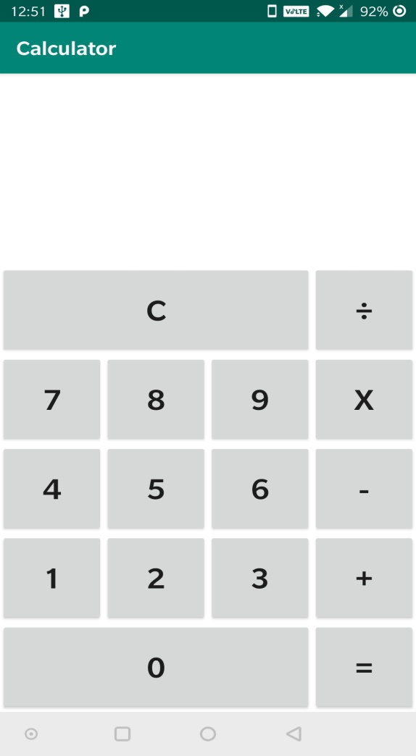 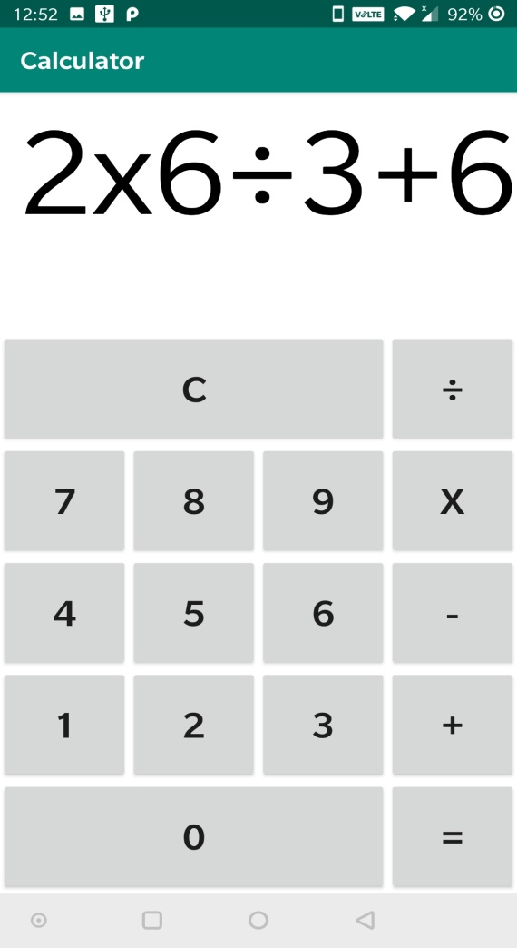

3. Result

