**1. MAIN_ACTIVITY.java**

**package** com.example.teams;  
**import** androidx.appcompat.app.AppCompatActivity;  
**import** android.content.Intent;  
**import** android.os.Bundle;  
**import** android.view.View;  
**import** android.widget.*;  
**import** java.util.ArrayList;  
**public class** MainActivity **extends** AppCompatActivity {  
 String[] **team**={**"India"**,**"England"**,**"Australia"**,**"New Zealand"**};  
 ListView **lv**;  
 Button **done**;  
 **int total**, **sum1**=0,**sum2**=0,**sum3**=0,**sum4**=0;  
 ArrayList <String> **t1**=**new** ArrayList<>(); ArrayList <String> **t2**=**new** ArrayList<>();   
 ArrayList <String> **t3**=**new** ArrayList<>(); ArrayList <String> **t4**=**new** ArrayList<>();  
 @Override  
 **protected void** onCreate(Bundle savedInstanceState) {  
 **super**.onCreate(savedInstanceState);  
 setContentView(R.layout.***activity_main***);  
 **lv**=findViewById(R.id.***lv***);  
 **lv**.setAdapter(**new** ArrayAdapter<String>(**this**,android.R.layout.***simple_dropdown_item_1line***,**team**));  
 **done**=findViewById(R.id.***done***);  
 **lv**.setOnItemClickListener(**new** AdapterView.OnItemClickListener() {  
 @Override  
 **public void** onItemClick(AdapterView<?> adapterView, View view, **int** i, **long** l){  
 **if**(i==0) {  
 Intent intent=**new** Intent(MainActivity.**this**,team1.**class**);  
 intent.putStringArrayListExtra(**"team1"**,**t1**);  
 startActivityForResult(intent,1);  
 }  
 **if**(i==1) {  
 Intent intent=**new** Intent(MainActivity.**this**,team2.**class**);  
 intent.putStringArrayListExtra(**"team2"**,**t2**);  
 startActivityForResult(intent,2);  
 }  
 **if**(i==2) {  
 Intent intent=**new** Intent(MainActivity.**this**,team3.**class**);  
 intent.putStringArrayListExtra(**"team3"**,**t3**);  
 startActivityForResult(intent,3);  
 }  
 **if**(i==3) {  
 Intent intent=**new** Intent(MainActivity.**this**,team4.**class**);  
 intent.putStringArrayListExtra(**"team4"**,**t4**);  
 startActivityForResult(intent,4);  
 } } }); }  
 **public void** doneAll(View view) {  
 ArrayList yourTeam1= **new** ArrayList(); ArrayList yourTeam2= **new** ArrayList();  
 ArrayList yourTeam3= **new** ArrayList(); ArrayList yourTeam4= **new** ArrayList();  
 **if**(**total**>11)  
 Toast.*makeText*(**this**,**"More than 11 members in team!! DELETE SOME"**,Toast.***LENGTH_LONG***).show();  
 **else if**(**total**<11)  
 Toast.*makeText*(**this**,**"Less than 11 members in team !! ADD MORE"**,Toast.***LENGTH_LONG***).show();  
 **else** {  
 **for** (**int** i=0;i<**t1**.size();i++) {  
 yourTeam1.add(**t1**.get(i));  
 }  
 **for** (**int** i=0;i<**t2**.size();i++) {  
 yourTeam2.add(**t2**.get(i));  
 }  
 **for** (**int** i=0;i<**t3**.size();i++) {  
 yourTeam3.add(**t3**.get(i));  
 }  
 **for** (**int** i=0;i<**t4**.size();i++) {  
 yourTeam4.add(**t4**.get(i));  
 }  
 ArrayList<String> all=**new** ArrayList<>();  
 **for** (**int** i=0;i<yourTeam1.size();i++) {  
 **if**(!yourTeam1.get(i).toString().equals(**""**))   
 all.add( yourTeam1.get(i).toString());  
 }   
 **for** (**int** i=0;i<yourTeam2.size();i++) {  
 **if**(!yourTeam2.get(i).toString().equals(**""**))   
 all.add(yourTeam2.get(i).toString());  
 }   
 **for** (**int** i=0;i<yourTeam3.size();i++) {  
 **if**(!yourTeam3.get(i).toString().equals(**""**))   
 all.add(yourTeam3.get(i).toString());  
 }   
 **for** (**int** i=0;i<yourTeam4.size();i++) {  
 **if**(!yourTeam4.get(i).toString().equals(**""**))  
 all.add(yourTeam4.get(i).toString());   
 }  
 Intent i = **new** Intent(**this**,finalTeam.**class**);  
 i.putStringArrayListExtra(**"final team1"**,all);  
 startActivity(i);  
 } }  
 **public void** onActivityResult(**int** requestcode,**int** resultCode,Intent data) {  
 **if**(requestcode==1) {  
 **if**(resultCode==***RESULT_OK***) {  
 **t1**=data.getStringArrayListExtra(**"team1"**);  
 **sum1**=data.getIntExtra(**"total"**,**total**);  
 **total**=**sum1**+**sum2**+**sum3**+**sum4**;  
 Toast.*makeText*(getApplicationContext(), **"Total Players Selected "**+**total**,Toast.***LENGTH_LONG***).show();  
 }  
 }  
 **else if**(requestcode==2) {  
 **if**(resultCode==***RESULT_OK***) {  
 **t2**=data.getStringArrayListExtra(**"team2"**);  
 **sum2**=data.getIntExtra(**"total"**,**total**);  
 **total**=**sum1**+**sum2**+**sum3**+**sum4**;  
 Toast.*makeText*(getApplicationContext(),**"Total Players Selected "**+**total**,Toast.***LENGTH_LONG***).show();  
 }  
 }  
 **else if**(requestcode==3) {  
 **if**(resultCode==***RESULT_OK***) {  
 **t3**=data.getStringArrayListExtra(**"team3"**);  
 **sum3**=data.getIntExtra(**"total"**,**total**);  
 **total**=**sum1**+**sum2**+**sum3**+**sum4**;  
 Toast.*makeText*(getApplicationContext(),**" Total Players Selected "**+**total**,Toast.***LENGTH_LONG***).show();  
 }  
 }  
 **else if**(requestcode==4) {  
 **if**(resultCode==***RESULT_OK***) {  
 **t4**=data.getStringArrayListExtra(**"team4"**);  
 **sum4**=data.getIntExtra(**"total"**,**total**);  
 **total**=**sum1**+**sum2**+**sum3**+**sum4**;  
 Toast.*makeText*(getApplicationContext(),**"Total Players Selected "**+**total**,Toast.***LENGTH_LONG***).show();  
 } } }}

**2. TEAM 1.java**

**package** com.example.teams;  
**import** android.app.Activity;  
**import** android.content.Intent;  
**import** android.os.Bundle;  
**import** android.view.View;  
**import** android.widget.*;  
**import** java.util.ArrayList;  
**public class** team1 **extends** Activity {  
 **int total1**=0;  
 ListView **lv1**;  
 Button **submit**;  
 Intent **ii1**;  
 ArrayList<String> **list1**;  
 String[] **team1**={**"Virat Kohli"**,**"Rohit Sharma"**,**"MS Dhoni"**,**"Rishabh Pant"**,**"K.L.Rahul"**,**"Harbhajan Singh"**,**"Hardik Pandya"**,**"Yuvraj Singh"**,**"Yuzvendra Chahal"**,**"Mohammed Shami"**,**"Jasprit Bumrah"**};  
 @Override  
 **public void** onCreate(Bundle savedInstanceState){  
 **super**.onCreate(savedInstanceState);  
 **ii1**=getIntent();  
 **list1**=**ii1**.getStringArrayListExtra(**"team1"**);  
 setContentView(R.layout.***team_1***);  
 **submit**=findViewById(R.id.***submit***);  
 **lv1**=findViewById(R.id.***lv1***);  
 **lv1**.setChoiceMode(ListView.***CHOICE_MODE_MULTIPLE***);  
 **lv1**.setAdapter(**new** ArrayAdapter<String>(**this**,android.R.layout.***simple_list_item_multiple_choice***,**team1**));  
 **if**( **list1**.size()!=0) {  
 **for** (**int** i=0;i<**list1**.size();i++) {  
 **for** (**int** j=0;j<**team1**.**length**;j++) {  
 **if**(**list1**.get(i).equals(**team1**[i]))  
 **lv1**.setItemChecked(i,**true**);  
 }  
 }  
 }  
 **submit**.setOnClickListener(**new** View.OnClickListener() {  
 @Override  
 **public void** onClick(View view)  
 {  
 **for** (**int** i=0;i<11;i++)  
 {  
 **if**(**lv1**.isItemChecked(i) && !**list1**.contains(**team1**[i]) ) {  
 **list1**.add(**team1**[i]);  
 }  
 **if**(**lv1**.isItemChecked(i) ) {  
 **total1** ++;  
 }  
 **else  
 list1**.add(**""**);  
 }  
 Intent i1=**new** Intent();  
 i1.putExtra(**"total"**,**total1**);  
 i1.putStringArrayListExtra(**"team1"**,**list1**);  
 setResult(Activity.***RESULT_OK***,i1);  
 finish();  
 }  
 });  
 }  
}

**3. Team2.java**

**package** com.example.teams;  
**import** android.app.Activity;  
**import** android.content.Intent;  
**import** android.os.Bundle;  
**import** android.view.View;  
**import** android.widget.*;  
**import** java.util.ArrayList;  
 **public class** team2 **extends** Activity {  
 **int total2**=0;  
 ListView **lv2**;  
 Button **submit**;  
 Intent **ii2**;  
 ArrayList<String> **list2**=**new** ArrayList<>();  
 String[] **team2**={**"Mark Wood"**,**"William Buckingham"**,**"Eoin Morgan"**,**"Liam Dawson"**,**"Tom Curran"**,**"Jos Buttler"**,**"Jonny Bairstow"**,**"Liam Plunkett"**,**"Jofra Archer"**,**"Jason Roy"**,**"Ben Stokes"**};  
 @Override  
 **public void** onCreate(Bundle savedInstanceState){  
 **super**.onCreate(savedInstanceState);  
 **ii2**=getIntent();  
 **list2**=**ii2**.getStringArrayListExtra(**"team2"**);  
 setContentView(R.layout.***team_2***);  
 **submit**=findViewById(R.id.***submit***);  
 **lv2**=findViewById(R.id.***lv2***);  
 **lv2**.setChoiceMode(ListView.***CHOICE_MODE_MULTIPLE***);  
 **lv2**.setAdapter(**new** ArrayAdapter<String>(**this**,android.R.layout.***simple_list_item_multiple_choice***,**team2**));  
 **if**( **list2**.size()!=0 {  
 **for** (**int** i=0;i<**list2**.size();i++){  
 **for** (**int** j=0;j<**team2**.**length**;j++){  
 **if**(**list2**.get(i).equals(**team2**[j]))  
 **lv2**.setItemChecked(i,**true**);  
 }  
 }  
 }  
 **submit**.setOnClickListener(**new** View.OnClickListener() {  
 @Override  
 **public void** onClick(View view) {  
 **for** (**int** i=0;i<**team2**.**length**;i++) {  
 **if**(**lv2**.isItemChecked(i) && !**list2**.contains(**team2**[i]) ) {  
 **list2**.add(**team2**[i]);  
 }  
 **if**(**lv2**.isItemChecked(i)) {  
 **total2**++;  
 }  
 **else  
 list2**.add(**""**);  
 }  
 Intent i2=**new** Intent();  
 i2.putExtra(**"total"**,**total2**);  
 i2.putStringArrayListExtra(**"team2"**,**list2**);  
 setResult(Activity.***RESULT_OK***,i2);  
 finish();  
 }})}}

**4. Team3.java**

**package** com.example.teams;  
**import** android.app.Activity;  
**import** android.content.Intent;  
**import** android.os.Bundle;  
**import** android.view.View;  
**import** android.widget.*;  
**import** java.util.ArrayList;  
**public class** team3 **extends** Activity {  
 **int total**=0;  
 ListView **lv3**;  
 Button **submit**;  
 Intent **ii3**;  
 ArrayList<String> **list3**;  
 String[] **team3**={**"Aaron Finch "**,**"Usman Khawaja"**,**"Shaun Marsh"**,**"Marcus Stoinis"**,**"Glenn Maxwell"**,**"Ashton Turner"**,**"Jhye Richardson"**,**"Jason Behrendorff"**,**"Pat Cummins"**,**"Nathan Lyon "**,**"Alex Carey"**};  
  
 @Override  
 **public void** onCreate(Bundle savedInstanceState){  
 **super**.onCreate(savedInstanceState);  
 **ii3**=getIntent();  
 **list3**=**ii3**.getStringArrayListExtra(**"team3"**);  
 setContentView(R.layout.***team_3***);  
 **submit**=findViewById(R.id.***submit***);  
 **lv3**=findViewById(R.id.***lv3***);  
 **lv3**.setChoiceMode(ListView.***CHOICE_MODE_MULTIPLE***);  
 **lv3**.setAdapter(**new** ArrayAdapter<String>(**this**,android.R.layout.***simple_list_item_multiple_choice***,**team3**));  
  
 **if**(**list3**.size()!=0) {  
 **for** (**int** i=0;i<**list3**.size();i++){  
 **for** (**int** j=0;j<**team3**.**length**;j++){  
 **if**(**list3**.get(i).equals(**team3**[j]))  
 **lv3**.setItemChecked(i,**true**);  
 }  
 }  
 }  
 **submit**.setOnClickListener(**new** View.OnClickListener() {  
 @Override  
 **public void** onClick(View view){  
 **for** (**int** i=0;i<**team3**.**length**;i++){  
 **if**(**lv3**.isItemChecked(i) && !**list3**.contains(**team3**[i]){  
 **list3**.add(**team3**[i]);  
 }  
 **if**(**lv3**.isItemChecked(i) ) {  
 **total** ++;}**else  
 list3**.add(**""**);}  
 Intent i3=**new** Intent();  
 i3.putExtra(**"total"**,**total**);  
 i3.putStringArrayListExtra(**"team3"**,**list3**);  
 setResult(Activity.***RESULT_OK***,i3);  
 finish();} });}}

**5. Team4.java**

**package** com.example.teams;  
**import** android.app.Activity;  
**import** android.content.Intent;  
**import** android.os.Bundle;  
**import** android.view.View;  
**import** android.widget.*;  
**import** java.util.ArrayList;  
  
**public class** team4 **extends** Activity {  
 **int total4**=0;  
 ListView **lv4**;  
 Button **submit**;  
 Intent **ii4**;  
 ArrayList<String> **list4**;  
 String[] **team4**={**"Kane Williamson"**,**"Trent Boult"**,**"Henry Nicholl"**,**"Colin de Grandhomme"**,**"Martin Guptill"**,**"Colin Munro"**,**"Matt Henry"**,**"Ross Taylor"**,**"Tom Blundell"**,**"Mitchell Santner"**,**"Ish Sodhi"**};  
  
 @Override  
 **public void** onCreate(Bundle savedInstanceState){  
 **super**.onCreate(savedInstanceState);  
 **ii4**=getIntent();  
 **list4**=**ii4**.getStringArrayListExtra(**"team4"**);  
 setContentView(R.layout.***team_4***);  
 **submit**=findViewById(R.id.***submit***);  
 **lv4**=findViewById(R.id.***lv4***);  
 **lv4**.setChoiceMode(ListView.***CHOICE_MODE_MULTIPLE***);  
 **lv4**.setAdapter(**new** ArrayAdapter<String>(**this**,android.R.layout.***simple_list_item_multiple_choice***,**team4**));  
 **if**( **list4**.size()!=0) {  
 **for** (**int** i=0;i<**list4**.size();i++) {  
 **for** (**int** j=0;j<**team4**.**length**;j++) {  
 **if**(**list4**.get(i).equals(**team4**[j]))  
 **lv4**.setItemChecked(i,**true**);  
 }  
 }  
 }  
 **submit**.setOnClickListener(**new** View.OnClickListener() {  
 @Override  
 **public void** onClick(View view)  
 {  
 **for** (**int** i=0;i<**team4**.**length**;i++) {  
 **if**(**lv4**.isItemChecked(i) && !**list4**.contains(**team4**[i]) ) {  
 **list4**.add(**team4**[i]);  
 }  
 **if**(**lv4**.isItemChecked(i)) {  
 **total4**++;  
 }  
 **else  
 list4**.add(**""**);  
 }  
 Intent i4=**new** Intent();  
 i4.putExtra(**"total"**,**total4**);  
 i4.putStringArrayListExtra(**"team4"**,**list4**);  
 setResult(Activity.***RESULT_OK***,i4);  
 finish();  
 }  
 });  
 }  
}

**6. FinalTeam.java**

**package** com.example.teams;  
**import** android.app.Activity;  
**import** android.content.Intent;  
**import** android.os.Bundle;  
**import** android.widget.ArrayAdapter;  
**import** android.widget.ListView;  
**import** java.util.ArrayList;  
**public class** finalTeam **extends** Activity {  
 ListView **lvf**;  
 Intent **itf**;  
 ArrayList<String> **finalTeam**=**new** ArrayList<>();  
 @Override  
 **public void** onCreate(Bundle savedInstanceState) {  
 **super**.onCreate(savedInstanceState);  
 setContentView(R.layout.***final_team***);  
 ArrayList<String> list=(ArrayList<String>)getIntent().getStringArrayListExtra(**"final team"**);  
 **lvf**=findViewById(R.id.***lvf***);  
 **lvf**.setAdapter(**new** ArrayAdapter<String>(**this**, android.R.layout.***simple_list_item_1***,list));}}

**7. ACTIVITY_MAIN.xml**

<?xml version="1.0" encoding="utf-8"?>  
<RelativeLayout  
 xmlns:android="http://schemas.android.com/apk/res/android"  
 xmlns:app="http://schemas.android.com/apk/res-auto"  
 xmlns:tools="http://schemas.android.com/tools"  
 android:layout_width="match_parent"  
 android:layout_height="match_parent"  
 tools:context=".MainActivity">  
  
 <TextView  
 android:id="@+id/text"  
 android:layout_width="match_parent"  
 android:layout_height="wrap_content"  
 android:layout_alignParentTop="true"  
 android:layout_marginTop="0dp"  
 android:text="Select total 11 players from given teams"  
 android:textAlignment="center"  
 android:textSize="30sp" />  
 <ListView  
 android:id="@+id/lv"  
 android:layout_below="@+id/text"  
 android:layout_width="wrap_content"  
 android:layout_height="500dp">  
 </ListView>  
 <Button  
 android:id="@+id/done"  
 android:onClick="doneAll"  
 android:layout_width="wrap_content"  
 android:layout_height="wrap_content"  
 android:layout_centerHorizontal="true"  
 android:layout_marginTop="50dp"  
 android:layout_below="@+id/lv"  
 android:text="DONE"  
 android:textSize="30sp"/>  
</RelativeLayout>

**8. team1.xml**

*<?*xml version="1.0" encoding="utf-8"*?>*<LinearLayout  
 xmlns:android="http://schemas.android.com/apk/res/android"  
 xmlns:app="http://schemas.android.com/apk/res-auto"  
 xmlns:tools="http://schemas.android.com/tools"  
 android:layout_width="match_parent"  
 android:layout_height="match_parent"  
 tools:context=".MainActivity"  
 android:orientation="vertical">  
 <TextView  
 android:layout_width="match_parent"  
 android:layout_height="wrap_content"  
 android:text="India"  
 android:textSize="50dp"  
 android:textAlignment="center"/>  
 <ListView  
 android:id="@+id/lv1"  
 android:layout_width="wrap_content"  
 android:layout_height="525dp"> </ListView>  
 <Button  
 android:id="@+id/submit"  
 android:layout_width="wrap_content"  
 android:layout_height="wrap_content"  
 android:layout_gravity="center"  
 android:layout_marginTop="50dp"  
 android:text="SUBMIT"  
 android:textSize="30sp" />  
</LinearLayout>

**9. team2.xml**

*<?*xml version="1.0" encoding="utf-8"*?>*<LinearLayout  
 xmlns:android="http://schemas.android.com/apk/res/android"  
 xmlns:app="http://schemas.android.com/apk/res-auto"  
 xmlns:tools="http://schemas.android.com/tools"  
 android:layout_width="match_parent"  
 android:layout_height="match_parent"  
 tools:context=".MainActivity"  
 android:orientation="vertical">  
 <TextView  
 android:layout_width="match_parent"  
 android:layout_height="wrap_content"  
 android:text="England"  
 android:textSize="50dp"  
 android:textAlignment="center"/>  
 <ListView  
 android:id="@+id/lv2"  
 android:layout_width="wrap_content"  
 android:layout_height="525dp">  
 </ListView>  
 <Button  
 android:id="@+id/submit"  
 android:layout_width="138dp"  
 android:layout_height="62dp"  
 android:layout_gravity="center"  
 android:layout_marginTop="10dp"  
 android:text="SUBMIT"  
 android:textSize="30sp" />  
</LinearLayout>

**10. team3.xml**

*<?*xml version="1.0" encoding="utf-8"*?>*<LinearLayout  
 xmlns:android="http://schemas.android.com/apk/res/android"  
 xmlns:app="http://schemas.android.com/apk/res-auto"  
 xmlns:tools="http://schemas.android.com/tools"  
 android:layout_width="match_parent"  
 android:layout_height="match_parent"  
 tools:context=".MainActivity"  
 android:orientation="vertical">  
 <TextView  
 android:layout_width="match_parent"  
 android:layout_height="wrap_content"  
 android:text="Australia"  
 android:textSize="50dp"  
 android:textAlignment="center"/>  
 <ListView  
 android:id="@+id/lv3"  
 android:layout_width="wrap_content"  
 android:layout_height="525dp">  
 </ListView>  
 <Button  
 android:id="@+id/submit"  
 android:layout_width="138dp"  
 android:layout_height="62dp"  
 android:layout_gravity="center"  
 android:layout_marginTop="10dp"  
 android:text="SUBMIT"  
 android:textSize="30sp" />  
</LinearLayout>

**11. team4.xml**

*<?*xml version="1.0" encoding="utf-8"*?>*<LinearLayout  
 xmlns:android="http://schemas.android.com/apk/res/android"  
 xmlns:app="http://schemas.android.com/apk/res-auto"  
 xmlns:tools="http://schemas.android.com/tools"  
 android:layout_width="match_parent"  
 android:layout_height="match_parent"  
 tools:context=".MainActivity"  
 android:orientation="vertical">  
 <TextView  
 android:layout_width="match_parent"  
 android:layout_height="wrap_content"  
 android:text="New Zealand"  
 android:textSize="50dp"  
 android:textAlignment="center"/>  
 <ListView  
 android:id="@+id/lv4"  
 android:layout_width="wrap_content"  
 android:layout_height="525dp">  
 </ListView>  
 <Button  
 android:id="@+id/submit"  
 android:layout_width="138dp"  
 android:layout_height="62dp"  
 android:layout_gravity="center"  
 android:layout_marginTop="10dp"  
 android:text="SUBMIT"  
 android:textSize="30sp" />  
</LinearLayout>

**12. final_team.xml**

*<?*xml version="1.0" encoding="utf-8"*?>*<LinearLayout  
 xmlns:android="http://schemas.android.com/apk/res/android"  
 xmlns:app="http://schemas.android.com/apk/res-auto"  
 xmlns:tools="http://schemas.android.com/tools"  
 android:layout_width="match_parent"  
 android:layout_height="match_parent"  
 tools:context=".MainActivity"  
 android:orientation="vertical">  
 <TextView  
 android:layout_width="match_parent"  
 android:layout_height="wrap_content"  
 android:text="Your Final Team"  
 android:textSize="50dp"  
 android:textAlignment="center"/>  
 <ListView  
 android:id="@+id/lvf"  
 android:layout_width="wrap_content"  
 android:layout_height="525dp"> </ListView>  
</LinearLayout>

**OUTPUT ::**

All Teams When total 11 players are selected

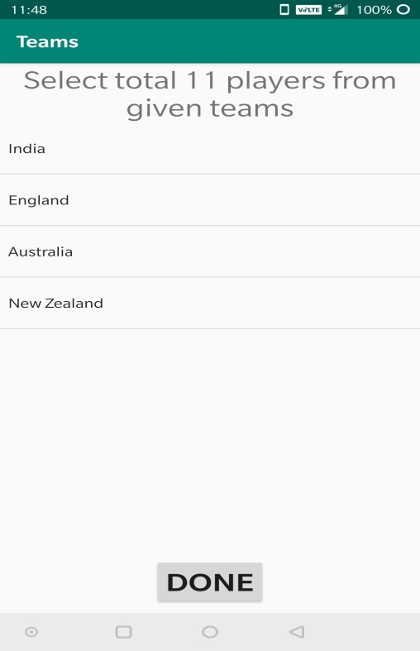 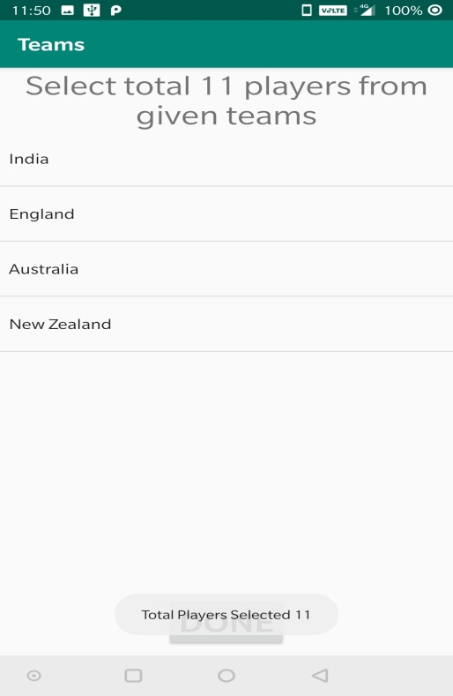

Final Team when more players are selected

