**GAME.java**

**package** com.example.mathgame;  
**import** androidx.appcompat.app.AlertDialog;  
**import** androidx.appcompat.app.AppCompatActivity;  
**import** android.content.DialogInterface;  
**import** android.content.Intent;  
**import** android.os.AsyncTask;  
**import** android.os.Bundle;  
**import** android.util.Log;  
**import** android.view.View;  
**import** android.widget.Button;  
**import** android.widget.TextView;  
**import** android.widget.Toast;  
**import** java.util.Random;  
**import** java.util.Stack;  
**public class** FrontPage **extends** AppCompatActivity {  
 TextView **ans**,**timer**,**level**,**question**,**rules**;  
 Button **submit**; String **s1**=**""**;  
 **int count**=150,**result**=0,**correctCount**=0,**submitClick**=0;  
 **boolean isCorrect**=**true**;  
 Stack<Character> **op** =**new** Stack<Character>();  
 Stack<Integer> **num**=**new** Stack<Integer>();  
 @Override  
 **protected void** onCreate(Bundle savedInstanceState) {  
 **super**.onCreate(savedInstanceState);  
 setContentView(R.layout.***activity_main***);  
 **ans** = findViewById(R.id.***answer***);  
 **timer** = findViewById(R.id.***timer***);  
 **submit**=findViewById(R.id.***submit***);  
 **level**=findViewById(R.id.***level***);  
 **question** =findViewById(R.id.***question***);  
 **rules**=findViewById(R.id.***rules***);  
 MyAsync run = **new** MyAsync();  
 run.execute(**count**);  
 **timer**.setText(String.*valueOf*(**count**));  
 expressionGenerator();  
 **submitClick**++;  
 **submit**.setOnClickListener(**new** View.OnClickListener() {  
 @Override  
 **public void** onClick(View view) {  
 **switch**(**submitClick**) {  
 **case** 1: calculate();expressionGenerator();**break**;  
 **case** 2: calculate();expressionGenerator();**break**;  
 **case** 3: calculate();expressionGenerator();**break**;  
 **case** 4: calculate();expressionGenerator();**break**;  
 **case** 5: calculate();  
 **if**(**isCorrect**) {  
 **level**.setText(**"LEVEL 2"**);  
 Toast.*makeText*(FrontPage.**this**,**"LEVEL 2 STARTED !"**,Toast.***LENGTH_LONG***).show();  
 }  
 expressionGenerator();  
 **break**;  
 **case** 6: calculate();expressionGenerator();**break**;  
 **case** 7: calculate();expressionGenerator();**break**;  
 **case** 8: calculate();expressionGenerator();**break**;  
 **case** 9: calculate();expressionGenerator();**break**;  
 **case** 10: calculate();  
 **if**(**isCorrect**) {  
 **level**.setText(**"LEVEL 3"**);  
 Toast.*makeText*(FrontPage.**this**,**"LEVEL 3 STARTED !"**,Toast.***LENGTH_LONG***).show();  
 }  
 expressionGenerator();  
 **break**;  
 **case** 11: calculate();expressionGenerator();**break**;  
 **case** 12: calculate();expressionGenerator();**break**;  
 **case** 13: calculate();expressionGenerator();**break**;  
 **case** 14: calculate();expressionGenerator();**break**;  
 **case** 15: calculate();  
 **if**(**isCorrect**) {  
 **level**.setText(**"LEVEL 4"**);  
 Toast.*makeText*(FrontPage.**this**,**"LEVEL 3 STARTED !"**,Toast.***LENGTH_LONG***).show();  
 }  
 expressionGenerator();  
 **break**;  
 **case** 16: calculate();expressionGenerator();**break**;  
 **case** 17: calculate();expressionGenerator();**break**;  
 **case** 18: calculate();expressionGenerator();**break**;  
 **case** 19: calculate();expressionGenerator();**break**;  
 **case** 20: calculate();**break**;  
 }  
 }  
 });  
 }  
 **public void** expressionGenerator() {  
 String expression=**""**;  
 Random r=**new** Random();  
 **int** num1=**new** Random().nextInt(10);  
 **int** num2=**new** Random().nextInt((9-1)+1)+1;  
 **int** num3=**new** Random().nextInt((9-1)+1)+1;  
 **int** num4=**new** Random().nextInt((9-1)+1)+1;  
 **int** num5=**new** Random().nextInt((9-1)+1)+1;  
 **char**[] operation=**new char**[]{**'+'**,**'-'**,**'*'**,**'/'**};  
 **char** oper1=operation[r.nextInt(operation.**length**)];  
 **char** oper2=operation[r.nextInt(operation.**length**)];  
 **char** oper3=operation[r.nextInt(operation.**length**)];  
 **char** oper4=operation[r.nextInt(operation.**length**)];  
 **if**(**"LEVEL 1"**.equals(**level**.getText().toString())) {  
 expression = num1+String.*valueOf*(oper1)+num2;  
 **question**.setText(expression);  
 }  
 **if**(**"LEVEL 2"**.equals(**level**.getText().toString())) {  
 expression = num1+String.*valueOf*(oper1)+num2+oper2+num3;  
 **question**.setText(expression);  
 }  
 **if**(**"LEVEL 3"**.equals(**level**.getText().toString())) {  
 expression = num1+String.*valueOf*(oper1)+num2+oper2+num3+oper3+num4;  
 **question**.setText(expression);  
 }  
 **if**(**"LEVEL 4"**.equals(**level**.getText().toString())) {  
 expression = num1+String.*valueOf*(oper1)+num2+oper2+num3+oper3+num4+oper4+num5;  
 **question**.setText(expression);  
 }  
 }  
 **public void** calculate(){  
 **char** []element=**new char**[100];  
 String s = **question**.getText().toString();  
 **for** (**int** i=0;i<s.length();i++)  
 element[i] = s.charAt(i);  
 **for** (**int** j = 0; j < element.**length**; j++){  
 **if** (element[j] >= **'0'**&& element[j] <= **'9'**) {  
 **num**.push(Integer.*parseInt*(String.*valueOf*(element[j])));  
 }  
 **else if** (element[j] == **'+'** || element[j] == **'-'** || element[j] == **'*'** || element[j] == **'/'**) {  
 **while** (!**op**.empty() && precedence(element[j], **op**.peek()))  
 **num**.push(cal(**op**.pop(), **num**.pop(), **num**.pop()));  
 **op**.push(element[j]);  
 }  
 }  
 **while**(!**op**.empty())  
 **num**.push(cal(**op**.pop(),**num**.pop(),**num**.pop()));  
 **result**=**num**.pop();  
 **s1** = String.*valueOf*(**result**);  
 **if**(**s1**.equals(**ans**.getText().toString())) {  
 **correctCount**++;  
 **submitClick**++;  
 **ans**.setText(**""**);  
 }  
 **else  
 isCorrect**=**false**;  
 }  
 **public boolean** precedence(**char** newOp,**char** topOp){  
 **if** ((newOp == **'*'** || newOp == **'/'**) && (topOp == **'+'** || topOp == **'-'**))  
 **return false**;  
 **else  
 return true**;  
 }  
 **int** cal(**char** op,**int** a,**int** b){  
 **switch** (op){  
 **case '+'**:**return** a+b;  
 **case '-'**:**return** b-a;  
 **case '*'**:**return** a*b;  
 **case '/'**:**return** b/a;}  
 **return** 0;  
 }  
 **class** MyAsync **extends** AsyncTask<Integer, Integer, Integer> {  
 **int count** = 150;  
 @Override  
 **protected** Integer doInBackground(Integer... integers) {  
 **while**(**count**!=0 && **isCorrect**) {  
 **try** {  
 Thread.*sleep*(1000);  
 **count**--;  
 publishProgress(**count**);  
 } **catch** (InterruptedException e) {  
 e.printStackTrace();  
 }  
 }  
 **return count**;  
 }  
 @Override **protected void** onProgressUpdate(Integer... values) {  
 **super**.onProgressUpdate(values);  
 **timer**.setText(values[0] + **""**);  
 **if** (!**isCorrect**) {  
 AlertDialog.Builder dialogBuilder = **new** AlertDialog.Builder(FrontPage.**this**);  
 dialogBuilder.setTitle(**"INCORRECT ANSWER !!! "**);  
 dialogBuilder.setMessage(**"Oops! Wrong answer \n Better luck next time :)!!"**);  
 dialogBuilder.setPositiveButton(**"RE-START"**, **new** DialogInterface.OnClickListener() {  
 @Override  
 **public void** onClick(DialogInterface dialogInterface, **int** i) {  
 Intent in=**new** Intent(FrontPage.**this**,MainActivity.**class**);  
 startActivity(in);  
 }  
 });  
 dialogBuilder.show();  
 }  
 **if** (**submitClick**==20) {  
 AlertDialog.Builder dialogBuilder = **new** AlertDialog.Builder(FrontPage.**this**);  
 dialogBuilder.setTitle(**"Congrats !!! "**);  
 dialogBuilder.setMessage(**"You completed all the levels :)"**);  
 dialogBuilder.setPositiveButton(**"Play again"**, **new** DialogInterface.OnClickListener() {  
 @Override  
 **public void** onClick(DialogInterface dialogInterface, **int** i) {  
 Intent in=**new** Intent(FrontPage.**this**,MainActivity.**class**);  
 startActivity(in);  
 }  
 });  
 dialogBuilder.show();  
 }  
 }  
 @Override **protected void** onPostExecute(Integer result) {  
 **super**.onPostExecute(result);  
 **timer**.setText(result + **""**);  
 **if**(**count**==0) {  
 AlertDialog.Builder dialogBuilder = **new** AlertDialog.Builder(FrontPage.**this**);  
 dialogBuilder.setTitle(**"TIME OUT !!! "**);  
 dialogBuilder.setMessage(**"Oops! Time over\n Try again !!"**);  
 dialogBuilder.setPositiveButton(**"TRY AGAIN"**, **new** DialogInterface.OnClickListener() {  
 @Override  
 **public void** onClick(DialogInterface dialogInterface, **int** i) {  
 Intent in=**new** Intent(FrontPage.**this**,MainActivity.**class**);  
 startActivity(in);  
 }  
 });  
 dialogBuilder.show();} }}}

FRONT_PAGE.java

**package** com.example.mathgame;  
**import** android.content.Intent;  
**import** android.os.Bundle;  
**import** android.view.View;  
**import** android.widget.Button;  
**import** androidx.appcompat.app.AppCompatActivity;  
**public class** MainActivity **extends** AppCompatActivity {  
 Button **start**;  
 @Override  
 **protected void** onCreate(Bundle savedInstanceState) {  
 **super**.onCreate(savedInstanceState);  
 setContentView(R.layout.***front_page***);  
 **start**=findViewById(R.id.***start***);  
 **start**.setOnClickListener(**new** View.OnClickListener() {  
 @Override  
 **public void** onClick(View view) {  
 Intent i=**new** Intent(MainActivity.**this**,FrontPage.**class**);  
 startActivity(i); } });}}

**MAIN_ACTIVITY.xml**

<?xml version="1.0" encoding="utf-8"?>  
<RelativeLayout  
 xmlns:android="http://schemas.android.com/apk/res/android"  
 xmlns:app="http://schemas.android.com/apk/res-auto"  
 xmlns:tools="http://schemas.android.com/tools"  
 android:layout_width="match_parent"  
 android:layout_height="match_parent"  
 android:background="@drawable/background"  
 tools:context=".MainActivity">  
 <TextView android:id="@+id/title"  
 android:layout_width="match_parent"  
 android:layout_height="wrap_content"  
 android:text="MATHS GAME"  
 android:textSize="30dp"  
 android:textAlignment="center"  
 android:textColor="#000000"/>  
 <TextView  
 android:id="@+id/level"  
 android:layout_width="wrap_content"  
 android:layout_height="wrap_content"  
 android:layout_below="@+id/title"  
 android:layout_marginLeft="100dp"  
 android:layout_marginTop="87dp"  
 android:text="LEVEL 1"  
 android:textColor="#000000"  
 android:textSize="25dp" />  
 <TextView  
 android:id="@+id/timer"  
 android:layout_width="wrap_content"  
 android:layout_height="wrap_content"  
 android:layout_below="@+id/title"  
 android:layout_marginLeft="260dp"  
 android:layout_marginTop="90dp"  
 android:text="00:00"  
 android:textColor="#000000"  
 android:textSize="25dp" />  
 <TextView  
 android:id="@+id/question"  
 android:layout_width="match_parent"  
 android:layout_height="wrap_content"  
 android:layout_below="@+id/level"  
 android:textAlignment="center"  
 android:layout_marginTop="79dp"  
 android:text=""  
 android:textColor="#000000"  
 android:textSize="30dp" />  
 <EditText  
 android:id="@+id/answer"  
 android:layout_width="wrap_content"  
 android:layout_height="wrap_content"  
 android:layout_below="@+id/question"  
 android:layout_centerInParent="true"  
 android:layout_marginTop="90dp"  
 android:text=""  
 android:textColor="#000000"  
 android:textSize="30dp" />  
 <Button  
 android:id="@+id/submit"  
 android:layout_width="wrap_content"  
 android:layout_height="wrap_content"  
 android:layout_below="@+id/answer"  
 android:layout_marginLeft="140dp"  
 android:layout_marginTop="98dp"  
 android:text="SUBMIT"  
 android:textColor="#000000"  
 android:textSize="30dp" />  
</RelativeLayout>

**FRONTPAGE.xml**

*<?***xml version="1.0" encoding="utf-8"***?>*<**RelativeLayout  
 xmlns:android="http://schemas.android.com/apk/res/android"  
 xmlns:app="http://schemas.android.com/apk/res-auto"  
 xmlns:tools="http://schemas.android.com/tools"  
 android:layout_width="match_parent"  
 android:layout_height="match_parent"  
 android:background="@drawable/front"  
 tools:context=".MainActivity"**>  
 <**TextView  
 android:id="@+id/title"  
 android:layout_width="match_parent"  
 android:layout_height="wrap_content"  
 android:layout_marginTop="50dp"  
 android:background="@color/colorAccent"  
 android:text="CLICK START !! \n TO PLAY GAME"  
 android:textAlignment="center"  
 android:textColor="#000000"  
 android:textSize="50dp"** />  
 <**TextView  
 android:id="@+id/rules"  
 android:layout_width="match_parent"  
 android:layout_height="wrap_content"  
 android:layout_below="@id/title"  
 android:layout_marginTop="203dp"  
 android:background="#000000"  
 android:text="RULES :\n 1.Total 4 levels\n 2.Total time provided 150 seconds"  
 android:textColor="#ffff"  
 android:textSize="20dp"** />  
 <**Button  
 android:id="@+id/start"  
 android:layout_width="wrap_content"  
 android:layout_height="wrap_content"  
 android:layout_below="@+id/title"  
 android:layout_marginLeft="140dp"  
 android:layout_marginTop="400dp"  
 android:text="START"  
 android:background="@color/colorAccent"  
 android:textColor="#000000"  
 android:textSize="30dp"** />  
</**RelativeLayout**>

**OUTPUT:**

1. **Instruction Page 2. Levels for playing**

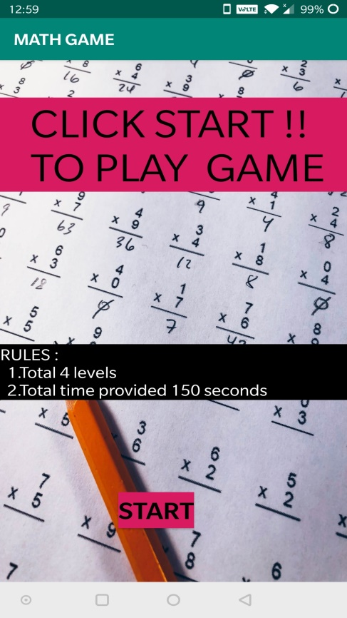 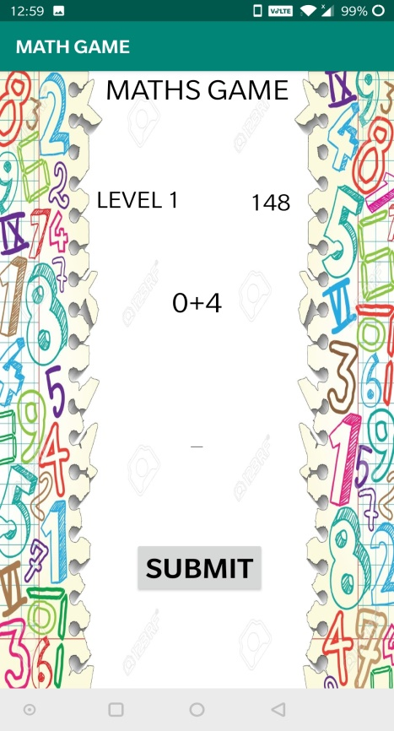

**3. Toast is given when new 4.When wrong answer is given**

**Level starts**

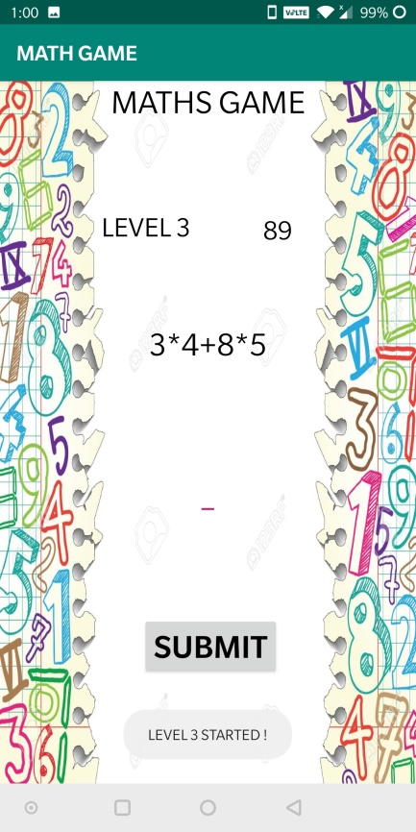 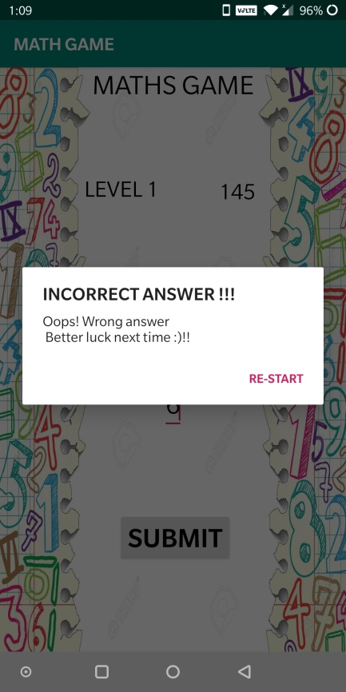

**5. When all levels are cleared 6.When timer ends**

