**MAIN_ACTIVITY.java**

**package** com.example.shoponline;  
**import** androidx.annotation.Nullable;  
**import** androidx.appcompat.app.AppCompatActivity;  
**import** android.content.Intent;  
**import** android.os.Bundle;  
**import** android.util.Log;  
**import** android.view.Menu;  
**import** android.view.MenuInflater;  
**import** android.view.MenuItem;  
**import** android.widget.Toast;  
**import** java.util.ArrayList;  
**public class** MainActivity **extends** AppCompatActivity {  
 ArrayList<String> **nameC**,**nameW**,**nameM**,**nameS**,**nameCart**,**priceC**,**priceW**,**priceM**,**priceS**,**priceCart**;  
 ArrayList<Integer> **imgC**,**imgW**,**imgM**,**imgS**,**imgCart**;  
 Intent **mainIntent**;  
 @Override  
 **protected void** onCreate(Bundle savedInstanceState) {  
 **super**.onCreate(savedInstanceState);  
 setContentView(R.layout.***activity_main***);  
 **nameC**=**new** ArrayList<>(); **nameW**=**new** ArrayList<>(); **nameM**=**new** ArrayList<>(); **nameS**=**new** ArrayList<>(); **nameCart**=**new** ArrayList<>();  
 **priceC**=**new** ArrayList<>(); **priceW**=**new** ArrayList<>(); **priceM**=**new** ArrayList<>(); **priceS**=**new** ArrayList<>();**priceCart**=**new** ArrayList<>();  
 **imgC**=**new** ArrayList<>(); **imgW**=**new** ArrayList<>(); **imgM**=**new** ArrayList<>(); **imgS**=**new** ArrayList<>(); **imgCart**=**new** ArrayList<>();  
 }  
 @Override  
 **public boolean** onCreateOptionsMenu(Menu menu) {  
 MenuInflater inflater=getMenuInflater();  
 inflater.inflate(R.menu.***main_menu***,menu);  
 **return true**;  
 }  
 **public boolean** onOptionsItemSelected(MenuItem item) {  
 **switch** (item.getItemId()) {  
 **case** R.id.***clothes***:  
 Toast.*makeText*(**this**,**"Refresh your wardrobe"**,Toast.***LENGTH_LONG***).show();  
 **mainIntent**=**new** Intent(MainActivity.**this**,clothClass.**class**);  
 **mainIntent**.putStringArrayListExtra(**"clothName"**,**nameC**);  
 **mainIntent**.putStringArrayListExtra(**"priceC"**,**priceC**);  
 **mainIntent**.putIntegerArrayListExtra(**"clothPic"**,**imgC**);  
 startActivityForResult(**mainIntent**,1);  
 **return true**;  
 **case** R.id.***accessories***:  
 Toast.*makeText*(**this**,**"You selected accessories"**,Toast.***LENGTH_LONG***).show();  
 **return true**;  
 **case** R.id.***watch***:  
 Toast.*makeText*(**this**,**"Add new collection of watches"**,Toast.***LENGTH_LONG***).show();  
 **mainIntent**=**new** Intent(MainActivity.**this**,watchClass.**class**);  
 **mainIntent**.putStringArrayListExtra(**"watchName"**,**nameW**);  
 **mainIntent**.putStringArrayListExtra(**"priceW"**,**priceW**);  
 **mainIntent**.putIntegerArrayListExtra(**"watchPic"**,**imgW**);  
 startActivityForResult(**mainIntent**,2);  
 **return true**;  
 **case** R.id.***shoes***:  
 Toast.*makeText*(**this**,**"Step on floor with new Shoes"**,Toast.***LENGTH_LONG***).show();  
 **mainIntent**=**new** Intent(MainActivity.**this**,shoesClass.**class**);  
 **mainIntent**.putStringArrayListExtra(**"shoesName"**,**nameS**);  
 **mainIntent**.putStringArrayListExtra(**"priceS"**,**priceS**);  
 **mainIntent**.putIntegerArrayListExtra(**"shoesPic"**,**imgS**);  
 startActivityForResult(**mainIntent**,3);  
 **return true**;  
 **case** R.id.***mobile***:  
 Toast.*makeText*(**this**,**"Latest Mobile here!!"**,Toast.***LENGTH_LONG***).show();  
 **mainIntent**=**new** Intent(MainActivity.**this**,mobileClass.**class**);  
 **mainIntent**.putStringArrayListExtra(**"mobileName"**,**nameM**);  
 **mainIntent**.putStringArrayListExtra(**"priceM"**,**priceM**);  
 **mainIntent**.putIntegerArrayListExtra(**"mobilePic"**,**imgM**);  
 startActivityForResult(**mainIntent**,4);  
 **return true**;  
 **case** R.id.***cart***:  
 Toast.*makeText*(**this**,**"Moved to cart"**,Toast.***LENGTH_LONG***).show();  
 **mainIntent**=**new** Intent(MainActivity.**this**,cartClass.**class**);  
 **mainIntent**.putStringArrayListExtra(**"cartName"**,**nameCart**);  
 **mainIntent**.putStringArrayListExtra(**"priceCart"**,**priceCart**);  
 **mainIntent**.putIntegerArrayListExtra(**"cartPic"**,**imgCart**);  
  
 **mainIntent**.putStringArrayListExtra(**"clothName"**,**nameC**);  
 **mainIntent**.putStringArrayListExtra(**"priceC"**,**priceC**);  
 **mainIntent**.putIntegerArrayListExtra(**"clothPic"**,**imgC**);  
  
 **mainIntent**.putStringArrayListExtra(**"mobileName"**,**nameM**);  
 **mainIntent**.putStringArrayListExtra(**"priceM"**,**priceM**);  
 **mainIntent**.putIntegerArrayListExtra(**"mobilePic"**,**imgM**);  
  
 **mainIntent**.putStringArrayListExtra(**"shoesName"**,**nameS**);  
 **mainIntent**.putStringArrayListExtra(**"priceS"**,**priceS**);  
 **mainIntent**.putIntegerArrayListExtra(**"shoesPic"**,**imgS**);  
  
 **mainIntent**.putStringArrayListExtra(**"watchName"**,**nameW**);  
 **mainIntent**.putStringArrayListExtra(**"priceW"**,**priceW**);  
 **mainIntent**.putIntegerArrayListExtra(**"watchPic"**,**imgW**);  
  
 startActivityForResult(**mainIntent**,5);  
 **return true**;  
 **default**:  
 **return super**.onOptionsItemSelected(item);  
 }  
 }  
 @Override  
 **protected void** onActivityResult(**int** requestCode, **int** resultCode, @Nullable Intent data) {  
 **super**.onActivityResult(requestCode, resultCode, data);  
  
 **if**(requestCode==1) {  
 **if**(resultCode==***RESULT_OK***) {  
 **nameC**=data.getStringArrayListExtra(**"clothName"**);  
 **priceC**=data.getStringArrayListExtra(**"priceC"**);  
 **imgC**=data.getIntegerArrayListExtra(**"clothPic"**);  
 } }  
 **if**(requestCode==2) {  
 **if**(resultCode==***RESULT_OK***) {  
 **nameW**=data.getStringArrayListExtra(**"watchName"**);  
 **priceW**=data.getStringArrayListExtra(**"priceW"**);  
 **imgW**=data.getIntegerArrayListExtra(**"watchPic"**);  
 }}  
 **if**(requestCode==3) {  
 **if**(resultCode==***RESULT_OK***) {  
 **nameS**=data.getStringArrayListExtra(**"shoesName"**);  
 **priceS**=data.getStringArrayListExtra(**"priceS"**);  
 **imgS**=data.getIntegerArrayListExtra(**"shoesPic"**);  
 }}  
 **if**(requestCode==4) {  
 **if**(resultCode==***RESULT_OK***) {  
 **nameM**=data.getStringArrayListExtra(**"mobileName"**);  
 **priceM**=data.getStringArrayListExtra(**"priceM"**);  
 **imgM**=data.getIntegerArrayListExtra(**"mobilePic"**);  
 }}  
 **if**(requestCode==5) {  
 **if**(resultCode==5) {  
 **nameCart**=data.getStringArrayListExtra(**"cartName"**);  
 **priceCart**=data.getStringArrayListExtra(**"priceCart"**);  
 **imgCart**=data.getIntegerArrayListExtra(**"cartPic"**);  
  
 **nameC**=data.getStringArrayListExtra(**"clothName"**);  
 **priceC**=data.getStringArrayListExtra(**"priceC"**);  
 **imgC**=data.getIntegerArrayListExtra(**"clothPic"**);  
  
 **nameM**=data.getStringArrayListExtra(**"mobileName"**);  
 **priceM**=data.getStringArrayListExtra(**"priceM"**);  
 **imgM**=data.getIntegerArrayListExtra(**"mobilePic"**);  
  
 **nameS**=data.getStringArrayListExtra(**"shoesName"**);  
 **priceS**=data.getStringArrayListExtra(**"priceS"**);  
 **imgS**=data.getIntegerArrayListExtra(**"shoesPic"**);  
  
 **nameW**=data.getStringArrayListExtra(**"watchName"**);  
 **priceW**=data.getStringArrayListExtra(**"priceW"**);  
 **imgW**=data.getIntegerArrayListExtra(**"watchPic"**);  
 }  
 }  
 }  
}

**CLOTHES.java ,SHOES.java,MOBILE.java,WATCH.java files**

**package** com.example.shoponline;  
**import** android.app.Activity;  
**import** android.content.Intent;  
**import** android.os.Bundle;  
**import** android.view.LayoutInflater;  
**import** android.view.View;  
**import** android.view.ViewGroup;  
**import** android.widget.AdapterView;  
**import** android.widget.ArrayAdapter;  
**import** android.widget.Button;  
**import** android.widget.ImageView;  
**import** android.widget.ListView;  
**import** android.widget.TextView;  
**import** android.widget.Toast;  
**import** androidx.appcompat.app.AppCompatActivity;  
**import** java.util.ArrayList;  
**public class** shoesClass **extends** AppCompatActivity {  
 String[] **maintitle** ={**"Nike"**,**"Puma"**, **"Adidas"**,**"Sketchers"**, **"Rebook"**};  
 String[] **subtitle** ={**"Price -₹799"**,**"Price - ₹659"**, **"Price - ₹349"**,**"Price - ₹1199"**, **"Price - ₹999"**};  
 **int**[] **imgid**={R.drawable.***shoe1***,R.drawable.***shoe2***, R.drawable.***shoe3***,R.drawable.***shoe4***, R.drawable.***shoe5***};  
 ArrayList<String> **nameS**,**priceS**;  
 ArrayList<Integer>**imgS**;  
 Button **moveToHomepage**;  
 Intent **shoesIntent**;  
 ListView **shoesList**;  
 **protected void** onCreate(Bundle savedInstanceState) {  
 **super**.onCreate(savedInstanceState);  
 setContentView(R.layout.***list_view***);  
 **shoesList**=findViewById(R.id.***list_view***);  
 **moveToHomepage**=findViewById(R.id.***moveTohomepage***);  
 **nameS**=**new** ArrayList<>(); **priceS**=**new** ArrayList<>(); **imgS**=**new** ArrayList<>();  
 **shoesIntent**=getIntent();  
 **nameS**=**shoesIntent**.getStringArrayListExtra(**"shoesName"**);  
 **priceS**=**shoesIntent**.getStringArrayListExtra(**"priceS"**);  
 **imgS**=**shoesIntent**.getIntegerArrayListExtra(**"shoesPic"**);  
 shoesListAdapter adapter=**new** shoesListAdapter(**this**, **maintitle**, **subtitle**,**imgid**);  
 **shoesList**.setAdapter(adapter);  
 **shoesList**.setOnItemClickListener(**new** AdapterView.OnItemClickListener() {  
 @Override  
 **public void** onItemClick(AdapterView<?> adapterView, View view, **int** i, **long** l) {  
 **if**(i==0){  
 Toast.*makeText*(getApplicationContext(),**"Nike added to cart"**,Toast.***LENGTH_SHORT***).show();  
 **nameS**.add(**maintitle**[i]);  
 **priceS**.add(**subtitle**[i]);  
 **imgS**.add(**imgid**[i]);}  
 **if**(i==1){  
 Toast.*makeText*(getApplicationContext(),**"Puma added to cart"**,Toast.***LENGTH_SHORT***).show();  
 **nameS**.add(**maintitle**[i]);  
 **priceS**.add(**subtitle**[i]);  
 **imgS**.add(**imgid**[i]);}  
 **if**(i==2){  
 Toast.*makeText*(getApplicationContext(),**"Adidas added to cart"**,Toast.***LENGTH_SHORT***).show();  
 **nameS**.add(**maintitle**[i]);  
 **priceS**.add(**subtitle**[i]);  
 **imgS**.add(**imgid**[i]);}  
 **if**(i==3){  
 Toast.*makeText*(getApplicationContext(),**"Sketchers added to cart"**,Toast.***LENGTH_SHORT***).show();  
 **nameS**.add(**maintitle**[i]);  
 **priceS**.add(**subtitle**[i]);  
 **imgS**.add(**imgid**[i]);}  
 **if**(i==4){  
 Toast.*makeText*(getApplicationContext(),**"Rebook added to cart"**,Toast.***LENGTH_SHORT***).show();  
 **nameS**.add(**maintitle**[i]);  
 **priceS**.add(**subtitle**[i]);  
 **imgS**.add(**imgid**[i]);  
 } }});  
 **moveToHomepage**.setOnClickListener(**new** View.OnClickListener() {  
 @Override  
 **public void** onClick(View view) {  
 Intent send=**new** Intent();  
 send.putStringArrayListExtra(**"shoesName"**,**nameS**);  
 send.putStringArrayListExtra(**"priceS"**,**priceS**);  
 send.putIntegerArrayListExtra(**"shoesPic"**,**imgS**);  
 setResult(***RESULT_OK***,send);  
 finish();  
 }});}}  
**class** shoesListAdapter **extends** ArrayAdapter<String> {  
 **private final** Activity **context**;  
 **private final** String[] **maintitle**;  
 **private final** String[] **subtitle**;  
 **private final int**[] **imgid**;  
 **public** shoesListAdapter(Activity context,String[] maintitle,String[] subtitle, **int**[] imgid) {  
 **super**(context,R.layout.***row_view***,maintitle);  
 **this**.**context**=context;  
 **this**.**maintitle**=maintitle;  
 **this**.**subtitle**=subtitle;  
 **this**.**imgid**=imgid;}  
 **public** View getView(**int** position, View view, ViewGroup parent) {  
 LayoutInflater inflater=**context**.getLayoutInflater();  
 View rowView=inflater.inflate(R.layout.***row_view***, **null**,**false**);  
 TextView titleText = (TextView) rowView.findViewById(R.id.***title***);  
 ImageView imageView = (ImageView) rowView.findViewById(R.id.***img***);  
 TextView subtitleText = (TextView) rowView.findViewById(R.id.***descript***);  
 titleText.setText(**maintitle**[position]);  
 imageView.setImageResource(**imgid**[position]);  
 subtitleText.setText(**subtitle**[position]);  
 **return** rowView;}}

**CART.java**

**package** com.example.shoponline;  
**import** android.app.Activity;  
**import** android.content.Intent;  
**import** android.os.Bundle;  
**import** android.view.LayoutInflater;  
**import** android.view.View;  
**import** android.view.ViewGroup;  
**import** android.widget.AdapterView;  
**import** android.widget.ArrayAdapter;  
**import** android.widget.Button;  
**import** android.widget.ImageView;  
**import** android.widget.ListView;  
**import** android.widget.TextView;  
**import** android.widget.Toast;  
**import** androidx.appcompat.app.AlertDialog;  
**import** androidx.appcompat.app.AppCompatActivity;  
**import** java.text.SimpleDateFormat;  
**import** java.util.ArrayList;  
**import** java.util.Calendar;  
**import** java.util.Date;  
**public class** cartClass **extends** AppCompatActivity {  
 Intent **Icart**;  
 Button **proceed**,**back**;  
 TextView **tv1**,**tv2**;  
 ListView **cartList**;  
 **int finalCost**=0;  
 ArrayList<String> **maintitle**,**subtitle**,**nameC**,**nameW**,**nameM**,**nameS**,**priceC**,**priceW**,**priceM**,**priceS**;  
 ArrayList<Integer> **imgid**,**imgC**,**imgW**,**imgM**,**imgS**;  
 **protected void** onCreate(Bundle savedInstanceState) {  
 **super**.onCreate(savedInstanceState);  
 setContentView(R.layout.***cart***);  
 **proceed** = findViewById(R.id.***proceed***);  
 **back**=findViewById(R.id.***back***);  
 **tv1**=findViewById(R.id.***tv1***);  
 **tv2**=findViewById(R.id.***tv2***);  
 **cartList**=findViewById(R.id.***lv1***);  
 **maintitle**=**new** ArrayList<>();  
 **subtitle**=**new** ArrayList<>();  
 **imgid**=**new** ArrayList<>();  
 **nameC**=**new** ArrayList<>(); **nameW**=**new** ArrayList<>(); **nameM**=**new** ArrayList<>(); **nameS**=**new** ArrayList<>();  
 **priceC**=**new** ArrayList<>(); **priceW**=**new** ArrayList<>(); **priceM**=**new** ArrayList<>(); **priceS**=**new** ArrayList<>();  
 **imgC**=**new** ArrayList<>(); **imgW**=**new** ArrayList<>(); **imgM**=**new** ArrayList<>(); **imgS**=**new** ArrayList<>();  
 **Icart**=getIntent();  
 **nameC**=**Icart**.getStringArrayListExtra(**"clothName"**);  
 **priceC**=**Icart**.getStringArrayListExtra(**"priceC"**);  
 **imgC**=**Icart**.getIntegerArrayListExtra(**"clothPic"**);  
 **nameM**=**Icart**.getStringArrayListExtra(**"mobileName"**);  
 **priceM**=**Icart**.getStringArrayListExtra(**"priceM"**);  
 **imgM**=**Icart**.getIntegerArrayListExtra(**"mobilePic"**);  
 **nameS**=**Icart**.getStringArrayListExtra(**"shoesName"**);  
 **priceS**=**Icart**.getStringArrayListExtra(**"priceS"**);  
 **imgS**=**Icart**.getIntegerArrayListExtra(**"shoesPic"**);  
 **nameW**=**Icart**.getStringArrayListExtra(**"watchName"**);  
 **priceW**=**Icart**.getStringArrayListExtra(**"priceW"**);  
 **imgW**=**Icart**.getIntegerArrayListExtra(**"watchPic"**);  
 **maintitle**=**Icart**.getStringArrayListExtra(**"cartName"**);  
 **subtitle**=**Icart**.getStringArrayListExtra(**"priceCart"**);  
 **imgid**=**Icart**.getIntegerArrayListExtra(**"cartPic"**);  
 cartListAdapter cartAdapter =**new** cartListAdapter(**this**,**maintitle**,**subtitle**,**imgid**);  
 **cartList**.setAdapter(cartAdapter);  
 **if**(**nameC**!=**null**) {  
 **for** (**int** i = 0; i < **nameC**.size(); i++) {  
 **maintitle**.add(**nameC**.get(i));  
 **subtitle**.add(**priceC**.get(i));  
 **imgid**.add(**imgC**.get(i));} }  
 **if**(**nameM**!=**null**) {  
 **for** (**int** i = 0; i < **nameM**.size(); i++) {  
 **maintitle**.add(**nameM**.get(i));  
 **subtitle**.add(**priceM**.get(i));  
 **imgid**.add(**imgM**.get(i));}}  
 **if**(**nameS**!=**null**) {  
 **for** (**int** i = 0; i < **nameS**.size(); i++) {  
 **maintitle**.add(**nameS**.get(i));  
 **subtitle**.add(**priceS**.get(i));  
 **imgid**.add(**imgS**.get(i));}}  
 **if**(**nameW**!=**null**) {  
 **for** (**int** i = 0; i < **nameW**.size(); i++) {  
 **maintitle**.add(**nameW**.get(i));  
 **subtitle**.add(**priceW**.get(i));  
 **imgid**.add(**imgW**.get(i));}}  
 **for**(**int** i=0;i<**subtitle**.size();i++)  
 **finalCost**+=Integer.*parseInt*(**subtitle**.get(i).replaceAll(**"[^0-9]"**,**""**));  
 **tv2**.setText(String.*valueOf*(**finalCost**));  
 **proceed**.setOnClickListener(**new** View.OnClickListener() {  
 @Override  
 **public void** onClick(View view) {  
 **if**(**finalCost**!=0){  
 AlertDialog.Builder dialogBuilder = **new** AlertDialog.Builder(cartClass.**this**);  
 dialogBuilder.setTitle(**"Delivery "**);  
 SimpleDateFormat dateFormat=**new** SimpleDateFormat(**"dd/MM/yyyy"**);  
 Calendar c= Calendar.*getInstance*();  
 c.setTime(**new** Date());  
 c.add(Calendar.***DAY_OF_YEAR***,3);  
 Date newDate=c.getTime();  
 String str=dateFormat.format(newDate);  
 dialogBuilder.setMessage(**"Order placed !!\n\nExpected Delivery date :"**+str+**"\n\nTotal amount to pay INR-"**+**finalCost**+**"\n\nThanks for shopping :)"**);  
 AlertDialog dialog = dialogBuilder.create();  
 dialog.show();  
 }  
 **else** Toast.*makeText*(cartClass.**this**,**"Please select some items! Cart is empty"**,Toast.***LENGTH_LONG***).show();  
 } });  
 **back**.setOnClickListener(**new** View.OnClickListener() {  
 @Override  
 **public void** onClick(View view) {  
 Intent send=**new** Intent();  
 send.putIntegerArrayListExtra(**"cartPic"**,**imgid**);  
 send.putStringArrayListExtra(**"cartName"**,**maintitle**);  
 send.putStringArrayListExtra(**"priceCart"**,**subtitle**);  
 setResult(***RESULT_OK***,send);  
 finish();}});}}  
  
**class** cartListAdapter **extends** ArrayAdapter<String> {  
 **private final** Activity **context**;  
 **private final** ArrayList<String> **maintitle**;  
 **private final** ArrayList<String> **subtitle**;  
 **private final** ArrayList<Integer> **imgid**;  
  
 **public** cartListAdapter(Activity context, ArrayList<String> maintitle, ArrayList<String> subtitle, ArrayList<Integer> imgid) {  
 **super**(context,R.layout.***row_view***,maintitle);  
 **this**.**context**=context;  
 **this**.**maintitle**=maintitle;  
 **this**.**subtitle**=subtitle;  
 **this**.**imgid**=imgi;}  
 **public** View getView(**int** position, View view, ViewGroup parent) {  
 LayoutInflater inflater=**context**.getLayoutInflater();  
 View rowView=inflater.inflate(R.layout.***row_view***, **null**,**false**);  
 TextView titleText = (TextView) rowView.findViewById(R.id.***title***);  
 ImageView imageView = (ImageView) rowView.findViewById(R.id.***img***);  
 TextView subtitleText = (TextView) rowView.findViewById(R.id.***descript***);  
 titleText.setText(**maintitle**.get(position));  
 imageView.setImageResource(**imgid**.get(position));  
 subtitleText.setText(**subtitle**.get(position));  
 **return** rowView;}}

**MAIN_ACTIVITY.xml**

*<?***xml version="1.0" encoding="utf-8"***?>*<**LinearLayout  
 xmlns:android="http://schemas.android.com/apk/res/android"  
 xmlns:app="http://schemas.android.com/apk/res-auto"  
 xmlns:tools="http://schemas.android.com/tools"  
 android:layout_width="match_parent"  
 android:layout_height="match_parent"  
 tools:context=".MainActivity"**>  
 <**ImageView  
 android:layout_width="match_parent"  
 android:layout_height="match_parent"  
 android:src="@drawable/frontpage"**/></**LinearLayout**>

**CART.xml**

*<?***xml version="1.0" encoding="utf-8"***?>*<**RelativeLayout  
 xmlns:android="http://schemas.android.com/apk/res/android"  
 xmlns:app="http://schemas.android.com/apk/res-auto"  
 xmlns:tools="http://schemas.android.com/tools"  
 android:layout_width="match_parent"  
 android:layout_height="match_parent"  
 tools:context=".cartClass"  
 android:orientation="vertical"**>  
 <**ListView android:id="@+id/lv1"  
 android:layout_width="wrap_content"  
 android:layout_height="446dp"**></**ListView**>  
 <**TextView android:id="@+id/tv1"  
 android:layout_width="wrap_content"  
 android:layout_height="wrap_content"  
 android:layout_below="@+id/lv1"  
 android:layout_marginLeft="30dp"  
 android:layout_marginTop="111dp"  
 android:text="CART VALUE in INR :"  
 android:textColor="#000000"  
 android:textSize="20dp"** />  
 <**TextView android:id="@+id/tv2"  
 android:layout_width="wrap_content"  
 android:layout_height="wrap_content"  
 android:layout_below="@+id/lv1"  
 android:layout_marginLeft="21dp"  
 android:layout_marginTop="110dp"  
 android:layout_toRightOf="@+id/tv1"  
 android:text="00"  
 android:textColor="#000000"  
 android:textSize="20dp"** />  
 <**Button android:id="@+id/proceed"  
 android:layout_width="wrap_content"  
 android:layout_height="wrap_content"  
 android:layout_below="@+id/tv2"  
 android:layout_marginLeft="50dp"  
 android:layout_marginTop="54dp"  
 android:text="PROCEED"  
 android:textSize="20dp"** />  
 <**Button android:id="@+id/back"  
 android:layout_width="wrap_content"  
 android:layout_height="wrap_content"  
 android:layout_below="@+id/tv2"  
 android:layout_marginStart="250dp"  
 android:layout_marginLeft="250dp"  
 android:layout_marginTop="53dp"  
 android:layout_marginEnd="250dp"  
 android:layout_marginRight="250dp"  
 android:layout_marginBottom="250dp"  
 android:text="BACK"  
 android:textSize="20dp"** />  
</**RelativeLayout**>

**LIST_VIEW.xml**

*<?***xml version="1.0" encoding="utf-8"***?>*<**RelativeLayout  
 xmlns:android="http://schemas.android.com/apk/res/android"  
 xmlns:app="http://schemas.android.com/apk/res-auto"  
 xmlns:tools="http://schemas.android.com/tools"  
 android:layout_width="match_parent"  
 android:layout_height="match_parent"  
 tools:context=".MainActivity"**>  
 <**TextView  
 android:id="@+id/tv1"  
 android:layout_width="match_parent"  
 android:layout_height="wrap_content"  
 android:text="CLICK TO ADD TO CART"  
 android:textColor="#000000"  
 android:textAlignment="center"  
 android:textSize="30dp"**/>  
 <**ListView  
 android:id="@+id/list_view"  
 android:layout_width="match_parent"  
 android:layout_height="wrap_content"  
 android:layout_below="@+id/tv1"  
 android:layout_marginTop="20dp"**></**ListView**>  
 <**Button  
 android:id="@+id/moveTohomepage"  
 android:layout_width="wrap_content"  
 android:layout_height="wrap_content"  
 android:layout_below="@id/list_view"  
 android:layout_marginHorizontal="120dp"  
 android:layout_marginTop="20dp"  
 android:text="MOVE TO HOME PAGE"  
 android:textSize="20sp"** />  
</**RelativeLayout**>

**ROW_VIEW.xml**

*<?***xml version="1.0" encoding="utf-8"***?>*<**LinearLayout  
 xmlns:android="http://schemas.android.com/apk/res/android"  
 xmlns:app="http://schemas.android.com/apk/res-auto"  
 xmlns:tools="http://schemas.android.com/tools"  
 android:layout_width="match_parent"  
 android:layout_height="match_parent"  
 android:orientation="horizontal"  
 tools:context=".MainActivity"**>  
 <**ImageView  
 android:id="@+id/img"  
 android:layout_width="90dp"  
 android:layout_height="90dp"  
 android:src="@mipmap/ic_launcher"**/>  
 <**LinearLayout  
 android:layout_width="match_parent"  
 android:layout_height="match_parent"  
 android:orientation="vertical"**>  
 <**TextView  
 android:id="@+id/title"  
 android:layout_width="match_parent"  
 android:layout_height="wrap_content"  
 android:textStyle="bold"  
 android:textColor="#000000"  
 android:textSize="20dp"**/>  
 <**TextView  
 android:id="@+id/descript"  
 android:textColor="#000000"  
 android:layout_width="match_parent"  
 android:layout_height="wrap_content"  
 android:textSize="15dp"**/>  
 </**LinearLayout**>  
</**LinearLayout**>

**OUTPUT—**

**1.MENU ITEMS 2.SUBMENU ITEMS**

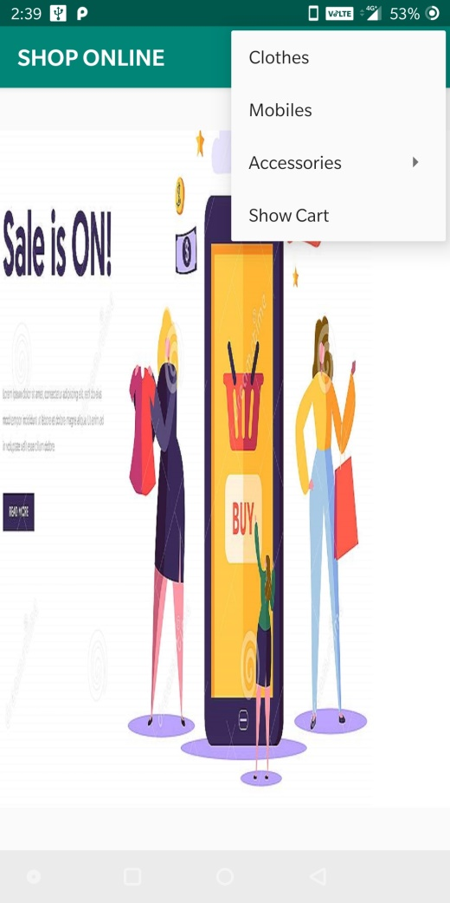 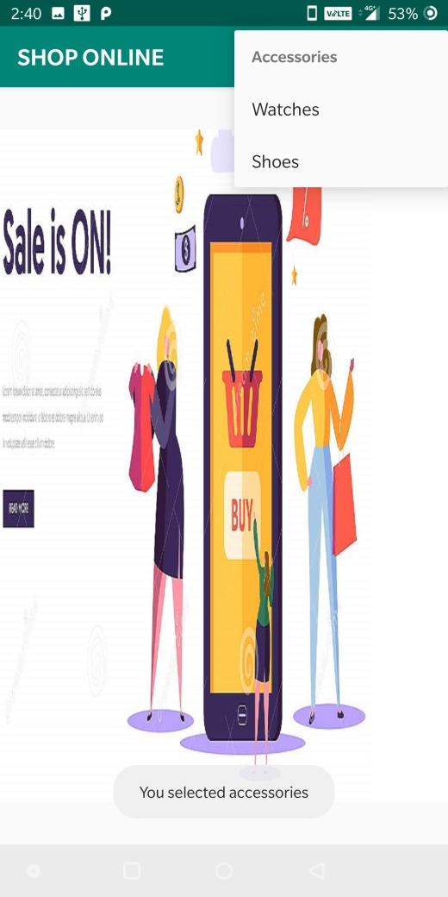

**3.CATEGORY –ITEMS 4.CART ITEMS**

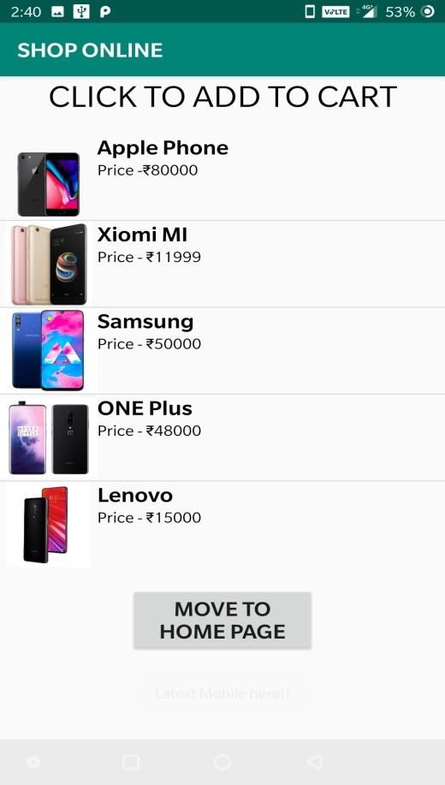 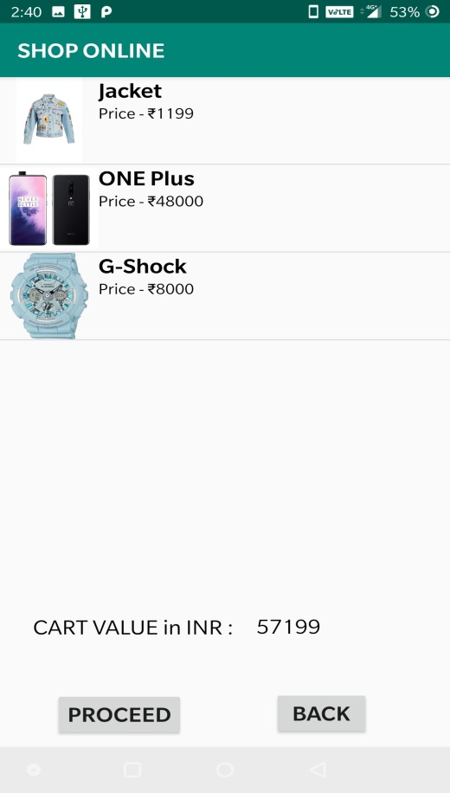

**5.WHEN ORDER IS PLACED**

