System design
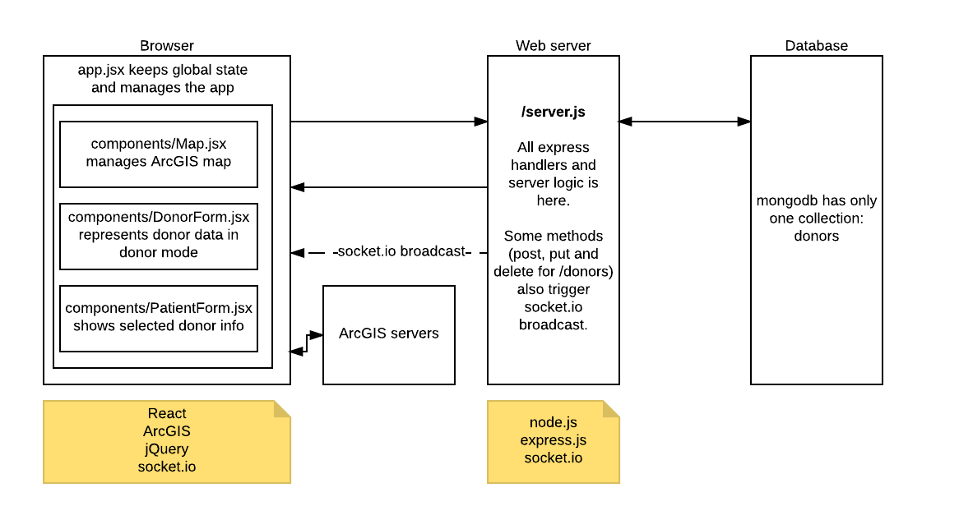
Figure 1 Component interaction diagram

Architecture overview
Co-test is a web application to let blood donors and patients know about each other. It’s built on MEAN technology stack (with React instead AngularJS).
Client tasks to server using traditional AJAX requests and also receives push notifications from server about changed (new, deleted) donors using socket.io lib. Client app is implemented using React as a backbone framework without any additional state management library. For geospatial functionality ArcGIS is used.
Web server is built on express.js framework. Application isn’t very big thus all handling is kept in file server.js. Web server keeps socket.io connection to notify clients and mongodb connection to store data about donors.

Technologies, libraries and APIs
- Back end
  - Node.js – platform
  - Express.js – app backbone framework
  - MongoDB – NoSQL database
  - Mongoose – node.js library to talk to MongoDB
  - Socket.io – used for real-time client->server and server->client communication
  - Node-uuid – generate UUIDs for donors
  - Mocha – test runner
  - Supertest – test http calls
  - Ejs – template engine
- Front end
  - React – view (VDOM) library
  - Material-ui – Material UI library for React
  - Scss – sweet CSS superset
  - ArcGIS – map component, geospatial services
  - Socket.io – see above
  - jQuery – utility methods
  - lodash – utility methods
- Front end (build)
  - Webpack – tool to build scripts and stylesheets
  - Webpack-dev-server – serve compiled resources without persisting and with hot reloading
  - Babel – transpile advanced js and jsx to js that browsers would understand
  - Css-modules – embedded CSS styles with strong local scope
  - React-hot-loader – reload browser page automatically after save

