

Network Programming (IE2102)
2nd Year, 2nd Semester

Assignment

Design and Implementation of a Secure Multiprocessor TCP Application Server with Custom Protocol and Session Management
Submitted to
Sri Lanka Institute of Information Technology

<IT24102423>
<Jayasiri D.N.D>

In partial fulfillment of the requirements for the
Bachelor of Science Special Honors Degree in Information Technology

<<11/04/2026>>

Declaration
I certify that this report does not incorporate without acknowledgement, any material previously submitted for a degree or diploma in any university, and to the best of my knowledge and belief it does not contain any material previously published or written by another person, except where due reference is made in text.

Name: Jayasiri D.N.D
Registration Number: IT24102423
Date: 11 April 2026
Introduction
This assignment focuses on the design and implementation of a secure TCP client-server application using socket programming concepts. The system was developed using the C programming language for the server and Python for the client. The communication between the client and server is established using a custom protocol over TCP.
The application supports multiple clients concurrently using process forking (fork()), allowing efficient handling of multiple connections. In addition, the system incorporates authentication mechanisms, session management, and security features such as rate limiting and brute-force attack protection. These features ensure that the system is both functional and secure.
System Overview
The system consists of two main components: a server and a client. The server is implemented in C and listens for incoming TCP connections on a predefined port. The client is implemented in Python and connects to the server to send commands.
The communication between the client and server follows a custom protocol format: LEN:\n, where represents the length of the message payload. This ensures proper message framing and reliable data transmission.
The server handles multiple clients using the fork() system call, where each client connection is processed by a separate child process. The parent process continues to listen for new connections, enabling concurrent client handling.
Authentication is implemented using REGISTER and LOGIN commands. Passwords are stored securely using salted hashing, and session tokens are generated upon successful login. Additional security mechanisms such as rate limiting and account lockout are implemented to prevent abuse and brute-force attacks.

HOSTNAME CONFIGURATION
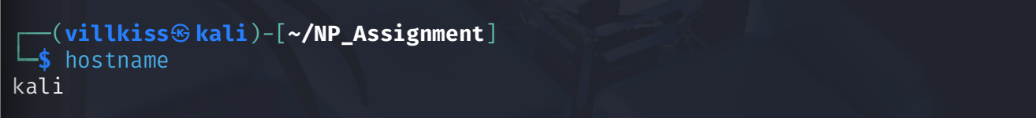
Figure 1: Host Name Configuration
This screenshot shows the system hostname and current user environment. It confirms that the system is properly configured and ready for executing the server and client applications.
NETWORK CONFIGURATION
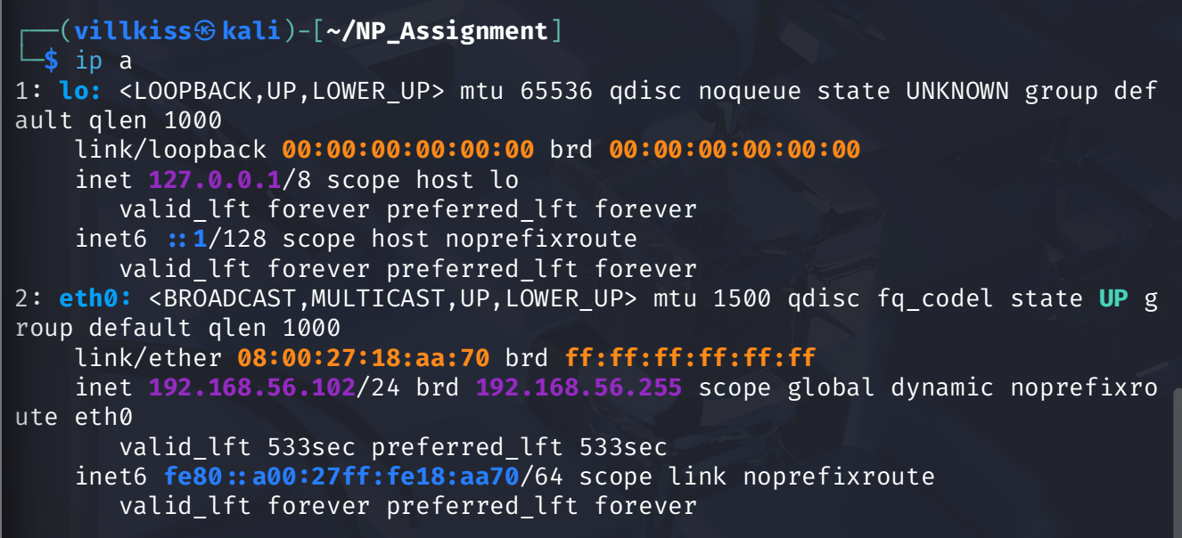
Figure 2:Network configuration
This screenshot shows the network interface configuration of the system using the ip command. It verifies that the system has a valid IP address and network setup required for TCP communication.
SERVER RUNNING
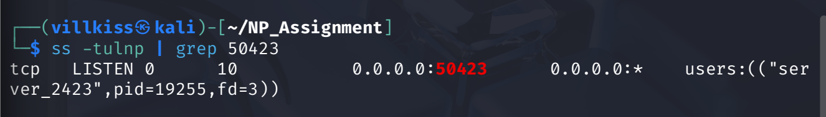
Figure 3:Server running on assigned port
This screenshot demonstrates that the server is successfully running and listening on the assigned port 50423. The output confirms that the socket has been correctly bound and is actively accepting incoming TCP connections.

SUCCESSFUL REGISTER AND LOGIN
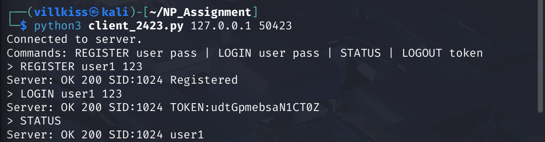
Figure 4:Successful REGISTER and LOGIN
This screenshot demonstrates the successful execution of REGISTER and LOGIN commands. The server responds with a success message and generates a session token upon successful authentication. This confirms that the authentication system is functioning correctly.
FAILED LOGIN AND ACCOUNT LOCKOUT
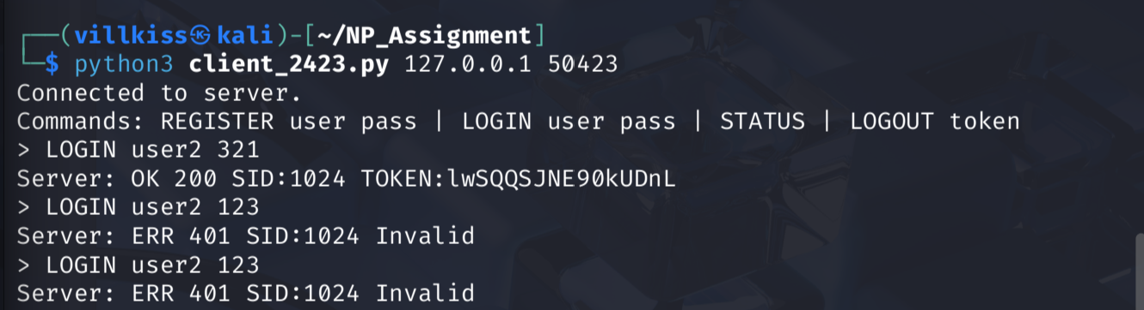

Figure 5:Failed login attempts and account lockout
This screenshot shows multiple failed login attempts followed by an account lockout. After several incorrect password entries, the system locks the account to prevent brute-force attacks. This demonstrates the implementation of security mechanisms in the system.
RATE LIMITING
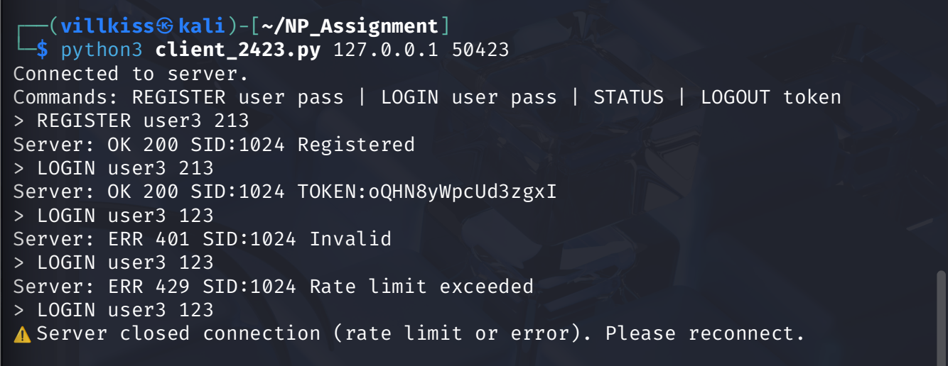
Figure 6:Rate limiting mechanism
This screenshot demonstrates the rate limiting feature of the server. When multiple requests are sent within a short period, the server restricts further requests and returns a rate limit exceeded error. This prevents abuse and ensures system stability.
MULTIPLE FORKED PROCESSES
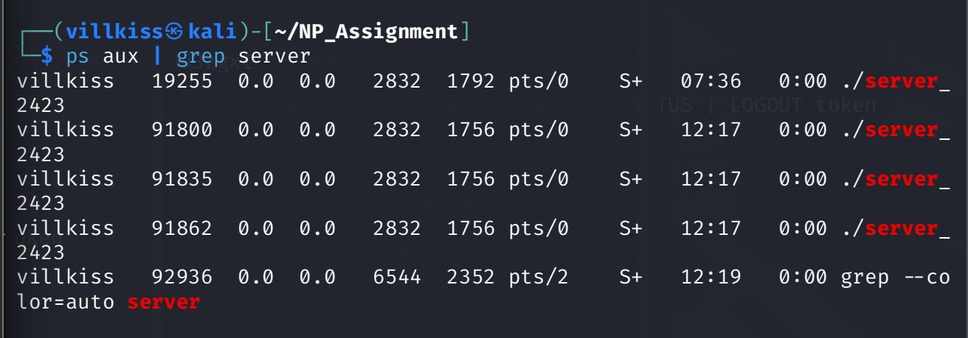
Figure 7:Multiple forked processes
This screenshot shows multiple server processes running simultaneously. Each process corresponds to a separate client connection, demonstrating the use of fork() for concurrent client handling.

LOG FILE ENTRIES
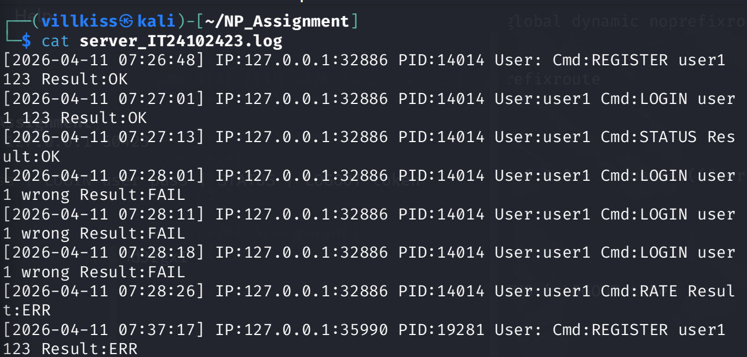
Figure 8:Log file entries
This screenshot displays the server log file, which records system activity including timestamps, client IP addresses, process IDs, commands executed, and results. This confirms that the logging functionality is correctly implemented.

NO ZOMBIE PROCESSES
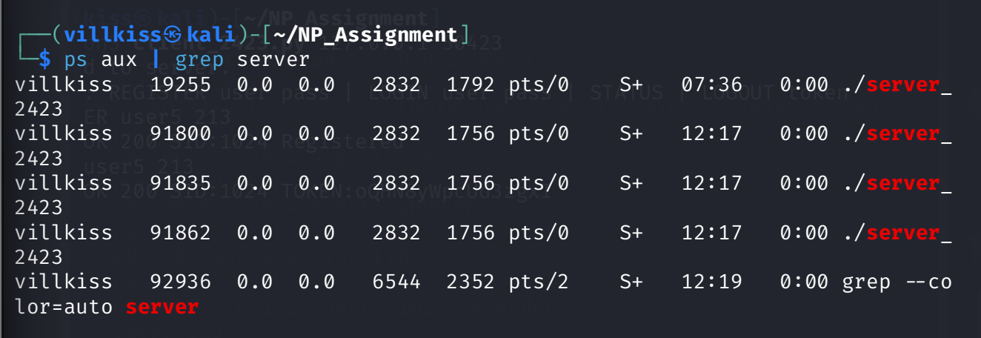
Figure 9.1:With 4 client connected
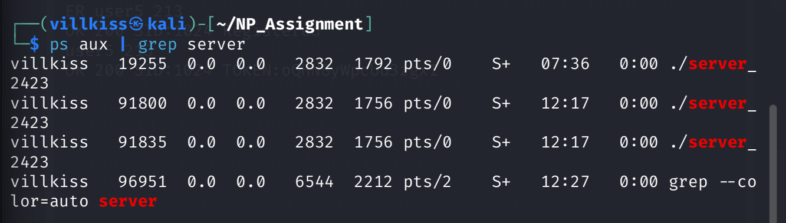
Figure 9.2:After disconnecting 1 client
This screenshot shows the process list before and after client disconnections. The absence of zombie processes confirms that the server correctly handles child process termination using the SIGCHLD signal and waitpid() function.
Conclusion
In conclusion, a secure and efficient TCP client-server application was successfully implemented. The system demonstrates key networking concepts such as socket communication, custom protocol design, and multiprocessing using fork(). Additionally, security features including authentication, session management, rate limiting, and account lockout were effectively implemented.
The system is capable of handling multiple clients concurrently while maintaining stability and security. Overall, this assignment provided practical experience in network programming and reinforced important concepts related to system design and security.

