COVER PAGE

Title of Proposal

Citizen Observatories for Health and Environment

List of participants

Participant No | Participant organization name | Country
1 (Coordinator) | University of Koblenz-Landau (Landau/ Koblenz)  Freelancer:  - Dr. Anna Smetanova (Laboratory for Studies of Interactions between Sol-Agrosystem-Hydrosystem, Mixed Unit INRA, SupAgro and IRD (Montpellier, France))  - Kayode Ayankoya (Nelson Mandela Metropolitan University, Department of Computing Sciences (Port Elizabeth, South Africa))  - Peter Grasch (Graz University of Technology (Graz, Austria))  - Gerhard Ackermann (Diehl BGT Defence (Überlingen, Germany)) | Germany
2 | IKT Technology - Geißler & Mäck GbR (in the next future: Senect GmbH & Co. KG) (Landau) | Germany
3 | Heidelberg University Hospital - Section: Clinical Tropical Medicine (Heidelberg) | Germany
4 | German Aerospace Center (DLR) - German Remote Sensing Data Center; Geohazards and Civil Security (Weßling) | Germany
5 | SPIDER (Swedish Programme for ICT in Developing Regions), DSV, Stockholm University (Stockholm) | Sweden
6 | Andalusian School of Public Health (Granada) | Spain
7 | Edmund Mach Foundation (San Michele all'Adige) | Italy
8 ? | Cirad (Montpellier ) | France
9 | University of El Salvador - Faculty of Natural Science and Mathematics (San Salvador) | El Salvador
10 | National Health Institute of EI Salvador (San Salvador) | El Salvador
11 | United States International University - School of Science and Technology (Nairobi) | Kenya
12 | CSIR - Meraka Institute (Pretoria) | South Africa

Abbreviations
CKD  CiOb  DSS  EU  GIS | Chronic Kidney Disease  Citizen Observatory  Decision Support System  European Union  Geographic Information System | ICT  IT  LL  LLinES  SME | Information and Communication Technology  Information Technology  Living Lab  Living Lab in El Salvador  Small and Medium Enterprise

1. Excellence
Citizens observe environmental conditions, get a short-term benefit and the design of the Citizen Observatories creates a long term impact on human health. The citizens' own digital devices serve to communicate environmental and human risk factors and risk mitigation strategies in the context of environmental and human health. The observations of citizens are used to optimize the available resources to leverage to full potential of them for a low carbon society. With a simple, everyday usable open source application for mobile devices, we will enable the communication of rare risk-incidents and the access to risk minimizing resources. In the context of Citizen Observatories (CiObs), the citizens can report resources and risks with this app. This app shall be used in the context of health, agriculture and environment in the pilot regions Kenya, Ghana and El Salvador. In Kenya, Ghana and El Salvador, one major problem are diseases which show their symptoms only in the long run (e.g. chronic kidney disease) or diseases like Buruli ulcer, where currently most people present themselves to public health facilities at advances stages, when treatment is costly, long and often not able to fully rectitude the function of the affected body part. The proposed in-situ observatory uses citizens' own devices as a spatial decision support client for e.g. low-cost precision agriculture and for the optimization of health service delivery. In the three pilot regions, different decision support is required due to different local conditions. Together with a geographic information system (GIS) for health related data or crop health the citizens' own devices are used to strengthen environmental monitoring capabilities for e.g. the application of agrochemicals. The crowd sourcing approach has the potential to support spatial decisions on analytic activities due to reported events to GISs. Focusing on the example of agriculture, low-cost applications via digital devices allow e.g. the reduction of agrochemicals due to crop health. The in-situ observations and monitoring of the citizens will create an economical benefit for tailored application of agrochemicals. Furthermore, the proposed solution creates an environmental benefit due to reduction of used agrochemicals and an expected long-term benefit for the environmental and human health. Nevertheless, the primary driver for citizens participating in the observation activities is the short term benefit of an efficient use of agrochemicals by preserving the same harvest yield. The involved novel partnerships between the agro-technical development, small and medium enterprises (SMEs) in the private sector is mandatory to develop regional accepted spatial decision support services that analyze the reported crop health and application data and return tailored recommendations for agrochemicals. The decision support client creates running costs for the spatial analysis of e.g. crop health. The app itself will be open source and thus available free of charge. The decision support data, which is required in developing countries or in locations, where human health is endangered, is freely available. For other users, we will make such decision support data available for a fee, e.g. decision support data for wine growing in Germany. Such decision support data could be information on an optimized way of spraying pesticides (low cost precision farming), which would be used by the wine grower to save costs and to increase sales. Public health agencies are involved to assess the reported observations. Public health recommendations can be submitted to registered users to improve risk-mitigation strategies with regional available resources. The decision support client for mobile devices is an open source tool with communication and crowd sourcing features to create a large number of users by utilizing existing mail server infrastructures. This open source approach offers a "WhatsApp"-like or "Threema"-like user interface by communication with the preferred mail servers. The free access to this communication alternative creates prospective users. The commercialization via SMEs is designed as spatial decision support services that have running costs that are covered by the citizens that have a commercial benefit due to optimized farming. The wide user acceptance of "WhatsApp" and co. shows the demand for those mobile phone applications. The spatial decision support of rare events and communication needs an application of software on an every day basis. Therefore, we selected an enhanced communication tool with decision support features as a software type to leveraging benefit of emerging spatial technologies, data and information sharing for crop monitoring and food security and an increased environmental and health impact. Keeping an eye on future cellphone generations, we will develop this app for cheap smartphones. Nevertheless, we will develop solutions for the "last mile problem" in rural areas in Kenya, Ghana and El Salvador in the context of this project, because in these regions mostly older cellphones or feature phones are used instead of smartphones and due to a lack of cell coverage. Such solutions for the last mile problem are a key factor to reach as many potential users as possible and to have an impact on optimizing the health situation. We focus on three different pilot regions to be able to derive a generative concept that can be applied to other pilot regions facing a problem with a similar structure and to profit from synergy-effects.

1.1 Objectives
Coarse Objective: Citizens can observe and report environmental and human risk factors with a simple, everyday usable open source app for the user's own devices. The communication of risk-incidents and the access to risk minimizing resources will be enabled to optimize the health-situation in the context of a CiOb. With the developed method, a short-term benefit shall be created, which has a long-term impact on health. The resource optimization contributes to the low carbon strategy of the proposed project. The citizens' own digital devices serve to communicate risk mitigation strategies to citizens in risk situations. The proposed in-situ observatory uses citizens' own devices as a spatial decision support client for e.g. low-cost precision agriculture and for the optimization of health service delivery.
Fine Objectives:
- Build up the sustainable infrastructure of CiObs by means of implementing Living Labs in the pilot regions El Salvador, Ghana and Kenya.
- Development of a simple, everyday usable open source app for mobile devices that enables the communication of rare risk-incidents and the access to risk minimizing resources in the agricultural and the health context in the manner of a spatial decision support client.
- Develop suitable (generative) decision support and risk mitigation strategies for the three different pilot regions.
- Find solutions to bridge the last mile problem to reach as many potential users as possible to enlarge the effect on the health-situation.
- Identify a deliverable short-term benefit to enlarge user engagement.
- Found new SMEs and build a network of EU and non-EU SMEs providing and adjusting continuously the services to the user requirements, even after the end of the project.
- Evaluation of the developed method and proof of concept.
Hypothesis: With the CiOb establishment and the developed method a larger number of people can be reached for risk minimization compared to the current situation.
How to test the Hypothesis? We will test the Hypothesis with Measurements at critical dates of the project. Within the LLs, digital devices are used for distributing and collecting information in the context of CiObs. This has two advantages: we know as a result the opportunities and limitations of the communication channel and we can optimize this communication channel for communicating agricultural and health information. We can determine how many people use the developed method on their digital devices by quantifying the user traffic and thus we can derive the quality of the developed method. If the survey is led by the community-members with digital devices, we also know how far the information technology (IT) bears and where other forms of communication must be used for data collection. The support of non-telecommunications can also be supported by IT, i.e. it is shown how to contact with whom in the best way, or how to transmit data without an internet connection or without suitable hardware. Furthermore, through encouraging the citizens to assist in (electronic) waste removal to eliminate e.g. empty contaminated pesticide containers (risk source for pesticide poisoning) or potential breeding places for mosquitoes (mosquitoes could be a vector for several diseases), we can measure the visible change and thus we can derive conclusions concerning the impact of the project.
Milestone 1: We know at the end of 16 months (Phase I), which IT requirements must be made for an efficient medical and agricultural use of an application on digital devices. Consequently, the present project concerns the establishment of a sustainable information channel the population uses. Furthermore, for the medical and agricultural needs, we would know after the first phase, for what this information channel is at all usable. That is, which information can be transmitted in what time and what quality?
Milestone 2: We will implement a client for spatial decision support based on the results of Phase I.

1.2 Relation to the work programme
We will develop an innovative technology for supporting health risk mitigation. With the developed method, a short-term benefit is created, which has a long-term impact on health. In the context of CiObs, access to risk minimizing resources and risk-incidents can be reported with an everyday usable open source app for citizens' own devices (e.g. mobile devices) by the citizens. This app shall be used in the context of health and environment (agriculture). Before the software development starts, we will perform a software analysis keeping an eye on emerging open source technologies that could be implemented and further developed for the app that will be developed in the present project.
The proposed in-situ observatory uses citizens' own mobile devices as a spatial decision support client for e.g. low-cost precision agriculture or for the optimization of health service delivery. Together with a GIS for e.g. health related data or crop health the mobile devices are used to strengthen environmental monitoring capabilities for e.g. the application of agrochemicals. Concluded, the citizens observe, report and receive decision support within the CiOb. Novel partnerships between the private sector, public bodies, NGOs and citizens are assured by implementing Living Labs (LLs). In the present project, data and information sharing is a very important aspect, as the Open Community Approach (cf. http://at6fui.weebly.com/open-community-approach.html) is pursued. Therefore, we will make the developed application available as open source software and use the open content of e.g. OSM, the Copernicus Land Monitoring Service (http://land.copernicus.eu/) or GEOSS (http://www.earthobservations.org/geoss.php). By evaluating and optimizing the work flow in the Living Labs, the system proposed for CiObs is scaled up, demonstrated, deployed, tested in its entirety and validated in real-life conditions. We will ensure the effective transfer of environmental knowledge for policy, industrial, research and societal use, with a focus on the domain of land cover/land use, both in rural and urban areas by implementing an everyday usable open source app for citizens' own devices and solutions for bridging the last mile, where the transferred environmental knowledge is tailored to the user and supporting the generation of risk awareness via risk literacy. The app is a communicator with a familiar, easily comprehensible user interface, to support frequent use. The open-source app is first of all a free communicator to have large numbers of users by using existing IT infrastructure of mail-servers for message exchange. The concept of a LL is based on strong involvement of citizens and citizens’ associations together with the industrial sector (e.g. SMEs). Through a Master Plus Programme at the University of Koblenz-Landau, a customized education program will be provided that supports the development of SMEs for the compiled project tasks using the services of the Founding Office of the University. The citizens in the CiOb receive a commercial benefit via the application of the spatial decision support provided by the app developed in this project. SMEs will provide the commercial spatial decision support services after the end of the present project. With the planed project, a reduction of carbon emission is implied. Carbon is created when chemical substances like pesticides/ medication are produced (a lot of energy is needed which is partly produced with oil/gas/coal) and also when pesticides are applied e.g. with a tractor or plane. Additionally pesticides and medication have to be transported to the location where they are supposed to be used. That means that the reduction of pesticides and logistic optimization of work processes lead to a carbon emission reduction. (Electronic) Waste removal and adequate disposal (instead of uncontrolled waste incineration) also contributes to carbon emission reduction. Consequently, we will create a low carbon society via the application of work-flow-optimization and resource optimization.

1.3 Concept and approach
1.3.1 Main ideas, models or assumptions involved/ overall approach and methodology
The key aspect of Citizens’ Observatories (CiObs) is the direct involvement of citizens living in a target region, and not just that of scientists/professionals in data collection as well as harnessing the citizens’ collective intelligence, i.e., the distributed information, experience and knowledge embodied within individuals and communities, to meet gaps that many areas of environmental management are still suffering from. Namely, CiObs should enable citizens’ participation in environmental monitoring, and contribute to environmental governance by providing relevant data and information that can help decision-makers make sound decisions. This can be advanced by providing citizens with a voice and supporting them with knowledge of their environment and as a consequence of raising their awareness (Liu et al. 2014). In this context, the concept of Living Labs (LLs) is a sustainable approach to apply the concept of CiObs and, by this means, minimize risk in the health and agricultural sector and maximize the benefits and reach of community-based interventions for diseases through integration with other agricultural, health and development sectors. An LL attempts to design successful problem solutions by including local people into the decision-making processes. Building a sustainable infrastructure for the operation of a LL can contribute to problem solving for a variety of scientific questions. The underlying idea of a LL is that the ideas, experiences and knowledge of the people, as well as their daily needs with respect to the support by products, services or applications, should be the starting point of innovation (cf. Cunningham et al. 2011). Stakeholders, like researchers, health care workers, agricultural workers, teachers or members of the industry, offer their services in the field of possible risk mitigation to the community members. The community members can select, which risk mitigation strategy is usable for them. Therefore, the risk mitigation strategies are user driven innovations. In the course of this, the individual parties of a LL pursue a common goal. Low-cost methods ensure that as many people as possible can participate in a successful problem-solution, particularly in developing countries. In the present case, the LL serves inter alia for exploration of low-cost techniques to reduce health-risks of the local population and for monitoring the community-needs concerning the health situation. In the present project, we focus on the pilot regions El Salvador, Ghana and Kenya. We focus on three different pilot regions to be able to derive a generative concept that can be applied to other pilot regions facing a problem with a similar structure and to profit from synergy-effects. One identified critical health problem in El Salvador is chronic renal failure. Nationally, chronic kidney disease (CKD) is currently the leading cause of hospital mortality in men with a case fatality rate of 11.0%, (Ministry of Health - El Salvador). Studies in the adult population of the Salvadoran farming communities show that the majority of cases with CKD were heavily influenced by factors such as male gender, older age, agricultural occupation, hypertension, family history of hypertension and contact with some pesticides, (cf. Orantes et al. 2014). In order to address this health problem, our project LLinES (Living Lab en El Salvador, http://llines.weebly.com/) proposed to establish a LL in El Salvador to carry out research on low-cost techniques to mitigate exposure to pesticides and other chemicals in the environment, to improve the production processes and to improve the care of kidney patients in rural areas. The project LLinES has the aim to reduce the risk to human health, to local farmers and community members, caused by the exposure to pesticides, through a One Health approach. The One Health approach recognizes, that the health of humans, animals and ecosystems are interconnected. Consequently, if risks that originate at the animal-human-ecosystems interface shall be addressed, a coordinated, collaborative, multidisciplinary and cross-sectoral approach is needed. (http://www.onehealthglobal.net). The project LLinES also has the objective to find agricultural productive alternatives without agrochemical inputs or with a rational use of them. By doing so, human health and the socio-economic situation are supposed to be optimized, as well as the environmental situation. LLinES is mainly focused on mitigating occupational factors and environmental risks for CKD affecting Salvadoran farmers in endemic and epidemic proportions. The research will be conducted with the involvement of local experts in agriculture, health and environment, as well as the affected population. In Kenya, human health is affected, among others, by the use of inefficient combustion devices. By inhaling carbon fumes of combustion devises from cooking with firewood, charcoal and use of African traditional candles, diseases such as bronchitis, lung infections, nasal problems etc. are triggered. Kenya has a vision to create a globally competitive and prospective nation with a high quality of life by the year 2030. The recent Kenya economic Health Survey shows that the rate at which improvements in the health sector are currently occurring is very low. With the present project we are willing to contribute to this vision by ensuring that health related information is accessible to all through an affordable and flexible solution. There is need to examine how to ensure the health information supplied is contextualized to enable it address five key requirements regardless of the target audience or platform: accuracy, timeliness, relevance, security and accessibility. In Ghana, the disease Buruli ulcer causes major health problems. Buruli ulcer is a human infectious disease caused by mycobacterium ulcerans. The clinical picture is characterized by necrosis of the subcutaneous tissue leading to devastating skin defects, permanent disability and death. The mode of transmission is unknown. Currently most people present themselves to public health facilities at advances stages, when treatment is costly, long and often not able to fully rectitude the function of the affected body part (mostly limbs). The only effective risk mitigation strategy - early recognition and treatment of suspicious skin lesions - faced numerous obstacles: physical (poor road conditions, inadequate public transport), economic (user fees, transportation costs) and social (disease perception) gaps between patients and health care providers; insufficient awareness of the disease and its cause; inadequate staff training; insufficient material supply; unreliable salary provision. These challenges have prompted the search for non-physical elements to complement a Buruli ulcer surveillance system established in the course of more than a decade of cooperative research between clinical medicine, social science and microbiology. An unprecedented spread of mobile communication technology has now opened even remote rural areas to the ever increasing possibilities of modern “smart” mobile phones including (picture) documentation and data exchange, GPS based epidemiology, supply chain management, e-learning and payment systems. This mix of technology available in remote areas can potentially also prove useful for the control of dengue fever, a viral disease transmitted by Aedes mosquitoes. Dengue has expanded in the past decades to unprecedented levels, due to its association with unplanned urbanization and poor housing conditions. About half of the world population live in areas under risk of dengue transmission. Mosquito breeding sites are abundant in areas with unreliable water supply, ongoing urban construction, and deposition of trash. Community participation is crucial for control efforts in times where an effective vaccine or therapy is not available. CiObs can create awareness by documenting potential or proven mosquito breeding sites, which can then be geo-positioned and made available for the public health agencies. This data can be used for creating small-scale GIS-based maps of dengue risk as perceived by citizen observatories and in a second step compared and validated against the reported cases over time from the same area. The research question we pursue in this case is two-fold: a) can citizen observatories create awareness for a more timely response and control of dengue transmission?; b) does the data collected by citizen observatories on dengue risk/transmission correlate well with reported dengue cases in the same time period? Dengue occurs in all three pilot regions of the present project. All diseases mentioned above have constraints that have an impact on the control and elimination of the diseases. Certain constraints that trigger the diseases or reduce the severity of the diseases have a divers spatial distribution and impact on risk mitigation in rural areas. In the three pilot regions Kenya, Ghana and El Salvador, different decision support is required due to different local conditions. One exemplary risk mitigation strategy is the provision of information on a disease tailored to the population. This information can be e.g. the current risk at the geo-location of the user, preventive measures to protect from an infection or available resources near the geo-location of the user. This information will be provided to the user in an adaptive way, to improve the comprehension and risk literacy. Therefore, we will analyze the health-situation, the information and communication technology (ICT)-situation, the cultural situation and the socio-economic situation and identify a frequently used information and communication-channel. In this context, a gender analysis will be applied, taking into account structural intersections such as ethnicity, religious affiliations, age, etc. to be able to provide adjusted decision support. Furthermore, we shall find solutions to bridge the last mile problem to reach as many potential users as possible to enlarge the effect on the health-situation. Figure 1 visualizes the communication circle in the context of the present project. Human beings make decisions mainly dependent on short-term benefits, (cf. AAAS Project 2061, 1990). Thus, the provided risk mitigation strategies should be based on the principle of visible short-term benefit that creates a long-term impact on health. We will investigate, develop and adjust resources for risk mitigation and provide them to the community members. Digital devices (e.g. smartphones, feature phones, tablets, PCs, etc.) combined with a last mile solution will be integrated into the CiOb to enable the provision of tailored information on risk mitigation to the community-members. We will determine the deviation between global health goals and community needs and we will develop and implement a solution with the maximum acceptance of the community with including issues like potential language barriers or low literacy. In the course of this, we will negotiate the health goals within the CiOb. Afterward, we will develop and implement methods to reach those health goals with the available resources. Concluded, we will develop a spatial decision support system (SDSS). A spatial decision support system is a combination of geographic information system (GIS) and decision support system (DSS) (Yang et al. 2007). In the context of the spatial decision support client, the crowd sourcing approach has the potential to support spatial decisions on analytic activities due to reported events to GISs. An SME-network of EU and non-EU SMEs is supposed to arise from the requirements and the structure of the LLs. Through the sustainable character of LLs, the project concept shall persist after the end of the project. That is, continuous feedback-inquiry of the citizens and provision and adjustment of the services to the user requirements by the SMEs after the end of the project. Additionally, through the Founding Office of the University of Koblenz-Landau the founding of new SMEs within the present project will be supported. Furthermore, the ICT infrastructure is renewed and extended and new communication channels will be created, which can be used by EU and non-EU SMEs to transfer their information, e.g. advertisement to market their products.
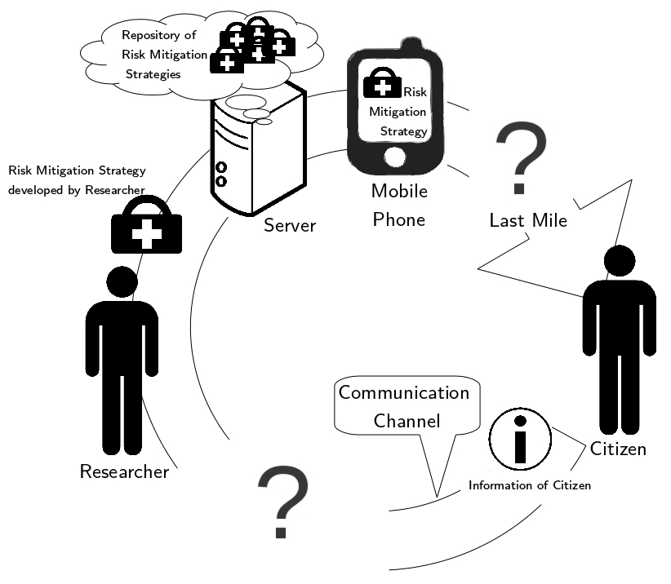
Figure 1: Communication Cycle (magnified version of the image available at http://mathematik.uni-landau.de/download/COHEN/communicationcycle.jpg)
1.3.2 Trans-disciplinary considerations
The citizen observations are used for risk and resource optimization in a One Health approach. Health observations will be evaluated according to the benefit for the environmental health assessment and vice-versa the environmental observations of citizens will be evaluated according to the benefit for the assessment of health risks. The primary driver is a short-term economical benefit that has the potential for a long-term public health improvement. We will measure a change in the work-flow of citizens and detect the workload for an optimized work-flow to assess the sustainability of proposed citizen observatory. A requirement of the combination of disciplines is that
- the citizen observations get a short-term (economical) benefit (e.g. precision-farming, consequence: less agrochemical with same harvest yield).
- citizens are aware of the long-term benefit of a sustainable CiOb (e.g. health related impact of economical benefit and the awareness about the value of citizen observations for a sustainable concept of the CiOb).
- the work-flow for integration of citizen observations will create an acceptable workload for the citizens.
- the whole process of development is citizen-driven/user-driven.
Environmental conditions (e.g. mosquito breeding places, exposure to agrochemicals) induce health risks. An integrated approach for One Health uses citizen observations to identify risk mitigation options in the environmental and the health domain, because the health risk can be reduced by intervention for environmental conditions. Furthermore environmental conditions might not be changeable completely and additional intervention in the health domain is needed. The citizen observations fulfill two tasks: to collect regional relevant data and an implemented and executed observation plan creates permanent awareness. In the present project, the following disciplines are combined in a trans-disciplinary manner:
ICT4D: To implement risk mitigation strategies, the identification of the ICT and non-ICT communication infrastructure is crucial to reach efficiently risk-exposed population. Therefore, effective non-ICT and ICT-channels will be identified. On this basis, options for optimizing the communication channels can be derived by conducting a cost-benefit analysis including the last mile problem. The implementation strategy will be evaluated in pilot regions in rural areas. A gender analysis will be applied, taking into account structural intersections such as ethnicity, religious affiliations, age, etc. to be able to provide adjusted decision support. Furthermore, the life span of ICT, especially low-end mobile phones is limited and electronic waste is a growing problem in many regions. By proper disposal of e-waste, toxic substances that would form when disposing the waste in a wrong way can be avoided as long as proper strategies are employed. Experts: Participants No. 1,5, 9, 10, 11.
Public Health: The public health support in rural areas is supposed to be optimized with the present project. In the context of CiObs, the observations of citizens will be used to identify risks or leverage to potential of accessible resources for risk mitigation in the health domain. The risk-exposed citizens receive health risk mitigation support for free. The input data for analysis are a combination of citizen observations and items in a questionnaire. The citizen observation are evaluated according to benefit as permanent sensor for the environmental impact on public health. Experts: Participants No. 3, 4, 5, 6, 10, 11
Water Quality Observation: Electronic systems which are designed for measuring and controlling water quality parameters will be used for water quality observation to improve public health. Via an embedded wireless data transmission system, the measured parameters can be sent to the user’s digital device and in case of an emergency, the user can be alarmed. Experts: Participant No. 2
Land Use Optimisation: The land use in rural areas is supposed to be optimized with the present project. In the context of CiObs, the observations of citizens have an influence on the agricultural situation. The risk-exposed citizens receive agro-technical benefit (and thus economical benefit) and risk mitigation support for free. The application of agrochemicals is observed. The benefit the user receives for participating in the CiOb is recommendations for improvement of harvest yield. Experts: Participants No. 1.1, 1.2, 8
Risk Literacy: Risk and resource awareness has to be created for risk mitigation. This can be done via (E-)Learning Modules (ICT for Education - ICT4E) by the education of risk awareness and risk mitigation options. Experts: Participants No. 1, 3, 5
Usability Workflow Analysis: A usability evaluation and a work-flow analysis of the ICT and non-ICT supported communication, of the agro-technical work-flow and of the health-work-flow have to be carried out. Thereby, the communication network and the work-flow that is actually transported via communication have to be separated. The execution of certain processes that happen locally is observed. Key questions in this context could be: How can a farm worker perform measurements himself? How does the work-flow of a farm worker or of a health affected person look and what causes concrete actions? Experts: Participants No. 1, 3, 5, 9, 10, 11, 12
Software Development: The aim of the present project is the development of a simple, everyday usable open source app for mobile devices, which enables the communication of rare risk-incidents and the access to risk minimizing resources. In the context of CiObs, resources and risks can be reported with this app by the citizens. This app should enable to receive risk-related information, to communicate risk-related information and a navigation-function should be available, to navigate a user to safe(r) locations or to risk minimizing resources. In this context, the open source app "mixare" could be used as app-client. The design and concept of this App should be similar to "WhatsApp", but independent from "Facebook" or "Google". That is, a GUI similar to the "WhatsApp"-GUI should be used and the messages will not be sent via a server, but as standardized e-mails. Speech recognition is required to simplify data collection within the meaning of the CiOb (especially for users in risk situations or for e.g. illiterate or blind users). The integration to an open source navigation-tool (e.g. Navit) will be crucial to enable navigation. An export interface for the open source software “GRASS GIS” to enable GIS mapping with digital devices and for the interoperability of digital devices should be incorporated. In this context, spatial analysis will be performed with “R”. Furthermore, offline use of this app should be enabled, as internet connection is not available everywhere. Multinational standards have to be taken into account. Keeping an eye on future cellphone generations, the hardware this app will be developed for are cheap smartphones. By setting all these requirements and constraints to soft- and hardware, a potentially large target group is supposed to be reached with this app to be able to having an influence on optimizing the health situation. Consequently, the app itself will be open source and thus available free of charge. The decision support data, which is required in developing countries or in locations, where human health is endangered, is freely available. For other users, such decision support data will only be available for a fee, e.g. decision support data for wine growing in Germany, to generate a profit for SMEs. Such decision support data could be information on an optimized way of spraying pesticides (low cost precision farming), which would be used by the wine grower to save costs and to increase sales. The first step would be to develop a first prototype, which enables communication in a simple, everyday usable way. Following this, an encoding-mechanism to protect sensible data should be implemented. Afterward, a link to e.g “mixare” and to an open source navigation system (e.g. Navit) should be realized.
Data Flow:
- Input Client to CiObs-Server:
  - MAIN: risk and resource-observations.
  - Feedback on regional decision support service provided by SMEs and during the project reported for scientific analysis.
  - Quality of regional decision support service provided to SMEs and during the project reported for scientific analysis and work flow optimization.
- Output CiObs-Server to Client:
  - Recommendations for resource allocation and usage of regional resources (e.g. agriculture, precision farming)
  - Risk warnings issued by health agencies (with digital signature).
Experts: Participants No. 1, 1.2, 4, 11
Speech-Based Interface: In order to support data collection from a broader range of users, including children, illiterate and elderly people, a speech-based user interface will be developed in addition to the traditional, touch-based system. This speech-based user interface, “SUI”, will use a text-to-speech system to read out visible menu options. The user can then select them by simply saying the name of the option, or sensible variations, such as “<Option>, please”. To implement the SUI as described above, both speech input and output are required.
- Speech Output: Established TTS systems, such as the ones integrated in the mobile operating systems of the target devices, as well as online services such as the free and open-source “MARY TTS” and similar commercial offerings will be evaluated in a pilot study. To this end, we will develop a survey interface where native speakers of the language that match with our target demographic rate the TTS voice's intelligibility. The best performing solution will be incorporated as the TTS engine for the SUI.
- Speech Input: Because of the expected difficult recording conditions, a dedicated speech input system will be developed based on the “Simon” speech recognition system. The speech model will be developed specifically for the target languages (e.g. Spanish, English and Kiswahili) and take local dialects, as well as the task specific vocabulary into account.
Experts: Participants No. 1.3
Server Infrastructure: For the software development, an analysis of the existing server infrastructure and the integration of mapping resources in e.g. the App Store/Play Store is important. Low cost Linux-Severs that can be cloned and reproduced free of charge shall be implemented within the CiObs. These servers shall be able to communicate and to network. SMEs shall maintain the distributions and offer services via the network. Experts: Participants No. 1, 3, 9, 10, 11
GIS Mapping: GIS risk and resource mapping is used as back-end for mobile devices. SMEs shall maintain the GIS-data and provide services of an economical benefit of low-cost precision agriculture by integration of citizen observations. Experts: Participants No. 1, 4, 7
Image Processing: Existing image processing technology (multispectral analysis) will be used for crop health, to determine the health status of plants, the fertilizer requirements and the pesticide amount required. Multistructural Analysis is used to determine further actions in the context of precision farming. Main result: detect environmental conditions that complement citizen observations for economical benefits or health risks, e.g. environmental conditions that trigger communicable diseases or as surveillance mechanism if certain agro-techniques or environmental risk mitigation strategies reported e.g. by citizen observations were successful. Experts: Participants No. 1
Big Data Analysis: Big Data analysis can help to understand the behavior of diseases by comparing epidemiological data between different countries (regardless their development status) creating a comparative analysis of several trends. Several layers of data ranging from demographic, economic, infrastructure, health-related, and clinical data can merge together to create a panorama of the disease in different countries-leading to a better planning of resources. The US federal government and public stakeholders have been opening their health-databases including data from clinical trials and information on patients covered by insurance programs and are available to the public and researchers. Experts: Participants No. 1.2
Waste Removal: By waste removal, e.g. empty contaminated pesticide containers (risk source for pesticide poisoning) or potential breeding places for mosquitoes (mosquitoes could be a vector for several diseases) will be eliminated. By proper disposal of waste, toxic substances that would form when disposing the waste in a wrong way, can be avoided. Experts: Participants No. 1, 3
CiObs & LL Implementation: A stakeholder analysis has to be done to be able to implement CiObs by means of implementing LLs in the context of environmental risk assessment and optimization of resources (e.g. application of agrochemicals), work-flow optimization for citizen observations of farm workers and environmental risk mitigation strategies; and health risk and resources work-flow for citizen observations and health risk mitigation strategies. Experts: Participants No. 1, 1.2, 3, 9, 10, 11, 12
Education – Master Plus Programme: Master Plus is an aggregation of course linking mathematical modeling of spatial decision support with other disciplines to find solutions to problems in rural areas of developing countries. In the context of this project, a Master Plus Programme will be established, so that external students from El Salvador, Ghana and Kenya can study at the University Koblenz-Landau. No fees have to be paid for the Master Plus Programme at the University of Koblenz-Landau. Course language is English. A Master Plus Course can be extended to PhD if applicable. The Educational programme of Master Plus will be tailored to the individual research questions. The Master Plus Course uses the OpenSource and OpenContent Philosophy. (Accommodation and travel will be covered by the fellowship bursary or program). Experts: Participant No. 1
Founding SMEs: Through the Founding Office of the University of Koblenz-Landau the founding of new SMEs within the present project will be supported. The Founding Office provides systematical and purposeful support of new businesses in the field of science. Experts: Participant No. 1
From these disciplines work packages can be derived, which will be connected as visualized in Figures 2 and 3.
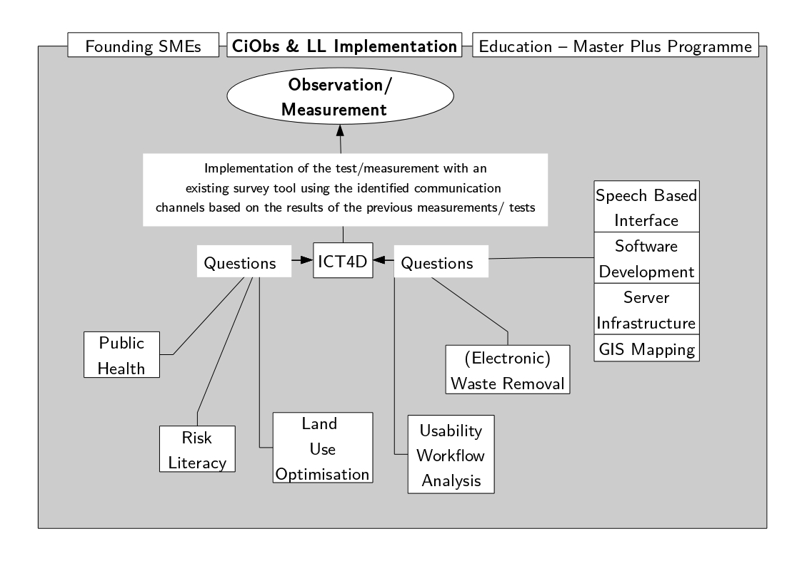Figure 2: Connections between Work Packages, Step 1 (magnified version of the image available at http://mathematik.uni-landau.de/download/COHEN/workpackages-1.jpg)
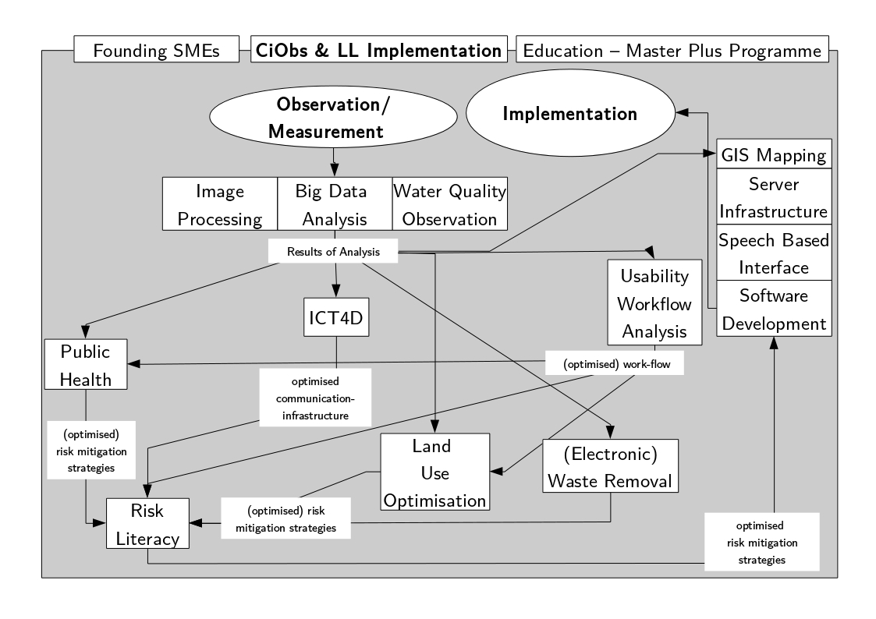
Figure 3: Connections between work packages, Step 2 (magnified version of the image available at http://mathematik.uni-landau.de/download/COHEN/workpackages-2.jpg)
1.3.3 Activities
Work Plan
*T: Time Span in Months
**PP: Project Participants; C: Members of the Community (Citizens), S: All Stakeholders of the LL
*** TRL: Technology Readiness Level
T* | What? | Who?** | What will be deliverable? | TRL***
Work Plan Phase I (16 Months)
1 | Investigation for enabling the selection of an appropriate test region | PP | Report on the selection-guidelines used to select the test region. | 1
2 | Implementation of the Pretest with an existing survey tool: What is currently available for supporting the accessibility of health services? Survey on the inventory including the analysis of the health-situation, the ICT-situation, the cultural situation, the socio-economic situation and of a frequently used information and communication-channel. Furthermore, a software analysis will be carried out. | PP, C | Requirements of the Community can be deducted and methods to reach a possibly large target group to enlarge the impact of risk mitigation strategies can be derived. Additionally, guidelines on how to use a survey in rural areas with which (digital) devices and software can be determined. | 1
3 | Interdisciplinary analysis of the status quo and identification of Stakeholders for the LL in the context of a CiOb. | PP, C | Milestone-report on the status quo; Identification of the required persons, information and goals for launching an LL. Furthermore, we define the primary communication channel. We identify which medical information can be sent how and in what quality over the network. | 1
2 | Development of risk mitigation strategies. | S | Kick off for the CiOb; Creation of a functional specification document for risk mitigation strategies. | 2
3 | Implementation of the developed risk mitigation strategies. | S | Proposals for risk mitigation strategies and a report on how to implement them. | 2
2 | Measurement 1: What has been achieved with the use of the intervention compared to the Pretest? | PP, C | Report on the Milestones that have been achieved immediately after the introduction of the developed method. | 2
3 | Review and adjustment of the work-flow-optimization in the CiOb. The results are entered in the suggestions for improvements in the developed method. The result is an optimized intervention. | S | Analyzing the effects of the mitigation strategies, if necessary improvement of the risk mitigation strategies and suggestion of a generative concept for implementing the developed method in other communities. | 3
Work Plan Phase II (20 Months)
2 | Development of a GUI-Design for a client for spatial decision support via rapid prototyping. (Prototype 1) | PP | GUI Prototype for a client for spatial decision support.
2 | Test-phase of the prototype in the CiOb | C, PP | Analyzing the effects of the GUI-design, if necessary improvement of the GUI-Design.
2 | Measurement 2: What has been preserved of this intervention after a certain time? At the same time the measurement checks whether the optimization is perceived by the rural community as an improvement. | PP, C | Report on the Milestones that have been achieved immediately after the introduction of the optimized intervention compared to the superseded method. | 3
2 | Development of a prototype of a client for spatial decision support, which enables communication in a simple, everyday usable way, based on the results of Phase I. (Prototype 2) | PP | First prototype of a client for spatial decision support. | 4
2 | Test-phase of the prototype in the CiOb | C, PP | Analyzing the effects of the client for spatial decision support, if necessary improvement of the client for spatial decision support. | 5
2 | Implementation of an encoding-mechanism to protect sensible data. (Prototype 3) | PP | Optimized prototype of a client for spatial decision support. | 5
2 | Test-phase of the prototype in the CiOb | C, PP | Analyzing the effects of the client for spatial decision support, if necessary improvement of the client for spatial decision support. | 5
2 | Realization of a link to an augmented reality tool (e.g. mixare, TRL 4/5) and to an open source navigation system (e.g. Navit, TRL 6). (Prototype 4) | PP | Optimized prototype of a client for spatial decision support | 5
2 | Test-phase of the prototype in the LL | C, PP | Analyzing the effects of the client for spatial decision support, if necessary improvement of the client for spatial decision support. | 5
2 | Measurement 3: What has been preserved of this intervention? At the same time the measurement checks whether the optimization is perceived by the rural community as an improvement. | C, PP | Report on the Milestones that have been achieved after the deployment of the client for spatial decision support. | 5
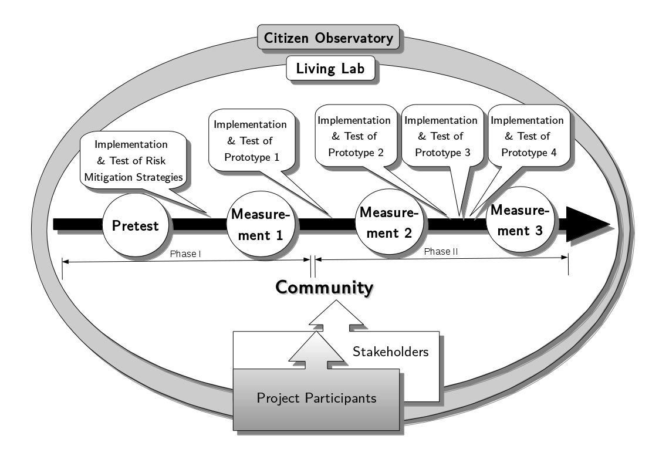
Figure 4: Illustrated Work Plan (magnified version of the image available at http://mathematik.uni-landau.de/download/COHEN/workplan.jpg)
Brief breakdown of allowable costs (budget: € 3 000 000 – 5 000 000)
Personnel (app development, research, translation work, conduction of surveys, audit): ca. 4 795 845 €
Travel (identification of the test region, kick off for the CiOb, review and adjustment of the work-flow-optimization in the CiOb, participant-meetings): ca. 133 740 €
Other expenses (equipment: information material, printed material, satellite data, software, hardware): ca. 68 669 €
Total: ca. 4 998 254 €

1.4 Ambition
1.4.1 State-of-the-art and Innovation Potential
- Health Risk Mitigation. With the developed method, we will create a short-term benefit, which has a long-term impact on health. The citizens' own digital devices serve to communicate risk mitigation strategies to a citizen in a risk situation. In the first work phase, we will develop the basic principles for a client for spatial decision support with already existing open source applications as proof of concept. In Phase II, we will implement a client for spatial decision support based on the results of Phase I.
Innovation potential of the methodology for health risk mitigation in the context of this project: The reduction of disease-rates, e.g. CKD in El Salvador, can only be measured in the long run. The aim to reduce the disease-rates can be achieved by means of the sustainability of the LLs and the created SME-networks.
- Recently, several Citizen Observatories (CiObs) emerged in an environmental context. In 2011, the environmental concept of CiObs was introduced in the project “Eye on Earth” (http://www.eyeonearth.org) with the European Environmental Agency (EEA) creating the first ‘official’ environmental portal that includes a CiOb on air, noise, nature, coral reefs and water quality, (Liu et al., 2014). Under the FP7 topic ENV.2012.6.5-1 “Developing community-based environmental monitoring and information systems using innovative and novel earth observation applications” the EU has funded five CiOb-related projects at the end of 2012:
  - “Citclops – Citizens’ Observatory for coast and ocean optical monitoring”, 2012–2015 (http://www.citclops.eu),
  - “Omniscientis – Odour monitoring and information system based on citizens and technology innovative sensors”, 2012–2014 (http://www.omniscientis.eu);
  - “CITI-SENSE – Development of sensor-based Citizens’ Observatory Community for improving quality of life in cities”, 2012–2016 (http://www.citi-sense.eu);
  - “WeSenseIt – Citizen Observatory of Water”, 2012–2016 (http://www.wesenseit.com); and
  - “COBWEB – Citizen Observatory Web”, 2012–2016 (http://cobwebproject.eu).
EU-funded projects which contain core components that were heavily based on the CiOb concept:
  - ENVIROFI, 2011–2013 (http://www.envirofi.eu) and
  - HENVINET, 2007–2011 (http://www.henvinet.eu.)
Innovation potential of the planned CiOb in the context of this project: The present project proposes a CiOb in which a simple, everyday usable open source app for the user's own devices is used for the communication of risk-incidents and the access to risk minimizing resources to optimize the health-situation. With the developed method, we will create a short-term benefit, which has a long-term impact on health. The citizens' own digital devices serve to communicate risk mitigation strategies to citizens in risk situations. Pilot regions are Kenya, Ghana and El Salvador. The present CiOb-project differs from the other mentioned CiOb-projects in so far, that health risk mitigation is supposed to be implemented in high risk locations, where the health system strongly requires optimization. Furthermore, diseases which show their symptoms only in the long run (e.g. CKD) shall be combated by creating a short-term benefit for the population to encourage the citizens to contribute to the development of and to apply risk mitigation strategies in the context of a CiOb.
- Living Labs (LLs), as a new approach to innovation and ICT development, emerged during the 1990’s. It encompasses the idea of creating an environment (e.g. an open innovation environment, also referred to as an ecosystem or platform) that offer users (i.e. different stakeholders such as public-private-partnerships) the opportunity to take part actively in the co-creation of innovation and, more specifically, the development of ICT-related products and services (e.g. idea generation, development, implementation and evaluation) (EnoLL, 2014; Følstad, 2008; Geerts, 2011).
IST-Africa is commencing an updated study on existing and emerging LLs in Africa during 2014 – 2015. Several LLs exist and emerge in Africa, that is in South Africa, Kenya, Mozambique and Tanzania, (cf. http://www.ist-africa.org/home/default.asp?page=livinglabs).
In Kenya, the following LLs exist (cf. Cunningham et al., 2011):
  - “East Africa Regional Mobile Application Laboratory”: “m:lab East Africa” (http://mlab.co.ke/) - Support Broadband Communication Networks & eServices in Rural Communities
  - “@iLabAfricaLL” (http://www.ilabafrica.ac.ke/) - Support ICT Research, Innovation, Entrepreneurship & Incubation
  - “iHub Nairobi” (http://www.ihub.co.ke/) - Supporting Entrepreneurship & Incubation though Open Innovation
  - “The Nailab” (http://www.nailab.co.ke/) - Supporting Co-Creation
  - “Nguruman Maarifa Centre” (http://ngurumanmaarifa.blogspot.com) - Supporting Rural Connectivity
  - “Map Kibera” (http://mapkibera.org/) - Engaging Youth in Africa’s Largest Slum
In Ghana, the following LL is established:
  - “Wenchi Living Lab” - Mobile Applications to Support Market Access for Cashew Farmers
Innovation potential of the planed LLs in the context of this project: Until now, no LL exists in any Central American Country (e.g. El Salvador). In Kenya and Ghana there already exist LLs. Most of the LLs focus on ICT and entrepreneurship. In contrast, “Map Kiberia” in Kenya focuses on in the participatory digital mapping of risks and vulnerabilities in their community. Young people are supposed to gain new awareness about their surroundings empowering them to address critical issues. The concept of this LL is close to the planned LL in the present project with respect to the focus on the generation of risk awareness through the creation of risk literacy in the context of the development of risk mitigation strategies. Furthermore, the CiOb-concept is partly addressed in the “Map Kiberia” through the participatory digital mapping. The LL planed in the present project goes beyond the concept of “Map Kiberia” with regard to the outreach by addressing a larger target group (citizens = the whole target community), the CiOb-Concept, the target locations El Salvador and Ghana beside Kenya and the focus on occupational health in El Salvador, on the disease Buruli Ulcer in Ghana and other diseases in Kenya and the focus on Dengue in all three pilot regions. Nevertheless, we can definitely learn from “Map Kiberia” and derive best practices. Furthermore, we can provide results gained in the present project (like health map data, concepts or software) that could support “Map Kiberia”.
We can also profit from “Wenchi Living Lab” implemented in Ghana which focuses on the implementation of mobile applications to support the linkage of smallholder farmer cooperatives to sustainable markets in the cashew sector with respect to creating an economical benefit in the agricultural context in El Salvador and thereby creating a short term benefit for the citizens in the CiOb.
Consequently, the planned LLs are the first of this kind in the three mentioned countries and might have the potential to be a model for the implementation of further LLs and perhaps to build LL-Networks similar to LLiSA (http://llisa.meraka.org.za/index.php/Living_Labs_in_Southern_Africa) in Southern Africa or EnoLL (http://www.openlivinglabs.eu/) in Europe. Additionally, an optimization of the health situation is strongly required in the pilot regions Kenya, Ghana and El Slavador. Other interventions were already tried but did not work or were not sustainable. The concept of LLs is promising due to the user-centric approach.
- Application: client for spatial decision support. One main aim of the present project is the development of a simple, everyday usable open source app for mobile devices that enables the communication of rare risk-incidents and the access to risk minimizing resources in the agricultural and the health context. We will develop this application as low cost technology and we will include therefore a combination of existing open content and open source software like:
  - Mixare (mix Augmented Reality Engine) is a free open source augmented reality browser (http://www.mixare.org/).
  - Navit is a free navigation software for real-time navigation and GPS-tracking (http://www.navit-project.org/).
  - OSM, the Free Wiki World Map – An openly licensed map of the world being created by volunteers using local knowledge, GPS tracks and donated sources. (www.openstreetmap.org/ ).
  - Copernicus Land Monitoring Service, which comprises satellite-borne earth observation, in-situ data and a services component that combines these in order to provide value added information essential for monitoring the earth's environment. (http://land.copernicus.eu/).
  - GEOSS, which provides provides decision-support tools to a wide variety of users. (http://www.earthobservations.org/geoss.php).
The application should serve as a client for spatial decision support. Several web-based services for decision support have already been developed (cf. Rinner, 2003). McIntosh et al. (2011) concerned with environmental decision support systems development and concluded challenges and best practices in their paper. In the health context, Eisen & Eisen (2011) developed a GIS-based decision support system for the prediction, prevention, and control of vector-borne diseases. Zhang et al. (2010) developed a decision support tool for variable rate application in the context of Zone mapping application for precision-farming. Ganchenko (2014) provides decision support for hardware and software, complex for precision farming tasks.
Innovation potential of the Application in the context of this project: In contrast to Rinner, 2003, the application developed in the present project will enable offline use, as internet connection will not be available everywhere in the world. Furthermore, solutions for the last mile problem are supposed to be found, which might not be web-based. Additionally, the application is supposed to be developed as low cost technology and includes therefore a combination of existing open content and open source software. The use of open source and open content is essential for the involved SMEs to keep the total cost of ownership as low as possible and consequently to reach a possibly large target group. Furthermore, the use of open source and open content makes it possible to make the application available free of charge. This is important in order to make the application available to everyone. Accordingly, the financial circumstances of the user do not matter, which in Kenya, Ghana and El Salvador is of great importance, because many potential users would be unable to afford it. By delivering an open source application, already developed components of other open source software and open content can be used, and the developed application can, in turn, be used in other open source software and open content. The advantage of this is faster development, faster improvement and, eventually, faster distribution of the application. Nevertheless, the in the present project suitable research and concepts developed by McIntosh et al. (2011), Eisen & Eisen (2011), Zhang et al. (2010) and Ganchenko (2014) will be involved into and used as base for the application development in the context of the present project.
1.4.2 Problems to be addressed
One problem identified is the language barrier (Spanish language in El Salvador, indigenous languages in Kenya (Kiswahili) and Ghana). As the CiOb and the LL concepts are very specific and unusual, the concepts require a lot of explanation effort. Therefore, translators will be needed to ensure all involved persons to understand the concept, to convince the participants, to build trust and to enable as many potential users as possible to use the app. Additionally, problems like low literacy have to be addressed during software development. Furthermore, solutions to bridge the last mile problem have to be found to reach as many potential users in located in risk situations as possible. In Kenya, Ghana and in El Salvador, Smartphone penetration is very low. The communication channels in the rural communities are others than Smartphones. The common communication channels even differ between Kenya, Ghana and El Salvador. Therefore, individual solutions have to be found to bridge the last mile problem in all three pilot regions.

2. Impact
2.1 Expected impacts
With a simple, everyday usable open source app for the user's own devices, the communication of risk-incidents and the access to risk minimizing resources will be enabled to optimize the health-situation in the context of a CiOb. With the developed method, a short-term benefit shall be created, which has a long-term impact on health. Thereby, we focus on the three different pilot regions Kenya, Ghana and El Salvador to be able to derive a generative concept that can be applied to other pilot regions facing a problem with a similar structure and to profit from synergy-effects. The citizens' own digital devices serve to communicate risk mitigation strategies to citizens in risk situations. The proposed in-situ observatory uses citizens' own devices as a spatial decision support client for e.g. low-cost precision agriculture and for the optimization of health service delivery. We will develop an open source communication app for mobile devices that allow SMEs to provide regional relevant services utilizing existing server infrastructure for mapping, mail server communication, offline routing, risk mapping and resource mapping and augmented reality visualization. Simultaneously, increased deployment and market uptake of innovative in-situ monitoring techniques and an increased European role in the business of in-situ monitoring of the environment is enabled. The app is a combination of
- a “WhatsApp” analogue messenger operating with standard e-mail servers,
- an augmented reality tool like “Mixare” and
- an offline & online navigation tool like “Navit” including e.g. “OSM”, “Copernicus Land Monitoring Service” and “GEOSS”.
Together with a commercial plug-in the concept provides a health and agrochemical crowd sourcing interface which reports back regional and local relevant health and environmental risks. The crowd sourcing concept provides also feedback for the usability, acceptance and reported benefits of citizens using the app. Furthermore, the use of open source and open content makes it possible to make the application available free of charge. Additionally, the development cost of SMEs is lowered by building on existing open source modules. We will assess and optimize the work-flow integration of CiObs in an every day work-flow to show a measurable and reported reduction of agrochemicals according to regional needs and local environmental conditions. Concluded, access to risk minimizing resources and rare risk-incidents can be reported with an everyday usable open source app for citizens' own devices (e.g. mobile devices) by the citizens in the context of CiObs. The app shall be used in the context of health and environment (agriculture). The proposed in-situ observatory uses citizens' own mobile devices as a spatial decision support client for e.g. low-cost precision agriculture for the optimization of health service delivery, to optimize decision making. Through the concept of a Living Lab, the empowerment and active role of citizens and citizen's associations in environmental monitoring, co-operative planning and environmental stewardship, with special impact on land resources management is supported, as well as the implementation of governance and global policy objectives. The success of this method shall be secured by creating a short-term benefit, which has a long-term impact on health. In the present project, data and information sharing is a very important aspect, as the Open Community Approach (cf. http://at6fui.weebly.com/open-community-approach.html) is pursued. Therefore, we will make the developed application available as open source software and we will use the open content of e.g. OSM and the Copernicus Land Monitoring Service (http://land.copernicus.eu/). The gathered data and information in the context of the present project will be used to extent the in-situ component of the GEOSS and Copernicus initiatives.

References
- American Association for the Advancement of Science (AAAS Project 2061). Science for all Americans – Online: Chapter 7: Human Society, 1990. Retrieved from http://www.project2061.org/publications/sfaa/online/chap7.htm
- Andreas Norrman and Ulf Jansson. Ericsson’s proactive supply chain risk management approach after a serious sub-supplier accident. International Journal of Physical Distribution and Logistics Management, 34:434–456, 2004.
- Antonio Marcomini, Andrea Critto, and Glenn W. Suter II, editors. Decision Support Systems for Risk-Based Management of Contaminated Sites. Springer Science+Business Media, LLC, 2009.
- Cunningham, P., Herselman, M., & Cunningham, M. (2011). Supporting the evolution of sustainable Living Labs and Living Labs networks in Africa. Retrieved from http://www.ist-africa.org/home/files/Supporting_the_Evolution_of_Sustainable_Living_Labs_and_Living_Labs_Networks_in_Africa.pdf
- Eisen, L., & Eisen, R. J. (2011). Using geographic information systems and decision support systems for the prediction, prevention, and control of vector-borne diseases. Annual review of entomology, 56, 41-61.
- EnoLL (2014). Open Living Labs by ENOLL. Retrieved from http://blog.openlivinglabs.eu
- Følstad, A. (2008). Living labs for innovation and development of information and communication technology: A literature review. The Electronic Journal for Virtual Organizations and Networks, 10 (Special Issue on Living Labs), August 2008.
- Ganchenko, V. V. (2014). Decision support for hardware and software, complex for precision farming tasks: student project. International Journal of Microelectronics and Computer Science, 5(1).
- Geerts, G., (2011), A design science research methodology and its application to accounting information systems research. International Journal of Accounting Information Systems. Retrieved from http://linkinghub.elsevier.com/retrieve/pii/S1467089511000200.
- Hans-Peter Bähr and Thomas Vögtle, editors. GIS for environmental monitoring. Schweizerbart, Stuttgart, 1999.
- Howe, J. The rise of crowdsourcing. Wired magazine 14.6 (2006): 1-4.
- JP Shim, M Warkentin, JF Courtney, DJ Power, R Sharda, and C Carlsson. Past present and future of decision support technology. In Decision Support Systems, volume 33, pages 111–126, 2002.
- Kun Yang, S. Peng, Quan-li Xu, and Yan-bo Cao. A study on Spatial Decision Support Systems for Epidemic Disease Prevention Based on ArcGIS, gis for health and environment 1, pages 30–43. Lecture Notes in Geoinformation and Cartography. Springer, 2007.
- Liu, H. Y., Kobernus, M., Broday, D., & Bartonova, A. (2014). A conceptual approach to a citizens' observatory-supporting community-based environmental governance. Environmental Health, 13(1), 107.
- McIntosh, B. S., Ascough, J. C., Twery, M., Chew, J., Elmahdi, A., Haase, D., ... & Voinov, A. (2011). Environmental decision support systems (EDSS) development–challenges and best practices. Environmental Modelling & Software, 26(12), 1389-1402.
- Ministry of Health – El Salvador (MINSAL). Informe de Labores 2013-2014 [Internet]. San Salvador, El Salvador: Ministry of Health of El Salvador Ed. Available in: http://www.salud.gob.sv
- Orantes, C.M., Herrera, R., Almaguer, M., Brizuela, E., Núñez, L., Alvarado, N., Fuentes, J., Bayarre, H., et al. (2014) Epidemiology of Chronic Kidney Disease in Adults of Salvadoran Agricultural Communities. MEDICC Review, 16, 23-30.
- Rinner, C. (2003). Web-based spatial decision support: status and research directions. Journal of Geographic Information and Decision Analysis, 7(1), 14-31.
- The American Heritage Dictionary (AHD) of the English Language. 4 edition, 2009.
- Zhang, X., Shi, L., Jia, X., Seielstad, G., & Helgason, C. (2010). Zone mapping application for precision-farming: a decision support tool for variable rate application. Precision Agriculture, 11(2), 103-114.

In the context of the present project, risk is understood as a quality that reflects both the range of possible outcomes and the distribution of respective probabilities for each of the outcomes. This can be expressed as: risk is equal to hazard (probability of occurrence of a dangerous event) times vulnerability (the characteristics and circumstances of a community, system or asset that make it susceptible to the damaging effects of a hazard, (cf. http://www.unisdr.org/we/inform/terminology ).
In the present project, a resource is understood as something that can be used for support or help, an available supply that can be drawn on when needed, (AHD, 2009)
The phrase 'last mile' is used in the telecommunications and technology industries to describe the technologies and processes used to connect the end customer to a communications network. A last mile problem exists, if the end link between consumers and connectivity has proved to be disproportionately expensive to solve, cf. http://www.investopedia.com/terms/l/lastmile.asp).
A GIS is a tool for planning development and environmental control, as well as an instrument for decision support. On the one hand, it consists of a geo-referenced database, while on the other it comprises techniques for data acquisition, actualization, processing and visualization of the results. The semantic data are geometrically related to a homogeneous geo-referenced coordinate system, allowing for the controlled interrelation of the information. (Bähr & Vögtle, 1999, p.1).
A DSS can be defined as a computer-based tool used to support complex decision making and problem solving. It provides access to a wealth of information pertaining to a specific problem. The following types of information are available: information content, maps and data. This information may be contained in databases and GIS. DSSs may help to answer questions about the level of risk, the remedial technology options, the costs or whether the regulatory targets can be achieved. DSSs can provide powerful functionalities for analysis, visualization, simulation and information storage that are essential to complex decision processes. Moreover, information and options can be presented within an ordered structure, visualized from a space-time perspective, elaborated in simulated scenarios and therefore more easily discussed by the interested parties to reach a common rehabilitation objective. (Shim et al. 2002, p. 1 & Marcomini et al. 2009, p. xviii f).
Crowd sourcing denotes the broadcasting of problems to the public, and an open call for contributions to solving a problem. Members of the public submit solutions which are then owned by the entity which broadcast the problem, (cf. Howe, 2006)

