1.1

cd ~

ln -s data_demo data_demo_link

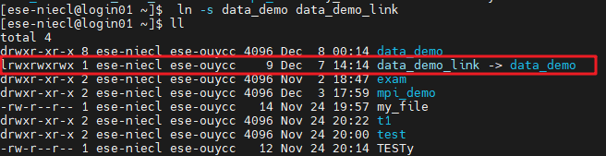

1.2

Echo ~



1.3

cd data_demo/molecules/ #1.3

touch test.pdb

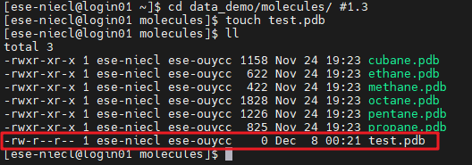

1.4

cd data_demo/data/elements/

find . -type f -print | wc -l



1.5

cd ~ #1.5

cd data_demo/data/pdb/

diff ethane.pdb ethanol.pdb

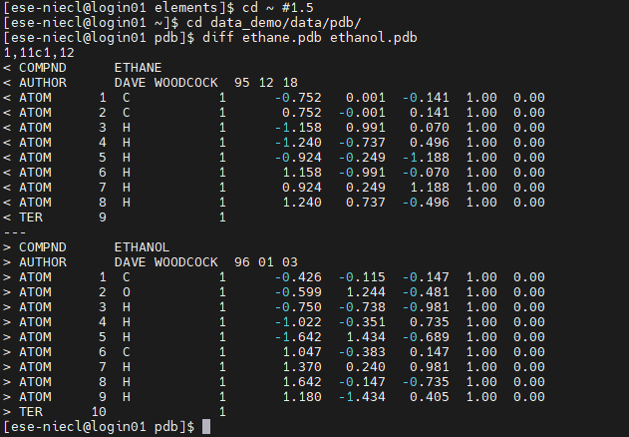

1.6

cd ~ #1.6

cd data_demo/writing/data/

grep 'But she' LittleWomen.txt

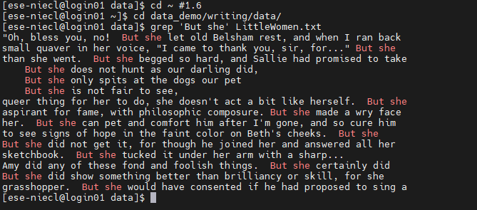

1.7

cd ~ #1.7

cd data_demo/data/

du -h

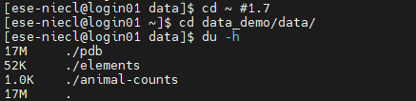

1.8

cp -r writing/ writing_new #1.8

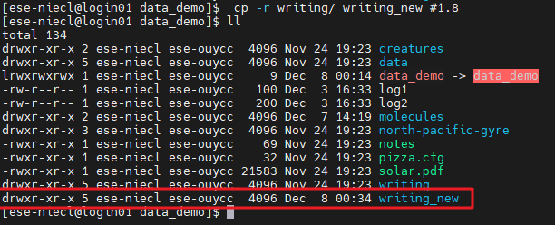

zip -r writing_new.zip writing_new/

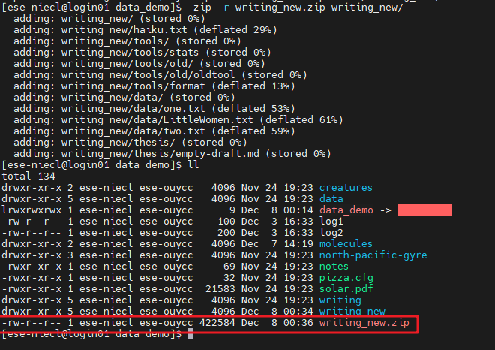

unzip writing_new.zip

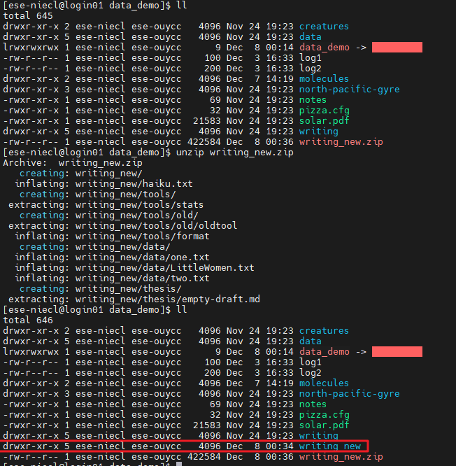

1.9

chmod 701 wriring_new

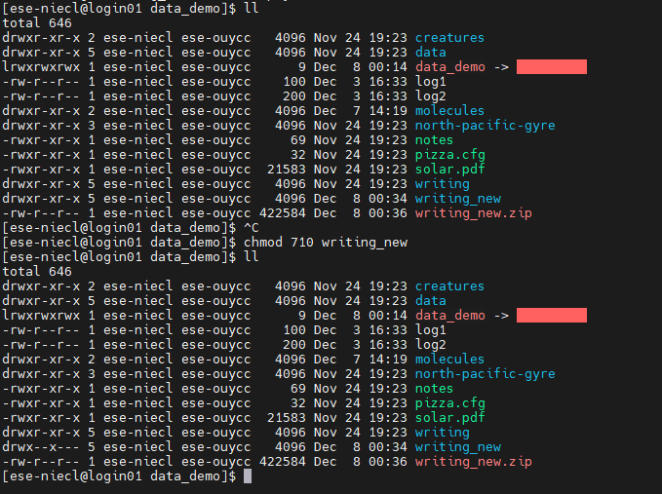

1.10

history 10

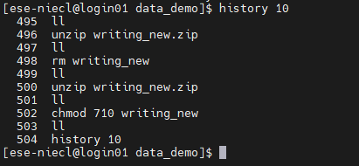

2

nano loop.sh

for i in $(cat pdb.list);

do

du -x $i

done

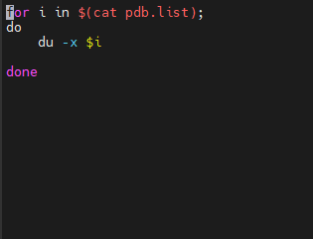

./loop.sh

