# 1.1

Main.f90

读取矩阵并打印

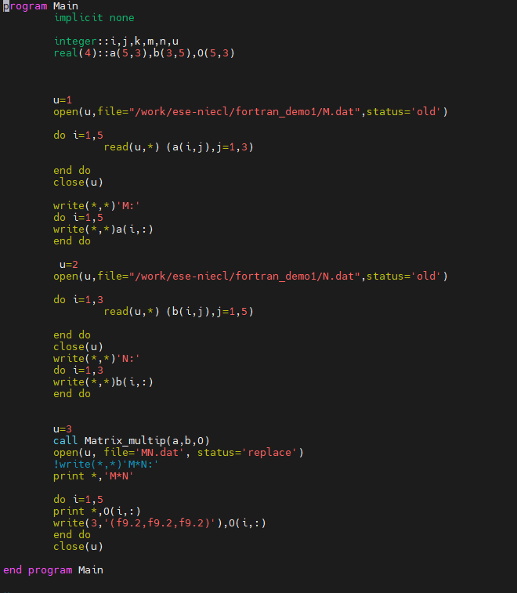

# 1.2

MaMatrix_multip.f90

通过循环的方式完成矩阵相乘

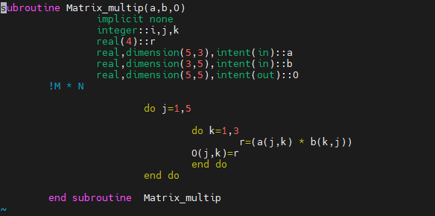

# 1.3

矩阵计算过程及结果

[ese-niecl@login01 fortran_demo1]$ gfortran Main.f90 Matrix_multip.f90 -o Main.x

[ese-niecl@login01 fortran_demo1]$ ./Main.x

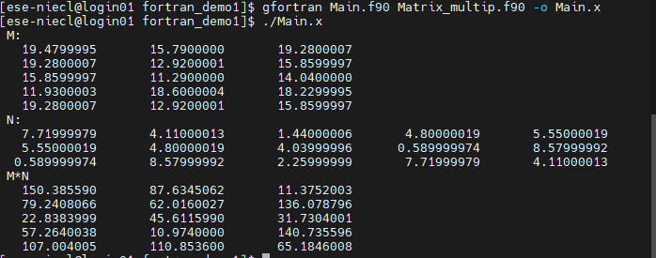

MN.dat

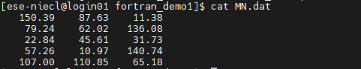

# 2.1

Declination_angle.f90

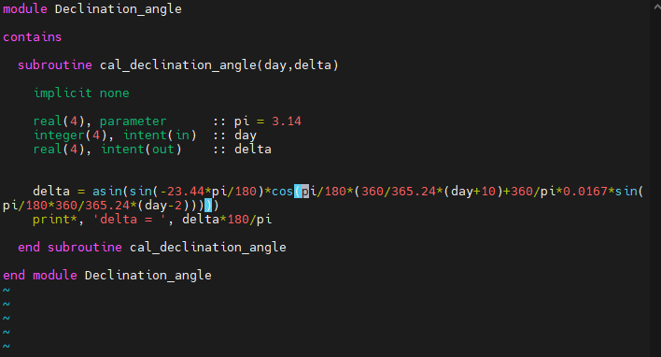

# 2.2

Solar_hour_angle.f90

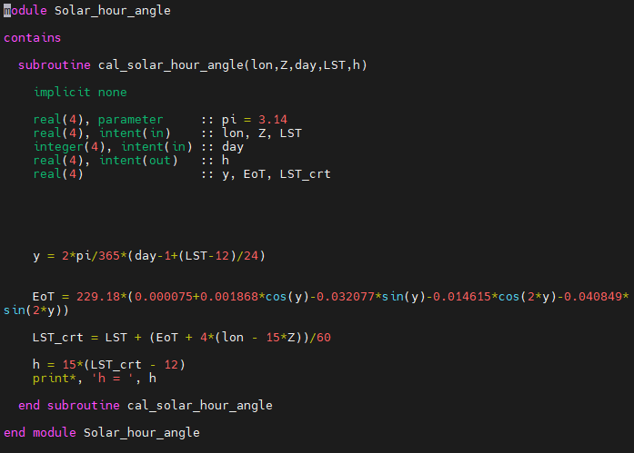

# 2.3

Solar_elevation_angle.f90

提前输入深圳的经纬度(22.542883N, 114.062996E) ，10:32 为10.533333。从UTC+8得Z=8 ，从日期 2021-12-31得到day=364

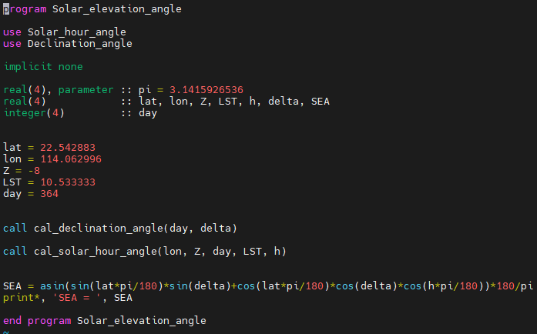

# 2.4

[ese-niecl@login01 fortran_demo1]$ gfortran -c Declination_angle.f90 [ese-niecl@login01 fortran_demo1]$ gfortran -c Solar_hour_angle.f90 [ese-niecl@login01 fortran_demo1]$ gfortran -c Solar_elevation_angle.f90 [ese-niecl@login01 fortran_demo1]$ gfortran Solar_elevation_angle.f90 Declination_angle.o Solar_hour_angle.o -o Solar_elevation_angle.x

[ese-niecl@login01 fortran_demo1]$ gfortran Solar_elevation_angle.f90 -o Solar_elevation_angle.x -L. -lsea

[ese-niecl@login01 fortran_demo1]$ ./Solar_elevation_angle.x

构建library，输出太阳高度角

