CoffeeLab

Liam Niehus-Staab

9/18/2018

#make a graphs  
ggplot(data = coffeeSales, aes(x = Location, y = Sales)) +   
 geom_boxplot() +   
 labs(title = "Box Plot of Sales by Location")

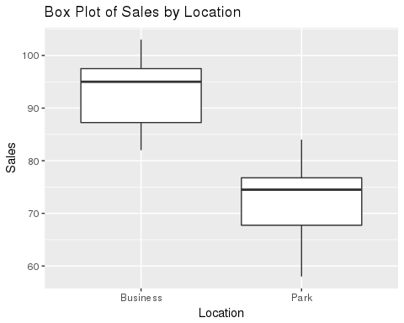

# null Hypothesis: There is no difference in average sales between the   
# park and the buisness district  
# alternate Hypothesis: There is a non 0 difference between the two locations  
business = filter(coffeeSales, Location == "Business")  
park = filter(coffeeSales, Location == "Park")  
t.test(park$Sales, business$Sales)

##   
## Welch Two Sample t-test  
##   
## data: park$Sales and business$Sales  
## t = -6.1196, df = 17.91, p-value = 9.025e-06  
## alternative hypothesis: true difference in means is not equal to 0  
## 95 percent confidence interval:  
## -26.73432 -13.06568  
## sample estimates:  
## mean of x mean of y   
## 72.8 92.7

Dear Joe, My analysis of the sales data you collected is complete. I conducted a simple T test on the data for number of sales by location and found some good evidence that there is a difference between the productivity of your shop at the two locations. Now I have some good news and some bad news. The good news is that the business district appears to consistently make more sales than the park. The T test showed a very small p value, signifying that the chance that these sales results being pure chance are tiny and gives us good reason to reject the hypothesis that there was no difference between the locations. The mean number of sales for the business district is about 14% higher than that of the park. If you wish to continue with your coffee truck, I would recommend selling in the business district. That brings us to the bad news: you didnt make a positive profit for any of the days. Really consider if this is what you want to do with your money.