MakeMaps.Rmd

Liam Niehus-Staab

10/2/2018

### On Your Own Questions

1.) Restrict the states and all.cities files to only a few contiguous states

NewStates <- filter(MainStates,region == "new york" | region ==  
 "vermont" | region == "new hampshire" | region ==  
 "massachusetts" | region == "rhode island" |   
 region == "connecticut" )

2.) Color each state by the number of electorial votes in that state.

merged = inner_join(NewStates, StatePopulation, by = "region")  
graph = ggplot() +   
 geom_polygon(data = merged, aes(x= long, y = lat, group = group, fill = elect_votes),  
 color = "black") +  
 scale_fill_continuous(name = "Colored by Electoral votes",  
 low = "pink", high = "purple")  
graph

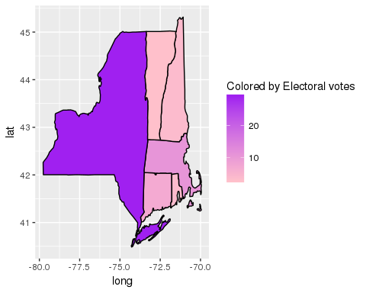 3.) Add a point to represent each city in these states.

cities <- filter(us.cities, country.etc == "NY" | country.etc == "RI" |   
 country.etc == "NH" | country.etc == "MA" |  
 country.etc == "CT" | country.etc == "VT")  
  
graph = graph + geom_point(data=cities, aes(x=long, y=lat),   
 color = "black")   
graph

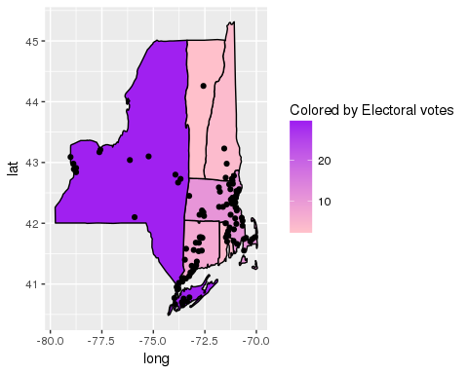 4.) Color the cities so state capitals are clearly differentiated from other cities.

capitals = filter(cities, capital == 2)  
  
graph = graph +   
 geom_point(data = capitals, aes(x = long, y = lat), color = "red")  
graph

