User manual

Nano Board with STM32F303CCT6 MCU

### Introduction

The Nano board allows users to easily develop applications with the STM32F303CCT6 microcontroller with the Arm Cortex-M4 32-bit core.

Based on STM32F303CCT6, it includes one MPU6050 (is a 3-axis gyroscope and a 3-axis accelerometer sensor), LEDs, push-buttons and a mini USB port.

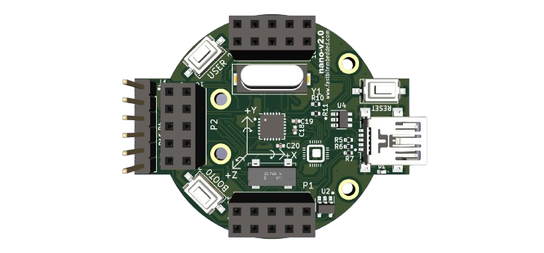

Figure 1: Nano

**Contents**

1. Features 7
2. List of tables 4
3. List of figures 5
4. Hardware and layout 8

**List of tables**

Table 1. Boot modes 10

Table 2. LSE pins 11

Table 3. HSE pins 11

Table 4. UART1 pins 11

**List of figures**

Figure 1. Nano 1

Figure 2. Nano top layout 8

Figure 3. Nano bottom layout 9

**List of Block-diagram**

Block 1: UART-USB bridge 12

**List of abbreviation**

SWD Serial Wire Debug

LQFP Low Profile Quad Flat Package

LSE Low Speed External

HSE High Speed External

**Feature:**

The Nano offers the following features:

* The STM32F303CCT6 microcontroller features a 32-bit Arm Cortex-M4 with FPU core (72 MHz max), 256-Kbyte Flash memory, and 48-Kbyte SRAM in a LQFP48 package.
* Three push buttons:
  + SW1(reset), SW2(user button), SW3(boot0).
* Four LEDs:
  + D1 (red) for 3.3 V power on / off.
  + Three user LEDs, D2 (blue), D3 (green), D4 (red).
* Board connectors:
  + J1 SWD.
  + J2 USB-B Micro.
  + 2.54 mm pitch extension header for 30 pins of LQFP48 I/Os for quick connection to prototyping board and easy probing.
* Power-supply options: ST-LINK or USB VBUS.

**Hardware and layout**

The Nano is designed around the STM32F303CCT6 microcontroller in a 48-pin LQFP package.

Figure 2 and Figure 3 help users to locate STM32F303CCT6 and its peripherals (MPU6050, push buttons, LEDs).

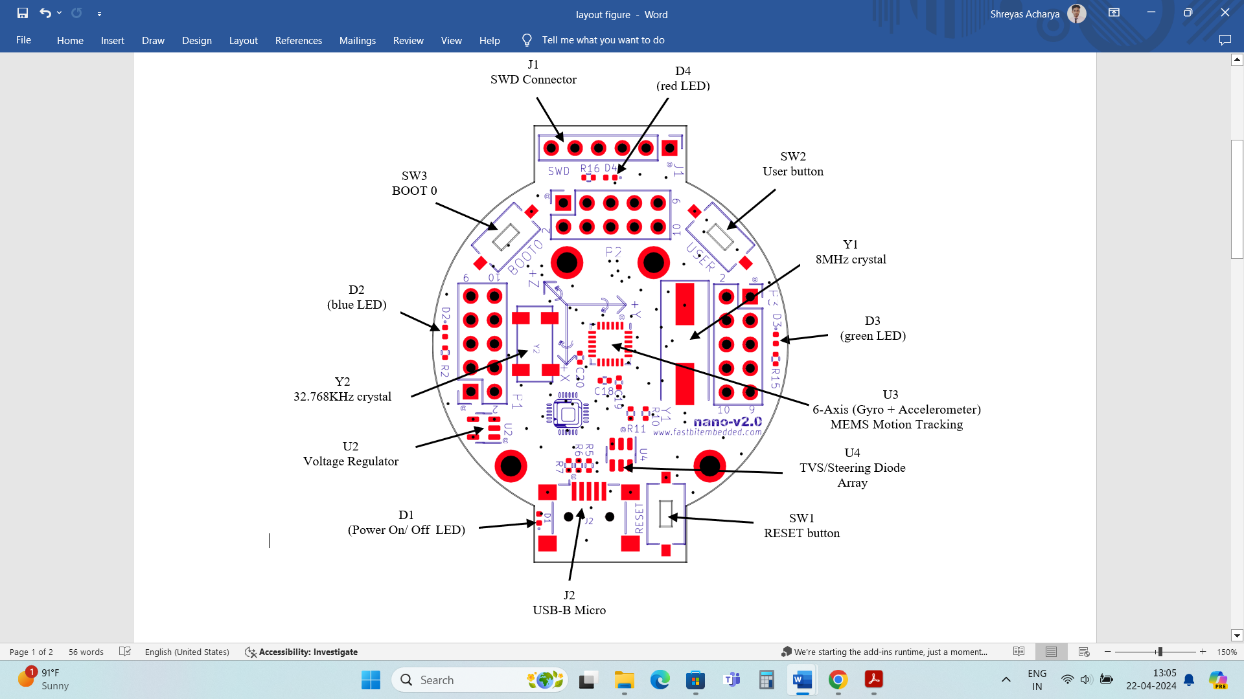

Figure 2: Nano top layout

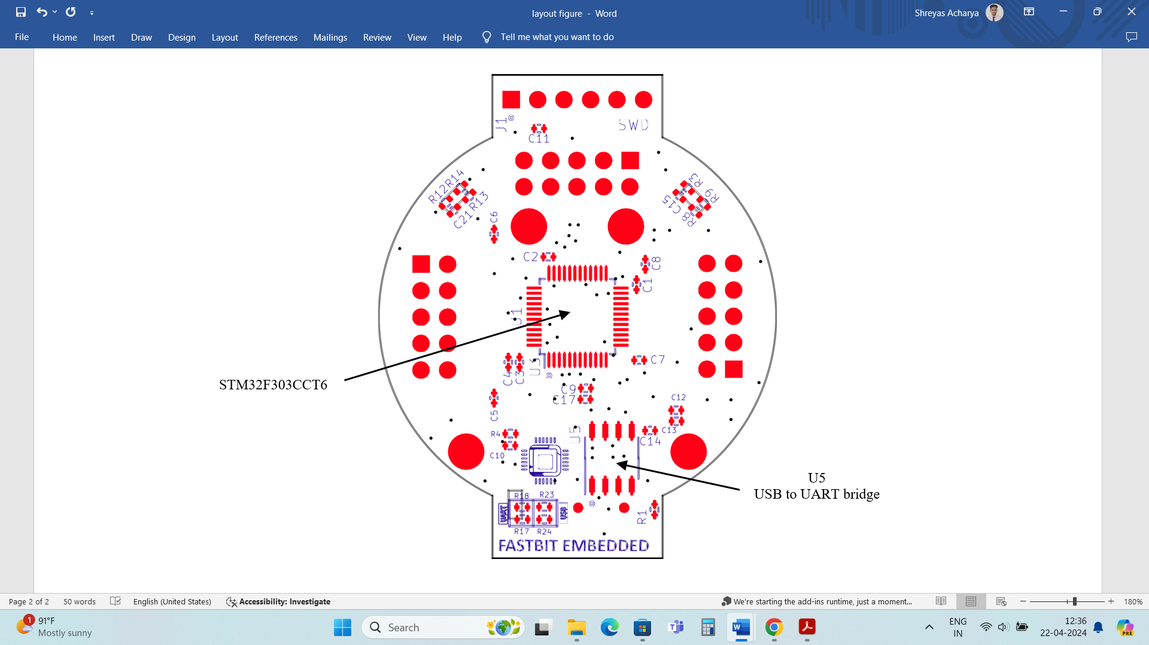

Figure 3: Nano bottom layout

**Power supply and power selection**

* The power supply is provided either by the host PC through the USB cable or via the SWD port using an ST-Link connection.
  + U2 regulates the 5V input from USB to provide a steady 3.3V output.

**Note: Don’t connect external power supply to header sockets.**

**LEDs**

* D1 PWR: red LED indicates that the board is powered.
* User D2: blue LED is a user LED connected to the I/O PA1 of the STM32F303CCT6.
* User D3: green LED is a user LED connected to the I/O PA2 of the STM32F303CCT6.
* User D4: red LED is a user LED connected to the I/O PA3 of the STM32F303CCT6.

**Push** **buttons**

* SW1 RESET: Push button connected to NRST is used to RESET the STM32F303CCT6.
* SW2 USER: User button is connected to the I/O PA0 of the STM32F303CCT6.
* SW3 BOOT0: Push button connected to BOOT0 is used to toggle the boot mode of the STM32F303CCT6.

|  |  |
| --- | --- |
| **BOOT0** | **Boot Mode** |
| 0 | Main flash memory |
| 1 | System memory |

Table 1: Boot modes

Note: By default, the microcontroller runs the application code from the main flash memory. To change this behavior, use the BOOT0 button.

1. Press the BOOT0 button and then press the reset button.
2. This action makes the microcontroller to run the built-in bootloader from the system memory (i.e., microcontroller enters the bootloader mode).

**6-Axis (Gyro + Accelerometer) MEMS Motion Tracking**

* MPU6050 sensor is a low power, low cost, and high-performance 6-axis (Gyro + Accelerometer).
* The MPU6050 devices combine a 3-axis gyroscope and a 3-axis accelerometer on the same silicon die, together with an onboard Digital Motion Processor (DMP), which processes complex 6-axis Motion Fusion algorithms.
* The STM32F303CCT6 microcontroller controls this sensor through the I2C interface.

**OSC Clock**

* **LSE: OSC 32.768 kHz clock supply**

Refers to an external oscillator running at 32.768 kHz. It typically provides a low-frequency clock source for real-time clocks (RTC) or other timing-sensitive functions.

|  |  |
| --- | --- |
| **Pin Name** | **Pin Function** |
| PC14 | OSC32_IN |
| PC15 | OSC32_OUT |

Table 1: LSE pins

* **HSE: OSC 8 MHz clock supply**

Refers to an external oscillator running at 8MHz. It provides a higher-frequency clock source suitable for driving the core processing unit or other high-speed peripherals.

|  |  |
| --- | --- |
| **Pin Name** | **Pin Function** |
| PF0 | OSC_IN |
| PF1 | OSC_OUT |

Table 2: HSE pins

**USB to UART bridge**

* The USB to UART bridge facilitates communication between a computer and a STM32F303CCT6, with UART1Tx and UART1Rx serving as the transmit and receive pins, respectively, connected to pins PA9 and PA10 on the microcontroller.

|  |  |
| --- | --- |
| **Pin Name** | **Pin Function** |
| PA9 | UART1_Tx |
| PA10 | UART1_Rx |

Table 3: UART1 pins

TO PC

**CH340N-U5**

**STM32F303CCT6 - U1**

TX

USART1_RX PA10

USART1_TX PA9

RX

Block1: UART-ISB Bridge