82.80.Bg

A high-repetition-rate, fast temperature-programmed gas chromatograph and its

on-line coupling to a supercritical fluid chromatograph (SFC×GC)

D Malan,1, [1] SJ van der Walt,1, [2] and ER Rohwer1, [3]

*Department of Chemistry, University of Pretoria, Pretoria, 0002,*

*South Africa*

(Dated: 19 August 2019)

We present a fast gas chromatographic system that can be used as a second dimension in comprehensive (supercritical fluid × gas) chromatography (SFC×GC). The temperature of the short (1 metre long) capillary column is controlled by a

resistively heated coaxial stainless-steel tube. The electrical resistance and therefore temperature of the stainless-steel tube is measured by continuous monitoring of the current/voltage ratio. Highly repeatable heating rates of up to 2100◦Cmin−1 (35◦Cs−1) are obtained, which should be high enough for the most demanding fast chromatograms. To reduce the cooling time between temperature programs the column is cooled by injecting evaporating carbon dioxide into the space between the coaxial heater and the column. This gives cooling rates of 5100◦Cmin−1 (85◦Cmin−1) which allows quick succession of temperature programs. More repeatable heating profiles with stable GC retention times together with faster cooling are significant improvements on previous SFC×GC systems. Cycle times of four gas chromatograms per minute could readily be achieved, which allows efficient coupling to high-resolution stop-flow SFC in the first dimension. We demonstrate the fast chromatograph by separating fatty information which would be useful in the food and biodiesel industries.

Keywords: high speed temperature programmed GC, sub-ambient GC, fast process

GC

# I. INTRODUCTION

Speed of analysis is a most important criterion for any analytical system. Chromatography as an analytical technique is notoriously slow, compared to, say, some spectroscopic

techniques.

While it is of interest to (especially high-throughput) laboratories to reduce run times, at some point the faster chromatography starts outstripping the sample preparation capacity. Once the chromatographic run duration approaches the time it takes to prepare the sample, faster chromatography will not improve the sample throughput. Technology development in fast chromatography is therefore driven not by conventional injection-based chromatography, but by applications where no sample preparation is necessary and rapid results are needed.

Examples of these would be headspace analysis for detecting explosives1, drugs2 and fuel adulteration3, monitoring anaesthetic agents in the breath of sedated patients4,5, and in ‘electronic noses’ that can distinguish between frozen and chill-stored meat6. Another

application for fast gas chromatography is industrial process monitoring7.

However, in the past two decades the major application for fast gas chromatography has not been in direct sample analysis, but in the analysis of fractions of eluate from chromatographic separations. This concept is called *comprehensively coupled chromatography*. For example, in comprehensively coupled gas chromatography (GC×GC), fractions of a conventional gas chromatographic run are collected by a *modulator* and then admitted to a second, fast gas chromatograph8. GC×GC has become well established: the annual GC×GC Symposium is in its 15th year, and major reviews are published regularly9,10.

In comprehensive 2D chromatography the second-dimension chromatography must be *fast*. The theory and practice of improving the speed of GC is well developed11,12. Typically, short columns and high carrier flows rates are used, which reduce retention times by reducing the void time. The use of narrow-bore columns and thin films reduce run times by improving mass transfer between the mobile and stationary phases, allowing higher linear flow rates of the carrier gas.

Comprehensively coupled chromatography depends on *orthogonality*: the second dimension (2D) separation must have a different mechanism than that of the first dimension (1D) separation13,14. The higher the orthogonality, the better the *separation space* offered by the system. The different separation mechanisms that determine orthogonality are usually provided by the different stationary phases offered by column manufacturers, but it is also possible to use a different form of chromatography as a first dimension: liquid chromatography has been used as a first dimension in LC×GC15, and in our laboratory we are developing SFC×GC instrumentation16.

If a chromatographic 2D separation is highly orthogonal to the 1D separation, then we will run into the *general elution problem*17: it becomes unlikely that one set of acceptable operating conditions (temperature, flow and stationary phase) will give acceptable (fast enough and with adequate resolution) separation.

In GC×GC as it is practised today, this has become a real problem. *Wraparound* is a well-known phenomenon in GC×GC18. Wraparound happens when a peak or peaks elute ‘late’ on the second dimension, so late that the next modulation period has already started before its elution and the peak appears on the next 2D chromatogram.

If wraparound is a problem in GC×GC, it becomes inevitable in SFC×GC. The first

dimension (SFC) does not normally separate compounds in a way that correlates with vapour pressure. Indeed, SFC is particularly good in performing group-type separations19, where compounds with a wide range of boiling points elute together.

# A. Column heating for gas chromatography

In GC the usual solution to the general elution problem is temperature programming, *i.e.* increasing the temperature of the column throughout the duration of the chromatograpic run. Temperature programming decreases the retention times of late-eluting analytes without sacrificing the resolution of early-eluting analytes. Instrument manufacturers have mastered the art of temperature programming, and today the vast majority of 1D gas chromatography uses temperature programming.

However, implementing temperature programming in the fast 2D GC poses some challenges. Since the recommended heating rate for temperature programmed chromatography is around 10◦C per void time20, the short void times of fast chromatography imply that high heating rates are required. Conventional air-bath GC ovens cannot attain these high heating rates, and therefore specialized column heating is required. Resistive heating by electric current offers a simple method, as reviewed21,22, and a recent paper23 describes the elimination of wraparound in GC×GC of diesel samples using resistive heating to implement a simple temperature program in the 2D column.

Of the three broad classes of resistive heating of capillary columns identified21 (*i.e.* (1) direct heating of a metal column or conductive coating on the column, (2) coaxial heating by a conductive tube around the column, (3) collinear heating by a heating element parallel to the column), we have experience with direct heating and coaxial heating.

In previous work in our laboratories16,24 a resistively heated metal column was used. The temperature of the column was controlled by following the temperature of a thermocouple glued to the column, but this method had some shortcomings, like uncertainty about the absolute temperature along the length of the column and stationary phase limitations: metal columns are often developed for high-temperature applications, and are not available with

all the stationary phases offered in fused silica columns.

In this work we used a coaxial heater, in the form of a thin-walled stainless-steel tube that surrounds the capillary column. This tube is resistively heated by controlled direct current. Due to the low thermal mass the heating is rapid, and since the resistance of the tube indicates its temperature there is no need for external temperature measuring devices. The benefit of this design is that it allows the use of commercially-available fused silica columns with their wide range of internal diameters and selectivities. Columns can be exchanged without altering the temperature feedback system and therefore the rapid heating characteristics. Additionally, the co-axial space between the capillary column and the stainless-steel tube can be filled with coolant to rapidly cool the column.

# B. Cooling of the GC column

At the end of temperature-programmed chromatographic run, GC columns are usually cooled to the starting temperature by ambient air. This cooling is slow and inefficient because of the poor conductivity and low heat capacity of air. Fast chromatography usually

implies analysis at high repetition rates, so cool-down times also need to be shortened.

There have been attempts to improve the cooling rate of air baths.

Agilent markets a ‘low thermal mass’ column, which includes a collinear heating wire and a collinear sensing element bundled with a short silica column. These units cool down faster than normal air-baths, but only to ambient temperature. For short columns a cooling time of 1*.*3min has been reported25. These columns are available with only a limited range of stationary phases.

The Zip Scientific solution is forced convection. Their ‘GC-Chaser’ system uses a blast

of (chilled) room air to the GC oven to cool it down after each GC run, allowing the use of conventional fused silica columns. In an example26 it reduces cooling time from 16 minutes to 7 minutes. Although this can significantly decrease the cost per analysis in a

high-throughput laboratory, the cooling is not fast enough for 2D chromatography.

The EZ Flash system uses a coaxial resistive heating system, which allows the column to

cool down ballistically. Reports from the literature claims cool-down periods of 30 seconds27.

The Valco FTP-200 fast temperature programmer28 (Valco Instruments Co. Inc.) uses a small, optional fan to cool down the columns.

Cryogenic coolers for GC ovens are available but are intended to cool the oven to low temperatures for the analysis of volatile compounds and not necessarily to improve cycle times. In previous SFC×GC work in our laboratories16,24 the cryogenic function of a Varian 3300 gas chromatograph was used to cool down the column oven at the beginning of each

run, using large quantities of coolant in the process. The resistively heated column cooling required 30 seconds to get back to the starting temperature in this cool environment. We estimate that a single SFC×GC run consumed an unacceptable 15 kg of carbon dioxide

coolant.

Recognizing that the precise application of coolant will require less coolant and permit faster cooling, we developed a system that injects liquid carbon dioxide into the space between the column and the coaxial heater. The evaporating carbon dioxide rapidly absorbs heat from the column and coaxial heater, achieving a high cooling rate to sub-ambient temperatures at a minimal expense of coolant.

At the same time, the cold GC column acts as a focusing trap for the subsequent sample, and thus forms an integral part of the modulator of the SFC×GC system.

# C. Application

The fast GC system described in this paper can be used in any application where fast chromatograms are needed in rapid succession, for example in process control. In our case we applied it as a 2D column comprehensively coupled to a supercritical fluid chromatograph.

We applied our fast GC system to the evaluation of fatty acid profiles of potential biodiesel feedstock. The fast GC separation was highly orthogonal to the 1D separation on SFC, showcasing this type of comprehensively coupled chromatography. An easily interpretable 2D separation was obtained, with run times similar to the total run times required by official methods for the determination of fatty acid profiles.

**II. EXPERIMENTAL**

# A. Introduction

For better understanding of subsequent detail, a description of the cycle of the SFC×GC

is appropriate.

The SFC subsystem runs in stop-flow mode. The eluate of the SFC passes through a

stop valve and a static capillary restrictor. The end of the restrictor is inserted through the septum into the hot inlet of the GC.

After the sample is injected, the SFC runs for an optional uninterrupted period, usually briefer than the void time. No data is collected during this time. Then the stop valve closes, and the cooling system activates to cool the GC column. Once the column is at the set temperature, the stop valve opens and the SFC eluate exits the restrictor into the hot splitless inlet of the GC, where it evaporates and is transported on to the column. The vapor-phase material is trapped in the cold stationary phase. Once the desired amount of the SFC eluate has been collected, the stop valve closes. Some time is allowed to pass so that the last of the evaporated SFC eluate flushes into the column. Then the split vent of the GC inlet opens for a short period, which vents excess carbon dioxide to the atmosphere. This normalizes the pressure in the inlet (having been raised by the high flow rate of CO2 from the SFC) and allows the carbon dioxide to be replaced by the pressure-controlled hydrogen carrier gas. Once the split vent closes the GC run starts, which of course means the start of the temperature program, which desorbs the analyte trapped on the head of the cold column. At the end of the GC run, the cooling process starts, cooling the column in a second or two. The next cycle then starts, marked by the opening of SFC the stop valve.

# B. Hardware

The short-cycle fast gas chromatograph was built into a modified Varian 3300 gas chromatograph.

The inlet was an unmodified Varian 1075 split/splitless inlet. The temperature control of the inlet was by the original electronics, controlled from the Varian 3300 front panel. The split vent valve was disconnected from the gas chromatograph and controlled from the

control computer described below.

The detector was an unmodified Varian 3300 flame ionization detector (FID). The

temperature of the detector was controlled by the original electronics, controlled from the front panel. The detector bias voltage was supplied by the original electronics, but a standalone high-speed electrometer (V.G. Micromass Ltd, Model M406-H) captured the signal, which was then conditioned by a bench-top amplifier (V.G. Micromass Ltd, Model M406) before it was sent to the computer.

The coaxial heater was made of a 940 mm length of stainless steel (SAE 304 grade), obtained from MIFAM (Milano´wek, Poland). It had an outside diameter of 1.06 mm and an inside diameter of 0.80 mm.

The ends of the coaxial heater tube terminated in two identical, specially designed Tpiece blocks. These blocks fulfilled three roles: It (1) sealed the coaxial tube to contain coolant, (2) allowed electrical connection to the coaxial heater, and (3) acted as a heated transfer line between the column and the detector and inlet.

The T-piece blocks were machined from brass. The stainless-steel tube of the coaxial heater was brazed onto the block. The cooling CO2 was let in from one side, and on the opposite side a thermocouple probe inserted into a blind hole measured the temperature of the block. A micro-union using a metal ferrule (Restek SilTite *µ*-Union Connectors), brazed to the block, was used to seal the capillary column. An electrical contact was added, to which an electrical conductor could be soft-soldered. Four holes through the length of the block allowed the fitting of four 220V, 100 W heater cartridges (Hotset), providing each of the two blocks 400W of heating.

The chromatographic column entered the T-piece block via the bottom port with the coaxial heater tube and passed out through the top port and into the inlet or detector. In the left-hand side of the T-piece block was the inlet or outlet port for the carbon dioxide

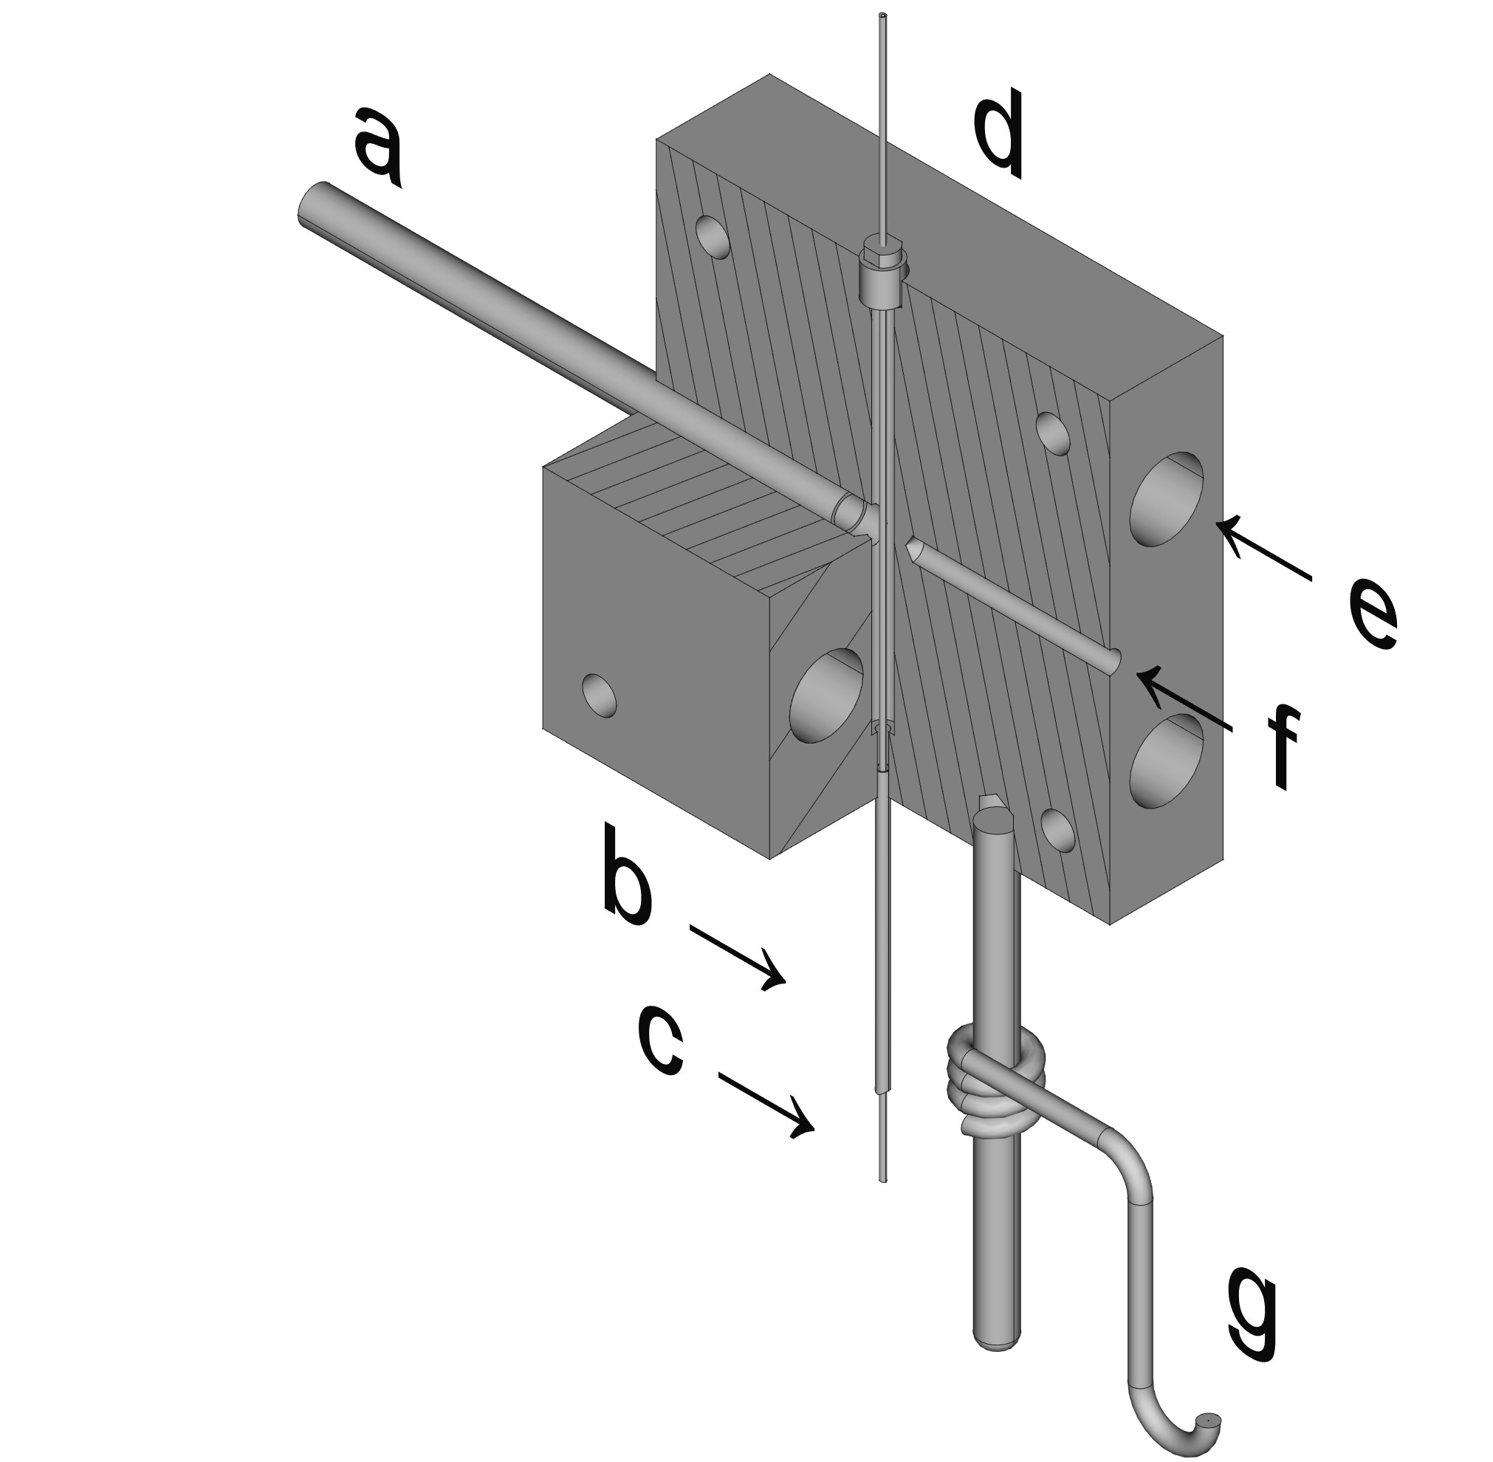

FIG. 1. A cutaway diagram of the inlet/outlet outlet T-piece blocks, showing the (a) cryogenic coolant inlet/outlet, (b) the coaxial heater, (c) the capillary column, (d) the mico-union seal, (e) the cartridge heater socket, (f) the thermocouple socket, and (g) the electrical connection.

coolant.

Since the coaxial heater resistance measurement used a two-wire technique, the currentcarrying circuit was made entirely of soldered joints to minimize stray resistance from de-

veloping in electrical connections.

The T-piece blocks were mounted on ‘cars’ that slid up and down twin round-bar rails

on brass bushes. The cars carried the weight of the inlet and outlet T-piece blocks and rigidly aligned the column with the inlet and detector of the gas chromatograph. The cars were isolated electrically from the rails by a sandwich construction that included siliconeimpregnated mica as insulating material. The whole of the inlet and outlet T-piece blocks

were at the electrical potential of the coaxial heater ends.

The cryogenic carbon dioxide (Afrox, Tec (Wet)) was supplied from a cylinder equipped with a dip tube. It flowed to a coil heat exchanger bathed in a cold −5◦C) propylene glycol heat transfer fluid, which was mounted on top of the Varian GC. From the heat exchanger the carbon dioxide flowed down to the cryo shut-off valve (ASCO, RedHat brand). This arrangement ensured a supply of liquid CO2 at the shut-off valve, without which some gaseous CO2 might have to vent through the coaxial heater before the liquid CO2 coolant could reach it. Downstream of the shut-of valve there was a 10-turn metering valve, which controlled the flow of carbon dioxide into the coaxial heater for evaporative cooling. At the outlet end of the coaxial heater the carbon dioxide escaped through the T-piece block into

the atmosphere.

The SFC subsystem consisted of five packed silica columns (150 mm 4.6 mm, 3 *µ*m

particles) (Restek, Pinnacle DB Silica) in series, a sample valve (VICI), and a stop valve (VICI). Carbon dioxide, (99.995 % purity, Air Products) was supplied to a Varian 8500 piston pump. The inlet pressure of the SFC columns was controlled by a software proportional controller driving the stepper motor of the piston pump. The high pressure at the column exit was maintained by a fused silica capillary restrictor with an internal diameter

of 0*.*050mm, 800mm long.

# C. Electronics

The electronics for controlling the fast temperature programmed gas chromatograph and the SFC front-end was developed in-house.

A controlled direct current was used to heat the coaxial heater. The heating circuit consisted of the coaxial heater in series with a reference resistor and a ballast resistor. The reference resistor was constructed out of parallel stainless-steel wires with an open construction to promote heat dissipation with the aim of keeping its temperature constant. The ballast resistor was of stainless-steel wire in a bifilar winding with an air core, to

+

_

R

col

R

ref

R

bal

FIG. 2. A simplified circuit diagram of the resistance measuring circuit.

minimize electromagnetic interference and encourage heat dissipation.

The resistance of the reference resistor (*Rref*) was about 0*.*005Ω, and the resistance of the coaxial heater (*Rcol*) was about 0*.*3Ω, so that most of the heat in the circuit was dissipated by the coaxial heater. The potential difference across the coaxial heater (*Vcol*) and the reference resistor (*Vref*) were measured (See Figure 2). If the resistances of the coaxial heater and the reference resistor were both constant, the ratio *Vcol/Vref* would be constant, independent of the current. But metals have positive coefficients of resistivity so the resistance of the coaxial heater will increase with temperature. If the assumption is made that the temperature of the reference resistor does not change, then the ratio *Vcol/Vref* will be proportional to *Rcol*. If the resistance *Rcol* is assumed to be a monotonically rising function of the temperature (*Rcol* = *f*(*T*)), then the inverse function will provide the temperature (*T* = *f*−1(*Rcol*)).

A bank of six PNP 2N2955 bipolar transistors mounted in parallel on an aluminium plate provided a controlled current of up to 20A at 20V for the coaxial heater. Their mounting

plate was air-cooled by two 4-inch fans.

A two-stage control system controlled the current. The first stage of the control system was a PID controller implemented in LabVIEW. The process variable was the temperature of the coaxial heater, as calculated from its electrical resistance, and the set value was determined by the desired chromatographic temperature program. The manipulated variable was the voltage of the digital-to-analog converter converter (DAC) of the data acquisition board. The final stage was an electronic system, where the voltage applied to the coaxial heater was the process variable, and the set value was a voltage provided by the DAC. The manipulated variable was the base current of the power transistors. In summary, the software set a voltage, which set the power of the coaxial heater. The two-stage design allows for switching of the control of the coaxial heater from computer control to manual control by a potentiometer on the instrument front panel. Being able to control the power

of the coaxial heater manually is extremely useful during development and fault-finding.

AD595 monolithic thermocouple amplifiers (Analog Devices) with integral cold junction compensation was used to condition the signal of the K-type thermocouples that were used

for temperature monitoring and calibration.

Solid state relays (Opto 22, Model 240D3) were used to switch the inlet and outlet T-piece block cartridge heaters (described above) on and off. Pulse width modulation, implemented in software, was used to control the amount of heat produced by the cartridge heaters, and hence the temperature of the T-piece blocks.

A PCI-6014 multifunction data acquisition board (National Instruments ) was used to interface the electronics with the computer.

# D. Coaxial heater temperature calibration

The temperature of the coaxial heater was calibrated by constructing a thermocouple probe from 0.025 mm diameter thermocouple alloy wire (T1 and T2 alloys, Goodfellow) threaded inside a 500 mm length of 0.25 mm i.d. capillary chromatography column. This thermocouple was then threaded inside the coaxial heater (just like the capillary column during GC operation), to record the temperature of the heater. The recorded temperature could then be used to calibrate the coaxial heater resistance.

# E. Heating uniformity

To determine whether the coaxial heater was heating the column with acceptable uniformity, we used two methods. First, we acquired thermal images of the coaxial heater, using a FLIR T660 infrared camera. Secondly, for experiments in determining temperature gradients, a thermocouple probe was constructed as described above, except that the probe contained two thermocouples, 330 mm apart, equidistant from the ends.

# F. Software

## 1. Instrument Control

The software for controlling the instrument and collecting data was written in LabVIEW 7.1 (National Instruments). Two main loops were used. One controlled the various aspects of the instrument, in particular the temperature control. This loop ran with a period of 200 ms. The second main loop collected the data and ran as often as the hardware allowed.

The coaxial heater temperature was controlled by proportional-integral-derivative (PID) controllers implemented in LabVIEW. In practice it was found that only proportional and integrative control was needed. We used a privately published29 step-by-step implementation of the Cohen-Coon loop tuning method.

Subsidiary PID controllers controlled the T-piece block temperatures and the CO2 pump

pressure.

## 2. Data structure

In GC×GC, 2D data is recorded as a continuous FID output stream, as if it is a 1D GC chromatogram, and later converted into a 2D chromatogram, using knowledge of the

modulation period.

For two reasons we could not use this approach. Firstly, in our instrument the first (SFC) dimension runs in a stop-flow mode making continuous data recording inappropriate. Secondly, the duration of the cooling cycle can vary slightly, which could introduce unacceptable

variation in 2D retention times.

We therefore constructed 2D chromatograms by starting to record data each time the GC fast temperature program started, noting the GC start time as the elution time of the first (SFC) dimension.

## 3. Data visualization

For data visualization we used the technical computing system Mathematica 11.3 (Wolfram). First the collected data was converted to a list of three-element lists, with 1D retention time, 2D retention time, and detector signal as the elements of the inner lists. The Mathematica functions List3DPlot[] and ContourPlot[] could then be used to plot 3D

chromatograms or contour plots respectively.

**III. RESULTS AND DISCUSSION**

# A. Heating uniformity

As a first step in developing the coaxial heater, we tried to answer the question about its temperature uniformity. Because the temperature coefficient of resistivity of metals is positive, in the absence of equalizing heat flow the resistive heating process in a long, thin tube is inherently unstable. To monitor the temperature profile along the length, we acquired a thermal video (Figure 3) of the coaxial heater. The video shows that the coaxial heater heats and cools smoothly with no run-away hot spots.

To quantify the non-uniformity of the coaxial heater, a dual thermocouple probe was inserted into the coaxial heater. The two thermocouples in the probe were 330 mm apart and positioned in the central third of the coaxial heater. The coaxial heater was submitted to a repeated program of cooling and ballistic heating. Figure 4 shows that the gradients established by cooling was small (approximately 10◦C), stable and repeatable, and should not prevent good chromatography.

# B. Temperature calibration

While it is conceptually possible to have a fast temperature program by using the voltage/current ratio alone as a temperature indicator and controlled variable, it would be hard to design chromatographic methods or translate methods without a knowledge of the real

temperature. Therefore, we went to some effort to calibrate the coaxial heater.

To calibrate a thermometer, the thermometer under test and its calibration environment must be in equilibrium. This requirement is hard to meet in our calibration, because a

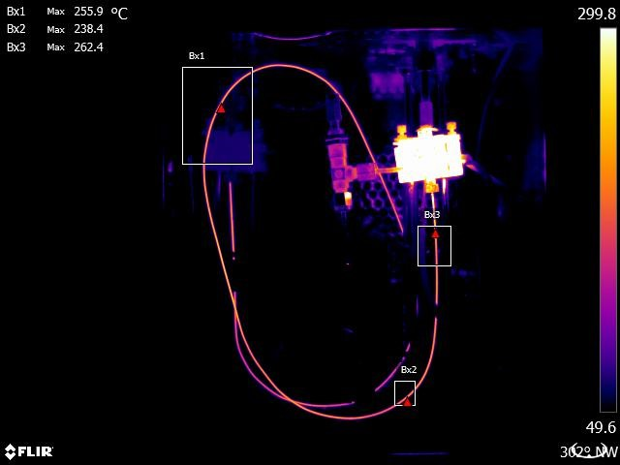

FIG. 3. A thermal image of the coaxial heater.

single point (the junction of the thermocouple) needs to be in equilibrium with the length of the coaxial heater during the whole of fast heating cycle. This equilibrium would be very difficult to maintain, especially because the uniformity of heating cannot be guaranteed, and is additionally influenced by the presence of the T-piece heaters at the high temperature of the GC inlet and detector — for a totally uniform heating of the coaxial heater the T-piece blocks would have to be at the same temperature as the coaxial heater. Acknowledging these limitations, we performed a calibration procedure assuming that the thermocouple junction was in equilibrium with the coaxial heater, which was assumed to be of uniform

temperature over its length.

For reasons not understood, the calibration (see Figure 5) curve is oddly curved, and we arbitrarily fitted a B-spline to the data points. This procedure can be automated30. Points from this B-spline curve were then extracted to create a calibration curve, from which an

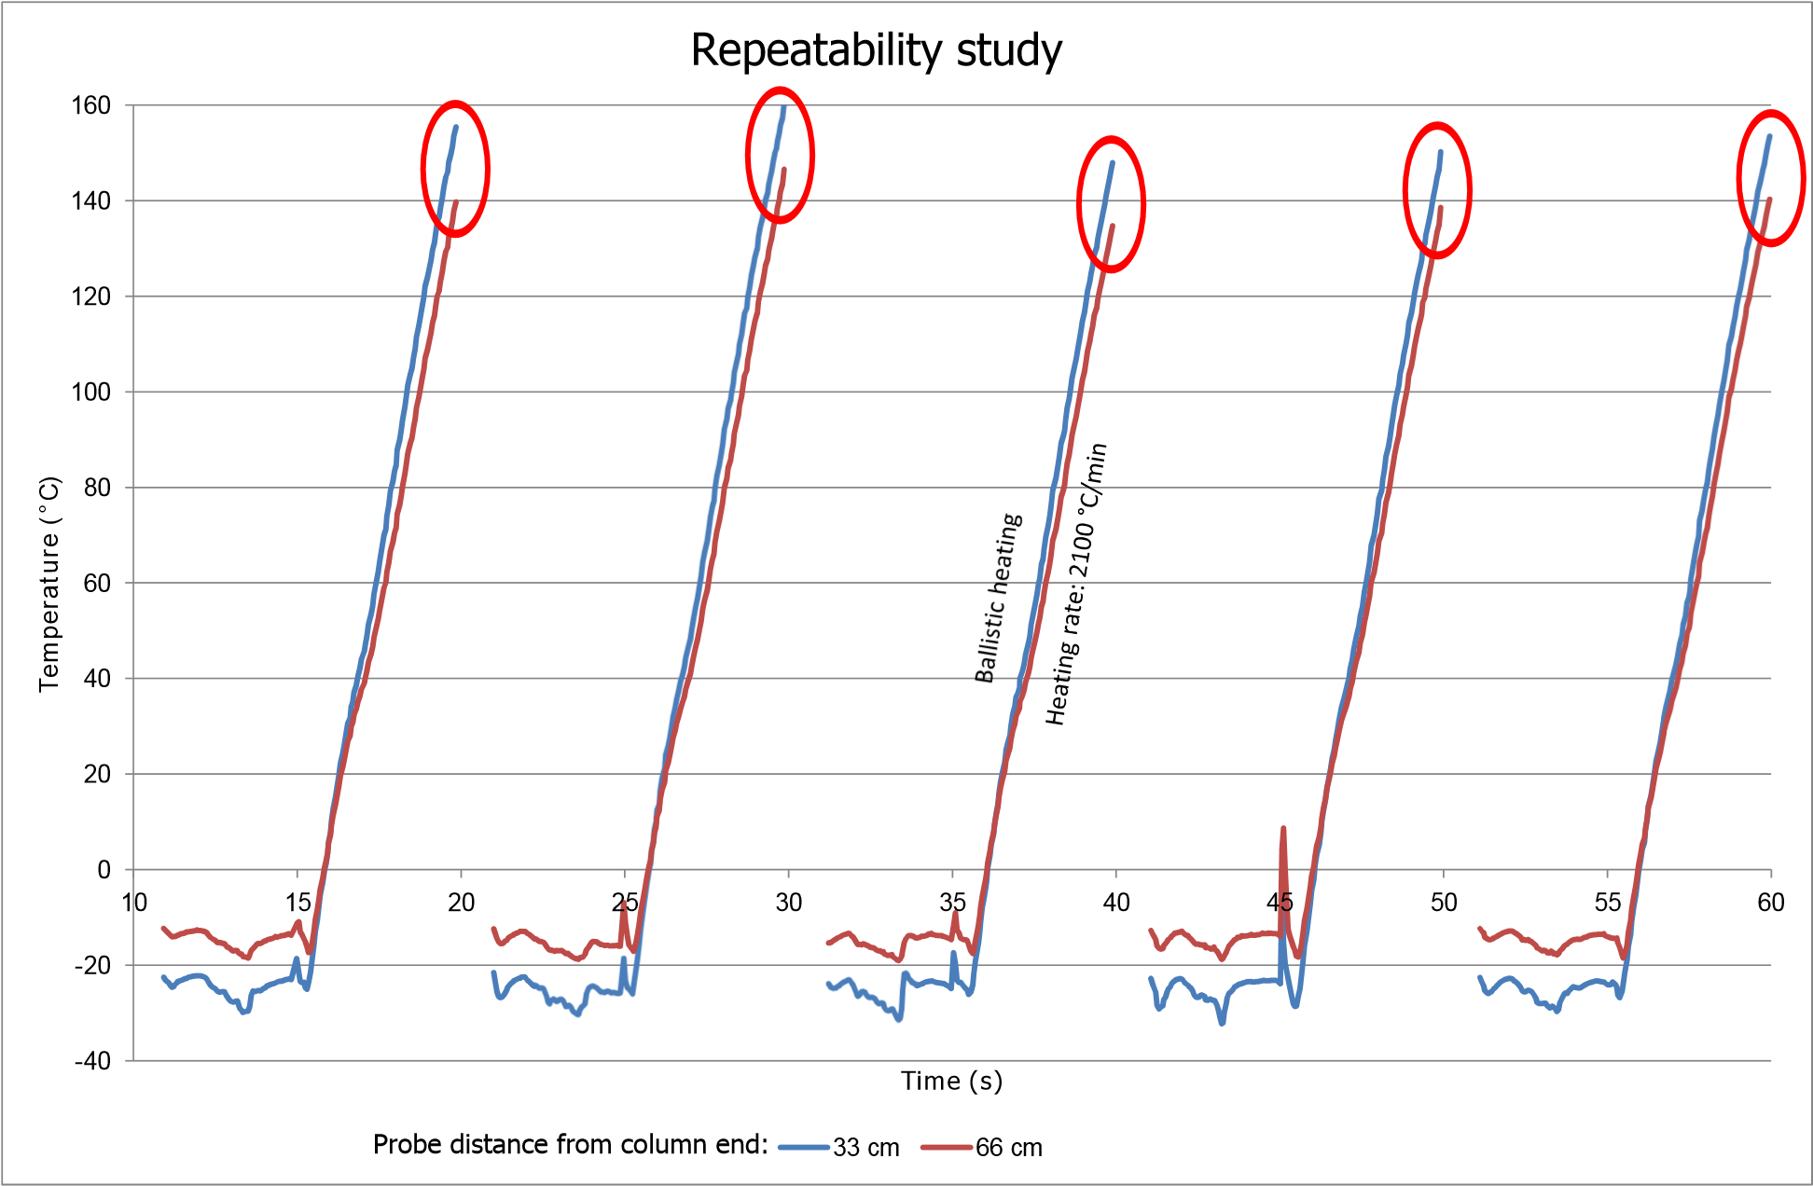

FIG. 4. A graph indicating that temperature gradients are modest, stable and repeatable

estimate of the temperature can be calculated by linear interpolation31.

# C. Heating rate

To achieve good resolution in temperature-programmed chromatography, a good rule of thumb for the heating rate is 10◦C per void time20. With hydrogen as carrier gas in a 0*.*25mm i.d. column of the optimum linear velocity is 40cms−1. Then the void time of a 1m column is 2*.*5s, so the recommended heating rate is 10◦C per 2*.*5s, which is 4◦C/s, or 240◦Cmin−1. Since in fast chromatography excess peak resolution is traded for shorter run times, higher than optimum flow rates will be used, so higher heating rates will be required. For narrower columns the flow will be even higher so heating rates of more than 1000◦Cmin−1 will be required.

The attainable heating rate is a function of power to the heater and of the temperature required. (In the instrument presented here power was limited by the voltage output range of the DAC of the data acquisition board, and not by the power of the heater.) We were able

Coaxial Heater Calibration

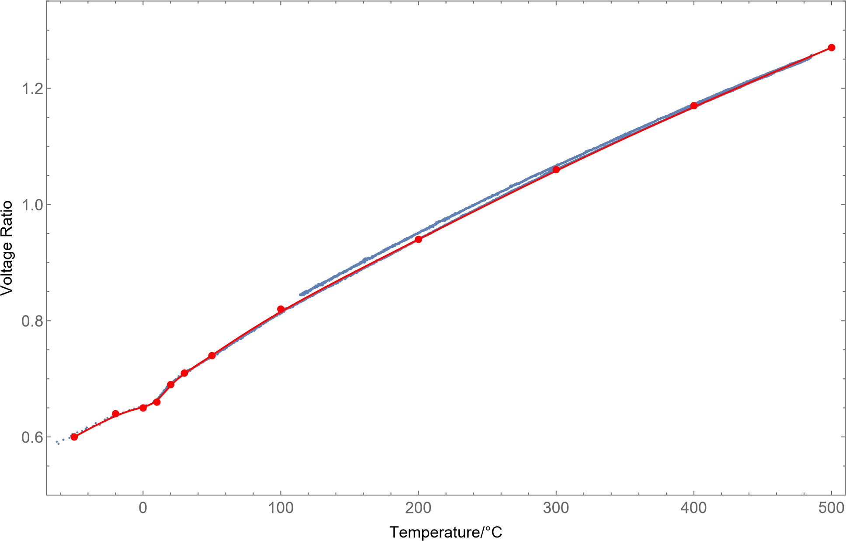

FIG. 5. A calibration curve of the coaxial heater. The markers were obtained from a B-spline fitted manually to the curve. The temperature is obtained by linear interpolation between markers. to maintain controlled heating rates of 2500◦Cmin−1 up to 400◦C, or up to 4000◦Cmin−1 up to 350◦C. (Figure 6.) The heating rates attainable seem to be high enough for the most demanding fast gas chromatography.

# D. Cooling rate

Using evaporating carbon dioxide as a powerful coolant, it was possible to cool down the column at a rate of 5100◦Cmin−1. The cooling rate depends on the setting of the metering valve, with the lowest coaxial heater temperatures and smallest gradients achieved at an intermediate flow of about 30gmin−1.

**Numberofplots:9**

0

5

10

15

20

0

100

200

300

400

**Time**

**(**

**s**

**)**

**Temperature**

**°**

**(**

**C**

**)**

**Temperatureramprepeatability**

FIG. 6. A graph of 9 identical, consecutive temperature ramps overlaid. The heating rate is

4000◦Cmin−1. The temperature follows the setpoint faithfully up to 350◦C

# E. Repeatability

Comprehensively coupled chromatography depends heavily on repeatable 2D separations. To test for chromatographic repeatability, we added small amounts of hydrocarbons to the 1D mobile phase. They are unretained on the silica stationary phase. Because they are not retained, they are present in every fraction of the SFC eluate in equal amounts, and

therefore they should yield identical 2D chromatograms.

Results obtained from creating a 2D blank chromatogram with two alkanes in the mobile phase is summarized in Table I. The peak widths were about 500ms, so the 20ms standard deviation for hexadecane means that the variation in retention time is only about 10% of the peak width. The relative standard deviations (RSD) of retention times were similar to those obtained in GC×GC32.

TABLE I. A summary of retention time repeatability of alkanes separated on the fast temperature programmed chromatograph.

|  |  |  |  |  |
| --- | --- | --- | --- | --- |
| Compound | n | tr (s) | S.D. of tr (s) | R.S.D. of tr (%) |
| Dodecane | 73 | 5.07 | 0.023 | 0.46 |
| Hexadecane | 73 | 6.58 | 0.052 | 0.78 |

# F. Chromatography

Comprehensively coupled chromatography is made possible by having different retention mechanisms in the columns of the two dimensions. When fatty acid methyl esters (FAMEs) are chromatographically separated on bare silica with pure carbon dioxide as a mobile phase, they are separated according to the number of double bonds, independent of chain length33. On a GC column, FAMEs are separated according to volatility or, equivalently, chain length. Therefore, when SFC and GC are comprehensively coupled, we can expect FAMEs to have

a highly orthogonal separation.

We prepared FAMEs by esterifying oil samples, following an official method34. Of these samples, 0*.*2 l was injected into the pure carbon dioxide mobile phase at 200bar and room

temperature and eluted through bare silica.

We collected 10-second fractions of SFC eluate on the cold GC column. The fast temperature program ramped the GC column temperature from −20◦C to 350◦C in 10s (2200◦Cs−1), then maintaining 350◦C for 2s. Then the cooling system would activate and cool the column to −20◦C or below, ready to trap the next SFC fraction.

In this way a series of GC chromatograms of SFC fractions were recorded, which could be assembled into a 2D chromatogram. Figure 7 shows a 2D chromatogram of a sample of FAME prepared from canola oil. This 2D chromatogram consists of 132 fast GC chromatograms collected in approximately 90 minutes.

# IV. CONCLUSION

To our knowledge, the cycle time of this new temperature programmed GC is unmatched in the literature, and it allows for the improved performance of SFC×GC instruments. The fast GC will be of interest to all GC analyses of highly dynamic chemical systems, including

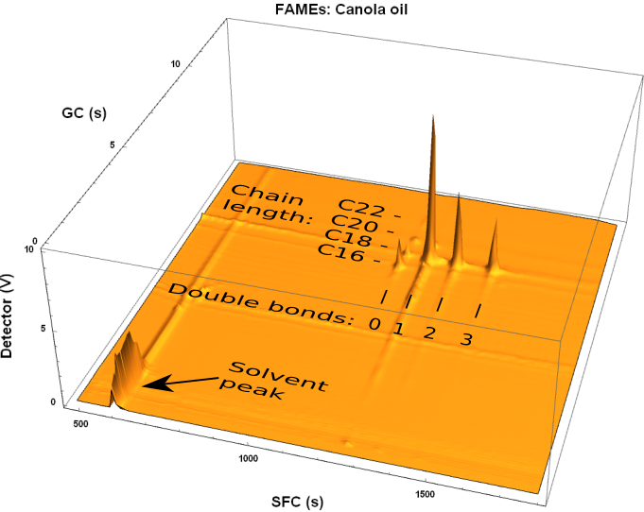

FIG. 7. A 2D chromatogram of FAMEs derived from canola oil. It is clear that the oil consists mostly of unsaturated fatty acids.

on-line monitoring and control of fast laboratory or industrial reactions.

The low thermal mass of the heater and column simplifies heating and cooling of a portable fast GC, reducing electrical and carbon dioxide coolant requirements. When subambient temperatures and extreme cycle times are not essential, compressed air could also serve to cool the column.

# SUPPLEMENTARY MATERIAL

In the supplementary material we provide a thermographic video of the coaxial heater heating and cooling, which indicates the evenness of heating and the rapidity of cooling.

# ACKNOWLEDGMENTS

Prof. Walter Meyer of the Department of Physics at the University of Pretoria supplied the idea for the resistance-measuring electronic circuit. Nico van Vuuren machined the Tpiece blocks and their mounting rails. We thank Restek for the generous donation of the packed silica columns. Reinhardt Heymans from FLIR Systems recorded the thermal images at no cost. David Masemula kept the laboratory supplied with consumables.

# REFERENCES

1G. Watson, W. Horton, and E. Staples, in [*IEEE 1991 Ultrasonics Symposium,*,](http://dx.doi.org/10.1109/ULTSYM.1991.234175) Vol. 1 (1991) pp. 305–309.

2S. He, J. Liu, and M. Liu, in [*Proceedings of the 2014 Symposium on Piezoelectricity, Acoustic Waves, and Device Applications*](http://dx.doi.org/10.1109/SPAWDA.2014.6998526)(2014) pp. 59–64.

3A. M. Hupp, J. Perron, N. Roques, J. Crandall, S. Ramos, and B. Rohrback, [Fuel](http://dx.doi.org/%20https://doi.org/10.1016/j.fuel.2018.05.102) [**231**, 264 (2018).](http://dx.doi.org/%20https://doi.org/10.1016/j.fuel.2018.05.102)

4X. Chen, X. L. Zhang, L. Liu, Y. Chen, M. Y. Piao, F. J. Zhang, W. D. Wu, Y. B. Zhong, K. Sun, Y. C. Zou, X. Zhang, D. Wan, P. Wang, and M. Yan, [British Journal of Anaesthesia](http://dx.doi.org/10.1093/bja/aeu193) [**113**, 807 (2014).](http://dx.doi.org/10.1093/bja/aeu193)

5H. Dong, F. J. Zhang, F. Y. Wang, Y. Y. Wang, J. Guo, G. M. Kanhar, J. Chen, J. Liu, C. Zhou, M. Yan, and X. Chen, [Journal of Chromatography](http://dx.doi.org/%2010.1016/j.chroma.2017.05.001) [A](http://dx.doi.org/%2010.1016/j.chroma.2017.05.001) [**1506**, 93 (2017).](http://dx.doi.org/%2010.1016/j.chroma.2017.05.001)

6E. G´orska-Horczyczak, I. Wojtasik-Kalinowska, D. Guzek, D.-W. Sun, and A. Wierzbicka, Journal of Food Process Engineerin[g](http://dx.doi.org/10.1111/jfpe.12540) [**40**](http://dx.doi.org/10.1111/jfpe.12540), e12540 (2017)[,](http://dx.doi.org/10.1111/jfpe.12540)

[https://onlinelibrary.wiley.com/doi/pdf/10.1111/jfpe.12540.](http://arxiv.org/abs/https://onlinelibrary.wiley.com/doi/pdf/10.1111/jfpe.12540)

7R. L. White, [Journal of Chromatography](http://www.sciencedirect.com/science/article/pii/S0021967315010791) [A](http://www.sciencedirect.com/science/article/pii/S0021967315010791) [**1421**, 129 (2015).](http://www.sciencedirect.com/science/article/pii/S0021967315010791)

8Z. Liu and J. B. Phillips, [Journal of Chromatographic Science](http://dx.doi.org/10.1093/chromsci/29.6.227) [**29**, 227 (1991).](http://dx.doi.org/10.1093/chromsci/29.6.227)

9J. V. Seeley and S. K. Seeley, [Anal. Chem.](http://dx.doi.org/10.1021/ac303195u) [**85**, 557 (2013).](http://dx.doi.org/10.1021/ac303195u)

10S. E. Prebihalo, K. L. Berrier, C. E. Freye, H. D. Bahaghighat, N. R. Moore, D. K. Pinkerton, and R. E. Synovec, [Analytical Chemistry](http://dx.doi.org/%2010.1021/acs.analchem.7b04226) [**90**, 505 (2018).](http://dx.doi.org/%2010.1021/acs.analchem.7b04226)

11C. A. Cramers, H. G. Janssen, M. M. Van Deursen, and P. A. Leclercq, [Journal of](http://dx.doi.org/10.1016/S0021-9673(99)00227-7)

[Chromatography](http://dx.doi.org/10.1016/S0021-9673(99)00227-7) [A](http://dx.doi.org/10.1016/S0021-9673(99)00227-7) [**856**, 315 (1999).](http://dx.doi.org/10.1016/S0021-9673(99)00227-7)

12P. Koryta´r, H.-G. Janssen, E. Matisova´, and U. A. Brinkman, [TrAC Trends in Analytical](http://dx.doi.org/https://doi.org/10.1016/S0165-9936(02)00811-7)

[Chemistry](http://dx.doi.org/https://doi.org/10.1016/S0165-9936(02)00811-7) [**21**, 558 (2002).](http://dx.doi.org/https://doi.org/10.1016/S0165-9936(02)00811-7)

13J. C. Giddings, [Journal of Chromatography](http://dx.doi.org/10.1016/0021-9673(95)00249-m) [A](http://dx.doi.org/10.1016/0021-9673(95)00249-m) [**703**, 3 (1995).](http://dx.doi.org/10.1016/0021-9673(95)00249-m)

14M. Camenzuli and P. J. Schoenmakers, [Analytica Chimica Acta](http://dx.doi.org/10.1016/j.aca.2014.05.048) [**838**, 93 (2014).](http://dx.doi.org/10.1016/j.aca.2014.05.048)

15S. de Koning, H.-G. Janssen, M. van Deursen, and U. A. T. Brinkman, Journal of sepa-

ration science **27**, 397 (2004).

16A. Venter and E. R. Rohwer, [Analytical chemistry](http://dx.doi.org/10.1021/ac035538c) [**76**, 3699 (2004).](http://dx.doi.org/10.1021/ac035538c)

17D. A. Skoog, F. J. Holler, and S. R. Crouch, [*Principles of instrumental analysis*,](https://UnivofPretoria.on.worldcat.org/oclc/77224390) sixth edition. ed. (Thomson Brooks/Cole, Belmont, CA, 2007).

18J. Dallu¨ge, J. Beens, and U. A. T. Brinkman, Journal of Chromatography A (2003).

19A. Venter, E. R. Rohwer, and A. E. Laubscher, Journal of Chromatography (1999).

20L. Blumberg and M. Klee, Journal of Microcolumn Separations **12**, 508 (2000).

21A. Wang, H. D. Tolley, and M. L. Lee, Journal of Chromatography A **1261**, 46 (2012).

22M. R. Jacobs, E. F. Hilder, and R. A. Shellie, [Analytica Chimica Acta](http://dx.doi.org/10.1016/j.aca.2013.04.063) [**803**, 2 (2013).](http://dx.doi.org/10.1016/j.aca.2013.04.063)

23H.-Y. J. Chow and T. G´orecki, [Analytical Chemistry](http://dx.doi.org/10.1021/acs.analchem.7b02134) [**89**, 8207 (2017).](http://dx.doi.org/10.1021/acs.analchem.7b02134)

24A. Venter, P. R. Makgwane, and E. R. Rohwer, [Analytical chemistry](http://dx.doi.org/10.1021/ac051693a) [**78**, 2051 (2006).](http://dx.doi.org/10.1021/ac051693a) 25J. Luong, R. Gras, R. Mustacich, and H. Cortes, [Journal of Chromatographic Science](http://dx.doi.org/10.1093/chromsci/44.5.253) [**44**,](http://dx.doi.org/10.1093/chromsci/44.5.253)

[253 (2006).](http://dx.doi.org/10.1093/chromsci/44.5.253)

26Zip Scientific, [“Fast cooling performance,”](http://www.zipsci.com/chaser-cool-down.htm) (2008).

27J. Dallu¨ge, R. Ou-Aissa, J. J. Vreuls, U. A. T. Brinkman, and J. R. Veraart, [Journal of](http://dx.doi.org/%2010.1002/(SICI)1521-4168(19990801)22:8%3C459::AID-JHRC459%3E3.0.CO;2-G)

[High Resolution Chromatography](http://dx.doi.org/%2010.1002/(SICI)1521-4168(19990801)22:8%3C459::AID-JHRC459%3E3.0.CO;2-G) [**22**, 459 (1999).](http://dx.doi.org/%2010.1002/(SICI)1521-4168(19990801)22:8%3C459::AID-JHRC459%3E3.0.CO;2-G)

28VICI AG International, [“Multichannel fast temperature programmer,”](https://vici.com/gc/FTP-200.php) (2019).

29F. Peacock, [“PID tuning blueprint,” I](http://www.pidtuning.net/)nternet (2008).

30W. Zheng, P. Bo, Y. Liu, and W. Wang, Computer Aided Geometric Design (2012).

31A. Possolo and H. K. Iyer, [Review of Scientific Instruments](http://dx.doi.org/10.1063/1.4974274) [**88**, 011301 (2017).](http://dx.doi.org/10.1063/1.4974274) 32R. A. Shellie, L.-L. Xie, and P. J. Marriott, [Journal of Chromatography](http://dx.doi.org/10.1016/s0021-9673(02)00961-5) [A](http://dx.doi.org/10.1016/s0021-9673(02)00961-5) [**968**, 161](http://dx.doi.org/10.1016/s0021-9673(02)00961-5)

[(2002).](http://dx.doi.org/10.1016/s0021-9673(02)00961-5)

33R. M. Smith, M. Hyytia¨nen, A. V. Felipe, and P. M. Morris, [Journal of Separation Science **24**, 208 (2001).](http://dx.doi.org/%20https://doi.org/10.1002/1615-9314(20010301)24:3%3C208::AID-JSSC208%3E3.0.CO;2-P)

34AOCS, “AOCS official method Ce 2-66,” in *Official Methods and Recommended Practices of the AOCS* (American Oil Chemists’ Society, 2017) 7th ed.

1. niel.malan@tuks.co.za; [www.scidat.co.za](http://www.scidat.co.za/)
2. sjvdwalt@lantic.co.za
3. egmont.rohwer@up.ac.za