**Setup Documentation**

1. **Installing Python**:

For this project we are using, Python 3. So first we need to install python on our machine and then configure the environment path. For linux, Python3 is already configured

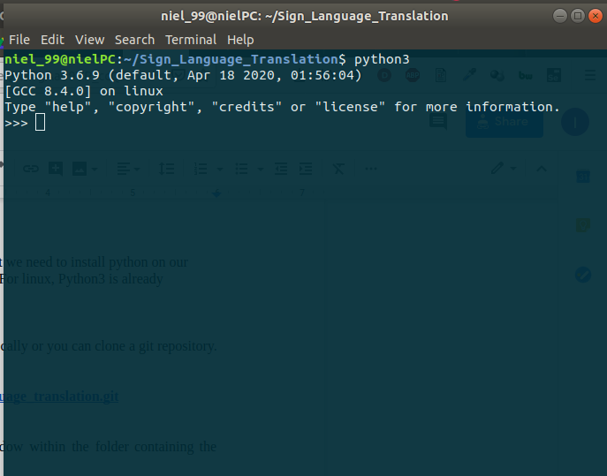

2. **Getting the repo**:

For this either you can have the code folder locally or you can clone a git repository. For cloning the git repository use-

**git clone** [**https://github.com/niel99/sign_language_translation.git**](https://github.com/niel99/sign_language_translation.git)

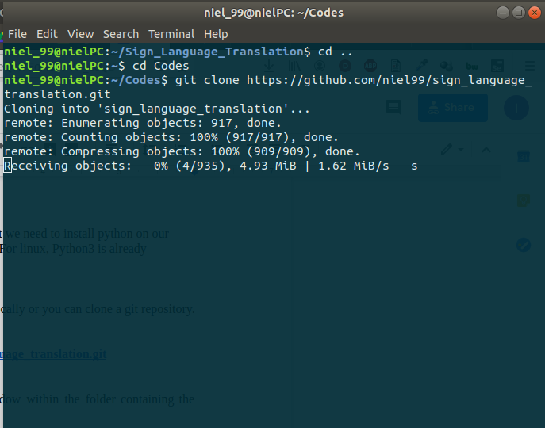

**Or you can also download from here: https://drive.google.com/drive/folders/1cgvy3ZptxY6iFg6BB0zan_75FPl4crTT**

3. **Getting the required packages**:

For this step, open your command line window within the folder containing the codes and then run the following command-

**pip install -r requirement.txt(Windows)**

**pip3 install -r requirement.txt(Linux)**

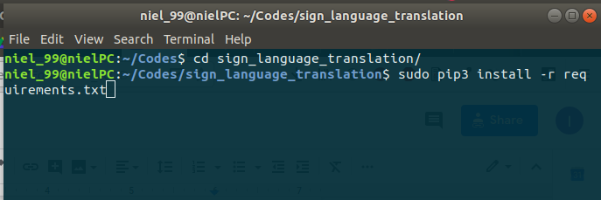

4. **For using the system:**

python3 prototype.py

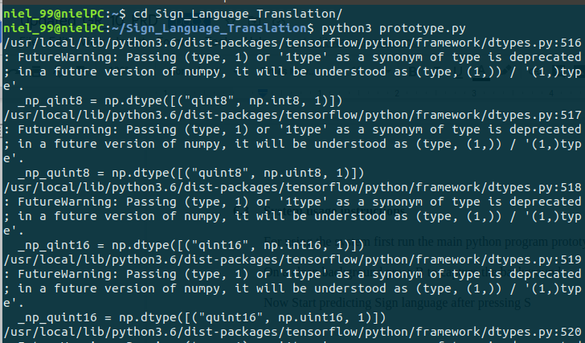

5. **On a clean background press B to capture the background**

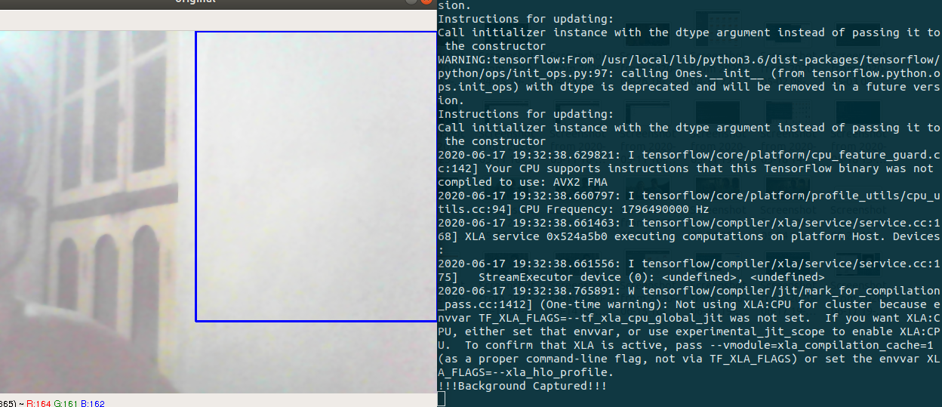

6.  **Now Start predicting Sign language after pressing S**

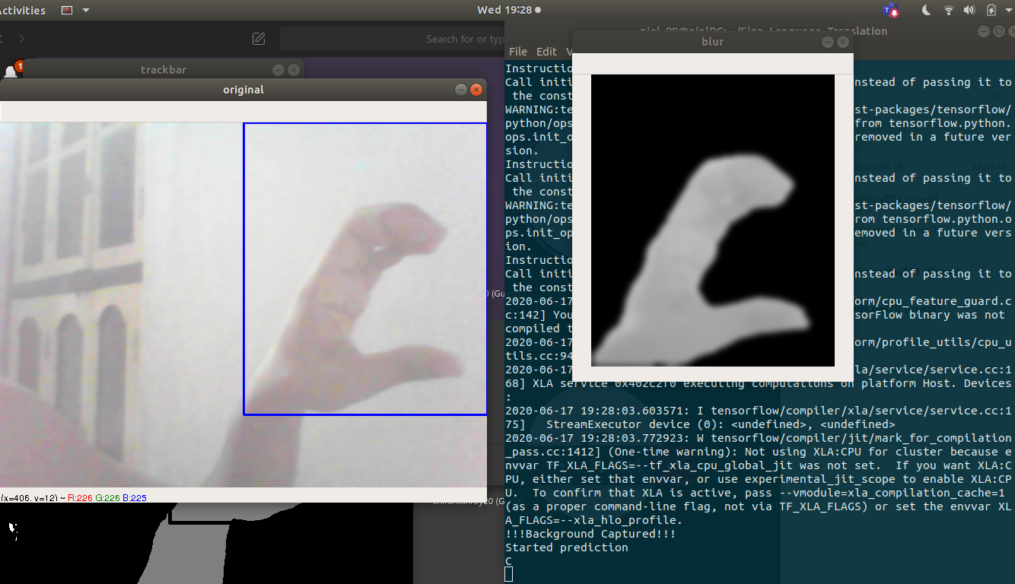

7. **Now to Quit the program press Q**

