SOFTWARE TESTING AND QUALITY ASSURANCE (STQA)
MINI PROJECT REPORT

on

Gym Management System
Web Application Testing using Python unittest Selenium IDE and Selenium WebDriver

Submitted by
Niel Mandhare (BC238)
Swanand Mukhavar (BC240)
Shruti Kokil (BC230)

Under the guidance of
Prof. Jagruti Wagh

Department of Computer Engineering
Marathwada Mitra Mandal's College of Engineering
Academic Year: 2026 – 27
Table of Contents
Project Details 4
Theory 5
Introduction of Mini Project 5
Testing Tool: PyUnit (unittest) 5
Testing Tool: Selenium IDE 6
Testing Approach Used in the Gym Management System 6
1 TEST PLAN 8
1.1 TEST STRATEGY 8
1.2 TESTING ENVIRONMENT 9
1.3 RISK AND ISSUES 9
2 TEST OBJECTIVE 9
3 TEST CRITERIA 10
3.1 Entry Criteria 10
3.2 Suspension Criteria 10
3.3 Exit Criteria 10
4 RESOURCE PLANNING 10
5 TEST TOOLS 11
6 TEST CASES 12
6.1 Selenium IDE Test Cases 12
6.2 Unit Test Cases 16
6.3 Integration Test Cases 19
6.4 White-box Test Mapping 20
6.5 Manual User-Interface Checks 22
6.6 Build and Static Check Test Cases 22
7 TEST EXECUTION 24
8 SCREENSHOT EVIDENCE 25
8.1 Application Screens 25
8.2 Test Execution 26
9 HISTORICAL TEST RESULTS 27
10 DEFECT REPORT AND RETESTING 28
10.1 Failed Test Cases 28
10.2 Defect Log 30
10.3 Defect Retesting 32
11 REGRESSION TESTING 33
12 HISTORICAL TEST SUMMARY AND ACCEPTANCE 34
13 LIMITATIONS AND FUTURE ENHANCEMENTS 35
13.1 Limitations 35
13.2 Future Enhancements 35
14 INITIAL TESTING CONCLUSION 36
15 REFERENCES / PROJECT ARTIFACTS 36
16 Selenium WebDriver Testing and Final Verification 37
16.1 Objectives and Test Environment 37
16.2 Automation Design and Execution Procedure 37
16.3 Functional Test Cases and Actual Results 38
16.4 Execution Summary and Regression Results 41
16.5 Defects and Automation Retests 42
16.6 Browser Evidence 43
Member Validation and Deletion Evidence 44
Trainer and Customer Evidence 45
Dashboard and Access Control Evidence 46
16.7 Deliverables and Reproducibility 47
16.8 Final Browser Testing Conclusion 47
16.9 WebDriver References 47

Project Details
Execution stages: Sections 1 to 15 retain the earlier PyUnit and Selenium IDE work. Section 16 records the final Chrome WebDriver completion run on 23 October 2026: 30 executed, 30 passed, no failures, errors or skips. Historical counts are separate and are not added to these results.
Title: Create and test a web-based Gym Management System by defining relevant test scenarios, preparing automated unit, white-box, integration, Selenium IDE (user-interface) and regression tests, identifying defects, and generating test execution reports using Python PyUnit (unittest) and Selenium IDE.
Problem Definition: Small gyms often keep member records on paper or in spreadsheets. This causes duplicate entries, invalid phone numbers and emails, wrong membership dates and difficulty in finding expired memberships. A simple web application with validated input can reduce these problems, and it needs systematic testing to show that its rules are enforced correctly and that changes do not break existing behaviour.
Prepared By:
Roll No. | Name
BC238 | Niel Mandhare
BC240 | Swanand Mukhavar
BC230 | Shruti Kokil

Prerequisite: Basic knowledge of web applications, REST APIs and SQL; basic knowledge of Python and the unittest module; Google Chrome or Firefox with the Selenium IDE extension; a free Supabase account (a separate project for testing is recommended).
Software Requirements:
- Node.js 20 or later (22 used)
- Python 3.11.15; Selenium 4.51.0 for browser testing
- Next.js 16.4.2 (App Router), TypeScript and Tailwind CSS 4
- Supabase PostgreSQL and Supabase Auth (@supabase/supabase-js)
- Python unittest (PyUnit) and urllib.request for HTTP tests
- Browser automation with Selenium IDE and Selenium WebDriver
- Visual Studio Code
- Google Chrome for Selenium IDE and WebDriver

Hardware Requirement: Any modern dual-core processor, 4 GB RAM or more, about 1 GB of disk space (mostly node_modules), Windows 10/11, Linux or macOS (developed on Windows 11), and internet access for Supabase.

Theory

Introduction of Mini Project
The Gym Management System is a web application used as the application under test for this Software Testing and Quality Assurance (STQA) mini project. It is built with Next.js, TypeScript and Tailwind CSS and stores its data in a Supabase PostgreSQL database. It provides a dashboard (total members, active members, expired memberships, total trainers and the five most recent members), member management (list, search by name or email, add, view, edit and delete after confirmation), trainer management (list, add and delete), user-account management and three membership plans: Monthly, Quarterly and Yearly (Rs. 1000, Rs. 2700 and Rs. 9600, demonstration values).
Users log in with an email and password through Supabase Auth, and each account has one role. Anyone can register, and a new account is always a customer; only an admin can change a role. A customer or trainer account is linked to the gym record that has the same email address.
Role | Permissions | Pages
Admin | Manage members, trainers, user accounts and roles | Dashboard, Members, Trainers, Users, My Profile, Plans
Trainer | Read dashboard, members and own trainer record (no changes) | Dashboard, Members (view only), My Profile, Plans
Customer | Read only their own membership | My Membership, Plans

Business rule for membership status. Status is not stored. It is calculated from the end date: a membership is Active if end_date >= today and Expired otherwise, so a membership whose end date is today is still Active. Access is controlled at three layers: the pages (proxy.ts and the navigation hide pages a role cannot use), the API (every route calls requireAuth(action) and returns 401 or 403) and the database (Row Level Security policies apply to the logged-in user).

Testing Tool: PyUnit (unittest)
PyUnit is the unittest module in Python's standard library. It is used to write, organise and run the automated unit and integration tests of this project. Unit and white-box tests run against a Python reference implementation of the documented rules (tests/reference_rules.py), because PyUnit cannot import TypeScript. Integration tests send real HTTP requests to the running Next.js application with urllib.request, so they exercise the actual application. The user interface is tested separately with Selenium IDE.
Element | Use in this project
unittest.TestCase | One class per subject (status, dates, plan, phone, email, name, member input)
assert* methods | Compare actual and expected values
assertRaises | Check that invalid input raises an error
subTest | Report each value in a small loop separately
setUpClass / SkipTest | Skip HTTP tests safely when the environment is not configured
tearDown | Delete test records created by the test
Discovery (discover -s ... -p ...) | Finds test files by pattern
-v | Prints one line per test, which gives readable evidence

Testing Tool: Selenium IDE
Selenium IDE is a record-and-playback tool for automated testing of web applications. It is installed as an extension in Google Chrome or Mozilla Firefox. A test is a list of commands; each command has a target (a locator such as css=, xpath= or name=) and an optional value. Selenium IDE runs the commands in a real browser against the running application at http://localhost:3000, so it checks the pages as a user sees them. In this project it replaces the earlier black-box API suite: 67 user-interface test cases (TC001 to TC067) were written in one Selenium IDE project and executed with Run all tests, and the log of that run is the evidence for Section 6.1.
Command | Use in this project
open | Opens a page such as /login, /register, /members or /members/new
setWindowSize | Fixes the browser window at 1280x900 so the layout is the same in every test
click | Clicks buttons and links (Log in, Register, sidebar links, Add member, Log out)
executeScript | Types values into the React-controlled form fields and reads window.location.pathname
executeAsyncScript | Calls POST /api/auth/logout at the start of every test so that each test begins logged out
waitForElementVisible | Waits up to 15 s for a form, heading, card or error message to appear
assertTitle / assertText | Checks the page title and the visible text of headings, buttons, links and labels
assertElementPresent | Checks that a field or control exists (for example name=email)
assert | Compares a stored value (the current path) with the expected path

Testing Approach Used in the Gym Management System
- Unit testing of each business rule in isolation, with fixed data and a fixed current date (2025-06-15).
- White-box (branch-oriented) testing: tests chosen so that both outcomes of each internal condition are exercised.
- Automated user-interface testing with Selenium IDE: login and registration pages, form validation messages, redirects for anonymous visitors, the admin dashboard, sidebar navigation and the Members pages, run in a real browser.
- Integration testing of API routes, server validation, the service layer and Supabase working together.
- Regression testing by re-running all suites after every change to validation or API code.
- Manual user-interface checks in the browser, recorded separately from the automated counts.

1 TEST PLAN
The Test Plan defines the testing approach, resources, test environment, scope, execution strategy and expected deliverables for testing the Gym Management System. It provides a structured method for verifying the membership business rules, input validation, member CRUD operations through the API, database persistence, error handling, role-based access and regression safety.

1.1 TEST STRATEGY
1.1.1 Scope of Testing
- Login, registration, logout and role-based access (admin, trainer, customer).
- Membership status calculation from the end date.
- Phone, email, name, plan and date validation.
- Member create, read, update, delete and list through the API.
- Duplicate, invalid and non-existent record handling.
- Role permissions and password and registration rules.
- User-interface behaviour of the login, registration, dashboard and Members pages (Selenium IDE).
1.1.2 Features to be Tested
Module | Feature | Testing Focus
Membership rules | Status calculation | Active when end_date >= today, Expired otherwise, including the boundary when end date equals today.
Validation | Member input | Reject blank names, invalid emails, phones that are not exactly 10 digits, unsupported plans and end dates earlier than start dates.
Members API | CRUD workflow | Create, retrieve, update, list, search and delete members, with 400, 404 and 409 errors where required.
Authentication | Login / logout | Valid and invalid login, session creation in httpOnly cookies, logout ending the session.
Authorization | Role permissions | 401 for anonymous visitors and 403 for roles that are not allowed (trainer, customer).
Registration | Account rules | Password length 8–72 characters, valid email, non-blank name; new accounts are customers.
User interface | Pages and navigation | Login and registration forms, validation messages, redirects to /login, dashboard cards, sidebar links and Members pages, tested in the browser with Selenium IDE.
1.1.3 Test Types
- Unit Testing
- White-box (Branch-oriented) Testing
- Selenium IDE (Automated UI) Testing
- Integration Testing
- Regression Testing
- Manual UI Checks
1.1.4 Features not Tested
Trainer API (manual only), password reset and email verification (not implemented), performance, load and penetration testing, accessibility and cross-browser compatibility (Selenium IDE tests were run in one browser only). Token signing and password hashing are Supabase's responsibility and are not tested.

1.2 TESTING ENVIRONMENT
Item | Environment / Tool
Operating Environment | Windows 11
Runtime | Node.js 22
Application Framework | Next.js 16.4.2 (App Router), TypeScript, Tailwind CSS 4
Database | Supabase PostgreSQL with Row Level Security
Authentication | Supabase Auth (email + password)
Test Language | Python 3.11.15
Test Framework | unittest (PyUnit), urllib.request
UI Test Tool | Selenium IDE and Selenium WebDriver; Chrome at 1280x900
Development Environment | Visual Studio Code
Application URL | http://localhost:3000

1.3 RISK AND ISSUES
Risk | Impact / Issue | Mitigation
Python and TypeScript rules differ | Unit tests check a Python reference implementation, not the TypeScript code itself. | HTTP integration tests and Selenium IDE user-interface tests check the real application behaviour.
Tests write to a real database | Test records could be left behind or mix with real data. | Opt-in flag, local-server guard, separate test project, and each test deletes only its own records.
Cleanup fails | Leftover @gymtest.example records. | tearDown fails loudly and prints the IDs to remove by hand.
Environment not configured | HTTP suites cannot reach the server or log in. | The suites are skipped with a reason; a skip is never counted as a pass.
UI tests depend on text, locators and timing | A changed label or a slow page makes a Selenium IDE test fail even when the feature works. | Stable locators (name, href, role), waitForElementVisible with a 15 s timeout, and every failure is analysed before it is reported as an application defect.

2 TEST OBJECTIVE
The main objective of the project is to build a simple Gym Management System with member and trainer CRUD operations and to verify it using STQA techniques. The project enforces input validation on both the server and the database, applies unit, white-box, integration, Selenium IDE (user-interface) and regression testing, uses PyUnit (unittest) and Selenium IDE to automate the tests and produce readable execution reports, records defects, fixes them and retests, and prepares a report containing only genuine test evidence.

3 TEST CRITERIA

3.1 Entry Criteria
- The application builds and lints without errors.
- The database schema (supabase/schema.sql) has been applied.
- .env.local points to the test Supabase project.
- The server is running (for the HTTP tests) and the admin test account exists.
- Selenium IDE is installed in the browser and the admin test account can log in (for the user-interface tests).

3.2 Suspension Criteria
- The application server or the Supabase project is unavailable, so the HTTP suites cannot run.
- The admin test account cannot log in, so the protected API cannot be tested.
- A blocking defect (for example a failing production build) prevents execution of most planned tests.

3.3 Exit Criteria
- All planned tests have been executed, or marked Not Run with a reason.
- There are no unresolved critical defects.
- Evidence files exist for every reported result (test-results/ folder).
- The final test report is generated and reviewed.

4 RESOURCE PLANNING
Resource | Requirement | Purpose
Hardware | Computer / Laptop | Development, application execution and automated testing
Software | Node.js + Python 3 + browser with Selenium IDE | Application runtime and test environment
Database | Supabase project (test) | Persistent storage, authentication and Row Level Security
Automation | PyUnit (unittest) + urllib | Automated unit and integration tests
UI automation | Selenium IDE and Selenium WebDriver | Historical IDE cases and final functional Chrome cases WD01 to WD30
Application | Gym Management System | System under test
Documentation | Test plan, test cases, test-results files, screenshots | Evidence and final submission

5 TEST TOOLS
Tool | Purpose
Python unittest (PyUnit) | Test framework used to write, discover, run and report all automated tests.
urllib.request | Sends real HTTP requests to the running Next.js API in the integration tests.
Selenium IDE | Records and plays back browser tests; runs the 67 user-interface test cases (TC001 to TC067) and logs the result of every command.
scripts/run_tests.py | Runs a suite and saves the real console output, counts and exit code in test-results/.
Next.js / npm scripts | npm run dev, npm run lint, npm run typecheck and npm run build for running and static checks.
Supabase | Hosts the PostgreSQL test database and Supabase Auth used by the application.
Visual Studio Code | Editor and terminal used to run the tests and capture the evidence.
Selenium WebDriver and ChromeDriver | Runs the 30 functional browser cases in Chrome using the Python Selenium package; saves results and screenshots.

6 TEST CASES
The project contains 149 automated test cases – 68 unit (UT-01 to UT-68), 14 integration (IT-01 to IT-14) and 67 Selenium IDE user-interface tests (TC001 to TC067) – plus 40 white-box branch mappings (WB-01 to WB-40) that reuse the unit, integration and Selenium IDE tests, and 15 manual user-interface checks (UI-01 to UI-15). In every table, "Expected Result" is the planned behaviour and "Actual Result" is what was observed. 148 automated tests were executed: 132 passed and 16 failed. TC067 was not completed because the Selenium IDE run was stopped while it was running. The failed cases (UT-65 to UT-68, IT-13 to IT-14 and ten Selenium IDE cases) are linked to open or deferred defects D-05 to D-09, D-13 and D-14. Of the manual checks, UI-13 to UI-15 were performed and failed (defects D-10 to D-12), and UI-01 to UI-12 are Not Run.

6.1 Selenium IDE Test Cases
The Selenium IDE project contains 67 test cases (TC001 to TC067) that drive the running application in the browser at http://localhost:3000. Every test begins with the same setup so that the tests do not depend on each other: setWindowSize 1280x900, open /login, call POST /api/auth/logout with executeAsyncScript, open /login again and waitForElementVisible css=form (15 s). From TC031 onwards the test then logs in as the admin test account ("Log in as admin": executeScript types the email and password, click Log in, waitForElementVisible css=nav). Values are typed with executeScript because the form fields are React-controlled. The Test Steps column lists only the commands after this setup. The suite was executed once with Run all tests: 66 tests completed (56 passed, 10 failed) and the run was stopped during TC067, which is recorded as Not Run. The Actual Result column is copied from the Selenium IDE log.
TC ID | Test Objective | Test Steps | Expected Result | Actual Result | Status
TC001 | Login page has the correct browser title | assertTitle | Page title is "Gym Management System" | As expected – all commands OK | Passed
TC002 | Login page shows the GymManager heading | assertText css=h1 | Heading reads "GymManager" | As expected – all commands OK | Passed
TC003 | Login page shows the subtitle | assertText css=h2 | Subtitle reads "Log in to your account" | As expected – all commands OK | Passed
TC004 | Login button is labelled Log in | assertText css=button[type='submit'] | Button reads "Log in" | As expected – all commands OK | Passed
TC005 | Login page has an email field | assertElementPresent name=email | Email field is present | As expected – all commands OK | Passed
TC006 | Login page has a password field | assertElementPresent name=password | Password field is present | As expected – all commands OK | Passed
TC007 | Password field hides its text | assertElementPresent css=input[name='password'][type='password'] | Password input has type=password | As expected – all commands OK | Passed
TC008 | Login page links to registration | assertText xpath=//a[@href='/register'] | Link reads "Create an account" | As expected – all commands OK | Passed
TC009 | Empty login shows the email error | click Log in with empty fields; waitForElementVisible error span | "Enter a valid email address" is shown | As expected – all commands OK | Passed
TC010 | Empty login shows the password error | click Log in with empty fields; waitForElementVisible error span | "Password is required" is shown | As expected – all commands OK | Passed
TC011 | Badly formed email is rejected | Type email "not-an-email"; click Log in; waitForElementVisible error span | "Enter a valid email address" is shown | As expected – all commands OK | Passed
TC012 | Wrong password shows an alert | Type admin email and password "WrongPass#999"; click Log in; waitForElementVisible css=[role='alert'] | Error alert is shown; user stays on /login | As expected – all commands OK | Passed
TC013 | Register page shows the customer subtitle | open /register, waitForElementVisible css=form. assertText css=h2 | Subtitle reads "Create a customer account" | As expected – all commands OK | Passed
TC014 | Register page has a full name field | open /register, waitForElementVisible css=form. assertElementPresent name=full_name | Full name field is present | As expected – all commands OK | Passed
TC015 | Register page has an email field | open /register, waitForElementVisible css=form. assertElementPresent name=email | Email field is present | As expected – all commands OK | Passed
TC016 | Register page has a password field | open /register, waitForElementVisible css=form. assertElementPresent name=password | Password field is present | As expected – all commands OK | Passed
TC017 | Register button says Register | open /register, waitForElementVisible css=form. assertText css=button[type='submit'] | Button reads "Register" | As expected – all commands OK | Passed
TC018 | Register page links back to login | open /register, waitForElementVisible css=form. assertText xpath=//a[@href='/login'] | Link reads "Log in" | As expected – all commands OK | Passed
TC019 | Empty registration shows the name error | open /register, waitForElementVisible css=form. click Register with empty fields | "Full name is required (max 100 characters)" is shown | As expected – all commands OK | Passed
TC020 | Empty registration shows the email error | open /register, waitForElementVisible css=form. click Register with empty fields | "Enter a valid email address" is shown | As expected – all commands OK | Passed
TC021 | Short password is rejected | open /register, waitForElementVisible css=form. Type name "Test User", a valid email and password "abc"; click Register | "Password must be 8 to 72 characters" is shown | As expected – all commands OK | Passed
TC022 | Register link opens the register page | click the "Create an account" link; wait for name=full_name; read window.location.pathname | Path is /register | As expected – all commands OK | Passed
TC023 | Anonymous visitor to / is sent to login | open / while logged out; read the path | Redirected; path is /login | As expected – all commands OK | Passed
TC024 | Anonymous visitor to /members is sent to login | open /members while logged out; read the path | Redirected; path is /login | As expected – all commands OK | Passed
TC025 | Anonymous visitor to /members/new is sent to login | open /members/new while logged out; read the path | Redirected; path is /login | As expected – all commands OK | Passed
TC026 | Anonymous visitor to /trainers is sent to login | open /trainers while logged out; read the path | Redirected; path is /login | As expected – all commands OK | Passed
TC027 | Anonymous visitor to /users is sent to login | open /users while logged out; read the path | Redirected; path is /login | As expected – all commands OK | Passed
TC028 | Anonymous visitor to /me is sent to login | open /me while logged out; read the path | Redirected; path is /login | As expected – all commands OK | Passed
TC029 | Anonymous visitor to /plans is sent to login | open /plans while logged out; read the path | Redirected; path is /login | As expected – all commands OK | Passed
TC030 | Login link on register returns to login | open /register, waitForElementVisible css=form. click the "Log in" link; read the path | Path is /login | As expected – all commands OK | Passed
TC031 | Admin login lands on the dashboard | Log in as admin; Wait for h1 "Dashboard"; read the path | Dashboard shown; path is / | As expected – all commands OK | Passed
TC032 | Admin sidebar shows the admin role | Log in as admin; assertText on the role label in the sidebar | Role label reads "admin" | assertText failed: actual value "Admin" did not match "admin". Defect D-13 | Failed
TC033 | Admin sidebar shows the GymManager name | Log in as admin; Check the app name in the sidebar | Sidebar shows "GymManager" | Setup step 5 failed: waitForElementVisible css=form timed out ("Unable to locate element within the timeout provided"); the check was not reached. Defect D-14 | Failed
TC034 | Dashboard shows the Total members card | Log in as admin; Wait for the "Total members" card | "Total members" card is shown | Setup step 5 failed: waitForElementVisible css=form timed out ("Unable to locate element within the timeout provided"); the check was not reached. Defect D-14 | Failed
TC035 | Dashboard shows the Active members card | Log in as admin; waitForElementVisible p "Active members" | "Active members" card is shown | As expected – all commands OK | Passed
TC036 | Dashboard shows the Expired memberships card | Log in as admin; waitForElementVisible p "Expired memberships" | "Expired memberships" card is shown | As expected – all commands OK | Passed
TC037 | Dashboard shows the Total trainers card | Log in as admin; waitForElementVisible p "Total trainers" | "Total trainers" card is shown | As expected – all commands OK | Passed
TC038 | Dashboard shows the Recent members section | Log in as admin; waitForElementVisible h2 "Recent members" | "Recent members" section is shown | As expected – all commands OK | Passed
TC039 | Dashboard subtitle is shown | Log in as admin; Check the dashboard subtitle | Subtitle is shown under the heading | Setup step 5 failed: waitForElementVisible css=form timed out ("Unable to locate element within the timeout provided"); the check was not reached. Defect D-14 | Failed
TC040 | Dashboard has an Add member button | Log in as admin; Check for the Add member link | "Add member" button is shown | Setup step 5 failed: waitForElementVisible css=form timed out ("Unable to locate element within the timeout provided"); the check was not reached. Defect D-14 | Failed
TC041 | Add member button opens the form | Log in as admin; click "Add member" on the dashboard; wait for h1 "Add Member" | Add Member form opens | As expected – all commands OK | Passed
TC042 | Logged-in admin visiting /login goes to the dashboard | Log in as admin; open /login; read the path | Redirected to the dashboard (/) | Setup step 5 failed: waitForElementVisible css=form timed out ("Unable to locate element within the timeout provided"); the check was not reached. Defect D-14 | Failed
TC043 | Logged-in admin visiting /register goes to the dashboard | Log in as admin; open /register; read the path | Redirected to the dashboard (/) | Setup step 5 failed: waitForElementVisible css=form timed out ("Unable to locate element within the timeout provided"); the check was not reached. Defect D-14 | Failed
TC044 | Admin logout returns to the login page | Log in as admin; click "Log out" in the sidebar; wait for css=form; read the path | Logged out; path is /login | As expected – all commands OK | Passed
TC045 | Admin sidebar has the Dashboard link | Log in as admin; assertText xpath=//nav//a[@href='/'] | Link reads "Dashboard" | As expected – all commands OK | Passed
TC046 | Admin sidebar has the Members link | Log in as admin; assertText xpath=//nav//a[@href='/members'] | Link reads "Members" | As expected – all commands OK | Passed
TC047 | Admin sidebar has the Trainers link | Log in as admin; assertText xpath=//nav//a[@href='/trainers'] | Link reads "Trainers" | As expected – all commands OK | Passed
TC048 | Admin sidebar has the Users link | Log in as admin; assertText on the /users link | Link reads "Users" | Setup step 5 failed: waitForElementVisible css=form timed out ("Unable to locate element within the timeout provided"); the check was not reached. Defect D-14 | Failed
TC049 | Admin sidebar has the My Profile link | Log in as admin; assertText xpath=//nav//a[@href='/me'] | Link reads "My Profile" | As expected – all commands OK | Passed
TC050 | Admin sidebar has the Plans link | Log in as admin; assertText xpath=//nav//a[@href='/plans'] | Link reads "Plans" | As expected – all commands OK | Passed
TC051 | Admin can open Members from the sidebar | Log in as admin; click the Members link; wait for h1 "Members"; read the path | Members page; path is /members | As expected – all commands OK | Passed
TC052 | Admin can open Trainers from the sidebar | Log in as admin; click the Trainers link; wait for h1 "Trainers"; read the path | Trainers page; path is /trainers | As expected – all commands OK | Passed
TC053 | Admin can open Users from the sidebar | Log in as admin; click the Users link; wait for h1 "Users"; read the path | Users page; path is /users | As expected – all commands OK | Passed
TC054 | Admin can open Membership Plans from the sidebar | Log in as admin; click the Plans link; wait for h1 "Membership Plans"; read the path | Plans page; path is /plans | As expected – all commands OK | Passed
TC055 | Admin can open My Profile from the sidebar | Log in as admin; click the My Profile link; wait for h1 "My Profile"; read the path | Profile page; path is /me | As expected – all commands OK | Passed
TC056 | Admin Log out button is in the sidebar | Log in as admin; Check for the Log out button in the sidebar | "Log out" button is shown | Setup step 5 failed: waitForElementVisible css=form timed out ("Unable to locate element within the timeout provided"); the check was not reached. Defect D-14 | Failed
TC057 | Members page has a subtitle | Log in as admin; open /members; check the subtitle | Subtitle is shown under the heading | Setup step 5 failed: waitForElementVisible css=form timed out ("Unable to locate element within the timeout provided"); the check was not reached. Defect D-14 | Failed
TC058 | Members page has a search box | Log in as admin; open /members; assertElementPresent input[aria-label='Search members'] | Search box is present | As expected – all commands OK | Passed
TC059 | Search box has a placeholder | Log in as admin; open /members; assertElementPresent search box with its placeholder | Placeholder reads "Search by name or email" | As expected – all commands OK | Passed
TC060 | Members page has an Add member button | Log in as admin; open /members; assertElementPresent xpath=//a[@href='/members/new'] | "Add member" link is present | As expected – all commands OK | Passed
TC061 | Searching for nonsense shows the empty state | Log in as admin; open /members; type a search text that matches no member | "No members match your search" is shown | As expected – all commands OK | Passed
TC062 | Empty state suggests a different search | Log in as admin; open /members; type a search text that matches no member | "Try a different name or email." is shown | As expected – all commands OK | Passed
TC063 | Add member button on members page opens the form | Log in as admin; open /members; click "Add member"; wait for h1 "Add Member" | Add Member form opens | As expected – all commands OK | Passed
TC064 | Admin can open the Members page directly | Log in as admin; open /members; read the path | Members page; path is /members | As expected – all commands OK | Passed
TC065 | Add member page shows its subtitle | Log in as admin; open /members/new; waitForElementVisible p "Register a new gym member" | Subtitle "Register a new gym member" is shown | As expected – all commands OK | Passed
TC066 | Add member form has the full_name field | Log in as admin; open /members/new; assertElementPresent name=full_name | Full name field is present | As expected – all commands OK | Passed
TC067 | Add member form has the email field | Log in as admin; open /members/new; assertElementPresent name=email | Email field is present | Not completed – the run was stopped (Aborting) while step 5 was running; result Undetermined | Not Run

6.2 Unit Test Cases
Files: tests/unit/test_unit_membership.py (UT-01 to UT-16), tests/unit/test_unit_validation.py (UT-17 to UT-43) and tests/unit/test_unit_auth.py (UT-44 to UT-64: role permissions, password rule, registration validation). All tests use fixed data, and the "current date" is fixed at 2025-06-15. The Actual Result and Status columns were taken from the saved output test-results/unit-tests.txt. The row "UT-41 (first run)" records the one unit-test failure observed during development (defect D-01); the UT-41 row below it is the retest after the fix.
TC ID | Test Objective | Test Steps | Expected Result | Actual Result | Status
UT-01 | End date in future is active | Run test_​UT01_​end_​date_​in_​future_​is_​active | Active | As expected | Passed
UT-02 | End date in past is expired | Run test_​UT02_​end_​date_​in_​past_​is_​expired | Expired | As expected | Passed
UT-03 | End date equal to today is active boundary | Run test_​UT03_​end_​date_​equal_​to_​today_​is_​active_​boundary | Active (end date itself is Active) | As expected | Passed
UT-04 | Day after end date is expired boundary | Run test_​UT04_​day_​after_​end_​date_​is_​expired_​boundary | Expired | As expected | Passed
UT-05 | Invalid range raises error | Run test_​UT05_​invalid_​range_​raises_​error | ValueError raised | As expected | Passed
UT-06 | Invalid current date raises error | Run test_​UT06_​invalid_​current_​date_​raises_​error | ValueError raised | As expected | Passed
UT-07 | End date before start date is rejected | Run test_​UT07_​end_​date_​before_​start_​date_​is_​rejected | Error message returned | As expected | Passed
UT-08 | End date equal to start date is accepted | Run test_​UT08_​end_​date_​equal_​to_​start_​date_​is_​accepted | No error | As expected | Passed
UT-09 | End date after start date is accepted | Run test_​UT09_​end_​date_​after_​start_​date_​is_​accepted | No error | As expected | Passed
UT-10 | Malformed date is rejected | Run test_​UT10_​malformed_​date_​is_​rejected | Rejected /​ error message | As expected | Passed
UT-11 | Impossible calendar date is rejected | Run test_​UT11_​impossible_​calendar_​date_​is_​rejected | Rejected | As expected | Passed
UT-12 | Leap day is accepted only in leap year | Run test_​UT12_​leap_​day_​is_​accepted_​only_​in_​leap_​year | 2024-02-29 valid,​ 2025-02-29 invalid | As expected | Passed
UT-13 | Each supported plan is accepted | Run test_​UT13_​each_​supported_​plan_​is_​accepted | All three accepted | As expected | Passed
UT-14 | Unsupported plan is rejected | Run test_​UT14_​unsupported_​plan_​is_​rejected | Rejected | As expected | Passed
UT-15 | Plan is case sensitive | Run test_​UT15_​plan_​is_​case_​sensitive | Rejected | As expected | Passed
UT-16 | Empty or non string plan is rejected | Run test_​UT16_​empty_​or_​non_​string_​plan_​is_​rejected | All rejected | As expected | Passed
UT-17 | Valid ten digit phone is accepted | Run test_​UT17_​valid_​ten_​digit_​phone_​is_​accepted | Accepted | As expected | Passed
UT-18 | Phone with letters is rejected | Run test_​UT18_​phone_​with_​letters_​is_​rejected | Rejected | As expected | Passed
UT-19 | Phone shorter than ten digits is rejected | Run test_​UT19_​phone_​shorter_​than_​ten_​digits_​is_​rejected | Rejected | As expected | Passed
UT-20 | Phone longer than ten digits is rejected | Run test_​UT20_​phone_​longer_​than_​ten_​digits_​is_​rejected | Rejected | As expected | Passed
UT-21 | Phone with spaces or symbols is rejected | Run test_​UT21_​phone_​with_​spaces_​or_​symbols_​is_​rejected | Both rejected | As expected | Passed
UT-22 | Empty or non string phone is rejected | Run test_​UT22_​empty_​or_​non_​string_​phone_​is_​rejected | All rejected | As expected | Passed
UT-23 | Non ascii digits are rejected | Run test_​UT23_​non_​ascii_​digits_​are_​rejected | Rejected | As expected | Passed
UT-24 | Valid email is accepted | Run test_​UT24_​valid_​email_​is_​accepted | Accepted | As expected | Passed
UT-25 | Email without at sign is rejected | Run test_​UT25_​email_​without_​at_​sign_​is_​rejected | Rejected | As expected | Passed
UT-26 | Email without domain dot is rejected | Run test_​UT26_​email_​without_​domain_​dot_​is_​rejected | Rejected | As expected | Passed
UT-27 | Email with whitespace is rejected | Run test_​UT27_​email_​with_​whitespace_​is_​rejected | Rejected | As expected | Passed
UT-28 | Email with empty domain label is rejected | Run test_​UT28_​email_​with_​empty_​domain_​label_​is_​rejected | Both rejected | As expected | Passed
UT-29 | Empty or non string email is rejected | Run test_​UT29_​empty_​or_​non_​string_​email_​is_​rejected | Both rejected | As expected | Passed
UT-30 | Overlong email is rejected | Run test_​UT30_​overlong_​email_​is_​rejected | Rejected | As expected | Passed
UT-31 | Nonblank name is accepted | Run test_​UT31_​nonblank_​name_​is_​accepted | Accepted | As expected | Passed
UT-32 | Empty name is rejected | Run test_​UT32_​empty_​name_​is_​rejected | Rejected | As expected | Passed
UT-33 | Whitespace only name is rejected | Run test_​UT33_​whitespace_​only_​name_​is_​rejected | Rejected | As expected | Passed
UT-34 | Overlong name is rejected | Run test_​UT34_​overlong_​name_​is_​rejected | Rejected | As expected | Passed
UT-35 | Missing name is rejected | Run test_​UT35_​missing_​name_​is_​rejected | Rejected | As expected | Passed
UT-36 | Correct member data is accepted | Run test_​UT36_​correct_​member_​data_​is_​accepted | Accepted,​ no errors | As expected | Passed
UT-37 | Blank name makes member invalid | Run test_​UT37_​blank_​name_​makes_​member_​invalid | Only full_​name reported | As expected | Passed
UT-38 | Unsupported plan makes member invalid | Run test_​UT38_​unsupported_​plan_​makes_​member_​invalid | Only membership_​plan reported | As expected | Passed
UT-39 | End before start makes member invalid | Run test_​UT39_​end_​before_​start_​makes_​member_​invalid | Only end_​date reported | As expected | Passed
UT-40 | Bad phone and email are both reported | Run test_​UT40_​bad_​phone_​and_​email_​are_​both_​reported | email and phone reported | As expected | Passed
UT-41 (first run) | Missing required fields are all reported | Run test_​UT41_​missing_​required_​fields_​are_​all_​reported | All six fields reported | Only five fields reported (end_​date missing). Console: Ran 43 tests – FAILED (failures=​1). Defect D-01 raised | Failed
UT-41 | Missing required fields are all reported | Run test_​UT41_​missing_​required_​fields_​are_​all_​reported | All six fields reported | As expected (retest after the D-01 fix) | Passed
UT-42 | Malformed request body is rejected | Run test_​UT42_​malformed_​request_​body_​is_​rejected | _​form error for every non-object body | As expected | Passed
UT-43 | Surrounding spaces in email and phone are trimmed | Run test_​UT43_​surrounding_​spaces_​in_​email_​and_​phone_​are_​trimmed | Accepted | As expected | Passed
UT-44 | Admin can perform every action | Run test_​UT44_​admin_​can_​perform_​every_​action | All seven actions allowed | As expected | Passed
UT-45 | Trainer can read members trainers and dashboard | Run test_​UT45_​trainer_​can_​read_​members_​trainers_​and_​dashboard | All four actions allowed | As expected | Passed
UT-46 | Trainer cannot write members | Run test_​UT46_​trainer_​cannot_​write_​members | Denied | As expected | Passed
UT-47 | Trainer cannot write trainers | Run test_​UT47_​trainer_​cannot_​write_​trainers | Denied | As expected | Passed
UT-48 | Trainer cannot manage users | Run test_​UT48_​trainer_​cannot_​manage_​users | Denied | As expected | Passed
UT-49 | Customer can only read own details | Run test_​UT49_​customer_​can_​only_​read_​own_​details | Only me:read allowed | As expected | Passed
UT-50 | Customer cannot list members | Run test_​UT50_​customer_​cannot_​list_​members | Denied | As expected | Passed
UT-51 | Customer has no dashboard | Run test_​UT51_​customer_​has_​no_​dashboard | Denied | As expected | Passed
UT-52 | Unknown role has no permissions | Run test_​UT52_​unknown_​role_​has_​no_​permissions | Denied for every action | As expected | Passed
UT-53 | Missing or non string role has no permissions | Run test_​UT53_​missing_​or_​non_​string_​role_​has_​no_​permissions | Denied | As expected | Passed
UT-54 | Role names are valid only when exact | Run test_​UT54_​role_​names_​are_​valid_​only_​when_​exact | Exact role names valid; others invalid | As expected | Passed
UT-55 | Eight character password is accepted | Run test_​UT55_​eight_​character_​password_​is_​accepted | Accepted | As expected | Passed
UT-56 | Seven character password is rejected | Run test_​UT56_​seven_​character_​password_​is_​rejected | Rejected | As expected | Passed
UT-57 | Seventy two character password is accepted | Run test_​UT57_​seventy_​two_​character_​password_​is_​accepted | Accepted | As expected | Passed
UT-58 | Seventy three character password is rejected | Run test_​UT58_​seventy_​three_​character_​password_​is_​rejected | Rejected | As expected | Passed
UT-59 | Empty or non string password is rejected | Run test_​UT59_​empty_​or_​non_​string_​password_​is_​rejected | All rejected | As expected | Passed
UT-60 | Valid registration is accepted | Run test_​UT60_​valid_​registration_​is_​accepted | Accepted,​ no errors | As expected | Passed
UT-61 | Invalid email is reported | Run test_​UT61_​invalid_​email_​is_​reported | Only email reported | As expected | Passed
UT-62 | Short password is reported | Run test_​UT62_​short_​password_​is_​reported | Only password reported | As expected | Passed
UT-63 | Blank name is reported | Run test_​UT63_​blank_​name_​is_​reported | Only full_​name reported | As expected | Passed
UT-64 | Non object body is rejected | Run test_​UT64_​non_​object_​body_​is_​rejected | _​form error for every non-object body | As expected | Passed
UT-65 | Phone with +91 country code is accepted | Run test_​UT65_​phone_​with_​country_​code_​is_​accepted with is_​valid_​phone("+919876543210") | Accepted (Indian number with country code) | Rejected – only exactly 10 digits are allowed. Defect D-05 | Failed
UT-66 | Phone with a space between digit groups is accepted | Run test_​UT66_​phone_​with_​space_​is_​accepted with is_​valid_​phone("98765 43210") | Accepted after removing the space | Rejected – spaces are not removed before checking. Defect D-05 | Failed
UT-67 | End date must match the plan duration | Run test_​UT67_​end_​date_​must_​match_​plan with Monthly,​ start 2025-06-01,​ end 2027-06-01 | Error: end date does not match a Monthly plan | No error – only end_​date >=​ start_​date is checked. Defect D-06 | Failed
UT-68 | Customer can update own contact details | Run test_​UT68_​customer_​can_​update_​own_​details with can("customer",​ "me:write") | Allowed | Denied – customer has only me:read. Defect D-07 | Failed

6.3 Integration Test Cases
tests/integration/test_integration_members_api.py sends HTTP requests with urllib.request to the running Next.js server. A request passes through the API route, server-side validation, the service layer and Supabase, and the JSON response is checked. Every test uses a unique @gymtest.example email, and tearDown deletes only the records the test created. The suite ran 14 tests: 12 passed, 2 failed (IT-13 and IT-14), 0 errored, 0 skipped. IT-04 also served as the HTTP-level retest for defect D-01.
TC ID | Test Objective | Test Steps | Expected Result | Actual Result | Status
IT-01 | Create a valid member | Run test_​IT01_​create_​valid_​member | 201; fields echoed; status =​ Active; ID and created_​at present | As expected | Passed
IT-02 | Retrieve the new member | Run test_​IT02_​retrieve_​created_​member | 200; same ID and email | As expected | Passed
IT-03 | Update phone, plan, end date | Run test_​IT03_​update_​member_​details | 200; change persisted when read again | As expected | Passed
IT-04 | Invalid phone | Run test_​IT04_​reject_​invalid_​phone | 400 VALIDATION_​ERROR,​ field phone | As expected (retest for D-01 against the real application) | Passed
IT-05 | End before start | Run test_​IT05_​reject_​invalid_​date_​range | 400,​ field end_​date | As expected | Passed
IT-06 | Duplicate email (also upper case) | Run test_​IT06_​reject_​duplicate_​email | 409 DUPLICATE_​EMAIL | As expected | Passed
IT-07 | Delete member | Run test_​IT07_​delete_​member | 200 | As expected | Passed
IT-08 | Retrieve after delete | Run test_​IT08_​deleted_​member_​cannot_​be_​retrieved | 404 NOT_​FOUND | As expected | Passed
IT-09 | List and search | Run test_​IT09_​list_​members_​includes_​created_​member | 200; list contains the member; search by email prefix finds it | As expected | Passed
IT-10 | Log in as admin, call /api/auth/me | Run test_​IT10_​login_​creates_​session_​that_​identifies_​the_​admin | 200; role admin; no token in the JSON body | As expected | Passed
IT-11 | Log out, then call /api/auth/me | Run test_​IT11_​logout_​ends_​the_​session | 401 UNAUTHENTICATED | As expected | Passed
IT-12 | Admin lists users | Run test_​IT12_​admin_​can_​list_​users_​and_​sees_​own_​account | 200; list contains the admin's own ID; roles are valid | As expected | Passed
IT-13 | Customer with a different login email sees own membership | Run test_​IT13_​customer_​with_​different_​email_​sees_​membership (member stored as ravi.k@gymtest.example,​ login as ravi.kumar@gymtest.example) | 200; membership details returned | 200 with no member – page shows "No membership found". Defect D-08 | Failed
IT-14 | Login blocked until email is verified | Run test_​IT14_​login_​requires_​verified_​email (register,​ then log in at once) | Login refused until the email is confirmed | 200 – login succeeds without verification. Defect D-09 | Failed

6.4 White-box Test Mapping
The unit tests were chosen so that each condition takes both its true and false outcome. The code path is the condition in the TypeScript source (lib/business/membership.ts, lib/validation/member.ts, lib/auth); the unit tests run against the Python reference implementation of the same condition. These are branch-oriented tests; no coverage tool was run, so no coverage percentage is claimed.
WB ID | Condition / branch | Outcome | Code path | Test ID(s) | Status
WB-01 | Phone is a string of exactly 10 ASCII digits | True | isValidPhone | UT-17 | Passed
WB-02 | Phone contains non-digits | False | isValidPhone | UT-18, UT-21, UT-23 | Passed
WB-03 | Phone has fewer than 10 digits | False | isValidPhone | UT-19 | Passed
WB-04 | Phone has more than 10 digits | False | isValidPhone | UT-20 | Passed
WB-05 | Phone is empty or not a string | False | isValidPhone | UT-22 | Passed
WB-06 | Email matches pattern and length <= 254 | True | isValidEmail | UT-24 | Passed
WB-07 | Email has no @, no domain dot, whitespace or empty label | False | isValidEmail | UT-25, UT-26, UT-27, UT-28 | Passed
WB-08 | Email empty or not a string | False | isValidEmail | UT-29 | Passed
WB-09 | Email longer than 254 characters | False | isValidEmail | UT-30 | Passed
WB-10 | Name nonblank and <= 100 characters | True | isValidName | UT-31 | Passed
WB-11 | Name empty or whitespace only | False | isValidName | UT-32, UT-33 | Passed
WB-12 | Name longer than 100 characters | False | isValidName | UT-34 | Passed
WB-13 | Name missing / not a string | False | isValidName | UT-35 | Passed
WB-14 | Plan is one of the three allowed values | True | isValidPlan | UT-13 | Passed
WB-15 | Plan is unsupported, wrong case, empty or not a string | False | isValidPlan | UT-14, UT-15, UT-16 | Passed
WB-16 | Date matches YYYY-MM-DD and is a real calendar date | True | isValidDateString | UT-12 | Passed
WB-17 | Date has wrong format | False | isValidDateString | UT-10 | Passed
WB-18 | Date has valid format but does not exist (e.g. 30 Feb, 29 Feb in non-leap year) | False | isValidDateString | UT-11, UT-12 | Passed
WB-19 | End date before start date | Error returned | validateMembershipDates | UT-07 | Passed
WB-20 | End date equal to start date | No error | validateMembershipDates | UT-08 | Passed
WB-21 | End date after start date | No error | validateMembershipDates | UT-09 | Passed
WB-22 | Start or end date malformed | Error returned | validateMembershipDates | UT-10 | Passed
WB-23 | Date range invalid | Throws | calculateMembershipStatus | UT-05 | Passed
WB-24 | Current date invalid | Throws | calculateMembershipStatus | UT-06 | Passed
WB-25 | end_date >= current_date (future) | True, Active | calculateMembershipStatus | UT-01 | Passed
WB-26 | end_date >= current_date (equal) | True, Active | calculateMembershipStatus | UT-03 | Passed
WB-27 | end_date < current_date (past) | False, Expired | calculateMembershipStatus | UT-02, UT-04 | Passed
WB-28 | Request body is not an object | _form error | validateMemberInput | UT-42 | Passed
WB-29 | Each field error is reported independently | Errors per field | validateMemberInput | UT-37, UT-38, UT-39, UT-40, UT-41 | Passed
WB-30 | All fields valid | Accepted | validateMemberInput | UT-36 | Passed
WB-31 | Email and phone are trimmed before checking | Accepted | validateMemberInput | UT-43 | Passed
WB-32 | API receives invalid member data (invalid phone, end date before start date) | HTTP 400 | route handlers, validateMemberInput | IT-04, IT-05 | Passed
WB-33 | Role is a known role and the action is in its permission list | True | can | UT-44, UT-45, UT-49 | Passed
WB-34 | Role is known but the action is not in its list | False | can | UT-46, UT-47, UT-48, UT-50, UT-51 | Passed
WB-35 | Role is unknown, wrongly cased, missing or not a string | False | isValidRole,​ can | UT-52, UT-53, UT-54 | Passed
WB-36 | Password length is below, at and above each limit (7, 8, 72, 73) | False / True / True / False | isValidPassword | UT-55, UT-56, UT-57, UT-58 | Passed
WB-37 | Password empty or not a string | False | isValidPassword | UT-59 | Passed
WB-38 | Registration: valid; each invalid field reported; body not an object | Accepted / errors / _form | validateRegister | UT-60, UT-61, UT-62, UT-63, UT-64 | Passed
WB-39 | No session cookie / expired session | 401 from the API; pages redirect to /login | requireAuth, proxy.ts | IT-11, TC023 to TC029 | Passed
WB-40 | Session valid but role lacks the permission | Denied (403 from the API) | can, requireAuth | UT-46, UT-48, UT-50 (rule level only) | Passed

6.5 Manual User-Interface Checks
These checks are performed by the student in the browser and are kept separate from the automated counts. UI-01 to UI-12 were not recorded step by step, so they are reported as Not Run. UI-13 to UI-15 were performed and failed.
TC ID | Test Objective | Test Steps | Expected Result | Actual Result | Status
UI-01 | Dashboard shows counts | Open /​ with some members | Four cards and recent-members table match the data | Not Run | Not Run
UI-02 | Dashboard empty state | Open /​ with no members | "No members yet" message | Not Run | Not Run
UI-03 | Add member with blank fields | Open /​members/​new,​ click Add | Validation messages shown under fields | Not Run | Not Run
UI-04 | Add valid member | Fill the form,​ submit | Success notification,​ member in list | Not Run | Not Run
UI-05 | Search members | Type part of a name | List is filtered; no-match shows empty state | Not Run | Not Run
UI-06 | Edit member | Open member,​ Edit,​ change phone,​ Save | Success notification,​ new value shown | Not Run | Not Run
UI-07 | Delete member | Open member,​ Delete,​ Confirm | Confirmation dialog,​ then removal | Not Run | Not Run
UI-08 | Trainers add/delete | Add a trainer,​ then delete it (as admin) | Trainer appears,​ then disappears after confirmation | Not Run | Not Run
UI-09 | Login with wrong password | Open /​login,​ enter a wrong password | Error message "Invalid email or password" | Not Run | Not Run
UI-10 | Visit a page without logging in | Open /​members in a private window | Redirected to /​login | Not Run | Not Run
UI-11 | Customer pages | Log in as customer | Lands on My Membership; menu shows only My Membership and Plans; /​members shows "Access denied" | Not Run | Not Run
UI-12 | Trainer pages | Log in as trainer | Members list is visible without Add,​ Edit or Delete buttons; no Users or Trainers menu entry | Not Run | Not Run
UI-13 | Forgot password | Open /​login and look for a password reset option | "Forgot password?" link sends a reset email | No reset option on the login page. Defect D-10 | Failed
UI-14 | Create the first admin from the app | Fresh database: register the first account and look for an admin set-up option | First admin can be created from the app | Account is a customer; admin role must be set with SQL. Defect D-11 | Failed
UI-15 | Assign a trainer to a member | Open a member as admin and edit | Trainer field to assign a trainer | No trainer field on the member form. Defect D-12 | Failed

6.6 Build and Static Check Test Cases
These checks run the npm scripts on the TypeScript application. They are not PyUnit tests and are not counted in the 149 automated tests. The IDs SC-01 to SC-04 are given in this report. The production build failed twice during development (defects D-02 and D-04); both rows are shown with their first run and their retest.
TC ID | Test Objective | Test Steps | Expected Result | Actual Result | Status
SC-01 (first run) | Production build completes | Run npm run build | Build completes and all routes are generated | Build failed while prerendering /​members/​[id]: usePathname() used outside a <Suspense> boundary. Defect D-02 raised | Failed
SC-01 (retest) | Production build completes | Run npm run build after wrapping the sidebar in <Suspense> | Build completes and all routes are generated | Build succeeded and all routes were generated | Passed
SC-02 (first run) | Build log is clean (no unexpected API errors) | Run npm run build and read the build log | No error messages in the build log | Unexpected API error: ... cookies() rejects ... logged for /​api/​me and /​api/​auth/​me (routes still worked). Defect D-04 raised | Failed
SC-02 (retest) | Build log is clean (no unexpected API errors) | Run npm run build after adding unstable_​rethrow and connection() | No error messages in the build log | The message no longer appears in the build log | Passed
SC-03 | Lint passes | Run npm run lint | No errors reported | No errors reported | Passed
SC-04 | Type check passes | Run npx tsc --noEmit | No errors reported | No errors reported | Passed

7 TEST EXECUTION
All commands are run from the repository root. The unit tests need no server or database. The integration tests are skipped unless RUN_INTEGRATION_TESTS=1 is set and a server, a test database and an admin test account are available; a skipped suite is reported as skipped, never as passed. The Selenium IDE tests need the running server and the admin test account.
- Install the dependencies with npm install and copy .env.example to .env.local with the Supabase URL and anon key.
- Apply supabase/schema.sql in the Supabase SQL Editor and turn off "Confirm email".
- Create the admin, trainer and customer test accounts (python scripts/create_test_users.py) and set their roles.
- Start the application with npm run dev (http://localhost:3000).
- Run the unit and integration suites with the commands below.
- Open Selenium IDE, open the project with TC001 to TC067, check that the base URL is http://localhost:3000, click Run all tests and save the log.
- Save the real output to test-results/ with scripts/run_tests.py and review the counts.
- Run the static checks: npm run lint, npm run typecheck and npm run build.

Unit tests (no server or database):
python -m unittest discover -s tests/unit -v
python -m unittest discover -s tests -p "test_unit_*.py" -v

Integration tests (server running, test database, admin test account):
$env:RUN_INTEGRATION_TESTS = "1"
$env:TEST_ADMIN_EMAIL = "admin@gymtest.example"
$env:TEST_ADMIN_PASSWORD = "<your test password>"
# optional, trainer and customer test accounts:
# TEST_TRAINER_EMAIL / TEST_TRAINER_PASSWORD, TEST_CUSTOMER_EMAIL / TEST_CUSTOMER_PASSWORD
python -m unittest discover -s tests -p "test_integration_*.py" -v

Complete suite and saved results:
python -m unittest discover -s tests -p "test_*.py" -v
python scripts/run_tests.py unit
python scripts/run_tests.py integration
python scripts/run_tests.py all

For the PyUnit suites, passwords are read from the environment only and are never written to files or printed. Each file in test-results/ has a header (date, command, exit code, counts) followed by the real, unmodified console output, and test-results/summary.json keeps the latest result per suite. The Selenium IDE project stores the admin test password inside its test steps, so it must be used only with the test account of the test Supabase project.

8 SCREENSHOT EVIDENCE
This section presents the screenshot evidence collected during the project, grouped into application screens and test execution. The application screens were captured while logged in as the demo admin account. The terminal screenshots show part of the verbose (-v) console output of the PyUnit suites, and the Selenium IDE screenshot shows the test list and log of the user-interface run; the complete PyUnit output is saved in the test-results/ folder.

8.1 Application Screens
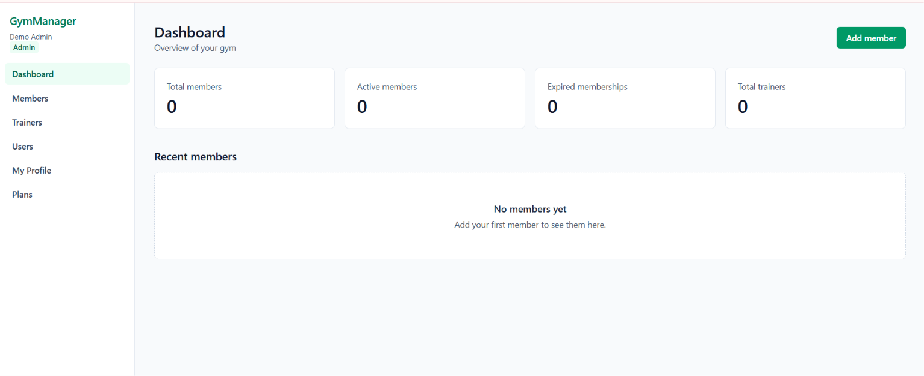
Figure 1: Dashboard showing member and trainer counts (admin view)
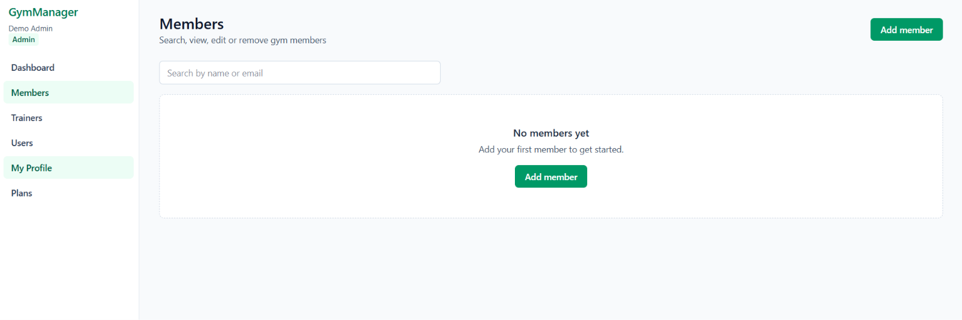
Figure 2: Members page with search, add member action and empty state
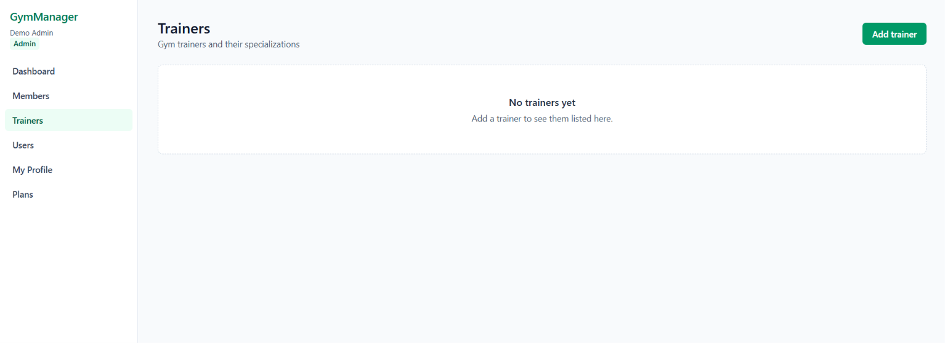
Figure 3: Trainers page with add trainer action and empty state

8.2 Test Execution
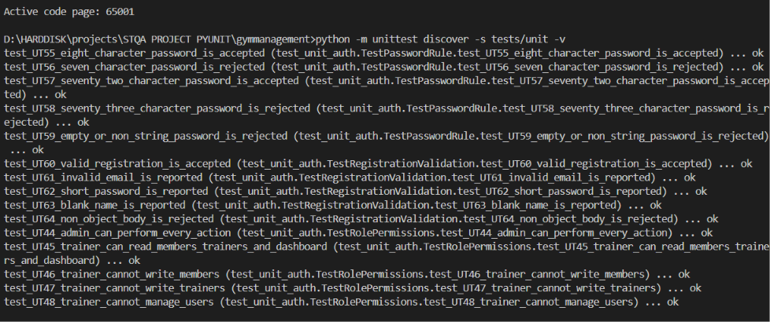
Figure 4: Unit test execution in the terminal (role, password and registration tests UT-44 to UT-64)
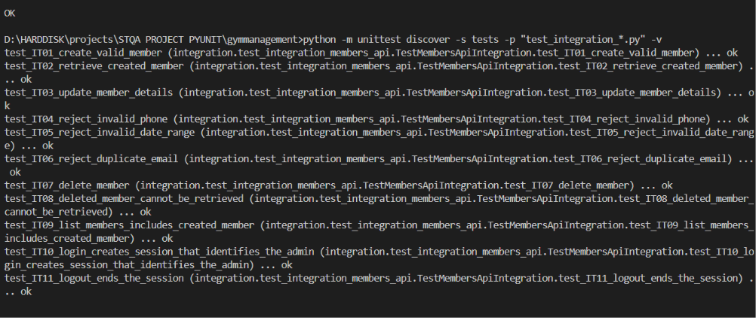
Figure 5: Integration test execution in the terminal (IT-01 to IT-11 shown)

9 HISTORICAL TEST RESULTS
PyUnit results are taken from test-results/unit-tests.txt, integration-tests.txt, full-test-suite.txt and summary.json, produced by scripts/run_tests.py; Selenium IDE results are taken from the log of the Run all tests execution. Each automated test is counted once, in the category where it was written. The combined run repeats the same tests and is not added to the totals. The white-box mapping in Section 6.4 reuses unit, integration and Selenium IDE tests, so it adds no executions. 16 automated tests failed and one Selenium IDE test (TC067) was not completed; the failures are listed in Section 10.1 with their defects. Earlier failures (UT-41 and two production build checks) were fixed and passed on retest.
Suite | Planned | Executed | Passed | Failed | Errored | Skipped / Not Run
Unit (incl. white-box evidence) | 68 | 68 | 64 | 4 | 0 | 0
Integration | 14 | 14 | 12 | 2 | 0 | 0
Selenium IDE (UI) | 67 | 66 | 56 | 10 | 0 | 1 (TC067, run stopped)
Total automated | 149 | 148 | 132 | 16 | 0 | 1
Manual UI checks | 15 | 3 | 0 | 3 | – | 12

Metric | Observed Result
Total automated tests | 149 (148 executed)
Passed | 132
Failed | 16
Errored | 0
Skipped | 0 (1 Not Run: TC067, Selenium IDE run stopped)
Pass rate | 132/148 executed tests (89.2%)
Manual UI checks | 15 planned, 3 executed, 3 failed, 12 Not Run
Run time | About 0.002 s for the unit suite, 20 to 40 s for the integration suite and about 6 minutes for the Selenium IDE run (14:56 to 15:03)

Static checks:
Check | Command | Result
Lint | npm run lint | No errors reported
Type check | npx tsc --noEmit | No errors reported
Production build | npm run build | Succeeded, with no errors or warnings in the build log (after the fixes in D-02 and D-04)

Historical outcome: 132 of 148 executed automated cases passed (89.2%); 16 failed and TC067 was not completed. Three manual checks failed and twelve were not run. Defects D-05 to D-14 record these outcomes.

10 DEFECT REPORT AND RETESTING
Defects D-01 to D-04 were found and fixed during development; defects D-05 to D-14 were raised from the failed test cases and are open or deferred. Severity is the impact of a defect (Critical, High, Medium, Low) and priority is how soon it should be fixed (High, Medium, Low); the two are independent.

10.1 Failed Test Cases
The table below lists every test case and check that failed: first the three failures found during development (UT-41, SC-01, SC-02), which were fixed and passed on retest, and then the 19 test cases that failed in the latest runs (16 automated and 3 manual). The unit, integration and manual failures test requirements that the current version does not meet; the ten Selenium IDE failures are caused by a wrong expected value in one test and by a session problem in the test setup. These are not yet retested because their defects are open or deferred. The same rows also appear in their own test case tables in Section 6.
TC ID | Test Objective | Test Steps | Expected Result | Actual Result (failed run) | Status | Defect ID | Retest Result
UT-41 | Missing required fields are all reported (member input validation) | Run test_​UT41_​missing_​required_​fields_​are_​all_​reported with validate_​member_​input({}) | All six fields reported: email,​ end_​date,​ full_​name,​ membership_​plan,​ phone,​ start_​date | Only five fields reported (end_​date missing). Console: Ran 43 tests – FAILED (failures=​1) | Failed | D-01 | Passed – Ran 43 tests, OK; IT-04 also passed against the real application
SC-01 | Production build completes | Run npm run build | Build completes and all routes are generated | Build failed while prerendering /​members/​[id]: usePathname() used outside a <Suspense> boundary | Failed | D-02 | Passed – build succeeded and all routes were generated
SC-02 | Build log is clean (no unexpected API errors) | Run npm run build and read the build log | No error messages in the build log | Unexpected API error: ... cookies() rejects ... logged for /​api/​me and /​api/​auth/​me (routes still worked) | Failed | D-04 | Passed – the message no longer appears in the build log
UT-65 | Phone with +91 country code is accepted | Run test_​UT65_​phone_​with_​country_​code_​is_​accepted with is_​valid_​phone("+919876543210") | Accepted (Indian number with country code) | Rejected – only exactly 10 digits are allowed | Failed | D-05 | Not retested – defect open
UT-66 | Phone with a space between digit groups is accepted | Run test_​UT66_​phone_​with_​space_​is_​accepted with is_​valid_​phone("98765 43210") | Accepted after removing the space | Rejected – spaces are not removed before checking | Failed | D-05 | Not retested – defect open
UT-67 | End date must match the plan duration | Run test_​UT67_​end_​date_​must_​match_​plan with Monthly,​ start 2025-06-01,​ end 2027-06-01 | Error: end date does not match a Monthly plan | No error – only end_​date >=​ start_​date is checked | Failed | D-06 | Not retested – defect open
UT-68 | Customer can update own contact details | Run test_​UT68_​customer_​can_​update_​own_​details with can("customer",​ "me:write") | Allowed | Denied – customer has only me:read | Failed | D-07 | Not retested – defect open
IT-13 | Customer with a different login email sees own membership | Run test_​IT13_​customer_​with_​different_​email_​sees_​membership (member stored as ravi.k@gymtest.example,​ login as ravi.kumar@gymtest.example) | 200; membership details returned | 200 with no member – page shows "No membership found" | Failed | D-08 | Not retested – defect open
IT-14 | Login blocked until email is verified | Run test_​IT14_​login_​requires_​verified_​email (register,​ then log in at once) | Login refused until the email is confirmed | 200 – login succeeds without verification | Failed | D-09 | Not retested – defect open
TC032 | Admin sidebar shows the admin role | Log in as admin; assertText on the role label in the sidebar | Role label reads "admin" | assertText failed: actual value "Admin" did not match "admin" | Failed | D-13 | Not retested – defect open
TC033 | Admin sidebar shows the GymManager name | Log in as admin; Check the app name in the sidebar | Sidebar shows "GymManager" | Setup step 5 failed: waitForElementVisible css=form timed out ("Unable to locate element within the timeout provided"); the check was not reached | Failed | D-14 | Not retested – defect open
TC034 | Dashboard shows the Total members card | Log in as admin; Wait for the "Total members" card | "Total members" card is shown | Setup step 5 failed: waitForElementVisible css=form timed out ("Unable to locate element within the timeout provided"); the check was not reached | Failed | D-14 | Not retested – defect open
TC039 | Dashboard subtitle is shown | Log in as admin; Check the dashboard subtitle | Subtitle is shown under the heading | Setup step 5 failed: waitForElementVisible css=form timed out ("Unable to locate element within the timeout provided"); the check was not reached | Failed | D-14 | Not retested – defect open
TC040 | Dashboard has an Add member button | Log in as admin; Check for the Add member link | "Add member" button is shown | Setup step 5 failed: waitForElementVisible css=form timed out ("Unable to locate element within the timeout provided"); the check was not reached | Failed | D-14 | Not retested – defect open
TC042 | Logged-in admin visiting /login goes to the dashboard | Log in as admin; open /login; read the path | Redirected to the dashboard (/) | Setup step 5 failed: waitForElementVisible css=form timed out ("Unable to locate element within the timeout provided"); the check was not reached | Failed | D-14 | Not retested – defect open
TC043 | Logged-in admin visiting /register goes to the dashboard | Log in as admin; open /register; read the path | Redirected to the dashboard (/) | Setup step 5 failed: waitForElementVisible css=form timed out ("Unable to locate element within the timeout provided"); the check was not reached | Failed | D-14 | Not retested – defect open
TC048 | Admin sidebar has the Users link | Log in as admin; assertText on the /users link | Link reads "Users" | Setup step 5 failed: waitForElementVisible css=form timed out ("Unable to locate element within the timeout provided"); the check was not reached | Failed | D-14 | Not retested – defect open
TC056 | Admin Log out button is in the sidebar | Log in as admin; Check for the Log out button in the sidebar | "Log out" button is shown | Setup step 5 failed: waitForElementVisible css=form timed out ("Unable to locate element within the timeout provided"); the check was not reached | Failed | D-14 | Not retested – defect open
TC057 | Members page has a subtitle | Log in as admin; open /members; check the subtitle | Subtitle is shown under the heading | Setup step 5 failed: waitForElementVisible css=form timed out ("Unable to locate element within the timeout provided"); the check was not reached | Failed | D-14 | Not retested – defect open
UI-13 | Forgot password | Open /​login and look for a password reset option | "Forgot password?" link sends a reset email | No reset option on the login page | Failed | D-10 | Not retested – defect open
UI-14 | Create the first admin from the app | Fresh database: register the first account and look for an admin set-up option | First admin can be created from the app | Account is a customer; admin role must be set with SQL | Failed | D-11 | Not retested – defect open
UI-15 | Assign a trainer to a member | Open a member as admin and edit | Trainer field to assign a trainer | No trainer field on the member form | Failed | D-12 | Not retested – defect open

Note: defect D-03 (the email lookup that could match a different account) did not come from a failed test. It was found by code review, and no automated test covers that route, so it has no row in this table. Its fix was checked with npx tsc --noEmit and npm run lint only (see Section 10.3).

10.2 Defect Log
Field | D-01 | D-02
Title | Missing end date not reported on its own field | Production build failed on /members/[id]
Description | Validation of a request with no dates reported an error only for start_date; the missing end_date was not reported. Both the TypeScript validator and the Python reference reported only the first date problem. | next build failed while prerendering /members/[id] because the sidebar called usePathname() outside a <Suspense> boundary.
Steps to reproduce | Run unit test UT-41 (validate_member_input({})). | Run npm run build.
Expected result | All six fields (including start_date and end_date) reported. | Build completes.
Actual result | Only five fields reported: email, full_name, membership_plan, phone, start_date. | Error: Route "/members/[id]": Next.js encountered URL data usePathname() in a Client Component outside of <Suspense>.
Severity | Low (error messages incomplete; invalid data still rejected) | High (application could not be built for production)
Priority | Medium | High
Category | Input-validation defect | Configuration and environment defect
Status | Closed | Closed
Related test ID | UT-41 | Not an automated test; found by npm run build

Field | D-03 | D-04
Title | Email lookup could match a different account | Build log showed an unexpected-error message for two API routes
Description | The first version of GET /api/me found the trainer or member record with a case-insensitive pattern match (ilike). In a pattern match _ and % are wildcards, and _ is common in email addresses, so a trainer's email could match a different trainer's record. | handle() caught every exception. During next build, Next.js aborts the prerender of GET routes that read cookies by throwing an internal signal, which handle() caught and logged as an "Unexpected API error".
Steps to reproduce | Found by code review, not by a test: read app/api/me/route.ts. | Run npm run build.
Expected result | Exact match on the lower-cased email. | Clean build log.
Actual result | Pattern match with wildcards. | Message Unexpected API error: Error: During prerendering, cookies() rejects ... for /api/me and /api/auth/me.
Severity | Medium (wrong record could be shown; customers were also protected by Row Level Security) | Low (log noise only; the routes still worked)
Priority | High | Low
Category | Functional / data-integrity | Error-handling
Status | Closed | Closed
Related test ID | None. Not caught by any test | Not an automated test; found by npm run build

Evidence for D-01 (first run, copied from the console):
FAIL: test_UT41_missing_required_fields_are_all_reported
AssertionError: Lists differ: ['email', 'full_name', 'membership_plan', 'phone', 'start_date']
!= ['email', 'end_date', 'full_name', 'membership_plan', 'phone']
Ran 43 tests in 0.003s

FAILED (failures=1)

Defects raised from the failed test cases (D-05 to D-14):
Defect ID | Title | Related Test IDs | Severity | Priority | Status
D-05 | Phone with +91 prefix or spaces is rejected | UT-65, UT-66 | Medium | Medium | Open
D-06 | End date is not checked against the plan duration | UT-67 | Medium | High | Open
D-07 | Customer cannot update own contact details | UT-68 | Low | Medium | Deferred
D-08 | Customer with a different login email sees no membership | IT-13 | Medium | Medium | Open
D-09 | Login allowed without email verification | IT-14 | Medium | Medium | Deferred
D-10 | No forgot-password option | UI-13 | Medium | High | Open
D-11 | First admin can only be created with SQL | UI-14 | Low | Low | Deferred
D-12 | No trainer-to-member assignment | UI-15 | Low | Low | Deferred
D-13 | Selenium IDE test expects the role label "admin"; the sidebar shows "Admin" | TC032 | Low | Low | Open
D-14 | Login form not shown after the logout step in the test setup (previous admin session still active) | TC033, TC034, TC039, TC040, TC042, TC043, TC048, TC056, TC057 | Medium | High | Open
Analysis of D-13 and D-14 (Selenium IDE): in TC032 the role is stored as "admin" and the sidebar displays it with CSS capitalisation, so the visible text read by Selenium IDE is "Admin". The application behaves as designed; the expected value in the test has to be changed to "Admin". In the nine D-14 cases the test stopped at its first wait (css=form not visible within 15 s), so the feature named in the test was never checked. Each of these tests ran directly after a test that had logged in as admin, and a logged-in user who opens /login is redirected to the dashboard, so the most likely cause is that the logout call in the setup had not ended the previous session when /login was opened. Logging out with the Log out button works (TC044 passed). The planned fix is to wait for the logout response and confirm that the session has ended in the setup, then re-run these tests together with TC067.

10.3 Defect Retesting
Defect | Fix applied | Retest | Result
D-01 | validateMemberInput (TypeScript) and validate_member_input (Python) now check each date separately and apply the ordering rule only if both dates are valid. The expected list in UT-41 was updated to include all six fields. | python -m unittest discover -s tests/unit -v | Ran 43 tests, OK (saved in test-results/unit-tests.txt)
D-02 | The sidebar in app/layout.tsx is wrapped in <Suspense>. | npm run build | Build succeeded and all routes were generated
D-03 | The lookup now uses an exact match (eq) on the lower-cased email. | npx tsc --noEmit, npm run lint. No automated test covers this route. | Compiles and lints cleanly. Behaviour is not verified by a test; it would be covered by a manual check with a trainer account.
D-04 | handle() now calls unstable_rethrow(err) so Next.js internal signals pass through, and requireAuth calls connection() so the routes are evaluated at request time. | npm run build | The build log no longer shows the message. A first attempt with only connection() still logged it; adding unstable_rethrow removed it.

The PyUnit unit tests exercise the Python implementation, so they alone could not verify the TypeScript change for D-01. Integration test IT-04, which calls the real application, passed after the HTTP suite was run. Defects D-05 to D-14 have not been retested yet; their test cases will be run again when the fixes or enhancements are made.

11 REGRESSION TESTING
After any change to validation or API code, all unit tests and all configured integration tests are run again, and the Selenium IDE suite is run again after any change to the pages, and the new result is compared with the previous one. Any test that passed before and fails now is a regression. The PyUnit suites are re-run with python scripts/run_tests.py all and the Selenium IDE suite with Run all tests.
Trigger | Suite | Result
Fix for D-01 | Unit | 43 of 43 passed at that time (the suite later grew to 64 tests with the role and registration tests; all 64 passed)
Fix for D-01 | Integration | Not Run at that time (no database was configured). Run later: 12 of 12 passed
Fix for D-02 | Lint, type check, build | Completed without errors
Adding login and roles (changes to every API route) | Unit | 64 of 64 passed
Adding login and roles | Integration | 12 of 12 passed, so the member API still works after authentication was added
Adding login and roles | Lint, type check, build | Completed without errors
Replacing the black-box API suite with Selenium IDE user-interface tests | Selenium IDE | First run: 56 of 66 completed tests passed. This run is the baseline for user-interface regression; its failures are D-13 and D-14

No regressions were found: the member API still works after authentication was added, and the regression check for D-01 is complete.

12 HISTORICAL TEST SUMMARY AND ACCEPTANCE
- 132 of 148 executed automated tests passed and 16 failed (unit 64/68, integration 12/14, Selenium IDE 56/66); TC067 was not completed because the Selenium IDE run was stopped. 3 manual checks failed and 12 were not run.
- The 16 automated failures and 3 manual failures are linked to defects D-05 to D-14 (6 open, 4 deferred). None is Critical or High severity. Ten of the automated failures come from the Selenium IDE run and are a test-script problem and a session problem in the test setup (D-13, D-14), not missing features.
- Two defects were found by tests or the build (D-01, D-02), one by code review (D-03) and one by the build log (D-04). All are closed. D-01 also has an HTTP-level retest (IT-04 passed); D-03 still has no automated test.
- The business rules (status calculation, phone, email, name, plan, dates) are verified at the unit level for both outcomes of each condition.
- The unit tests verify a Python reference implementation; evidence for the real TypeScript application comes from the HTTP suites.
- The integration tests verified, against a real Supabase project, member create/read/update/delete, persistence of updates, rejection of invalid and duplicate input (including case-insensitive duplicate email), login, and 401 after logout.
- The Selenium IDE tests verified in the browser the login and registration pages and their validation messages, the redirect of anonymous visitors to /login from every protected page, admin login and logout, the dashboard cards, the sidebar links and the Members and Add Member pages.
- Not verified: the trainer and customer views in the browser (the Selenium IDE tests use only the admin account), adding, editing and deleting a member through the user interface, the trainer API, /api/me, the Users page operations, 403 responses for the trainer and customer accounts at HTTP level, and the admin-only Row Level Security policies beyond the effects visible through the API. No code-coverage measurement was made.

Acceptance decision: Conditionally accepted.
Criterion | Evaluation
All critical business rules pass their tests | Met for the implemented rules (UT-01 to UT-64 passed). UT-65 to UT-68 fail on requirements not yet implemented
All planned tests executed or marked Not Run with reasons | Met: 148 of 149 automated tests were executed; TC067 is Not Run because the run was stopped, and UI-01 to UI-12 are Not Run with the reason in Section 6.5
No unresolved critical defects | Met: no Critical or High severity defect is open
Member CRUD works in the configured environment | Met: IT-01 to IT-09 passed
User interface works in the browser | Met for the admin pages tested: 56 of 66 Selenium IDE tests passed; the 10 failures are test-script and session problems (D-13, D-14)
Invalid requests are rejected | Met: UT tests and IT-04 to IT-06 passed; the login and registration forms show validation messages (TC009 to TC012, TC019 to TC021 passed)
Unauthenticated and unauthorized requests are refused | Partly met: anonymous visitors are redirected to /login (TC023 to TC029) and the API returns 401 after logout (IT-11); 403 for trainer and customer is checked only at rule level (UT-46 to UT-51)
Open defects from failed test cases | Not met: D-05, D-06, D-08, D-10, D-13 and D-14 are open; D-07, D-09, D-11 and D-12 are deferred
Report reflects the test results | Met

Condition for full acceptance: fix the open defects D-05, D-06, D-08, D-10, D-13 and D-14 and re-run their test cases (including the complete Selenium IDE suite with TC067), perform the 12 remaining manual interface checks (UI-01 to UI-12), and resolve any defect they reveal. The deferred defects are planned as future enhancements (Section 13.2).

13 LIMITATIONS AND FUTURE ENHANCEMENTS

13.1 Limitations
- Authentication is basic: no password reset, email verification, multi-factor login or rate limiting of its own; cookie sessions rely on SameSite=Lax. The design is for a college demonstration, not for production.
- Accounts are linked to member and trainer records by email address only; the first admin has to be promoted with an SQL statement.
- The Python reference implementation is separate from the TypeScript code; PyUnit does not run TypeScript.
- Phone validation (exactly 10 digits) is a simplification, and membership status uses the server's local date (time zones are not handled).
- Trainers have no automated tests, and there is no coverage measurement or performance testing. The Selenium IDE tests cover only the admin account in one browser, and they depend on visible text and locators, so a change of wording on a page requires the test to be updated.
- HTTP tests write to a real Supabase project (the student's single project was used) and need a running server and demo accounts.

13.2 Future Enhancements
- Add password reset, email verification and rate limiting, and let customers update their own phone number.
- Add a stronger link between accounts and member or trainer records (for example a foreign key) and a trainer-to-member assignment.
- Add trainer API tests and measure coverage with coverage.py and a JavaScript test runner.
- Add pagination, filtering by status, attendance, payments and renewal reminders.
- Run the PyUnit suites and the Selenium IDE project (with selenium-side-runner) automatically in continuous integration.
- Extend the Selenium IDE suite to the trainer and customer accounts and to adding, editing and deleting members.

14 INITIAL TESTING CONCLUSION
This STQA mini project delivered a small but complete Gym Management System with login and three roles (admin, trainer and customer), and tested it with PyUnit for unit, white-box, integration and regression testing and with Selenium IDE for automated user-interface testing. 148 automated tests were executed – 68 unit, 14 integration and 66 Selenium IDE (TC067 was not completed) – of which 132 passed and 16 failed (89.2% pass rate). Four defects found during development (D-01 to D-04) were fixed and retested with no regressions. The failed unit and integration tests and the 3 failed manual checks show requirements the current version does not meet, such as phone numbers with a country code, plan-duration checks, email verification and password reset; the 10 Selenium IDE failures come from one wrong expected value and a session problem in the test setup. All are recorded as defects D-05 to D-14. The system is conditionally accepted until the open defects are fixed and the remaining tests and manual checks are performed.

15 REFERENCES / PROJECT ARTIFACTS
- Gym Management System application source (app/, components/, lib/, proxy.ts)
- Database schema, constraints and RLS policies (supabase/schema.sql)
- Python test suites (tests/unit, tests/integration) and reference rules (tests/reference_rules.py)
- Selenium IDE project (TC001 to TC067) and the log of its Run all tests execution
- Test runner and saved results (scripts/run_tests.py, test-results/)
- Test plan (docs/test-plan.md)
- Project README and mini project report (miniprojectreport.md)
- Python unittest documentation – docs.python.org/3/library/unittest.html
- Selenium IDE documentation – selenium.dev/selenium-ide
- STQA mini project report reference format supplied for this submission

16 Selenium WebDriver Testing and Final Verification
We implemented and executed 30 functional Selenium WebDriver tests in Google Chrome. All 30 passed in the final complete run. The tests cover real member and trainer operations, validation, search, persistence, account controls and role restrictions. Twenty-seven cases cover gym workflows and authorization; three cover authentication. Browser sessions are reused within each role group.
This section completes the browser-testing work and supplies current execution evidence. The earlier report remains the record of its own execution stage. A successful browser run does not close unrelated historical requirements such as password reset or email verification, and it does not establish production readiness.

16.1 Objectives and Test Environment
The objective was to verify user-observable behavior through the rendered application, including successful workflows and rejected input. Selenium controls Chrome through ChromeDriver; the application then calls its Next.js API and Supabase. API helpers prepare uniquely named test records, called fixtures, verify selected stored outcomes and remove only records owned by the run. The feature being tested is exercised with browser interactions.
Component | Executed environment
Browser | Google Chrome 134.0.6998.89
Driver | ChromeDriver 134.0.6998.165 selected by Selenium Manager
Automation | Selenium 4.51.0; Python 3.11.15; unittest
Application | Next.js 16.4.2; React; TypeScript; Supabase Auth and PostgreSQL
Machine | Windows 11 Pro 22H2 build 22621.4317; 8 GB RAM
Server and viewport | http://localhost:3000; visible Chrome at 1280 by 900
Final run started | 2026-10-23T01:12:34+05:30
Elapsed time | 380.028 seconds; includes role setup and cleanup

Firefox was suspended after two Windows kernel crashes. Chrome was used for this completed run. The underlying Windows issue remains unresolved; no cross-browser equivalence, OS repair, load-test result or code-coverage percentage is claimed.

16.2 Automation Design and Execution Procedure
The suite is organized into authentication, admin functional, trainer-permission and customer-permission groups. The three functional role groups each log in once. A separate valid admin login is required by the logout test. The final run recorded 4 successful browser logins in total.
Reusable helpers locate visible controls, type through Selenium send_keys, click buttons and links, wait for loaded data, select membership plans and interact with confirmation dialogs. Explicit waits re-find elements after React updates and tolerate transient stale references. A segmented date input is assigned an ISO value through its native DOM setter and normal input/change events; date validation still runs through the actual form submission.
Each test uses unique data and records ownership before a UI create request. Teardown captures the actual browser screen and cleans up only recorded IDs or exact unique fixture emails. Existing gym records and real account roles are not changed. The user-form test exercises validation without creating a permanent authentication account.
Run the application in one terminal and the suite in another:
npm.cmd run dev:local
npm.cmd run test:webdriver
.\.venv\Scripts\python.exe scripts/run_webdriver.py --browser chrome --match WD07
The third command is the focused member-lifecycle pilot, not an additional case added to the final total. Full output and structured results are saved in timestamped run folders under test-results/webdriver/chrome. The latest-full.json pointer identifies the completed evidence set.

16.3 Functional Test Cases and Actual Results
ID | Objective | Steps | Expected result | Actual result | Status
WD01 | Reject empty login credentials | Submit the empty login form. | Email and password errors appear and no authenticated navigation appears. | Displayed validation: Enter a valid email address | Password is required | Pass
WD02 | Reject an invalid password | Enter the configured admin email with an incorrect password; submit. | Invalid credentials are reported and the protected area stays inaccessible. | Invalid email or password shown; URL remained /login; no authenticated navigation. | Pass
WD03 | Logout ends protected browser access | Log in; click Logout; request Members directly. | Logout returns to login; a subsequent Members request redirects to login. | Logout and direct /members access both ended at /login. | Pass
WD04 | Dashboard reflects active and expired member fixtures | Prepare active/expired fixtures; open Dashboard; compare cards and recent rows. | All four counts match stored data and both newly added members appear in Recent members. | Dashboard counts matched API data: {'Total members': 4, 'Active members': 3, 'Expired memberships': 1, 'Total trainers': 0}; both known recent records were visible. | Pass
WD05 | Navigate between management pages using the sidebar | Click Members, Trainers, Users and Plans in the sidebar. | Members, Trainers, Users and Plans links open the corresponding pages without application errors. | All four sidebar links opened the intended loaded page. | Pass
WD06 | Verify all plan prices and durations | Open Plans; read all three price and duration cards. | Monthly is INR 1000 for 1 month, Quarterly INR 2700 for 3 months, Yearly INR 9600 for 12 months. | Monthly: INR 1,000, 1 month; Quarterly: INR 2,700, 3 months; Yearly: INR 9,600, 12 months | Pass
WD07 | Complete a member create view edit reload delete journey | Create in UI; open details; edit phone; reload; confirm deletion; search. | A valid member is created in the UI, viewed, edited, persists after reload, and is deleted through confirmation. | UI create and view succeeded; phone edit persisted after reload; confirmed deletion removed the record. | Pass
WD08 | Retain stored member values after page reload | Open a stored member; reload; compare five fields. | Name, email, phone, plan and dates remain identical after reloading the member detail page. | All five stored detail values survived a full browser reload. | Pass
WD09 | Reject missing required member fields | Submit a blank Add Member form. | Blank name, email and phone produce the appropriate field messages and remain unsaved. | Displayed validation: Full name is required | Enter a valid email address | exactly 10 digits | Pass
WD10 | Reject an invalid member email | Fill a member with malformed email; submit. | Invalid email produces an email field error and the form stays open. | Displayed validation: Enter a valid email address | Pass
WD11 | Reject a short member phone number | Fill a member with a five-digit phone; submit. | A five-digit phone is rejected with the exact ten-digit rule. | Displayed validation: Phone number must contain exactly 10 digits | Pass
WD12 | Reject a membership end date before its start | Set end date before start; submit the member form. | The reversed date range produces an ordering error and no member is saved. | Displayed validation: End date must not be earlier than start date | Pass
WD13 | Reject a duplicate email regardless of letter case | Prepare a member; submit uppercase duplicate email; inspect error and stored record. | Creating a member with the uppercase form of an existing email is rejected and the original record remains. | Duplicate-email message displayed; exactly the original member remained. | Pass
WD14 | Find a member by name and exclude a nonmatch | Prepare matching and nonmatching members; search by name. | Name search returns the matching member and excludes an unrelated fixture. | Name search returned one matching row and excluded the nonmatching fixture. | Pass
WD15 | Find a member by email | Prepare a member; search by its unique email. | A full unique email query returns the correct member row. | Email search returned exactly the intended member. | Pass
WD16 | Show an empty result for an unmatched search | Search for a unique nonexistent member. | An unmatched query shows the no-match message and no member rows. | No-match message appeared with zero member rows. | Pass
WD17 | Show the selected member details accurately | Follow a member link from the list; compare its detail fields. | The list link opens that member with the correct identity, plan, dates and active status. | List navigation opened the correct ID with all six expected detail values. | Pass
WD18 | Persist an edited member phone and plan | Edit phone and select Yearly; save; reload details. | The phone and plan change through the UI and remain changed after a reload. | After reload: phone 9123456780, Yearly plan, end date 2031-01-01. | Pass
WD19 | Cancel deletion without losing the member | Open member deletion dialog; cancel; reload. | Cancel closes the confirmation dialog and the same member remains after reload. | Cancellation retained the exact member ID after reload. | Pass
WD20 | Confirm deletion and verify the member disappears | Confirm member deletion; search; check stored ID is absent. | Confirm removes the member from the UI search and the stored record returns 404. | Confirmed deletion: no UI search result and record GET returned HTTP 404. | Pass
WD21 | Create a trainer through the form | Submit a valid trainer; inspect all four values in its row. | A valid trainer appears with the submitted name, email, phone and specialization. | New trainer row displayed all four submitted contact/specialization values. | Pass
WD22 | Validate required trainer name and specialization | Submit a blank trainer form. | A blank trainer form reports required name and specialization. | Displayed validation: Full name is required | Specialization is required | Pass
WD23 | Reject invalid trainer contact details | Submit malformed trainer email and short phone. | Invalid email and five-digit phone produce their field errors. | Displayed validation: Enter a valid email address | exactly 10 digits | Pass
WD24 | Delete a trainer through confirmation | Select a trainer; confirm deletion; inspect table and record absence. | The selected trainer is removed from the table and stored record after confirmation. | Trainer row disappeared and record GET returned HTTP 404. | Pass
WD25 | List accounts and protect the admin own-role control | Open Users; locate three accounts; inspect own role and other selector. | The configured three accounts appear; the current admin is marked (you) with no editable role selector. | Three configured accounts listed; own role was noneditable while another account had a role selector. | Pass
WD26 | Validate the create-user form without creating an account | Submit a blank Create User form; inspect errors and role choices. | Blank name, invalid email and missing password are reported; role choices remain admin, trainer and customer. | Required-field messages appeared and all three allowed roles were offered; no auth account was created. | Pass
WD27 | Trainer can read a member without write controls | As trainer, open a known member; inspect available controls. | Trainer can view a known member, with no Add member, Edit, Delete or Users control. | Known member was readable; create/edit/delete controls and Users navigation were absent. | Pass
WD28 | Trainer cannot bypass restrictions with direct URLs | As trainer, request Add Member and Users directly. | Direct Add Member and Users pages both show Access denied with no editable form. | Both restricted URLs displayed Access denied and no editable form. | Pass
WD29 | Customer sees only the membership linked to their account | As customer, open My Membership; compare own values and exclude another record. | Own membership values are visible; an unrelated member is absent and management links are hidden. | Own name/plan/phone matched the linked record; unrelated fixture and management links were absent. | Pass
WD30 | Customer cannot access management pages or dashboard | As customer, request three management URLs and Dashboard. | Members, Trainers and Users direct URLs are denied; dashboard redirects to My Membership. | All three management URLs denied access; dashboard redirected to /me. | Pass

16.4 Execution Summary and Regression Results
Area | Executed | Passed | Failed or errored
Authentication | 3 | 3 | 0
Dashboard navigation and plans | 3 | 3 | 0
Members | 14 | 14 | 0
Trainers | 4 | 4 | 0
Users | 2 | 2 | 0
Trainer permissions | 2 | 2 | 0
Customer permissions | 2 | 2 | 0
Total | 30 | 30 | 0

The final WebDriver result is 30 of 30 passed, with no failures, errors or skips. No intentionally false assertion was added to this suite. Earlier failed pilot attempts were retained for traceability and are not counted as additional final cases. Every owned fixture cleanup completed successfully.
Execution started | Executed | Passed | Failed | Errors | Skipped
2026-10-23T01:02:39+05:30 | 30 | 27 | 2 | 1 | 0
2026-10-23T01:12:34+05:30 | 30 | 30 | 0 | 0 | 0

This execution history keeps the earlier complete attempts visible. Only the final run supplies the per-case passing results and screenshots above; repeated attempts are not added to the final case count.
The latest separate Python discovery run executed 103 test entries: 98 unit/API passes and five explicit browser skips. The 98 passes comprise 64 unit, 12 integration and 22 black-box API tests. The five skips belonged to the preliminary browser suite at that time and were not treated as passes. Those preliminary browser cases have now been replaced by the 30-case suite. Unit tests exercise a Python reference implementation; the HTTP and browser suites exercise the actual application.
Lint and TypeScript verification are recorded separately from automated case counts. The current production-build status is not inferred from the historical build rows. The legacy IDE project contains 100 cases with 16 deliberately failing demonstrations, but its recent full CLI run did not finish; no completed 100-case result is claimed or added to the totals.
Exact final execution output excerpt:
Browser group: AAuthenticationTests role: authentication Chrome: 134.0.6998.89
Browser group: BAdminFunctionalTests role: admin Chrome: 134.0.6998.89
Browser group: CTrainerPermissionTests role: trainer Chrome: 134.0.6998.89
Browser group: DCustomerPermissionTests role: customer Chrome: 134.0.6998.89
Ran 30 tests in 380.028s
OK

16.5 Defects and Automation Retests
Finding | Correction or disposition | Retest evidence
WD D01 Early login submission and PWA hydration mismatch | Auth submission waits for hydration; install control uses a consistent hydration state. | Final WD01 to WD03 and the three authenticated role groups passed.
WD D02 Development badge intercepted Logout | Moved the development indicator to bottom-right without disabling runtime diagnostics. | Final WD03 performed a real Logout click and verified protected-page redirection.
WD D03 Cold API cleanup exceeded 20 seconds | Allowed a 60-second local request timeout; cleanup errors retain owned record IDs. | Complete Python rerun: 98 passes; final browser fixture cleanup clean.
WD D04 Locked Word temporary file caused a Turbopack CSS panic | Moved document work outside the app; excluded test-results from Tailwind scanning; restarted with a clean generated cache. | Member lifecycle pilot passed; final 30-case run completed after the workaround.
WD D05 Presence-based wait matched retained hidden form DOM | Native helpers re-find visible controls; edit completion uses visibility and persisted detail values. | WD07 lifecycle pilot passed, followed by final WD07, WD08 and WD18 passes.
WD D06 Invalid-login assertion used the wrong text | Matched the application specification and actual message Invalid email or password; retained the rejection and unauthenticated-state assertions. | Focused WD02 retest and final WD02 passed.
WD D07 Search assertion sampled the loading transition | Waited for the final matching row and row count together, rather than treating a temporary empty table as the search result. | Focused WD14 retest and final WD14 passed.
WD D08 Own-role marker differed only in CSS capitalization | Compared the displayed admin marker without case sensitivity while still requiring no own-role selector and an editable selector for another account. | Focused WD25 retest and final WD25 passed.
Legacy IDE compatibility and incomplete run | Three regex text expectations adapted; stale-element limitation isolated. Legacy run remains incomplete. | Not closed by this native suite; do not label the 100-case IDE run as complete.

Historical defects D-05 to D-14 are retained in the earlier sections with their original scope. The results above do not silently close unimplemented requirements, unexecuted manual checks or all legacy IDE cases. Environment and test-script defects are distinguished from application behavior.

16.6 Browser Evidence
The following figures are genuine screenshots saved by Chrome WebDriver during the final complete run. They show workflow states, validation, management data and permission enforcement; the structured report and console log retain the per-case outcomes.
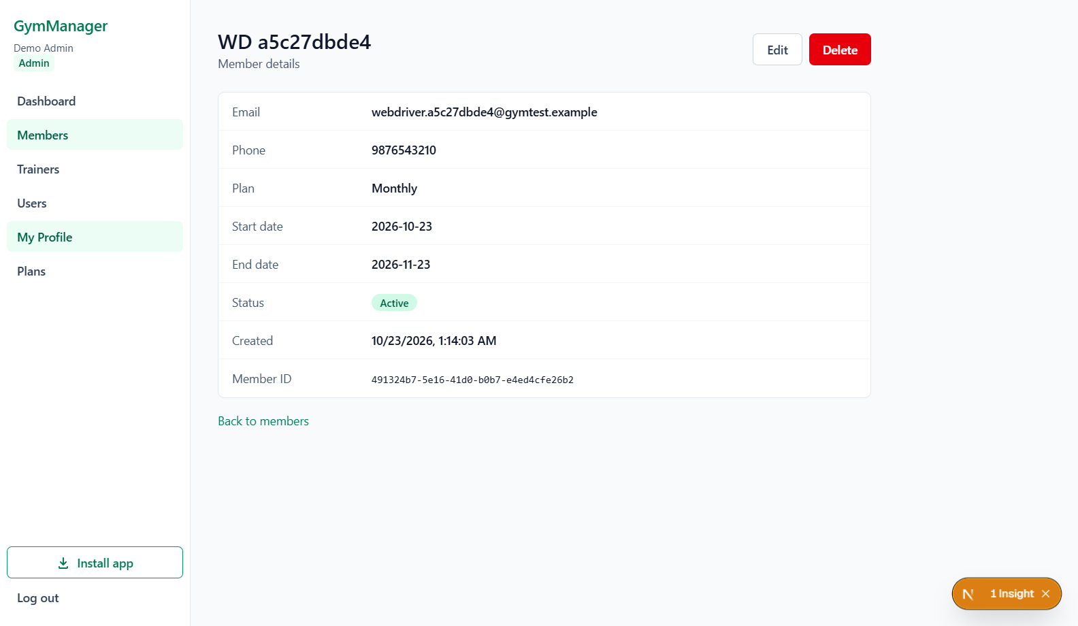
Figure 6 Member created through the UI and opened in the detail view
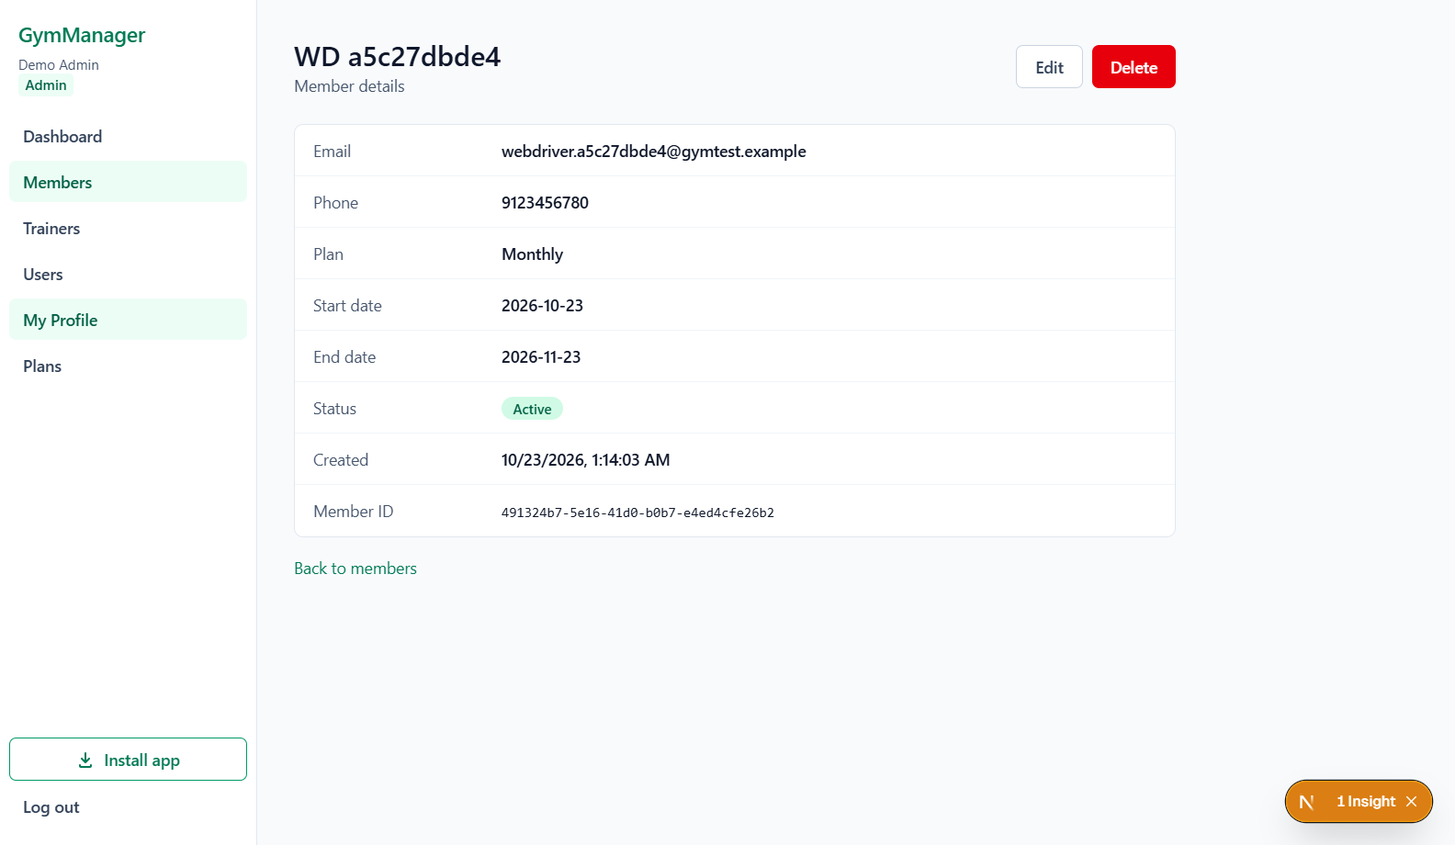
Figure 7 Updated member phone persists after a full page reload

Member Validation and Deletion Evidence
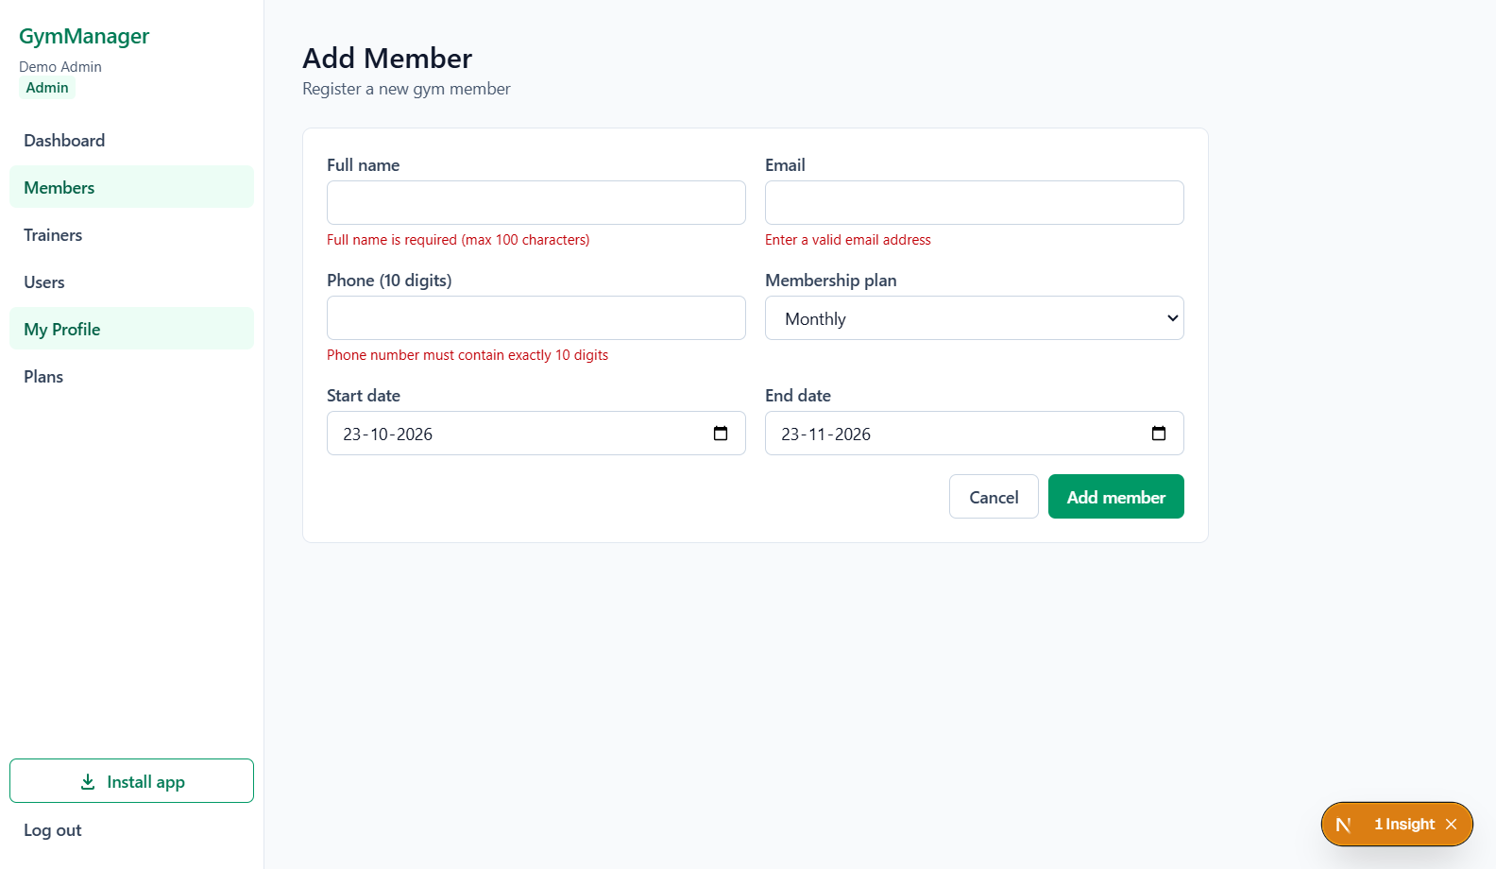
Figure 8 Required member fields are rejected with visible validation messages
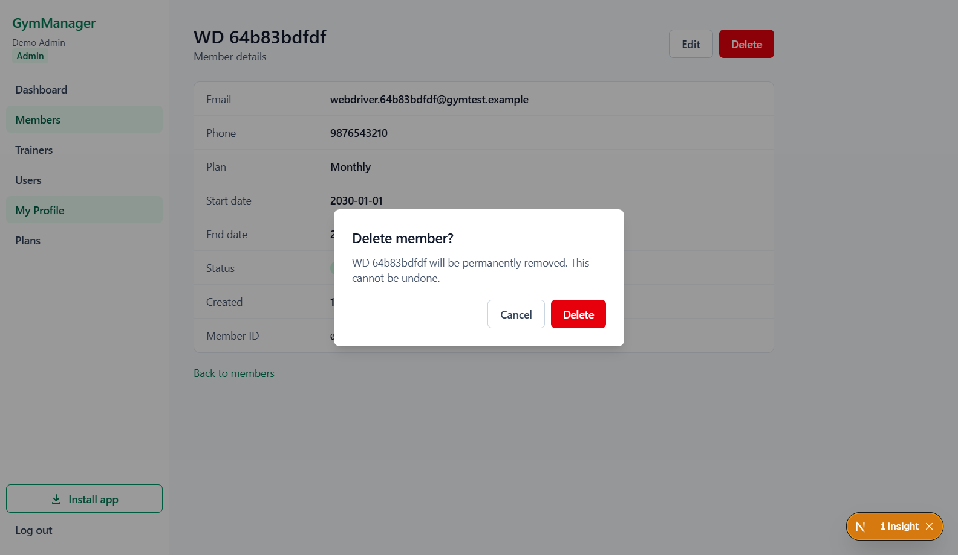
Figure 9 Member deletion requires confirmation and can be cancelled

Trainer and Customer Evidence
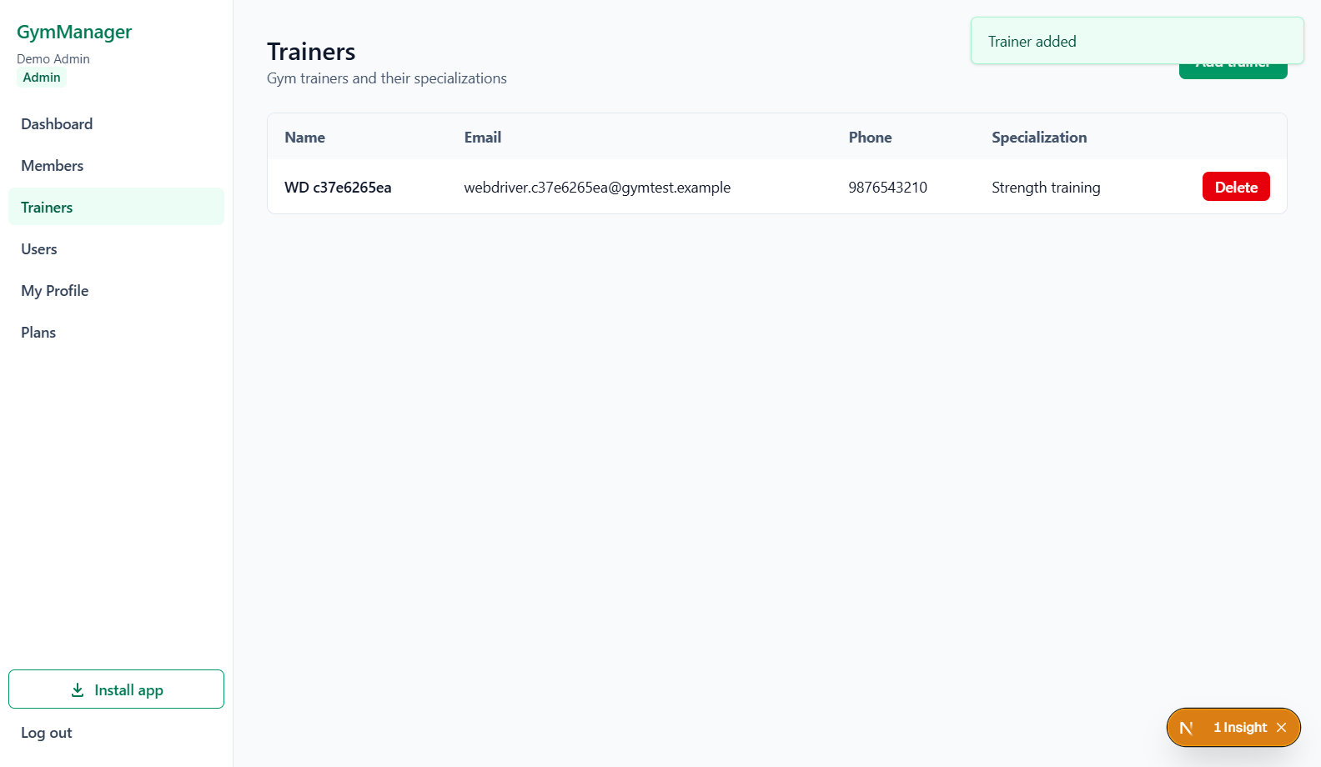
Figure 10 Trainer created through the form appears with its submitted details
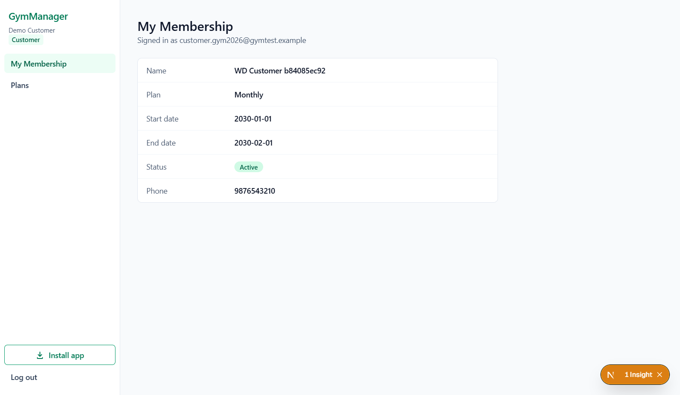
Figure 11 Customer view shows the membership linked to that account

Dashboard and Access Control Evidence
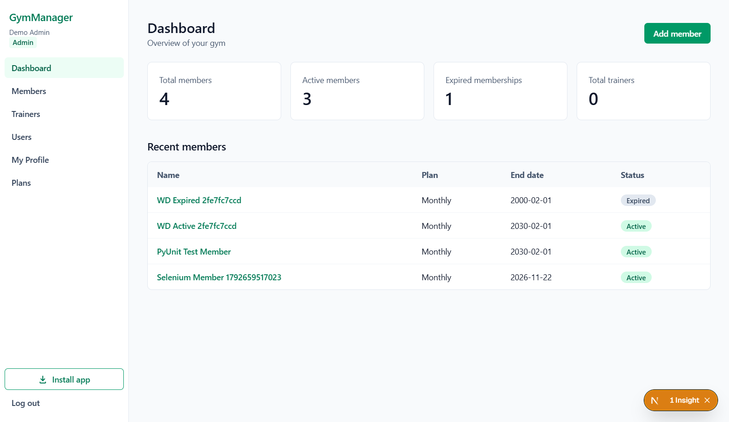
Figure 12 Dashboard counts and recent records verified against known fixtures
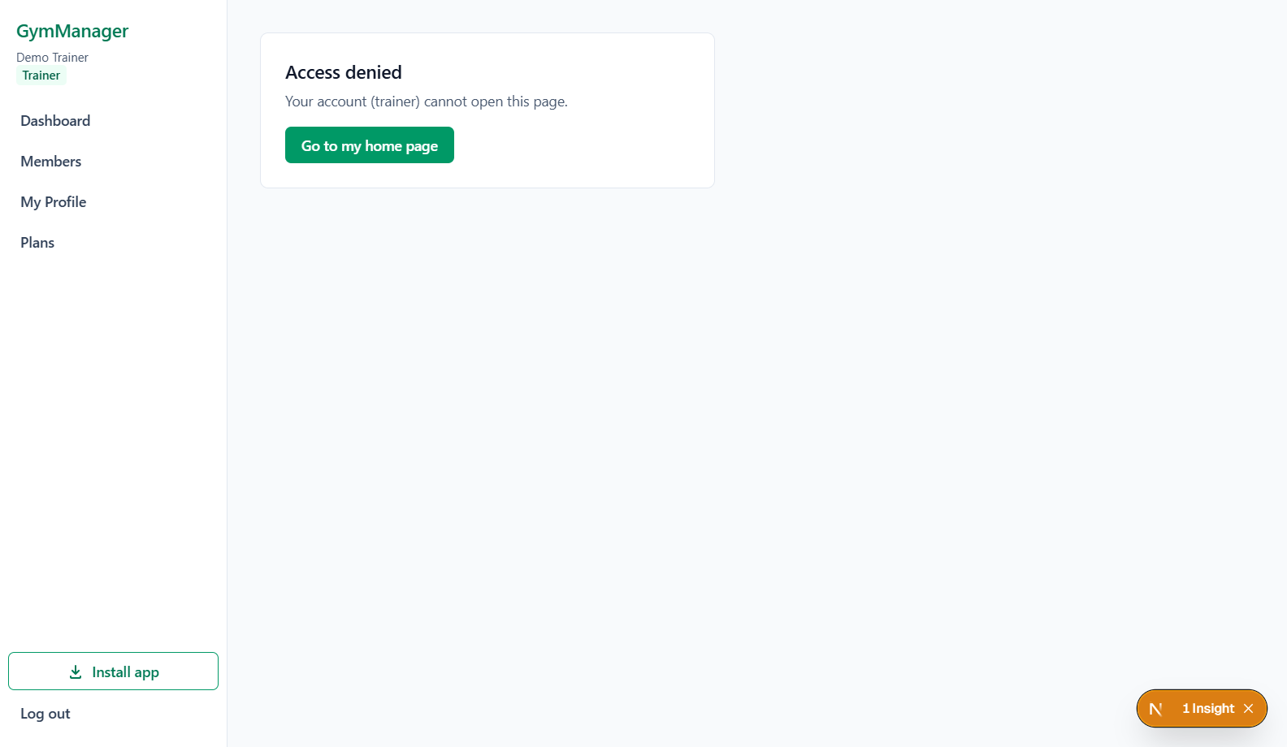
Figure 13 Trainer direct access to an admin page is denied

16.7 Deliverables and Reproducibility
Artifact | Purpose
tests/selenium/test_webdriver.py | Thirty named test cases and their expected behaviors.
tests/selenium/browser_helpers.py | Visible-element waits, page interactions, role setup and owned fixture cleanup.
scripts/run_webdriver.py | Opt-in Chrome execution, timestamped evidence folders and authentic console log.
scripts/execute_webdriver_suite.py | Structured per-case outcomes, versions, duration, screenshot and cleanup records.
test-results/webdriver/chrome/latest-full.json | Pointer to the final completed execution report.
test-results/webdriver/chrome/20261023-011232-full/results.json | Exact final results.json source for this section.
docs/webdriver-completion-plan.md and HANDOFF.md | Coverage plan and environment/continuation instructions.

Credentials remain in the local environment configuration. They are omitted from this report and must not be published with the IDE file or raw private diagnostics. The complete console log and structured per-case outcomes accompany the saved browser screenshots in the run folder.

16.8 Final Browser Testing Conclusion
The WebDriver completion objective is met for the 30 defined cases. Real Chrome interactions verified member and trainer workflows, rejected invalid data, checked search and stored updates, exercised account controls and enforced trainer/customer restrictions. The member lifecycle was first proved in isolation and then passed again in the final complete run. All test-owned data was cleaned up.
The result supports the tested behaviors in the stated environment. It does not constitute full cross-browser, performance, accessibility or penetration testing. Windows modernization, unrelated historical defects, remaining manual checks and a completed legacy IDE run remain separate scope. These limitations are retained rather than turning unexecuted work into passing evidence.

16.9 WebDriver References
Selenium WebDriver documentation https://www.selenium.dev/documentation/webdriver/
Selenium Chrome browser documentation https://www.selenium.dev/documentation/webdriver/browsers/chrome/
Selenium waits documentation https://www.selenium.dev/documentation/webdriver/waits/
Python unittest documentation https://docs.python.org/3/library/unittest.html
Tailwind source detection documentation https://tailwindcss.com/docs/detecting-classes-in-source-files

