**Instructions for EMMA data entry**

EMMA stands for Email MArketing Archiver. The purpose of EMMA is to archive e-mail newsletters from companies. We call these companies "Publishers".

Navigation bar

At the top of the screen, you can find the navigation bar, which you can use to navigate EMMA.



The primary pages data entry will be working in, is the “Subscribe” and “Unconfirmed subscriptions” sections.

Subscribing to newsletters

In order for the EMMA software to archive newsletters, we first need to manually subscribe to the publisher newsletters.

We need to subscribe with a special email address, which is different from publisher to publisher. This email address is supplied by EMMA.

Subscribing can usually be done on the website of the publisher. There will typically be a section on the website called "Subscribe to newsletter", "Sign up for email news" or similar.

**To start subscribing:**

1) Click the "Subscribe" link in the navigation bar.



You will then be shown a random selected company / publisher. This page contains a link to the publisher website. It also contains the special email address, which must be used to subscribe.

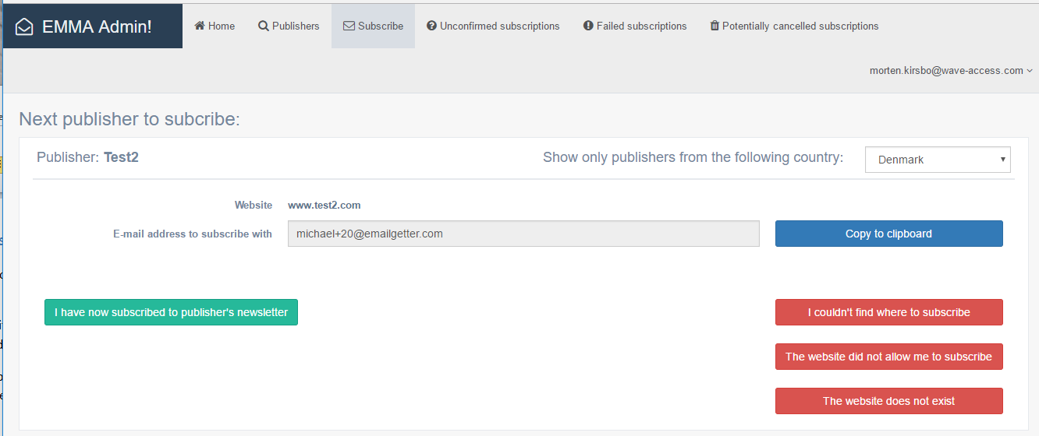

**2)** Copy the special email address to the clipboard, by clicking the blue "Copy to clipboard" button.

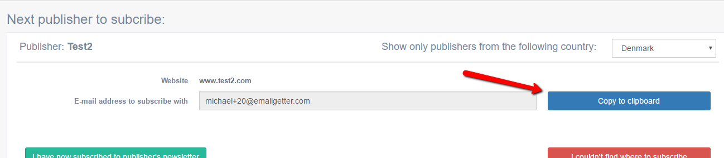

**3)** Visit the website of the publisher, by clicking the website link. The website should open in a new browser tab.

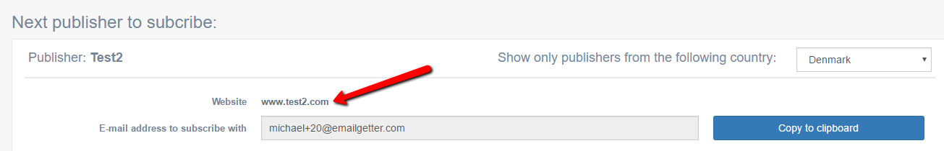

*If the website does not exist: Close the tab and return to EMMA. Then click the red "The website does not exist" button. The page will refresh and a new publisher will be loaded, for you to repeat the process.*

**4)** Find the section on the website, where you can sign up to the company's newsletter.

*Tip: You can often find the newsletter section very fast, by pressing Control + F and searching the page for the word "news" or "newsletter" (or equivalent word in the local language, ex. "nyheder" or "nyhedsbrev" in danish).*

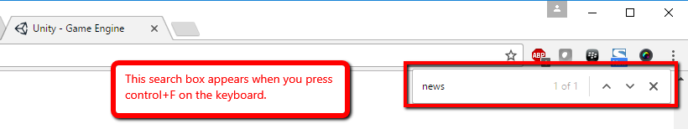

*If you cannot find where to subscribe: Close the tab, and return to EMMA. Then click the red "I couldn't find where to subscribe" button. The page will refresh and a new publisher will be loaded, for you to repeat the process.*



**5)** Once you have found the newsletter subscribe section, paste the special email address into the email field. This can be done by pressing control + V or by right-clicking in the email box on the website and choosing "paste" from the pop-up menu.

**6)** Fill in any other information which the website has marked as "mandatory" (usually shown with a * sign next to the text box). For name, always use the name "Michael Knuff".

**7)** Subscribe to the newsletter. Sometimes you will have to choose what kind of content you want to receive, typically with a bunch of checkboxes. This is sometimes formulated as "Tell us about your interests" or similar. In this case, select all possible checkboxes. You will then usually be presented with a message like "You have now signed up for the newsletter".

*As you may notice, the special email addresses look a bit weird. They have a "+" sign in them, and a number. Sometimes, the websites will not allow such an email address to subscribe.*

*You will then get an error message saying something like "The email address is invalid", or similar.*

*If this happens: Close the tab and return to EMMA. Then click the red "The website did not allow me to subscribe" button.*

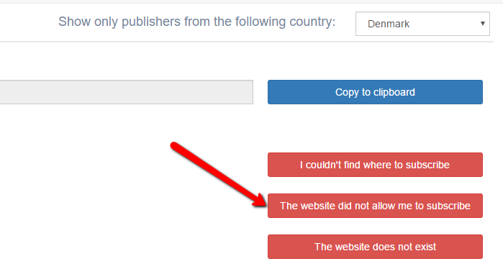

**8)** Close the tab and return to EMMA. Then click the green "I have now subscribed to publisher's newsletter". The page will refresh and a new publisher will be loaded, for you to repeat the progress.

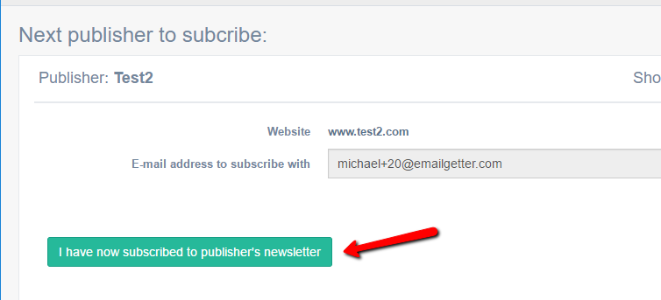

Confirming subscriptions

Often a subscription will need to be "confirmed". This means the company / publisher requires you to click a link in an email they send, before they "activate" your newsletter subscription. This email typically arrives within minutes of subscribing on their website.

Therefore we have designed the workflow, so everytime we subscribe to a newsletter, it is marked as "unconfirmed". We must manually confirm newsletters, before EMMA finally considers them "confirmed" / completed.

**To confirm subscriptions:**

**1)** Click the "Unconfirmed subscriptions" in the top navigation bar.



**2)** You should now be presented with a random unconfirmed email, like the below.

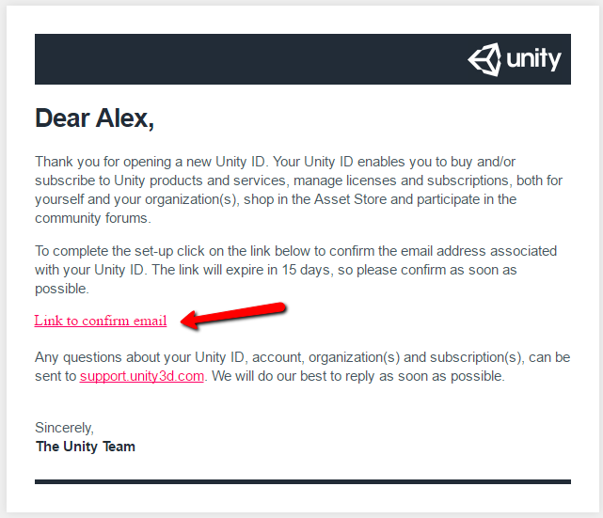

Find the confirmation link in the email and click it.

Note that not all publishers will require you to click a confirm link. Sometimes it is just a welcome email, without any special instructions.

**3)** Click the green “I have now confirmed the publisher’s newsletter” button. Do this both if you have clicked a link, or if the email did not require a click.

The red “I couldn’t find where to confirm” button, will most likely never be used. The only case where it should be used if the email asks you to confirm the subscription, but you can’t find any confirm link.

