Assimilating model outcomes with seasonally resolved paleoclimate data: Methods and considerations
Niels J. de Winter, Michiel Baatsen, Pepijn Bakker, Alexander Farnsworth, Barbara Goudsmit-Harzevoort, Brendan Oerlemans, Rob Witbaard, Martin Ziegler
Abstract
Data assimilation techniques are becoming increasingly prevalent in the paleoclimate literature, providing a basis for contrasting and combining paleoclimate reconstructions and climate model simulations on various temporal and spatial scales. At the same time, analyses of highly-resolved climate archives delivers information about ancient climates on increasingly fine temporal scales, resolving seasonal to monthly climate variability or beyond. These high-resolution reconstructions have not yet been implemented in data assimilation frameworks, likely because these datasets remain comparatively scarce. Here, we present and test a routine for assimilating sub-annual paleoclimate data with monthly climate model simulations. The aim of this contribution is to lay the groundwork for data assimilation of paleoclimate data on the seasonal to monthly scale, making data assimilation accessible for sclerochronologists, and explore the sensitivity of data assimilation outcomes to the quality of paleoclimate data and decisions made in the assimilation routine.
- Introduction
Ancient climates hold crucial information about background climate variability and the sensitivity of Earth’s climate to perturbations (He et al., 2023; von der Heydt et al., 2021; Westerhold et al., 2020). This archive facilitates the tuning and testing of climate models developed to project climates dissimilar to those sampled in our instrumental records (Burke et al., 2018; Goudsmit-Harzevoort et al., 2023; Lunt et al., 2024; Tierney et al., 2020). Such models play an important role in informing strategies to mitigate and adapt to the present and future consequences of anthropogenic climate and environmental change (IPCC, 2021; Meinshausen et al., 2020). However, the various spatio-temporal distribution of climate model outcomes and proxy-based climate reconstructions complicates comparison between these two sources of data.
Data assimilation (DA) holds promise to overcome this distribution problem by combining paleoclimate proxy data and models into a coherent data product while propagating their uncertainties and distributions in a Bayesian framework (Hakim et al., 2016; Okazaki and Yoshimura, 2017; Tierney et al., 2025). The principles of paleoclimate data assimilation (paleoDA) are explained in more detail in (Tierney et al., 2025) and references therein. Briefly, paleoDA extracts climate model outcomes for a target period to inform a “prior” for the state of climate. Proxy values for this prior state are then forward-modelled using Proxy System Models (Evans et al., 2013) to allow direct comparison between the model prior and proxy data. This proxy-model comparison in the proxy domain (the “innovation”) is used to update our prior information of the climate state through the Kalman filter (Kalman, 1960; Steiger et al., 2014). The Kalman filter allows propagation of the covariance between models, climate variables, locations, time slices and between the model and proxy data while considering uncertainties on the inputs. This allows updating of aspects of the climate state that were not directly sampled by proxy information through the covariance within the prior. The result is a “posterior” data product, which should ideally represent our best estimate of the state of past climate. Additionally, the difference between the prior and posterior shows how much the proxy data informs our knowledge of past climate, and yields information about proxy-model mismatches. These can in turn lead to development of better model simulations (Lunt et al., 2024), inform better proxy data coverage and enhance our understanding of proxy systems (Hao et al., 2025).
PaleoDA has been applied increasingly frequently on paleoclimate datasets in recent years (Hakim et al., 2016; Judd et al., 2024; Osman et al., 2021; Tierney et al., 2020). These studies show that the technique (sometimes referred to as “reanalysis”; (Bengtsson et al., 2007)) effectively resolves differences in spatial distribution of proxy and model data, which are known to bias our understanding of past climate (Hao et al., 2025; Judd et al., 2020; Mann et al., 2007). The degree by which DA is able to reconcile differences in time resolution between climate model simulations and proxy data is, however, limited by our understanding of the timing of climate variables recorded in our climate proxies. Seasonal biases in proxy data are most notable in this respect (Bova et al., 2021; Liu et al., 2014), and become increasingly problematic in more ancient reconstructions (Carré and Cheddadi, 2017; Ivany and Judd, 2022).
Seasonally resolved proxy records can help identify and overcome these seasonal biases in proxy data (Carré and Cheddadi, 2017). A wide range of archives exist that record information on seasonal scale change in climate variables, including corals (Brocas et al., 2016; Gagan et al., 1994; Watanabe et al., 2001), sclerosponges (Lazareth et al., 2000; McCulloch et al., 2024), speleothems (Van Rampelbergh et al., 2014b, a; Vansteenberge et al., 2019), tooth bioapatite (De Winter et al., 2016; Fricke et al., 1998; Sharp and Cerling, 1998), brachiopod (Garbelli et al., 2022; Mii and Grossman, 1994) and mollusc shells (Caldarescu et al., 2021; Ivany, 2012; de Winter et al., 2020a, 2021). Brachiopod and mollusc shells are arguably most relevant for overcoming seasonal bias in ancient climates because of their potential to preserve their original chemical composition, and the sub-annual climate information encoded within it, on long geological timescales (tens to hundreds of millions of years; e.g. (Alberti et al., 2017; Henkes et al., 2018; Ivany and Runnegar, 2010; Posenato et al., 2022; de Winter et al., 2017). As such, the application of sclerochronology, the study of incrementally growing carbonate archives, on deep time fossils has gained increased attention in recent years. Additionally, development of the “clumped isotope” proxy on fossil mollusc shells overcomes inherent bias in carbonate-based temperature reconstructions, which predominantly rely on oxygen isotope paleothermometry, by resolving seasonal temperature variability independent from assumptions of the isotopic composition of water in ancient oceans (Caldarescu et al., 2021; Henkes et al., 2018; Meckler et al., 2022; de Winter et al., 2021, 2022).
While recent paleoDA studies assimilate proxy and model information on seasonal to monthly scales (Franke et al., 2017; King et al., 2021), seasonally-resolved proxy records have, to our knowledge, not yet been included in paleoDA studies. As a consequence, sub-annual scale variability in climate parameters is either not included in paleoDA products (e.g. (Judd et al., 2024; Osman et al., 2021)) or indirectly included in proxy-system models through estimates of the growing seasons of organisms producing proxy records (Evans et al., 2013; King et al., 2021).
Here, we present a data assimilation framework for combining sub-annually resolved carbonate clumped (Δ₄₇) and stable oxygen isotope (δ¹⁸O_{c}) proxy data with model outcomes on the monthly and seasonal scale. The aim of this contribution is twofold: Firstly, we provide a detailed methodology for data assimilation at the sub-annual scale to make the paleoDA workflow accessible for researchers in the field of sclerochronology. Secondly, we apply our paleoDA framework to modern and ancient seasonal proxy datasets to test the sensitivity of the paleoDA “posterior” to proxy data characteristics and choices made in the assimilation routine.
- Data and methods
2.1 Input data
We assimilated General Circulation Model (GCM) outcomes with proxy data for four case studies: One modern dataset and three datasets consisting of paleoclimate reconstructions on the monthly or seasonal scale.
2.1.1 Modern case study
A modern case study was assimilated based on the seasonal-scale clumped isotope dataset obtained from two bivalve shells (Megapitaria aurantiaca and Argopecten ventricosus) from the Gulf of Panama (7°30’ - 9°01’ N, 78°10’ - 80°40’ W) originally presented in (Caldarescu et al., 2021). We used the original clumped isotope dataset as published in the EarthChem database (Caldarescu et al., 2020) as our likelihood for this assimilation. This data is presented only against sample number, but the study mentions that daily increments are visible and counted in the shells. We therefore reconstructed the estimated date of shell formation by linking the number of counted increments to the sample number for each interval of counted increments in the shells based on the information in section 3.2, Table 1 and Figure 3 in the study. For the Megapitaria aurantiaca specimen, we assumed the last-grown sample (ontogenetically oldest sample: #115) to represent shell growth on October 1st. For Argopecten ventricosus, the outermost sample (ontogenetically oldest sample: #2) was assumed to have grown on June 1st. For both specimens, these ontogenetically oldest samples are assumed to have mineralized in 2004 (during the last year before the collection date in February 2005). While this is far from certain, it does not influence the data assimilation outcome, as all data is processed relative to the annual cycle. From these dates, using the numbers of daily growth increments, we were able estimate the day of growth for each sample in both shells by counting back the days. All calculations associated with this data pre-processing step are provided in SI_Caldarescu_preprocessing.
We used mean monthly outcomes for the period 1995 2014 CE from the ensemble of CMIP6 (Eyring et al., 2016) GCM simulations for sea surface temperature (SST; 28 models), surface air temperature (SAT; 35 models) and precipitation (34 models), obtained through the IPCC Interactive Atlas (Iturbide et al., 2022) as prior estimates for these climate variables. Sea surface salinity (SSS) was not available for the CMIP6 ensemble through the Interactive Atlas and was therefore obtained from the calibrated global Soil Moisture and Ocean Salinity (SMOS) L-band radiometer measurements by the European Space Agency (ESA; (Font et al., 2013)) for the period between 2010 and 2018 CE. To validate the outcome of the data assimilation for this modern case study, we used data from the nearby Isla Senorita and Punta Culebra marine monitoring stations obtained through the Smithsonian Tropical Research Institute (Smithsonian Tropical Research Institute, 2025) and the World Ocean Atlas version 2023 (Locarnini et al., 2013; Reagan et al., 2024).
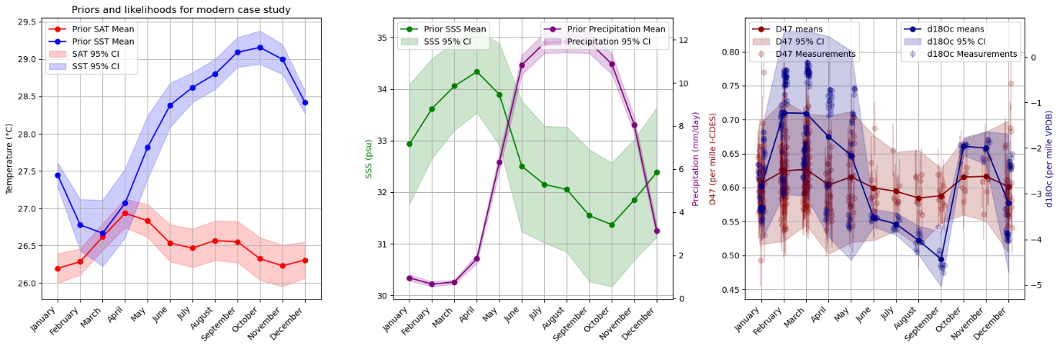
Figure 1: Modern PRIOR (monthly model) and LIKELIHOOD (individual D47 and d18Oc data)
2.1.2 Pliocene case study
A case study focused on the Pliocene Warm Period (PWP) was assimilated based on Δ₄₇ and δ¹⁸O data from 7 shells from 6 different bivalve species dated to within the mid-Piazencian Warm Period (3.3 – 3.0 Ma) of the North Sea Basin (de Winter et al., 2024). Clumped and oxygen isotope data was not further processed for this study and used to form the likelihood for data assimilation. By default, isotope data was aggregated into monthly time bins before assimilation, propagating measurement uncertainty. However, since this dataset contains a detailed internal age model with uncertainty estimation per datapoint (see (de Winter, 2022) for details on the statistical treatment of these uncertainties), we use this dataset to assess the impact of internal dating uncertainty on paleoDA outcomes by propagating the dating uncertainty through the assimilation and aggregating data and model outcomes in both monthly and seasonal (three-monthly) bins.
As a prior estimate for the climate state in the Pliocene North Sea, monthly SST, SAT, SSS and precipitation outcomes were extracted from local ocean grid cells (51°N to 55°N, 2°E to 4°E) in the Pliocene Model Intercomparison Project phase 2 (PlioMIP2) assimilated (Haywood et al., 2016). Model uncertainties were calculated from variability between grid cells.
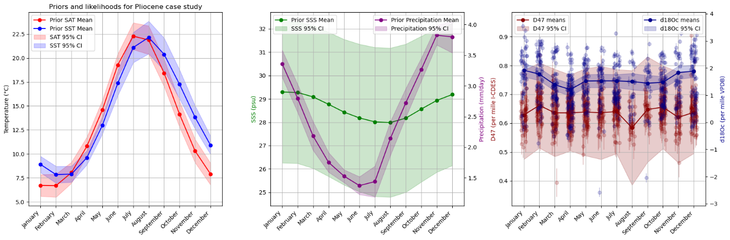
Figure 2: Pliocene PRIOR (monthly model) and LIKELIHOOD (individual D47 and d18Oc data)>
2.1.3 Eocene case study
A second paleoDA case study was based on a high-resolution clumped and oxygen isotope dataset obtained from the giant marine gastropod Campanile giganteum from the Lutetian (middle Eocene, ~45 Ma) Paris Basin in northern France (49°06’05”N; 3°52’54”E; (de Winter et al., 2020b). The clumped and oxygen isotope data originally published in (Van Horebeek et al., 2025) was used as the likelihood for this paleoDA. Data was aggregated into monthly bins using the age model presented in the original study, and uncertainty on the age assignment was considered to be within these monthly bins.
The prior estimate of Lutetian SST, SAT, SSS and precipitation seasonality in the Paris Basin was based on simulations by the Community Earth System Model (CESM; (Danabasoglu et al., 2020)) identical to those used in the original study presenting C. giganteum clumped isotope data (Van Horebeek et al., 2025) which were presented and discussed in (Baatsen et al., 2020). Monthly averages for SST, SAT, SSS and precipitation were extracted for model grid cells with latitudes between 37°N and 47°N and longitudes between 5°E and 15°E consistent with the paleo-location of the Paris Basin (Gély and Merle, 2008). Uncertainties on model outcomes were propagated from variability between grid cells within the area of interest.
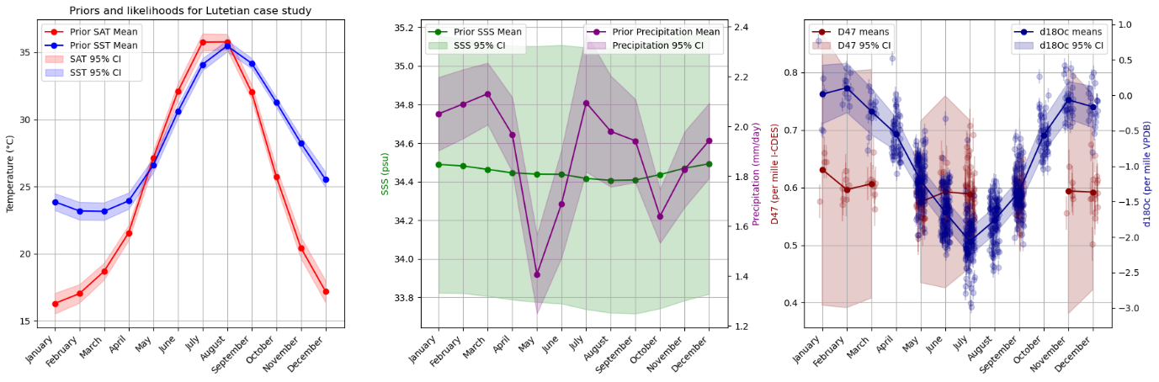
Figure 3: Lutetian PRIOR (monthly model) and LIKELIHOOD (individual D47 and d18Oc data)>
2.1.4 Cretaceous case study
A third case study was assimilated based on clumped and oxygen isotope data from three fossil mollusc shells from the Campanian (~78 Ma) Kristianstad Basin (56°2’ N, 14° 9’ E) in southern Sweden (de Winter et al., 2021). The isotope data were assigned to monthly time bins such that the warmest months of each specimen are aligned. Uncertainty on the age alignment was considered to be within the monthly time bins. Since the clumped isotope ratios (Δ₄₇) in (de Winter et al., 2021) were originally reported relative to the Carbon Dioxide Equilibrium Scale (CDES) with an acid digestion temperature of 25°C, a 0.071‰ correction factor was applied to bring the values into the now-standard I-CDES scale (Petersen et al., 2019). Note that the acid digestions for the clumped isotope measurements in this dataset were originally done at 70°C, so this acid correction factor was previously applied to bring the data into the then-standard 25°C reference frame (see Methods in (de Winter et al., 2021)) and is now simply reversed.
The prior estimates for SST, SAT, SSS and precipitation were based on simulations of Campanian (78 Ma) climate using the HadCM model (version HadCM3BL-M2.1aE) using a 4 times pre-industrial pCO₂ radiative forcing (details in (de Winter et al., 2021). The simulation is identical to the 4x pCO₂ simulation for presented for the Campanian in (Farnsworth et al., 2019). Model data for the target parameters was extracted from the climate fields for the area of interest (42.5-50°N, 7.5-15°E paleolatitude, calculated based on (van Hinsbergen et al., 2015)) and variability between grid cells within the area was propagated into the assimilation result as uncertainty.
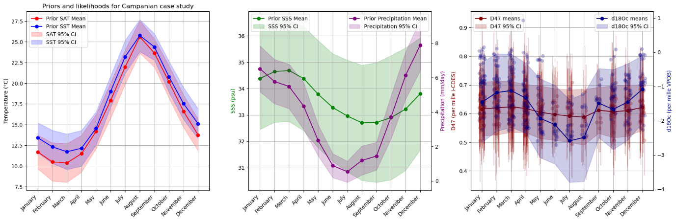
Figure 4: Campanian PRIOR (monthly model) and LIKELIHOOD (individual D47 and d18Oc data)
2.2 Data assimilation routine
Below follows a step-by-step breakdown of the data assimilation routine used for this study. All calculations were carried out in Python (Python Software Foundation, 2025) using Jupyter Notebooks (Kluyver et al., 2016) to track each step in the procedure and allow us to show in-between results. We provide all these Notebooks along with the data required to run them on an open online repository on GitHub (de Winter, 2025). A stable release of this data and code package will be released on the open source repository Zenodo prior to publication. All data processing was done in the open-source text editor Microsoft Visual Studio Code (Microsoft, Redmond, Washington, U.S.) interfaced with GitHub Copilot (GitHub and OpenAI, 2025).
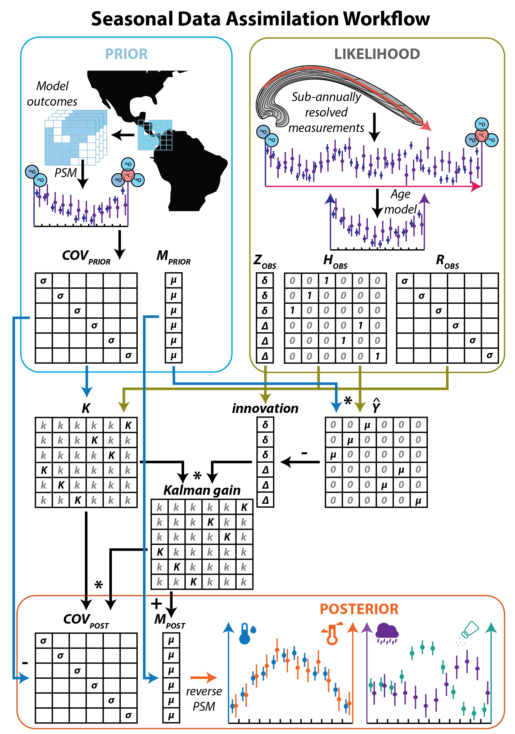
Figure 5: Flow chart DA routine
2.2.1 Data pre-processing
Data from both model simulations and reconstructions are pre-processed to align them on the same time and parameter scale. The default form in which we assimilated model outcomes with data is as means and variances of proxy values in monthly time bins.
On the model side, this means that model data from the area of interest has to first be extracted from model climate fields and then converted from climate parameter into proxy space. The former was done by extracting and combining values for the four assimilated climate variables (SST, SAT, SSS and precipitation) from each grid cell in the area of interest for each month, if applicable combining outcomes from multiple models. The variance amongst values for the same climate parameter in the same month was taken as a measure of the uncertainty on the model simulation outcome and, together with the covariance between months, propagated through the routine.
Outcomes were converted to the proxy domain using existing relationships between proxies and climate parameters. Clumped isotope values were forward-modelled from model SST and SAT outcomes using the Omnivariant Generalized Least Squares regression by (Daëron and Vermeesch, 2023) with the associated “D47calib” package which allows us to propagate full uncertainties on and covariances between the input variables along with uncertainties on the clumped isotope calibration onto the end result. Carbonate stable oxygen isotope values were estimated from SST and SSS model outcomes by first estimating water oxygen isotopes (δ¹⁸O_{w}) from SSS using a local δ¹⁸O_{w}-salinity relationship. By default, we use the North Sea δ¹⁸O_{w}-salinity relationship by (Harwood et al., 2008) for this conversion, but we tested the impact of using different δ¹⁸O_{w}-salinity relationships on the data assimilation outcome. As a second step, δ¹⁸O_{c} values were estimated from δ¹⁸O_{w} and SST using the δ¹⁸O_{w}-δ¹⁸O_{c}-temperature relationship for aragonitic biominerals by (Grossman and Ku, 1986) modified to project δ¹⁸O data on the VPDB-VSMOW scale by subtracting -0.27‰ (Dettman et al., 1999; Gonfiantini et al., 1995).
After these conversions, the model outcomes were combined into: 1) A state vector (M_{prior}) listing monthly mean values for SST-derived Δ₄₇, SAT-derived Δ₄₇, SSS- and SST-derived δ¹⁸O_{c} and precipitation (length: 4 * 12 = 48 values) and 2) a covariance matrix (COV_{prior}) listing variances (on the diagonal) and covariances between all monthly model outcomes of these transformed parameters (dimensions: 48 * 48 values).
The reconstruction Δ₄₇ and δ¹⁸O_{c} data was left in its original unit, but needed to be aggregated into monthly time bins for assimilation. This was done using the original internal age models of the datasets used as likelihood data (Caldarescu et al., 2021; Van Horebeek et al., 2025; de Winter et al., 2021, 2024). Alignment of transient Δ₄₇ and δ¹⁸O_{c} data into monthly bins was followed monthly (Van Horebeek et al., 2025; de Winter et al., 2021) or seasonal (Caldarescu et al., 2021; de Winter et al., 2024) data assignment in the original studies. In cases where data was referenced relative to the day of the year, months were assigned by dividing the year into 12 equal time bins. Uncertainty on the timing of Δ₄₇ and δ¹⁸O_{c} datapoints was considered to lie within the monthly bins by default, but the effect of propagating age model uncertainty was tested (see below).
Monthly reconstruction outcomes were prepared for assimilation by forming three matrices: 1) A measurement matrix (Z_{obs}) listing all monthly Δ₄₇ and δ¹⁸O_{c} outcomes in order of appearance in the reconstruction data (length: 2 * 12 = 24 values). 2) An observation matrix (H_{obs}) linking the index of each monthly measurement in Z_{obs} to the index of the corresponding monthly model parameter in the state vector M_{prior} by representing each combination of monthly Δ₄₇ and δ¹⁸O_{c} value with its corresponding SST- Δ₄₇ and SSS- δ¹⁸O_{c} value with a 1 in H_{obs} and assigning all other values in the observation matrix the value 0 (dimensions: 24 * 48 values). 3) Finally, the propagated uncertainties on monthly reconstruction data were listed in order of appearance on the diagonal of an uncertainty matrix (R_{obs}; dimensions: 24 * 24), of which all non-diagonal positions were given the value 0. The latter represents the fact that the reconstructions are statistically independent (while the climate parameters in the model outcomes are not).
2.2.2 Data assimilation
Reconstruction and model data were assimilated through an offline Kalman filter (Kalman, 1960), meaning that all data is assimilated at one time (batch processing). The Kalman filter, or linear quadratic estimator, minimizes the mean square error of the parameters in the end result (posterior) by estimating an optimal joint posterior distribution. Kalman filtering assumes that the uncertainty around the parameters being estimated is normally distributed, which is one of the main reasons why assimilation is done in the proxy domain: The uncertainty on proxy measurements is often produced by a stochastic process that can be approximated with a normal distribution (e.g. shot noise in Faraday cups in mass spectrometry; (Appelblad et al., 2001)). The fact that Kalman filtering is comparatively analytically straightforward and the fact that proxy data uncertainty can often be considered normally distributed has made the Kalman filter the most common posterior estimator in paleoDA (Hakim et al., 2016; Judd et al., 2024; Osman et al., 2021; Steiger et al., 2014). To apply Kalman filtering, we first calculated the matrix K from the prior covariance, the observation matrix and the uncertainty matrix:
$$K={COV}_{prior}∙{H_{obs}}^{T}∙{\left({H_{obs}∙COV}_{prior}∙{H_{obs}}^{T}+R_{obs}\right)}^{-1}$$
The K-matrix is a matrix with dimensions opposite to the observation matrix (48 * 24). It links the uncertainty in the reconstructions (R_{obs}) to the covariance in the models (COV_{prior}) and the connection between reconstructions and model parameters (H_{obs}) to “distribute” the new information gained by the reconstructions over the model parameters. To do so, first the innovation is calculated. The innovation represents this “new information” that is gained by adding the reconstructions to the assimilation and is defined as the difference between the reconstructions and the model predictions for the same parameters:
$$innovation=Z_{obs}-\hat{Y}$$
With:
$$\hat{Y}=H_{obs}∙M_{prior}$$
The innovation is a vector with the same length as the measurement matrix. Finally, the Kalman gain is calculated by multiplying the K-matrix with the innovation:
$$Kalman gain=K∙innovation$$
The Kalman gain is a vector with the same length as the state vector (M_{prior}) and can therefore be used to directly update the state vector to obtain the posterior state vector (M_{post}):
$$M_{post}=M_{prior}+Kalman gain$$
The posterior covariance matrix (COV_{post}) is obtained by updating the prior covariance matrix with the innovation in terms of estimate uncertainty which follows from combining the K-matrix with the prior covariance matrix:
$${COV}_{post}={COV}_{prior}-Kalman gain∙K∙{COV}_{prior}$$
The posterior state vector and covariance matrix represent the updated state of the climate parameters after data assimilation.
2.2.3 Converting posteriors into climate parameter space
The final step in the data assimilation routine is the conversion of posterior estimates of proxy values and their uncertainties back into the climate parameter space. For the SST and SAT parameters, this is achieved by reapplying the Omnivariant Generalized Least Squares clumped isotope temperature calibration (Daëron and Vermeesch, 2023) in reverse direction to obtain monthly posterior temperature estimates and their variance. The “D47calib” package allows this conversion back into temperature space while propagating uncertainties on the posterior Δ₄₇ estimate as well as on the regression equation.
Posterior monthly δ¹⁸O_{w} estimates are obtained by inverting the updated δ¹⁸O_{w}-δ¹⁸O_{c}-temperature equation (Grossman and Ku, 1986) to solve for the δ¹⁸O_{w} value:
$${δ{}_{}^{18}O}_{w,post}={δ{}_{}^{18}O}_{c,post}-\frac{20.6-{SST}_{post}}{4.34}+0.27‰$$
The covariance on the posterior δ¹⁸O_{w} estimates can be obtained by applying the square derivative of this equation to the posterior covariance matrices of δ¹⁸O_{c} and SST:
$${COV}_{{δ{}_{}^{18}O}_{w,post}}={COV}_{{δ{}_{}^{18}O}_{c,post}}+{\left(\frac{1}{4.34}\right)}^{2}*{COV}_{{SST}_{post}}$$
To calculate the posterior SSS estimate, the SSS-δ¹⁸O_{w} equation is applied in a similar way to the posterior δ¹⁸O_{w} estimates and their covariance matrix. In the case of the North Sea (Harwood et al., 2008) equation, the calculations are as follows:
$${SSS}_{post}=\frac{\left({δ{}_{}^{18}O}_{w,post}+7.89\right)}{0.23}$$
$${COV}_{SSS,post}={\left(\frac{1}{0.23}\right)}^{2}*{COV}_{{δ{}_{}^{18}O}_{w,post}}$$
For plotting, the standard deviations of posterior covariance matrices are derived by taking the square root of the diagonal of the posterior covariance matrix.
2.2.4 Validating the posterior estimates
For the modern case study, it is possible to validate the posterior outcome of the data assimilation by comparing posterior estimates to in situ measurements of the climate parameters in the area (see section 2.1.1). These measurements were aggregated into monthly means and variances to allow direct comparison with the DA outcome.
2.3 Sensitivity experiments
With the data assimilation protocol in place, it becomes possible to test the effect of certain choices in data treatment and input on the assimilated result. We believe this important, because such choices (e.g. whether or not to fully propagate uncertainty, which model boundary conditions to use, and which calibration or transfer functions to use to relate between variables) are often made in the paleoclimate literature without strict consensus on best practices. Through the sensitivity experiments below, we hope to show the added value of data assimilation for assessing the impact of data treatment choices both on proxy-model comparisons and on our “best estimate” of what sub-annual climate variability looked like in the geological past.
2.3.1 Treatment of proxy uncertainty in time domain
Throughout our data assimilation routine, we have chosen by default to assimilate proxy and model data in monthly time bins. This is in accordance with the default output of most GCMs and therefore facilitates proxy-model comparison. However, it is not always straightforward to align deep-time proxy data to monthly bins as no calendar dates are known for this data and models can have different calendar systems (see the “Calendar Problem”; (Shi et al., 2022)). This alignment procedure therefore often assigns months based on their mean temperature, for example by aligning the warmest 1/12th-of-the-year time bin to the warmest month in the mean model outcomes, as is common in the datasets used in this study (see 2.2.1 and e.g. (de Winter et al., 2021, 2024)). Furthermore, the internal age models of seasonally-resolved climate records comes with its own uncertainty, which is often not considered in reconstructions since it is hard to estimate.
To test the impact of these two potential sources of variability between data assimilation products, we carried out two sensitivity studies:
Firstly, we assimilate our Pliocene case study both on monthly and seasonal scale. Seasons are, in this case, defined as three-monthly (quarter-year) time bins, sensu (de Winter et al., 2024).
Secondly, we use uncertainties on sub-annual age models through climate records in the Pliocene case study calculated using the ShellChron routine with Monte Carlo uncertainty estimation (de Winter, 2022) to propagate the impact of internal dating uncertainty on the data assimilation product and proxy-model comparison. To do so, we assigned a probability of each datapoint belonging to any of the monthly time bins in the observation matrix H_{obs} (see 2.2.1) by representing each combination of a sample and a time bin with a value between 0 and 1 representing this probability. These probabilities were calculated by using a wrapped normal distribution:
$$H_{sample,t}=\frac{N\left(t,μ=T_{sample},σ=σ_{T}\right)}{\sum{\left(N\left(t,μ=T_{sample},σ=σ_{T}\right)\right)}}for t in B$$
Here, each entry for the sample in the observation matrix for a given time bin t (H_{sample,t}) is described by the relative probability that that sample falls within that time bin. This probability is described by a normal distribution with the mean age of the datapoint (T_{sample} in days of the year) as the mean of the distribution and the uncertainty on the sample age (σ_{sample} in days of the year) as the standard deviation of the distribution. The collection B describes the range of possible time bins (e.g. 12 in the case of monthly time binning). Assigning these probabilities to the observation matrix ensures that the weight of each datapoint in the assimilation is proportional to the chance that that datapoint belongs to the time bin in question. The data assimilation is otherwise identical to the default case where time uncertainty is ignored (see 2.2.1).
2.3.2 Propagating proxy measurement uncertainty
To test the effect of proxy uncertainty on the data assimilation, we assimilated different versions of the modern case study while artificially varying uncertainties on Δ₄₇ and δ¹⁸O_{c} in the likelihood. To do so, we artificially increased or decreased the standard deviation of measurement precision for Δ₄₇ and δ¹⁸O_{c} data by a factor of 10, and repeated the data assimilation procedure for cases where only Δ₄₇ precision or only δ¹⁸O_{c} precision were increased/decreased and cases where both proxies were artificially rendered more or less precise. We also tested the effect of assimilating individual Δ₄₇ and δ¹⁸O_{c} datapoints one-by-one versus aggregating likelihood data in monthly time bins first before assimilation. In the first case, we applied the enhanced or reduced precision described above to individual datapoints, while in the latter case we increased or decreased the precision of the aggregated monthly proxy value.
2.3.3 Assimilating multiple proxies
Since both Δ₄₇ and δ¹⁸O_{c} are related to the same climate variable (SST), we tested the impact of assembling only Δ₄₇ or only δ¹⁸O_{c} information on the posterior of the modern case study. This allows us to discuss the impact of potential “feedback” mechanisms in our data assimilation procedure caused by the “competition” of two sources of proxy data for updating the variance of the same climate variable. To do this, we simply removed the likelihood information from the other proxy variable from the assimilation routine and compared the outcomes with and without both Δ₄₇ and δ¹⁸O_{c} data.
2.3.4 Treatment of uncertainty and choice in proxy-forward models
Two potentially significant choices are made in our data assimilation procedure to link δ¹⁸O_{c} proxy data climate variables: Firstly, the δ¹⁸O_{w}-δ¹⁸O_{c}-temperature calibration by (Grossman and Ku, 1986) modified by (Dettman et al., 1999; Gonfiantini et al., 1995) is used by default (see 2.2.1 and 2.2.3) while there are other options for correlating aragonitic δ¹⁸O_{c} values to temperature and δ¹⁸O_{w} (e.g. (Kim et al., 2007; Lécuyer et al., 2012) Secondly, we use the North Sea SSS-δ¹⁸O_{w} relationship by (Harwood et al., 2008) to link δ¹⁸O_{c} values to SSS values by default, but it is well known that this relationship varies across ocean basins (LeGrande and Schmidt, 2006). We therefore carried out sensitivity experiments for our data assimilation routine by assimilating proxy data with model priors for the Pliocene case study using three different δ¹⁸O_{w}-δ¹⁸O_{c}-temperature relationships (Grossman and Ku, 1986; Kim et al., 2007; Lécuyer et al., 2012) and four different SSS-δ¹⁸O_{w} relationships ((Harwood et al., 2008) for the North Sea, (Graniero et al., 2017) for the Gulf of Panama and both the icehouse and greenhouse model by (Railsback et al., 1989)).
2.3.5 Variation in model boundary conditions
Finally, since the prior state of our data assimilations is based on model outcomes, we included a sensitivity test to assess the fact of model boundary conditions on the data assimilation outcome. Needless to say, GCMs have many boundary conditions, and exploring the effects of all of them would vastly increase the scope of this study. We therefore only consider the impact of variations in radiative forcing in this study, but note that the impact of other model conditions can (and should) be explored in paleoDA studies to assess the sensitivity of posterior outcomes to model choices. We tested the sensitivity of our DA protocol on the Lutetian case study by assimilating the same proxy data with prior climate state (SST, SAT, SSS and precipitation) information from two different models run with varying radiative forcing (here expressed in terms of atmospheric pCO₂): The HadCM model (also used for the Cretaceous case study) run with atmospheric pCO₂ concentrations of 280 ppm, 560 ppm and 1120 ppm and the CESM model (same as the default Lutetian case study) run with 2x (560 ppm) and 4x pre-industrial (1120 ppm) atmospheric pCO₂ concentrations.
Results
- Fully assimilated default posteriors for all case studies + compare data and model information on different parameters
- Model priors, reconstruction likelihoods, posterior estimates and aggregated measurement data for the modern case study using the default choices for assimilation are plotted in Figure 6.
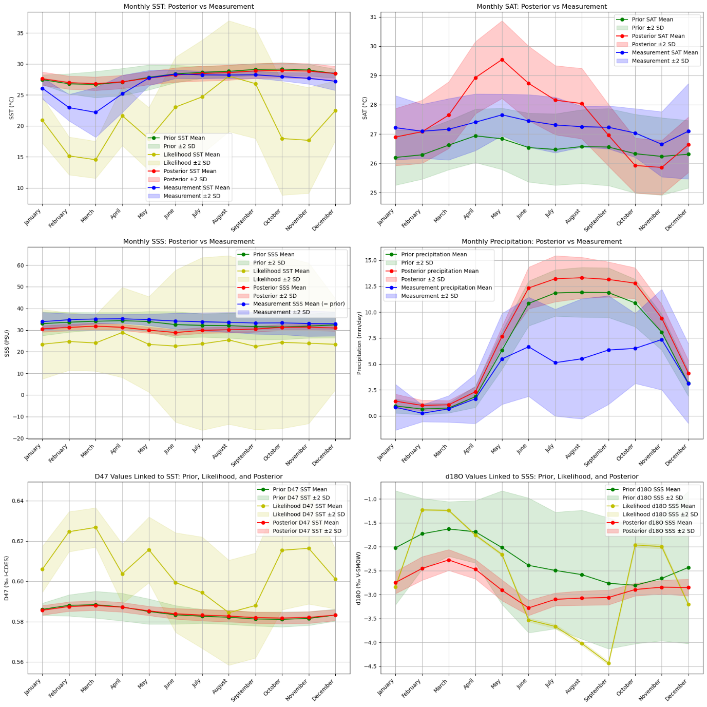
Figure 6: Data assimilation model priors (green), reconstruction likelihood (yellow) and posterior estimates (red) for the modern case study compared to local measurements (blue).
- Compare different ways of treating proxy data and time uncertainty
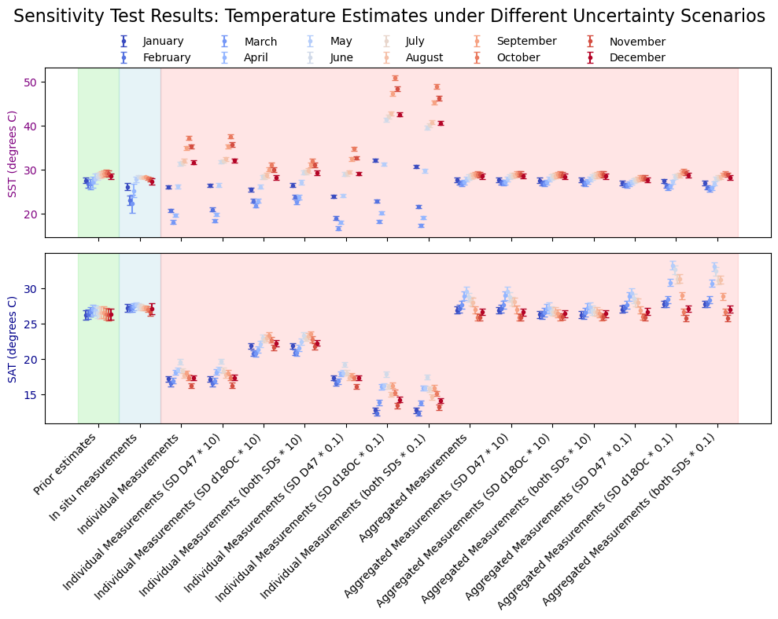
Figure 7: Effect of uncertainty on proxy values on posterior precision and accuracy in the proxy domain (green = model prior, blue = in situ measurement, red = posteriors)
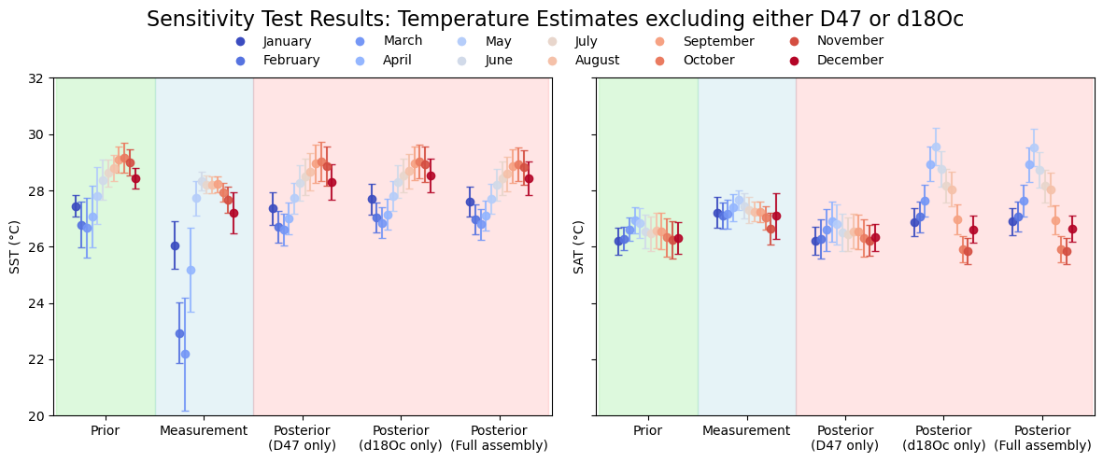
Figure 8: Effect of including or excluding d18Oc or D47 from the data assimilation on SST and SAT outcomes
- Sensitivity to assembling different climate variables (exclude precip and SAT?)
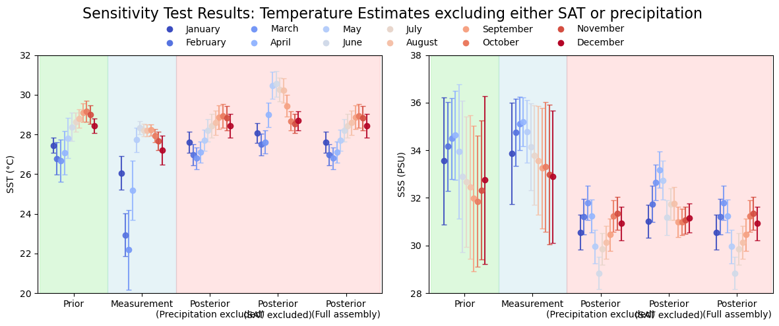
- Comparison different d18Oc-hydrology treatments (Harwood vs assuming -7 permille?)
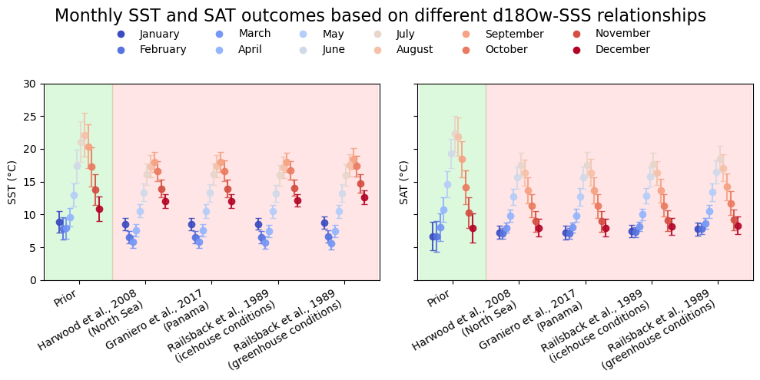
Figure 9: Effect of SSS-d18Ow relationships on assimilation posteriors
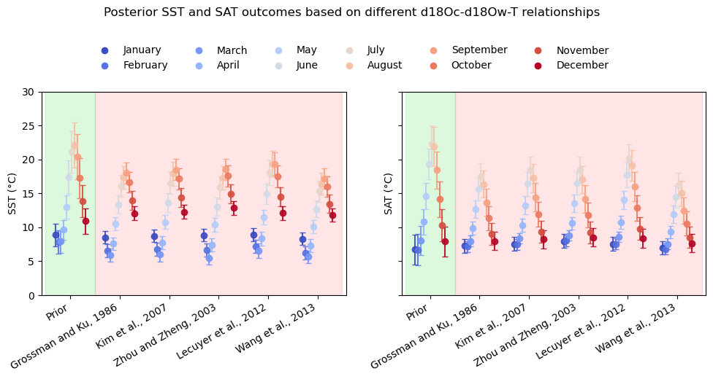
Figure 10: Effect of different δ¹⁸O_{w}-δ¹⁸O_{c}-temperature equations
- Sensitivity of PWP result to different pCO2 forcing in models
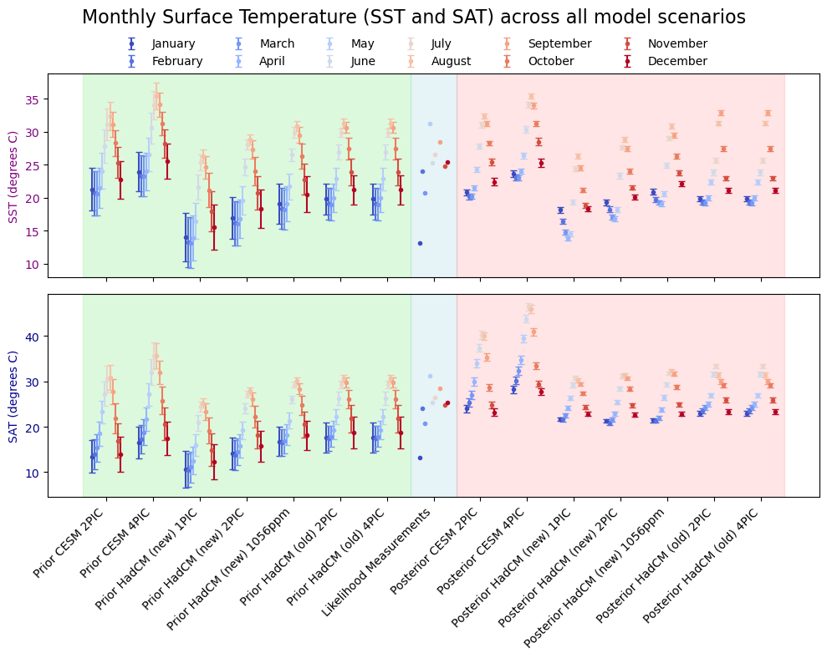
Figure 11: Comparison of assimilations of Lutetian case study with different models and different pCO2 forcing
- Assembling measurements as priors instead of model priors for SSS and/or SST
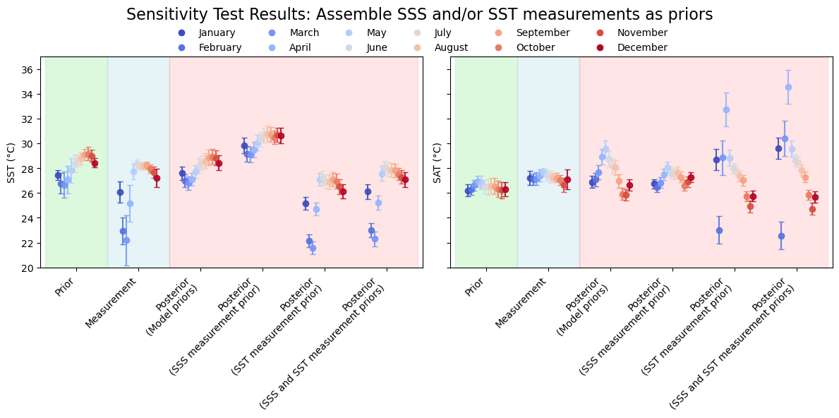

Discussion
- Where do proxy and model outcomes agree or disagree?
- Quality of proxy data and transfer functions vs bias in models?
- How to weigh proxy vs model information?
- Can seasonal proxy data be used to inform or tune modelling efforts?
- How powerful is DA for inferring structure of un-sampled climate parameters?
Outlook and recommendations
- Which proxy(-forward model) improvements are the best to focus on to improve our ground-truth information for model assessment?
- What model biases can be highlighted and how might they be addressed?
- Any technical improvements in the DA script needed to better assimilate these data types?
References
Alberti, M., Fürsich, F. T., Abdelhady, A. A., and Andersen, N.: Middle to Late Jurassic equatorial seawater temperatures and latitudinal temperature gradients based on stable isotopes of brachiopods and oysters from Gebel Maghara, Egypt, Palaeogeography, Palaeoclimatology, Palaeoecology, 468, 301–313, https://doi.org/10.1016/j.palaeo.2016.11.052, 2017.
Appelblad, P. K., Rodushkin, I., and Baxter, D. C.: Sources of Uncertainty in Isotope Ratio Measurements by Inductively Coupled Plasma Mass Spectrometry, Anal. Chem., 73, 2911–2919, https://doi.org/10.1021/ac001537y, 2001.
Baatsen, M., von der Heydt, A. S., Huber, M., Kliphuis, M. A., Bijl, P. K., Sluijs, A., and Dijkstra, H. A.: The middle to late Eocene greenhouse climate modelled using the CESM 1.0.5, Climate of the Past, 16, 2573–2597, https://doi.org/10.5194/cp-16-2573-2020, 2020.
Bengtsson, L., Arkin, P., Berrisford, P., Bougeault, P., Folland, C. K., Gordon, C., Haines, K., Hodges, K. I., Jones, P., Kallberg, P., Rayner, N., Simmons, A. J., Stammer, D., Thorne, P. W., Uppala, S., and Vose, R. S.: The Need for a Dynamical Climate Reanalysis, Bulletin of the American Meteorological Society, 88, 495–501, 2007.
Bova, S., Rosenthal, Y., Liu, Z., Godad, S. P., and Yan, M.: Seasonal origin of the thermal maxima at the Holocene and the last interglacial, Nature, 589, 548–553, https://doi.org/10.1038/s41586-020-03155-x, 2021.
Brocas, W. M., Felis, T., Obert, J. C., Gierz, P., Lohmann, G., Scholz, D., Kölling, M., and Scheffers, S. R.: Last interglacial temperature seasonality reconstructed from tropical Atlantic corals, Earth and Planetary Science Letters, 449, 418–429, 2016.
Burke, K. D., Williams, J. W., Chandler, M. A., Haywood, A. M., Lunt, D. J., and Otto-Bliesner, B. L.: Pliocene and Eocene provide best analogs for near-future climates, PNAS, 115, 13288–13293, https://doi.org/10.1073/pnas.1809600115, 2018.
Caldarescu, D., Sadatzki, H., Andersson, C., Schäfer, P., Fortunato, H., and Meckler, A. N.: Clumped Isotope Data from Caldarescu et al 2020 Geochimica et Cosmochimica Acta, 2020.
Caldarescu, D. E., Sadatzki, H., Andersson, C., Schäfer, P., Fortunato, H., and Meckler, A. N.: Clumped isotope thermometry in bivalve shells: A tool for reconstructing seasonal upwelling, Geochimica et Cosmochimica Acta, 294, 174–191, https://doi.org/10.1016/j.gca.2020.11.019, 2021.
Carré, M. and Cheddadi, R.: Seasonality in long-term climate change, Quaternaire. Revue de l’Association française pour l’étude du Quaternaire, 28, 173–177, https://doi.org/10.4000/quaternaire.8018, 2017.
Daëron, M. and Vermeesch, P.: Omnivariant generalized least squares regression: Theory, geochronological applications, and making the case for reconciled Δ47 calibrations, Chemical Geology, 121881, https://doi.org/10.1016/j.chemgeo.2023.121881, 2023.
Danabasoglu, G., Lamarque, J.-F., Bacmeister, J., Bailey, D. A., DuVivier, A. K., Edwards, J., Emmons, L. K., Fasullo, J., Garcia, R., Gettelman, A., Hannay, C., Holland, M. M., Large, W. G., Lauritzen, P. H., Lawrence, D. M., Lenaerts, J. T. M., Lindsay, K., Lipscomb, W. H., Mills, M. J., Neale, R., Oleson, K. W., Otto-Bliesner, B., Phillips, A. S., Sacks, W., Tilmes, S., van Kampenhout, L., Vertenstein, M., Bertini, A., Dennis, J., Deser, C., Fischer, C., Fox-Kemper, B., Kay, J. E., Kinnison, D., Kushner, P. J., Larson, V. E., Long, M. C., Mickelson, S., Moore, J. K., Nienhouse, E., Polvani, L., Rasch, P. J., and Strand, W. G.: The Community Earth System Model Version 2 (CESM2), Journal of Advances in Modeling Earth Systems, 12, e2019MS001916, https://doi.org/10.1029/2019MS001916, 2020.
De Winter, N., Snoeck, C., and Claeys, P.: Seasonal cyclicity in trace elements and stable isotopes of modern horse enamel, PLoS ONE, 11, 1, https://doi.org/10.1371/journal.pone.0166678, 2016.
Dettman, D. L., Reische, A. K., and Lohmann, K. C.: Controls on the stable isotope composition of seasonal growth bands in aragonitic fresh-water bivalves (unionidae), Geochimica et Cosmochimica Acta, 63, 1049–1057, https://doi.org/10.1016/S0016-7037(99)00020-4, 1999.
Evans, M. N., Tolwinski-Ward, S. E., Thompson, D. M., and Anchukaitis, K. J.: Applications of proxy system modeling in high resolution paleoclimatology, Quaternary Science Reviews, 76, 16–28, https://doi.org/10.1016/j.quascirev.2013.05.024, 2013.
Eyring, V., Bony, S., Meehl, G. A., Senior, C. A., Stevens, B., Stouffer, R. J., and Taylor, K. E.: Overview of the Coupled Model Intercomparison Project Phase 6 (CMIP6) experimental design and organization, Geoscientific Model Development, 9, 1937–1958, https://doi.org/10.5194/gmd-9-1937-2016, 2016.
Farnsworth, A., Lunt, D. J., O’Brien, C. L., Foster, G. L., Inglis, G. N., Markwick, P., Pancost, R. D., and Robinson, S. A.: Climate Sensitivity on Geological Timescales Controlled by Nonlinear Feedbacks and Ocean Circulation, Geophys. Res. Lett., 46, 9880–9889, https://doi.org/10.1029/2019GL083574, 2019.
Font, J., Boutin, J., Reul, N., Spurgeon, P., Ballabrera-Poy, J., Chuprin, A., Gabarró, C., Gourrion, J., Guimbard, S., Hénocq, C., Lavender, S., Martin, N., Martínez, J., McCulloch, M., Meirold-Mautner, I., Mugerin, C., Petitcolin, F., Portabella, M., Sabia, R., Talone, M., Tenerelli, J., Turiel, A., Vergely, J.-L., Waldteufel, P., Yin, X., Zine, S., and Delwart, S.: SMOS first data analysis for sea surface salinity determination, International Journal of Remote Sensing, 34, 3654–3670, https://doi.org/10.1080/01431161.2012.716541, 2013.
Franke, J., Brönnimann, S., Bhend, J., and Brugnara, Y.: A monthly global paleo-reanalysis of the atmosphere from 1600 to 2005 for studying past climatic variations, Sci Data, 4, 170076, https://doi.org/10.1038/sdata.2017.76, 2017.
Fricke, H. C., Clyde, W. C., and O’Neil, J. R.: Intra-tooth variations in δ 18 O (PO 4) of mammalian tooth enamel as a record of seasonal variations in continental climate variables, Geochimica et Cosmochimica Acta, 62, 1839–1850, 1998.
Gagan, M. K., Chivas, A. R., and Isdale, P. J.: High-resolution isotopic records from corals using ocean temperature and mass-spawning chronometers, Earth and Planetary Science Letters, 121, 549–558, https://doi.org/10.1016/0012-821X(94)90090-6, 1994.
Garbelli, C., Angiolini, L., Posenato, R., Harper, E. M., Lamare, M. D., Shi, G. R., and Shen, S.: Isotopic time-series (δ13C and δ18O) obtained from the columnar layer of Permian brachiopod shells are a reliable archive of seasonal variations, Palaeogeography, Palaeoclimatology, Palaeoecology, 607, 111264, https://doi.org/10.1016/j.palaeo.2022.111264, 2022.
Gély, J. P. and Merle, D.: La stratigraphie et la paléogéographie du Lutétien en France, Stratotype Lutétien. Muséum National d’Histoire Naturelle, Paris, 182–227, 2008.
GitHub and OpenAI: GitHub Copilot, 2025.
Gonfiantini, R., Stichler, W., and Rozanski, K.: Standards and intercomparison materials distributed by the International Atomic Energy Agency for stable isotope measurements, 1995.
Goudsmit-Harzevoort, B., Lansu, A., Baatsen, M. L. J., von der Heydt, A. S., de Winter, N. J., Zhang, Y., Abe-Ouchi, A., de Boer, A., Chan, W.-L., Donnadieu, Y., Hutchinson, D. K., Knorr, G., Ladant, J.-B., Morozova, P., Niezgodzki, I., Steinig, S., Tripati, A., Zhang, Z., Zhu, J., and Ziegler, M.: The Relationship Between the Global Mean Deep-Sea and Surface Temperature During the Early Eocene, Paleoceanography and Paleoclimatology, 38, e2022PA004532, https://doi.org/10.1029/2022PA004532, 2023.
Graniero, L. E., Grossman, E. L., Robbins, J., Morales, J., Thompson, R., and O’Dea, A.: Conus Shell δ13C values as proxies for δ13CDIC in tropical waters, Palaeogeography, Palaeoclimatology, Palaeoecology, 472, 119–127, https://doi.org/10.1016/j.palaeo.2017.02.007, 2017.
Grossman, E. L. and Ku, T.-L.: Oxygen and carbon isotope fractionation in biogenic aragonite: temperature effects, Chemical Geology: Isotope Geoscience section, 59, 59–74, 1986.
Hakim, G. J., Emile-Geay, J., Steig, E. J., Noone, D., Anderson, D. M., Tardif, R., Steiger, N., and Perkins, W. A.: The last millennium climate reanalysis project: Framework and first results, Journal of Geophysical Research: Atmospheres, 121, 6745–6764, https://doi.org/10.1002/2016JD024751, 2016.
Hao, S., Zhang, X., Duan, Y., Gowan, E. J., Zhu, J., Cauquoin, A., Chen, J., Werner, M., and Chen, F.: Model seasonal and proxy spatial biases revealed by assimilated mid-Holocene seasonal temperatures, Science Bulletin, 70, 2014–2022, https://doi.org/10.1016/j.scib.2025.03.039, 2025.
Harwood, A. J. P., Dennis, P. F., Marca, A. D., Pilling, G. M., and Millner, R. S.: The oxygen isotope composition of water masses within the North Sea, Estuarine, Coastal and Shelf Science, 78, 353–359, https://doi.org/10.1016/j.ecss.2007.12.010, 2008.
Haywood, A. M., Dowsett, H. J., Dolan, A. M., Rowley, D., Abe-Ouchi, A., Otto-Bliesner, B., Chandler, M. A., Hunter, S. J., Lunt, D. J., Pound, M., and Salzmann, U.: The Pliocene Model Intercomparison Project (PlioMIP) Phase 2: scientific objectives and experimental design, Climate of the Past, 12, 663–675, https://doi.org/10.5194/cp-12-663-2016, 2016.
He, T., Kemp, D. B., Li, J., and Ruhl, M.: Paleoenvironmental changes across the Mesozoic–Paleogene hyperthermal events, Global and Planetary Change, 222, 104058, https://doi.org/10.1016/j.gloplacha.2023.104058, 2023.
Henkes, G. A., Passey, B. H., Grossman, E. L., Shenton, B. J., Yancey, T. E., and Pérez-Huerta, A.: Temperature evolution and the oxygen isotope composition of Phanerozoic oceans from carbonate clumped isotope thermometry, Earth and Planetary Science Letters, 490, 40–50, https://doi.org/10.1016/j.epsl.2018.02.001, 2018.
von der Heydt, A. S., Ashwin, P., Camp, C. D., Crucifix, M., Dijkstra, H. A., Ditlevsen, P., and Lenton, T. M.: Quantification and interpretation of the climate variability record, Global and Planetary Change, 197, 103399, https://doi.org/10.1016/j.gloplacha.2020.103399, 2021.
van Hinsbergen, D. J., de Groot, L. V., van Schaik, S. J., Spakman, W., Bijl, P. K., Sluijs, A., Langereis, C. G., and Brinkhuis, H.: A paleolatitude calculator for paleoclimate studies, PloS one, 10, e0126946, 2015.
IPCC: Climate Change 2021: The Physical Science Basis. Contribution of Working Group I to the Sixth Assessment Report of the Intergovernmental Panel on Climate Change, edited by: Masson-Delmotte, V., Zhai, P., Pirani, A., Connors, S. L., Péan, C., Berger, S., Caud, N., Chen, Y., Goldfarb, L., Gomis, M. I., Huang, M., Leitzell, K., Lonnoy, E., Matthews, J. B. R., Maycock, T. K., Waterfield, T., Yelekçi, Ö., Yu, R., and Zhou, B., Cambridge University Press, 2021.
Iturbide, M., Fernández, J., Gutiérrez, J. M., Pirani, A., Huard, D., Al Khourdajie, A., Baño-Medina, J., Bedia, J., Casanueva, A., Cimadevilla, E., Cofiño, A. S., De Felice, M., Diez-Sierra, J., García-Díez, M., Goldie, J., Herrera, D. A., Herrera, S., Manzanas, R., Milovac, J., Radhakrishnan, A., San-Martín, D., Spinuso, A., Thyng, K. M., Trenham, C., and Yelekçi, Ö.: Implementation of FAIR principles in the IPCC: the WGI AR6 Atlas repository, Sci Data, 9, 629, https://doi.org/10.1038/s41597-022-01739-y, 2022.
Ivany, L. C.: Reconstructing paleoseasonality from accretionary skeletal carbonates—challenges and opportunities, The Paleontological Society Papers, 18, 133–166, 2012.
Ivany, L. C. and Judd, E. J.: Deciphering Temperature Seasonality in Earth’s Ancient Oceans, Annual Review of Earth and Planetary Sciences, 50, 123–152, https://doi.org/10.1146/annurev-earth-032320-095156, 2022.
Ivany, L. C. and Runnegar, B.: Early Permian seasonality from bivalve δ18O and implications for the oxygen isotopic composition of seawater, Geology, 38, 1027–1030, 2010.
Judd, E. J., Bhattacharya, T., and Ivany, L. C.: A Dynamical Framework for Interpreting Ancient Sea Surface Temperatures, Geophysical Research Letters, 47, e2020GL089044, https://doi.org/10.1029/2020GL089044, 2020.
Judd, E. J., Tierney, J. E., Lunt, D. J., Montañez, I. P., Huber, B. T., Wing, S. L., and Valdes, P. J.: A 485-million-year history of Earth’s surface temperature, Science, 385, eadk3705, https://doi.org/10.1126/science.adk3705, 2024.
Kalman, R. E.: A New Approach to Linear Filtering and Prediction Problems, J. Basic Eng, 82, 35–45, https://doi.org/10.1115/1.3662552, 1960.
Kim, S.-T., O’Neil, J. R., Hillaire-Marcel, C., and Mucci, A.: Oxygen isotope fractionation between synthetic aragonite and water: Influence of temperature and Mg2+ concentration, Geochimica et Cosmochimica Acta, 71, 4704–4715, https://doi.org/10.1016/j.gca.2007.04.019, 2007.
King, J. M., Anchukaitis, K. J., Tierney, J. E., Hakim, G. J., Emile-Geay, J., Zhu, F., and Wilson, R.: A Data Assimilation Approach to Last Millennium Temperature Field Reconstruction Using a Limited High-Sensitivity Proxy Network, https://doi.org/10.1175/JCLI-D-20-0661.1, 2021.
Kluyver, T., Ragan-Kelley, B., P&#233, Rez, F., Granger, B., Bussonnier, M., Frederic, J., Kelley, K., Hamrick, J., Grout, J., Corlay, S., Ivanov, P., Avila, D., n, Abdalla, S., Willing, C., and Team, J. D.: Jupyter Notebooks – a publishing format for reproducible computational workflows, in: Positioning and Power in Academic Publishing: Players, Agents and Agendas, IOS Press, 87–90, https://doi.org/10.3233/978-1-61499-649-1-87, 2016.
Lazareth, C. E., Willenz, P., Navez, J., Keppens, E., Dehairs, F., and André, L.: Sclerosponges as a new potential recorder of environmental changes: Lead in Ceratoporella nicholsoni, Geology, 28, 515–518, 2000.
Lécuyer, C., Hutzler, A., Amiot, R., Daux, V., Grosheny, D., Otero, O., Martineau, F., Fourel, F., Balter, V., and Reynard, B.: Carbon and oxygen isotope fractionations between aragonite and calcite of shells from modern molluscs, Chemical Geology, 332–333, 92–101, https://doi.org/10.1016/j.chemgeo.2012.08.034, 2012.
LeGrande, A. N. and Schmidt, G. A.: Global gridded data set of the oxygen isotopic composition in seawater, Geophysical research letters, 33, 2006.
Liu, Z., Zhu, J., Rosenthal, Y., Zhang, X., Otto-Bliesner, B. L., Timmermann, A., Smith, R. S., Lohmann, G., Zheng, W., and Elison Timm, O.: The Holocene temperature conundrum, Proceedings of the National Academy of Sciences, 111, E3501–E3505, https://doi.org/10.1073/pnas.1407229111, 2014.
Locarnini, R. A., Mishonov, A. V., Antonov, J. I., Boyer, T. P., Garcia, H. E., Baranova, O. K., Zweng, M. M., Paver, C. R., Reagan, J. R., Johnson, D. R., Hamilton, M., and Seidov, D.: World ocean atlas 2013. Volume 1, Temperature, U.S. Department of Commerce, National Oceanic and Atmospheric Administration, National Environmental Satellite, Data and Information Service, https://doi.org/10.7289/v55x26vd, 2013.
Lunt, D. J., Otto-Bliesner, B. L., Brierley, C., Haywood, A., Inglis, G. N., Izumi, K., Kageyama, M., Kaufman, D., Mauritsen, T., McClymont, E. L., Salzmann, U., Steinig, S., Tierney, J. E., Zhao, A., and Zhu, J.: Paleoclimate data provide constraints on climate models’ large-scale response to past CO2 changes, Commun Earth Environ, 5, 419, https://doi.org/10.1038/s43247-024-01531-3, 2024.
Mann, M. E., Rutherford, S., Wahl, E., and Ammann, C.: Robustness of proxy-based climate field reconstruction methods, Journal of Geophysical Research: Atmospheres, 112, https://doi.org/10.1029/2006JD008272, 2007.
McCulloch, M. T., Winter, A., Sherman, C. E., and Trotter, J. A.: 300 years of sclerosponge thermometry shows global warming has exceeded 1.5 °C, Nat. Clim. Chang., 14, 171–177, https://doi.org/10.1038/s41558-023-01919-7, 2024.
Meckler, A. N., Sexton, P. F., Piasecki, A. M., Leutert, T. J., Marquardt, J., Ziegler, M., Agterhuis, T., Lourens, L. J., Rae, J. W. B., Barnet, J., Tripati, A., and Bernasconi, S. M.: Cenozoic evolution of deep ocean temperature from clumped isotope thermometry, Science, 377, 86–90, https://doi.org/10.1126/science.abk0604, 2022.
Meinshausen, M., Nicholls, Z. R. J., Lewis, J., Gidden, M. J., Vogel, E., Freund, M., Beyerle, U., Gessner, C., Nauels, A., Bauer, N., Canadell, J. G., Daniel, J. S., John, A., Krummel, P. B., Luderer, G., Meinshausen, N., Montzka, S. A., Rayner, P. J., Reimann, S., Smith, S. J., van den Berg, M., Velders, G. J. M., Vollmer, M. K., and Wang, R. H. J.: The shared socio-economic pathway (SSP) greenhouse gas concentrations and their extensions to 2500, Geoscientific Model Development, 13, 3571–3605, https://doi.org/10.5194/gmd-13-3571-2020, 2020.
Mii, H.-S. and Grossman, E. L.: Late Pennsylvanian seasonality reflected in the 18O and elemental composition of a brachiopod shell, Geology, 22, 661–664, https://doi.org/10.1130/0091-7613(1994)022%253C0661:LPSRIT%253E2.3.CO;2, 1994.
Okazaki, A. and Yoshimura, K.: Development and evaluation of a system of proxy data assimilation for paleoclimate reconstruction, Climate of the Past, 13, 379–393, https://doi.org/10.5194/cp-13-379-2017, 2017.
Osman, M. B., Tierney, J. E., Zhu, J., Tardif, R., Hakim, G. J., King, J., and Poulsen, C. J.: Globally resolved surface temperatures since the Last Glacial Maximum, Nature, 599, 239–244, https://doi.org/10.1038/s41586-021-03984-4, 2021.
Petersen, S. V., Defliese, W. F., Saenger, C., Daëron, M., Huntington, K. W., John, C. M., Kelson, J. R., Bernasconi, S. M., Colman, A. S., Kluge, T., Olack, G. A., Schauer, A. J., Bajnai, D., Bonifacie, M., Breitenbach, S. F. M., Fiebig, J., Fernandez, A. B., Henkes, G. A., Hodell, D., Katz, A., Kele, S., Lohmann, K. C., Passey, B. H., Peral, M. Y., Petrizzo, D. A., Rosenheim, B. E., Tripati, A., Venturelli, R., Young, E. D., and Winkelstern, I. Z.: Effects of Improved 17O Correction on Interlaboratory Agreement in Clumped Isotope Calibrations, Estimates of Mineral-Specific Offsets, and Temperature Dependence of Acid Digestion Fractionation, Geochemistry, Geophysics, Geosystems, 20, 3495–3519, https://doi.org/10.1029/2018GC008127, 2019.
Posenato, R., Crippa, G., de Winter, N. J., Frijia, G., and Kaskes, P.: Microstructures and sclerochronology of exquisitely preserved Lower Jurassic lithiotid bivalves: Paleobiological and paleoclimatic significance, Palaeogeography, Palaeoclimatology, Palaeoecology, 602, 111162, https://doi.org/10.1016/j.palaeo.2022.111162, 2022.
Python Software Foundation: Python Language, 2025.
Railsback, L. B., Anderson, T. F., Ackerly, S. C., and Cisne, J. L.: Paleoceanographic modeling of temperature-salinity profiles from stable isotopic data, Paleoceanography, 4, 585–591, https://doi.org/10.1029/PA004i005p00585, 1989.
Reagan, J. R., Seidov, D., Wang, Z., Dukhovskoy, D., Boyer, T. P., Locarnini, R. A., Baranova, O. K., Mishonov, A. V., Garcia, H. E., and Bouchard, C.: World ocean atlas 2023, volume 2: salinity, 2024.
Sharp, Z. D. and Cerling, T. E.: Fossil isotope records of seasonal climate and ecology: straight from the horse’s mouth, Geology, 26, 219–222, 1998.
Shi, X., Werner, M., Krug, C., Brierley, C. M., Zhao, A., Igbinosa, E., Braconnot, P., Brady, E., Cao, J., D’Agostino, R., Jungclaus, J., Liu, X., Otto-Bliesner, B., Sidorenko, D., Tomas, R., Volodin, E. M., Yang, H., Zhang, Q., Zheng, W., and Lohmann, G.: Calendar effects on surface air temperature and precipitation based on model-ensemble equilibrium and transient simulations from PMIP4 and PACMEDY, Climate of the Past, 18, 1047–1070, https://doi.org/10.5194/cp-18-1047-2022, 2022.
Smithsonian Tropical Research Institute: SST Monitoring - Physical Monitoring | Smithsonian Tropical Research Institute, 2025.
Steiger, N. J., Hakim, G. J., Steig, E. J., Battisti, D. S., and Roe, G. H.: Assimilation of Time-Averaged Pseudoproxies for Climate Reconstruction, Journal of Climate, 27, 426–441, https://doi.org/10.1175/JCLI-D-12-00693.1, 2014.
Tierney, J. E., Poulsen, C. J., Montañez, I. P., Bhattacharya, T., Feng, R., Ford, H. L., Hönisch, B., Inglis, G. N., Petersen, S. V., Sagoo, N., Tabor, C. R., Thirumalai, K., Zhu, J., Burls, N. J., Foster, G. L., Goddéris, Y., Huber, B. T., Ivany, L. C., Turner, S. K., Lunt, D. J., McElwain, J. C., Mills, B. J. W., Otto-Bliesner, B. L., Ridgwell, A., and Zhang, Y. G.: Past climates inform our future, Science, 370, https://doi.org/10.1126/science.aay3701, 2020.
Tierney, J. E., Judd, E. J., Osman, M. B., King, J. M., Truax, O. J., Steiger, N. J., Amrhein, D. E., and Anchukaitis, K. J.: Advances in Paleoclimate Data Assimilation, Annual Review of Earth and Planetary Sciences, 53, 625–650, https://doi.org/10.1146/annurev-earth-032320-064209, 2025.
Van Horebeek, N., de Winter, N. J., Baatsen, M., Ziegler, M., Speijer, R. P., and Vellekoop, J.: A European monsoon-like climate in a warmhouse world, Nat Commun, 16, 9207, https://doi.org/10.1038/s41467-025-64241-0, 2025.
Van Rampelbergh, M., Verheyden, S., Allan, M., Quinif, Y., Cheng, H., Edwards, L., Keppens, E., and Claeys, P.: A 500 year seasonally resolved δ&lt;sup&gt;18&lt;/sup&gt;O and δ&lt;sup&gt;13&lt;/sup&gt;C, layer thickness and calcite fabric record from a speleothem deposited in equilibrium of the Han-sur-Lesse cave, Belgium, Climate of the Past Discussions, 10, 4149–4190, https://doi.org/10.5194/cpd-10-4149-2014, 2014a.
Van Rampelbergh, M., Verheyden, S., Allan, M., Quinif, Y., Keppens, E., and Claeys, P.: Seasonal variations recorded in cave monitoring results and a 10 year monthly resolved speleothem &amp;delta;&lt;sup&gt;18&lt;/sup&gt;O and &amp;delta;&lt;sup&gt;13&lt;/sup&gt;C record from the Han-sur-Lesse cave, Belgium, Climate of the Past Discussions, 10, 1821–1856, https://doi.org/10.5194/cpd-10-1821-2014, 2014b.
Vansteenberge, S., Winter, N. de, Sinnesael, M., Verheyden, S., Goderis, S., Malderen, S. J. M. V., Vanhaecke, F., and Claeys, P.: Reconstructing seasonality through stable isotope and trace element analysis of the Proserpine stalagmite, Han-sur-Lesse Cave, Belgium: indications for climate-driven changes during the last 400 years, Climate of the Past Discussions, 1–32, https://doi.org/10.5194/cp-2019-78, 2019.
Watanabe, T., Winter, A., and Oba, T.: Seasonal changes in sea surface temperature and salinity during the Little Ice Age in the Caribbean Sea deduced from Mg/Ca and 18O/16O ratios in corals, Marine Geology, 173, 21–35, 2001.
Westerhold, T., Marwan, N., Drury, A. J., Liebrand, D., Agnini, C., Anagnostou, E., Barnet, J. S. K., Bohaty, S. M., De Vleeschouwer, D., Florindo, F., Frederichs, T., Hodell, D. A., Holbourn, A. E., Kroon, D., Lauretano, V., Littler, K., Lourens, L. J., Lyle, M., Pälike, H., Röhl, U., Tian, J., Wilkens, R. H., Wilson, P. A., and Zachos, J. C.: An astronomically dated record of Earth’s climate and its predictability over the last 66 million years, Science, 369, 1383–1387, https://doi.org/10.1126/science.aba6853, 2020.
de Winter, N. J.: ShellChron 0.4.0: a new tool for constructing chronologies in accretionary carbonate archives from stable oxygen isotope profiles, Geoscientific Model Development, 15, 1247–1267, https://doi.org/10.5194/gmd-15-1247-2022, 2022.
de Winter, N. J.: nielsjdewinter/SeasonalDA_script, 2025.
de Winter, N. J., Goderis, S., Dehairs, F., Jagt, J. W. M., Fraaije, R. H. B., Van Malderen, S. J. M., Vanhaecke, F., and Claeys, P.: Tropical seasonality in the late Campanian (late Cretaceous): Comparison between multiproxy records from three bivalve taxa from Oman, Palaeogeography, Palaeoclimatology, Palaeoecology, 485, 740–760, https://doi.org/10.1016/j.palaeo.2017.07.031, 2017.
de Winter, N. J., Goderis, S., Malderen, S. J. M. V., Sinnesael, M., Vansteenberge, S., Snoeck, C., Belza, J., Vanhaecke, F., and Claeys, P.: Subdaily-Scale Chemical Variability in a Torreites Sanchezi Rudist Shell: Implications for Rudist Paleobiology and the Cretaceous Day-Night Cycle, Paleoceanography and Paleoclimatology, 35, e2019PA003723, https://doi.org/10.1029/2019PA003723, 2020a.
de Winter, N. J., Vellekoop, J., Clark, A. J., Stassen, P., Speijer, R. P., and Claeys, P.: The giant marine gastropod Campanile giganteum (Lamarck, 1804) as a high-resolution archive of seasonality in the Eocene greenhouse world, Geochemistry, Geophysics, Geosystems, 21, e2019GC008794, https://doi.org/10.1029/2019GC008794, 2020b.
de Winter, N. J., Müller, I. A., Kocken, I. J., Thibault, N., Ullmann, C. V., Farnsworth, A., Lunt, D. J., Claeys, P., and Ziegler, M.: Absolute seasonal temperature estimates from clumped isotopes in bivalve shells suggest warm and variable greenhouse climate, Commun Earth Environ, 2, 1–8, https://doi.org/10.1038/s43247-021-00193-9, 2021.
de Winter, N. J., Witbaard, R., Kocken, I. J., Müller, I. A., Guo, J., Goudsmit, B., and Ziegler, M.: Temperature Dependence of Clumped Isotopes (∆47) in Aragonite, Geophysical Research Letters, 49, e2022GL099479, https://doi.org/10.1029/2022GL099479, 2022.
de Winter, N. J., Tindall, J., Johnson, A. L. A., Goudsmit-Harzevoort, B., Wichern, N., Kaskes, P., Claeys, P., Huygen, F., van Leeuwen, S., Metcalfe, B., Bakker, P., Goolaerts, S., Wesselingh, F., and Ziegler, M.: Amplified seasonality in western Europe in a warmer world, Science Advances, 10, eadl6717, https://doi.org/10.1126/sciadv.adl6717, 2024.

