Peter Stroopwafel B.V.

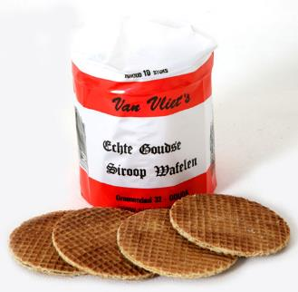

*Peter has been on the market in Gouda for years with a Stroopwafel stall. He sells ordinary, sugar-free and superwaffles. This is attributable to three suppliers: A, B and C.*

*A year ago Peter asked his nephew - who previously made a website for him - to automate this for him. They have negotiated with the suppliers and agreed on an interface. His nephew made a web page for Peter to get prices and place the orders.*

*Peter is now using the system to full satisfaction, and has great ideas for the future. His website does not contain much more than contact information, and his wish is also to let customers order stroopwafels through the website. His nephew has already made a piece of software (see PeterStroopwafel.Bestellen), but it's not completely finished and he has no time left to finish it. Thus Peter is looking for someone who can deliver a working system.*

**Functional acceptance criteria:**

* For the first version, customers need not have an account with Peter, providing a name and wish date (on which date the customer can pick up the order from Peter) is sufficient. It can not be collected on Sundays and on public holidays.
* The solution must in all cases select the cheapest possible order that meets the customer's request. This means that when Peter orders multiple types, the different types (with different delivery dates) can be ordered from different suppliers.
* Peter wants to earn 1 euro on every pack of stroopwafels he sells.
* If the stroopwafels come from different suppliers, the delivery dates should not be more than 1 day apart.
* Supplier A calculates 5 euro shipping costs and delivers 4 business days after ordering.
* Supplier B charges 5 euro shipping costs, but these will be zero when orders exceed 50 euros. Supplier B delivers 3 business days after ordering. Supplier B can not be ordered on Sundays and National Holidays.
* Supplier C is an American company, delivering 5 days after ordering and calculates 5% shipping.

**Non-functional acceptance criteria:**

* Peter does not understand the design and implementation of software. The software that was written by his nephew is therefore very flawed at various points. Since Peter has more future plans for the site, we would like to see you improve, clean up and expand the software. In addition to the functional correctness, we are also looking at things like code structure and design principles.
* The solution must be sent to the stakeholder's email address (Peter).
* Peter is available at the email address at the bottom of the assignment. He checks his mail daily.
* The code of the solution must be production ready (except the "Out-of-scope").
* The solution should be delivered as a Visual Studio solution (in zip), using any packages from nuget.org. These packages may not be delivered in binary form (nuget restore, build & run). Please remove the bin and obj folders.
* If a database is used, it should be usable for us without further instructions.

**Out of scope:**

* Security mechanisms
* REST services from suppliers (these are available online)
* Integration, acceptance and chain tests: these are developed in a later phase

**Interactive service specifications of supplier APIs:**

* Supplier A: http://stroopwafela.azurewebsites.net/swagger
* Supplier B: http://stroopwafelb.azurewebsites.net/swagger
* Supplier C: http://stroopwafelc.azurewebsites.net/swagger

**Take care:**

* The time spent on this assignment should be no more than 3 to 5 hours (to not overload you). To stay within that time, it is highly recommended to continue with what is available (PeterStroopwafel.Bestellen) and make an MVP from that! The business logic around the wish date / delivery data is the most complex, leave it for the end. If you want to stop at some point and cannot finish it all, just send us what you have.

**Stakeholder mail address:** stroopwafel@t-mobile.nl