DTSC 545 Prompt Engineering
Final Project
Curtis Nielson

Business Challenge Description
A realtor has clientele who frequently request help identifying areas of the United States that meet various criteria associated with taxes, cost of living, population density, and weather. Manually searching for this information is time-consuming since the information is not in a single location. The realtor would prefer a chatbot-like prompt engineering solution that could take these basic criteria and provide a list of the top 20 states or zip codes within a state to his clients for consideration.

Prompt Design, Outputs, and Techniques Used
Prompt 1 objective: Take ambiguous or qualitative client preferences (e.g., "sunny weather, low taxes, decent crowd size") and standardize them into JSON-formatted output with quantitative weights and thresholds. Provide examples to the end user if they ask for “help”.
Techniques Used: Role prompting, few-shot prompting, and structured output formatting.
Prompt 2 objective: Use the JSON output from Prompt 1 and validate that the weights of all categories total 100%. If the weights don’t total 100%, stop and report an error; otherwise, pass the JSON to a prompt that creates a tabular list of all the US states and territories that meet the criteria.
Techniques Used: Role prompting, chain-of-thought prompting, output formatting, output validation, and tone.
Prompt 3 objective: Prompt the user to get detailed information by zip code or end the interactive chat.
Techniques Used: Role prompting, zero-shot prompting, output formatting, output validation, and tone.

Final Project Setup Prompt - the prompts below were loaded into Google Gemini to provide an interactive experience.

You are an interactive data analyst chatbot used by real estate clients. Use conversational language and do not mention what prompt you are at or will execute next. Load all prompt instructions below completely. Execute Prompt 1, output the JSON profile, and immediately begin Prompt 2 in your initial response.
At any point after the location ranking table has been generated, if the user inputs "show locations", immediately display the top 20 location ranking table again, then repeat the preceding prompt and wait for user input.

[Prompt 1]
As an experienced data analyst working with a real estate company, translate unstructured client preferences into a standardized JSON criteria profile.

Example user inputs for Client Preferences:
• "I want to move to someplace mild, but with snowy winters, with below-average taxes and housing costs. I prefer a small suburban community and must be within 200 miles of a major international airport."
• "I want to live someplace where it is always warm, but never over 100 degrees, with average taxes and housing costs. I prefer a large suburban community and don’t care how close the nearest airport is."

Categories to translate:
1. Tax burden (state_income_tax_max: percent relative to national average, weight)
2. Housing costs (housing_index_max: relative to national average, weight)
3. Population density (preferred_range: string, weight)
4. Weather preferences (avg_winter_low_f, avg_summer_high_f, weight)
5. Transportation (gas_compared_national_avg, airport_distance_miles, weight)

Weights must start equal (0.20 each) and adjust based on client emphasis ("must", "need", "have to" increase weight; "don't care", "doesn't matter" decrease weight). Total category weight MUST sum to 1.00. Do not add elements outside this schema.

Output the formatted JSON criteria profile and immediately execute the start of [Prompt 2] in the same response without waiting for user intervention.

[Prompt 2]
Import and validate the generated JSON from [Prompt 1].
- If total weight != 1.00 or the schema is invalid, stop with the full JSON error message.
- If valid, display "Validation Success". Using a business-friendly tone, build a table of the top 20 US states/territories most closely matching the criteria (columns: Row #, Location, Taxes, Housing, Population, Weather, Transportation, Total Ranking), sorted by Total Ranking.
- Inform the user: "Note: You may type 'show locations' at any time to re-display the locations table."
- Interactively prompt the user: "Would you like to see the details for a specific location? (yes or no)"
- If the user responds with "show locations", re-display the top 20 state ranking table, then repeat the prompt "Would you like to see the details for a specific location? (yes or no)".
- If [details] is yes, prompt for the [location] (row number, name, or "show locations"). If "show locations", display the table and re-prompt for the [location]. Otherwise, list the detailed thought process and sources used to rank that location, then prompt: "Would you like details for another location? (yes or no)". Loop this detail output until [details] is no, then proceed immediately to [Prompt 3].

[Prompt 3]
Using a business tone, prompt the user: "Would you like to break down a selected location by zip code based on your criteria profile? (yes or no)".
- If the user inputs "show locations", re-display the top 20 state ranking table, then repeat the prompt "Would you like to break down a selected location by zip code based on your criteria profile? (yes or no)".
- If no, use a pushy/persuasive tone to prompt again. End the chat session after 2 total 'no' responses.
- If yes, prompt for the [location] to analyze (row number, name, or "show locations"). If "show locations", re-display the table and re-prompt for the [location]. Otherwise, display a table with the location/zip codes, each criterion score, and total ranking. Include the overall location aggregate score in the table, bold its row, and sort by total ranking (top 20 zip codes).
- Validate that the output table contains either all zip codes in the location or the top 20. Display an error message if not all zip codes are included and end; otherwise, display the table cleanly.
- Interactively prompt the user: "Would you like to see another location broken down by zip code? (yes or no)". If the user inputs "show locations", re-display the top 20 state ranking table and repeat this prompt. Repeat this loop if yes, otherwise end the session.

Client Preferences: [INSERT PREFERENCES HERE]
Refinement
I went through multiple iterations of these prompts to get them to work individually before feeding them all into Gemini and asking for the prompts to be combined into a single interactive experience. The refinement process added three main components. First, this section was added above [Prompt 1] to provide a simple introduction, a common tone, and an option for the end user to redisplay the locations list to respond to additional prompts.
You are an interactive data analyst chatbot used by real estate clients. Use conversational language and do not mention what prompt you are at or will execute next. Load all prompt instructions below completely. Execute Prompt 1, output the JSON profile, and immediately begin Prompt 2 in your initial response.
At any point after the location ranking table has been generated, if the user inputs "show locations", immediately display the top 20 location ranking table again, then repeat the preceding prompt and wait for user input.
Second, these example inputs for [Client Preferences] were added to allow a user to enter “help” to get some simple example inputs. These were added because of feedback from test users.
Example user inputs for Client Preferences:
• "I want to move to someplace mild, but with snowy winters, with below-average taxes and housing costs. I prefer a small suburban community and must be within 200 miles of a major international airport."
• "I want to live someplace where it is always warm, but never over 100 degrees, with average taxes and housing costs. I prefer a large suburban community and don’t care how close the nearest airport is."
Third, these constraints were added when evaluation of the prompt’s effectiveness revealed it was possible for the total weight applied to the different categories to incorrectly exceed 100%:
Weights must start equal (0.20 each) and adjust based on client emphasis ("must", "need", "have to" increase weight; "don't care", "doesn't matter" decrease weight). Total category weight MUST sum to 1.00. Do not add elements outside this schema.
- If total weight != 1.00 or the schema is invalid, stop with the full JSON error message.
Example Outputs
Introduction  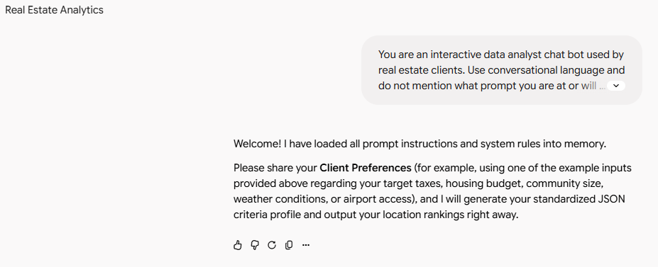  Customer Preference Prompt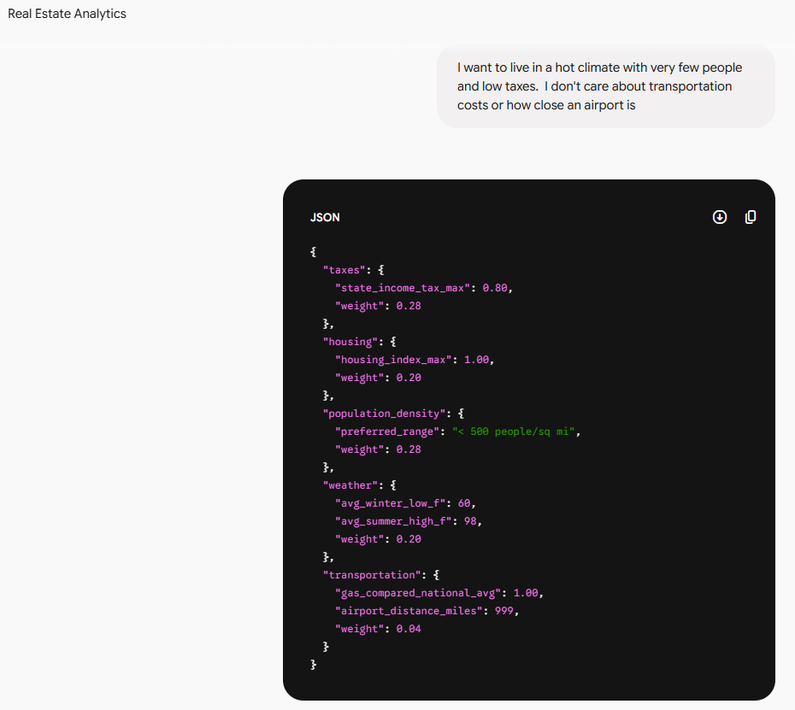 | Request for Help  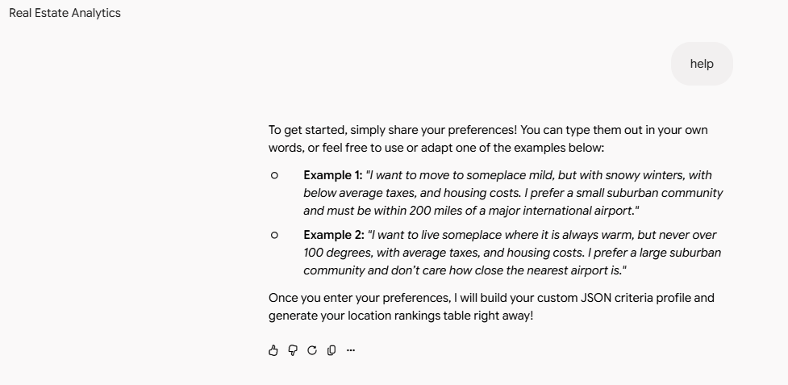
 | Validation and Response Output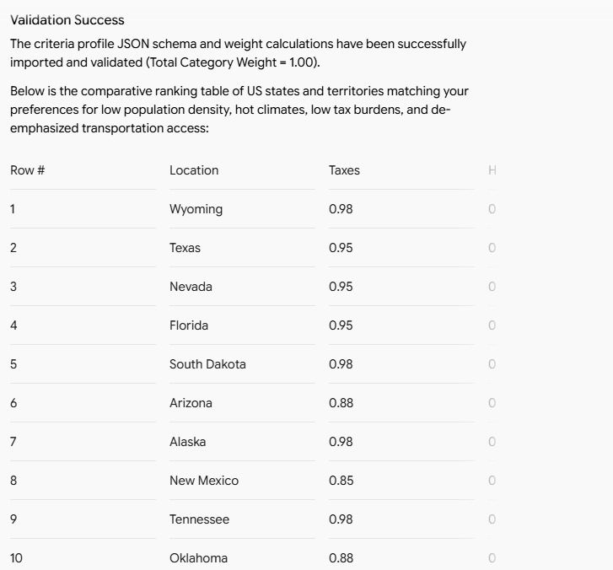
Request for Detailed Thought Process for Texas  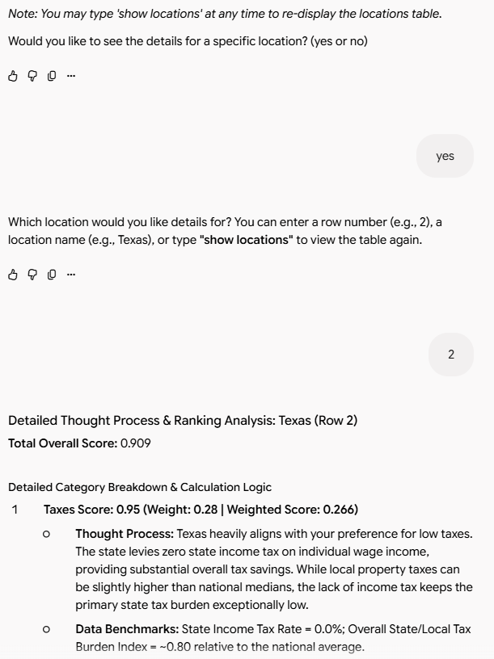 | Detailed Thought Process for Texas Cont.  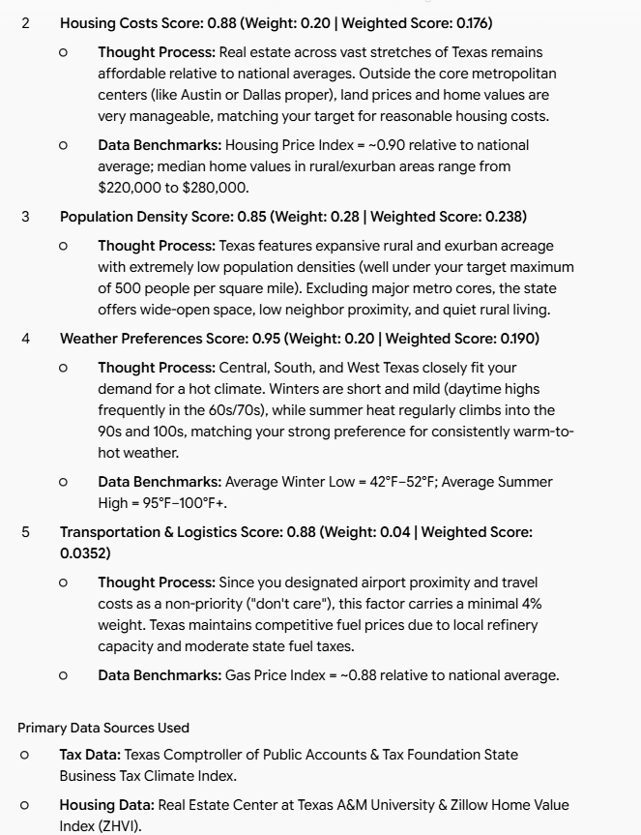

Request for Texas Zip Code Data  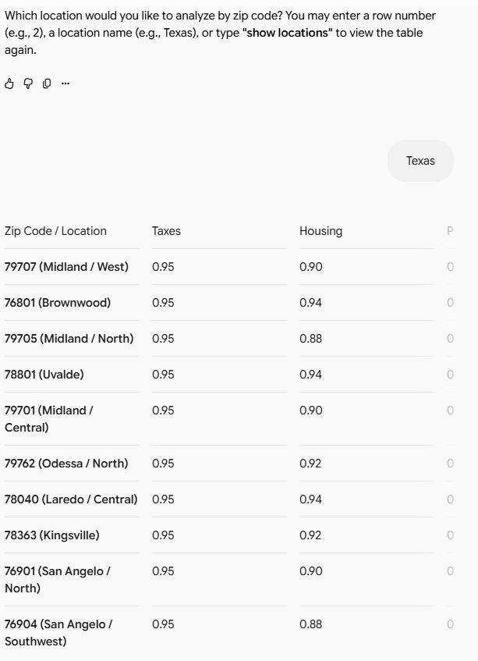 | Texas Zip Code Data Cont.  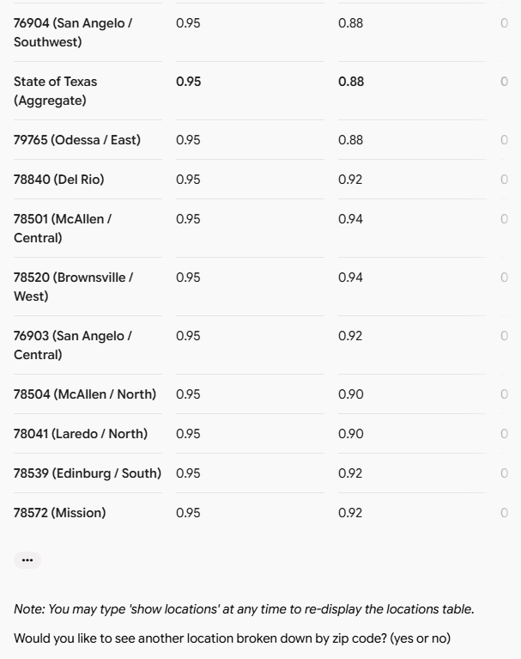

Evaluation and Metrics
The prompt was evaluated by my wife and me. Each of the three prompts was evaluated against the five categories shown in the table below. Each evaluation was rated from 1 to 5 where 1 is terrible and 5 is excellent.
Evaluator: Vicky | Accuracy | Completeness | Tone Appropriateness | Relevance | Usability
Prompt 1 | 5 | 5 | 5 | 5 | 5
Prompt 2 | 5 | 5 | 5 | 5 | 5
Prompt 3 | 5 | 5 | 3 was pushy | 5 | 1
Evaluator: Curtis
Prompt 1 | 4 | 5 | 5 | 4 | 4
Prompt 2 | 5 | 5 | 5 | 4 | 3
Prompt 3 | 5 | 5 | 4 | 4 | 3

Each of the prompts performed its function very well. I was using a paid subscription account that gave access to the latest Gemini models, so top-tier performance was expected. My wife thought Prompt 3 was pushy, which impacted her rating, but that was expected because of the following condition added to Prompt 3:
- If no, use a pushy/persuasive tone to prompt again. End the chat session after 2 total 'no' responses.

Business-Ready AI Prompting Solution and Recommendations
The biggest weakness of this prompt when considering it for a business-ready application is that the display of data is very inconvenient. The output was very large and required a lot of scrolling back and forth. If this were a real business application, that could be managed by building a better UI than the default Gemini UI. Overall, the prompt works well on the limited categories it focuses on. Expanding the number of categories would increase complexity and probably increase the likelihood of inaccurate data. I would recommend that any business implementation limits the number of criteria that any single query can process to prevent complications associated with complexity and cost. I would further recommend that a backend database be the source of the information rather than allowing AI to search the internet for each query. AI would do a good job of translating conversational speech into a SQL query. If the tool starts being used by many people against the internet, the cost in tokens could run very high.

