DTSC 671: AI Solutions in the Cloud
Assignment: Budget and Pricing Calculator
Curtis Nielson

Part 1
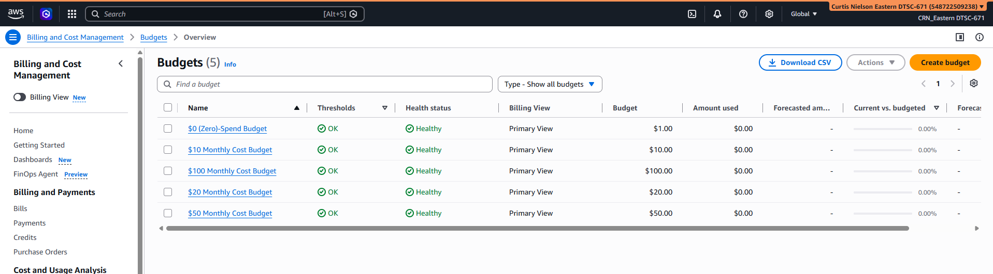
Figure 1: 5 Budgets in personal AWS account
Part 2
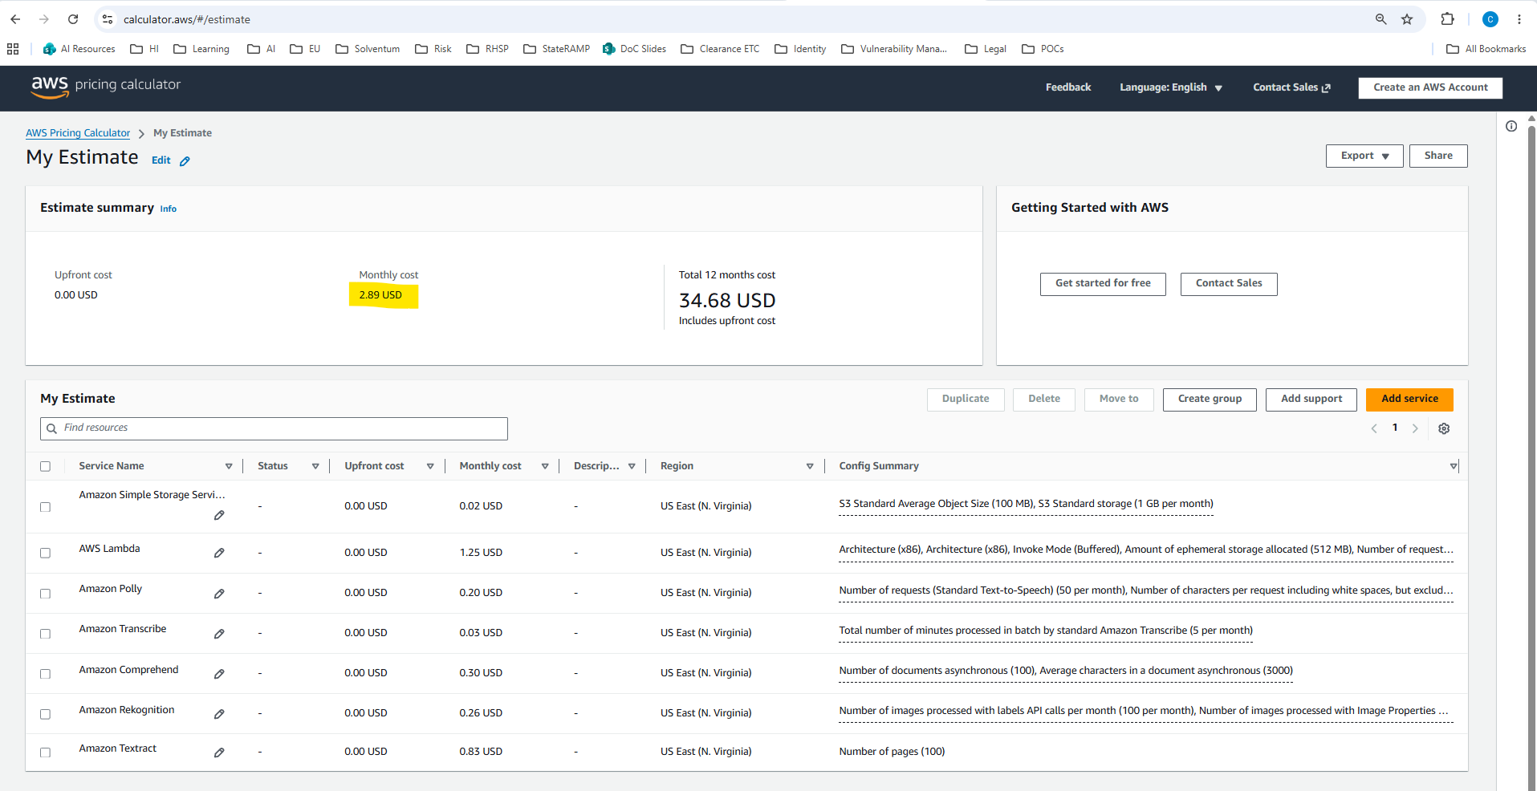
Figure 2: Estimate 1 Screenshot (S3, Lambda, Polly, Transcribe, Comprehend, Rekognition, and Textract)
Question #1: Based on these calculations, what is an estimate for completing the labs and assignments in this course?
Answer: The course is less than 2 months long, and the estimated monthly cost (highlighted) is 2.89 USD, so the estimated cost for completing the labs and assignments is less than 2*2.89 USD or < 5.78 USD.

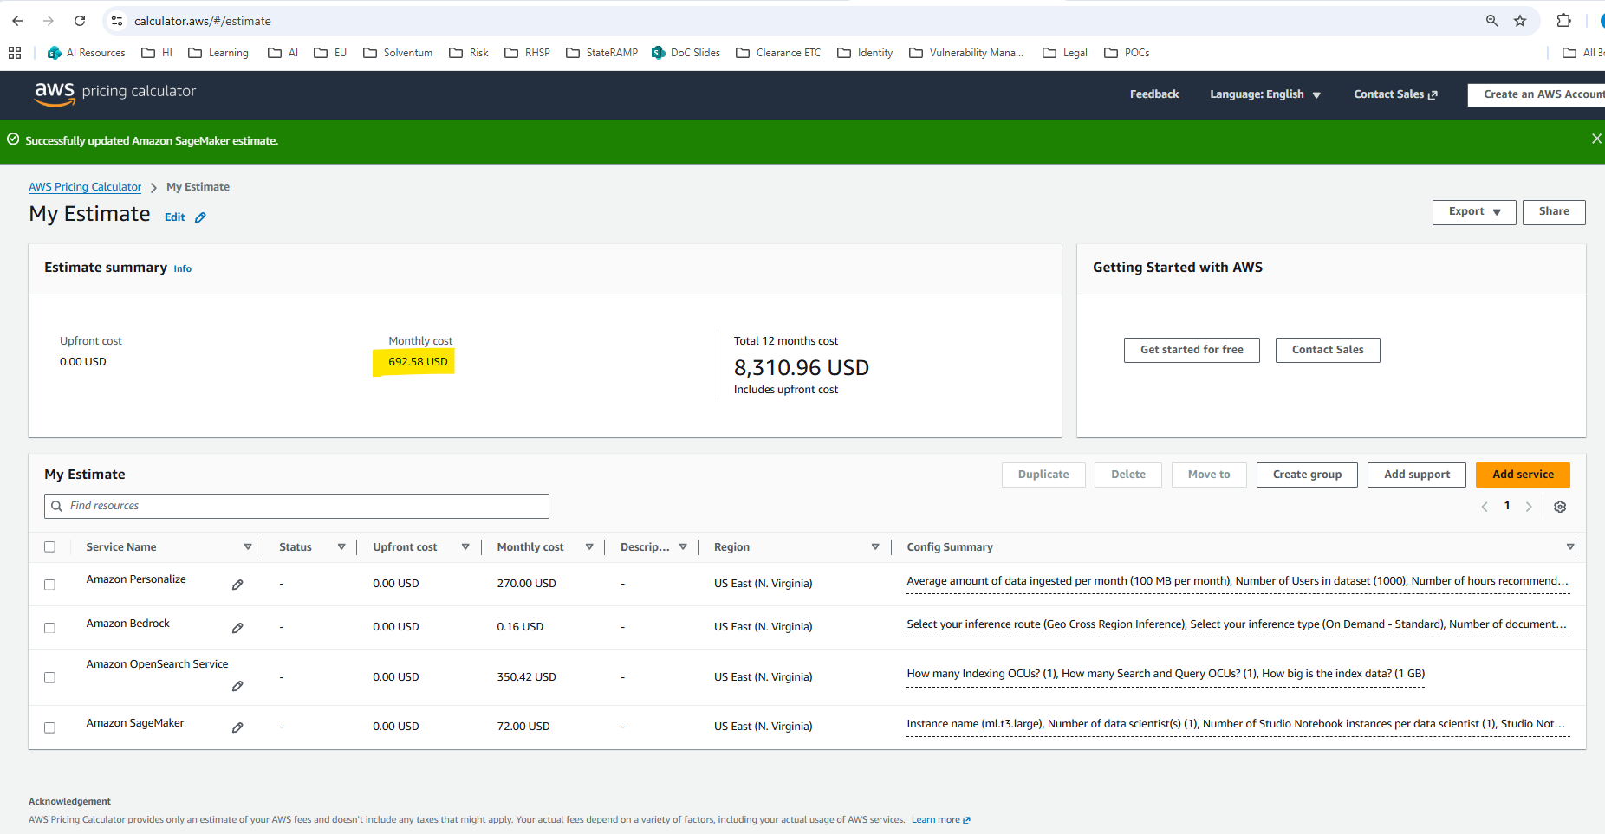
Figure 3: Estimate 2 Screenshot (Personalize, BedRock, OpenSearch Serverless, and SageMaker)
Question #2: Based on these calculations, what is an estimate for your monthly bill if you’re not careful with these services?
Answer: The estimated monthly bill if the services above are left running is 692.58 USD (highlighted).

