DTSC-540
Module 4 – Fundamentals of ML Models
Recommended reading
Chapter 3 of You Look Like a Thing - *only if you did not finish it in Module 2. We will touch on concepts from this reading in Module 4 as well so may want to review it.
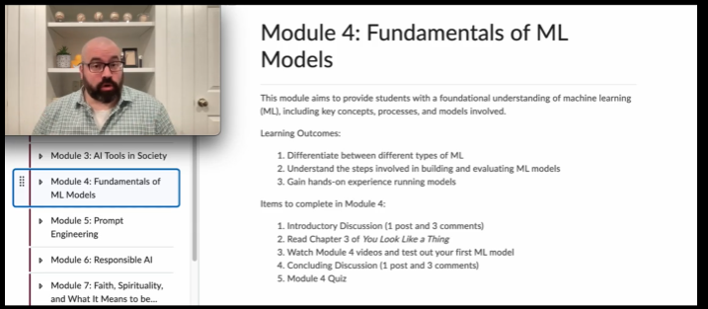

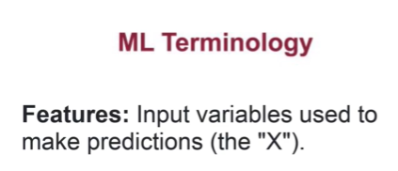
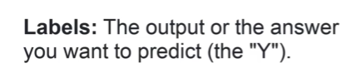
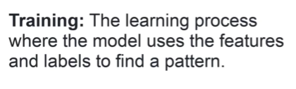
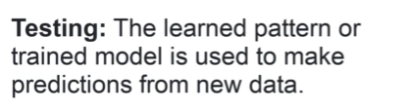
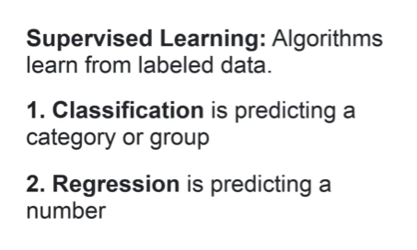
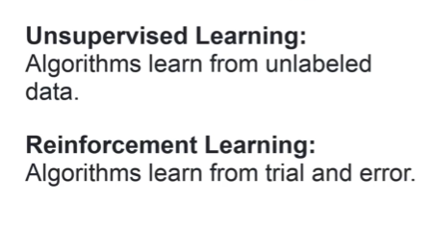
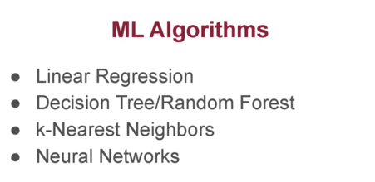
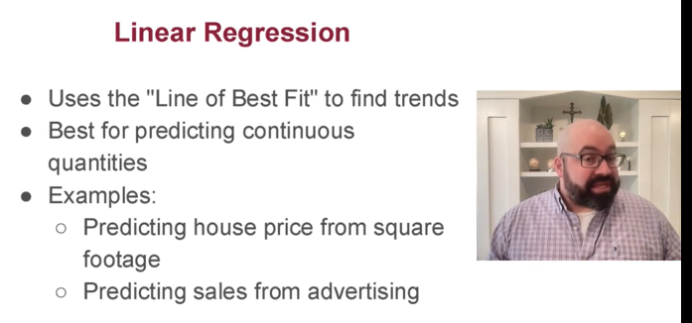
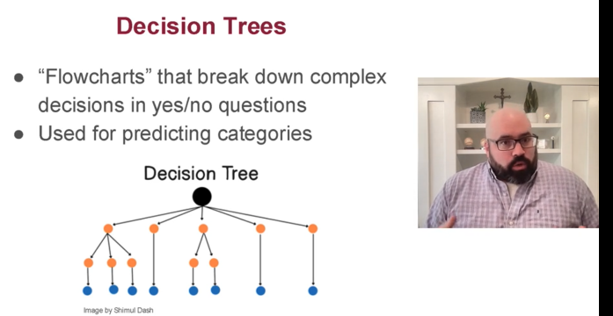
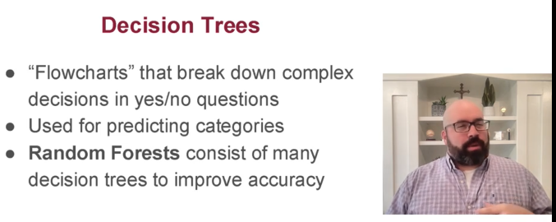
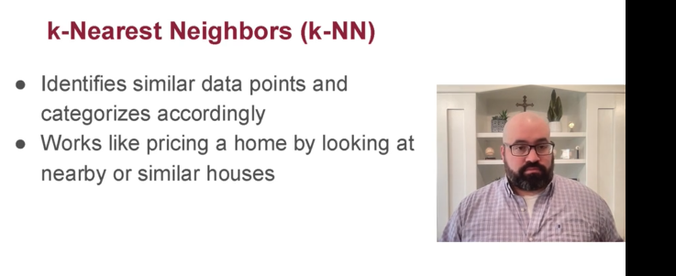
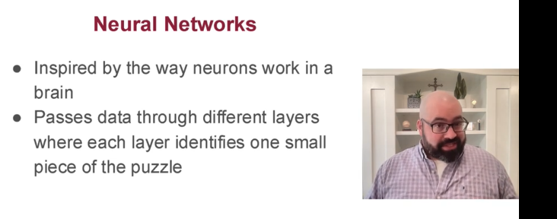
Linear Regression – draws a line, best for numbers
Decision Tress – makes a series of rules (choices) best for categories
K-Nearest Neighbors – Checks neighbors, best for finding similarities
Neural Networks – similar to how the brain works, best for very complex pattern recognition scenarios 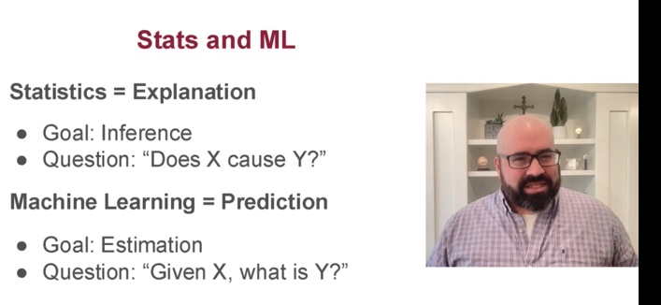
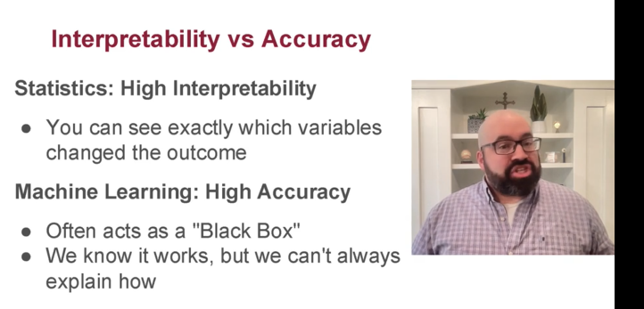
Statistics explains the system and values interpretability
Machine learning focuses on prediction and values getting the right answer as frequently as possible

