DTSC-540
Module 2 – AI Theory and Key Concepts
Recommended reading
Chapter 1 and Chapter 3 of You Look Like a Thing (Chapter 2 is optional)
https://ai-2027.com/
Voss, P., & Jovanovic, M. "Why We Don't Have AGI Yet"
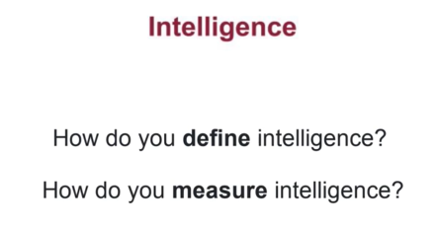
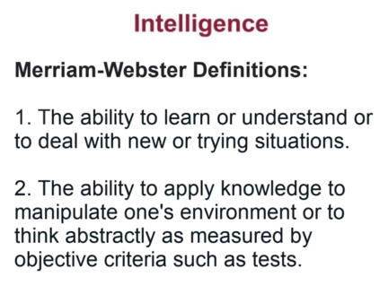
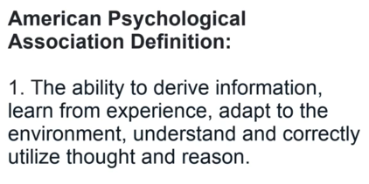
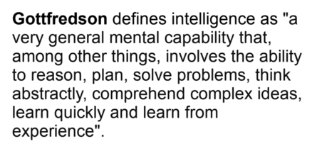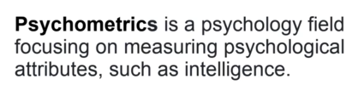
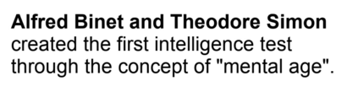
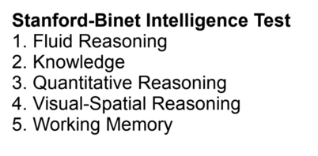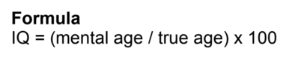
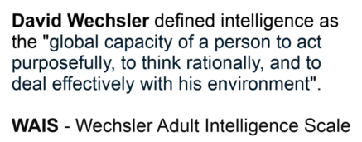
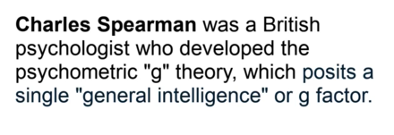
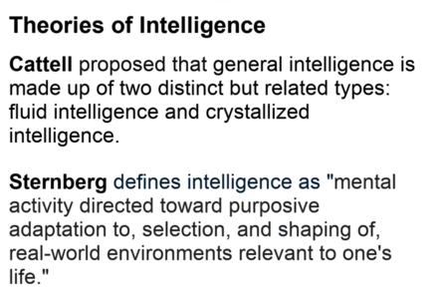
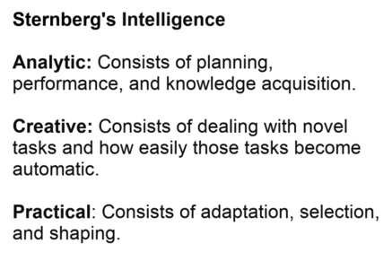
File / Title | Focus Area | Key Point | Why It Matters
Attention Is All You Need | Transformer architecture | Introduces self-attention as a replacement for recurrence and convolution in sequence modeling. | Foundation for modern large language models and generative AI.
Vaswani et al. 2023 | Transformer architecture | Another version of the Transformer paper, emphasizing multi-head attention, parallel training, and strong translation performance. | Reinforces why attention-based architectures became central to AI progress.
Legg & Hutter 2007 — A Collection of Definitions of Intelligence | Definition of intelligence | Surveys definitions and frames intelligence as the ability to achieve goals across many environments. | Provides a useful baseline for discussing AI, AGI, and general capability.
Morris et al. 2024 — Levels of AGI | AGI measurement | Defines AGI through levels of performance, generality, and autonomy rather than consciousness or human-like processes. | Useful framework for comparing AI systems and assessing risk.
Searle 1980 — Minds, Brains, and Programs | Philosophy of mind | Uses the Chinese Room argument to challenge the idea that symbol manipulation equals understanding. | Important critique of strong AI and purely computational theories of mind.
Newell & Simon 1976 — Computer Science as Empirical Inquiry | Symbolic AI | Argues that physical symbol systems and heuristic search are central to intelligent action. | Foundational paper for symbolic AI and problem-solving models.
The Artificial Intelligence Revolution | AI futures | Explains the path from narrow AI to AGI and superintelligence, emphasizing accelerating progress. | Accessible overview of why AI could become transformative or risky.
Why We Don’t Have AGI Yet | AGI barriers | Argues that LLMs and statistical AI lack key AGI capabilities such as real-time learning, reasoning, and metacognition. | Highlights why cognitive architectures may be needed for AGI.
Turing — Computing Machinery and Intelligence | Machine intelligence | Reframes “Can machines think?” through the imitation game, later called the Turing Test. | Establishes a performance-based approach to evaluating machine intelligence.
Imago Dei in the Age of Artificial Intelligence | Theology and AI | Explores how AI challenges Christian views of human uniqueness, dignity, intelligence, and creativity. | Shows that human identity cannot be reduced to intelligence alone.

PDF Summaries
Attention Is All You Need. This paper introduces the Transformer architecture, replacing recurrence and convolution with self-attention for sequence modeling. It uses encoder-decoder stacks, multi-head attention, positional encoding, and feed-forward layers to improve parallelization and capture long-range dependencies efficiently. Its central contribution is showing that attention alone can serve as the foundation for powerful language models.
Vaswani et al. 2023. This version of Attention Is All You Need presents the Transformer as a self-attention-based architecture for sequence transduction. It emphasizes scaled dot-product attention, multi-head attention, parallel training, machine translation performance, and generalization to parsing tasks. The paper became foundational for modern large language models and generative AI systems.
Legg & Hutter 2007 — A Collection of Definitions of Intelligence. This survey compiles definitions of intelligence from dictionaries, psychologists, and AI researchers. The authors identify recurring themes: intelligence involves achieving goals, adapting to environments, learning, reasoning, and solving problems. Their preferred framing defines intelligence as an agent’s ability to achieve goals across a wide range of environments.
Morris et al. 2024 — Levels of AGI. This paper proposes a framework for measuring progress toward Artificial General Intelligence using levels of performance, generality, and autonomy. It argues that AGI should be defined by capabilities rather than consciousness or human-like internal processes. The framework gives researchers, policymakers, and developers a shared vocabulary for assessing AGI progress and risk.
Searle 1980 — Minds, Brains, and Programs. Searle challenges “strong AI,” the claim that a correctly programmed computer literally understands and has mental states. His Chinese Room argument claims that symbol manipulation alone is insufficient for understanding because a person could follow formal rules for Chinese responses without understanding Chinese. The paper is a major critique of purely computational theories of mind.
Newell & Simon 1976 — Computer Science as Empirical Inquiry. Newell and Simon argue that computer science is an empirical science and that intelligence arises from physical symbol systems. Their Physical Symbol System Hypothesis claims that symbol manipulation is necessary and sufficient for general intelligent action. They also emphasize heuristic search as a core mechanism of problem solving.
The Artificial Intelligence Revolution. Tim Urban’s article explains AI progress for a general audience, emphasizing accelerating technological change and the possible transition from narrow AI to AGI and then artificial superintelligence. It distinguishes Artificial Narrow Intelligence, Artificial General Intelligence, and Artificial Superintelligence, warning that exponential progress may make transformative AI arrive sooner than expected.
Why We Don’t Have AGI Yet. Voss and Jovanović argue that current statistical and generative AI approaches, including large language models, are unlikely to produce true AGI by themselves. They claim AGI requires autonomous, adaptive, real-time learning; conceptual reasoning; metacognition; memory; abstraction; and cognitive architectures. The paper advocates shifting from statistical AI toward cognitive AI.
Turing — Computing Machinery and Intelligence. Turing reframes the question “Can machines think?” through the imitation game, now known as the Turing Test. Instead of defining thought directly, he proposes evaluating whether a machine can produce conversational behavior indistinguishable from a human. The paper laid conceptual foundations for machine intelligence and AI evaluation.
Imago Dei in the Age of Artificial Intelligence. This theological paper explores how AI challenges and enriches Christian understandings of the image of God. It raises questions about intelligence, creativity, relationality, uniqueness, and human dignity. Its key point is that human identity in the image of God cannot be reduced to intelligence alone.

