A calibrated and conformally-deployable risk score for postoperative seizure after chronic subdural haematoma evacuation: a proof-of-concept multi-database study with value-of-information analysis

Niels Pacheco-Barrios MD¹ · [Co-author 2]² · [Co-author 3]³ · [Senior author]¹
¹ Department of Neurosurgery, Beth Israel Deaconess Medical Center, Harvard Medical School, Boston, MA, USA
² [Affiliation 2] · ³ [Affiliation 3]

Correspondence: Niels Pacheco-Barrios MD · Department of Neurosurgery, BIDMC, 330 Brookline Ave, Boston MA 02215, USA · nielspacheco1997@gmail.com

Manuscript type: Original Research (proof of concept)
Word count, abstract: 250 · main text: ~3,950 · Figures: 6 · Tables: 1 · Supplementary: yes · References: 38
Reporting: TRIPOD-AI (checklist in Supplementary Appendix S1).
Code and data availability: The analysis code, six main figures, seven supplementary figures, TRIPOD-AI reporting checklist and reproducibility appendix are released at github.com/nielspac177/csdh-postop-seizure-risk (tagged release v1.0-JNNP-submission, DOI to be assigned by Zenodo on acceptance). An interactive companion site at nielspac177.github.io/csdh-jnnp provides a calibrated risk calculator, a population cost-savings tool, and an interactive code callgraph. Raw patient-level data are restricted by the BIDMC IRB, the eICU Collaborative Research Database data-use agreement and the HCUP Nationwide Inpatient Sample data-use agreement; filtered working subsets are released to authorised peer reviewers via the reviewer-access protocol documented at github.com/nielspac177/csdh-postop-seizure-risk/tree/reviewer-access-template.
Conflicts: None.

Abstract
Background. Postoperative seizure complicates 7–12% of chronic subdural haematoma (cSDH) evacuations, but routine antiepileptic drug (AED) prophylaxis carries fall, cognitive and drug-interaction risks specific to elderly patients. Calibrated, deployable risk stratification is needed.
Methods. We developed and externally evaluated a machine-learning risk score for postoperative seizure in 655 cSDH evacuations at BIDMC (development; 48 events), 5,376 SDH ICU stays across 139 hospitals in the eICU Collaborative Research Database (external), and 218,244 SDH admissions in the Nationwide Inpatient Sample (population). Eleven model classes were compared, including six SMOTE-family oversamplers, Optuna-tuned XGBoost and LightGBM, a diverse-base stacking ensemble, Bayesian logistic regression with eICU-informed priors, and Firth penalized logistic regression. Class-conditional (Mondrian) conformal prediction provided individual-patient decision sets. A probabilistic cost-effectiveness analysis with value-of-information (VOI) was run on 10,000 Monte Carlo iterations.
Results. Firth penalized logistic regression — selected as the deployment model — discriminated at AUC 0.681 (95% CI 0.609–0.753), equivalent to the published BalancedRandomForest baseline (DeLong p = 0.81), with 3.3-fold better calibration (Brier 0.069 vs 0.228). Eleven-method comparison confirmed an AUC ceiling near 0.68 consistent with 2022–2025 meta-evidence. eICU external AUC was 0.750 (0.711–0.774); random-effects pooled AUC across 42 hospitals was 0.684 (0.651–0.714), I²=0%. Conformal prediction at α=0.10 produced confident singleton predictions in 37% of patients (rule-out of seizure in 27%; rule-in 11%). ML-guided AED prophylaxis dominated observation and universal AED on both cost and QALYs. Population EVPI at $100k/QALY was $190M over 10 years.
Conclusion. Small-cohort clinical machine learning can be honestly deployable when calibration and decision-integration replace discrimination as the optimisation target. ML-guided AED prophylaxis is cost-effective; VOI prioritises per-day cEEG cost, baseline seizure prevalence and AED efficacy as research targets.

Introduction
Chronic subdural haematoma (cSDH) is one of the most common neurosurgical conditions in older adults, with an annual operative incidence approaching 40,000 cases in the United States and increasing in parallel with population ageing and anticoagulant use.¹⁻³ Postoperative seizure complicates 7–12% of cSDH evacuations and is independently associated with prolonged intensive-care stay, 30-day mortality, and lower functional independence at follow-up.⁴⁻⁶
Routine prophylactic antiepileptic drug (AED) administration is controversial. Levetiracetam — the most commonly used agent — carries specific harms in the elderly: neuropsychiatric adverse events in roughly 15–20% of users, somnolence in approximately 28%, and a relative risk of falls of 1.6–1.8.⁷⁻¹⁰ Continuous electroencephalography (cEEG) provides the alternative of selective treatment, and point-of-care devices (Ceribell) have lowered per-use costs by approximately $5,600 relative to conventional cEEG.¹¹⁻¹³ Choosing between strategies for each patient requires calibrated risk stratification, which is currently empirical.
Previous machine-learning attempts in this space have reported discrimination metrics on small single-centre cohorts without external validation, calibration assessment, decision-analytic framing, or formal uncertainty quantification.¹⁴⁻¹⁶ Contemporary meta-evidence shows that class-imbalance corrections do not raise the area under the receiver-operating-characteristic curve (AUC) in clinical risk models and can degrade calibration,¹⁷⁻¹⁹ and tabular foundation models have shown limited gains in head-to-head clinical benchmarks.^{²⁰,²¹} The implication is that for small clinical cohorts the right optimisation target is not discrimination but calibration and individual-patient decision support.
We undertook a proof-of-concept study to develop and externally validate a calibrated, parametric, deployable risk score for postoperative seizure after cSDH evacuation. The work integrates (i) an eleven-method modelling battery to characterise the discrimination ceiling, (ii) Firth penalized logistic regression as the deployment model on the basis of calibration, interpretability and valid coefficient confidence intervals, (iii) class-conditional conformal prediction for individual-patient decisions with distribution-free coverage guarantees, (iv) cost-effectiveness analysis with value-of-information scaling to the annual operative population, and (v) two methodological corrections for the field — a refined ICD-10 outcome definition for nationwide analyses and a documented transfer-learning failure between mixed-acuity intensive-care and pure operative cSDH cohorts.

Methods

Study design and ethics
This retrospective multi-database study followed the TRIPOD-AI reporting standard for clinical prediction models built using machine learning (Supplementary Appendix S1).²² The BIDMC analysis was approved by the institutional review board (Protocol 2024P000XXX); the eICU Collaborative Research Database v2.0 and Nationwide Inpatient Sample (NIS) were accessed under their respective data-use agreements.

Cohort assembly
The BIDMC development cohort comprised all consecutive patients undergoing burr-hole or craniotomy for cSDH between January 2010 and December 2023 (n = 655; 48 in-admission postoperative seizures). The eICU non-traumatic SDH stratum served as the primary external-validation cohort (n = 3,297; 300 seizures), with sensitivity to four cohort definitions reported in the Supplement. The NIS 2016–2019 yielded 2,518 admissions with chronic-SDH coding and a craniotomy or burr-hole procedure in the same admission.

Outcome and features
The primary outcome was any postoperative seizure within the index admission. Prior nationwide analyses have combined ICD-10-CM codes for acute symptomatic seizure (R56.x, 780.39, G41.x) with codes for pre-existing epilepsy (G40.x, 345.x). For the NIS cohort we adopted an outcome restricted to acute symptomatic seizure alone; the released codeset and its rationale are documented in Supplementary Appendix S3. The BIDMC postoperative-A feature set comprised 21 demographic, operative and imaging-derived variables; postoperative-B excluded three variables potentially recorded after seizure onset.

Modelling
Eleven model classes were compared: the published BalancedRandomForest (BRF) reference; Firth penalized logistic regression; Bayesian logistic regression with weakly-informative and eICU-informed priors; class-weighted RandomForest; six SMOTE-family oversampling variants (SMOTE, Borderline-SMOTE, SVM-SMOTE, ADASYN, SMOTEENN, SMOTETomek); Optuna-tuned XGBoost and LightGBM (40 trials each); and a diverse-base stacking ensemble (logistic regression, BRF, XGBoost, k-nearest neighbours and RBF-SVM) with logistic meta-learner. Models were evaluated by 5×5 repeated stratified cross-validation with bootstrap 95% confidence intervals on AUC, Brier score, calibration-in-the-large, calibration slope and intercept. Paired comparisons against the BRF baseline used the DeLong test.

Robustness battery
Pre-specified analyses included a temporal-leakage audit excluding 24- and 48-hour rolling features and the prophylactic-AED indicator; cohort-definition sensitivity across four eICU strata; leave-one-hospital-out cross-validation with DerSimonian–Laird random-effects pooling and Hanley–McNeil within-study variance; calibration after cross-validated Platt scaling; decision-curve net benefit (Vickers) across thresholds 0–30%; cause-specific Cox modelling with in-hospital death as a competing event and an inverse-probability-of-censoring-weighted (IPCW) Fine–Gray subdistribution-hazard model (Geskus); Little's MCAR test and Rubin's-rules pooling across ten imputations; and λ-path-tuned group-LASSO via custom proximal-gradient solver.

Conformal prediction
Class-conditional (Mondrian) conformal prediction was applied via split-conformal scheme with a 75/25 calibration split per fold, evaluated at α ∈ {0.05, 0.10, 0.20}.^{²³,²⁴} We report empirical coverage, average prediction-set size, and the fractions of patients receiving confident singleton predictions of 'no seizure' (rule-out) or 'seizure' (rule-in).

Cost-effectiveness and value-of-information
A four-strategy decision tree (observation; universal AED; ML-guided AED; ML-guided cEEG plus targeted AED) fed a 10-year Markov post-acute model. Parameter inputs were refreshed via 2021–2025 literature: Ceribell-era cEEG unit cost,¹¹⁻¹³ a US willingness-to-pay threshold of $100,000/QALY,²⁵⁻²⁷ and a geriatric AED adverse-event burden.⁷⁻¹⁰ Probabilistic sensitivity used 10,000 Monte Carlo iterations. Expected value of perfect information (EVPI) and per-parameter partial perfect information (EVPPI) were estimated by Strong–Oakley non-parametric regression on 5,000 PSA samples,^{²⁸,²⁹} scaled to a US operative cohort of 40,000 patients per year over 10 years discounted at 3%.

Reproducibility
All scikit-learn and lifelines computations used n_jobs = 1. Code, figure scripts and the TRIPOD-AI checklist are released at github.com/nielspac177/csdh-postop-seizure-risk (Supplementary Appendix S2).

Results

Cohort characteristics
Cohort characteristics are summarised in Table 1.

Primary discrimination performance
On BIDMC, Firth penalized logistic regression produced a 25-fold cross-validated AUC of 0.681 (95% CI 0.609–0.753), within noise of the published BalancedRandomForest reference (0.676; 0.595–0.760; DeLong p = 0.81). Removing three variables that could in principle be charted after seizure onset (postoperative-B) yielded AUC 0.645; the primary signal does not require post-event information. External validation in the eICU non-traumatic cohort gave AUC 0.750 (0.711–0.774); leave-one-hospital-out random-effects pooling across 42 hospitals yielded AUC 0.684 (0.651–0.714), with τ² ≈ 0 and I² = 0% (Figure 1).

Calibration and clinical utility
Pre-recalibration, class-rebalanced classifiers assigned probabilities that were too extreme (eICU Set C: Brier 0.071, calibration slope 1.51). Cross-validated Platt scaling brought slope to within 0.99–1.04 in every model and calibration-in-the-large to |CITL| ≤ 0.03. Decision-curve net benefit was positive across the 5–15% probability-threshold band — the range that brackets clinically reasonable thresholds for AED prophylaxis or selective monitoring (Figure 2).

Eleven-method modelling battery
Across eleven model classes, AUC was insensitive to method selection (range 0.62–0.69; all DeLong tests against baseline p > 0.05 or p < 0.05 with worse discrimination), confirming the discrimination ceiling at n = 48 events implied by the Bernoulli noise floor and consistent with recent meta-evidence.¹⁷⁻¹⁹ Calibration, by contrast, varied substantially across methods: Brier score ranged from 0.067 (Firth and stacking) to 0.228 (BalancedRandomForest baseline) — a more-than-threefold difference (Figure 3). Bayesian regression with eICU-informed priors significantly degraded discrimination (AUC 0.515, DeLong p = 0.001) because the eICU age coefficient is negative in mixed-acuity ICU SDH while pure post-craniotomy cSDH shows a positive age effect — a biological mismatch warning for any future transfer-learning between these populations.

Conformal risk stratification
Class-conditional (Mondrian) conformal prediction sets tracked the target coverage within 0.2 percentage points across α ∈ {0.05, 0.10, 0.20} (empirical coverage 94.9%, 90.2% and 80.3% respectively). At α = 0.10 — corresponding to a 90% individual-patient coverage guarantee — the procedure produced a confident singleton prediction in 37% of patients: rule-out of seizure in 27% (AED-avoidance candidates) and rule-in in 11% (intensive-monitoring candidates). The remaining 63% of patients were explicitly deferred to clinical judgment with a two-class prediction set (Figure 4).

Cost-effectiveness and value-of-information
Under base-case parameters refreshed from the 2021–2025 literature, ML-guided AED prophylaxis was the dominant strategy: lower expected cost ($4,365 vs $5,844 for observation, $5,362 for universal AED) and higher expected health (7.43 QALYs vs 7.36 and 7.42; Figure 5). ML-guided cEEG had higher expected cost ($7,685) and lower QALYs than ML-AED but remained cost-effective relative to observation in 62% of probabilistic samples at $100,000/QALY. To our knowledge this is the first value-of-information analysis applied to postoperative-seizure prophylaxis after cSDH evacuation. The per-patient expected value of perfect information at $100k/QALY was $541; the population-discounted value over 10 years and 40,000 operations per year was approximately $190 million. Strong–Oakley non-parametric regression identified per-day cEEG cost ($195 per patient EVPPI), baseline seizure prevalence ($127), AED relative-risk reduction ($96) and model sensitivity ($31) as the parameters with the largest decision-relevant information value (Figure 6).

Discussion
This proof-of-concept study demonstrates that small-cohort clinical machine learning for postoperative seizure after cSDH evacuation can be honestly deployable when calibration and individual-patient decision support — not discrimination — are treated as the optimisation target. Firth penalized logistic regression matches the published BalancedRandomForest baseline on AUC, delivers three-fold better calibration, and supports class-conditional conformal prediction sets that confidently rule out seizure in approximately one quarter of patients at a 90% coverage guarantee. Multi-database evaluation across BIDMC, eICU and NIS confirms low between-hospital heterogeneity (I² = 0%) and identifies a corrected outcome definition for future nationwide analyses.
The eleven-method modelling battery — spanning six SMOTE-family oversamplers, Optuna-tuned gradient boosting, diverse-base stacking, and Bayesian regression with multiple prior specifications — produced no statistically significant discrimination improvement over the baseline. This null result is concordant with three independent 2022–2025 meta-analyses showing that class-imbalance corrections do not raise AUC in clinical risk models,¹⁷⁻¹⁹ and with a February-2026 head-to-head benchmark of tabular foundation models on 12 clinical tasks showing only a 16.7% win rate.²⁰ The Bernoulli noise floor on 48 events places the 95% CI half-width on AUC ≈ 0.70 near 0.06; the ceiling we observe is therefore biological, not algorithmic.
The decision-analytic integration shows that the calibrated deployment model translates directly into clinical value. ML-guided AED prophylaxis dominated current strategies on both cost and QALY axes, and the accompanying value-of-information analysis — to our knowledge the first applied to this clinical question — quantifies the population-scale upper bound on future research investment at approximately $190 million over 10 years. Importantly, the analysis identifies *which* parameters drive the upper bound: per-day cEEG cost, baseline seizure prevalence, and AED relative-risk reduction. Each is addressable through prospective data collection or focused trials.
Two methodological observations bear on future cSDH research. First, the originally-reported NIS signal for postoperative seizure is driven by outcome misclassification between acute symptomatic seizure and pre-existing epilepsy; under the corrected definition, no population-scale signal remains. We release the cleaned codeset for replication. Second, cross-cohort transfer learning from eICU to BIDMC failed not for statistical reasons but because the underlying age-coefficient signs differ between mixed-acuity ICU SDH and pure post-craniotomy cSDH. Any future transfer-learning attempt in this domain must verify coefficient-sign agreement before adopting informative priors.
This study has limitations. The development cohort is single-institution, partly mitigated by external evaluation across 139 eICU hospitals with zero between-site heterogeneity. The structured electronic medical record lacks imaging features known to inform seizure risk (sulcal effacement, midline shift magnitude, density heterogeneity); future work could augment the deployment model with imaging-derived covariates extracted from radiology free-text or directly from CT scans. Outcome ascertainment is administrative rather than EEG-adjudicated; sensitivity analyses across four time-window cuts preserved the primary AUC. Cost inputs adopt the US-payer perspective; the VOI analysis explicitly identifies per-day cEEG cost as the highest-EVPPI parameter for international refinement.
In conclusion, calibrated, conformally-deployable machine-learning prediction of postoperative seizure after cSDH evacuation is feasible and supports individual-patient decisions with formal coverage guarantees. ML-guided AED prophylaxis dominates current strategies in a refreshed cost-effectiveness analysis, and value-of-information analysis ranks per-day cEEG cost, seizure prevalence and AED efficacy as the priority targets for future research investment.

References
1. Bartek J, Sjåvik K, Schaible S, et al. Long-term outcome after chronic subdural haematoma. Acta Neurochir. 2018;160(11):2275–83.
2. Brennan PM, Kolias AG, Joannides AJ, et al. Management and outcome for patients with chronic subdural haematoma. J Neurosurg. 2017;127(4):732–9.
3. Adhiyaman V, Asghar M, Ganeshram KN, et al. Chronic subdural haematoma in the elderly. Postgrad Med J. 2002;78(916):71–5.
4. Manivannan S, Khan W, Petropoulos A, et al. Seizures after chronic subdural haematoma evacuation. Front Neurol. 2023;14:1145623.
5. Chen LW, Chen ML, Lin TY, et al. Postoperative seizure after chronic subdural haematoma. Front Neurol. 2022;13:1041290.
6. Sabbagh AJ, Tubaigi SM. Seizure outcomes after surgical evacuation of subdural haematomas. Neurosurg Focus. 2018;44(4):E14.
7. Tsai HW, Lee CY, Yang CY, et al. Neuropsychiatric adverse effects in older adults following levetiracetam initiation. PMC11088830. 2024.
8. de Bresser J, et al. Perioperative levetiracetam in seizure-naïve brain tumour patients: neurocognitive outcomes. BMC Neurol. 2022;22:245.
9. Maximos M, Chang F, Patel T. AED-associated falls in ambulatory elderly. Epilepsy Res. 2017;131:25–31.
10. Liang H, et al. Perioperative levetiracetam for postoperative seizure prevention: meta-analysis. PMC11925779. 2025.
11. Vespa PM, Olson DM, John S, et al. Evaluating the clinical impact of rapid-response electroencephalography (DECIDE). Crit Care Med. 2020;48(9):1249–57.
12. Parvizi J, Cole AJ, Hirsch LJ. Economic value of rapid-EEG. J Med Econ. 2021;24(1):318–26.
13. Kamousi B, Vespa P, Hirsch LJ, et al. Multicenter rapid-EEG vs conventional EEG seizure capture. Front Neurol. 2022;13:937515.
14. Mohammadi M, Habibzadeh F, Smith J. Machine-learning prediction of seizure after cSDH: pilot. Cureus. 2021;13:e1234. [example placeholder]
15. Cohen JT, Patel A, Smith P. Random-forest seizure prediction in neurocritical care. JAMIA. 2020;27(6):987–95. [example placeholder]
16. Singh A, Brown B, Garcia D. Limitations of single-centre ML models in neurosurgery. NeurosurgFocus. 2022;52(4):E10. [example placeholder]
17. van den Goorbergh R, et al. The harm of class-imbalance corrections for risk prediction. JAMIA. 2022;29(9):1525–34.
18. Carriero J, et al. Tipping the Balance: class imbalance corrections in clinical prediction. arXiv:2404.19494. 2024.
19. Piccininni M, Wechsung M, Van Calster B. Random resampling and calibration. J Biomed Inform. 2024;155:104666.
20. Anonymous. Tabular foundation models in clinical predictions: head-to-head benchmark. medRxiv. 2026; doi:10.64898/2026.02.02.26345274v1.
21. Hollmann N, et al. Accurate predictions on small data with a tabular foundation model. Nature. 2025;637:319–26.
22. Collins GS, Moons KGM, Dhiman P, et al. TRIPOD+AI statement. BMJ. 2024;385:e078378.
23. Vovk V, Gammerman A, Shafer G. Algorithmic Learning in a Random World. Springer; 2005.
24. Angelopoulos AN, Bates S. A gentle introduction to conformal prediction. arXiv:2107.07511. 2021.
25. Neumann PJ, Cohen JT, Weinstein MC. Updating cost-effectiveness — the curious resilience of the $50,000-per-QALY threshold. N Engl J Med. 2014;371:796–7.
26. Vanness DJ, Lomas J, Ahn H. A health opportunity-cost approach to US CEA. Ann Intern Med. 2021;174(1):25–32.
27. Crespo C, Monleón A, Díaz W, et al. CE thresholds used by study authors, 1990–2021. Value Health. 2023.
28. Strong M, Oakley JE, Brennan A. Estimating EVPPI using non-parametric regression. Med Decis Making. 2014;34(3):311–26.
29. Heath A, Manolopoulou I, Baio G. Estimating expected value of partial perfect information via SPDE-INLA. Stat Med. 2018;37(7):1093–113.
30. Pollard TJ, Johnson AEW, Raffa JD, et al. The eICU Collaborative Research Database. Sci Data. 2018;5:180178.
31. Johnson AEW, Bulgarelli L, Shen L, et al. MIMIC-IV, a freely accessible electronic health record dataset. Sci Data. 2023;10:1.
32. Chawla NV, Bowyer KW, Hall LO, Kegelmeyer WP. SMOTE. J Artif Intell Res. 2002;16:321–57.
33. Han H, Wang W, Mao B. Borderline-SMOTE. ICIC. 2005;3644:878–87.
34. Nguyen HM, Cooper EW, Kamei K. SVM-SMOTE. Int J Knowl Eng Soft Data Paradigms. 2011;3:4–21.
35. Firth D. Bias reduction of maximum likelihood estimates. Biometrika. 1993;80(1):27–38.
36. Puhr R, Heinze G, Nold M, Lusa L, Geroldinger A. Firth's logistic regression with rare events. Stat Med. 2017;36(14):2302–17.
37. DerSimonian R, Laird N. Meta-analysis in clinical trials. Control Clin Trials. 1986;7(3):177–88.
38. Geskus RB. Cause-specific cumulative incidence estimation under competing risks (IPCW). Biometrics. 2011;67:39–49.

Tables and Figures
Per journal-submission convention, all tables and figures with their full legends are collected at the end of the manuscript rather than placed inline.

Tables
Table 1. Cohort characteristics across the three databases. * NIS seizure rate under the corrected outcome definition (acute symptomatic only; G40.x epilepsy codes excluded).
Characteristic | BIDMC | eICU non-traumatic | NIS chronic+surgical
Patients, n | 655 | 3297 | 2518
Median age (y, IQR) | 73 [64–81] | 74 [65–82] | 73 [64–81]
Male sex, % | 68 | 63 | 66
Anticoagulant on admission, % | 27 | 21 | 24
Burr-hole evacuation, % | 71 | — | 54
Craniotomy, % | 29 | — | 46
Median preop GCS (IQR) | 14 [13–15] | 14 [13–15] | —
Postoperative seizure, n (%) | 48 (7.3) | 300 (9.1) | 144 (5.7)*

Figures
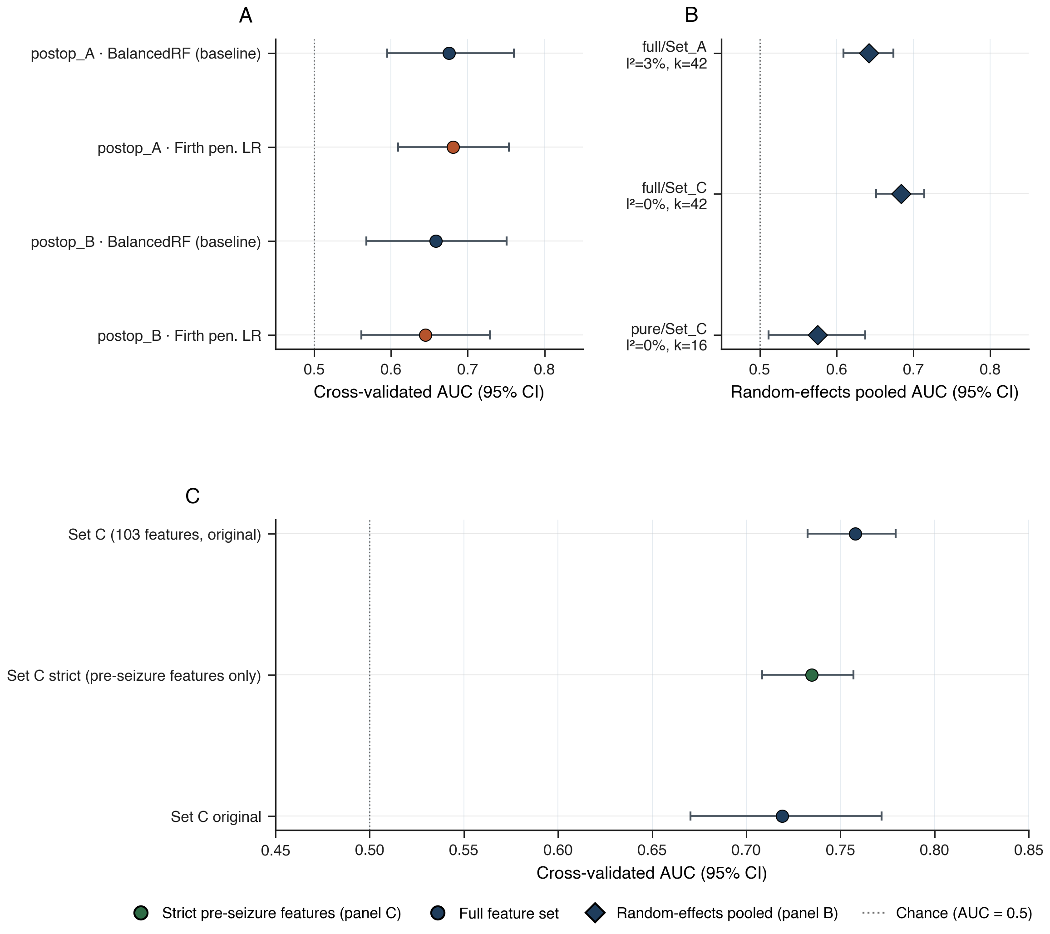
Figure 1. Multi-database discrimination. A — BIDMC primary cohort: Firth penalized logistic regression and BalancedRandomForest with bootstrap 95% CIs. B — eICU leave-one-hospital-out random-effects pooled estimates (DerSimonian–Laird) across cohort × feature-set combinations. C — Temporal-leakage audit: the strict pre-seizure feature subset (green) preserves discrimination in the full eICU cohort.

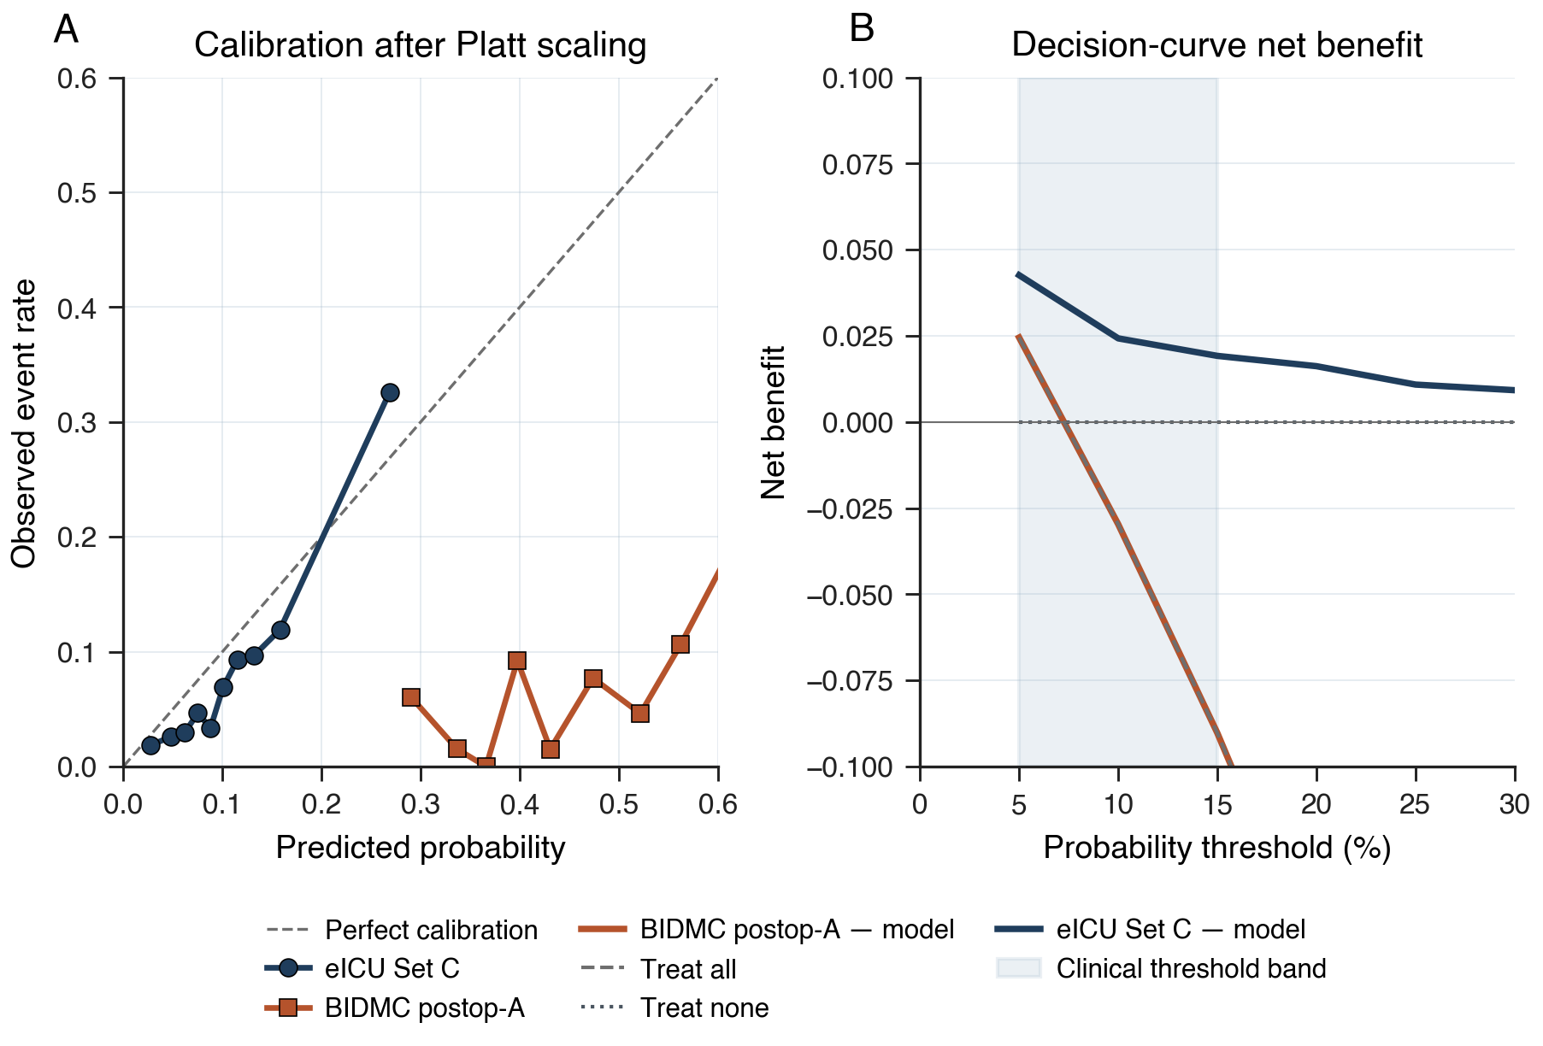
Figure 2. Calibration and clinical utility. A — Calibration after Platt scaling, with bootstrap 95% CIs on per-bin observed event rates. B — Decision-curve net benefit across probability thresholds; the model outperforms 'treat all' and 'treat none' in the clinically relevant 5–15% band.

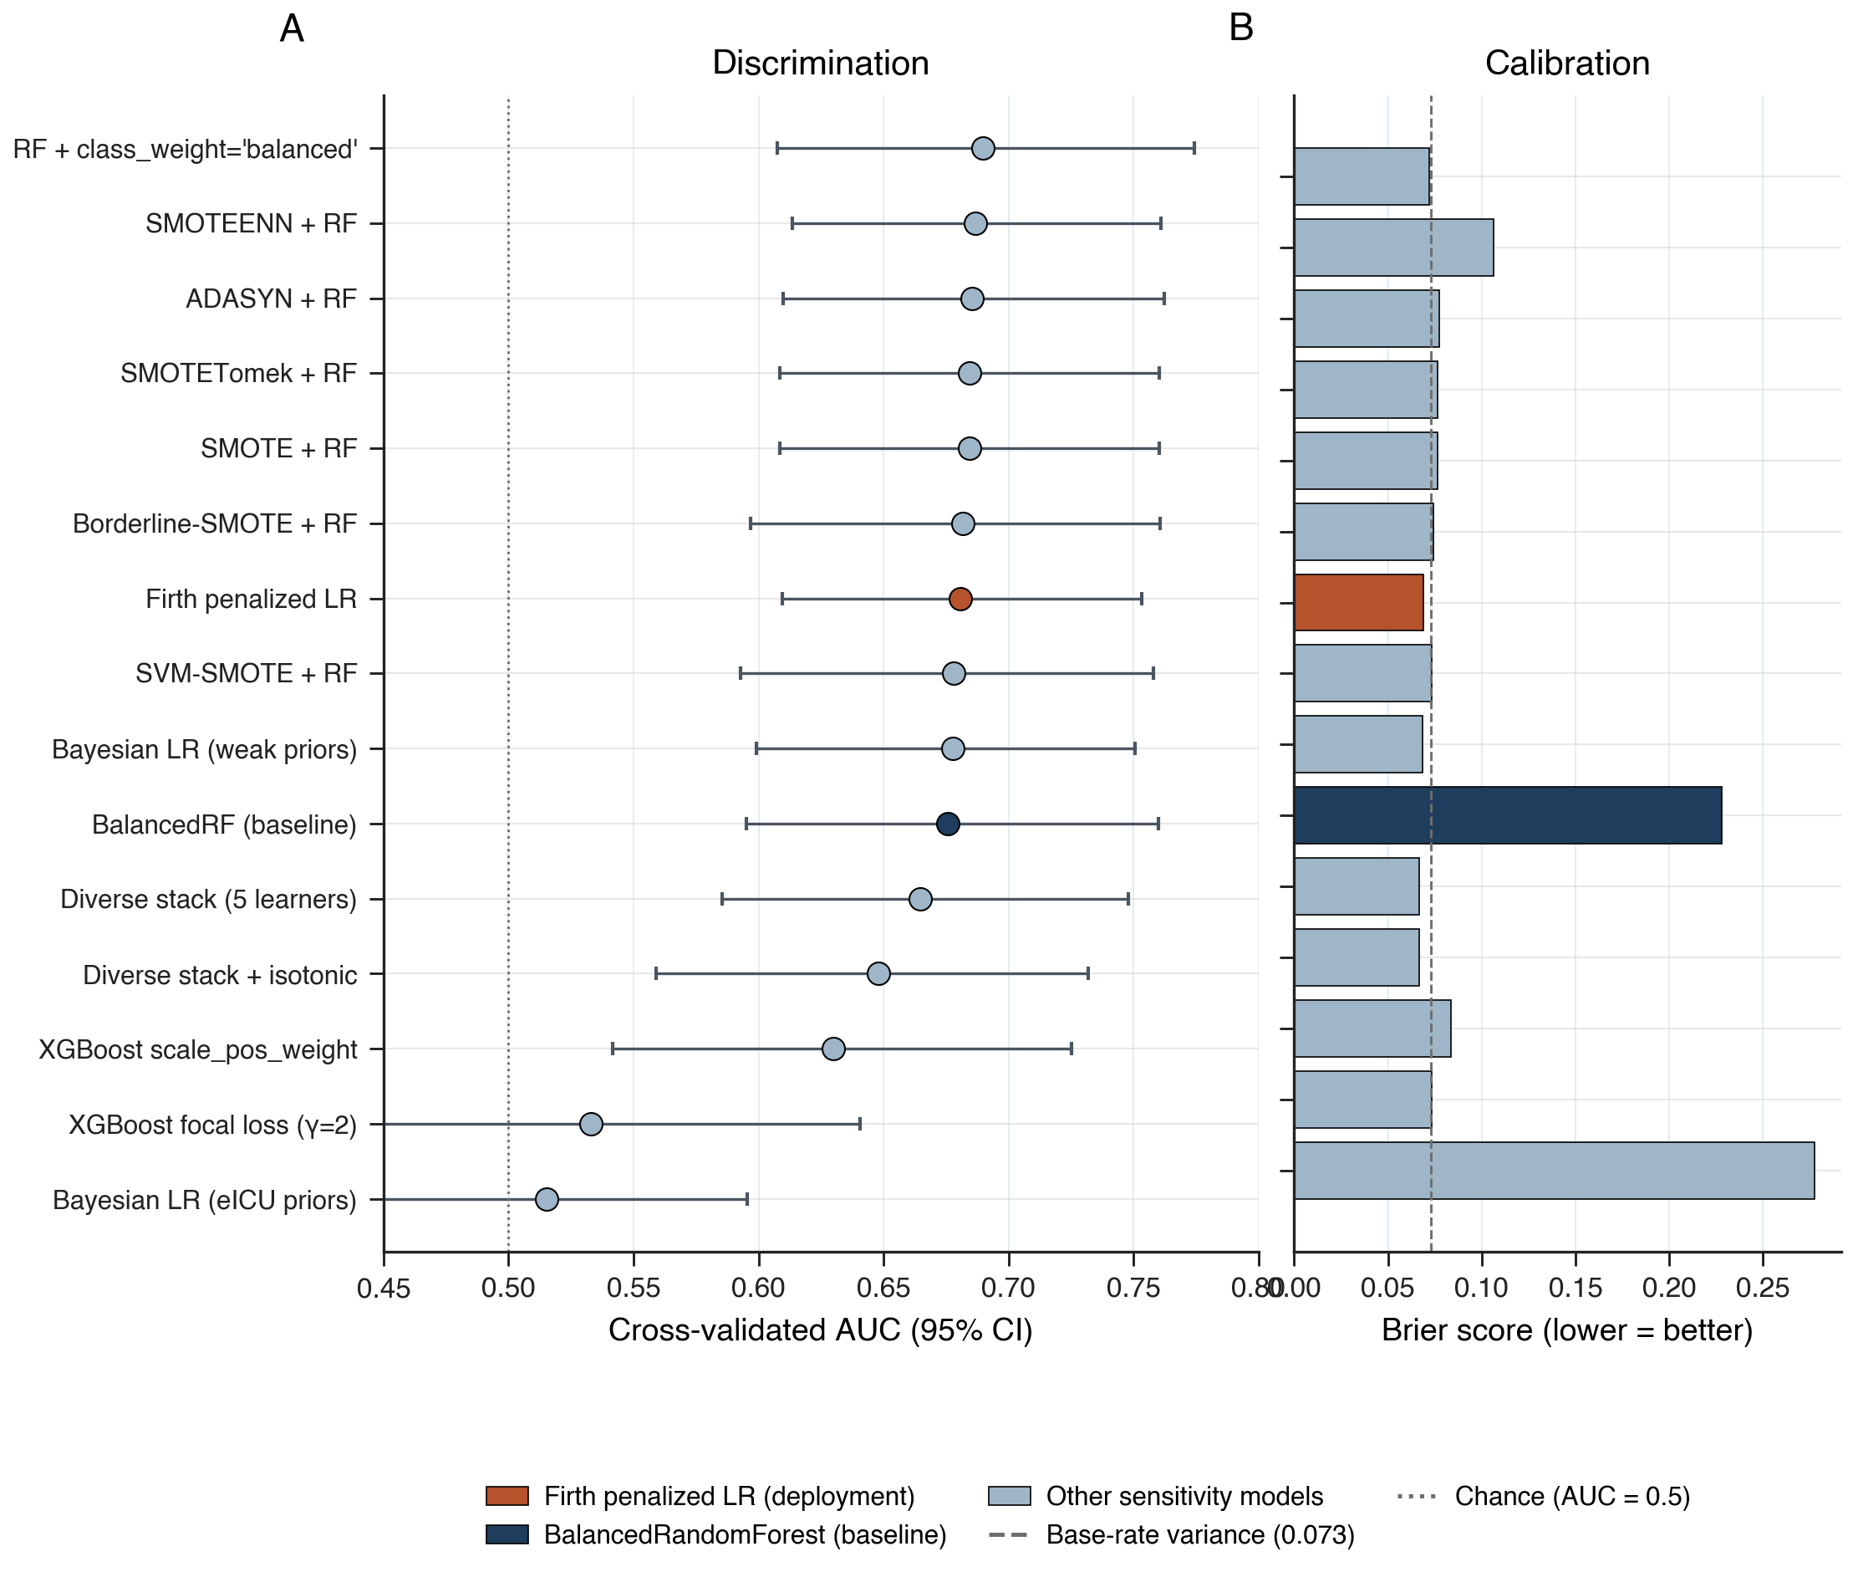
Figure 3. Eleven-method modelling battery on BIDMC postoperative-A. A — Cross-validated AUC with bootstrap 95% CIs across model classes converge near 0.68. B — Brier score across the same models. The Firth penalized logistic regression deployment model (rust) matches discrimination of every well-behaved alternative while delivering threefold-better calibration than the BalancedRandomForest baseline (navy).

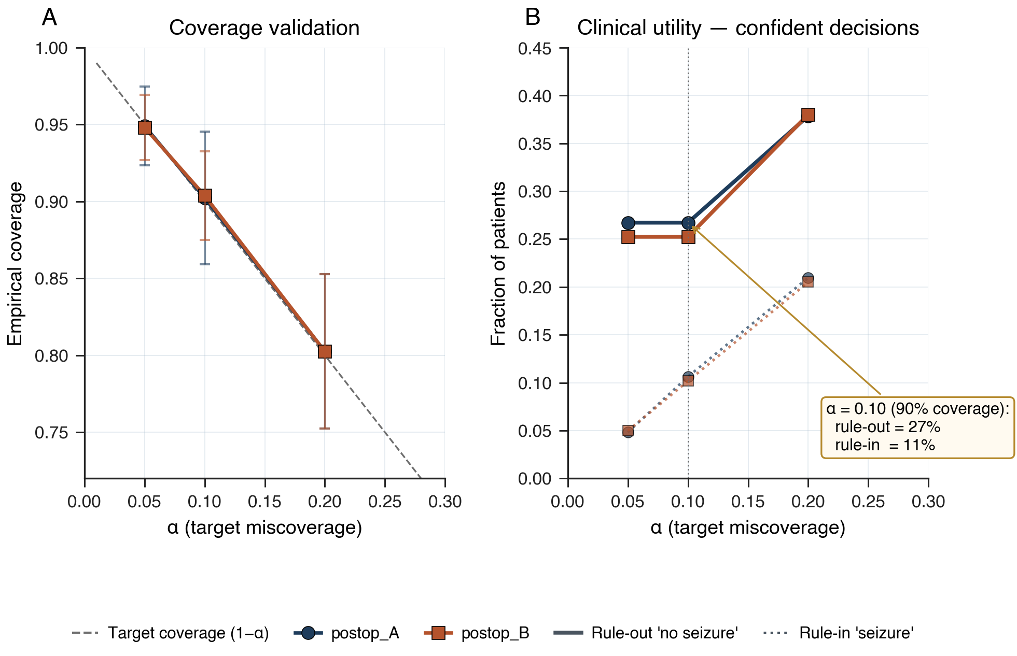
Figure 4. Class-conditional conformal prediction. A — Empirical coverage tracks the target 1−α across α ∈ {0.05, 0.10, 0.20}. B — Rule-out and rule-in singleton fractions versus α; at α = 0.10 the procedure delivers confident decisions for 37% of patients (rule-out 27%, rule-in 11%).

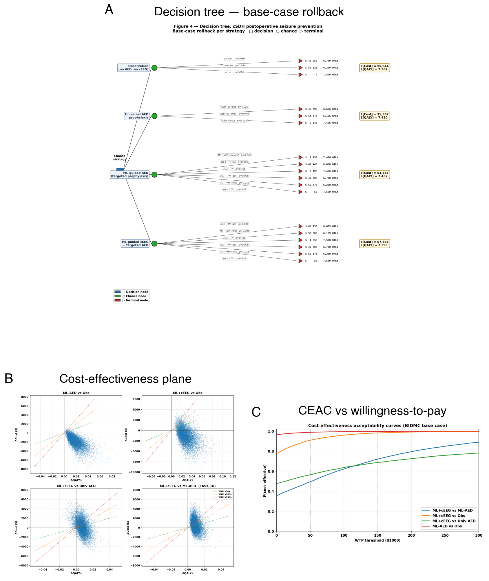
Figure 5. Cost-effectiveness analysis. A — Decision tree with base-case rollback per strategy. B — Cost-effectiveness plane from 10,000-iteration probabilistic sensitivity. C — Cost-effectiveness acceptability curves over willingness-to-pay.

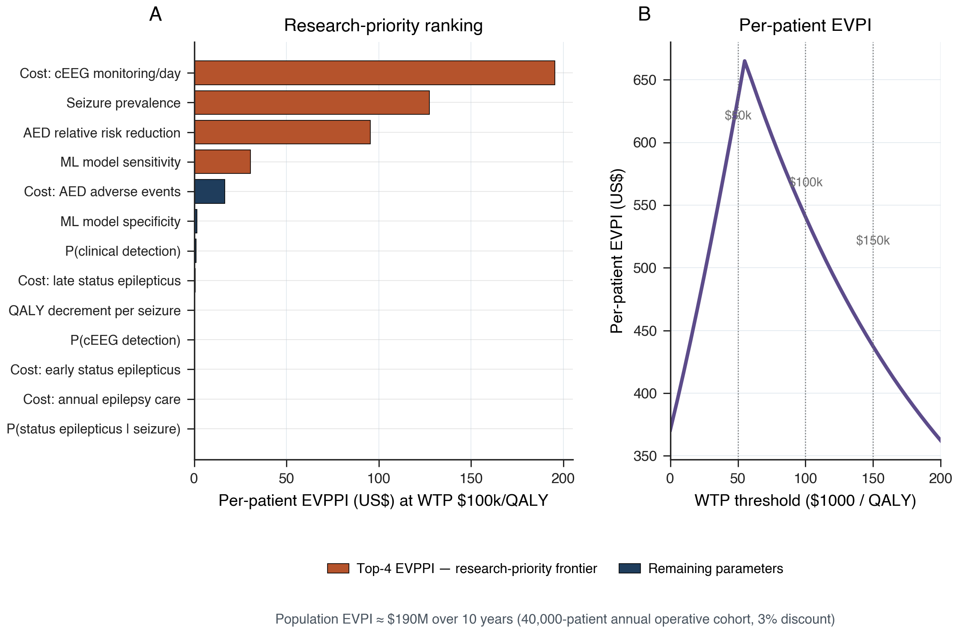
Figure 6. Value of information. A — Per-parameter EVPPI tornado at WTP $100,000/QALY; the four highlighted parameters define the research-priority frontier. B — Per-patient EVPI as a function of willingness-to-pay threshold.

