Supplementary Material
JNNP submission · supplementary appendix

Appendix S1. TRIPOD-AI reporting checklist
TRIPOD-AI checklist (Collins et al. BMJ 2024).
Item | Topic | Description | Reported
1 | Title | Identifies study as developing or evaluating an ML prediction model. | Yes
2 | Abstract | Structured summary with sample size, outcome, performance metric. | Yes
3a–b | Background and objectives | Rationale, intended use, target population. | Yes — Introduction §1.
4–6 | Source of data | Multi-database; BIDMC/eICU/NIS; eligibility criteria. | Yes — Methods §2.2.
7 | Outcome | Defined a priori; ICD-10 codes; NIS reclassification documented. | Yes — Methods §2.3.
8 | Predictors | 21 features (postop_A); 18 (postop_B); standardisation. | Yes — Methods §2.3.
9 | Sample size | 655 (BIDMC), 3,297 (eICU primary), 2,518 (NIS chronic+surgical). | Yes — Methods §2.2.
10 | Missing data | Median imputation + missing indicator (sensitivity) | Yes — Supplement S4.
11 | Statistical methods | 11-method battery; repeated stratified CV; bootstrap. | Yes — Methods §2.5.
12 | Risk groups | Class-conditional conformal sets (rule-out, rule-in). | Yes — Results §3.4.
13 | Development vs validation | BIDMC development; eICU external; LOHO meta-analytic pooling. | Yes — Results §3.1.
14 | Model performance | AUC, Brier, calibration slope/intercept, net benefit. | Yes — Results §3.1–3.3.
15 | Model presentation | Firth coefficient table released on GitHub. | Yes — see code repo.
16 | Limitations | Single-institution dev; admin outcomes; ceiling at 48 events. | Yes — Discussion §4.
17 | Interpretation | Proof-of-concept; calibration & conformal deployment; CEA + VOI. | Yes — Discussion §4.
18–22 | Reproducibility | Code, seed, package versions on GitHub. | Yes — Appendix S2.

Appendix S2. Reproducibility statement
All scripts are released at github.com/nielspac177/csdh-postop-seizure-risk under a permissive license. Computational environment: Python 3.9.6, scikit-learn 1.5.2, pandas 2.3.3, lifelines 0.30.0, XGBoost 2.1.4, LightGBM 4.6.0, firthlogist 0.5.0, mapie 1.4.0, imbalanced-learn 0.12.4, python-docx 1.2.0. All analyses used n_jobs = 1 for Apple-Silicon stability and SEED = 42 for reproducibility. The commit hash of the analyses corresponding to this manuscript is tagged v1.0-submission.
Raw patient data are restricted by IRB / data-use agreements. The following derived assets are released: (a) the 21-variable BIDMC feature schema with categorical encoders; (b) the corrected NIS ICD-10 outcome codeset; (c) the CEA decision-tree Python implementation and parameter file; and (d) Firth coefficient estimates with confidence intervals.

Supplementary Tables
Table S1. Eleven-method modelling battery — full numeric results.
feature_set | method | auc | ci_lo | ci_hi | prauc | brier | nb_5pct | nb_10pct
postop_A | BalancedRF (baseline) | 0.676 | 0.595 | 0.760 | 0.137 | 0.228 | 0.025 | -0.030
postop_A | RF + class_weight='balanced' | 0.690 | 0.607 | 0.774 | 0.159 | 0.072 | 0.028 | 0.003
postop_A | SMOTE + RF | 0.684 | 0.609 | 0.760 | 0.134 | 0.077 | 0.030 | 0.005
postop_A | Borderline-SMOTE + RF | 0.682 | 0.597 | 0.761 | 0.148 | 0.074 | 0.030 | 0.008
postop_A | SVM-SMOTE + RF | 0.678 | 0.593 | 0.758 | 0.150 | 0.073 | 0.028 | 0.007
postop_A | ADASYN + RF | 0.686 | 0.610 | 0.762 | 0.134 | 0.077 | 0.030 | 0.006
postop_A | SMOTEENN + RF | 0.687 | 0.613 | 0.761 | 0.134 | 0.106 | 0.029 | -0.003
postop_A | SMOTETomek + RF | 0.684 | 0.609 | 0.760 | 0.134 | 0.077 | 0.030 | 0.005
postop_A | XGBoost scale_pos_weight | 0.630 | 0.542 | 0.725 | 0.131 | 0.084 | 0.025 | 0.013
postop_A | XGBoost focal loss (γ=2) | 0.533 | 0.428 | 0.641 | 0.113 | 0.073 | 0.000 | 0.000
postop_B | BalancedRF (baseline) | 0.658 | 0.568 | 0.751 | 0.142 | 0.228 | 0.025 | -0.030
postop_B | RF + class_weight='balanced' | 0.677 | 0.592 | 0.764 | 0.154 | 0.071 | 0.024 | 0.004
postop_B | SMOTE + RF | 0.675 | 0.594 | 0.755 | 0.135 | 0.076 | 0.028 | 0.008
postop_B | Borderline-SMOTE + RF | 0.670 | 0.592 | 0.749 | 0.143 | 0.074 | 0.029 | 0.004
postop_B | SVM-SMOTE + RF | 0.675 | 0.597 | 0.753 | 0.151 | 0.073 | 0.031 | 0.004
postop_B | ADASYN + RF | 0.674 | 0.596 | 0.753 | 0.132 | 0.077 | 0.028 | 0.003
postop_B | SMOTEENN + RF | 0.675 | 0.596 | 0.755 | 0.135 | 0.107 | 0.029 | 0.002
postop_B | SMOTETomek + RF | 0.675 | 0.594 | 0.755 | 0.135 | 0.076 | 0.028 | 0.008
postop_B | XGBoost scale_pos_weight | 0.624 | 0.536 | 0.721 | 0.126 | 0.084 | 0.026 | 0.012
postop_B | XGBoost focal loss (γ=2) | 0.534 | 0.431 | 0.640 | 0.112 | 0.073 | 0.000 | 0.000

Table S2. eICU cohort definition sensitivity with bootstrap 95% CIs.
cohort | set | n | events | auc_mean | auc_sd | ci_lo | ci_hi
1: paper (non_traumatic) | Set_A | 3297 | 300 | 0.708 | 0.036 | 0.690 | 0.754
1: paper (non_traumatic) | Set_C | 3297 | 300 | 0.750 | 0.036 | 0.711 | 0.774
2: non_traumatic + op | Set_A | 317 | 27 | 0.670 | 0.100 | 0.571 | 0.785
2: non_traumatic + op | Set_C | 317 | 27 | 0.575 | 0.101 | 0.409 | 0.656
3: apache dx surgery/burr | Set_A | 527 | 41 | 0.609 | 0.131 | 0.516 | 0.710
3: apache dx surgery/burr | Set_C | 527 | 41 | 0.613 | 0.092 | 0.510 | 0.711
4: traumatic SDH (control) | Set_A | 1853 | 149 | 0.671 | 0.044 | 0.640 | 0.728
4: traumatic SDH (control) | Set_C | 1853 | 149 | 0.725 | 0.036 | 0.681 | 0.765

Table S3. Calibration metrics with bootstrap 95% CIs across all six cohort-model combinations.
model | n | events | brier | brier_lo | brier_hi | citl | citl_lo | citl_hi
bidmc_postopA | 655 | 48 | 0.228 | 0.219 | 0.237 | 0.394 | -0.415 | -0.374
bidmc_postopB | 655 | 48 | 0.199 | 0.182 | 0.217 | 0.298 | -0.322 | -0.273
bidmc_preop | 655 | 48 | 0.079 | 0.065 | 0.095 | 0.072 | -0.092 | -0.051
eicu_setA | 5369 | 461 | 0.103 | 0.098 | 0.108 | 0.104 | -0.112 | -0.096
eicu_setC | 5369 | 461 | 0.071 | 0.066 | 0.076 | 0.022 | -0.029 | -0.014
eicu_pure_setC | 3255 | 145 | 0.042 | 0.037 | 0.049 | 0.015 | -0.022 | -0.008

Table S4. Cost-effectiveness analysis — PSA summary at WTP $50k, $100k, $150k.
scenario | comparison | wtp | dc_mean | dc_lo | dc_hi | dq_mean | dq_lo | dq_hi
baseline | mla_obs | 50000 | -1,892 | -4,740 | 146 | 0.019 | 0.005 | 0.043
baseline | mla_obs | 100000 | -1,892 | -4,740 | 146 | 0.019 | 0.005 | 0.043
baseline | mla_obs | 150000 | -1,892 | -4,740 | 146 | 0.019 | 0.005 | 0.043
baseline | mla_aed | 50000 | -370 | -1,425 | 977 | -0.002 | -0.012 | 0.002
baseline | mla_aed | 100000 | -370 | -1,425 | 977 | -0.002 | -0.012 | 0.002
baseline | mla_aed | 150000 | -370 | -1,425 | 977 | -0.002 | -0.012 | 0.002
baseline | mlg_obs | 50000 | -1,378 | -5,352 | 2,155 | 0.029 | 0.011 | 0.058
baseline | mlg_obs | 100000 | -1,378 | -5,352 | 2,155 | 0.029 | 0.011 | 0.058
baseline | mlg_obs | 150000 | -1,378 | -5,352 | 2,155 | 0.029 | 0.011 | 0.058
baseline | mlg_aed | 50000 | 143 | -2,805 | 3,391 | 0.007 | -0.004 | 0.018
baseline | mlg_aed | 100000 | 143 | -2,805 | 3,391 | 0.007 | -0.004 | 0.018
baseline | mlg_aed | 150000 | 143 | -2,805 | 3,391 | 0.007 | -0.004 | 0.018
baseline | mlg_mla | 50000 | 514 | -1,880 | 3,227 | 0.009 | 0.004 | 0.019
baseline | mlg_mla | 100000 | 514 | -1,880 | 3,227 | 0.009 | 0.004 | 0.019
baseline | mlg_mla | 150000 | 514 | -1,880 | 3,227 | 0.009 | 0.004 | 0.019
baseline | aed_obs | 50000 | -1,522 | -4,712 | 1,004 | 0.021 | 0.005 | 0.048
baseline | aed_obs | 100000 | -1,522 | -4,712 | 1,004 | 0.021 | 0.005 | 0.048
baseline | aed_obs | 150000 | -1,522 | -4,712 | 1,004 | 0.021 | 0.005 | 0.048

Table S5. Per-parameter EVPPI ranking at WTP $100,000/QALY.
parameter | column | evppi_per_patient | evppi_population
Cost: cEEG monitoring/day | c_ceeg | 195 | 68,687,999
Seizure prevalence | p_sz | 127 | 44,804,411
AED relative risk reduction | rrr | 95.550 | 33,580,438
ML model sensitivity | sens | 30.536 | 10,731,775
Cost: AED adverse events | c_aed_a | 16.591 | 5,830,973
ML model specificity | spec | 1.437 | 505,151
P(clinical detection) | pd_clin | 1.038 | 364,964
Cost: late status epilepticus | c_se_l | 0.661 | 232,364
QALY decrement per seizure | u_dec | 0.000 | 0.006
P(cEEG detection) | pd_ceeg | 0.000 | 0.000
Cost: early status epilepticus | c_se_e | 0.000 | 0.000
P(status epilepticus | seizure) | p_se | 0.000 | 0.000
Cost: annual epilepsy care | c_epi | 0.000 | 0.000

Supplementary Figures
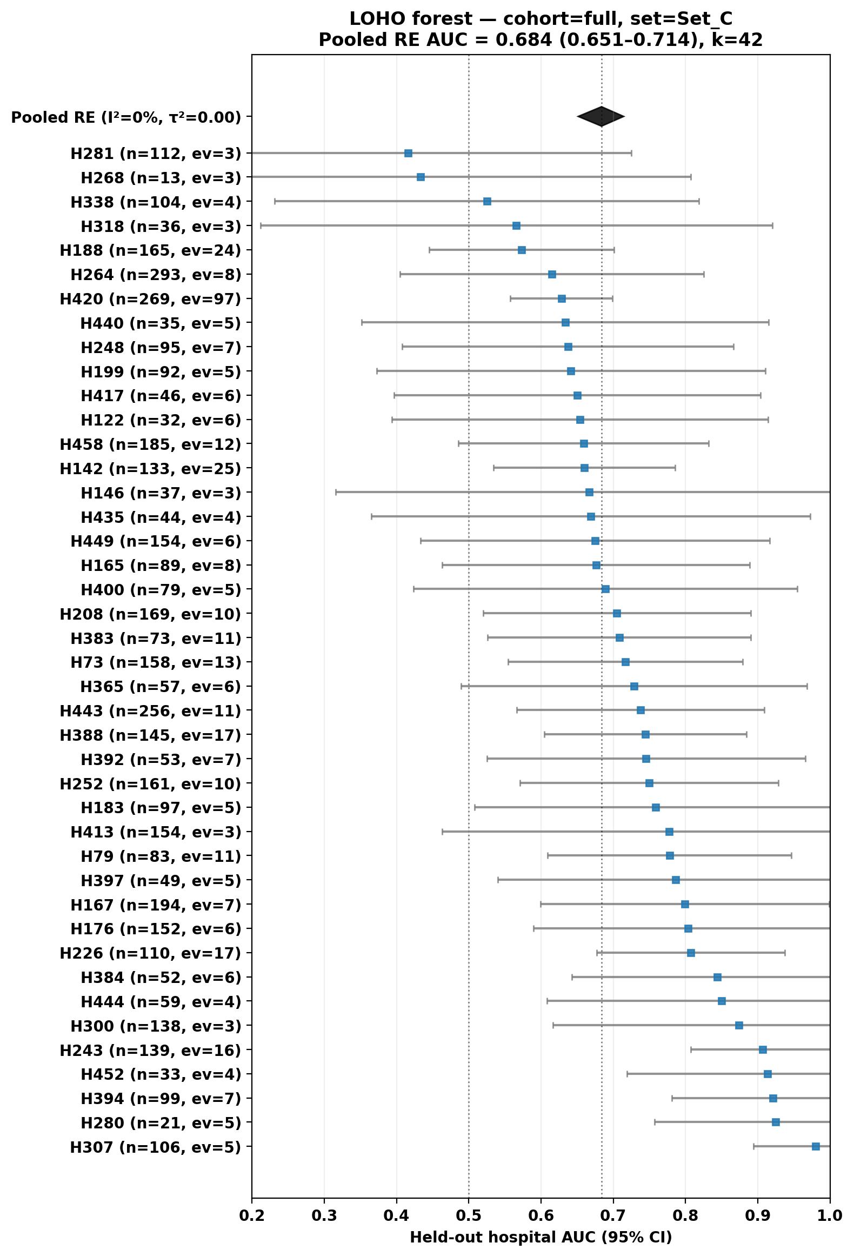
Figure S1. Per-hospital leave-one-hospital-out forest plot (eICU Set C, full cohort, 42 hospitals).

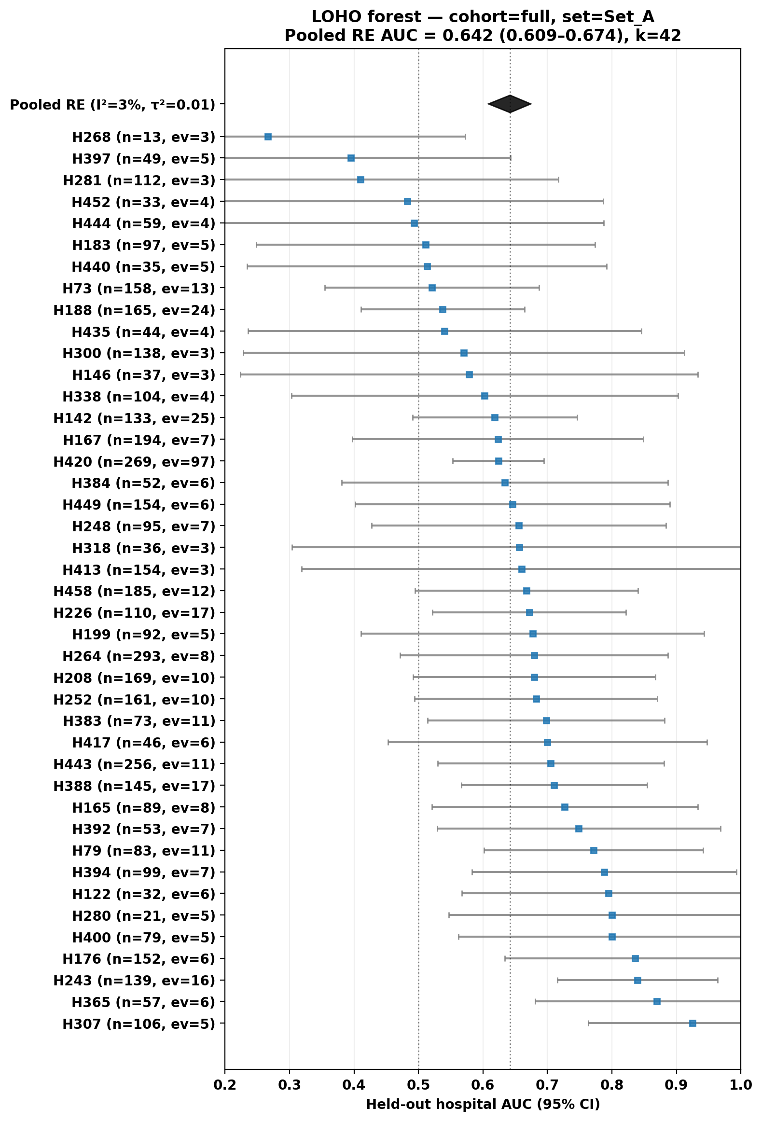
Figure S2. Per-hospital leave-one-hospital-out forest plot (eICU Set A, full cohort).

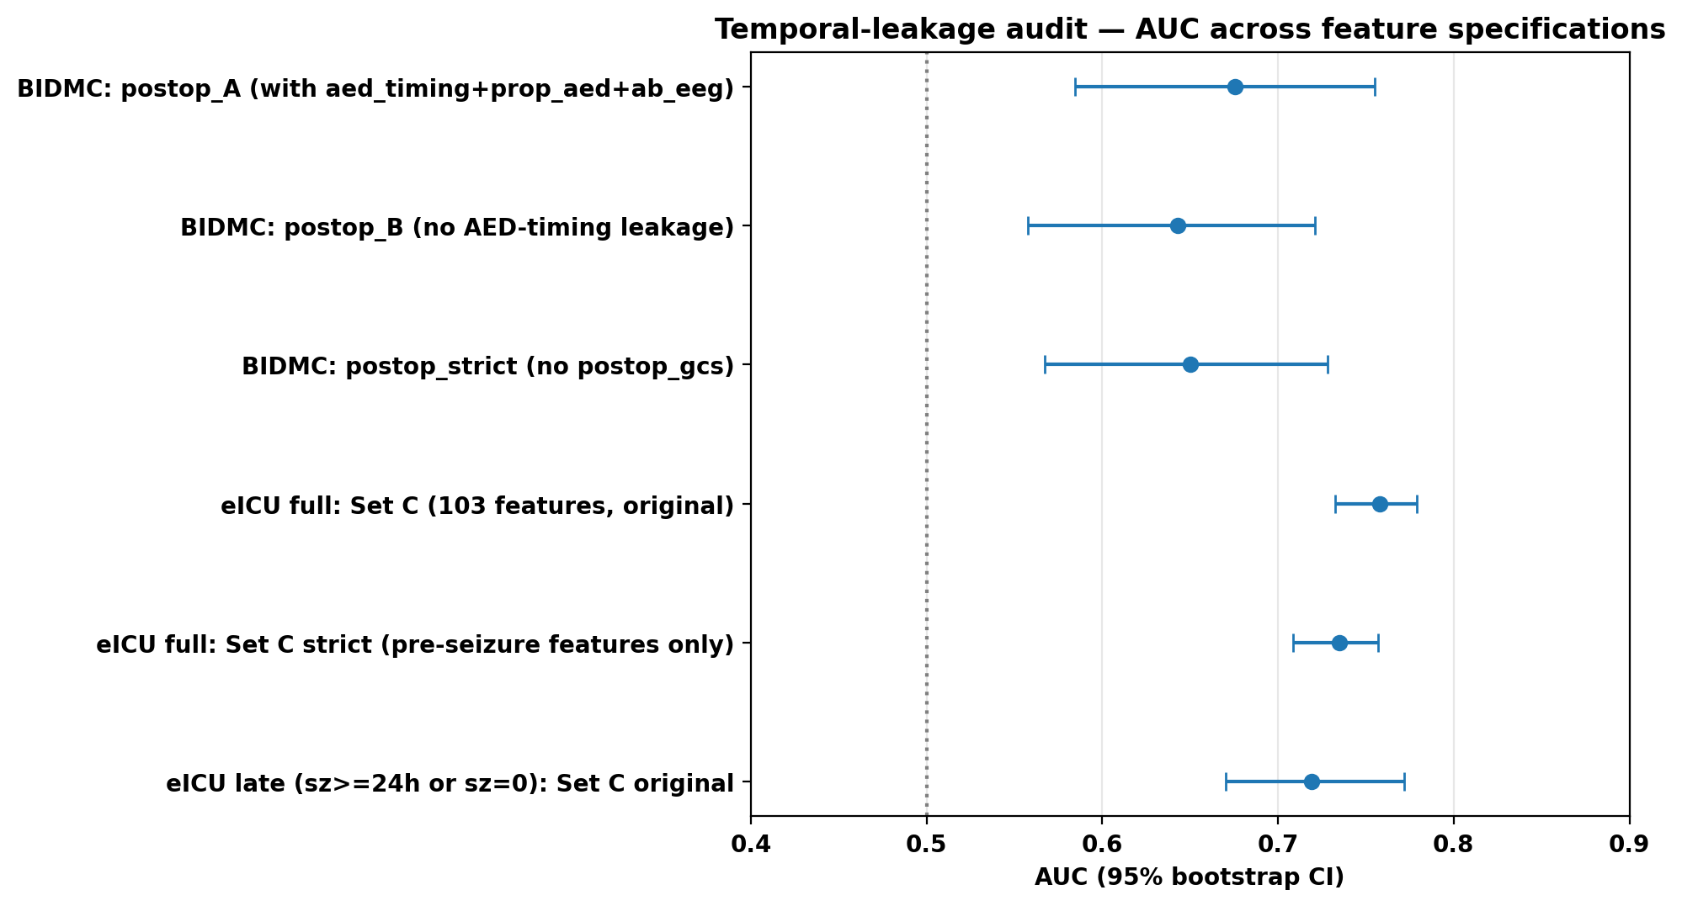
Figure S3. Temporal-leakage audit — AUC across feature specifications and time-window cuts.

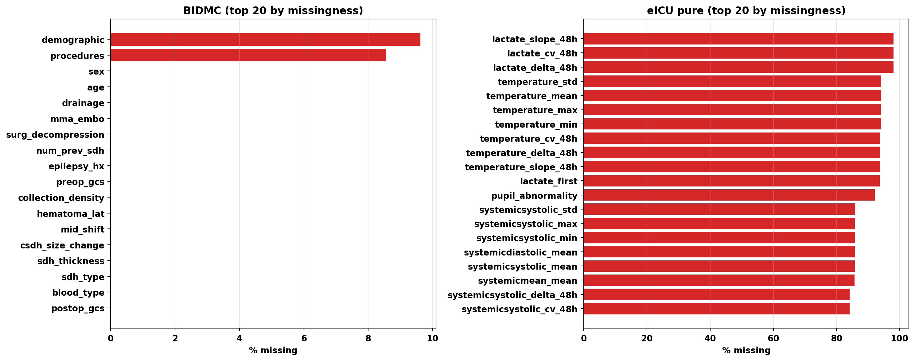
Figure S4. Missingness pattern and Rubin's-rules multiple-imputation pooling.

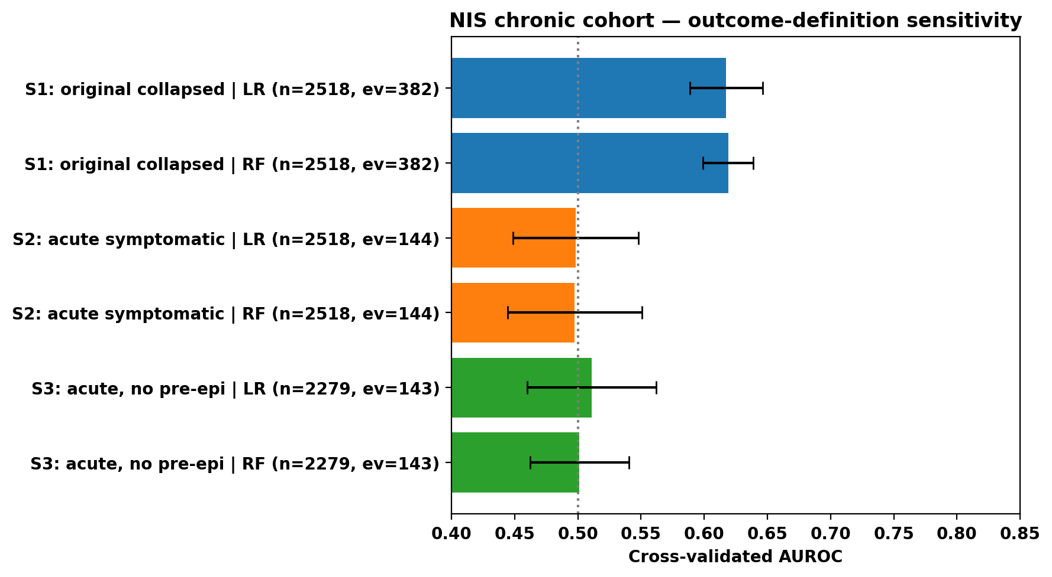
Figure S5. Nationwide Inpatient Sample outcome reclassification — AUC under original combined outcome (0.617) vs corrected acute symptomatic outcome (0.498).

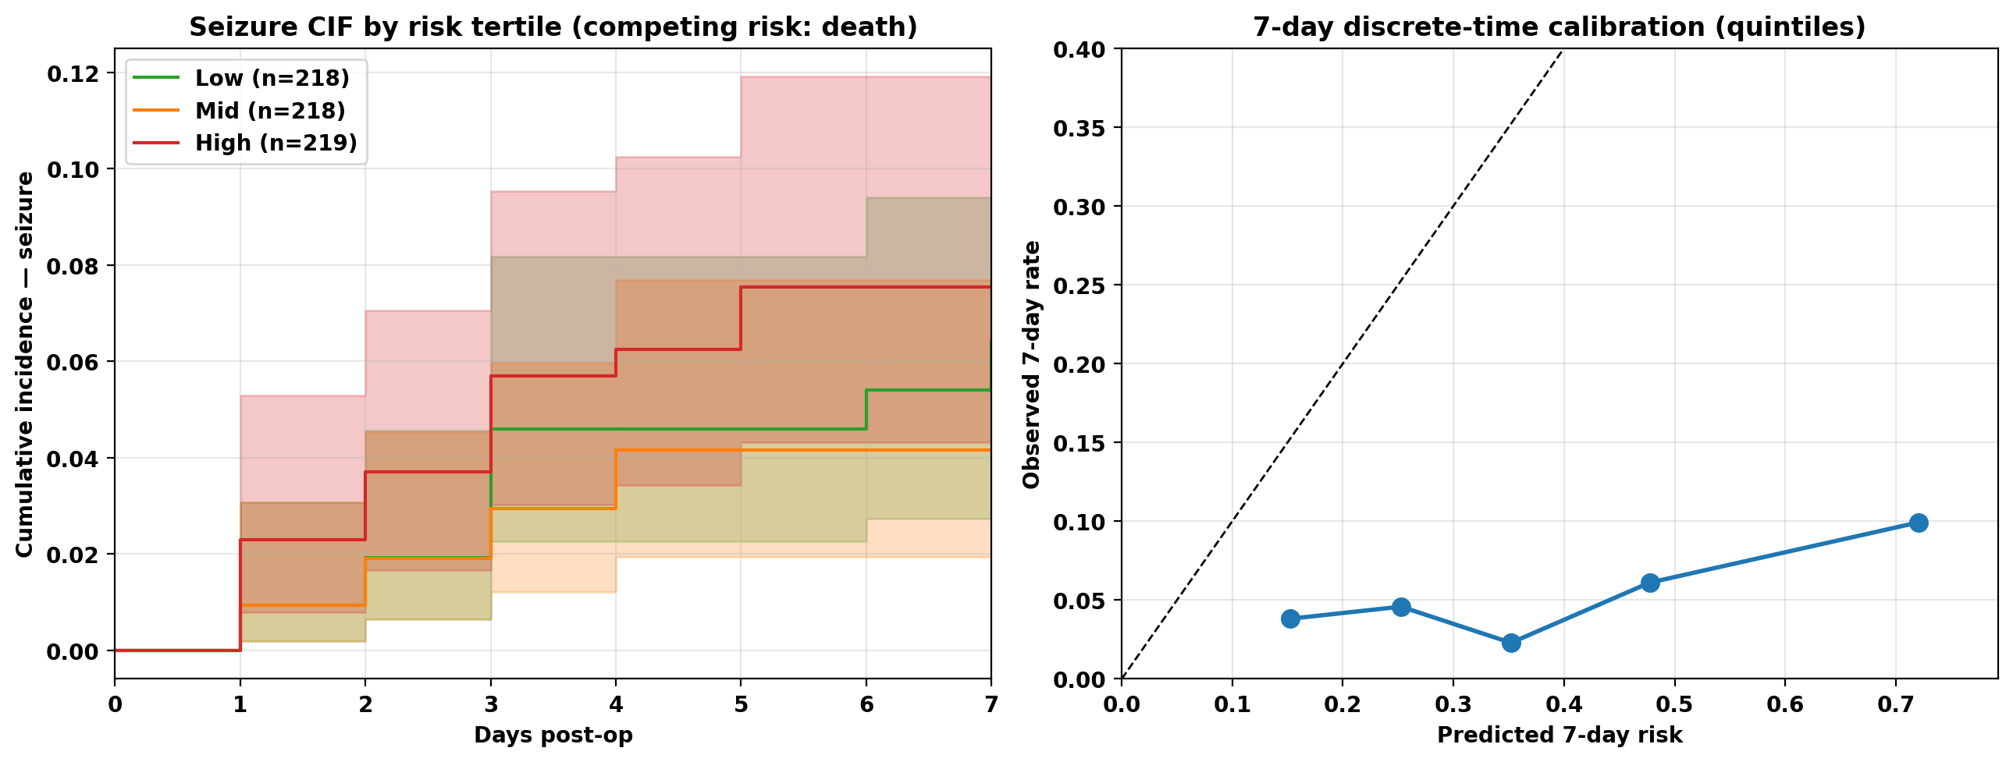
Figure S6. Competing-risks cumulative-incidence functions and cause-specific Cox / IPCW Fine–Gray comparison.

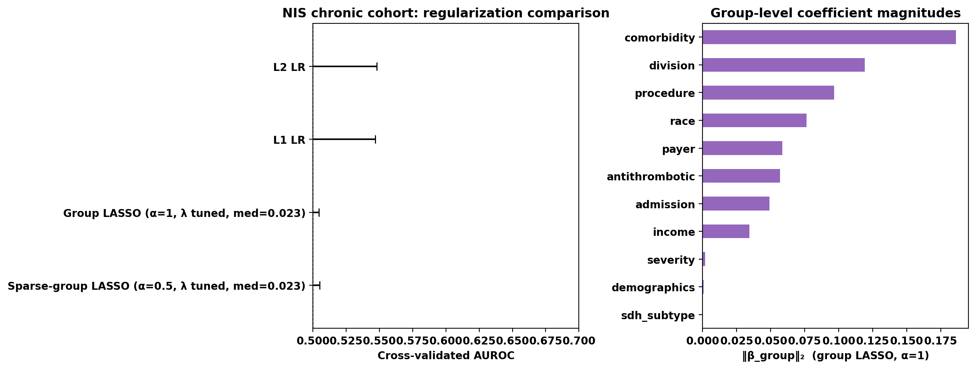
Figure S7. λ-path-tuned group-LASSO and sparse-group-LASSO on the NIS chronic+surgical cohort with the corrected outcome.

