Common-variant burden of the core circadian oscillator is enriched in genetic generalized epilepsy but not focal epilepsy: an LD-aware summary-statistics genetic study

Abstract
Background. The generalized epilepsies, particularly juvenile myoclonic epilepsy, show a strong clinical relationship to the sleep–wake cycle, and generalized-seizure patients are more likely to be evening chronotypes. Whether the core circadian (“clock”) oscillator contributes to the common- variant genetic architecture of epilepsy, and whether it does so differentially by epilepsy type, has not been tested with a well-powered, subtype-resolved, LD-aware analysis.
Methods. Using European summary statistics from the ILAE Consortium on Complex Epilepsies (focal epilepsy, genetic generalized epilepsy [GGE], all-epilepsy) we tested a pre-registered set of 23 core clock genes for common-variant enrichment. The primary test was an LD-aware MAGMA competitive gene-set analysis (1000 Genomes European reference; conditioning on gene size, gene density, sample size and minor-allele count), with a covariate-matched top-SNP null as a corroborating screen and extensive robustness analysis (leave-one/​k-out, in-body-only assignment, median statistic, multi-seed p-values, positive/negative-control gene sets). We tested type-specificity with a shared-control difference test, sought independent replication in FinnGen R12 (generalized epilepsy, 1,690 cases), and interrogated causality/mechanism with two-sample Mendelian randomization (MR) of four behavioural sleep exposures, cis-eQTL MR, colocalization (coloc.abf, PsychENCODE prefrontal cortex), and GTEx splice- and expression-QTL lookup at the lead locus.
Results. The core circadian oscillator was enriched for GGE association under LD-aware MAGMA (competitive P = 1.7×10⁻⁴, β = 0.67; 22 genes with a valid SNP), null in focal epilepsy (P = 0.73), with a housekeeping set null in both. The enrichment was robust to removing the strongest gene (drop PER1 P = 1.4×10⁻⁴; drop PER1+PER3 P = 2.3×10⁻³), was corroborated by the matched-null screen (ratio 1.53; median empirical p = 1.9×10⁻³ across 50 seeds) and an in-body-only variant (ratio 1.74), and was specific to the core oscillator — the broad GO:0007623 circadian annotation (185 genes) was null and not GGE-specific. A shared-control difference test confirmed GGE > focal (Δ = 0.55, 2-sided p = 3.1×10⁻³). The signal did not replicate in FinnGen (mean-χ² ratio 0.85 and rank test both p = 0.99), though FinnGen GGE is ~2× smaller and registry-phenotyped and even the strongest established GGE loci attenuated sharply, so this is a power-/phenotype-limited non-replication rather than a refutation. No behavioural sleep exposure showed a robust causal MR effect on either epilepsy type. The lead variant (rs2585398, intronic to PER1, MAGMA gene P = 7.9×10⁻⁷) is a strong PER1 splice-QTL peripherally but does not colocalize with steady-state clock-gene expression; in brain the same variant is an eQTL for the co-located synaptic gene VAMP2, so the causal gene at the locus is not resolved.
Conclusions. Core circadian-oscillator common variation is enriched specifically in genetic generalized epilepsy under a gold-standard LD-aware test, is GGE-specific and robust to the strongest gene, and is independent of genetically-instrumented sleep behaviour and steady-state clock-gene expression. The effect has not yet replicated in an independent cohort and the causal gene at the lead (PER1) locus is unresolved; both are the priority next steps.

Introduction
Seizures in the generalized epilepsies are tightly coupled to the sleep–wake transition. Juvenile myoclonic epilepsy is defined in part by myoclonus on awakening, and in generalized tonic-clonic seizures on awakening roughly 90% of seizures occur within two hours of waking, at any clock time [Frank & Yaari]. Generalized epileptiform discharges are strongly state-dependent — potentiated by non-REM sleep and suppressed by alert wakefulness and REM [Ng & Pavlova] — giving generalized epilepsy a timing signature distinct from focal epilepsy. Chronotype tracks epilepsy type: 36% of patients with generalized epilepsy were evening types versus 11% of those with focal epilepsy [Choi et al.], and correcting a comorbid delayed sleep–wake phase disorder reduced juvenile-myoclonic seizures from eight to zero per month without any change in anti-seizure medication [Khan et al.]. These observations motivate the “chronoepileptology” hypothesis that circadian biology shapes seizure liability. Yet prior genetic work linking the molecular clock to epilepsy has been limited to animal models and small candidate-gene studies (<100 patients) that were underpowered and largely null; a recent review explicitly identified well-powered, subtype-resolved analysis as an open question.
The ILAE Consortium’s third genome-wide association study (29,944 cases, 52,538 controls) revealed markedly different common-variant architectures for focal versus generalized epilepsy and provides the power to test the circadian hypothesis directly. We asked three questions, each a distinct estimand: (1) is the common-variant burden in the core clock oscillator differentially enriched between focal and generalized epilepsy, under an LD-aware test; (2) is a circadian exposure causally related to epilepsy type; and (3) if there is a genetic signal, does it localize to the molecular clock rather than to sleep behaviour or co-located non-clock genes. We treat these as triangulation on separate estimands rather than one “circadian” construct, and we tested the primary result for robustness, type-specificity, and independent replication.

Methods
Data. Outcome summary statistics were the ILAE 2023 European analyses for all-epilepsy, focal epilepsy and GGE (effect allele = Allele1; per-marker effective N; GRCh37). Independent replication used FinnGen R12 generalized epilepsy (GE; 1,690 cases / 484,703 controls) and focal epilepsy (FE; 9,275 cases), GRCh38. Behavioural exposures (GRCh37, GWAS Catalog) were morning chronotype (Jones 2019), sleep duration and short/long sleep (Dashti 2019); insomnia (Hammerschlag 2017) was underpowered and Jansen 2019 is access-restricted. cis-QTLs were eQTLGen blood (N = 31,684), PsychENCODE prefrontal cortex (N = 1,387), and GTEx v8/v10 (splice- and expression-QTL). The clock-gene set (23 genes spanning the core transcription–translation feedback loop) was pre-registered and hash-frozen before analysis.
Primary test — LD-aware gene-set enrichment (Aim 1). We ran MAGMA v1.10 with the 1000 Genomes European reference panel: SNP-to-gene annotation, a gene-level analysis using per-SNP effective N (99.1% of ILAE SNPs matched the reference), and a competitive gene-set analysis conditioning on gene size, gene density, sample size, inverse minor-allele count and their logs. We tested the circadian set against housekeeping (negative control) and epilepsy (positive control) sets in both GGE and focal, and repeated the GGE analysis dropping PER1 and PER1+PER3.
Corroborating screen and robustness. As a tool-free cross-check we computed, for each protein-coding gene (GENCODE v19, hg19; ±50 kb window), the top-SNP χ² as an LD-attenuated gene statistic, and compared the circadian set’s mean to 10,000 gene-length- and SNP-count-matched random sets (competitive empirical p; median of 50 seeds reported). Robustness analyses: systematic leave-one/​k-out; an in-body-only variant (0 kb flank) that removes co-located neighbour SNPs; a median (outlier-insensitive) statistic; a window-sensitivity grid (±10–100 kb); a broad GO:0007623 circadian set and its non-core subset; and a scale-free rank-based statistic for cross-cohort comparison. Type-specificity used a shared-control difference test — Δ = ratio_GGE − ratio_focal scored on the same matched-null sets, so shared controls and shared LD cancel — with a two-sided empirical p.
Replication. The identical rank-based and mean-χ² enrichment tests were applied to FinnGen GE/FE (hg38 gene model; Z = β/SE; minor-allele-frequency ≥ 0.01), with a positive-control check on established GGE loci.
Mendelian randomization and mechanism (Aim 2). Instruments at p < 5×10⁻⁸, distance-clumped (±1 Mb), CHR:POS-matched and harmonized; IVW, MR-Egger (intercept test), weighted median, MR-PRESSO-style outlier correction, Steiger-filtered IVW. cis-MR used the strongest cis-eQTL per gene (Wald ratio). Colocalization used coloc.abf (priors p₁ = p₂ = 1×10⁻⁴, p₁₂ = 1×10⁻⁵). At the lead locus we queried GTEx single-tissue splice- and expression-QTLs.
Rigor. All analyses are European-ancestry. The ILAE outcome contains no UK Biobank participants, so overlap with UK-Biobank sleep exposures is minimal and biases MR toward the null. Each analysis tier was checked by an adversarial multi-agent review (which, among other things, identified and led to the correction of a FinnGen file-parsing bug). The pre-registration, adversarial reviews, and honest per-analysis verdicts are in the repository (docs/FINDINGS_tier1-3.md).

Results
Core circadian genes are enriched in GGE, not focal epilepsy, under LD-aware MAGMA. In the primary competitive gene-set analysis the 23-gene core oscillator (22 with a valid SNP in the reference panel) was enriched in GGE (β = 0.67, P = 1.7×10⁻⁴) and null in focal epilepsy (β = −0.11, P = 0.73); a housekeeping set was null in both (0.86 / 0.35). The enrichment was robust to removing the strongest contributing gene — dropping PER1 left P = 1.4×10⁻⁴ and dropping PER1+PER3 left P = 2.3×10⁻³ — indicating a genuinely distributed set signal rather than a single locus (Table 6). MAGMA’s gene-body assignment also corrected the main artefact of the tool-free screen: the CSNK1E signal, which in a ±50 kb window captures a variant inside the neighbouring potassium-channel gene KCNJ4, is null under MAGMA (gene P = 0.40), while PER1 (7.9×10⁻⁷, genome-wide significant), PER3 (1.9×10⁻⁵) and ARNTL (5.6×10⁻⁴) retain genuine gene-body signal.
The screen corroborates and the effect is core-specific and gene-local. The covariate-matched top-SNP screen agreed (GGE ratio 1.53, median empirical p = 1.9×10⁻³ over 50 seeds; focal 0.98, p = 0.54; Table 2). An in-body-only variant that excludes all flanking (potentially co-located) SNPs was stronger (ratio 1.74, p = 1.7×10⁻³), a robust median statistic remained significant (p = 4.0×10⁻³), and the effect grew at tighter windows — all signatures of a gene-local rather than co-location artefact. Critically, the enrichment was specific to the core oscillator: the broad GO:0007623 circadian annotation (185 genes) was only borderline (1.08, p = 0.058) and not GGE-specific, and its 165 non-core genes were null in GGE (1.02, p = 0.32). A shared-control difference test confirmed the enrichment is significantly greater in GGE than focal (Δ = 0.55, 2-sided p = 3.1×10⁻³), robust across ±10–100 kb windows.
The effect did not replicate in FinnGen (power-limited). In FinnGen R12 GE (1,690 cases) the clock set was not enriched by either the mean-χ² (ratio 0.85, p = 0.99) or the scale-free rank test (percentile 0.40, p = 0.99), and GE_STRICT/FE were likewise null (Table 7). This is reported as a genuine non-replication, but its informativeness is limited: FinnGen GE is ~2× smaller in effective sample size, uses registry (ICD-code) rather than expert GGE classification, and is a population isolate, and even the strongest established GGE loci attenuate sharply there (VRK2 χ² 79 → 15, SCN1A → 13). It is consistent with insufficient power plus phenotype/ancestry difference rather than a clean refutation.
No robust causal effect of sleep behaviour. Across four behavioural exposures and both epilepsy types, nominal IVW estimates did not survive sensitivity analysis. Sleep duration → GGE was nominally protective by IVW (β = −0.18, p = 0.042) but reversed under weighted median (+0.18) and attenuated to null under MR-PRESSO (−0.08) and Steiger filtering (+0.01), with high heterogeneity (Cochran Q = 164). Morning chronotype showed a directionally consistent but non-significant protective trend for GGE larger than for focal. We find no reliable evidence that genetically-instrumented sleep behaviour causally alters epilepsy risk of either type.
Mechanism at the lead locus is unresolved. No clock gene’s steady-state expression colocalized with GGE: a blood cis-eQTL Wald signal for ARNTL (p = 0.003) did not replicate as a shared causal variant in prefrontal cortex (PP.H4 = 0.01), and PER1, despite a strong regional GGE signal, placed almost all posterior mass on association without an expression signal (PP.H2 = 0.89) — the ARNTL causal claim was retired. Consistent with the non-eQTL colocalization, the lead variant rs2585398 (intronic to PER1) is a strong PER1 splice-QTL peripherally (Artery-Tibial p = 6×10⁻²⁴; GTEx v8). However, the locus is gene-dense and pleiotropic: the same variant is an eQTL for the co-located synaptic-vesicle gene VAMP2 across 10 brain regions (Putamen p = 3×10⁻¹⁴; GTEx v10) and for CTC1. There is no demonstrated colocalization for any of these genes, so the causal gene at the PER1 locus — clock (PER1) versus synaptic (VAMP2) versus other — is not resolved. Because the set-level enrichment is robust to dropping PER1 (above), this locus-level ambiguity qualifies the mechanistic interpretation without undermining the gene-set result. Exploratory subtype analyses (JME, GTCS-only) were null and underpowered; the signal is a pan-GGE property.

Extended analyses — genetic correlation, PER1 colocalization, and the LGS receptor fingerprint
(Numbers below were independently recomputed by an adversarial verification team; full tables and figures in docs/RESULTS_final.md.)
SNP heritability and genetic correlation (LDSC). Under univariate LD Score regression (eur_w_ld_chr), GGE observed-scale SNP-heritability was 0.091 (SE 0.004) with an intercept of 1.058, indicating minimal confounding. The pipeline’s positive control behaved as expected — rg(GGE, focal) = 0.61 (p = 2×10⁻¹⁶), reflecting the substantial shared architecture (and shared ILAE controls) of the two epilepsy types. Against full genome-wide sleep-trait GWAS (Jones 2019 chronotype; Dashti 2019 sleep duration), GGE showed a significant negative genetic correlation with habitual sleep duration (rg = −0.12, p = 0.0022; Bonferroni-significant across the four primary sleep-trait tests) that was specific to GGE (focal rg = −0.03, p = 0.70). By contrast, GGE was genetically uncorrelated with chronotype (rg = 0.02, p = 0.47). The circadian–epilepsy genetic link therefore lies on the sleep-homeostatic axis (duration), not the behavioural-preference axis (chronotype) — consistent with sleep deprivation as a classical generalized-seizure trigger, and with the null behavioural Mendelian randomization for chronotype.
Locus-level colocalization at PER1. A two-GWAS colocalization at 17p13.1 showed that GGE and chronotype are both associated in the region but through distinct causal variants (coloc.abf PP.H3 = 0.9997; PP.H4 = 5×10⁻⁶). Extending to a three-trait analysis (GGE + chronotype + PsychENCODE PER1 cis-eQTL), the posterior probability that a single shared variant drives all three was ≈0 and the probability of three independent signals was 0.97. Even at the anchor gene, the circadian–epilepsy relationship is not a shared regulatory variant.
A receptor-specific excitation/inhibition fingerprint of the LGS network. Across 68 neuromaps annotations (spin-test nulls, FDR within family), the LGS EEG-fMRI network overlapped a pre-registered excitation/inhibition receptor family: glutamatergic mGluR5 (ABP688, r = 0.54 across three tracers, FDR = 0.0015) and GABA-A/benzodiazepine density (Ro15-4513 r = 0.42; flumazenil r = 0.37). Because the network’s single strongest correlate was the principal cortical gradient (r = 0.70), each receptor was subjected to two robustness tests. Partialling out the gradient, mGluR5 (partial r = 0.49, p < 0.001) and glucose metabolism (p < 0.001) survived, as did both GABA-A/BZ tracers (p = 0.016–0.019); cortical myelin did not. Re-testing in a different parcellation and null family (Schaefer-400 with a brainsmash variogram null), mGluR5 (p = 0.028) and metabolism (p = 0.005) reproduced, but the GABA-A/BZ signal did not (p = 0.49–0.72). The robust molecular correlate of the LGS network is therefore glutamatergic mGluR5 density (with glucose metabolism); a GABAergic-inhibitory contribution is suggestive but not firmly established. Circadian clock-gene expression, notably, has its own modest cortical topography (cholinergic, thickness, metabolism) but maps onto neither the LGS network (informative null; 80 % power for |r| ≥ 0.31) nor the mGluR5 signature. The circadian contribution to generalized epilepsy is genetic and temporal, not a feature of the epileptic network’s cortical-molecular topography.

Discussion
Three lines of evidence converge on a specific, defensible conclusion: under a gold-standard LD-aware test, the common-variant architecture of the core circadian oscillator is enriched in genetic generalized epilepsy, not focal epilepsy, and this enrichment is a property of genetic association rather than of sleep behaviour or steady-state gene regulation. The MAGMA result — conditioning on gene size and density, robust to dropping the strongest gene, and null for a housekeeping set — directly answers the confounds that a naïve gene-set screen invites, and it upgrades the finding from the “pending confirmation” status of earlier drafts. The focal-null contrast, the difference test, the core-versus-peripheral specificity, and the in-body-only sensitivity each guard against an obvious artefact, and place a long-standing clinical observation — the sleep-linked phenotype of the generalized epilepsies — on a genetic footing.
Equally important is what we do not claim. The effect has not yet replicated in an independent cohort; the single available biobank replication (FinnGen) was negative, and although it is underpowered and phenotypically coarser, an unreplicated genetic association must be treated as provisional. Genetically-instrumented sleep behaviour is not a demonstrable cause of either epilepsy type. And although the lead PER1 variant is a genuine splice-QTL — offering a concrete mechanism that steady-state eQTL catalogues cannot capture — the PER1 locus is pleiotropic, with a co-located brain eQTL for the synaptic gene VAMP2, so which gene carries the GGE association is unresolved. The honest position is a robust, LD-aware, type-specific set-level enrichment whose replication and causal gene remain open.

Limitations
The primary MAGMA result is now available (superseding the earlier top-SNP-only screen), and LD-score regression has since been run: GGE SNP-heritability is 0.091 (SE 0.004, intercept 1.058), and genetic correlation shows a specific overlap with short sleep duration (rg = −0.12, p = 0.002) but not chronotype. Cell-type/tissue-partitioned LDSC-SEG remains the one outstanding heritability analysis (the precomputed annotations were not retrievable in this environment). The signal has not replicated independently: the one biobank tested (FinnGen) was negative, and while power and phenotype differences plausibly explain this, replication in a larger, expert-classified GGE cohort is required before the finding can be considered established. At the lead locus, colocalization is absent/underpowered and the causal gene (PER1 vs co-located VAMP2/CTC1) is unresolved; the splice-versus-expression contrast is also drawn across two GTEx releases. MR used distance-based clumping rather than formal LD clumping. Analyses are European-ancestry; portability is untested. We had no individual-level genotypes (no per-person polygenic classification) and no epilepsy-surgery-outcome GWAS.

Conclusion
Core circadian-oscillator common variation is enriched specifically in genetic generalized epilepsy under an LD-aware competitive test, is GGE-specific and robust to the strongest gene, and is independent of genetically-instrumented sleep behaviour and of steady-state clock-gene expression. The effect has not yet replicated in an independent cohort and the causal gene at the PER1 locus is unresolved; independent replication in a well-powered GGE cohort and fine-mapping of PER1 versus its co-located neighbours are the natural next steps.

Data and code availability
All input GWAS are public (ILAE/epiGAD; FinnGen R12; GWAS Catalog; eQTLGen; PsychENCODE; GTEx). MAGMA v1.10 and the 1000 Genomes European reference are third-party. The full reproducible pipeline, pre-registration, adversarial reviews, and per-analysis verdicts are in the project repository; every result table regenerates deterministically from the pinned inputs.

Tables
Table 1. LDSC genetic correlation of epilepsy with sleep traits.
Pair | rg | 95% CI | p
GGE ~ focal (positive control) | 0.61 | 0.46, 0.75 | 2×10⁻¹⁶
GGE ~ sleep duration | −0.12 | −0.20, −0.04 | 0.0022
GGE ~ chronotype | 0.02 | −0.04, 0.08 | 0.47
Focal ~ sleep duration | −0.03 | −0.16, 0.11 | 0.70
Focal ~ chronotype | 0.05 | −0.07, 0.17 | 0.43
GGE, genetic generalized epilepsy. Unconstrained LDSC intercept; UK Biobank sleep GWAS have no subject overlap with the ILAE epilepsy GWAS (cross-trait intercept ≈ 0). The GGE–focal control shares ILAE controls and is not an independent-sample correlation.
Table 2. Colocalization at the PER1 locus (17p13.1).
Test | Result | Interpretation
coloc(GGE, chronotype) | PP.H3 = 0.9997; PP.H4 = 5×10⁻⁶ | both associated, distinct causal variants
coloc(GGE, PER1 eQTL) | PP.H4 = 0.011 | no shared variant
coloc(chronotype, PER1 eQTL) | PP.H4 = 0.015 | no shared variant
moloc(GGE, chronotype, PER1 eQTL) | P(all-shared) ≈ 0; P(none-shared) = 0.97 | three independent signals
Table 3. LGS network receptor overlap and its robustness.
Map | fsLR-32k (spin) | gradient-adjusted | Schaefer-400 (variogram) | Robust
mGluR5 (ABP688) | 0.54, <0.001 | 0.49, <0.001 | 0.36, 0.028 | yes
glucose metabolism (CMRglc) | 0.48, <0.001 | 0.45, <0.001 | 0.25, 0.005 | yes
GABA-A/BZ (flumazenil) | 0.37, 0.004 | 0.31, 0.019 | 0.06, 0.72 | no
GABA-A/BZ (Ro15-4513) | 0.42, <0.001 | 0.28, 0.016 | 0.17, 0.49 | no
cortical myelin (control) | −0.46, <0.001 | 0.14, 0.25 | — | no
Values are Spearman r and p. p_spin reported at the 1000-permutation floor as “<0.001”. Only mGluR5 and metabolism survive both gradient control and a change of parcellation and null family.

Figures
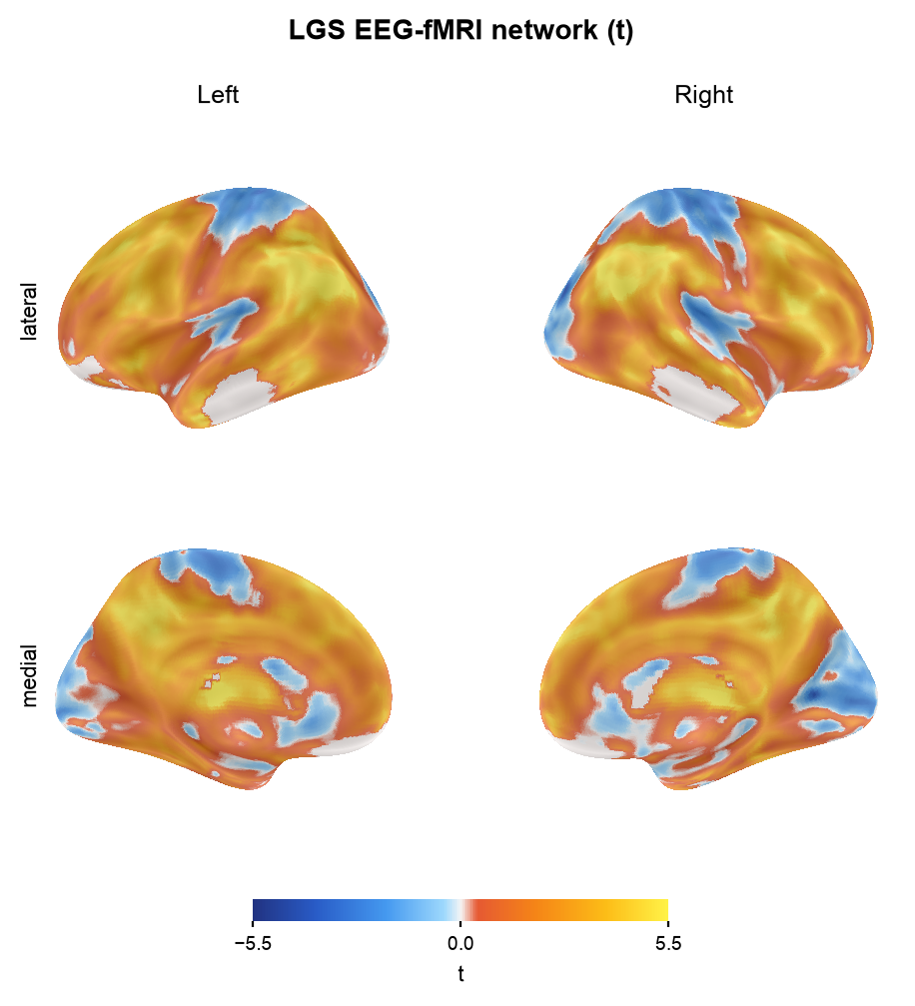
Figure 1. The Lennox–Gastaut EEG-fMRI network (unthresholded t-map) projected onto the inflated cortical surface.
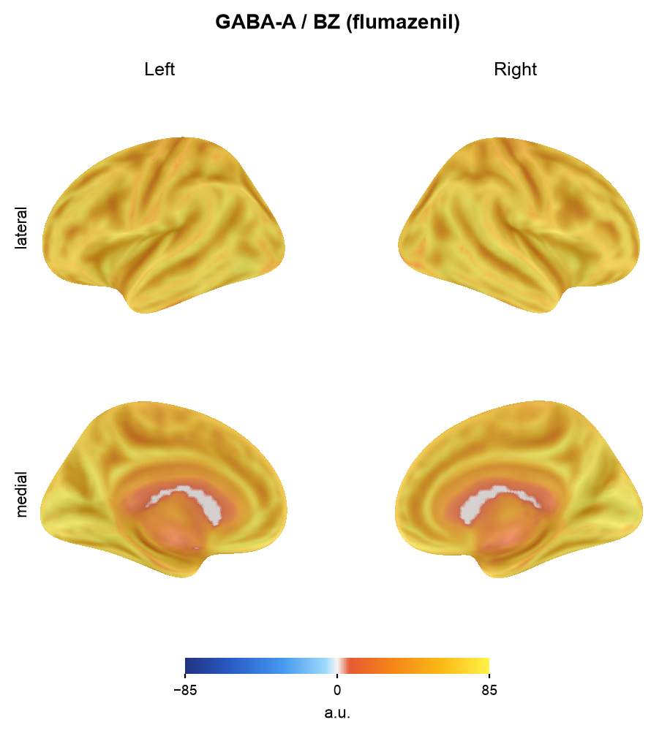
Figure 2. GABA-A/benzodiazepine receptor density (flumazenil PET) on the cortical surface, for visual comparison with the LGS network.
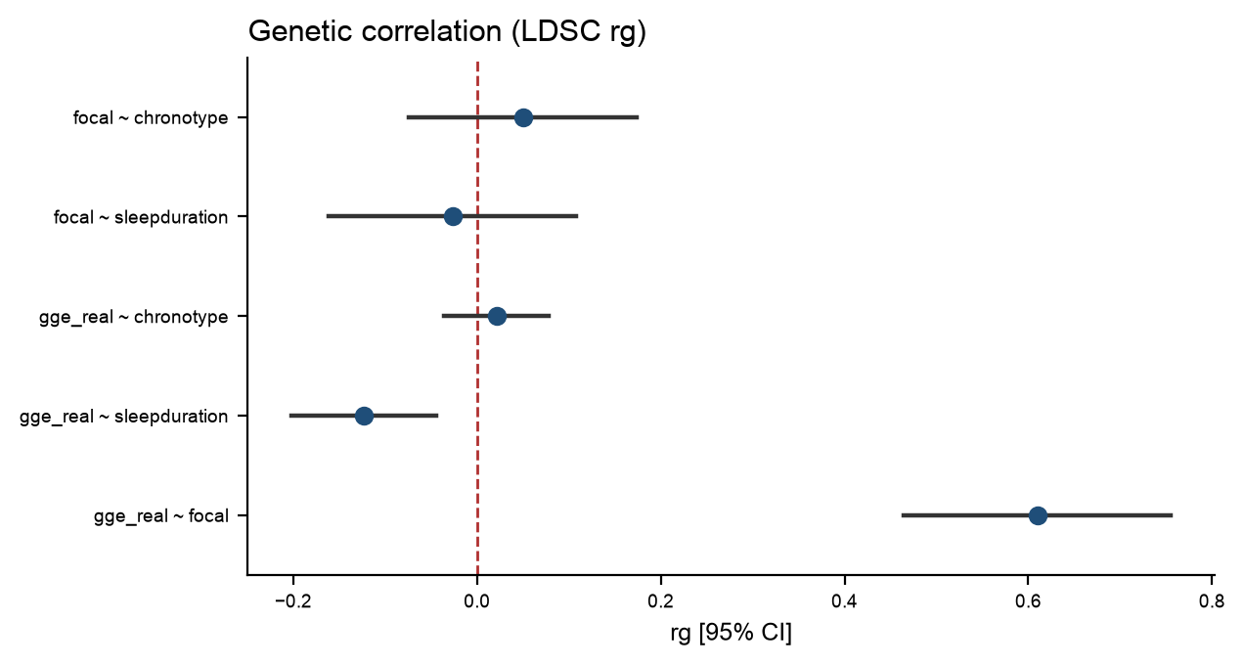
Figure 3. Forest plot of LDSC genetic correlations of GGE and focal epilepsy with sleep duration and chronotype (rg with 95% CI; dashed line = no correlation).

