|  |  |  |  |  |  |
| --- | --- | --- | --- | --- | --- |
|  | **V-pipe** | **nf-core/**  **viralrecon** | **HAVoC** | **ViralFlow** | **ViReflow** |
| Graphical user interface (GUI) | No | No | No | No | Yes |
| Amplicon sequencing support | No | Yes | Yes | Yes | Yes |
| Workflow tool | Snakemake13 | Nextflow14 | Bash script | Python script | Reflow |
| Native cloud compute support | None | AWS, GCP, Azure | None | None | AWS |
| Automatic compute resource scaling | No | No | No | No | Yes |
| Supported read trimmers | PRINSEQ15 | Cutadapt16, fastp17, iVar18 | fastp, Trimmomatic19 | fastp | fastp, iVar, PRINSEQ, pTrimmer20 |
| Supported read mappers | BWA-MEM21 | Bowtie222 | Bowtie2, BWA-MEM | BWA-MEM | Bowtie2, BWA-MEM, HISAT223, Minimap224 |
| Supported variant callers | LoFreq25 | iVar, bcftools26 | LoFreq | iVar | FreeBayes27, iVar, LoFreq |
| Supported viral lineage assignment tools | None | Pangolin | Pangolin | Pangolin | Pangolin, VirStrain |
| Supported *de novo* genome assemblers | Haploclique28, SAVAGE29, ShoRAH30 | minia31, SPAdes32, Unicycler33 | None | None | MEGAHIT34, minia, SPAdes, Unicycler |

**Table 1 | Pipeline comparison.** Gray denotes analyses that are optional in ViReflow.

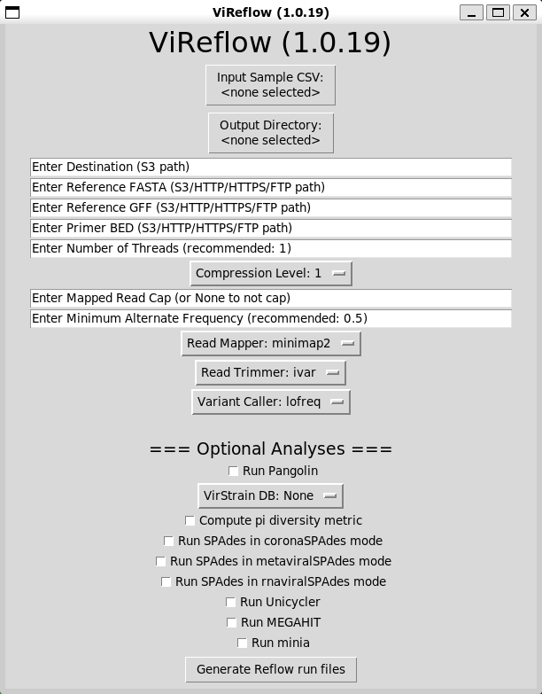

**Figure 2 | ViReflow Graphical User Interface (GUI).**