tallh - CIqøÔj úoHdj

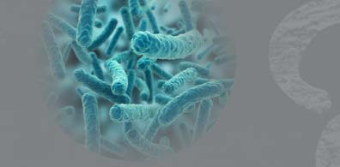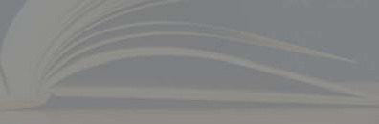

Ôj úoHdj - 13 fYa%Ksh

fuu mqkÍCIK jevigyk

2020$0 $03 Èk

6

fm'j' 07'00 isg 09'00 olajd

úldY h fõ'

tallh - CIqøÔj úoHdj

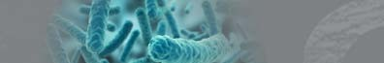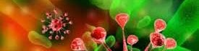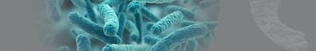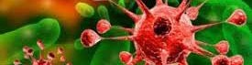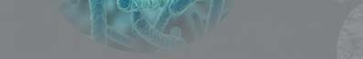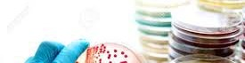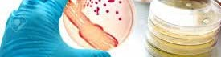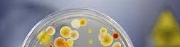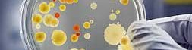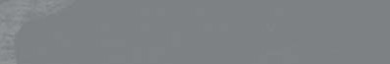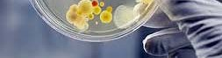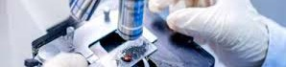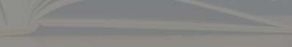

Ôj úoHdj - 13 fYa%Ksh

09 - ta lh

CIqøÔj úoHdj

tallh - CIqøÔj úoHdj



Ôj úoHdj - 13 fYa%Ksh

tallh - CIqøÔj úoHdj

Ôj úoHdj - 13 fYa%Ksh

# ^01& my; i|yka tajd iajdNdúl jdiia:d

**w**

^1& ñksia uydka;%h

^2& ksfrda.S ñksfil=f.aa

s a S s

^3& uqyqÿ c,h

^4& Ydl uq,l u;=msg

# ;ßka ljrla nelaàßhdj,g hla fkdjkafka o @

reêrh

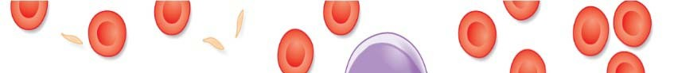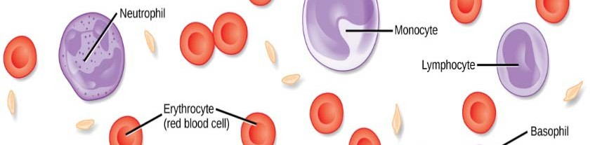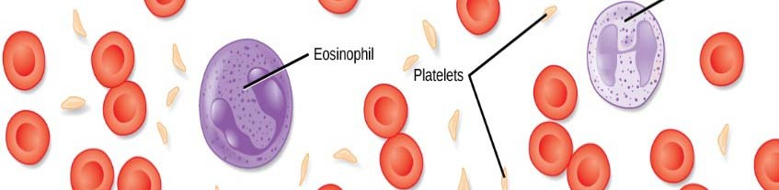

^5& wm wdYajdi lrk jd;h

tallh - CIqøÔj úoHdj

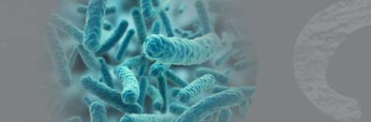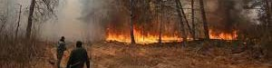

Ôj úoHdj - 13 fYa%Ksh

# ^02& khg%ck ijd dúl j pl%lrKh ùfï §

**s a a**

**S**

**w,am jYfhka u odhljkafka my; i|yka**

**lskï ls%hdj,shl o @**

^1& wefudakslrKh ^2& oykh

a s

^3& khsg%%cka ;sr lsÍu ^4& úfhdackh

^5& l=Kqùu

tallh - CIqøÔj úoHdj

Ôj úoHdj - 13 fYa%Ksh

# ^03& meiagÍlrKfha § lsß "

^1& 170 **0**C § meh 2 la r;afldg isis,a lrkq ,efí'

a a s

s a

^2& wvq WIaK;ajhl § jeä ld,hla ;=< r;alr isis,a lrkq ,efí'

^3& wvq WIaK;ajhl § wê mvkhla hgf;a fmrkq ,efí'

S

^4& 72 **0**C § ;;amr 15 la r;afldg

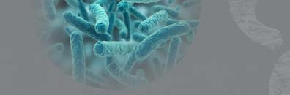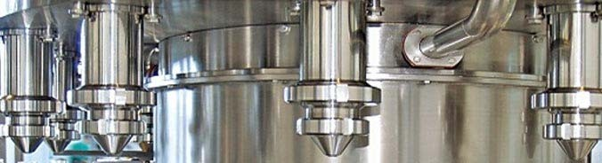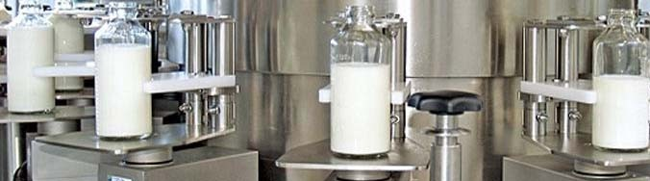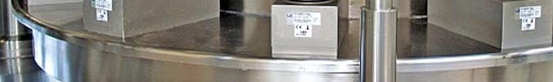

^5& ñks;a;= 15 - 20 UV - lsrKj,g

isis,a lrkq ,efí' Ndckh lrkq ,efí'

tallh - CIqøÔj úoHdj

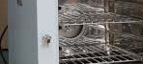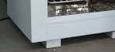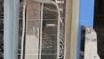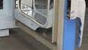

Ôj úoHdj - 13 fYa%Ksh

# ^04& my; ±lafjk l% w;ßka ljrla mdi,a

**úoHd.drfha § fmá%§is ÔjdKqyrKh lsÍu**

**i|yd jvd;a iqoqiq jkafka @**

tallh - CIqøÔj úoHdj

Ôj úoHdj - 13 fYa%Ksh

^1& mSvk ;dmlhla ^´fgdalaf,ajrhla& u`.ska

^2& UV - lsrK u`.ska

s a

^3& yqqud,h u`.ska

^4& t;s,Ska vfhdlaihs wkdjrKh lsÍu

â



^5& WKqiqï úh<s jd;h

s

jeks ridhksl jdIamhkag

u`.ska ÔjdKqyrKh lsÍfuka

s a a

tallh - CIqøÔj úoHdj

Ôj úoHdj - 13 fYa%Ksh

# ^05& - ^09& jk m%Yak my; mokï fõ‘'

**‘**

**i|yka nelaàßhd úfYaI u;**

## ^1& *Bacillus subtilis*

**^2& *Vibrio cholerae***

## ^3& *Staphylococcus aureus*

**^6& *Lactobacillus bulgaricus***

**^7& *Clostridium tetani***

**^8& *Azotobacter vinelandii***

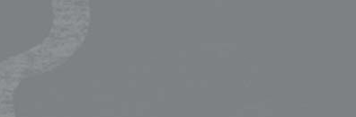

**^4& *Pseudomanas denitrificans* ^9& *Nitrosomonas europaea***

**^5& *Acetobactor aceti* ^10& *Escherichia coli***

tallh - CIqøÔj úoHdj

Ôj úoHdj - 13 fYa%Ksh

# ^05& ñksiqkag jHdêckl jk nelaàßhd folla kï lrkak

## ^1& *Bacillus subtilis* yd *Staphylococcus aureus*

^2& ***Staphylococcus aureus*** yd ***Azotobacter vinelandii***

^3& ***Vibrio cholerae*** yd ***Cl***

***o***



^4& ***Clostridium tetani*** yd

^5& ***Vibrio cholerae*** yd ***Ps***

***e***

## *stridium tetani* Azotobacter vinelandii udomanas denitrificans

tallh - CIqøÔj úoHdj

Ôj úoHdj - 13 fYa%Ksh

# ^06& iajNdúl khsg%cka plS%lrKfha § jeo.;a

**jk nelaàßhd folla kï lrkak**

## ^1& *Staphylococcus aureus*

y

^2& ***Pseudomanas denitrific***

***a***

^3& ***Clostridium tetani*** yd ***A***

## d *Pseudomanas denitrificans* ns yd *Azotobacter vinelandii* otobacter vinelandii

^4& ***Bacillus subtilis*** yd ***Vibrio cholerae***



^5& ***Vibrio cholerae*** yd ***Pseudomanas denitrificans***

tallh - CIqøÔj úoHdj

**tallh - CIqøÔj úoHdj**

**13 fYa%Ksh Ôj úoHdj**

Ôj úoHdj - 13 fYa%Ksh

# ^07& l¾udka;j,g jeo.;a jk nelaàßhd folla kï lrkak'

## ^1& *Staphylococcus aureus* yd *Pseudomanas denitrificans*

^2& ***Acetobactor aceti*** yd ***Lactobacillus bulgaricus***

^3& ***Clostridium tetani*** yd ***Azotobacter vinelandii***

^4& ***Bacillus subtilis*** yd

***V***



## ^5& *Nitrosomonas euro*

***ibrio cholerae***

***ae*** yd ***Escherichia coli***

***p***

tallh - CIqøÔj úoHdj

**tallh - CIqøÔj úoHdj**

**13 fYa%Ksh Ôj úoHdj**



Ôj úoHdj - 13 fYa%Ksh

# ^08& nysIaOQ,l ksmojk nelaàßhd 2 la kï lrkak'

## ^1& *Bacillus subtilis* yd *Staphylococcus aureus*

^2& ***Vibrio cholerae*** y ***Staphylococcus aureus***

^3& ***Staphylococcus aureus*** yd ***Clostridium tetani***

^4& ***Vibrio cholerae*** yd ***Clostridium tetani***

^5& ***Nitrosomonas europaea*** yd ***Escherichia coli***

tallh - CIqøÔj úoHdj

Ôj úoHdj - 13 fYa%Ksh

# ^09& weuhsf,aia tkaihsu ksmojk yd wdydr

**úIùu isÿ l olajd we;af;a**

**k nelaàßhd hq., wkqms<sfj,ska**

^1& ***Bacillus subtilis*** yd ***St***

***a***



^2& ***Bacillus subtilis*** yd ***L***

***a***

## ^3& *Staphylococcus aure*

^4& ***Bacillus subtilis*** yd ***L***

## ^5& *Staphylococcus aure*

***u***

***phylococcus aureus ctobacillus bulgaricus***

***s*** yd ***Lactobacillus bulgaricus***

***ctobacillus bulgaricus s*** yd ***Escherichia coli***

tallh - CIqøÔj úoHdj

**tallh - CIqøÔj úoHdj**

**13 fYa%Ksh Ôj úoHdj**

Ôj úoHdj - 13 fYa%Ksh

# ^10& jerÈ m%ldYh f;darkak'

^1& fmksis,ska ksmojkafka È,Srhla u`.sks'

s

^2& mg.eiau we;jkafka nela

s s

^3& fm%danfhdála nelaàßhdjla

ßhdjla u`.k' f,i

***Clostridium botulinum*** y÷kajdÈh yels h'



^4& WKikaksmd;h yd fld,rdj jeks frda.

c,h yd wdydr u.k iïf %IKh úh yelh'

s a

a s

^5& nelaàßhdj,g m%;sÔjl ksmoúh yelsh'

tallh - CIqøÔj úoHdj

**tallh - CIqøÔj úoHdj**

**13 fYa%Ksh Ôj úoHdj**

Ôj úoHdj - 13 fYa%Ksh

# ^11& my; i|yka Ôù hq., w;ßka ljrl tluq;=

**ls%hdj ksid úkdlsß ksmofõ o @**

**^1& *Lactobacillus*** yd ***Saccharomyces***

**^2& *Saccharomyces***

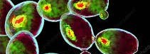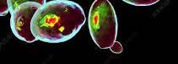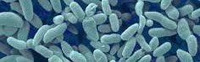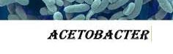

**^3& *Aspergillus* yd**

**^4& *Acetobactor* yd**

**^5& *Saccharomyces***

## yd *Aspergillus* Acetobactor Lactobacillus yd *Acetobactor*

tallh - CIqøÔj úoHdj

**tallh - CIqøÔj úoHdj**

**13 fYa%Ksh Ôj úoHdj**

Ôj úoHdj - 13 fYa%Ksh

# ^12& my; i|yka frda. ldKav w;ßka ljrla

**nelaàßhd u`.ska we;s fõ o @**

^1& msg.eiau" ir

ï

^2& mg.eiu" W

s a

m " CIhfrda.h ikkmd;h*"* CIhfrd.h

^3& mefmd,*"* f.dfkdaßhdj" WKikaksmd;h

a s a



^4& msg.eiau" kshqfudakshdj" refn,a,d

^5& CIhfrda.h" fymghsàia" kshqfudakshdj

tallh - CIqøÔj úoHdj

**tallh - CIqøÔj úoHdj**

**13 fYa%Ksh Ôj úoHdj**

Ôj úoHdj - 13 fYa%Ksh

**^13& *Clostridium tetani* iïnkaOfhka my; i|yka tajd w;ßka ljrla ksjerÈ o @**

^1& th ffjl,ams; ks¾jdhq nelaàßhdjls'

^2& Yajik moaO;shg iïnkaO frda. we;s lrhs'

^3& th nysIaOQ,l ksmojk

^4& uQ, f.da,fha Ôj;afjñ øjH ksmojhs'

Ôúfhls'

a Ydl j¾Ol

^5& ffcj fmdfydr f,i Ndú; lrhs'



tallh - CIqøÔj úoHdj

**tallh - CIqøÔj úoHdj**

**13 fYa%Ksh Ôj úoHdj**

Ôj úoHdj - 13 fYa%Ksh

# ^14& my; i|yka tajd fndafjk frda.hla

**w;ßka ljrla c,h u`.ska o @**



^1& f d,rdj

l

^2& jiQßh

^3& , ÿre

^4& lïuq,a.dh

^5& irïm

tallh - CIqøÔj úoHdj

**tallh - CIqøÔj úoHdj**

**13 fYa%Ksh Ôj úoHdj**

Ôj úoHdj - 13 fYa%Ksh

# ^15& iqfl%dia iys; øj udOHhl

**j**

**,ndÿka úg isÿúh fkdyels"**

^1& ffi,j, iS>% úNd

c

^2& ldnkavfhdlaihsâ

a a

# Q hSiaÜ frdamkhlg Tlaiscka

**my; i|yka tajd w;ßka l=ula o @**

khùu'

ksmojk fõ.h jeäùu'

^3& **ATP** ixiaf,aIKh



^4& uoHidr ksmofjk

^5& ødjKfha iqlafrdaia

jk fõ.h jeäùu' fõ.h jeäùu' idkaøKh wvqùu'

tallh - CIqøÔj úoHdj

**tallh - CIqøÔj úoHdj**

**13 fYa%Ksh Ôj úoHdj**

Ôj úoHdj - 13 fYa%Ksh

# ^16& CIqøÔùka u`.ska wdydr krlaùu iïnkaOfhka

**my; i|yka ljrla ksjerÈ o @**

^1& nelaàßhdj, iS>% j¾Okhg fya;=jk ish¨ u mßir idOl wdydr krlaùu iS>%fhka isÿ ùug o fya;= fõ'

^2& wdydr krla ùug fya;= ldrl muK h'

jkafka m%d.akHIaál úIufmdAISka



^3& iajhxfmdaIS nelaàßhd j¾. o wdydr krlaùu i|yd odhl fõ'

^4& idudkHfhka wêl f;;ukh we;s wdydr È,Sr u`.ska krla fõ'

^5& wdydr krlaùu i|yd wdydrfha wvx.= fmdaIl m%udKh jeo.;a fkdfõ'

tallh - CIqøÔj úoHdj

**tallh - CIqøÔj úoHdj**

**13 fYa%Ksh Ôj úoHdj**

Ôj úoHdj - 13 fYa%Ksh

# ^17& my; i|yka nela ldKavhla mfiys

**à**

**w**

**lrhs o@**

n

^1& ihfkd

^2& khsg%cka

^3& khsá%yd

# ßhd ldKav w;ßka ljr efudakshï whk TlaislrKh

elaàßhd

;sr lrk nelaàßhd nelaàßhd

a

^4& uQ

.eá

s nelaàßhd



^5& khsá%ld nelaàßhd

Í

tallh - CIqøÔj úoHdj

**tallh - CIqøÔj úoHdj**

**13 fYa%Ksh Ôj úoHdj**



Ôj úoHdj - 13 fYa%Ksh

# ^18& my; ±lafjk nelaàßhd .K w;ßka ljr

**.Khl jHdêckl nelaàßhd wvx.= fõ o @**

**^1& *Lactobacillus***

**^2& *Acetobacter***

**^3& *Staphylococcus***

**^4& *Azotobacter***

**^5& *Nitrobacter***

tallh - CIqøÔj úoHdj

**tallh - CIqøÔj úoHdj**

**13 fYa%Ksh Ôj úoHdj**

Ôj úoHdj - 13 fYa%Ksh

# ^19& ffcj f,i khsg%cka ;sr l< yelafla"

^1& hSiaÜ u`.ska khsg%c a TlaisyrKfhks'

^2& ihfkdnelaàßhd u`.ska khsg%cka TlaisyrKfhks'

**^3& *Rhizobium*** u`.ska

k

**^4& *Nitrobacter*** u`.ska

a

hsfÜ%Ü iE§fï §' khsg%cka TlaisyrKfhks'

**^5& *Nitrosomonas*** u`.ska khsg%cka TlaisyrKfhks'

a a



tallh - CIqøÔj úoHdj

**tallh - CIqøÔj úoHdj**

**13 fYa%Ksh Ôj úoHdj**

Ôj úoHdj - 13 fYa%Ksh

# ^20& úoHd.drj, Ndú; lrkq ,nk ùÿre msfmÜgq

**ÔjdkqyrKh i|yd i|yka ldrl w;ß**

^1& f;;a

;

# Ndú; flfrkafka my; a ljrla o @

dmh

**a a**

^2& úh,s ;dmh

^3& laf,daÍka vfhdlaihsâ

^4& UV -



^5& újD;

srK

±,a,

tallh - CIqøÔj úoHdj

**tallh - CIqøÔj úoHdj**

**13 fYa%Ksh Ôj úoHdj**

Ôj úoHdj - 13 fYa%Ksh

# ^21& wldnksl ldnka m% my; i|yka Ôùka

**N**

**jhlska ldnka ,nd.kafka w;ßka ljfrla o @**



**^1& *Clostridium***

**^2& *Streptococcus***

**^3& *Pseudomonas***

**^4& *Nitro omonas***

***s***

**^5& *Azotobacter***

tallh - CIqøÔj úoHdj

**tallh - CIqøÔj úoHdj**

**13 fYa%Ksh Ôj úoHdj**



Ôj úoHdj - 13 fYa%Ksh

# ^22& my; i|yka tajdhska ffjri ms<sn| j jerÈ jkqfha l=ula o @

**a a**

^1& tajd ffi,Sh ixúOd hla fkdfmkajhs'

^2& tajd wksjd¾h mrfmdaIs;hska fõ'

^3& ffjri Ôfkdaufha DNA fyda RNA we;'

^4& iuyr RNA ffjrij, ßj¾ia g%dkaials%mafÜia tkaihsu we;'

^5& ;udf.au fm%daàk ixiaf,aIK hdka;%Khla we;'

tallh - CIqøÔj úoHdj

**tallh - CIqøÔj úoHdj**

**13 fYa%Ksh Ôj úoHdj**

Ôj úoHdj - 13 fYa%Ksh

# ^23& khsg%cka pl%fha my; ±lafjk ridhksl mßj¾;k w;ßka ljrla khsfg%dnelag¾ u`.ska

**a**

**a s a s a**

**isÿfõ o @**

**^1& NO- NO -**

**2 3**

**^2& NH4+ NO2-**

**^3& NO2-**

**NH3**

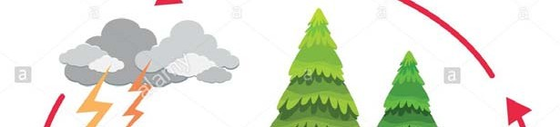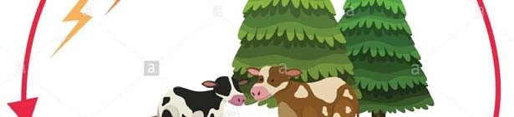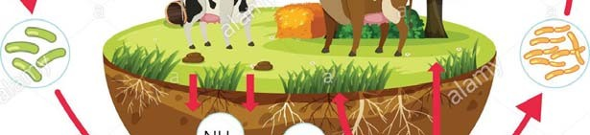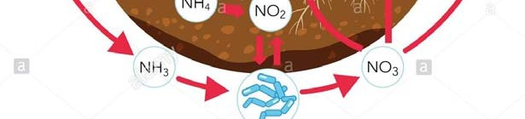

**^4& NO3- N2**

**^5& N2 NH3 / NH4+**

tallh - CIqøÔj úoHdj

**tallh - CIqøÔj úoHdj**

**13 fYa%Ksh Ôj úoHdj**

Ôj úoHdj - 13 fYa%Ksh

# ^24& frdamK udOH ÔjdKqqyrKh lsÍfï § my;

**i|yka l%u w;=ß wkq.ukh lsÍu**

**k**

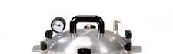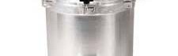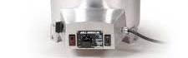

**a ljrla $ ljr tajd ksjerÈ jkafka o @**

**tallh - CIqøÔj úoHdj 13 fYa%Ksh Ôj úoHdj**

^A& **100 0C** c, ;dmlhl mehla kegùu'

^B& mdrcïnq, lsrKj,g meh 24 la ksrdjrKh lsÍu'

^C& mSvk ;dmlhl **121 0C** WIaK;ajhl § ñks;a;= 15 la ;eîu'

a a s a a

^D& ÔjdKqyrKh lrk ,o m



^E& NIaólrKh

, fmrykla u`.ska fmÍu'

tallh - CIqøÔj úoHdj

**tallh - CIqøÔj úoHdj**

**13 fYa%Ksh Ôj úoHdj**

Ôj úoHdj - 13 fYa%Ksh

# ^25& CIqøÔùka bjy,a jkafka "

^A & Ydl yd i;a;aj fldgia

j

^B& fmd,a hqIj,ska meKs iE

§

^C& rd j,ska úkdlsß iE§fï

^D& we;eï tkk; j¾. iE

a a

,ska fldïfmdaiaÜ iE§fï § h' fï § h'

§ h'

fï § h'



^E& úgñk " fm%daàk W!k;djhka uÕyrjd .ekSug h'

tallh - CIqøÔj úoHdj

**tallh - CIqøÔj úoHdj**

**13 fYa%Ksh Ôj úoHdj**

Ôj úoHdj - 13 fYa%Ksh

# ^26& my; i|yka tajd w;ßka l=ula $l=uk tajd

**ksIamdokfha § nelaàßhdj, ls%hdldß;ajh wod< fõ o @**

1. uqojmq lsß



(c)

a

(e) yl=re

1. whsialS%ï
2. a

tallh - CIqøÔj úoHdj

**tallh - CIqøÔj úoHdj**

**13 fYa%Ksh Ôj úoHdj**



Ôj úoHdj - 13 fYa%Ksh

# ^27& wdydr úIùu we;súh yelafla " my; i|yka tajd

**w;ßka ljrla$ljr tajd ksid o@**

## *Staphylococcus aureus*

* 1. ***Clostridium botulinum***
  2. ***Salmonella typhi***
  3. ***Vibrio cholerae***
  4. ***Aspergillus flavus***

tallh - CIqøÔj úoHdj

**tallh - CIqøÔj úoHdj**

**13 fYa%Ksh Ôj úoHdj**

Ôj úoHdj - 13 fYa%Ksh

# ^28& CIqøÔùka iïnkaOfhka my; l=uk j.ka;sh idjoH fõ o @

^1& ffcj f.da,h ;=< jvd;au jHdma; jQ Ôùka ùu'

^2& nelaàßhd wêrdcOdkshg j¾ ffi, ì;a;s fkdue;'

a s

.S s s s a

SlrKh lr we;s fud,slHqghskag

^3& ffjfrdhsv k.ak RNA muKla ork w;r Ydl wdidokh lrhs'



^4& ms%fhdak ñksiqkaf.a yd .jhskaf.a iakdhq moaO;sj,g wdidokh lrk kHIaál wï, rys; fm%daàkuh wdidol fõ'

s

^5& CIqøÔùka ish,a, u mshú weig fkdfmfkk m%%d.akHIaál fõ'