## BAN502 Module4

## Assignment 1. Missing Data

## Mahepath-Corbitt, Niesha

options(tidyverse.quiet = TRUE)  
library(tidyverse)  
library(VIM)

## Warning: package 'VIM' was built under R version 3.6.2

## Loading required package: colorspace

## Loading required package: grid

## Loading required package: data.table

##   
## Attaching package: 'data.table'

## The following objects are masked from 'package:dplyr':  
##   
## between, first, last

## The following object is masked from 'package:purrr':  
##   
## transpose

## VIM is ready to use.   
## Since version 4.0.0 the GUI is in its own package VIMGUI.  
##   
## Please use the package to use the new (and old) GUI.

## Suggestions and bug-reports can be submitted at: https://github.com/alexkowa/VIM/issues

##   
## Attaching package: 'VIM'

## The following object is masked from 'package:datasets':  
##   
## sleep

library(mice)

## Warning: package 'mice' was built under R version 3.6.2

## Loading required package: lattice

## Registered S3 methods overwritten by 'lme4':  
## method from  
## cooks.distance.influence.merMod car   
## influence.merMod car   
## dfbeta.influence.merMod car   
## dfbetas.influence.merMod car

##   
## Attaching package: 'mice'

## The following object is masked from 'package:tidyr':  
##   
## complete

## The following objects are masked from 'package:base':  
##   
## cbind, rbind

grades <- read_csv("class-grades.csv")

## Parsed with column specification:  
## cols(  
## Prefix = col_double(),  
## Assignment = col_double(),  
## Tutorial = col_double(),  
## Midterm = col_double(),  
## TakeHome = col_double(),  
## Final = col_double()  
## )

Task 1: How much data is missing and in what variables? There are 11 NAs in the data: 1 in Tutorial, 3 in Midterm, 3 in TakeHome, and 4 in Final.

str(grades)

## Classes 'spec_tbl_df', 'tbl_df', 'tbl' and 'data.frame': 99 obs. of 6 variables:  
## $ Prefix : num 5 8 8 7 8 7 8 7 8 7 ...  
## $ Assignment: num 57.1 95 83.7 81.2 91.3 ...  
## $ Tutorial : num 34.1 105.5 83.2 96.1 93.6 ...  
## $ Midterm : num 64.4 67.5 30 49.4 95 ...  
## $ TakeHome : num 51.5 99.1 63.1 105.9 107.4 ...  
## $ Final : num 52.5 68.3 48.9 80.6 73.9 ...  
## - attr(*, "spec")=  
## .. cols(  
## .. Prefix = col_double(),  
## .. Assignment = col_double(),  
## .. Tutorial = col_double(),  
## .. Midterm = col_double(),  
## .. TakeHome = col_double(),  
## .. Final = col_double()  
## .. )

summary(grades)

## Prefix Assignment Tutorial Midterm   
## Min. :4.000 Min. : 28.14 Min. : 34.09 Min. : 28.12   
## 1st Qu.:7.000 1st Qu.: 80.88 1st Qu.: 83.93 1st Qu.: 52.50   
## Median :8.000 Median : 89.94 Median : 93.37 Median : 69.38   
## Mean :7.313 Mean : 85.49 Mean : 89.79 Mean : 67.70   
## 3rd Qu.:8.000 3rd Qu.: 95.00 3rd Qu.:100.56 3rd Qu.: 81.56   
## Max. :8.000 Max. :100.83 Max. :112.58 Max. :110.00   
## NA's :1 NA's :3   
## TakeHome Final   
## Min. : 16.91 Min. : 28.06   
## 1st Qu.: 69.91 1st Qu.: 52.91   
## Median : 88.42 Median : 66.11   
## Mean : 81.12 Mean : 68.23   
## 3rd Qu.: 99.07 3rd Qu.: 83.61   
## Max. :108.89 Max. :108.89   
## NA's :3 NA's :4

Task 2: Use the VIM package to visualize missingness. Does there appear to be systematic missingness? In other words, are there students that are mising multiple pieces of data? Yes. There are students missing several data in midterms, takehome, and final, but most of the data is represented in the Final row with 4 variables.

vim_plot = aggr(grades, numbers = TRUE, prop = c(TRUE, FALSE), cex.axis = .7)

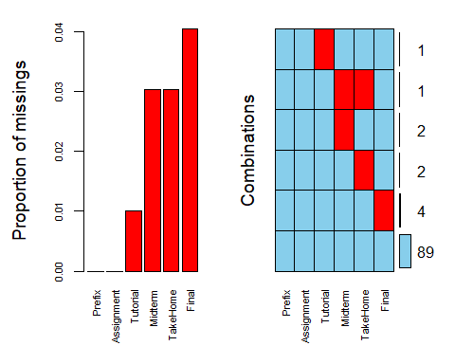

Task 3: Use row-wise deletion of missing values to create a new data frame. How many rows remain in this data frame? After using drop_na function to do a row-wise deletion on the Final variable, there are now 95 variables (rows) left in the new data frame, grades1.

gradesrow = grades %>% drop_na(Final)  
str(gradesrow)

## Classes 'tbl_df', 'tbl' and 'data.frame': 95 obs. of 6 variables:  
## $ Prefix : num 5 8 8 7 8 7 8 7 8 7 ...  
## $ Assignment: num 57.1 95 83.7 81.2 91.3 ...  
## $ Tutorial : num 34.1 105.5 83.2 96.1 93.6 ...  
## $ Midterm : num 64.4 67.5 30 49.4 95 ...  
## $ TakeHome : num 51.5 99.1 63.1 105.9 107.4 ...  
## $ Final : num 52.5 68.3 48.9 80.6 73.9 ...

Task 4: Use column-wise deletion of missing values to create a new data frame (from the original data frame not from the data frame created in Task 3). How many columns remain in this data frame? Using the column-wise deletion to delete the Final row, has completely deleted the column and now there are only 89 variable left in the new data frame, gradescolumn.

gradescolumn = grades %>% select(-Final)  
vim_plot1 = aggr(gradescolumn, number = TRUE, prop = c (TRUE, FALSE), cex.axis = .7)

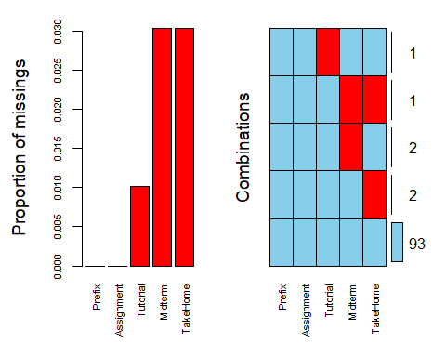

Task 5: Which approach (Task 3 or Task 4) seems preferable for this dataset? Brieﬂy discuss your answer As more important data has been removed with the column-wise deletion, the row-wise deletion is the more preferable method.

Task 6 Use the code below to impute the missing values in the dataset using the mice package.

grades_imp = mice(grades, m=1, method = "pmm", seed = 12345) #in line above: m=1 -> runs one imputation, seed sets the random number seed to get repeatable results

##   
## iter imp variable  
## 1 1 Tutorial Midterm TakeHome Final  
## 2 1 Tutorial Midterm TakeHome Final  
## 3 1 Tutorial Midterm TakeHome Final  
## 4 1 Tutorial Midterm TakeHome Final  
## 5 1 Tutorial Midterm TakeHome Final

summary(grades_imp)

## Class: mids  
## Number of multiple imputations: 1   
## Imputation methods:  
## Prefix Assignment Tutorial Midterm TakeHome Final   
## "" "" "pmm" "pmm" "pmm" "pmm"   
## PredictorMatrix:  
## Prefix Assignment Tutorial Midterm TakeHome Final  
## Prefix 0 1 1 1 1 1  
## Assignment 1 0 1 1 1 1  
## Tutorial 1 1 0 1 1 1  
## Midterm 1 1 1 0 1 1  
## TakeHome 1 1 1 1 0 1  
## Final 1 1 1 1 1 0

densityplot(grades_imp) #red imputed, blue original, only shows density plots when more than 1 value the variable was imputed #note that the density plots are fairly uninteresting given the small amount of missing data

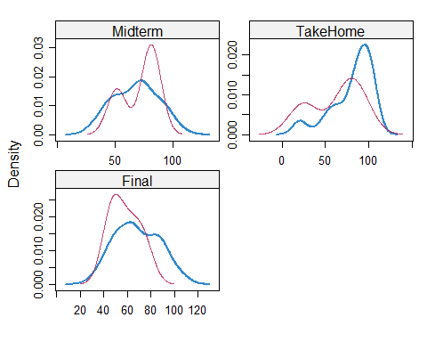

grades_complete = complete(grades_imp)   
summary(grades_complete)

## Prefix Assignment Tutorial Midterm   
## Min. :4.000 Min. : 28.14 Min. : 34.09 Min. : 28.12   
## 1st Qu.:7.000 1st Qu.: 80.88 1st Qu.: 84.69 1st Qu.: 52.50   
## Median :8.000 Median : 89.94 Median : 93.10 Median : 69.38   
## Mean :7.313 Mean : 85.49 Mean : 89.76 Mean : 67.80   
## 3rd Qu.:8.000 3rd Qu.: 95.00 3rd Qu.:100.55 3rd Qu.: 81.88   
## Max. :8.000 Max. :100.83 Max. :112.58 Max. :110.00   
## TakeHome Final   
## Min. : 16.91 Min. : 28.06   
## 1st Qu.: 67.96 1st Qu.: 52.09   
## Median : 87.96 Median : 65.56   
## Mean : 80.54 Mean : 67.81   
## 3rd Qu.: 98.42 3rd Qu.: 83.19   
## Max. :108.89 Max. :108.89

Task 7: Brieﬂy discuss potential issues that could be encountered when working with missing data. Describe situations where imputation may not be advisable.

Imputation may not be advisable when the data is skewed.