User’s Guide

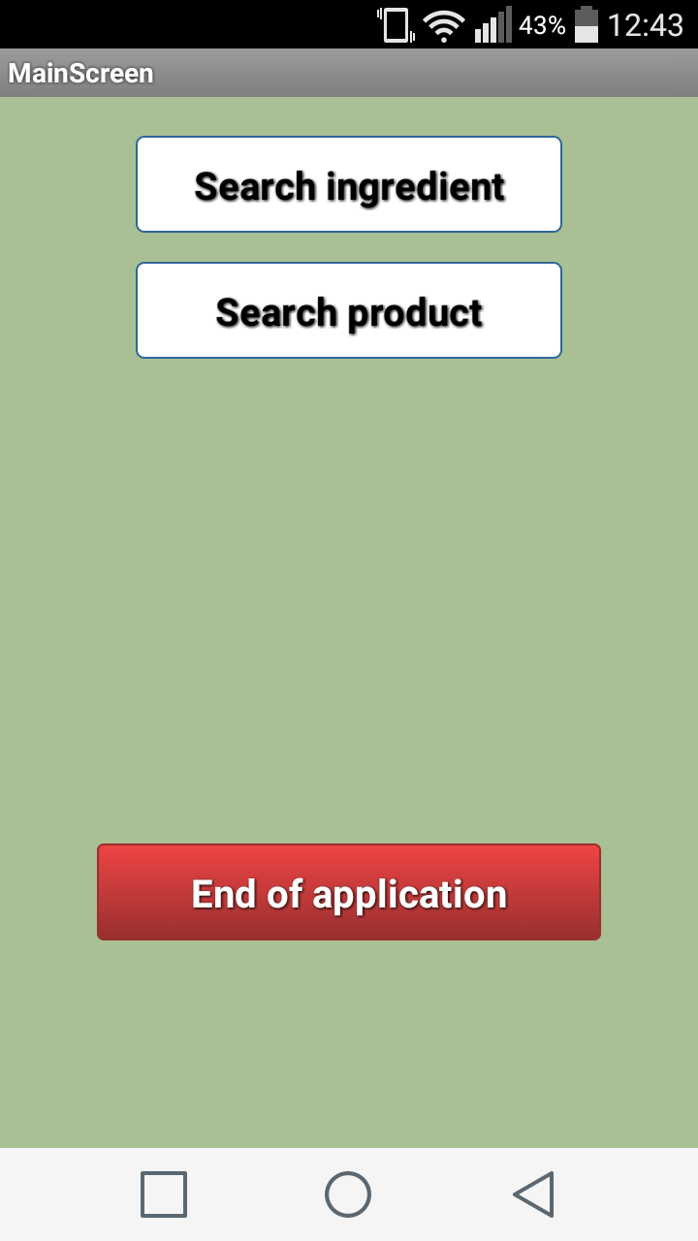

Main menu:

- Search ingredient
- Search product:

- Search product by name
- Search product by QR Code

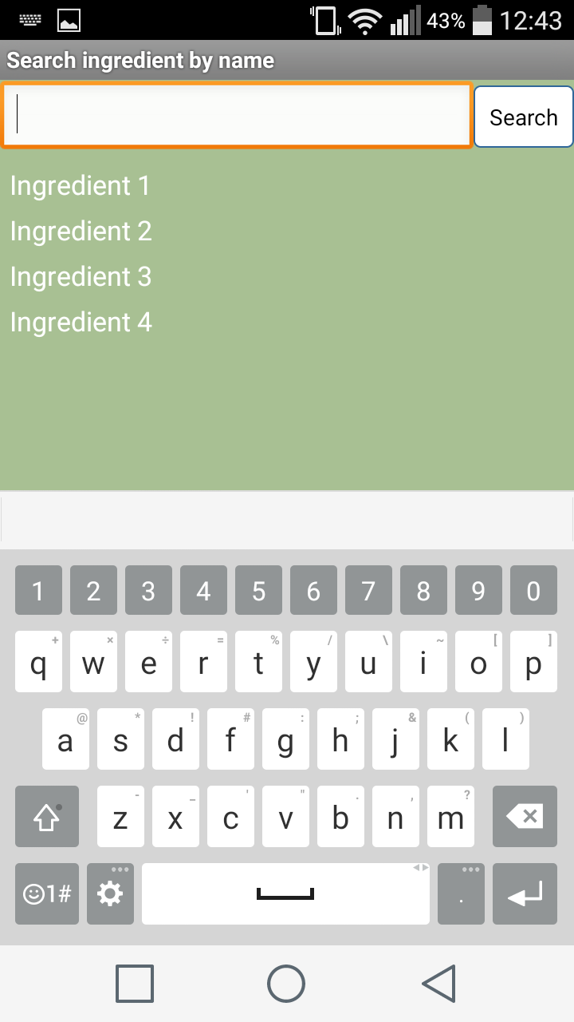
3. End of application

1.Search ingredient:

Lets you search for ingredient, you can pick the ingredient from the list or write ingredient name in the textbox.

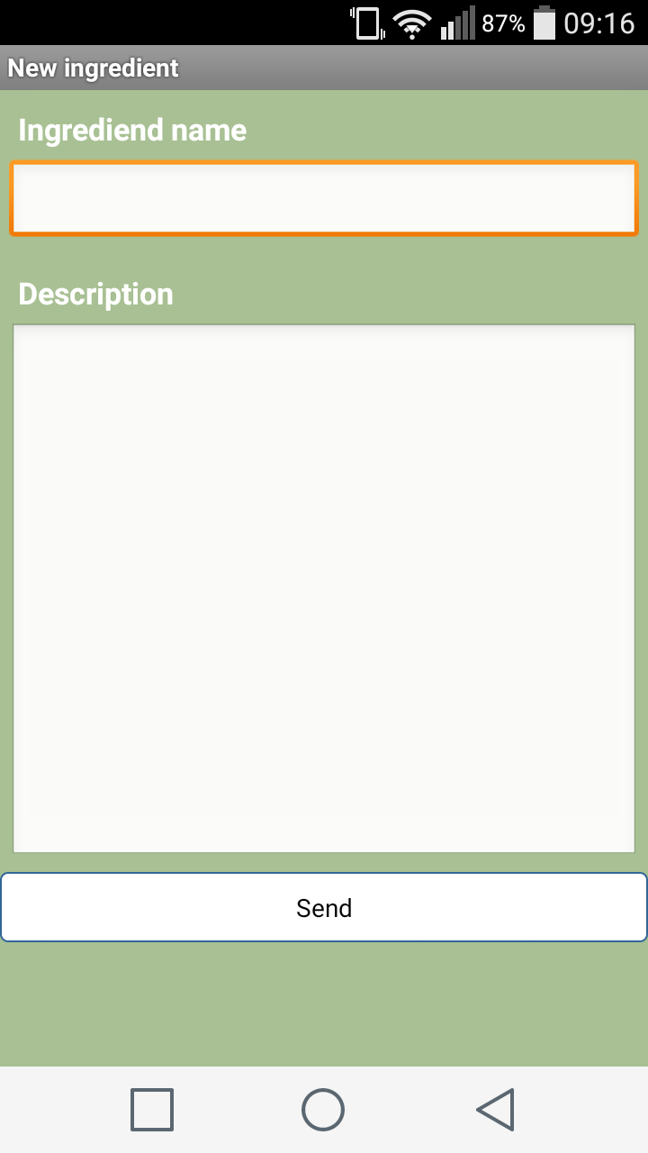
If the ingredient is not in the
database you can add it yourself
with a short description.

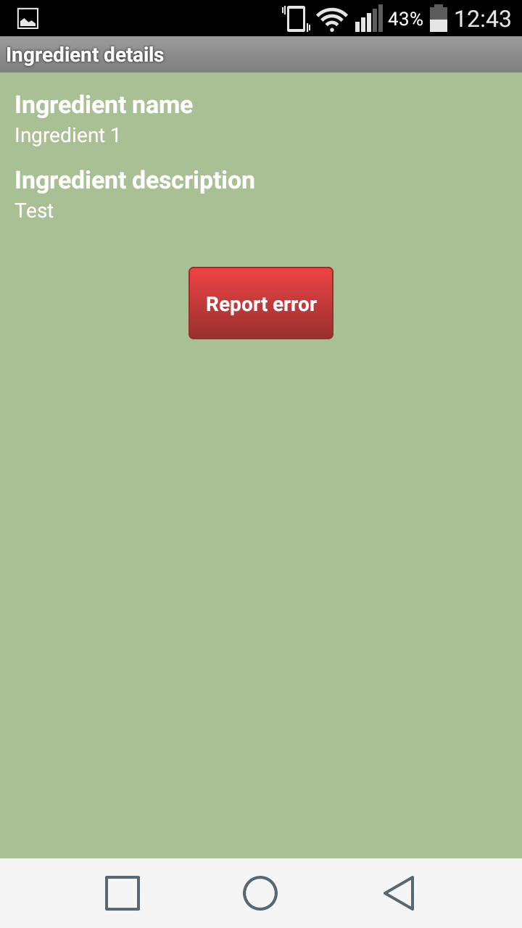
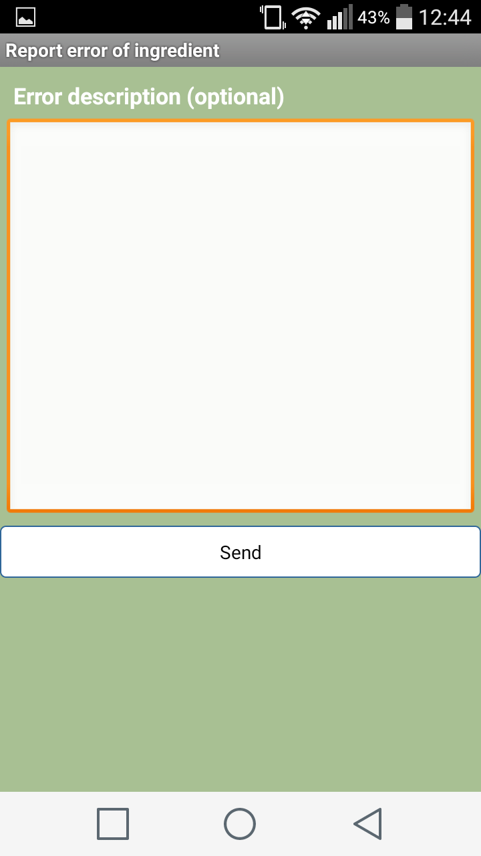
After you choosing ingredient, the Ingredient details screen will show where you can see Ingredient name, Ingredient description and Report error. You can report errors with optional description.
Search product:
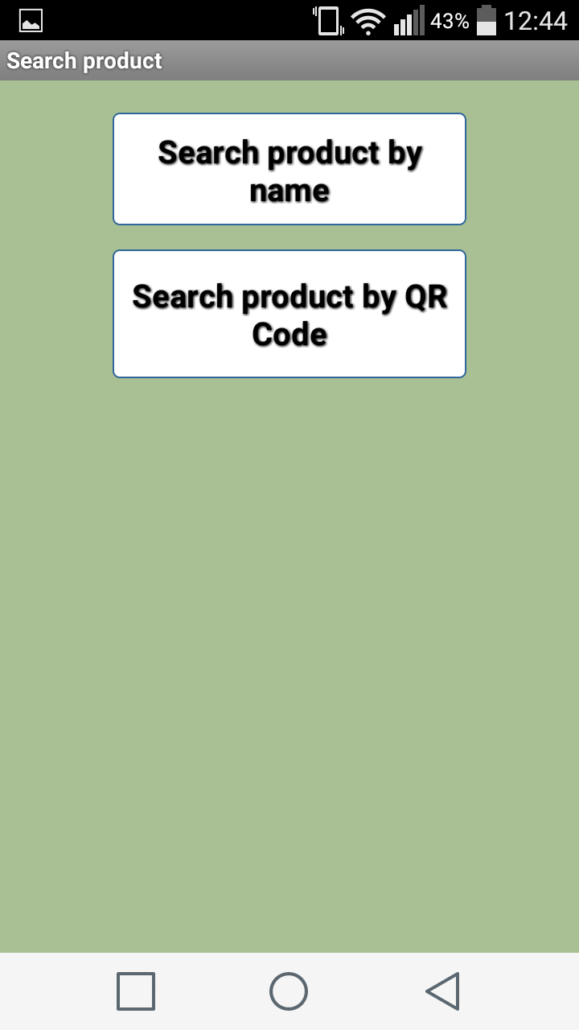
Search product by Name: Search product by QR by
- same as search ingredient Code:
by name You can scan QR Code of the product with an external application.
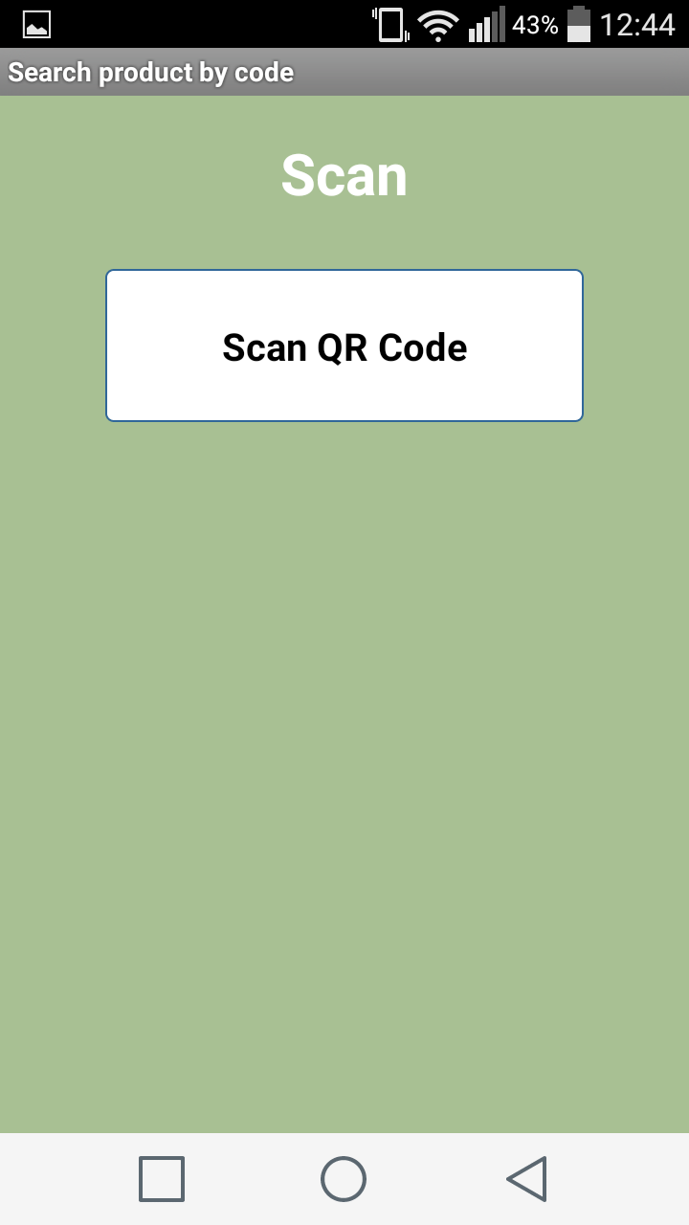
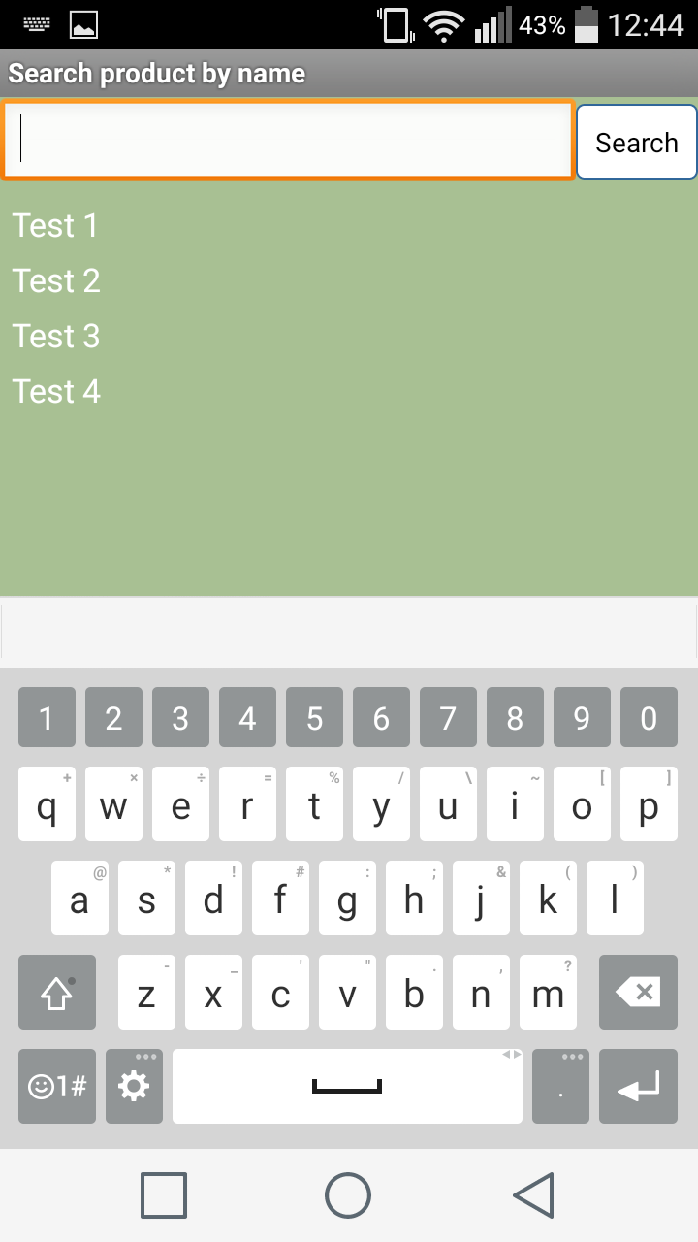

If product is not found in database you can add this product name to the database.
If you find product you are looking forthe product description screen will show up:
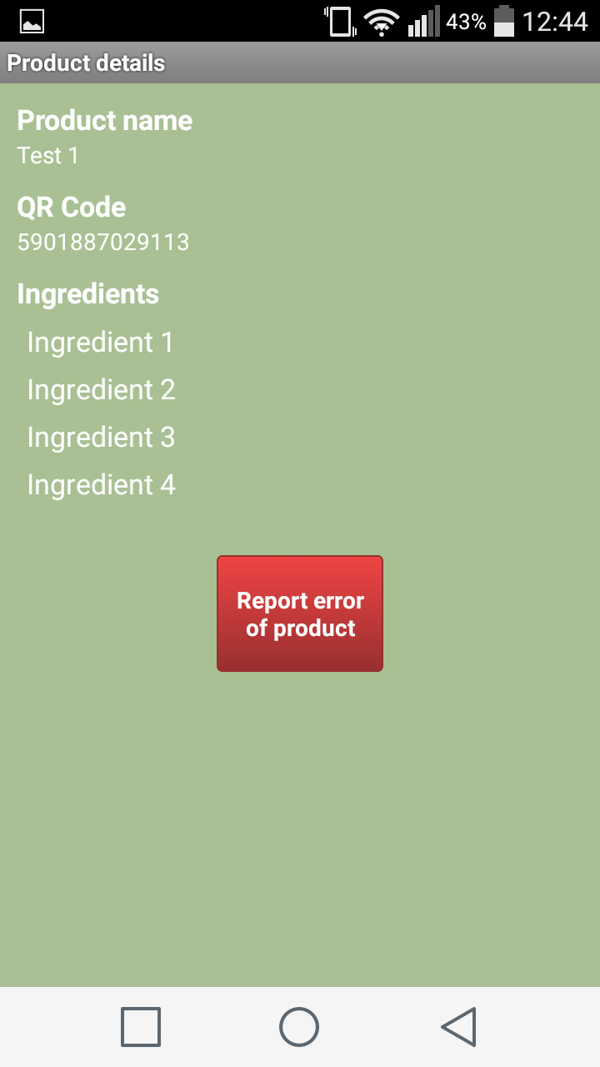
Here you can see information about the product:
- Product Name
- QR Code used to find product by QR Code
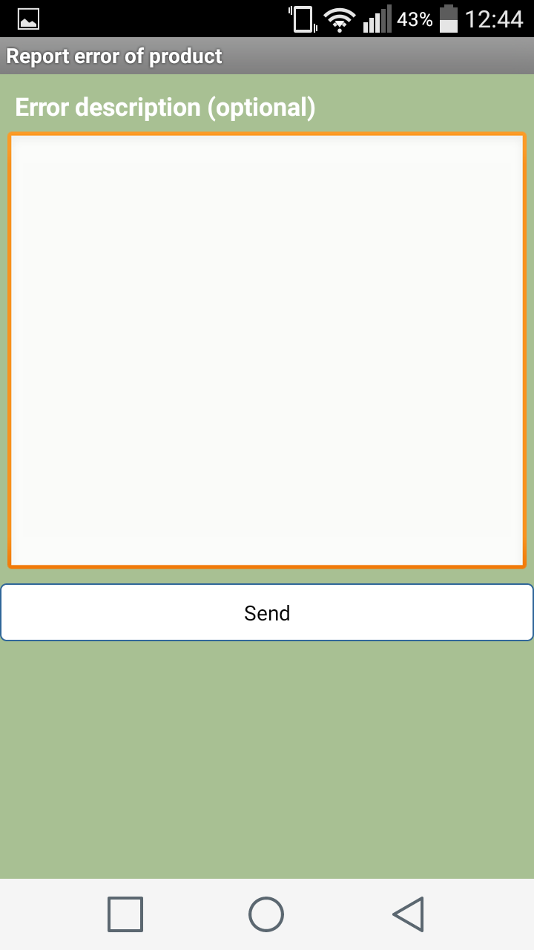
- Ingredients of the product

From this view you can Report
error of the product:

