import_labels example

Jordan Prendez

2016-08-11

The import_labels function is used to import SPSS ® style labels and attach them to a dataset in R. Currently both the dataset and the definitions must be external files (i.e. files located on a local drive -- not those already loaded into R)

## Dataset format

Variable names must be the first row. Data values follow in each subsequent row. Values should be comma seperated and saved in a .txt file.

### Dataset format example

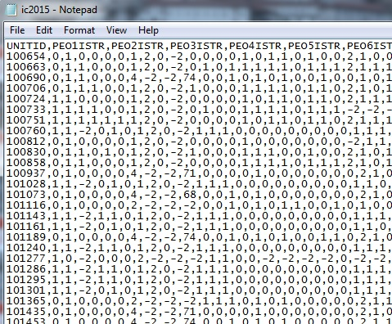

Dataset format example

Each new variable should start with a forward slash "/" (no quotes) and must match the variable name in the dataset exactly (case sensitive)

import_labels accepts definitions with the level of the variable (either string or numeric) followed by the variable definition. Levels that are strings must be surrounded by single quotes ''.

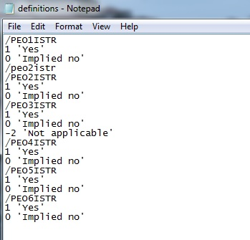

definition format example

## Running the program Example

dataset=path of the dataset file (with formating shown above)

dataset=path of the definition file (with formating shown above)

import_labels(dataset="C:/Users/jprendez/Desktop/ic2015.csv", definitions="C:/Users/jprendez/Desktop/definitions.txt")