

移动应用设计实践

FocusFlow报告

学号： 1230205081
姓名： 聂志理
班级： 通信工程232

浙江科技大学人工智能与信息工程学院

1. 目标
The primary objective of this project is to develop a simple and functional Notes application for Android devices using Java. The app enables users to:
*****
******
*****

2. 设计描述
The Notes App is a mobile application that allows users to manage their notes in a user-friendly way.
*****
******
*****.

3. 设计要求
- Language: Java
- IDE: Android Studio
*****
******
*****

4. 设计结构
The application follows a basic MVC (Model-View-Controller) architecture:
*****
******
*****

5. 界面设计
The main interface consists of:
*****
******

6. 主要功能流程图
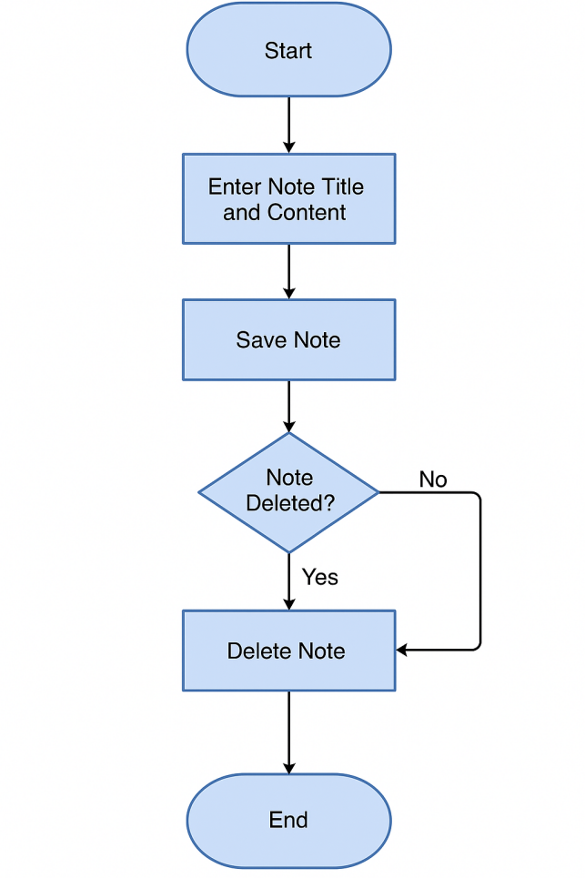

7. 主要函数描述说明
- addNote(String title, String content): Adds a new note to the SQLite database
- getAllNotes(): Fetches all notes from the database
*****
******
*****

8. 文件结构
Java Files:
- *****
******
*****

9. App运行截图

